1. 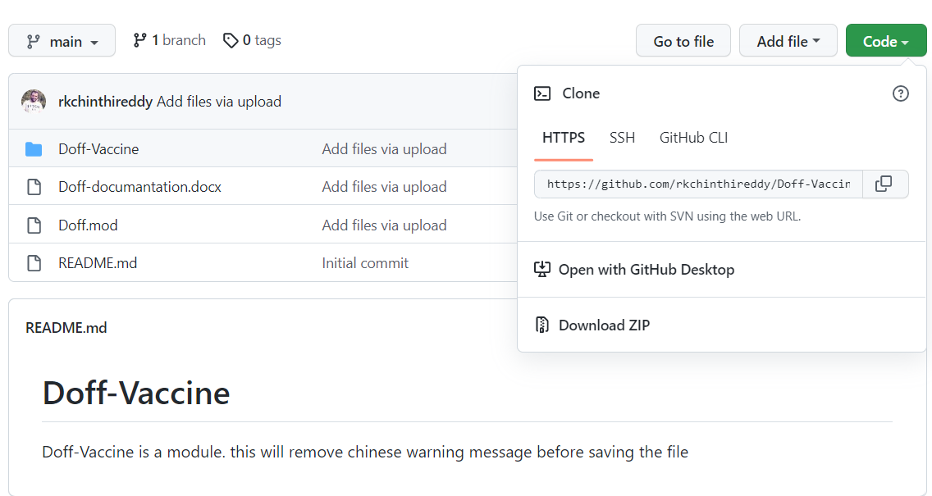Download Zip and exctract it.
2. Paste Doff.mod file in “modules” directory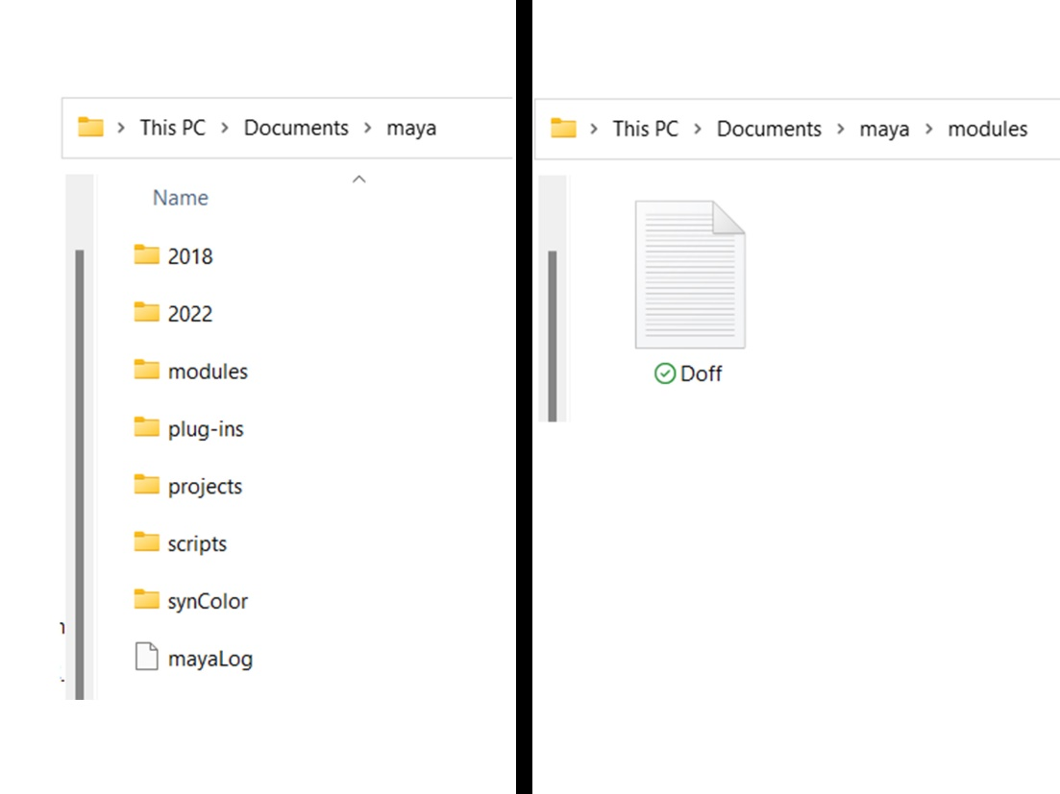
3. Paste Doff-Vaccine folder in your scripts folder. Where ever you want in your pc
4. Edit Doff.mod file

Replace this path **C:/Users/rkChinthireddy/Documents/Doff-Vaccine,** with your Doff-Vaccine path and save. [ use only forward slash]

After installation restart maya.

This module will automatically run before you saving the file and remove vaccine script nodes. So, your file will save without that Chinese warning message