**Department of Computer Science**

Master’s Project and Thesis Guidelines

**Fall 2016 Edition**

*F 2003 edition by Allen Holliday*

*Revised: August, 2016, Mariko Molodowitch*

**Table of Contents**

Introduction 1

Prerequisites 2

Subject Categories 2

Development Project 2

Research Project 3

Thesis 3

Proposing a Project or Thesis 4

Select Topic or Problem 4

Select Advisor and Reviewer / Committee 5

Project 5

Thesis 5

Prepare Proposal 5

Objectives 5

Activities 5

Environment 6

Reports and Products 6

Schedule 6

Submit Proposal 7

Performing The Work 8

Progress Reports 8

Draft Documents 8

Demonstration / Presentation 8

Final Submission 8

Project 8

Thesis 9

Final Evaluation 9

Appendix A: Project / Thesis Definition Form 10

Appendix B: Project / Thesis Proposal 12

Appendix C: Schedule Example 13

Appendix D: Development Project Report 15

Appendix E: Research Project Report 16

Appendix F: Approval Cover Page 17

# Introduction

Every student in the Master of Science in Computer Science program at California State University, Fullerton must complete a computer science project or write a thesis. This document describes the process that you must follow when completing a project or thesis. Much of the process is the same for either project or thesis; where there are differences, they are clearly identified.

The following two paragraphs are taken from the University’s 2016-2017 Catalog’s

*Dissertations, Theses and Projects* section.

*“A thesis is defined as the written product of a systematic study of a significant topic. Within the body of the paper, the student identifies the problem, states the major assumptions, explains the significance of the undertaking, sets forth the sources for and methods of gathering information, analyzes the data, evidence or patterns to offer a conclusion or recommendation. The finished product provides clear evidence of originality, critical and independent thinking, and organization and format, as appropriate for discipline. Normally, an oral defense of the thesis is required.*

*A project is a significant undertaking appropriate to the fine and applied arts or to professional fields. It also evidences originality and independent thinking, appropriate form and organization, and a rationale. It is described and summarized in a written abstract that includes the project’s significance, objectives, methodology and a conclusion or recommendation. An oral defense of the project is strongly encouraged.”*

You may refer to this Catalog section for more information about the University’s gener5al regulations, format guidelines and style manuals, deadlines and final procedures. This section may be found by going to the University Catalog website (<http://catalog.fullerton.edu/>) and then choosing *Graduate Regulations -> Dissertations, Theses, and Projects*.

A project involves the analysis of a computer science problem and the solution of that problem. The analysis and solution show that you have mastered the knowledge and skills of computer science, which you have gained from the courses you have taken and the activities you have performed throughout the master’s degree program in computer science.

A thesis involves study of a significant area of computer science. It shows your ability to think critically and independently, and to develop original ideas from your research. Most projects involve the development of a software product, although a research project can also be done. A thesis usually covers a more intensive research topic; it has more formal documentation requirements and involves a more rigorous approval process.

When you are deciding between a project and a thesis, remember that they are more than a requirement for the Master’s degree; they are also something you can use when you apply for a job or to a graduate school.

## Prerequisites

You must register in CPSC 597 Project or CPSC 598 Thesis to complete this requirement for your degree. To enroll in either class you must have already completed CPSC 589 and have Classified Standing (See the Graduate Handbook’s Classification section for the description of this term.) You must file an approved project proposal in the Computer Science department office no later than the two weeks before the last day of instruction of the preceding semester before you plan to register in CPSC 597 or 598.. For the Fall semester, this deadline is usually the first day after the Fall break, and for the Spring semester, it is usually May 1, but students should check with the office for the actual deadline each semester.

## Subject Categories

A project or thesis involves the systematic creation and execution of a plan for addressing a significant computer science problem. You demonstrate the skills and knowledge that you have acquired by finding a solution to the problem you chose, or by conducting research into a significant area of computer science.

Computer Science projects can come from either of these categories:

1. Software Development
2. Research Project

### Development Project

A development project produces a working implementation of a problem solution. You use software engineering techniques and computer science principles to develop software by:

1. analyzing and specifying requirements.
2. designing a software solution to the requirements specifications.
3. implementing the design in computer programs.
4. testing and integrating the programs.
5. writing the required documents.
6. demonstrating the project.
7. delivering the software program and documents.

Examples of software development projects are: software development aids, user interface tools, Internet applications, and various business or scientific application programs. Some development tools may interact with a special hardware environment. Examples are: program debuggers, device drivers, network systems, code generators, and linkage editors.

### Research Project

In a research project, you investigate a computer science problem or topic by

1. analyzing the problem or topic.
2. conducting extensive research.
3. summarizing your findings from your research investigation.
4. recommending additional research on the topic.
5. drawing conclusions from your research.
6. documenting the results of the study.
7. presenting your results.

Research projects may or may not include software development; such software is normally experimental and is not expected to be production quality.

Before you choose a research project, you must work closely with your faculty advisor to make sure that the requirements are clearly defined and that a quality final report can be delivered.

### Thesis

A thesis is an endeavor of more significance and difficulty than a research project. It involves:

1. analyzing the problem or topic.
2. conducting extensive research.
3. summarizing your findings from your research investigation.
4. recommending additional research on the topic.
5. drawing conclusions and making recommendations.
6. documenting the results of your research.. 7.defending your conclusions and recommendations.

# Proposing a Project or Thesis

You must prepare a proposal for your project or thesis, and have it approved before you may enroll in CPSC 597 or CPSC 598.

The project must demonstrate your understanding of computer science principles and practices, and prove your ability to:

1. Identify a computer science problem.
2. Perform an analysis of the problem.
3. Postulate a solution.
4. Investigate current research to support your solution.
5. Solve the problem.
6. Test the problem.
7. Document the results.
8. Demonstrate your program or present your results.
9. Deliver the final product.

The thesis must demonstrate your understanding of computer science principles and practices, and prove your ability to:

1. Identify a significant computer science problem.
2. Perform extensive research in the topic’s subject area.
3. Analyze the results of that research.
4. Form conclusions and develop recommendations.
5. Document the results of your research in the required form.
6. Present and defend your results.

## Select Topic or Problem

You should start thinking about a computer science problem early in your degree program. The graduate courses you take, especially the CPSC 589 Seminar, provide an opportunity to explore interesting areas of computer science. By the time you finish this course, you should have identified one or more problems of interest.

The Computer Science Department’s Graduate Handbook has a link to a list of faculty and their interests, which may suggest project topics and identify potential advisors.

You should discuss possible topics and problems with faculty members. If you cannot think of a topic or problem, these faculty members may suggest some.

## Select Advisor and Reviewer / Committee

### Project

You must have a faculty advisor and a faculty reviewer for your project. The advisor must be a full-time faculty member; it is preferable to have a full-time faculty member as a reviewer, but a part-time instructor may serve if he or she agrees. They review the project proposal, observe the demonstration or presentation, and evaluate the final report.

You and your advisor should maintain a close working relationship throughout your project. You should meet regularly and often, usually every two weeks or so.

You will see the reviewer primarily at the beginning or the end of your project. The reviewer’s responsibility is evaluation of the final products, although you may ask him or her to comment on draft versions.

### Thesis

You must have a committee of three faculty members to supervise and review your thesis. The chair of this committee will be your thesis advisor and must be a full-time faculty member. It is preferable to have full-time faculty members as other committee members, but a part-time faculty may serve if he or she agrees. All members should have an interest in the problem area that you select. They review the proposal, observe and evaluate your defense.

You and your advisor should maintain a close working relationship throughout your project. You should meet regularly and often, usually every two weeks or so.

You will see the other committee members primarily at the beginning or the end of your thesis. Their responsibility is the evaluation of the final products, although you may ask him or her to comment on draft versions.

## Prepare Proposal

You must write a proposal for your project or thesis, have it approved by your advisor and reviewer or committee, and submitted to the Computer Science Department. See Appendix A Project/Thesis Definition form and Appendix B Project/Thesis Proposal for information on format and organization.

### Objectives

State clearly what is to be accomplished and why it is significant enough for a master’s project or thesis.

### Activities

Describe in detail how the objectives will be achieved. Describe the development phases and the tasks that will be performed.

Include charts, graphics and project models if they will show your activities more clearly.

### Environment

Describe the computers, programming languages, and software tools that will be used in your development or research.

### Reports and Products Project

Define clearly what the final products of the project will be. Identify what you will deliver to your advisor for demonstration and what you will deliver to the Computer Science Department when your project is completed. Possible deliverables include:

* 1. Final report ( required of all projects).
  2. Source code.
  3. User’s manuals.

Appendices D and E provide sample tables of content for the required project reports.

### Thesis

The thesis format and content is described in a manual available from the Graduate Studies Office. You should get a copy as soon as possible and become familiar with its content.

### Schedule

The schedule is a significant part of the project or thesis proposal. It defines what you are going to do and when you are planning to do it. You should consider how long each activity is going to take, which activities must precede others, and how much overlap is possible or desirable. The schedule identifies tasks to be performed, milestones to be met, and the estimated number of hours for each task.

You should work closely with your advisor to develop the schedule. It will help you define the scope of your project and establish a baseline for measuring progress.

A project or thesis should be sized so that they will require 150 – 200 hours of effort. Your schedule should be for a one-semester project. If there are unforeseen difficulties, you should discuss with your advisor about extending it for another semester.

### Project

Allow enough time for analysis and design. One of the common scheduling errors in development projects is having an analysis and design phase that is too short, and coding and integration phase that is too long and drawn-out because of inadequate analysis and design. Schedule time for analysis and design and the use the time to come up with a well-thought out design.

An example of a project schedule is provided in Appendix C.

### Thesis

The University Catalog’s *Dissertations, Theses and Projects* section has a detailed description of the preparation and approval process. Be sure that you are familiar with the deadlines given in this section. Allow enough time for your advisor, your committee, and the university thesis reader (from the Graduate Studies Office) to read, comment, and approve your thesis. Be prepared to modify your thesis in response to their comments, and to resubmit the updated version.

### Submit Proposal

When you, your advisor, and your reviewer or committee agree that the proposal is complete, attach it to a completed Project /Thesis Definition form (see Appendix A) and submit it to the Computer Science Department.

(At this time, a hard copy of the proposal and the form with all required signatures should be submitted, but in the future, the Department may switch to submitting digital documents to a special site.)

# Performing The Work

## Progress Reports

Make periodic progress reports to your advisor; every two weeks is recommended. Compare your actual progress with your schedule and discuss any problems with your advisor. Adjust your schedule if necessary.

## Draft Documents

Create draft versions of the required documents and submit them to your advisor for review. Incorporate comments when preparing the final documents.

## Demonstration / Presentation

Project

Demonstrate the final project to your advisor and your reviewer. For research projects, an oral presentation will substitute for the demonstration.

Thesis

Present your results to your committee and defend your conclusions and recommendations.

## Final Submission

### Project

When your demonstration or presentation and your final project report have been approved by your faculty advisor and your reviewer, you must submit to the Computer Science Department the following:

1. Project Approval form (Appendix E.)

The form must be complete with the signatures of your advisor and reviewer. The office staff will scan the form so that the Department will retain it digitally, and return the original form for you to keep.

1. Project deliverables

This will be the project report and any other final products such as source code and user manuals. They must be submitted in digital form using a link that your advisor will give you.

The report must include an abstract – a **short** (100 words or less) one-paragraph summary of the topic and results, which may be posted on the Computer Science website. It must also include a list of keywords that can be used in a database to help faculty and students locate projects addressing specific topics.

### Thesis

The University Catalog’s *Dissertations, Theses and Projects* section has a detailed description of the requirements for approval signatures, reading by the University thesis reader, and binding and microfilming. Contact the Graduate Studies Office to make sure you know all the requirements for submitting a thesis and getting it approved.

## Final Evaluation

Your grade on your project is based on your advisor’s and reviewer’s assessment of

1. The quality of the final report.
2. The quality of the product developed.
3. The thoroughness of the individual tasks that you performed.

**Appendix A:**

**Project / Thesis Definition Form**

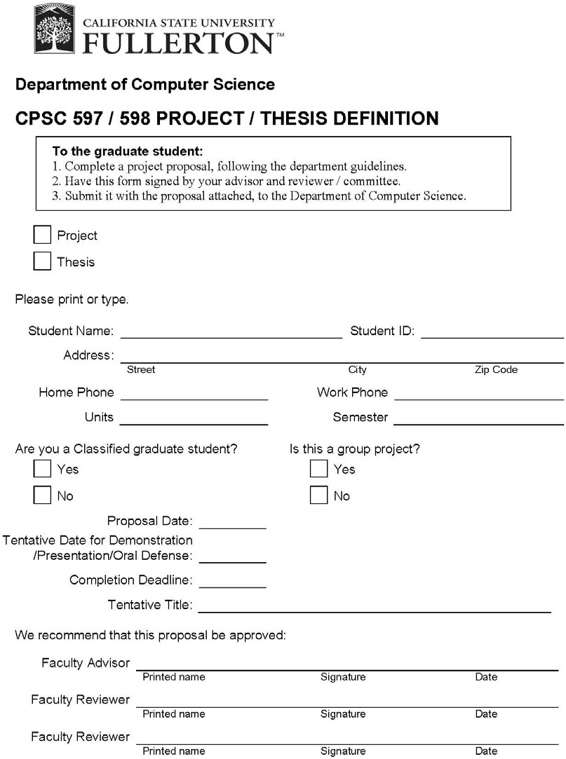

# Appendix B: Project / Thesis Proposal

A sample table of contents and outline for the proposal:

Cover page (Title of project/thesis, your name)

Table of Contents (including Tables, Figures, and Appendices)

1. Introduction
2. Objectives
3. Activities
4. Research / Development Environment
5. Reports and Products
6. Schedule
7. References
8. Appendices (as needed, for supporting documentation.)

# Appendix C: Schedule Example

**Project Schedule Example**

|  |  |  |  |  |  |  |  |  |  |  |  |  |  |  |  |  |  |  |  |
| --- | --- | --- | --- | --- | --- | --- | --- | --- | --- | --- | --- | --- | --- | --- | --- | --- | --- | --- | --- |
| 2016 | February | | | | March | | | | April | | | | May | | | | | Summary | |
| **Tasks:** | 1 | 2 | 3 | 4 | 1 | 2 | 3 | 4 | 1 | 2 | 3 | 4 | 1 | 2 | 3 | 4 | 5 | Hours | Percent |
| Requirements | 12 | 12 | 8 | 6 |  |  |  |  |  |  |  |  |  |  |  |  |  | 38 | 17.9% |
| Design |  |  | 4 | 6 | 12 | 8 |  |  |  |  |  |  |  |  |  |  |  | 30 | 14.2% |
| Code & Unit Test |  |  |  |  | 4 | 8 | 12 | 6 |  |  |  |  |  |  |  |  |  | 30 | 14.2% |
| Integrate & Test |  |  |  |  |  |  | 4 | 6 | 12 | 12 | 12 | 12 | 8 |  |  |  |  | 66 | 31.1% |
| Write User’s  Manual |  |  |  |  |  |  |  |  |  |  |  |  | 6 | 8 |  |  |  | 14 | 6.6% |
| Write Final Report |  |  |  |  |  |  |  |  |  |  |  |  |  | 6 | 12 | 12 |  | 30 | 14.2% |
| Demonstrate |  |  |  |  |  |  |  |  |  |  |  |  |  |  |  |  | 4 | 4 | 1.9% |
| Hours | 12 | 12 | 12 | 12 | 16 | 16 | 16 | 12 | 12 | 12 | 12 | 12 | 14 | 14 | 12 | 12 | 4 | **212** | 100.0% |

# Appendix D: Development Project Report

A sample table of contents for the final report for a development project is shown below:

Approval Cover page (see Appendix F) Abstract (**short!**)

Keyword List

Table of Contents (including Tables, Figures, and Appendices)

1. Introduction
   1. Description of the Problem
   2. Project Objectives
   3. Development Environment (software and hardware)
   4. Operational Environment (software and hardware)
2. Requirements Description (external functions and interfaces)
3. Design Description (architecture, internal functions, and interfaces)
4. Implementation (organization of source file structure, reference list of files)
5. Test and Integration (plan and results)
6. Installation Instructions
7. Operating Instructions
8. Recommendations for Enhancement
9. Bibliography (citing all references used)

# Appendix E: Research Project Report

A sample table of contents for the final report for a research project is shown below:

Approval Cover page (see Appendix F) Abstract (**short!**)

Keyword List

Table of Contents (including Tables, Figures, and Appendices)

1. Introduction
   1. Definition of the Problem
   2. Objective of the Study
   3. Significance of the Problem
   4. Review of Significant Research
   5. Assumptions and Limitations
2. Research Approach or Methodology
3. Research Results and Analysis of Results
4. Summary and Conclusions
5. Bibliography (citing all references used)

# Appendix F: Approval Cover Page

