

**Department of Computer Science**

CPSC 597 / 598 PROJECT / THESIS DEFINITION

|  |
| --- |
| **To the graduate student:** 1. Complete a project proposal, following the department guidelines. 2. Have this form signed by your advisor and reviewer / committee. 3. Submit it with the proposal attached, to the Department of Computer Science. |

|  |  |
| --- | --- |
| X | Project |
|  |  |
|  | Thesis |

Please print or type.

|  |  |  |  |  |  |  |  |  |  |  |  |
| --- | --- | --- | --- | --- | --- | --- | --- | --- | --- | --- | --- |
| Student Name: | | Rosa Kim Cho | | | Student ID: | | | | 888244357 | | |
| Address: | | ­­­­­­­­­­­­­­­­­­­­­­­­­­­­­­­­­­­­­­­­­­­­­­­­20721 E. Crest Ln #D Walnut ,CA 91789 | | | | | | | | | |
|  | | Street | | | City | | | | | Zip Code | |
| Home Phone: | | (909) 973-7826 | Work Phone: | | | | n/a | | | | |
| E-Mail: | rkcho317@csu.fullerton.edu | | | Units: | | 3.0 | | Semester: | | | Spring 2023 | |

Are you a Classified graduate student? Is this a group project?

|  |  |  |  |  |  |  |
| --- | --- | --- | --- | --- | --- | --- |
|  | Yes |  | | |  | Yes |
|  |  |  | | |  |  |
| X | No |  | | | X | No |
| Proposal Date: | | | | 12/12/2022 |
| Tentative Date for Demonstration  /Presentation/Oral Defense: | | | | 4/18/2023 |
| Completion Deadline: | | | | 4/12/2023 |
| Tentative Title: | | | | Brain Tumors Detection using Deep learning | | | | |

We recommend that this proposal be approved:

|  |  |  |  |
| --- | --- | --- | --- |
| Faculty Advisor | **Dr. Kanika Sood** |  | 12/22/2022 |
|  | Printed name | Signature | Date |
| Faculty Reviewer | **Dr. Wenlin Han** |  | 12/12/2022 |
|  | Printed name | Signature | Date |
| Faculty Reviewer | **Dr. Doina Bein** |  | 12/12/2022 |
|  | Printed name | Signature | Date |

Table of Contents

**Cover Page** 1

**Introduction** 3

**Objectives** 3

**Activities** 3

Libraries 3

Medical Imagery 3

Neural Network Development 4

Coding 4

**Research/Development Environment** 5

**Reports and Products** 5

**Schedule** 6

**Appendix A:** **References** 6

Introduction

Computer vision and image processing have been two fields I have enjoyed studying here at Cal State University, Fullerton. As a graduate student, I understand that what I am expected to know is reflected in what I should endeavor to write. Having a background in neuroscience and cognitive science, I am familiar with medical imagery and the anatomy of the brain. As such, I would like to work on a project that would not only reflect my interests but also to apply them in a practical matter. Brain tumors have been among the most studied topics in neuroscience of their prevalence and huge effect on cognition and psychology. To able to detect the presence of brain tumors in MRI scans is among the first steps towards diagnosis. If I were to work on how to apply deep learning to make brain tumor detection easier to do, it would be a great contribution to medical imagery research.

Objectives

My thesis project is titled “Brain Tumor Detections in MRI Scans using Deep Learning” and it will be a project that takes place during the Spring 2023 semester. My goal with this project is to demonstrate how a neural network is able to learn how to detect brain tumors using a dataset composed of 1000 images. This neural network will then be compared to a machine learning model to demonstrate its effectiveness in terms of efficiency, time, and complexity.

Activities

What I have done so far is to research these topics: libraries, medical imagery, and neural network development. I have also created a skeleton of a code for the neural network upon which my project is based on.

## Libraries

The libraries I would like to focus on are OpenCV, TensorFlow, and Sci-kit neural network.

I have used OpenCV for a project for CPSC 483: Machine Learning which focused on image repair and restoration. What the project accomplished was taking in damaged images and then restoring them using a method called INPAINT_TELEA which identified flaws, removed them, and replaced the missing pixels with ones from within the image itself in order to recreate the image as a whole. The INPAINT_TELEA method is one such example of how robust OpenCV is when it comes to image processing and study.

## Medical Imagery

The dataset that I will be using comes from the OpenNeuro development program which takes thousands of MRI scans from volunteers and medical organizations and then processes them for use in research.

## Neural Network Development

As shown in the figure below, there have been several neural network models made for this purpose that have already been developed by various research institutions, organizations, and individual researchers.

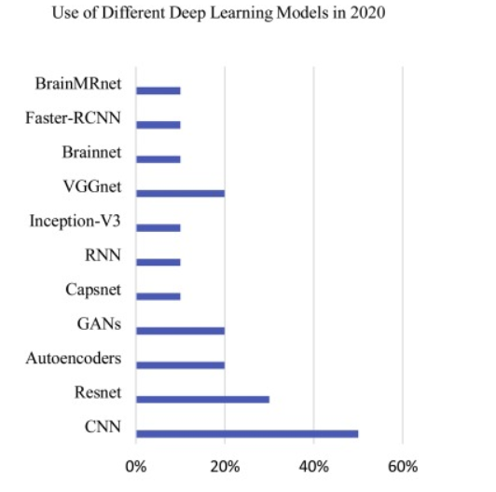  
Nazir, Maria. Shakil, Sadia. First name. “Use of Different Deep Learning Models in 2020.” ScienceDirect, 2021, <https://doi.org/10.1016/j.compmedimag.2021.101940>.

From using 9-layer convolutional neural networks to hybrid models the combine different techniques and machine-learning models, each NN has managed to achieve varying levels of accuracy. What I hope to accomplish is to make a CNN model that is not only accurate but also simple enough to be made within the spring semester.

## Coding

The code contains the libraries that I will use, paths set to where the datasets are stored, and the preprocessing stages which take in the dataset and clean them by setting the proper sizes of each one. The preprocessing stages are merely a failsafe in case the dataset I use has any errors that need to be weeded before being fed to the models.

Research/Development Environment

A majority of my project has been developing on a personal MSI laptop containing a i7 core processor with a NVIDIA GeForce GTX GPU. I have recently been informed that the CSUF computer science department has a network of GPUS called AERES NET that I could use for rendering and compilation purposes when it comes to deploying and testing the neural network. The entire project will be written in the PyCharm IDE’s scientific environment which naturally combines both Jupyter Notebook and Google Collaboratory. I will use Collaboratory primarily as a backup just in case my primary laptop fails.

Reports and Products

What will be produced is a Jupyter Notebook (.ipynb) product which has a neural network that will take in a dataset composed of 1000 images of Brain MRI scans.

As shown by this diagram, the neural network is divided into different sections which themselves are composed of layers that will scan and determine the presence of tumors within a scan. But, I hope to take this a step further by including a classification model which will determine what type of tumor is present.   
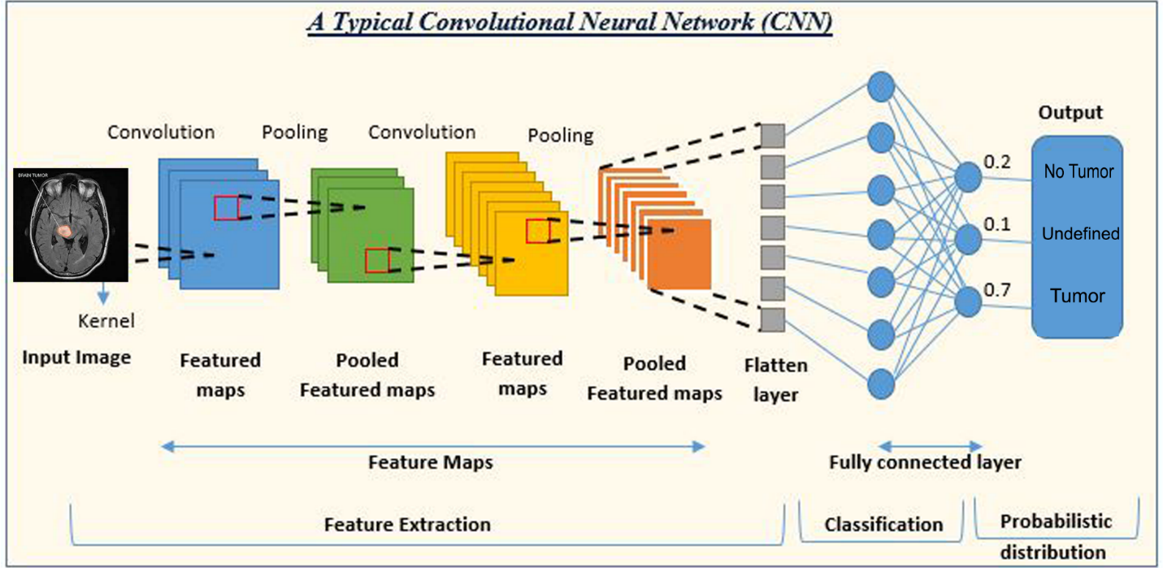

Schedule

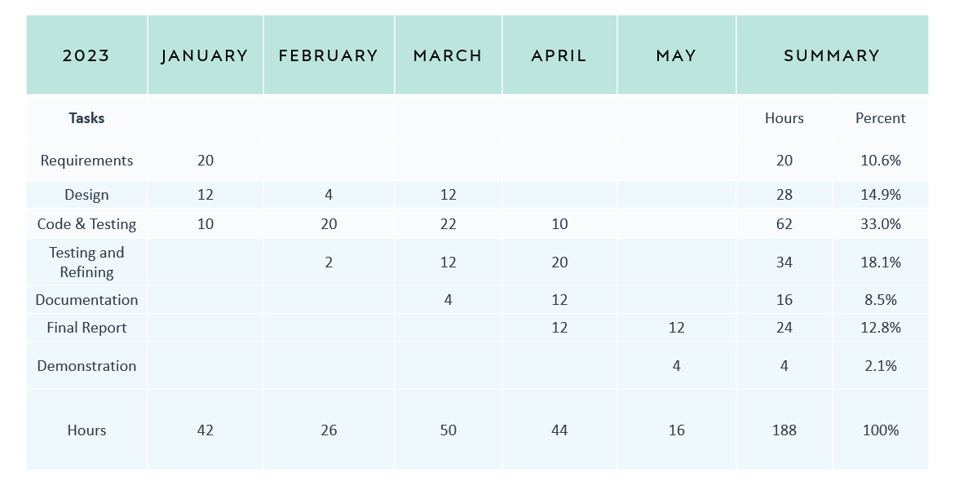

References

1. Akkus, Z., Galimzianova, A., Hoogi, A. *et al.* Deep Learning for Brain MRI Segmentation: State of the Art and Future Directions. *J Digit Imaging* **30**, 449–459 (2017). <https://doi.org/10.1007/s10278-017-9983-4>
2. Heba Mohsen, El-Sayed A. El-Dahshan, El-Sayed M. El-Horbaty, Abdel-Badeeh M. Salem, Classification using deep learning neural networks for brain tumors, Future Computing and Informatics Journal, Volume 3, Issue 1, 2018, Pages 68-71, ISSN 2314-7288, https://doi.org/10.1016/j.fcij.2017.12.001.
3. A. Saleh, R. Sukaik and S. S. Abu-Naser, "Brain Tumor Classification Using Deep Learning," 2020 International Conference on Assistive and Rehabilitation Technologies (iCareTech), 2020, pp. 131-136, doi: 10.1109/iCareTech49914.2020.00032.
4. Ashwini S Shinde, BM Mahendra, Santosh Nejakar, Santosh M Herur, Nagaraj Bhat, Performance analysis of machine learning algorithm of detection and classification of brain tumor using computer vision, Advances in Engineering Software, Volume 173, 2022, 103221, ISSN 0965-9978, <https://doi.org/10.1016/j.advengsoft.2022.103221>.
5. Maria Nazir, Sadia Shakil, Khurram Khurshid, Role of deep learning in brain tumor detection and classification (2015 to 2020): A review, Computerized Medical Imaging and Graphics, Volume 91, 2021, 101940, ISSN 0895-6111, <https://doi.org/10.1016/j.compmedimag.2021.101940>.