기계학습 기초 및 전기정보 응용

Assignment 4

**전기정보공학북**

**2017-19509 강민구**

**문제 4-1.**

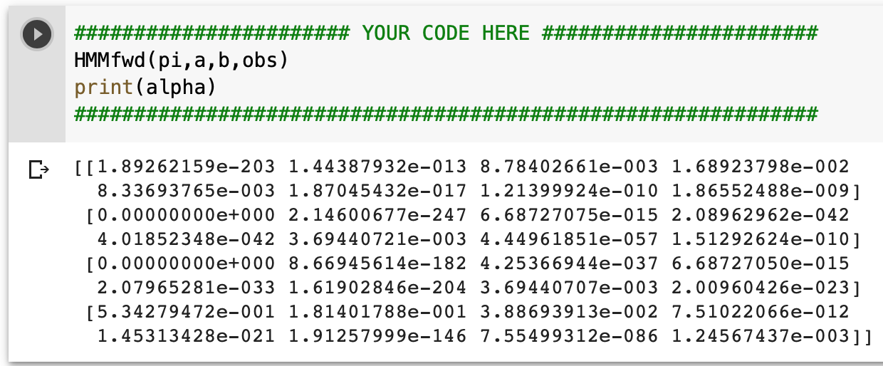

Tired – Tired – Good – Hangover – Hangover – Anxiety – Hangover – Good

1 – 1 – 4 – 2 – 2 – 3 – 2 – 4

0.25 * 1.9E-203 * 1.8E-1 * 6.687E-15 * 2E-42 * 2E-33 * 3.7E-3 * 7.6E-86 = 6.43E-381

**A: 6.43E-381**

**문제 4-2.**

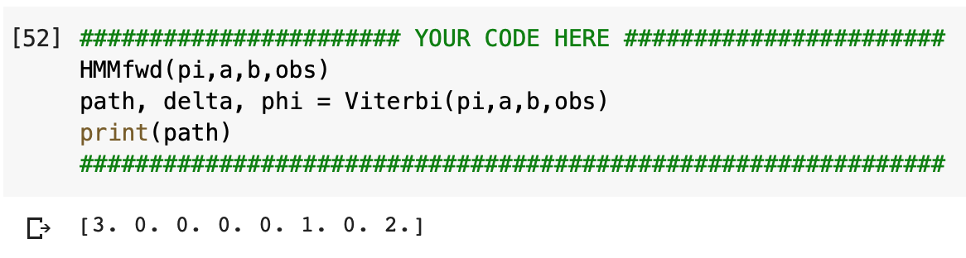

**A: Good(3) – Tired(0) – Tired(0) – Tired(0) – Tired(0) – Hangover(1) – Tired(0) – Anxiety(2)**

**문제 4-3.**

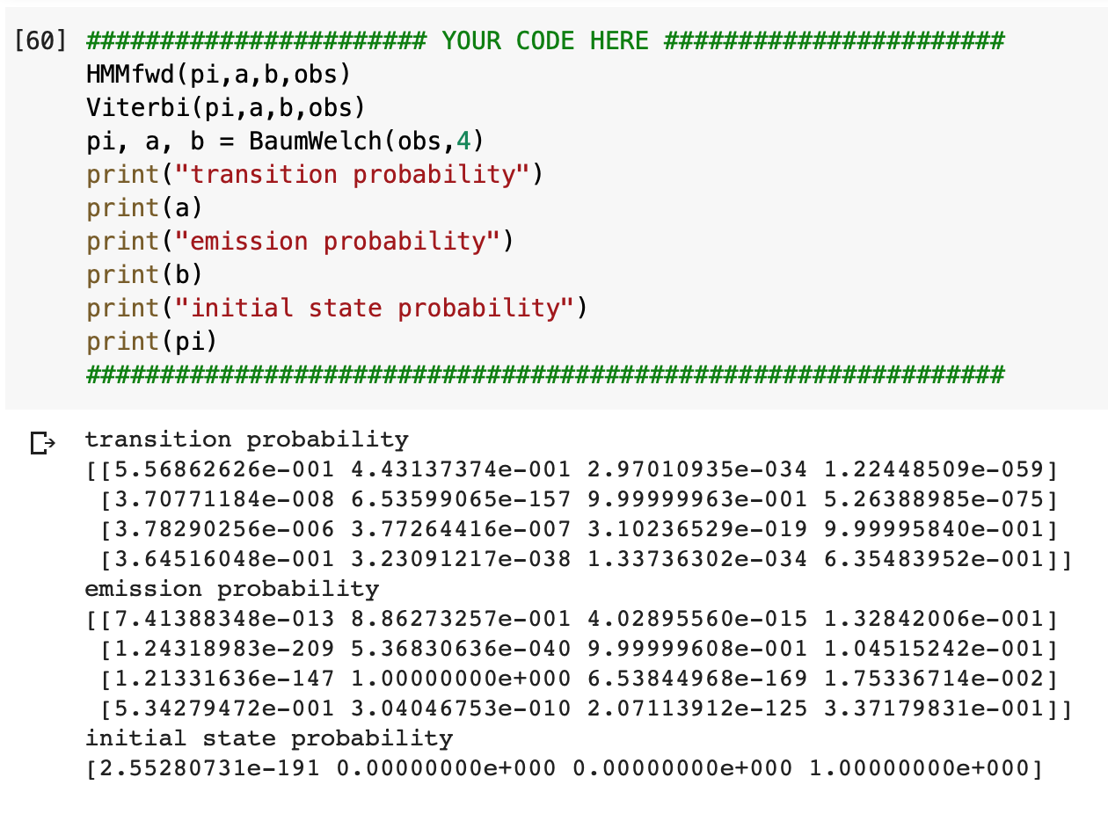

**A: Transition Probability – Emission Probability – Initial state Probability**