Government Intervention in South Korea’s Crop Disaster Insurance:
An Empirical Analysis of Cultivated Area, Yield, and Production
By
KANG, Jiyeon

THESIS
Submitted to
KDI School of Public Policy and Management
In Partial Fulfillment of the Requirements
For the Degree of
MASTER OF PUBLIC POLICY
2026

Government Intervention in South Korea’s Crop Disaster Insurance:
An Empirical Analysis of Cultivated Area, Yield, and Production
By
KANG, Jiyeon

THESIS
Submitted to
KDI School of Public Policy and Management
In Partial Fulfillment of the Requirements
For the Degree of
MASTER OF PUBLIC POLICY
2026
Professor Lee, Jongyearn

Government Intervention in South Korea’s Crop Disaster Insurance:
An Empirical Analysis of Cultivated Area, Yield, and Production
By
KANG, Jiyeon
THESIS
Submitted to
KDI School of Public Policy and Management
In Partial Fulfillment of the Requirements
For the Degree of
MASTER OF PUBLIC POLICY
Committee in charge:

Professor Lee, Jongyearn, Supervisor ____________________
Professor Merfeld, Joshua D. ____________________
Approval as of October, 2026

ABSTRACT

Government Intervention in South Korea’s Crop Disaster Insurance:
An Empirical Analysis of Cultivated Area, Yield, and Production

This thesis examines government support for crop disaster insurance in South Korea. I assess premium subsidies, administrative cost subsidies, and state reinsurance, and compare agricultural outcomes around insurance introduction. Each instrument raises a different evaluation question: who can obtain protection and who receives support, what delivery costs achieve, and how losses are shared between private insurers and the state. I then compare six annual crops with crops not yet exposed to insurance and compare rice planted area in early and later pilot municipalities. The mean production contrast across the six crops is −0.002 log points, with an exploratory 95 percent interval of [−0.318, 0.315]. The estimates vary with reference periods, comparison crops, and weights, and area and production show differences in pre-pilot growth. The rice estimate is −0.021 log points, with a 95 percent interval of [−0.064, 0.022], and changes with sample composition. These comparisons leave substantial uncertainty about production responses. Together, the institutional and empirical analyses show why the assessment of public support requires evidence on access, distribution, service quality, and fiscal exposure as well as production.

Keywords: crop disaster insurance; government intervention; premium subsidies; state reinsurance; South Korea

ACKNOWLEDGEMENTS

My sincere thanks to Professor Jongyearn Lee and Professor Joshua Merfeld. Professor Lee, learning from you was always intellectually challenging, yet genuinely enjoyable. Thank you for making learning so much fun and for always seeing the best in me. Professor Merfeld, thank you for always being there when I needed help. Your prompt support was truly reassuring.
To my mom, thank you for trusting me enough to let me do whatever I wanted, without ever questioning why. To my dad, I have found myself thinking about you a lot lately. To my two younger sisters, now that all three of us are finally adults, I hope life treats us all well. And to our dog, Boksil, I hope you live forever.
To all my unnies and oppas who shared cafeteria meals, sleepless nights, and countless laughs with me, thank you. Who knew we could have so much fun being so exhausted?
To everyone I have loved or come to love over these past two years, thank you for being part of my life. If you are reading this and wondering why your name isn't here, please know that this thesis was written with your help as well.
TABLE OF CONTENTS
1 Introduction 1
2 Institutional Background and Literature Review 3
2.1 Program Structure and Premium Components 3
2.2 Expansion, Enrollment, and Financing 4
2.3 Related Literature 7
3 Assessment of Government Intervention 9
3.1 Economic Rationale 9
3.2 Premium Subsidies 9
3.3 Administrative Cost Subsidies 11
3.4 State Reinsurance 12
4 Data and Empirical Strategy 14
4.1 Data and Summary Statistics 14
4.2 Sample and Exposure Timing 15
4.3 National Crop Comparisons 17
4.4 Municipal Rice Comparison 18
4.5 Identification, Inference, and Scope 19
5 Results 20
5.1 Pre-Pilot Trajectories 20
5.2 Aggregate and Crop-Level Contrasts 21
5.3 Sensitivity to Comparison Choices 23
5.4 Municipal Rice Comparison 26
5.5 Comparability of Treated and Comparison Crops 28
6 Discussion and Policy Implications 30
6.1 Policy Implications 30
6.2 Climate Risk and the Design of Support 31
6.3 Limitations and Future Research 31
7 Conclusion 33
References 34
Appendix A. National Inference and Crop Influence 38

LIST OF TABLES
1 Enrollment and Loss Ratios for Selected Crops, 2023 6
2 Summary Statistics 15
3 Insurance Timing for the Six Annual Crops 16
4 Mean Post-Period Contrasts 22
5 Sensitivity to the Reference Period, Comparison Crops, and Timing 24
6 Contrasts under Pre-Pilot Area Weights 25
7 Pre-Pilot Characteristics of Early and Later Rice Municipalities, 2000-2008 26
8 Rice Planted Area in Pilot and Later-Entering Municipalities, 2000-2010 27
9 Pre-Pilot Growth of Treated and Comparison Crops, 1998-2007 29
A1 Leave-One-Crop-Out Contrasts 39

LIST OF FIGURES
1 Organizational Structure of Crop Disaster Insurance in South Korea 3
2 National Enrollment Rate and Loss Ratio, 2001–2025 5
3 Shares of the Pure Premium by Payer, 2001-2024 6
4 Premium Support and the Demand for Insurance Coverage 10
5 Allocation of Claims under Stop-Loss and Proportional Reinsurance 13
6 Event-Time Contrasts for Cultivated Area, Yield, and Production 21
7 Mean Contrasts by Treated Crop 23
8 Event-Study Coefficients for Rice Planted Area, 2000-2010 28

1. Introduction
Weather shocks can cause losses across many farms at once, limiting the scope for private insurers to pool risk. Insurers also have incomplete information about farm risks and farmers’ efforts to prevent losses (Miranda & Glauber, 1997; Mahul & Stutley, 2010). South Korea supports crop disaster insurance through premium subsidies, administrative cost subsidies, and state reinsurance. The 2026 implementation guidelines list 78 crops and a budget of KRW 556.6 billion for national premium and loading support (Ministry of Agriculture, Food and Rural Affairs [MAFRA], 2026a).
These market constraints help explain government intervention, but the design of support also depends on its objectives and incentives. Korean studies examine production and price effects (Han, 2014), input use and farm income (Nam & Ahn, 2022), and output and technical efficiency among fruit farms (Lee & Kim, 2026). This evidence describes agricultural outcomes. Evaluating the support instruments also requires examining how risks are shared, who receives assistance, and what public expenditure achieves.
In this thesis, I examine the roles of the three support instruments and the production patterns that accompany insurance availability. I first assess financing arrangements and incentives using program rules and financing data. I then compare six annual crops with crops not yet exposed to insurance and compare rice planted area in early and later pilot municipalities. For the national analysis, I separate changes in area from changes in yield and examine alternative reference periods, comparison crops, and aggregation weights.
The institutional assessment identifies different evaluation priorities: access and distribution for premium support, delivery costs and service quality for administrative support, and risk allocation and pricing for state reinsurance. The national production contrast is −0.002 log points, but estimates vary across specifications and pre-pilot growth differs across groups. The rice area estimate is −0.021 log points and changes with sample composition. Both estimates have intervals that include zero. The rice comparison holds crop identity fixed and covers the first two years of availability. These comparisons concern insurance availability as a policy package; the institutional analysis examines the roles of the individual instruments.
Chapters 2 and 3 describe the program and assess the three forms of government support. Chapters 4 and 5 present the data, empirical strategy, and results. Chapters 6 and 7 discuss the policy implications and conclude.

2. Institutional Background and Literature Review

2.1 Program Structure and Premium Components
MAFRA delegates management of the program to the Agricultural Policy Insurance & Finance Service (APFS). NH Nonghyup Property & Casualty Insurance (NH) is the sole operator. It sells contracts through local agricultural cooperatives, services policies, and pays indemnities. Figure 1 shows the payments and risk transfers among these parties.
Figure 1
Organizational Structure of Crop Disaster Insurance in South Korea
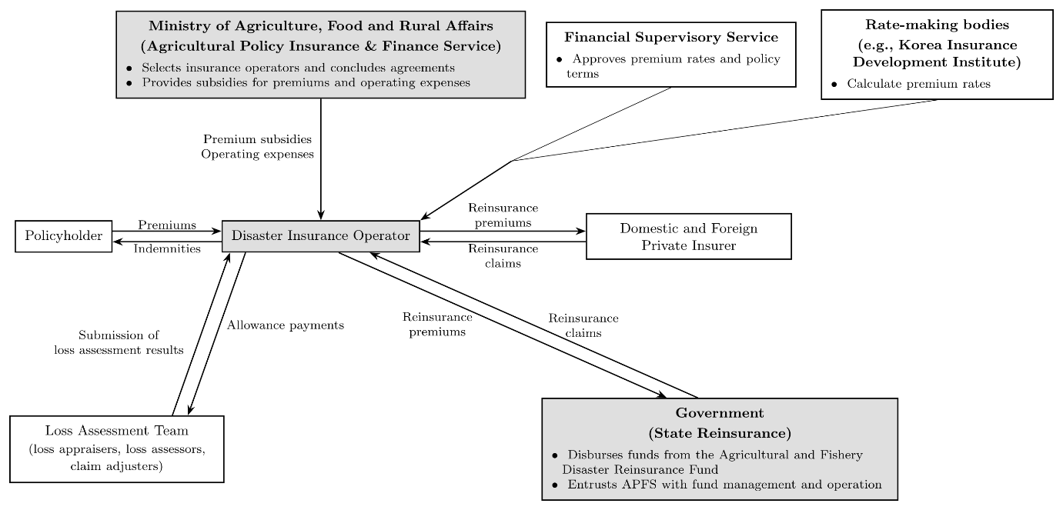
Notes: Arrows indicate payments and the submission of loss assessment results; dashed lines indicate the verification and approval of premium rates and policy terms. Local agricultural cooperatives, which sell contracts on behalf of the operator, are not shown. Adapted from MAFRA (2025, 2026a).
NH transfers part of its risk to private reinsurers and the Agricultural and Fishery Disaster Reinsurance Fund. In 2024, the first-stage shares under the main program’s profit-and-loss-sharing arrangement were 10 percent for NH, 40 percent for private reinsurers, and 50 percent for the state (MAFRA, 2025, p. 274). Additional non-proportional provisions alter the allocation at higher loss levels. These initial shares therefore do not describe the allocation of every layer of loss.
The gross premium consists of a pure premium and a loading. The pure premium covers insured risk and loss-investigation expenses. The loading covers specified operating expenses, including delegated selling costs. Under the 2026 rules, the government finances part of the pure premium and the entire loading (MAFRA, 2026a). The subsidy rate in equation (1) applies only to the pure premium. Public support consequently accounts for a larger share of the gross premium than this rate alone indicates.

2.2 Expansion, Enrollment, and Financing
The program began with apples and pears in 2001 and expanded to 78 crops and 94 products by 2026 (MAFRA, 2026a). A crop’s pilot, expansion of sales regions, and administrative entry into the main program need not coincide. In the national analysis, I use the last pre-pilot year as the reference and examine ten target years beginning with the first harvest covered by documented nationwide sales (Table 3). These dates measure availability, while enrollment measures farmers’ use of that availability.
In the series used for Figure 2, the national enrollment rate rose from 12.5 percent in 2009 to 54.2 percent in 2024 and stood at 54.0 percent in 2025, when insured area declined from 676,226 to 655,456 hectares (APFS, n.d.-a; MAFRA, 2026b). This rate divides insured area by eligible area. Changes in the rate reflect both take-up and changes in eligibility as crops or regions enter the program. The loss ratio divides portfolio claims by the premium measure specified in the figure notes. It measures claims relative to premiums, rather than individual farms’ income losses or NH’s company-wide profitability after reinsurance.
Figure 3 reports the financing shares of the pure premium in the APFS series used here. In 2024, local governments paid 39.7 percent, policyholders paid 12.6 percent, and the central government paid the remaining 47.7 percent. Combined central and local support amounted to KRW 996.9 billion for 676,226 insured hectares, or approximately KRW 1.47 million per insured hectare (APFS, n.d.-a). These amounts exclude the publicly financed loading. Transfers to individual policyholders depend on insured value, rated risk, and coverage.
Figure 2
National Enrollment Rate and Loss Ratio, 2001–2025
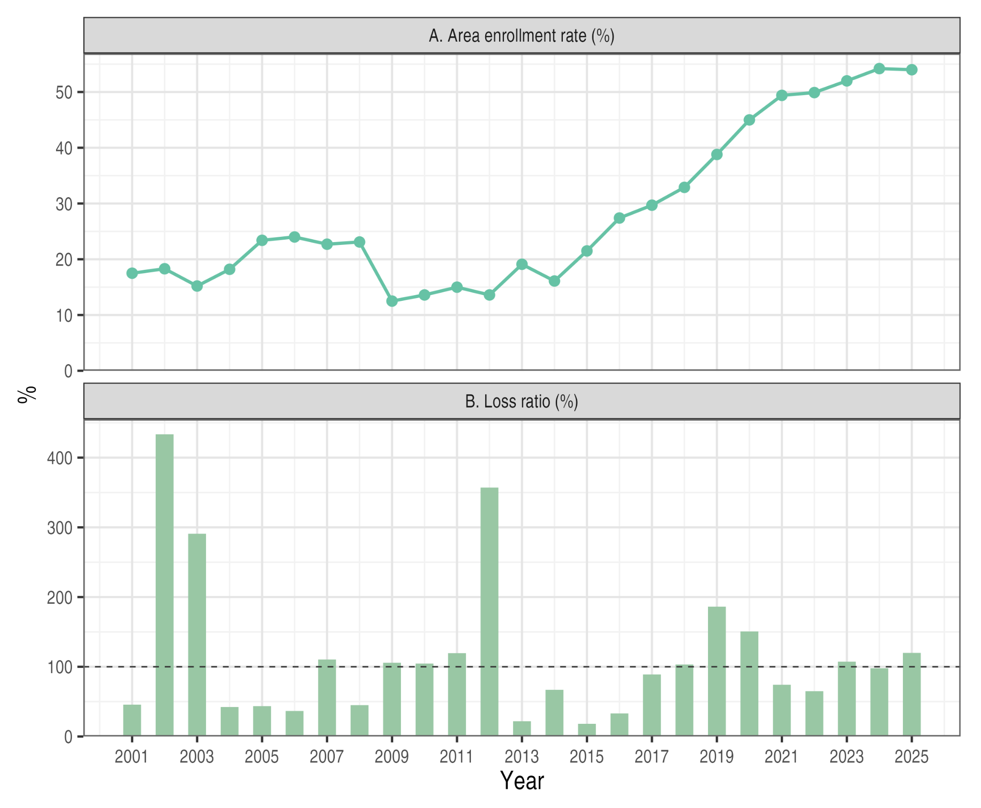
Notes: Enrollment is insured area divided by eligible area. The loss ratio is indemnities divided by premium net of refunds through 2011 and by risk premium from 2012. The horizontal line marks 100 percent. Enrollment through 2024 is from APFS (n.d.-a), and loss ratios through 2023 from APFS (n.d.-b). The 2025 enrollment rate and 2024–2025 loss ratios are from MAFRA (2026b, p. 4).

Enrollment varies substantially across crops (Table 1). In 2023, insurance covered 89.0 percent of eligible apple area and 61.0 percent of eligible rice area, compared with 7.1 percent for sweet potato and 5.4 percent for corn. Insurance availability thus corresponded to very different levels of coverage among the six annual crops examined in Chapter 5.
Figure 3
Shares of the Pure Premium by Payer, 2001-2024
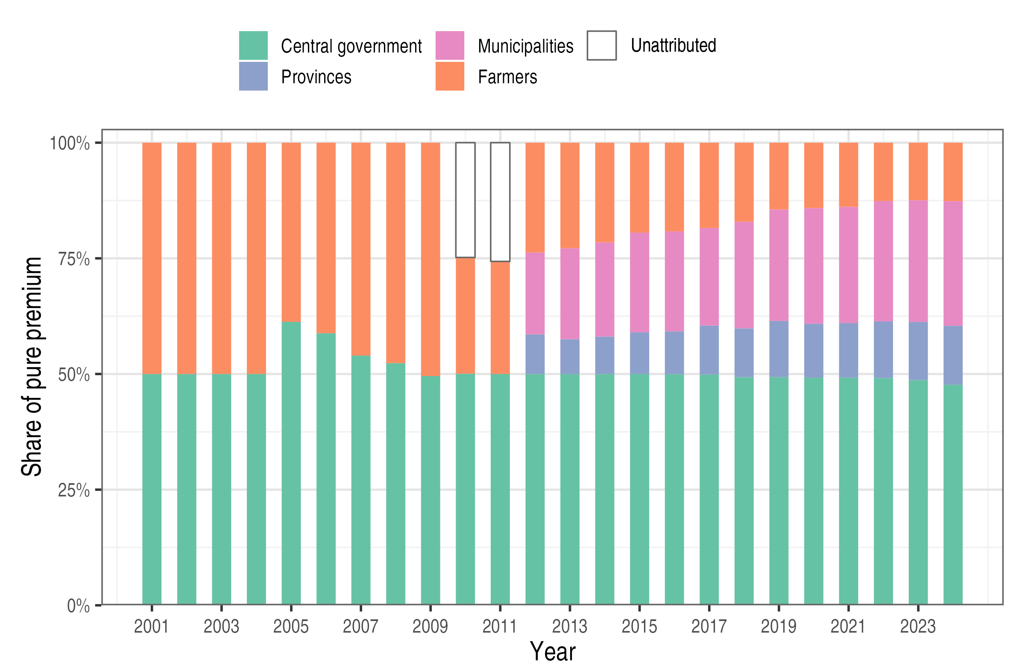
Notes: Shares of the reported pure-premium total. Unattributed segments in 2010-2011 are the difference between that total and the identified payer components. The publicly financed loading is excluded. Data from APFS (n.d.-a).

Table 1
Enrollment and Loss Ratios for Selected Crops, 2023
Crop | Eligible area (ha) | Insured area (ha) | Enrollment (%) | Loss ratio (%)
Panel A. Rice and major fruits
Rice | 725,882 | 443,136 | 61.0 | 103.5
Apple | 24,945 | 22,209 | 89.0 | 116.1
Pear | 10,078 | 7,683 | 76.2 | 60.5
Panel B. Six annual crops
Soybean | 55,326 | 28,649 | 51.8 | 158.9
Onion | 17,128 | 6,811 | 39.8 | 73.1
Garlic | 21,110 | 5,936 | 28.1 | 119.0
Red pepper | 26,126 | 8,522 | 32.6 | 141.7
Sweet potato | 18,389 | 1,300 | 7.1 | 195.5
Corn | 14,073 | 764 | 5.4 | 129.2
Notes: Eligible area can differ from national cultivated area because it depends on each product’s sales regions. The loss ratio is indemnities divided by risk premium. Data from APFS (n.d.-c); author’s calculations.

2.3 Related Literature
Two features of agricultural insurance motivate the literature on public support. First, insurers observe farm risks and farmers’ actions imperfectly. Nelson and Loehman (1987) examine the implications of adverse selection and moral hazard for contract design. Just et al. (1999) show that participation reflects both subsidy incentives and asymmetric information, while Lee and Jung (2014) examine these information problems among Korean rice farms. Second, weather shocks can generate losses across many policyholders at once. Miranda and Glauber (1997) examine the resulting systemic risk and the role of reinsurance.
The next question is how farmers, insurers, and the government should share costs and risk. Jia et al. (2025) show theoretically that the public role depends on loss correlation and the relative efficiency of public and private risk bearing. Kang and Chung (2017) evaluate Korea’s risk-group reinsurance arrangement piloted during 2014–2016 and its implications for losses and default risk in the state fund. For premium subsidies, Hazell et al. (2017) emphasize explicit objectives, targeting, and cost-effective design. Insurance demand may also depend on expected assistance outside the insurance market (Raschky & Weck-Hannemann, 2007). Participation alone therefore provides an incomplete measure of performance. Lusk (2017) examines the distribution of subsidy benefits and costs among producers, consumers, and taxpayers.
Insurance can also affect production by changing expected returns and exposure to risk. Goodwin et al. (2004) find modest acreage responses in the U.S. crop regions they examine, and Yu et al. (2018) estimate acreage responses to premium subsidies. In Korea, Han (2014) compares insurable and non-insurable crops to examine production and price effects. Nam and Ahn (2022) study input use and farm income, while Lee and Kim (2026) examine output and technical efficiency using fruit-farm panel data. These studies provide evidence on production decisions and farm outcomes. The present study places that evidence alongside an assessment of the purposes and incentives of public support.
The timing of insurance introduction also raises methodological questions. Callaway and Sant’Anna (2021) develop a framework for comparisons across treatment cohorts, including comparisons with units not yet treated. Roth (2022) shows why a statistically insignificant pre-trend test should not be treated as proof of parallel trends. The literature on clustered inference addresses uncertainty when observations are dependent and the number of treated clusters is small (Cameron et al., 2008; MacKinnon & Webb, 2018; MacKinnon et al., 2023; Webb, 2023). These studies inform the choice of comparison groups and uncertainty measures here; they do not establish the validity of the specific national score procedure described in Appendix A.
I bring these perspectives together by assessing each support instrument and comparing changes in area, yield, and production around insurance introduction. The national analysis compares outcomes across crops. The rice analysis holds crop identity fixed and examines the first two years of availability across municipalities. The two comparisons describe production responses to the policy package, while the institutional assessment identifies the additional evidence needed to evaluate its components.

3. Assessment of Government Intervention

3.1 Economic Rationale
I assess each instrument by the constraint it addresses, the incentives it creates, and the distribution of its costs and benefits. Correlated losses motivate public risk sharing, while information and delivery costs motivate investment in insurance infrastructure (Miranda & Glauber, 1997; Mahul & Stutley, 2010). Premium assistance can serve affordability and distributional objectives (Hazell et al., 2017). Each instrument can affect production by changing prices, access, or risk bearing. Chapter 5 examines this possible consequence of insurance availability, complementing the assessment of program design.

3.2 Premium Subsidies
Let $P$ denote the pure premium per unit of coverage and $s$ the combined national and local subsidy rate. Policyholders then pay $\left(1-s\right)P$ per unit. Given coverage demand $D\left(⋅\right)$, purchases without and with the subsidy are
$q_{0}=D\left(P\right), q_{1}=D\left(\left(1-s\right)P\right)$ (1)
In Figure 4, supply is perfectly elastic at $P$. The subsidy increases coverage from $q_{0}$ to $q_{1}$ and costs the government $sPq_{1}$. Of this amount, $sPq_{0}$ supports purchases that would have occurred without the subsidy.
Figure 4
Premium Support and the Demand for Insurance Coverage
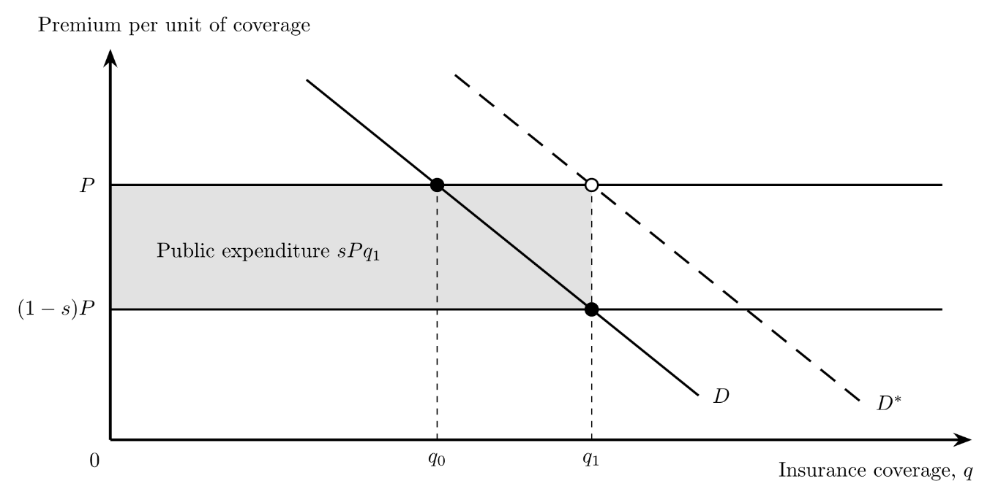
Notes: P is the pure premium per unit of coverage and s the combined subsidy rate. Supply is perfectly elastic at P, and the loading is financed separately. D is observed demand; D* is demand when the value of protection is fully perceived. The shaded rectangle is public pure-premium support, sPq₁, a transfer rather than a welfare loss. Arbitrary units.

The figure holds the risk class and premium fixed and treats the loading as separately financed. The shaded rectangle measures a public transfer. If willingness to pay reflects the benefits of protection and P equals marginal resource cost, coverage above q₀ generates an allocative loss. If demand understates those benefits, D* shows why additional coverage might be warranted. The interpretation depends on these assumptions. Risk preferences, liquidity constraints, and information can affect demand differently, and changes in the insured risk pool can change premiums. The figure illustrates these mechanisms; it does not estimate welfare gains in Korea or identify an optimal subsidy rate.
Under the 2026 national schedule, support covers 33-65 percent of the pure premium for specified product-coverage combinations and 50 percent for other combinations. National support is capped at KRW 50 million per policyholder per product (MAFRA, 2026a, p. 2). At a given subsidy rate, the transfer rises with the eligible premium until the ceiling binds. Additional premiums then receive no further national subsidy. The ceiling limits transfer size but does not target household income, and local assistance remains a separate consideration. For products sold from July 2026, policyholders with a five-year cumulative loss ratio of at least 500 percent cannot choose coverage of 80 percent or higher. For products whose sales begin from November 2026, the guidelines provide for premium adjustments based on individual loss experience (MAFRA, 2026a). Greater risk differentiation may improve pricing incentives while making protection less affordable for repeatedly affected farms.

3.3 Administrative Cost Subsidies
Administrative support finances the full loading under the 2026 rules (MAFRA, 2026a). The loading includes delegated selling and other specified operating costs. Loss-investigation expenses instead form part of the pure premium, together with the risk premium. Comparisons of administrative spending must keep these categories separate to avoid counting investigation costs twice. The relevant question is whether public financing delivers coverage and timely, accurate settlement at a reasonable resource cost.
Delivery costs can be assessed at two stages. Selling and policy-servicing expenditure can be measured per active contract, and claim-assessment expenditure per completed claim. Settlement times and assessment corrections provide corresponding measures of service. Operating-cost ratios can supplement these measures, provided that their premium denominator is clearly defined. Risk prices, claim frequency, product complexity, and geographical dispersion can change the ratios without changing efficiency. Comparisons should therefore account for these differences across products and regions.
Mahul and Stutley (2010, pp. 84–87) discuss the importance of low-cost delivery channels. Korea’s 2026 guidelines also require payment within seven days after the indemnity has been determined and the policyholder submits a claim (MAFRA, 2026a, p. 5). This deadline applies after loss assessment; it does not measure the full time from loss notification to payment. Evaluating service therefore requires both compliance with existing rules and evidence on the cost, duration, and quality of the full process.

3.4 State Reinsurance
State reinsurance increases the capacity to cover correlated losses but creates a contingent public liability. Under a stop-loss contract with attachment point $a$, total covered claims $L$ are divided into retained and ceded claims as follows:
$L^{ret}=min\left(L,a\right), L^{ced}=max\left(L-a,0\right)$ (2)
Under a proportional contract, the state receives a fixed share of premiums and pays the same share of claims. Korea used a stop-loss contract with a 180 percent attachment point in 2005-2013. A mixed arrangement combining stop-loss coverage and profit-and-loss sharing began in 2014 and applied to the entire program from 2019 (MAFRA, 2025, pp. 268, 273-274). Figure 5 compares the two benchmark contracts. Panel B uses a 50 percent first-stage state share for illustration; it does not reproduce the full Korean treaty.
In the uncapped stop-loss benchmark, private claims remain constant above the attachment point. Actual incentives also depend on coverage limits, pricing, and renewal terms. Proportional sharing retains private exposure at the margin but transfers part of ordinary losses to the state. The appropriate allocation depends on loss correlation and relative risk-bearing capacity (Jia et al., 2025). Let $R$ denote the reinsurance premium in the same units as $L$ and $a$. Expected public cost under stop-loss equals expected ceded claims less the premium received:
$E\left[C\right]=E\left[max\left(L-a,0\right)\right]-R$ (3)
From 2005 to 2024, reported crop reinsurance payments totaled KRW 923.8 billion and receipts totaled KRW 470.0 billion (MAFRA, 2025, p. 269). The difference, KRW 453.8 billion, is a cumulative nominal cash flow. It is neither an inflation-adjusted cost measure nor the fund’s complete financial balance. Assessing actuarial adequacy requires comparing premiums with expected losses and the cost of bearing risk under each treaty. Comparisons over time must also account for changes in prices, insured exposure, coverage, contract terms, and settlement dates. Payments per insured hectare do not by themselves adjust for insured value or loss severity.
Figure 5
Allocation of Claims under Stop-Loss and Proportional Reinsurance
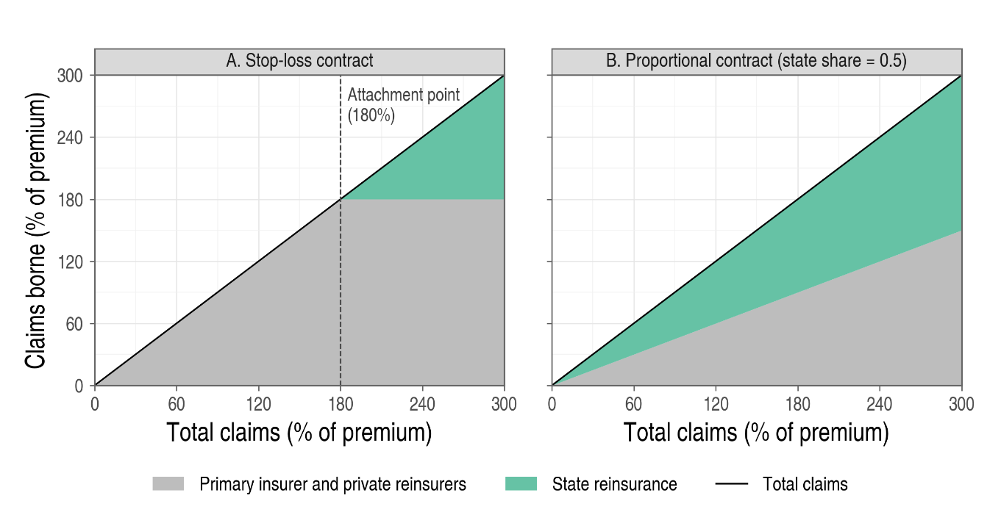
Notes: Both axes express claims as percentages of premium. Panel A uses the 180 percent attachment point reported for 2005-2013 (MAFRA, 2025, p. 273). Private claims combine those of the operator and private reinsurers. In both panels, the private and state shares are stacked and sum to total claims. Panel B is an illustrative proportional contract without additional layers, premium transfers, expenses, or commissions.
A prospective evaluation must distinguish expected net cost from liquidity needs and exposure to severe or consecutive loss years. Assessing each requires information on treaty terms, premiums, reserves, and committed financing. Catastrophe exposure depends on how losses co-move as well as on their frequency and severity (Mahul & Stutley, 2010; Kang & Chung, 2017). Historical payments should be assessed under the contracts that generated them, rather than under current sharing rates.

4. Data and Empirical Strategy

4.1 Data and Summary Statistics
I use a national crop-year panel from the Crop Production Survey (Statistics Korea, n.d.), containing 43 crop or crop-form series over 1991–2024. Area is measured in hectares, yield in kilograms per 10 ares, and production in metric tonnes. In these units, production equals area × yield / 100, apart from reporting and rounding differences. When calculated using the same observations and weights, the log production contrast therefore approximately equals the sum of the log area and yield contrasts. This accounting relationship separates changes in cultivated area from changes in average yield. Changes in average yield can reflect weather, input use, technology, or shifts in the composition of cultivated land.
I define exposure as the availability of crop insurance, regardless of whether individual farms enroll. The national outcomes therefore cover both insured and uninsured farms. Two changes in data collection affect comparability over time. Sweet potato statistics shifted to administrative reporting in 2005, while spring napa cabbage and spring radish statistics shifted to a sample survey in 2012 (Statistics Korea, 2014, pp. 67, 79–80).
Table 2 summarizes the unique crop-year observations used in the main comparison. It reports means, standard deviations, and ranges. Treated crops have more than three times the cultivated area of comparison crops on average. These differences in levels help describe the sample. Section 5.5 separately examines pre-pilot growth, which is more directly relevant to the comparison of changes.
Table 2
Summary Statistics
 | Mean | S.D. | Min. | Max. | Obs. | Crops
Panel A. Area (ha)
Treated, reference year | 35,112 | 24,804 | 15,392 | 76,267 | 6 | 6
Treated, target years | 29,445 | 16,858 | 14,673 | 80,842 | 60 | 6
Comparison, reference years | 9,775 | 9,659 | 1,062 | 34,875 | 66 | 22
Comparison, target years | 9,119 | 9,779 | 619 | 45,474 | 232 | 22
Panel B. Yield (kg/10a)
Treated, reference year | 1,787 | 2,495 | 150 | 6,725 | 6 | 6
Treated, target years | 1,743 | 2,319 | 147 | 8,541 | 60 | 6
Comparison, reference years | 2,488 | 2,696 | 37 | 10,946 | 66 | 22
Comparison, target years | 2,390 | 2,782 | 30 | 11,286 | 232 | 22
Panel C. Production (t)
Treated, reference year | 348,196 | 354,247 | 92,830 | 1,035,076 | 6 | 6
Treated, target years | 378,579 | 458,011 | 55,714 | 1,594,450 | 60 | 6
Comparison, reference years | 208,852 | 330,283 | 1,589 | 1,582,966 | 66 | 22
Comparison, target years | 175,178 | 314,754 | 1,598 | 1,896,828 | 232 | 22
Notes: Statistics are computed over unique crop-year observations entering the main comparison. S.D. is the standard deviation of observations. Each treated crop’s reference year is the year before its pilot; its target years are the ten years beginning with expansion. Comparison observations are counted once per crop-year across the reference years (2007–2009) and target years (2011–2023) of the treated crops they are matched to.

4.2 Sample and Exposure Timing
I select six annual crops: soybean, onion, sweet potato, corn, garlic, and red pepper. Each has a continuous series from 1991, documented pilot and nationwide sales seasons, and ten observed target years. I exclude fruit crops because orchard area and perennial production adjust over different time horizons. The three potato series do not meet these criteria. Potato insurance initially covered highland summer and autumn potatoes but not lowland spring potatoes (Gouk et al., 2024, pp. 17–18). Highland potato insurance has remained limited to Gangwon Province, and the first nationwide sales season of autumn potato is not reported separately from the general potato milestones (Gouk et al., 2024, p. 221). For lowland spring potato, the year in which coverage began is not documented, so I use this series neither as a treated crop nor as a comparison crop. I examine rice separately using the municipal rollout described in Section 4.4.
Table 3 reports timing in harvest years. Pilot seasons are identified from first-sale dates or first-year enrollment and indemnity records (Choi et al., 2010, p. 163; Gouk et al., 2024, pp. 17–21). Nationwide sales began in 2011 for soybean and onion, in 2012 for sweet potato, corn, and garlic, and in 2014 for red pepper (Gouk et al., 2024, pp. 18, 221; Ministry for Food, Agriculture, Forestry and Fisheries, 2011b, 2012; MAFRA, 2014). Autumn sales of onion and garlic cover the following harvest, giving expansion years of 2012 and 2013. Availability does not imply eligibility for every variety: the initial corn product covered specified waxy-corn varieties (Gouk et al., 2024, p. 20), whereas the outcome series aggregates corn production.
Table 3
Insurance Timing for the Six Annual Crops
Crop | Pilot year | Expansion year | Product-table year | Reference year | Transition years
Soybean | 2008 | 2011 | 2011 | 2007 | 3
Onion | 2009 | 2012 | 2011 | 2008 | 3
Sweet potato | 2009 | 2012 | 2012 | 2008 | 3
Corn | 2009 | 2012 | 2012 | 2008 | 3
Garlic | 2010 | 2013 | 2012 | 2009 | 3
Red pepper | 2008 | 2014 | 2014 | 2007 | 6
Notes: Pilot and expansion years are the first harvest years covered by pilot and documented nationwide sales. Autumn sales of onion and garlic are assigned to the following harvest year. Reference year equals pilot year minus one; transition years run from pilot introduction through the year before expansion. Product-table years are the administrative milestones used as an alternative timing convention in Table 5, Panel E. Sources: MAFRA (2014, 2025, pp. 37, 44, 46), Choi et al. (2010, p. 163), Gouk et al. (2024, pp. 17–21, 221), and Ministry for Food, Agriculture, Forestry and Fisheries (2011b, 2012).
The candidate comparison pool contains 24 annual crop series; 22 enter the main contrast. A comparison crop must either have no pilot by 2024 or remain unexposed in both the reference and target years. All six treated crops entered pilots by 2010, before the first target year in 2011. They therefore do not serve as controls for one another in the main post-period comparisons.

4.3 National Crop Comparisons
For the national analysis, I calculate crop-specific difference-in-differences contrasts and average them across six crops and ten target years. For treated crop $i$, let $p_{i}$ denote the pilot year, $g_{i}$ the expansion year, and $b_{i}=p_{i}-1$ the reference year. Event year $e$ corresponds to target year $g_{i}+e$. The set $C_{i,e}$ contains the $n_{i,e}$ comparison crops observed and not yet exposed in both $b_{i}$ and $g_{i}+e$. For log outcome $y$, the crop-event contrast is
δi,e=yi,gi+e-yi,bi-1ni,ej∈Ci,e​yj,gi+e-yj,bi (4)
I then average these contrasts equally across crops and event years:
${\hat{θ}}_{e}=\frac{1}{6}\sum_{i=1}^{6}{{\hat{δ}}_{i,e}}, \hat{θ}=\frac{1}{10}\sum_{e=0}^{9}{{\hat{θ}}_{e}}$ (5)
The first term in equation (4) measures the treated crop’s log change from the reference year. The second measures the average log change among eligible comparison crops over the same period. The contrast is the difference between these changes. The statistic $\hat{θ}$ averages the contrasts across six crops and ten target years; multiplying it by 100 gives an approximate difference in percentage growth. Because the reference year is before the pilot, $\hat{θ}$ includes changes during the pilot transition as well as after expansion.
I also report an alternative that weights treated crops by their mean cultivated area in 2003-2007, before the earliest pilot:
${\hat{θ}}^{A}=\frac{1}{10}\sum_{e=0}^{9}{\sum_{i=1}^{6}{w_{i}^{A}}} {\hat{δ}}_{i,e}, w_{i}^{A}=\frac{{\overset{‾}{A}}_{i}^{pre}}{\sum_{k=1}^{6}{{\overset{‾}{A}}_{k}^{pre}}}$ (6)
For Figure 6, I apply equation (4) to pilot-relative target years, retaining the last pre-pilot year as the reference. Comparison crops must be observed and unexposed in both years and are drawn only from the comparison pool. I average the six crop-specific contrasts equally. The reference contrast is zero by construction. The joint test evaluates the nine earlier contrasts; non-rejection does not establish parallel trends. Post-pilot contrasts include the transition before expansion.

4.4 Municipal Rice Comparison
Rice insurance became available in 20 municipalities in 2009 and ten more in 2011 (Choi et al., 2010; Ministry for Food, Agriculture, Forestry and Fisheries, 2011a). Both cohorts were designated as major producing areas. I compare early entrants with later entrants through 2010. This common designation does not imply random rollout timing.
The outcome is log paddy-rice planted area from the Crop Production Survey for 2000-2010. I retain mainland municipalities with complete series and consistent boundaries. The resulting sample contains 17 early entrants and nine later entrants, yielding 286 municipality-years. I estimate
$$lnA_{mt}=α_{m}+λ_{t}+βD_{mt}+ε_{mt} \left(7\right)$$
where $A_{mt}$ is planted area in municipality $m$ in year $t$, and $α_{m}$ and $λ_{t}$ denote municipality and year fixed effects. The indicator $D_{mt}$ equals one for early entrants in 2009-2010. Municipality fixed effects absorb time-invariant differences in soil quality, irrigation infrastructure, and proximity to markets. Year fixed effects absorb changes common to all municipalities; they do not absorb regional differences in weather or investment.

4.5 Identification, Inference, and Scope
A causal interpretation requires parallel changes without insurance, correctly dated exposure, and no anticipation or spillovers. Crop substitution and common-market responses could change comparison-crop outcomes before those crops become eligible. Pre-pilot trajectories help assess observed comparability. The rice design holds crop identity fixed, although regional weather, investment, and other changing local conditions may still differ across cohorts.
For national contrasts, I use crop-level scores and Webb six-point multipliers (Appendix A). This procedure is neither null-imposed nor studentized; its small-sample coverage is not established. Webb weights alone do not resolve inference with few treated clusters (MacKinnon & Webb, 2018). For rice, I use a null-imposed, CR1-studentized wild cluster bootstrap with Webb weights, 9,999 draws, and confidence intervals from test inversion (Cameron et al., 2008; Webb, 2023). This analysis has 26 municipality clusters, including nine comparison municipalities. Tables report standard errors in parentheses and 95 percent intervals in brackets. Asterisks denote * p < 0.10, ** p < 0.05, and *** p < 0.01; the stated significance threshold is 5 percent.
Precision and identification impose separate limits: narrow intervals do not correct a biased comparison, and wide intervals leave uncertainty even under valid assumptions. I treat national intervals as exploratory and examine alternative reference periods, comparison pools, and weights. These alternatives were examined after the main results were known.

5. Results

5.1 Pre-Pilot Trajectories
Figure 6 compares changes before and after the pilots relative to the last pre-pilot year. Each point averages six crop-specific contrasts, each calculated against its eligible comparison crops. Pre-pilot contrasts near zero would be consistent with parallel observed changes. A pattern in which those contrasts move toward or away from zero indicates differences in observed growth before insurance became available. The reference-year contrast equals zero by construction.
Pre-pilot yield contrasts range from approximately −0.04 to 0.02 log points. The joint p-value is 0.92. This pattern provides less evidence of divergent observed growth than the area and production series, although a failure to reject with six treated crops does not establish parallel trends.
Area and production show larger differences in pre-pilot growth. Contrasts of approximately −0.2 log points in earlier years approach zero near the reference year, indicating that treated crops were gaining relative to comparison crops before insurance became available. The exploratory joint p-values are 0.084 for area and 0.0535 for production. The production value is close to 0.05, and its position relative to that threshold changes across multiplier draws. The observed trajectories are therefore more informative than a sharp distinction between rejection and non-rejection. Their similar patterns are consistent with the accounting relationship among area, yield, and production.
Figure 6
Event-Time Contrasts for Cultivated Area, Yield, and Production
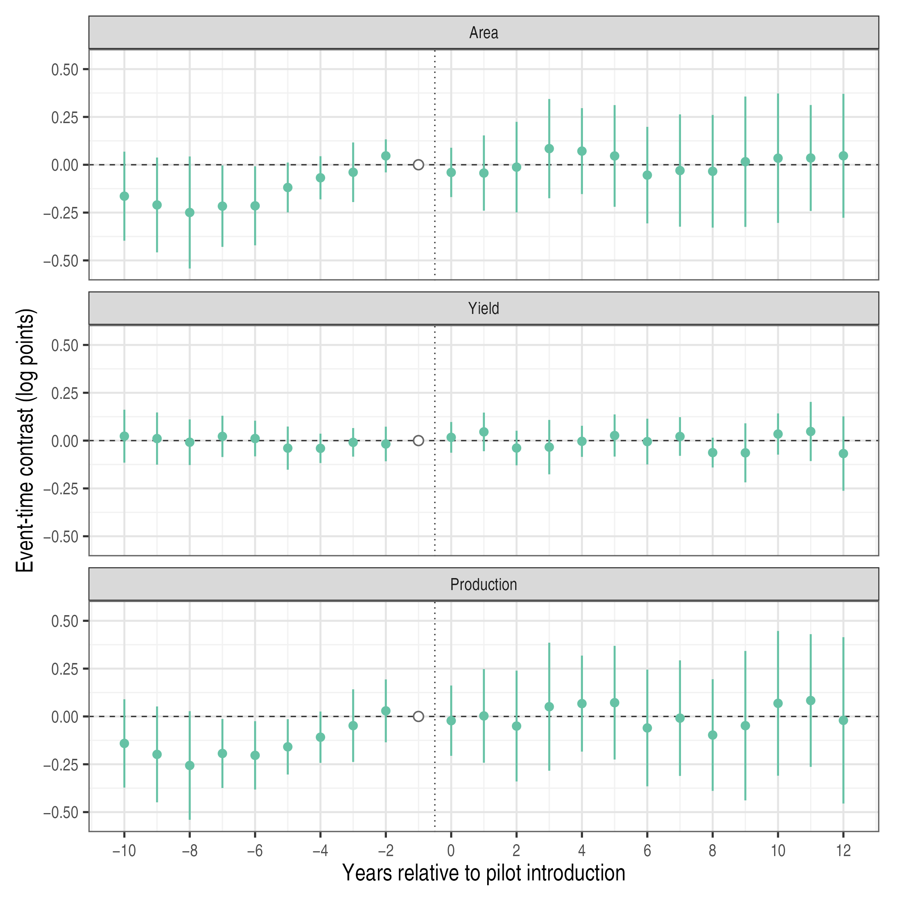
Notes: Event-time contrasts relative to the last pre-pilot year (open circle), averaged over the six treated crops; comparison crops exclude the other treated crops. Bars are exploratory 95 percent intervals from 9,999 Webb multiplier draws; nominal coverage is not established for this design (Appendix A). The vertical dotted line separates pre-pilot and post-pilot years; post-pilot years include the transition years between the pilot and expansion.

This pre-pilot divergence also affects the choice of baseline. A reference year close to introduction measures subsequent changes from a later point in the relative gains of treated crops. Section 5.3 examines how earlier reference periods change the contrasts.

5.2 Aggregate and Crop-Level Contrasts
Table 4 presents the main contrasts using two comparison pools. The first includes the full pool. The second excludes spring napa cabbage and spring radish, whose survey method changed in 2012. The documentation used here does not establish how these series relate to the winter series reported separately from 2014.
Table 4
Mean Post-Period Contrasts
 | (1)  Area | (2)  Yield | (3)  Production
Panel A. Full comparison pool
Mean contrast | 0.011 | −0.012 | −0.002
 | (0.141) | (0.056) | (0.168)
 | [−0.253, 0.275] | [−0.118, 0.093] | [−0.318, 0.315]
Comparison series | 22 | 22 | 22
Panel B. Excluding two spring series
Mean contrast | −0.069 | −0.014 | −0.084
 | (0.139) | (0.059) | (0.169)
 | [−0.332, 0.193] | [−0.125, 0.096] | [−0.406, 0.238]
Comparison series | 20 | 20 | 20
Notes: Log outcomes; six treated crops; ten target years. Target years begin with the expansion year, whereas Figure 6 indexes time relative to pilot introduction. Panel B excludes spring napa cabbage and spring radish. Score-based standard errors in parentheses and 95 percent intervals in brackets from 9,999 Webb multiplier draws; their nominal coverage is not established for this design (Appendix A). * p < 0.10, ** p < 0.05, *** p < 0.01.

Using the full pool, I obtain mean contrasts of 0.011 log points for area, −0.012 for yield, and −0.002 for production, with respective exploratory p-values of 0.94, 0.84, and 0.99. Excluding the two spring series changes the contrasts to −0.069, −0.014, and −0.084. Area reverses sign and production moves further below zero, while yield changes little. The production interval under the full pool, [−0.318, 0.315] log points, includes both substantial decreases and substantial increases.
Figure 7 reports the crop-specific means underlying the aggregate contrasts.
Figure 7
Mean Contrasts by Treated Crop
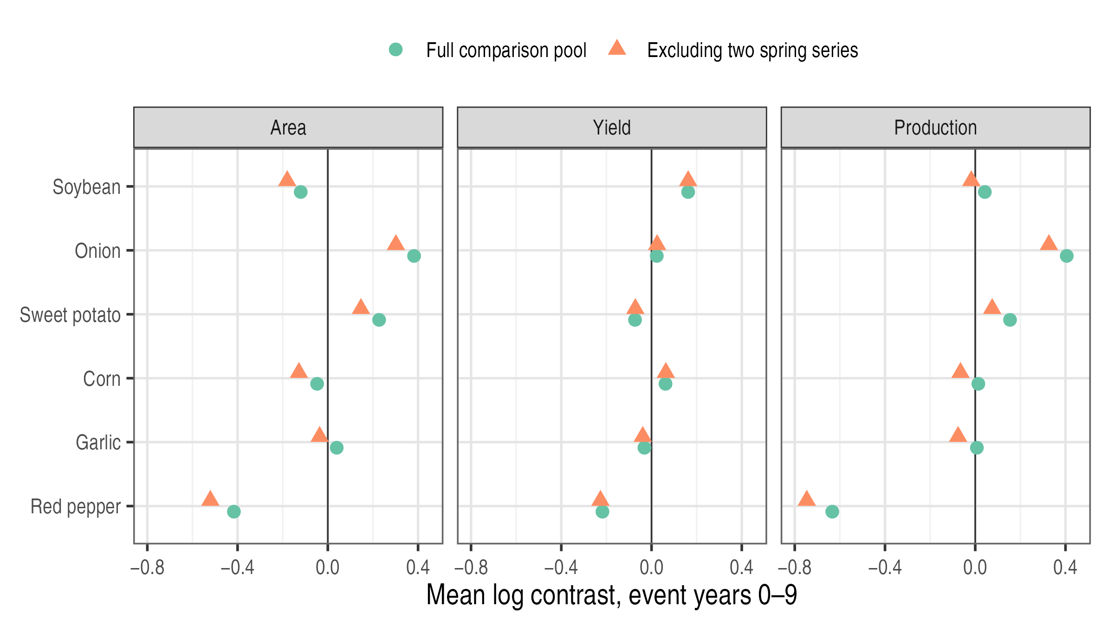
Notes: Each point averages ten crop-specific contrasts. Circles use the full comparison pool, and triangles exclude spring napa cabbage and spring radish. Log points.

The small aggregate combines large differences across crops. Production contrasts are 0.406 for onion, 0.154 for sweet potato, and −0.634 for red pepper. Under equal weights, these crops contribute approximately 0.068, 0.026, and −0.106 log points, respectively. Dropping one crop at a time moves the aggregate between −0.083 and 0.125 (Appendix Table A1). Individual crops thus strongly influence the mean. The comparison alone does not distinguish insurance responses from other shocks or differences in untreated growth.

5.3 Sensitivity to Comparison Choices
Table 5 changes one comparison choice at a time and reports the results in the same format as Table 4.
Table 5
Sensitivity to the Reference Period, Comparison Crops, and Timing
 | (1)  Area | (2)  Yield | (3)  Production
Panel A. Reference period: mean of last five pre-pilot years
Contrast | 0.051 | 0.008 | 0.059
 | (0.154) | (0.049) | (0.170)
 | [−0.244, 0.346] | [−0.085, 0.102] | [−0.264, 0.382]
Panel B. Reference period: mean of all pre-pilot years
Contrast | 0.238 | −0.029 | 0.209
 | (0.202) | (0.076) | (0.208)
 | [−0.144, 0.621] | [−0.172, 0.114] | [−0.184, 0.601]
Panel C. Comparison crops: field crops only
Contrast | −0.082 | −0.011 | −0.094
 | (0.198) | (0.083) | (0.250)
 | [−0.450, 0.285] | [−0.166, 0.143] | [−0.557, 0.369]
Panel D. Comparison crops: excluding uncertain seasonal forms
Contrast | −0.113 | −0.005 | −0.118
 | (0.160) | (0.067) | (0.196)
 | [−0.414, 0.187] | [−0.130, 0.120] | [−0.487, 0.250]
Panel E. Timing: product-table years
Contrast | 0.015 | −0.012 | 0.002
 | (0.139) | (0.056) | (0.165)
 | [−0.247, 0.277] | [−0.116, 0.092] | [−0.308, 0.313]
Panel F. Timing: target years begin with pilot
Contrast | 0.001 | −0.010 | −0.009
 | (0.117) | (0.050) | (0.136)
 | [−0.220, 0.221] | [−0.102, 0.082] | [−0.267, 0.249]
Notes: Log outcomes; six treated crops; ten target years; full comparison pool unless stated. Score-based standard errors in parentheses and exploratory 95 percent intervals in brackets from 9,999 Webb multiplier draws (Appendix A). * p < 0.10, ** p < 0.05, *** p < 0.01. The main specification is Table 4, Panel A. Multi-year references require comparison crops to be observed and unexposed in every reference year. Panel D excludes napa cabbage and radish forms, carrot, and green onions, whose survey definitions are uncertain. Panel E uses product-table milestones in place of harvest-year timing. Panel F starts the ten target years at the pilot year.

All intervals in Table 5 include zero. The smallest exploratory p-value is 0.244, for area when all pre-pilot years form the reference. Point estimates nevertheless vary substantially. Earlier reference periods raise the production contrast to 0.059 and 0.209, consistent with the relative gains before introduction shown in Figure 6. Restricting the comparison pool lowers it to −0.094 or −0.118. The two alternative timing conventions give production contrasts of 0.002 and −0.009. Standard errors for area and production range from 0.12 to 0.25. The comparisons therefore remain imprecise across these specifications.
Pre-pilot area weights also change the aggregate (Table 6). The production contrast falls from −0.002 to −0.105 with the full comparison pool and from −0.084 to −0.186 after excluding the two spring series. Soybean and red pepper account for 65 percent of these weights. Onion and sweet potato, which have positive contrasts, receive less weight. None of the weighted contrasts is statistically significant. This weighting provides a different summary of the same crop contrasts; it does not estimate the percentage change in national production.
Table 6
Contrasts under Pre-Pilot Area Weights
 | (1)  Area | (2)  Yield | (3)  Production
Panel A. Full comparison pool
Contrast | −0.108 | 0.004 | −0.105
 | (0.140) | (0.092) | (0.189)
 | [−0.368, 0.152] | [−0.158, 0.165] | [−0.439, 0.229]
Panel B. Excluding two spring series
Contrast | −0.186 | 0.001 | −0.186
 | (0.135) | (0.095) | (0.192)
 | [−0.433, 0.060] | [−0.168, 0.169] | [−0.527, 0.156]
Notes: Rows and symbols as in Table 5. Contrasts with equal weights are reported in Table 4. Area weights are soybean 39.0, red pepper 25.7, garlic 13.4, sweet potato 7.6, corn 7.2, and onion 6.9 percent; equal weights are 16.7 percent. Comparison crops remain equally weighted within each contrast.

5.4 Municipal Rice Comparison
Table 7 compares the rice cohorts over 2000-2008. Early entrants had a mean planted area of 14,425 hectares, compared with 13,666 hectares among later entrants. Mean slopes of log area were approximately −0.011 per year in both cohorts, although area levels were more dispersed among early entrants. Welch tests do not reject equality of the reported means at the 10 percent level.
Table 7
Pre-Pilot Characteristics of Early and Later Rice Municipalities, 2000-2008
 | (1)  Early entrants | (2)  Later entrants | (3)  Difference
Mean planted area, 2000-2008 (ha) | 14,425 | 13,666 | 759
 | (5,871) | (1,998) | (1,572)
Annual growth of planted area, 2000-2008 | −0.011 | −0.011 | −0.000
 | (0.011) | (0.009) | (0.004)
Change in log planted area, 2000-2008 | −0.079 | −0.075 | −0.003
 | (0.077) | (0.069) | (0.030)
Dispersion around the pre-pilot trend | 0.017 | 0.012 | 0.005
 | (0.012) | (0.003) | (0.003)
Municipalities | 17 | 9
Notes: Columns (1) and (2) report means across municipalities, with standard deviations in parentheses. Column (3) reports the difference in means, with its Welch standard error in parentheses. Annual growth is the least-squares slope of log planted area on year; dispersion around the pre-pilot trend is the standard deviation of the residuals from that trend. * p < 0.10, ** p < 0.05, *** p < 0.01, from Welch t-tests. Data from Statistics Korea (n.d.).

The main estimate from equation (7) is −0.021 log points (Table 8). Its 95 percent interval, [−0.064, 0.022], corresponds to approximately −6.2 to +2.2 percent. Figure 8 reports pre-pilot coefficients between approximately −0.001 and 0.010, with a joint p-value of 0.52. Assigning a placebo period of 2006-2008 within the pre-pilot sample gives an estimate of 0.001 (p = 0.956).
Table 8
Rice Planted Area in Pilot and Later-Entering Municipalities, 2000-2010
 | (1)  Main sample | (2)  Excluding municipalities adjoining weirs
Early entry × Post | −0.021 | −0.002
 | (0.022) | (0.021)
 | [−0.064, 0.022] | [−0.045, 0.039]
Municipalities (early / later) | 17 / 9 | 14 / 8
Municipality-years | 286 | 242
Municipality and year FE | Yes | Yes
Notes: The dependent variable is log paddy-rice planted area. Municipality-clustered (CR1) standard errors in parentheses. The 95 percent intervals in brackets and the significance levels are based on the null-imposed wild cluster bootstrap-t with Webb weights, 9,999 draws, and municipality clusters. * p < 0.10, ** p < 0.05, *** p < 0.01. Column (2) excludes Gumi, Sangju, Naju, and Uiseong, municipalities adjoining weirs built under the Four Major Rivers Restoration Project (K-water, n.d.-a, n.d.-b).

The estimate changes to −0.002 (p = 0.940) when I exclude Gumi, Sangju, Naju, and Uiseong, which adjoin weirs built under the Four Major Rivers Restoration Project. This result shows sensitivity to the municipalities included. Because the exclusion changes the sample, it does not separately identify the effect of river works. As an additional inference check, province-clustered CR1 standard errors yield p = 0.387 using a t distribution with seven degrees of freedom. Inference at this level relies on only eight province clusters.
Figure 8
Event-Study Coefficients for Rice Planted Area, 2000-2010
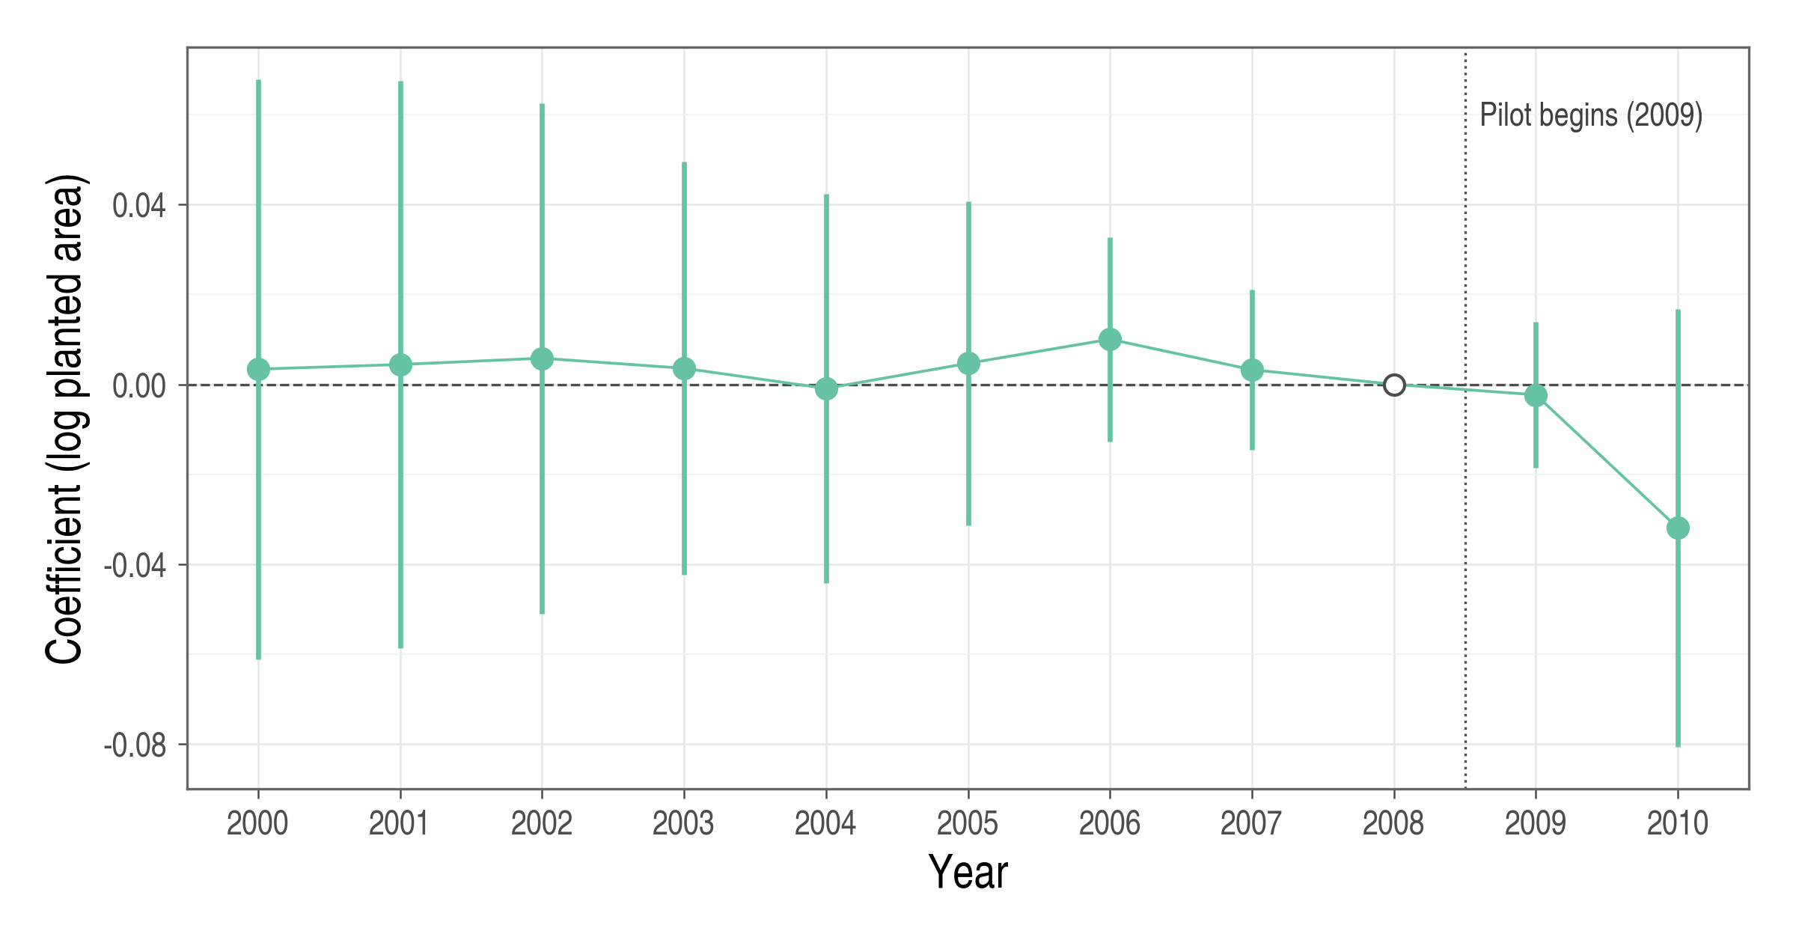
Notes: Coefficients from a regression of log paddy-rice planted area on municipality and year fixed effects and interactions of early-entry status with year indicators; 2008 is the reference year (open circle). Bars are 95 percent confidence intervals based on municipality-clustered (CR1) standard errors with t(25) critical values; they differ from the wild bootstrap intervals in Table 8. The sample comprises 17 early and nine later-entering municipalities over 2000-2010.

5.5 Comparability of Treated and Comparison Crops
Table 9 shows that treated and comparison crops followed different pre-pilot growth paths. Across the six treated and 22 contributing comparison crops, mean log-area slopes were −0.016 and −0.046 per year, respectively. Mean production slopes were −0.007 and −0.031. Yield slopes were closer, at 0.008 and 0.015. The standardized differences are 0.83 for area, 0.64 for production, and −0.37 for yield. The larger gaps for area and production reinforce the divergence shown in Figure 6.
Table 9
Pre-Pilot Growth of Treated and Comparison Crops, 1998-2007
 | (1)  Treated crops | (2)  Comparison crops | (3)  Difference | (4)  Std. difference
Annual growth of cultivated area | −0.016 | −0.046 | 0.030 | 0.833
 | (0.024) | (0.045)
Annual growth of yield | 0.008 | 0.015 | −0.007 | −0.371
 | (0.021) | (0.014)
Annual growth of production | −0.007 | −0.031 | 0.023 | 0.643
 | (0.023) | (0.046)
Crop series | 6 | 22
Notes: Unweighted means of crop-specific least-squares slopes of log outcomes on year over 1998-2007; standard deviations across crops in parentheses. Difference is the treated mean minus the comparison mean. Standardized difference divides that gap by the square root of the average of the two group variances; it is descriptive, not a test statistic. Large and small green onions have eight annual observations; other crops have ten.

The national results therefore depend on which growth histories define the comparison. Changing the reference period or comparison pool changes those histories, helping explain the sensitivity of the estimates. The municipal analysis removes differences in crop identity but still relies on comparisons of regional growth paths.

6. Discussion and Policy Implications

6.1 Policy Implications
The institutional and empirical analyses address different parts of program performance. Premium subsidies lower the price of protection, administrative subsidies finance delivery, and state reinsurance shares losses that are difficult to diversify. Production comparisons describe one possible response to the combined program. Evaluating its components also requires evidence on access, the distribution of support, service quality, and public financial exposure. Subsidies and indemnities are transfers; their amounts alone do not measure welfare gains. Those gains depend on risk protection, behavioral responses, delivery costs, and the cost of raising public funds.
For premium support, the policy question is how the existing subsidy schedule balances affordability and the distribution of public assistance. The cap limits national support per policyholder per product, while the amount received below the cap depends on eligible premiums and subsidy rates. Assessing this distribution requires considering household income, farm size, crop choice, coverage, and local subsidies. Such an assessment would help determine whether changes to the schedule could improve targeting while maintaining access to insurance.
For administrative support, evaluation can build on existing expenditure controls, reporting requirements, and loss-assessment procedures (MAFRA, 2026a). Linking expenditure data to service outcomes would help assess what public funding delivers. Relevant measures include administrative cost per active contract, loss-assessment cost per completed claim, settlement times, and the frequency and reasons for assessment revisions. Comparisons should distinguish cost categories and account for differences in product complexity and regional service conditions.
For reinsurance, evaluation should examine how the loss-sharing rules allocate risk between private insurers and the state. Comparing the existing arrangement with alternative retention levels and loss-sharing terms under the same loss scenarios would clarify their implications for private incentives and public financing. Relevant outcomes include expected net public cost, financing needs in severe or consecutive loss years, and the risk retained by private insurers. These comparisons would inform whether adjustments to the reinsurance terms are warranted.

6.2 Climate Risk and the Design of Support
Climate risk can change both the size of losses and their dependence across regions. More frequent or severe losses can raise expected claims. Holding regional loss distributions fixed, higher pairwise correlations increase the variance of aggregate losses. Under a purely proportional treaty with a fixed sharing rate, expected ceded claims remain unchanged. Under nonlinear contracts, expected reinsurance payments also depend on joint tail behavior; correlation alone does not determine how those payments change.
Stress tests should therefore apply the actual treaty to joint regional loss scenarios. They should distinguish expected net expenditure from the financing required in severe or consecutive loss years. Climate risk may also raise the cost of premium support. If risk-rated premiums increase, public subsidy spending can rise even when subsidy rates remain fixed, subject to the applicable caps.

6.3 Limitations and Future Research
The national analysis measures aggregate outcomes for insured and uninsured farms, including varieties that may not be eligible for coverage. It therefore describes responses at the crop level. Farm-level data would be needed to distinguish participants’ responses and the household distribution of support. Differences in pre-pilot growth limit causal interpretation, and the national inference procedure remains exploratory. Crop substitution also matters: if insurance shifts land from comparison crops to insured crops, the comparison outcomes may themselves respond to the program.
The rice comparison holds crop identity fixed but covers only two post-pilot years. It describes short-run changes in the early-pilot setting. Rollout timing was not randomized, and changing local investment or weather may differ across cohorts. Both empirical analyses concern insurance availability as a policy package. The separate contributions of premium subsidies, administrative support, and reinsurance require additional variation and data.
Future work could link insurance contracts to farm-production records to distinguish enrollment, coverage choices, and production responses while addressing selection into insurance. Regional rollout designs would benefit from stronger evidence on the selection of locations and introduction dates. Identifying whether disaster relief discourages enrollment would require variation in assistance that can be separated from disaster severity. Fiscal analysis would require treaty-level models incorporating the full loss-sharing rules, joint regional losses, and financing conditions.

7. Conclusion
This thesis examines the design of government support for crop disaster insurance and the production patterns around its introduction in South Korea. The institutional assessment distinguishes three questions: how premium support affects access and the distribution of assistance, what administrative expenditure delivers, and how reinsurance allocates risk and public financial exposure.
Across six annual crops, the mean production contrast is −0.002 log points, with an exploratory 95 percent interval of [−0.318, 0.315]. Estimates vary with reference periods, comparison crops, and weights, and area and production differ in pre-pilot growth. For municipal rice area, the estimate is −0.021 log points, with a 95 percent interval of [−0.064, 0.022], and changes with sample composition. The rice cohorts have closer observed pre-pilot paths, but the analysis covers only two years after introduction. Together, these results leave substantial uncertainty about production responses.
The results support evaluating production alongside the other purposes of public support. For premium subsidies, this requires evidence on who receives assistance and who obtains protection. For administrative support, it requires relating expenditure to comparable measures of service and cost. For reinsurance, it requires comparing risk retention and public financing under alternative loss-sharing terms. Production responses form one part of this assessment; they do not alone determine the appropriate level or design of government support.

REFERENCES
Agricultural Policy Insurance & Finance Service. (n.d.-a). Crop disaster insurance: Annual enrollment (2024-12-31 version) [Data set]. Public Data Portal. https://www.data.go.kr/data/15068600/fileData.do
Agricultural Policy Insurance & Finance Service. (n.d.-b). Crop disaster insurance: Annual payments (2023-12-31 version) [Data set]. Public Data Portal. https://www.data.go.kr/data/15068602/fileData.do
Agricultural Policy Insurance & Finance Service. (n.d.-c). Crop disaster insurance: Enrollment and payments by crop (2023-12-31 version) [Data set]. Public Data Portal. https://www.data.go.kr/data/15126188/fileData.do
Callaway, B., & Sant’Anna, P. H. C. (2021). Difference-in-differences with multiple time periods. Journal of Econometrics, 225(2), 200-230. https://doi.org/10.1016/j.jeconom.2020.12.001
Cameron, A. C., Gelbach, J. B., & Miller, D. L. (2008). Bootstrap-based improvements for inference with clustered errors. Review of Economics and Statistics, 90(3), 414-427. https://doi.org/10.1162/rest.90.3.414
Choi, K. H., Chae, G. S., & Yoon, B. S. (2010). The performance and tasks of crop insurance (Research Report R615). Korea Rural Economic Institute. https://www.krei.re.kr/krei/page/53?biblioId=373070&cmd=view
Goodwin, B. K., Vandeveer, M. L., & Deal, J. L. (2004). An empirical analysis of acreage effects of participation in the federal crop insurance program. American Journal of Agricultural Economics, 86(4), 1058-1077. https://doi.org/10.1111/j.0002-9092.2004.00653.x
Gouk, S., Kim, M. B., Kim, T. H., Joo, J. Y., Choi, H. D., Kim, D. Y., & Kim, S. H. (2024). Improving the operating system of crop disaster insurance (Research Report C2023-57). Korea Rural Economic Institute. https://www.krei.re.kr/attach/pdf/e4c5e193-861e-411d-b126-f20caf797a9c.pdf
Han, S. (2014). An empirical analysis on the production and price effect by agricultural disaster insurance. KDI Journal of Economic Policy, 36(4), 135-169. https://doi.org/10.23895/kdijep.2014.36.4.135
Hazell, P., Sberro-Kessler, R., & Varangis, P. (2017). When and how should agricultural insurance be subsidized? Issues and good practices. World Bank Group. http://documents.worldbank.org/curated/en/330501498850168402
Jia, R., Lin, J., Powers, M. R., & Wang, H. (2025). Catastrophe risk sharing among individuals, private insurance, and government. Journal of Risk and Insurance, 92(2), 263-311. https://doi.org/10.1111/jori.12506
Just, R. E., Calvin, L., & Quiggin, J. (1999). Adverse selection in crop insurance: Actuarial and asymmetric information incentives. American Journal of Agricultural Economics, 81(4), 834-849. https://doi.org/10.2307/1244328
Kang, S., & Chung, W. (2017). An evaluation of current government reinsurance program and its improvement strategies for crop insurance. Korean Journal of Agricultural Economics, 58(2), 21-48. https://doi.org/10.24997/KJAE.2017.58.2.21
K-water. (n.d.-a). Nakdong River weir management facilities. https://www.kwater.or.kr/busi/sub02/facilitiespresent03Page.do?s_mid=1509
K-water. (n.d.-b). Yeongsan River weir management facilities. https://www.kwater.or.kr/water/sub01/sub05/20050049/works.do?s_mid=910&s_officecode=50039533
Lee, J., & Jung, J. H. (2014). Adverse selection and moral hazard in the Korean crop insurance market. Korean Journal of Agricultural Economics, 55(1), 29-47. https://www.kaea1957.org/en/journal?mode=view&seqidx=182
Lee, S., & Kim, T. (2026). Effects of crop insurance on the output and technical efficiency of fruit farms: A stochastic frontier analysis. Journal of Rural Development, 49(1), 1-24. https://doi.org/10.36464/jrd.2026.49.1.001
Lusk, J. L. (2017). Distributional effects of crop insurance subsidies. Applied Economic Perspectives and Policy, 39(1), 1-15. https://doi.org/10.1093/aepp/ppw002
MacKinnon, J. G., Nielsen, M. Ø., & Webb, M. D. (2023). Cluster-robust inference: A guide to empirical practice. Journal of Econometrics, 232(2), 272-299. https://doi.org/10.1016/j.jeconom.2022.04.001
MacKinnon, J. G., & Webb, M. D. (2018). The wild bootstrap for few (treated) clusters. The Econometrics Journal, 21(2), 114-135. https://doi.org/10.1111/ectj.12107
Mahul, O., & Stutley, C. J. (2010). Government support to agricultural insurance: Challenges and options for developing countries. World Bank. https://doi.org/10.1596/978-0-8213-8217-2
Ministry for Food, Agriculture, Forestry and Fisheries. (2011a). Rice disaster insurance goes on sale from May 11 [Press release]. https://gongu.copyright.or.kr/gongu/wrt/wrt/view.do?menuNo=200019&wrtSn=12035486
Ministry for Food, Agriculture, Forestry and Fisheries. (2011b). Soybean disaster insurance enrollment period extended [Press release]. https://www.korea.kr/briefing/pressReleaseView.do?newsId=155771961
Ministry for Food, Agriculture, Forestry and Fisheries. (2012). Rice insurance expanded nationwide; farmers pay 20-30 percent of premiums [Policy news]. https://www.korea.kr/news/policyNewsView.do?newsId=148732398
Ministry of Agriculture, Food and Rural Affairs. (2014). Make use of crop disaster insurance for worry-free farming [Press release]. https://www.korea.kr/briefing/pressReleaseView.do?newsId=155956185
Ministry of Agriculture, Food and Rural Affairs. (2025). 2025 agricultural insurance yearbook.
Ministry of Agriculture, Food and Rural Affairs. (2026a). 2026 crop disaster insurance implementation guidelines. https://www.mafra.go.kr/bbs/home/798/596394/download.do
Ministry of Agriculture, Food and Rural Affairs. (2026b, February 1). Changes to crop insurance in 2026 [Press release]. https://www.mafra.go.kr/bbs/home/792/594126/download.do
Miranda, M. J., & Glauber, J. W. (1997). Systemic risk, reinsurance, and the failure of crop insurance markets. American Journal of Agricultural Economics, 79(1), 206-215. https://doi.org/10.2307/1243954
Nam, K., & Ahn, B. (2022). The effect of purchasing crop insurance on the input utilization and farm income. Korean Journal of Agricultural Management and Policy, 49(2), 157-190. https://www.kci.go.kr/kciportal/ci/sereArticleSearch/ciSereArtiView.kci?sereArticleSearchBean.artiId=ART002860673
Nelson, C. H., & Loehman, E. T. (1987). Further toward a theory of agricultural insurance. American Journal of Agricultural Economics, 69(3), 523-531. https://doi.org/10.2307/1241688
Raschky, P. A., & Weck-Hannemann, H. (2007). Charity hazard: A real hazard to natural disaster insurance? Environmental Hazards, 7(4), 321-329. https://doi.org/10.1016/j.envhaz.2007.09.002
Roth, J. (2022). Pretest with caution: Event-study estimates after testing for parallel trends. American Economic Review: Insights, 4(3), 305-322. https://doi.org/10.1257/aeri.20210236
Statistics Korea. (n.d.). Crop Production Survey [Data set]. Korean Statistical Information Service. https://kosis.kr
Statistics Korea. (2014). Regular statistical quality assessment of the Crop Production Survey: Final report. https://lib1.mods.go.kr/dl_image2/IMG/03/000000010074/SERVICE/000000010074_01.PDF
Webb, M. D. (2023). Reworking wild bootstrap-based inference for clustered errors. Canadian Journal of Economics, 56(3), 839-858. https://doi.org/10.1111/caje.12661
Yu, J., Smith, A., & Sumner, D. A. (2018). Effects of crop insurance premium subsidies on crop acreage. American Journal of Agricultural Economics, 100(1), 91-114. https://doi.org/10.1093/ajae/aax058

Appendix A. National Inference and Crop Influence
The national contrast is linear in log outcomes and can be expressed as θ=c,t​act yct. I fit crop and year fixed effects using unexposed observations to obtain residuals ${\hat{u}}_{ct}$. Treated post-period residuals are then centered by their event-year contrast. The crop-level score and analytic standard error are
ψc=t​act uct, SEscore=GG-1c​ψc2, (A1)
where $G$ denotes the number of contributing crop series. For each of 9,999 draws, I draw one multiplier per crop with equal probability from Webb’s (2023) six-point distribution:
$v_{c}∈\left\{-\sqrt{3/2}, -1, -\sqrt{1/2}, \sqrt{1/2}, 1, \sqrt{3/2}\right\}.$ (A2)
For each draw, the multiplier statistic is the sum of crop scores multiplied by their respective draws. The interval adds and subtracts the 95th percentile of the statistic’s absolute value from the estimated contrast. The p-value is the proportion of draws with an absolute value at least as large as the estimate, with a plus-one adjustment. Area-weighted and event-time statistics use the cell weights implied by equation (6) and the event-time comparisons, retaining the same residuals and draws. The joint pre-pilot test compares the sum of squared standardized contrasts with its distribution across these draws. Independent multipliers preserve dependence within crops but not residual dependence across crops. This score procedure differs from the null-imposed, studentized regression bootstrap used for rice. Webb weights alone do not establish its finite-sample validity.
Table A1
Leave-One-Crop-Out Contrasts
Omitted crop | (1)  Area | (2)  Yield | (3)  Production
Soybean | 0.037 | −0.047 | −0.011
Onion | −0.063 | −0.020 | −0.083
Sweet potato | −0.032 | 0.000 | −0.033
Corn | 0.023 | −0.027 | −0.005
Garlic | 0.005 | −0.009 | −0.004
Red pepper | 0.096 | 0.029 | 0.125
Notes: Log-point contrasts with five treated crops, the full comparison pool, the last pre-pilot reference year, and event years 0-9. Omitted crops are not added to the comparison pool.

A normal-approximation benchmark, treating the reported standard errors as fixed (0.168 for the national production contrast and 0.022 for the rice estimate), gives minimum detectable effects of approximately 0.47 and 0.06 log points for 80 percent power at a two-sided 5 percent level. These calculations do not establish the power of the bootstrap procedures used here.

