Government Intervention in South Korea’s Crop Disaster Insurance:
An Empirical Analysis of Cultivated Area, Yield, and Production
By
KANG, Jiyeon

THESIS
Submitted to
KDI School of Public Policy and Management
In Partial Fulfillment of the Requirements
For the Degree of
MASTER OF PUBLIC POLICY
2026

Government Intervention in South Korea’s Crop Disaster Insurance:
An Empirical Analysis of Cultivated Area, Yield, and Production
By
KANG, Jiyeon

THESIS
Submitted to
KDI School of Public Policy and Management
In Partial Fulfillment of the Requirements
For the Degree of
MASTER OF PUBLIC POLICY
2026
Professor Lee, Jongyearn

Government Intervention in South Korea’s Crop Disaster Insurance:
An Empirical Analysis of Cultivated Area, Yield, and Production
By
KANG, Jiyeon
THESIS
Submitted to
KDI School of Public Policy and Management
In Partial Fulfillment of the Requirements
For the Degree of
MASTER OF PUBLIC POLICY
Committee in charge:

Professor Lee, Jongyearn, Supervisor ____________________
Professor Merfeld, Joshua D. ____________________
Approval as of October, 2026

ABSTRACT

Government Intervention in South Korea’s Crop Disaster Insurance:
An Empirical Analysis of Cultivated Area, Yield, and Production

This thesis examines three forms of government support for South Korea’s crop disaster insurance program: premium subsidies, administrative cost subsidies, and state reinsurance. I assess the role and incentives of each instrument and compare agricultural outcomes around insurance introduction. The institutional assessment identifies distinct evaluation priorities: access and the distribution of support, delivery costs and service quality, and risk allocation and fiscal exposure. For the production analysis, I compare six annual crops with crops for which insurance was not yet available, and rice planted area in early and later pilot municipalities. The mean production contrast across the six crops is −0.002 log points, with an exploratory 95 percent interval of [−0.318, 0.315]. Its sign changes with comparison choices, and pre-pilot differences in growth limit causal interpretation. The rice estimate is −0.021 log points, with a 95 percent interval of [−0.064, 0.022], and changes with sample composition. These results leave considerable uncertainty about production responses. They complement the institutional assessment but do not measure the separate effects of the three instruments. Assessing public support requires connecting production evidence to each instrument’s purpose.

Keywords: crop disaster insurance; government intervention; premium subsidies; state reinsurance; South Korea

ACKNOWLEDGEMENTS

My sincere thanks to Professor Jongyearn Lee and Professor Joshua Merfeld. Professor Lee, learning from you was always intellectually challenging, yet genuinely enjoyable. Thank you for making learning so much fun and for always seeing the best in me. Professor Merfeld, thank you for always being there when I needed help. Your prompt support was truly reassuring.
To my mom, thank you for trusting me enough to let me do whatever I wanted, without ever questioning why. To my dad, I have found myself thinking about you a lot lately. To my two younger sisters, now that all three of us are finally adults, I hope life treats us all well. And to our dog, Boksil, I hope you live forever.
To all my unnies and oppas who shared cafeteria meals, sleepless nights, and countless laughs with me, thank you. Who knew we could have so much fun being so exhausted?
To everyone I have loved or come to love over these past two years, thank you for being part of my life. If you are reading this and wondering why your name isn't here, please know that this thesis was written with your help as well.
TABLE OF CONTENTS
1 Introduction 1
2 Institutional Background and Literature Review 3
2.1 Program Structure and Premium Components 3
2.2 Expansion, Enrollment, and Financing 4
2.3 Related Literature 7
3 Assessment of Government Intervention 9
3.1 Economic Rationale 9
3.2 Premium Subsidies 9
3.3 Administrative Cost Subsidies 11
3.4 State Reinsurance 12
4 Data and Empirical Strategy 14
4.1 Data and Summary Statistics 14
4.2 Sample and Exposure Timing 15
4.3 National Crop Comparisons 16
4.4 Municipal Rice Comparison 17
4.5 Identification, Inference, and Scope 18
5 Results 20
5.1 Pre-Pilot Trajectories 20
5.2 Aggregate and Crop-Level Contrasts 21
5.3 Sensitivity to Comparison Choices 23
5.4 Municipal Rice Comparison 26
5.5 Comparability of Treated and Comparison Crops 28
6 Discussion and Policy Implications 30
6.1 Policy Implications 30
6.2 Climate Risk and the Design of Support 31
6.3 Limitations and Future Research 31
7 Conclusion 33
References 34
Appendix A. National Inference and Crop Influence 37

LIST OF TABLES
1 Enrollment and Loss Ratios for Selected Crops, 2023 6
2 Summary Statistics 15
3 Insurance Timing for the Six Annual Crops 16
4 Mean Post-Period Contrasts 22
5 Sensitivity to the Reference Period, Comparison Crops, and Timing 24
6 Contrasts under Pre-Pilot Area Weights 25
7 Pre-Pilot Characteristics of Early and Later Rice Municipalities, 2000-2008 26
8 Rice Planted Area in Pilot and Later-Entering Municipalities, 2000-2010 27
9 Pre-Pilot Growth of Treated and Comparison Crops, 1998-2007 29
A1 Leave-One-Crop-Out Contrasts 38

LIST OF FIGURES
1 Organizational Structure of Crop Disaster Insurance in South Korea 3
2 National Enrollment Rate and Loss Ratio, 2001-2024 5
3 Shares of the Pure Premium by Payer, 2001-2024 6
4 Premium Support and the Demand for Insurance Coverage 10
5 Allocation of Claims under Stop-Loss and Proportional Reinsurance 13
6 Event-Time Contrasts for Cultivated Area, Yield, and Production 21
7 Mean Contrasts by Treated Crop 23
8 Event-Study Coefficients for Rice Planted Area, 2000-2010 28

1. Introduction
Crop disaster insurance is difficult to supply privately because weather shocks can cause losses across many farms at the same time. Insurers also have incomplete information about farm risks and farmers’ efforts to prevent losses (Miranda & Glauber, 1997; Mahul & Stutley, 2010). In South Korea, the government supports this insurance by subsidizing farmers’ premiums, financing administrative costs, and sharing insured losses through state reinsurance. The 2026 implementation guidelines list 78 crops and a budget of KRW 556.6 billion for national premium and loading support (Ministry of Agriculture, Food and Rural Affairs [MAFRA], 2026).
Correlated losses and incomplete information help explain the public role in crop insurance. The appropriate level and design of support depend on the objectives of each instrument and the incentives it creates. Korean studies examine production and price effects (Han, 2014), input use and farm income (Nam & Ahn, 2022), and output and technical efficiency among fruit farms (Lee & Kim, 2026). This evidence helps explain how insurance relates to agricultural outcomes. Assessing public support also requires examining how risks are shared, who receives the benefits, and how public funds are used. An assessment of the individual support instruments complements the production evidence by connecting program design to these broader policy objectives.
In this thesis, I examine how the three instruments address constraints in Korea’s crop insurance market and what production patterns accompany insurance availability. I first assess their financing arrangements and incentives using program rules and financing data. I then compare six annual crops with crops for which insurance was not yet available, and municipalities where rice insurance became available earlier with those where it became available later. For the national analysis, I examine changes in area, yield, and production and assess how the results vary across reference periods, comparison crops, and aggregation weights.
The institutional analysis identifies distinct evaluation priorities: access and the distribution of benefits for premium support, delivery costs and service quality for administrative support, and risk allocation and pricing for state reinsurance. The national production contrast is −0.002 log points, and its sign changes with comparison choices and pre-pilot growth differs across groups. The rice area estimate is −0.021 log points and changes with sample composition. The rice comparison holds crop identity fixed and covers the first two years of availability. Both analyses examine insurance availability as a policy package. Their results complement the assessment of individual instruments by showing what the production comparisons establish and what additional evidence is needed.
Chapters 2 and 3 describe the program and assess the three forms of government support. Chapters 4 and 5 present the data, empirical strategy, and results. Chapters 6 and 7 discuss the policy implications and conclude.

2. Institutional Background and Literature Review

2.1 Program Structure and Premium Components
MAFRA delegates management of the program to the Agricultural Policy Insurance & Finance Service (APFS). NH Nonghyup Property & Casualty Insurance (NH) is the sole operator. It sells contracts through local agricultural cooperatives, services policies, and pays indemnities. Figure 1 shows the payments and risk transfers among these parties.
Figure 1
Organizational Structure of Crop Disaster Insurance in South Korea
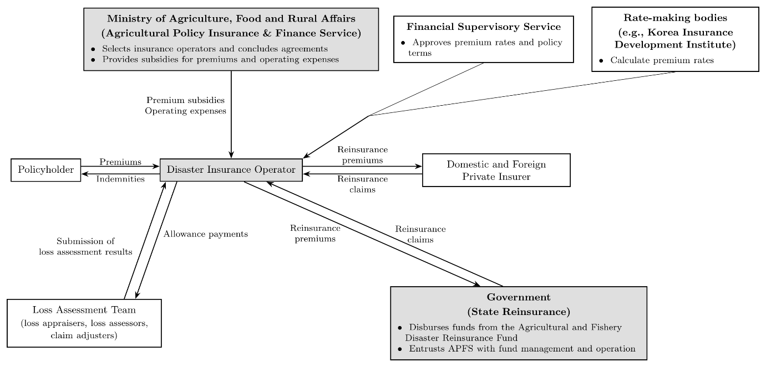
Notes: Arrows indicate payments and the submission of loss assessment results; dashed lines indicate the verification and approval of premium rates and policy terms. Local agricultural cooperatives, which sell contracts on behalf of the operator, are not shown. Adapted from MAFRA (2025, 2026).
NH transfers part of its risk to private reinsurers and the Agricultural and Fishery Disaster Reinsurance Fund. In 2024, the first-stage shares under the main program’s profit-and-loss-sharing arrangement were 10 percent for NH, 40 percent for private reinsurers, and 50 percent for the state (MAFRA, 2025, p. 274). Additional non-proportional provisions alter the allocation at higher loss levels. These initial shares therefore do not describe the allocation of every layer of loss.
The gross premium consists of a pure premium and a loading. The pure premium covers insured risk and loss-investigation expenses. The loading covers specified operating expenses, including delegated selling costs. Under the 2026 rules, the government finances part of the pure premium and the entire loading (MAFRA, 2026). The subsidy rate in equation (1) applies only to the pure premium. Public support consequently accounts for a larger share of the gross premium than this rate alone indicates.

2.2 Expansion, Enrollment, and Financing
The program began with apples and pears in 2001 and expanded to 78 crops and 94 products by 2026 (MAFRA, 2026). For a given crop, the pilot, expansion of sales regions, and entry into the main program may occur in different years. I use the last pre-pilot year as the reference year in the national comparison and follow ten crop-specific target years beginning with the coded expansion year (Table 3). These dates describe availability; they do not measure enrollment.
In the APFS series used for Figure 2, the national enrollment rate rose from 12.5 percent in 2009 to 54.2 percent in 2024. This rate divides insured area by eligible area. Because the denominator expands when the program adds crops or regions, changes in the rate reflect both take-up and program scope. The loss ratio divides portfolio claims by the premium measure specified in the figure notes. It does not measure individual farms’ income losses or NH’s company-wide profitability after reinsurance.
Figure 3 reports the financing shares of the pure premium in the APFS series used here. In 2024, local governments paid 39.7 percent, policyholders paid 12.6 percent, and the central government paid the remaining 47.7 percent. Combined central and local support amounted to KRW 996.9 billion for 676,226 insured hectares, or approximately KRW 1.47 million per insured hectare (APFS, n.d.). These amounts exclude the publicly financed loading. Transfers to individual policyholders depend on insured value, rated risk, and coverage.
Figure 2
National Enrollment Rate and Loss Ratio, 2001-2024
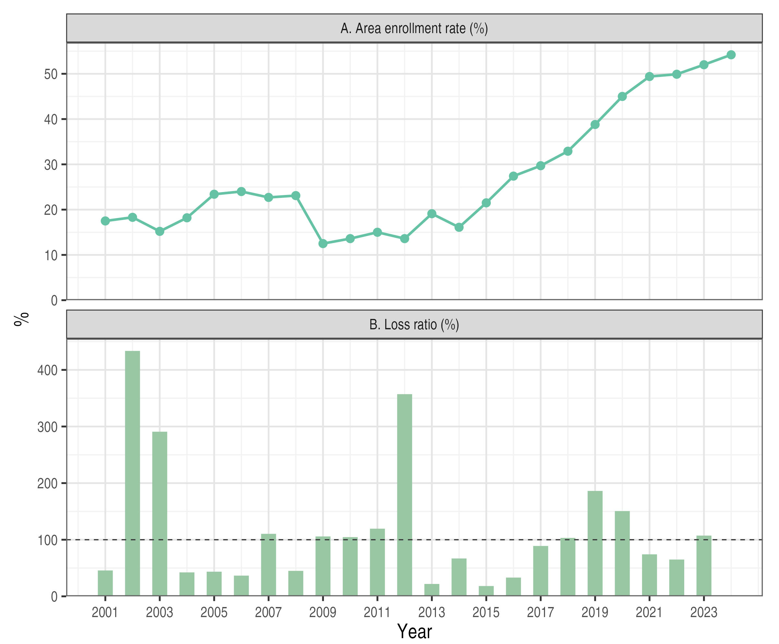
Notes: Enrollment is insured area divided by eligible area. The loss ratio is indemnities divided by premium net of refunds through 2011 and by risk premium from 2012; it is shown through 2023. The horizontal line marks 100 percent. Data from APFS (n.d.).

Enrollment varies substantially across crops (Table 1). In 2023, insurance covered 89.0 percent of eligible apple area and 61.0 percent of eligible rice area, compared with 7.1 percent for sweet potato and 5.4 percent for corn. Insurance availability thus corresponded to very different levels of coverage among the six annual crops examined in Chapter 5.
Figure 3
Shares of the Pure Premium by Payer, 2001-2024
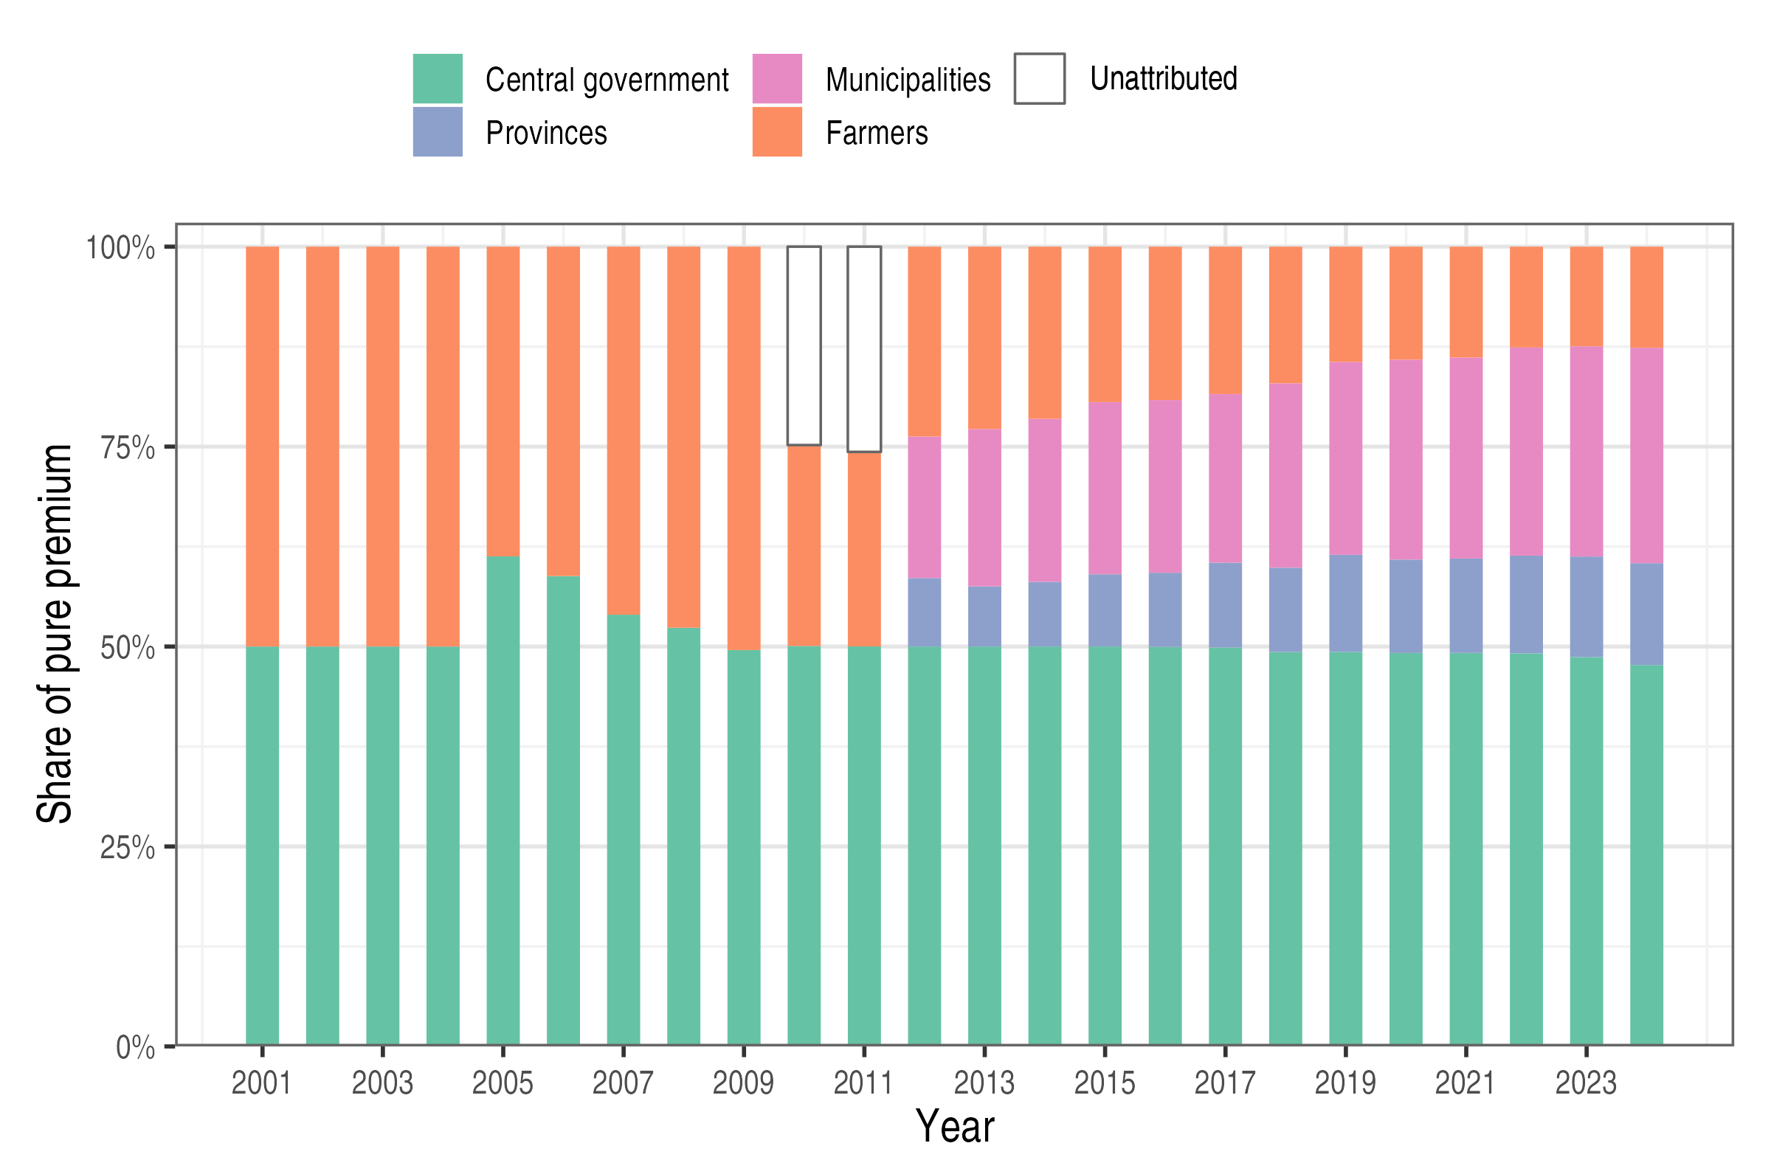
Notes: Shares of the reported pure-premium total. Unattributed segments in 2010-2011 are the difference between that total and the identified payer components. The publicly financed loading is excluded. Data from APFS (n.d.).

Table 1
Enrollment and Loss Ratios for Selected Crops, 2023
Crop | Eligible area (ha) | Insured area (ha) | Enrollment (%) | Loss ratio (%)
Panel A. Rice and major fruits
Rice | 725,882 | 443,136 | 61.0 | 103.5
Apple | 24,945 | 22,209 | 89.0 | 116.1
Pear | 10,078 | 7,683 | 76.2 | 60.5
Panel B. Six annual crops
Soybean | 55,326 | 28,649 | 51.8 | 158.9
Onion | 17,128 | 6,811 | 39.8 | 73.1
Garlic | 21,110 | 5,936 | 28.1 | 119.0
Red pepper | 26,126 | 8,522 | 32.6 | 141.7
Sweet potato | 18,389 | 1,300 | 7.1 | 195.5
Corn | 14,073 | 764 | 5.4 | 129.2
Notes: Eligible area can differ from national cultivated area because it depends on each product’s sales regions. The loss ratio is indemnities divided by risk premium. Data from APFS (n.d.); author’s calculations.

2.3 Related Literature
The literature on agricultural insurance begins with two problems: insurers have incomplete information about individual farms, and weather shocks can generate losses across many farms at once. Nelson and Loehman (1987) examine how adverse selection and moral hazard affect insurance contracts and the scope for improving their design. Just et al. (1999) show that participation decisions reflect both subsidy incentives and asymmetric information, while Lee and Jung (2014) examine adverse selection and moral hazard among Korean rice farms. Even when these information problems can be managed, correlated losses limit the benefits of pooling risks across policyholders. Miranda and Glauber (1997) identify access to reinsurance as an important condition for managing this systemic risk.
These problems raise a further question: how should risk and costs be shared among farmers, insurers, and the government? Jia et al. (2025) show theoretically that the appropriate public role depends on loss correlation and the relative efficiency of public and private risk bearing. In Korea, Kang and Chung (2017) evaluate the risk-group reinsurance arrangement piloted during 2014–2016, examining its implications for losses and default risk in the state reinsurance fund. Their analysis illustrates how the terms of public risk sharing affect the government’s financial exposure. For premium support, Hazell et al. (2017) emphasize the importance of explicit policy objectives, targeting, and cost-effective design. Demand also depends on the protection farmers expect outside the insurance market: anticipated disaster assistance may reduce incentives to purchase coverage (Raschky & Weck-Hannemann, 2007). Evaluating support therefore involves both participation and the allocation of benefits and costs. Lusk (2017) makes this distinction explicit by examining the welfare effects of premium subsidies on producers, consumers, and taxpayers.
A related literature asks how insurance changes agricultural production. By changing expected returns and exposure to risk, insurance can influence both the area planted and the inputs used on that land. Goodwin et al. (2004) find modest acreage responses in the U.S. crop regions they examine, while Yu et al. (2018) estimate acreage responses to changes in premium subsidies. Korean studies examine several parts of this relationship. Han (2014) compares insurable and non-insurable crops to study production and price effects. Nam and Ahn (2022) examine input use and farm income, and Lee and Kim (2026) analyze output and technical efficiency using panel data on fruit farms. Together, these studies show how insurance relates to production decisions and farm outcomes, providing a basis for examining how those outcomes connect to the objectives of public support.
Comparing outcomes across different dates of insurance introduction also requires attention to comparison groups and statistical inference. Callaway and Sant’Anna (2021) provide a framework for comparisons across treatment cohorts, including the use of units that have not yet received treatment. Roth (2022) explains why pre-treatment trends should inform the assessment of a research design without treating a statistically insignificant pre-trend test as proof of parallel trends. Research on clustered inference further guides the choice of uncertainty measures, including bootstrap methods and adjustments for settings with few treated clusters (Cameron et al., 2008; MacKinnon & Webb, 2018; MacKinnon et al., 2023; Webb, 2023). These contributions inform the construction of comparison groups, the examination of pre-program outcomes, and the reporting of uncertainty in this study.
This paper brings the institutional and production perspectives together. It assesses premium subsidies, administrative cost subsidies, and state reinsurance against their respective purposes, and compares changes in area, yield, and production following insurance availability. The national crop comparisons provide evidence across crops, while the municipal rice comparison holds crop identity fixed and examines the first two years of availability. Together, these analyses connect evidence on production responses to the broader question of how government support for crop insurance should be assessed.

3. Assessment of Government Intervention

3.1 Economic Rationale
I assess each instrument by the constraint it addresses, the incentives it creates, and the distribution of its costs and benefits. Correlated losses provide a rationale for public risk sharing, while information problems and delivery costs highlight the importance of insurance infrastructure (Miranda & Glauber, 1997; Mahul & Stutley, 2010). Premium assistance can serve affordability and distributional objectives, with the appropriate level of support depending on these objectives and the costs of achieving them (Hazell et al., 2017). Together, these instruments shape the cost and availability of coverage and the allocation of risk, potentially influencing production decisions. The rollout comparisons in Chapter 5 complement this institutional assessment by examining changes in production following the introduction of insurance supported by the three instruments.

3.2 Premium Subsidies
Let $P$ denote the pure premium per unit of coverage and $s$ the combined national and local subsidy rate. Policyholders then pay $\left(1-s\right)P$ per unit. Given coverage demand $D\left(⋅\right)$, purchases without and with the subsidy are
$q_{0}=D\left(P\right), q_{1}=D\left(\left(1-s\right)P\right)$(1)
In Figure 4, supply is perfectly elastic at $P$. The subsidy increases coverage from $q_{0}$ to $q_{1}$ and costs the government $sPq_{1}$. Of this amount, $sPq_{0}$ supports purchases that would have occurred without the subsidy.
Figure 4
Premium Support and the Demand for Insurance Coverage
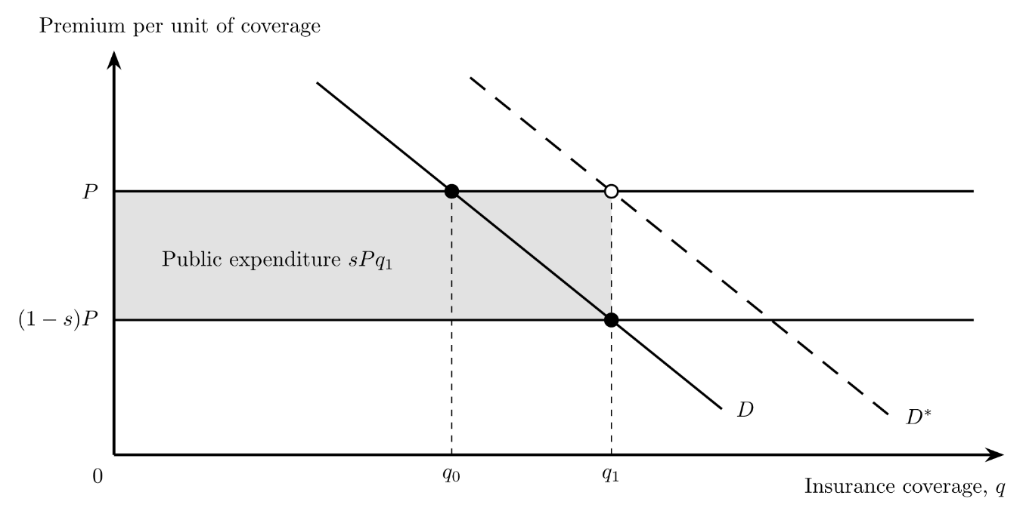
Notes: P is the pure premium per unit of coverage and s the combined subsidy rate. Supply is perfectly elastic at P, and the loading is financed separately. D is observed demand; D* is demand when the value of protection is fully perceived. The shaded rectangle is public pure-premium support, sPq₁, a transfer rather than a welfare loss. Arbitrary units.

The figure holds the risk class and premium fixed and treats the loading as separately financed. The shaded rectangle measures a public transfer. If willingness to pay reflects the benefits of protection and P equals marginal resource cost, coverage above q₀ generates an allocative loss. If demand understates those benefits, D* shows why additional coverage might be warranted. The interpretation depends on these assumptions. Risk preferences, liquidity constraints, and information can affect demand differently, and changes in the insured risk pool can change premiums. The figure illustrates these mechanisms; it does not estimate welfare gains in Korea or identify an optimal subsidy rate.
Under the 2026 national schedule, support covers 33-65 percent of the pure premium for specified product-coverage combinations and 50 percent for other combinations. National support is capped at KRW 50 million per policyholder per product (MAFRA, 2026, p. 2). At a given subsidy rate, the transfer rises with the eligible premium until the ceiling binds. Additional premiums then receive no further national subsidy. The ceiling limits transfer size but does not target household income, and local assistance remains a separate consideration. For products sold from July 2026, policyholders with a five-year cumulative loss ratio of at least 500 percent cannot choose coverage of 80 percent or higher. For products whose sales begin from November 2026, the guidelines provide for premium adjustments based on individual loss experience (MAFRA, 2026). Greater risk differentiation may improve pricing incentives while making protection less affordable for repeatedly affected farms.

3.3 Administrative Cost Subsidies
Administrative support finances the full loading under the 2026 rules (MAFRA, 2026). The loading includes delegated selling and other specified operating costs. Loss-investigation expenses instead form part of the pure premium, together with the risk premium. Comparisons of administrative spending must keep these categories separate to avoid counting investigation costs twice. The relevant question is whether public financing delivers coverage and timely, accurate settlement at a reasonable resource cost.
I consider several measures of delivery costs. Selling and policy-servicing expenditure can be reported per active contract, while claim-assessment expenditure can be reported per completed claim. Comparisons across products and regions should also report operating costs relative to a clearly defined premium measure, together with settlement times and assessment corrections. These indicators require careful interpretation. Risk prices, claim frequency, product complexity, and geographical dispersion can change cost ratios without changing efficiency. Comparisons within similar product and risk categories are therefore more informative than an aggregate international ranking.
Mahul and Stutley (2010, pp. 84–87) discuss the importance of low-cost delivery channels. Korea’s 2026 guidelines also require payment within seven days after the indemnity has been determined and the policyholder submits a claim (MAFRA, 2026, p. 5). This deadline applies after loss assessment; it does not measure the full time from loss notification to payment. Evaluating service therefore requires both compliance with existing rules and evidence on the cost, duration, and quality of the full process.

3.4 State Reinsurance
State reinsurance increases the capacity to cover correlated losses but creates a contingent public liability. Under a stop-loss contract with attachment point $a$, total covered claims $L$ are divided into retained and ceded claims as follows:
$L^{ret}=min\left(L,a\right), L^{ced}=max\left(L-a,0\right)$(2)
Under a proportional contract, the state receives a fixed share of premiums and pays the same share of claims. Korea used a stop-loss contract with a 180 percent attachment point in 2005-2013. A mixed arrangement combining stop-loss coverage and profit-and-loss sharing began in 2014 and applied to the entire program from 2019 (MAFRA, 2025, pp. 268, 273-274). Figure 5 compares the two benchmark contracts. Panel B uses a 50 percent first-stage state share for illustration; it does not reproduce the full Korean treaty.
In the uncapped stop-loss benchmark, private claims remain constant above the attachment point. Actual incentives also depend on coverage limits, pricing, and renewal terms. Proportional sharing retains private exposure at the margin but transfers part of ordinary losses to the state. The appropriate allocation depends on loss correlation and relative risk-bearing capacity (Jia et al., 2025). Let $R$ denote the reinsurance premium in the same units as $L$ and $a$. Expected public cost under stop-loss equals expected ceded claims less the premium received:
$E\left[C\right]=E\left[max\left(L-a,0\right)\right]-R$(3)
From 2005 to 2024, reported crop reinsurance payments totaled KRW 923.8 billion and receipts totaled KRW 470.0 billion (MAFRA, 2025, p. 269). The difference, KRW 453.8 billion, is a cumulative nominal cash flow. It is neither an inflation-adjusted cost measure nor the fund’s complete financial balance. Assessing actuarial adequacy requires comparing premiums with expected losses and the cost of bearing risk under each treaty. Comparisons over time must also account for changes in prices, insured exposure, coverage, contract terms, and settlement dates. Payments per insured hectare do not by themselves adjust for insured value or loss severity.
Figure 5
Allocation of Claims under Stop-Loss and Proportional Reinsurance
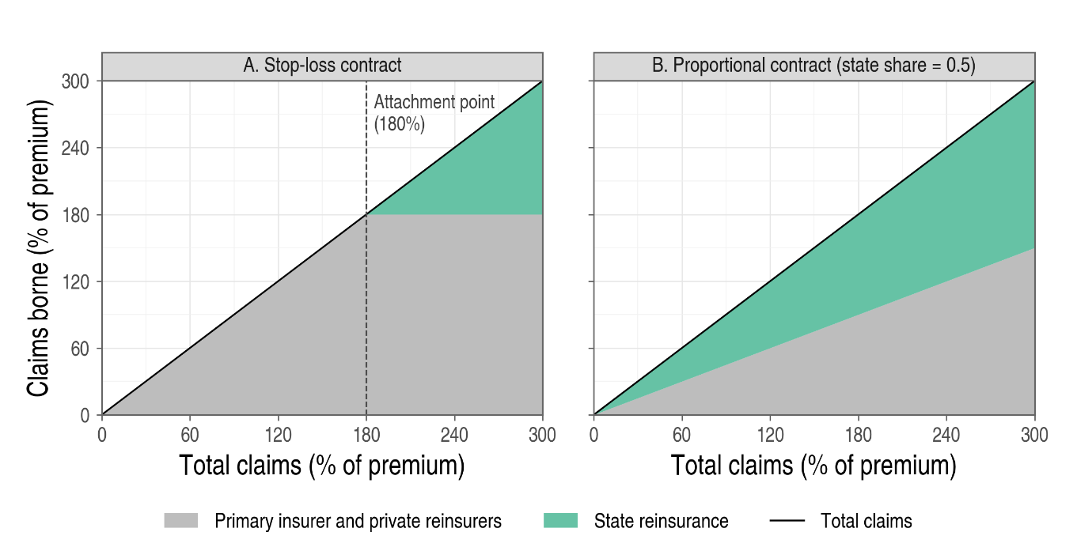
Notes: Both axes express claims as percentages of premium. Panel A uses the 180 percent attachment point reported for 2005-2013 (MAFRA, 2025, p. 273). Private claims combine those of the operator and private reinsurers. In both panels, the private and state shares are stacked and sum to total claims. Panel B is an illustrative proportional contract without additional layers, premium transfers, expenses, or commissions.
A prospective evaluation must distinguish expected net cost from liquidity needs and exposure to severe or consecutive loss years. Assessing each requires information on treaty terms, premiums, reserves, and committed financing. Catastrophe exposure depends on how losses co-move as well as on their frequency and severity (Mahul & Stutley, 2010; Kang & Chung, 2017). Historical payments should be assessed under the contracts that generated them, rather than under current sharing rates.

4. Data and Empirical Strategy

4.1 Data and Summary Statistics
I use a national crop-year panel from the Crop Production Survey (Statistics Korea, n.d.), containing 43 crop or crop-form series over 1991–2024. Area is measured in hectares, yield in kilograms per 10 ares, and production in metric tonnes. In these units, production equals area × yield / 100, apart from reporting and rounding differences. When calculated using the same observations and weights, the log production contrast therefore approximately equals the sum of the log area and yield contrasts. This accounting relationship separates changes in cultivated area from changes in average yield. Changes in average yield can reflect weather, input use, technology, or shifts in the composition of cultivated land.
I define exposure as the availability of crop insurance, regardless of whether individual farms enroll. The national outcomes therefore cover both insured and uninsured farms. Two changes in data collection affect comparability over time. Sweet potato statistics shifted to administrative reporting in 2005, while spring napa cabbage and spring radish statistics shifted to a sample survey in 2012 (Statistics Korea, 2014, pp. 67, 79–80).
Table 2 summarizes the unique crop-year observations used in the main comparison. It reports means, standard deviations, and ranges. Treated crops have more than three times the cultivated area of comparison crops on average. These statistics describe outcome levels and dispersion; they do not establish that the groups would have followed parallel trends. Section 5.5 examines their observed pre-pilot changes. Taking logs does not by itself resolve differences in those trends.
Table 2
Summary Statistics
 | Mean | S.D. | Min. | Max. | Obs. | Crops
Panel A. Area (ha)
Treated, reference year | 35,112 | 24,804 | 15,392 | 76,267 | 6 | 6
Treated, target years | 29,445 | 16,858 | 14,673 | 80,842 | 60 | 6
Comparison, reference years | 9,775 | 9,659 | 1,062 | 34,875 | 66 | 22
Comparison, target years | 9,119 | 9,779 | 619 | 45,474 | 232 | 22
Panel B. Yield (kg/10a)
Treated, reference year | 1,787 | 2,495 | 150 | 6,725 | 6 | 6
Treated, target years | 1,743 | 2,319 | 147 | 8,541 | 60 | 6
Comparison, reference years | 2,488 | 2,696 | 37 | 10,946 | 66 | 22
Comparison, target years | 2,390 | 2,782 | 30 | 11,286 | 232 | 22
Panel C. Production (t)
Treated, reference year | 348,196 | 354,247 | 92,830 | 1,035,076 | 6 | 6
Treated, target years | 378,579 | 458,011 | 55,714 | 1,594,450 | 60 | 6
Comparison, reference years | 208,852 | 330,283 | 1,589 | 1,582,966 | 66 | 22
Comparison, target years | 175,178 | 314,754 | 1,598 | 1,896,828 | 232 | 22
Notes: Statistics are computed over unique crop-year observations that enter the main comparison. S.D. is the standard deviation of observations. Reference years are crop-specific; target years are the ten years beginning with the coded expansion year.

4.2 Sample and Exposure Timing
I select six annual crops: soybean, onion, sweet potato, corn, garlic, and red pepper. Each has a continuous series from 1991, a documented pilot year and first nationwide sales season, and ten observed years following expansion. I exclude fruit crops because orchard area and perennial production adjust over different time horizons. Autumn potato is excluded because its program milestones are not reported separately from those of other potato forms. I also exclude spring potato. The product insured as spring potato from 2009 was a highland summer crop sold only in Pyeongchang through at least 2013 (Jeong & Choi, 2013, pp. 9-10), which corresponds to the separately reported highland potato series rather than to the lowland spring potato series used here. Lowland spring potato appears as a separately insured form only by 2020 and was sold in two provinces in 2023 (Kim et al., 2021, p. 33; Kook et al., 2024, p. 221), so its first year of coverage is undocumented and ten post-expansion years cannot be observed. For the same reason, I do not use it as a comparison crop. I examine rice separately using the municipal rollout described in Section 4.4.
Table 3 lists the dates used in the national comparisons. The pilot marks the start of regional availability, while the expansion year, the harvest year of the first documented nationwide sales season, marks the beginning of the ten target years. Neither date establishes universal enrollment or geographical coverage. Pilot seasons are confirmed by first-sale dates or first-year enrollment and indemnity records (Choi et al., 2010, p. 163; Kook et al., 2024, pp. 17-21). Nationwide sales began in 2011 for soybean and onion, in 2012 for sweet potato, corn, and garlic, and in 2014 for red pepper (Kook et al., 2024, p. 18; Ministry for Food, Agriculture, Forestry and Fisheries, 2011b, 2012; MAFRA, 2014). Onion and garlic are sold in autumn, so their nationwide sales in 2011 and 2012 cover the 2012 and 2013 harvests. For soybean, sweet potato, corn, and red pepper, the first nationwide season precedes the main-program date recorded in the yearbook by one harvest year. Table 5 examines alternative definitions of these milestones.
Table 3
Insurance Timing for the Six Annual Crops
Crop | Pilot year | Expansion year | Product-table year | Reference year | Transition years
Soybean | 2008 | 2011 | 2011 | 2007 | 3
Onion | 2009 | 2012 | 2011 | 2008 | 3
Sweet potato | 2009 | 2012 | 2012 | 2008 | 3
Corn | 2009 | 2012 | 2012 | 2008 | 3
Garlic | 2010 | 2013 | 2012 | 2009 | 3
Red pepper | 2008 | 2014 | 2014 | 2007 | 6
Notes: Pilot and expansion years are the first harvest years covered by pilot and nationwide sales. An announcement applies to the same year’s crop if it precedes the end of that crop’s sales window and to the following year’s crop otherwise. Reference year is the pilot year minus one. Transition years run from the pilot year to the year before expansion. Product-table years are an alternative milestone used in Table 5. Data from MAFRA (2014, 2025, pp. 37, 44, 46), Choi et al. (2010, p. 163), Kook et al. (2024, pp. 17-21, 221), and Ministry for Food, Agriculture, Forestry and Fisheries (2011b, 2012).
The candidate comparison pool contains 24 annual crop series; 22 enter the main contrast. A comparison crop must either have no pilot by 2024 or remain unexposed in both the reference and target years. All six treated crops entered pilots by 2010, before the first target year in 2011. They therefore do not serve as controls for one another in the main post-period comparisons.

4.3 National Crop Comparisons
For the national analysis, I calculate crop-specific difference-in-differences contrasts and average them across six crops and ten target years. For treated crop $i$, let $p_{i}$ denote the pilot year, $g_{i}$ the expansion year, and $b_{i}=p_{i}-1$ the reference year. Event year $e$ corresponds to target year $g_{i}+e$. The set $C_{i,e}$ contains the $n_{i,e}$ comparison crops observed and not yet exposed in both $b_{i}$ and $g_{i}+e$. For log outcome $y$, the crop-event contrast is
δi,e=yi,gi+e-yi,bi-1ni,ej∈Ci,e​yj,gi+e-yj,bi (4)
I then average these contrasts equally across crops and event years:
${\hat{θ}}_{e}=\frac{1}{6}\sum_{i=1}^{6}{{\hat{δ}}_{i,e}}, \hat{θ}=\frac{1}{10}\sum_{e=0}^{9}{{\hat{θ}}_{e}}$(5)
The first term in equation (4) measures the treated crop’s log change from the reference year. The second measures the average log change among eligible comparison crops over the same period. The contrast is the difference between these changes. The statistic $\hat{θ}$ averages the contrasts across six crops and ten target years; multiplying it by 100 gives an approximate difference in percentage growth. Because the reference year is before the pilot, $\hat{θ}$ includes changes during the pilot transition as well as after expansion.
I also report an alternative that weights treated crops by their mean cultivated area in 2003-2007, before the earliest pilot:
${\hat{θ}}^{A}=\frac{1}{10}\sum_{e=0}^{9}{\sum_{i=1}^{6}{w_{i}^{A}}} {\hat{δ}}_{i,e}, w_{i}^{A}=\frac{{\overset{‾}{A}}_{i}^{pre}}{\sum_{k=1}^{6}{{\overset{‾}{A}}_{k}^{pre}}}$(6)
For the event-time analysis, I index each target year relative to the pilot year, retaining the last pre-pilot year as the reference. I apply equation (4) using this pilot-relative target year in place of the expansion-relative target year, and determine comparison-crop eligibility for that year and the reference year. Comparison crops are drawn from the comparison pool; treated crops are not used as comparisons for one another before their pilots. I average the six crop-specific contrasts equally. The reference-year contrast is zero by construction. The joint pre-pilot test evaluates whether all nine earlier contrasts are zero. A failure to reject does not establish parallel untreated trends. Post-pilot contrasts include the transition years before coded expansion.

4.4 Municipal Rice Comparison
Rice insurance became available in 20 municipalities in 2009 and ten additional municipalities in 2011 (Choi et al., 2010; Ministry for Food, Agriculture, Forestry and Fisheries, 2011a). Both cohorts were designated as major producing areas. I use later entrants as comparisons for early entrants through 2010, before later entrants became eligible. The common designation holds some selection criteria constant, but it does not imply random rollout timing. Section 5.4 examines pre-pilot characteristics and trajectories.
The outcome is log paddy-rice planted area from the Crop Production Survey for 2000-2010. I retain mainland municipalities with complete series and consistent boundaries. The resulting sample contains 17 early entrants and nine later entrants, yielding 286 municipality-years. I estimate
$$lnA_{mt}=α_{m}+λ_{t}+βD_{mt}+ε_{mt} \left(7\right)$$
where $A_{mt}$ is planted area in municipality $m$ in year $t$, and $α_{m}$ and $λ_{t}$ denote municipality and year fixed effects. The indicator $D_{mt}$ equals one for early entrants in 2009-2010. Municipality fixed effects absorb time-invariant differences in soil quality, irrigation infrastructure, and proximity to markets. Year fixed effects absorb changes common to all municipalities; they do not absorb regional differences in weather or investment.

4.5 Identification, Inference, and Scope
Interpreting these comparisons causally requires parallel changes in the absence of insurance, correctly dated exposure, and no anticipation or spillovers. In the national analysis, crop substitution and common-market responses could affect comparison crops before they become eligible. Pre-pilot trajectories and characteristics describe observed comparability, but they cannot establish what would have happened after the pilots without insurance. The rice design holds crop identity fixed, although regional weather, investment, and other changing local conditions may still differ across cohorts.
For the national contrasts, I summarize uncertainty using crop-level scores and independent Webb six-point multipliers (Appendix A). This procedure is neither null-imposed nor studentized, and its small-sample coverage is not established. Using Webb weights does not by itself resolve the problem of few treated clusters (MacKinnon & Webb, 2018). For rice, I use a null-imposed, CR1-studentized wild cluster bootstrap with Webb weights and 9,999 draws. Confidence intervals are obtained by test inversion (Cameron et al., 2008; Webb, 2023). Inference remains subject to finite-sample concerns with 26 municipality clusters, only nine of which are comparisons. Tables report standard errors in parentheses and 95 percent intervals in brackets. Asterisks denote * p < 0.10, ** p < 0.05, and *** p < 0.01. Unless stated otherwise, statistical significance refers to the 5 percent level.
Precision and identification impose separate limits on interpretation. A wide interval indicates imprecision even if the identifying assumptions hold. A narrow interval cannot correct a biased comparison. I treat the national intervals as exploratory because the score procedure’s nominal coverage is uncertain. I also report alternative reference periods, comparison pools, and weights as sensitivity analyses. These alternatives were examined after the main results were known.

5. Results

5.1 Pre-Pilot Trajectories
Figure 6 compares changes before and after the pilots relative to the last pre-pilot year. Each point averages six crop-specific contrasts, each calculated against its eligible comparison crops. Pre-pilot contrasts near zero would be consistent with parallel observed changes. A pattern in which those contrasts move toward or away from zero indicates differences in observed growth before insurance became available. The reference-year contrast equals zero by construction.
Pre-pilot yield contrasts range from approximately −0.04 to 0.02 log points. The joint test does not reject at the 5 percent level (p = 0.92). With only six treated crops, a failure to reject provides limited evidence about parallel trends, and the test’s small-sample calibration remains uncertain.
Area and production show larger differences in pre-pilot growth. The contrasts are approximately −0.2 log points in earlier years and approach zero near the reference year. Treated crops were therefore gaining relative to comparison crops before insurance became available. The exploratory joint p-values are 0.08 for area and 0.05 for production. The production value, 0.0535 before rounding, lies at the stated 5 percent threshold and falls below it under some sets of multiplier draws; both trajectories matter for comparability. Their similar patterns are consistent with the accounting relationship among area, yield, and production.
Figure 6
Event-Time Contrasts for Cultivated Area, Yield, and Production
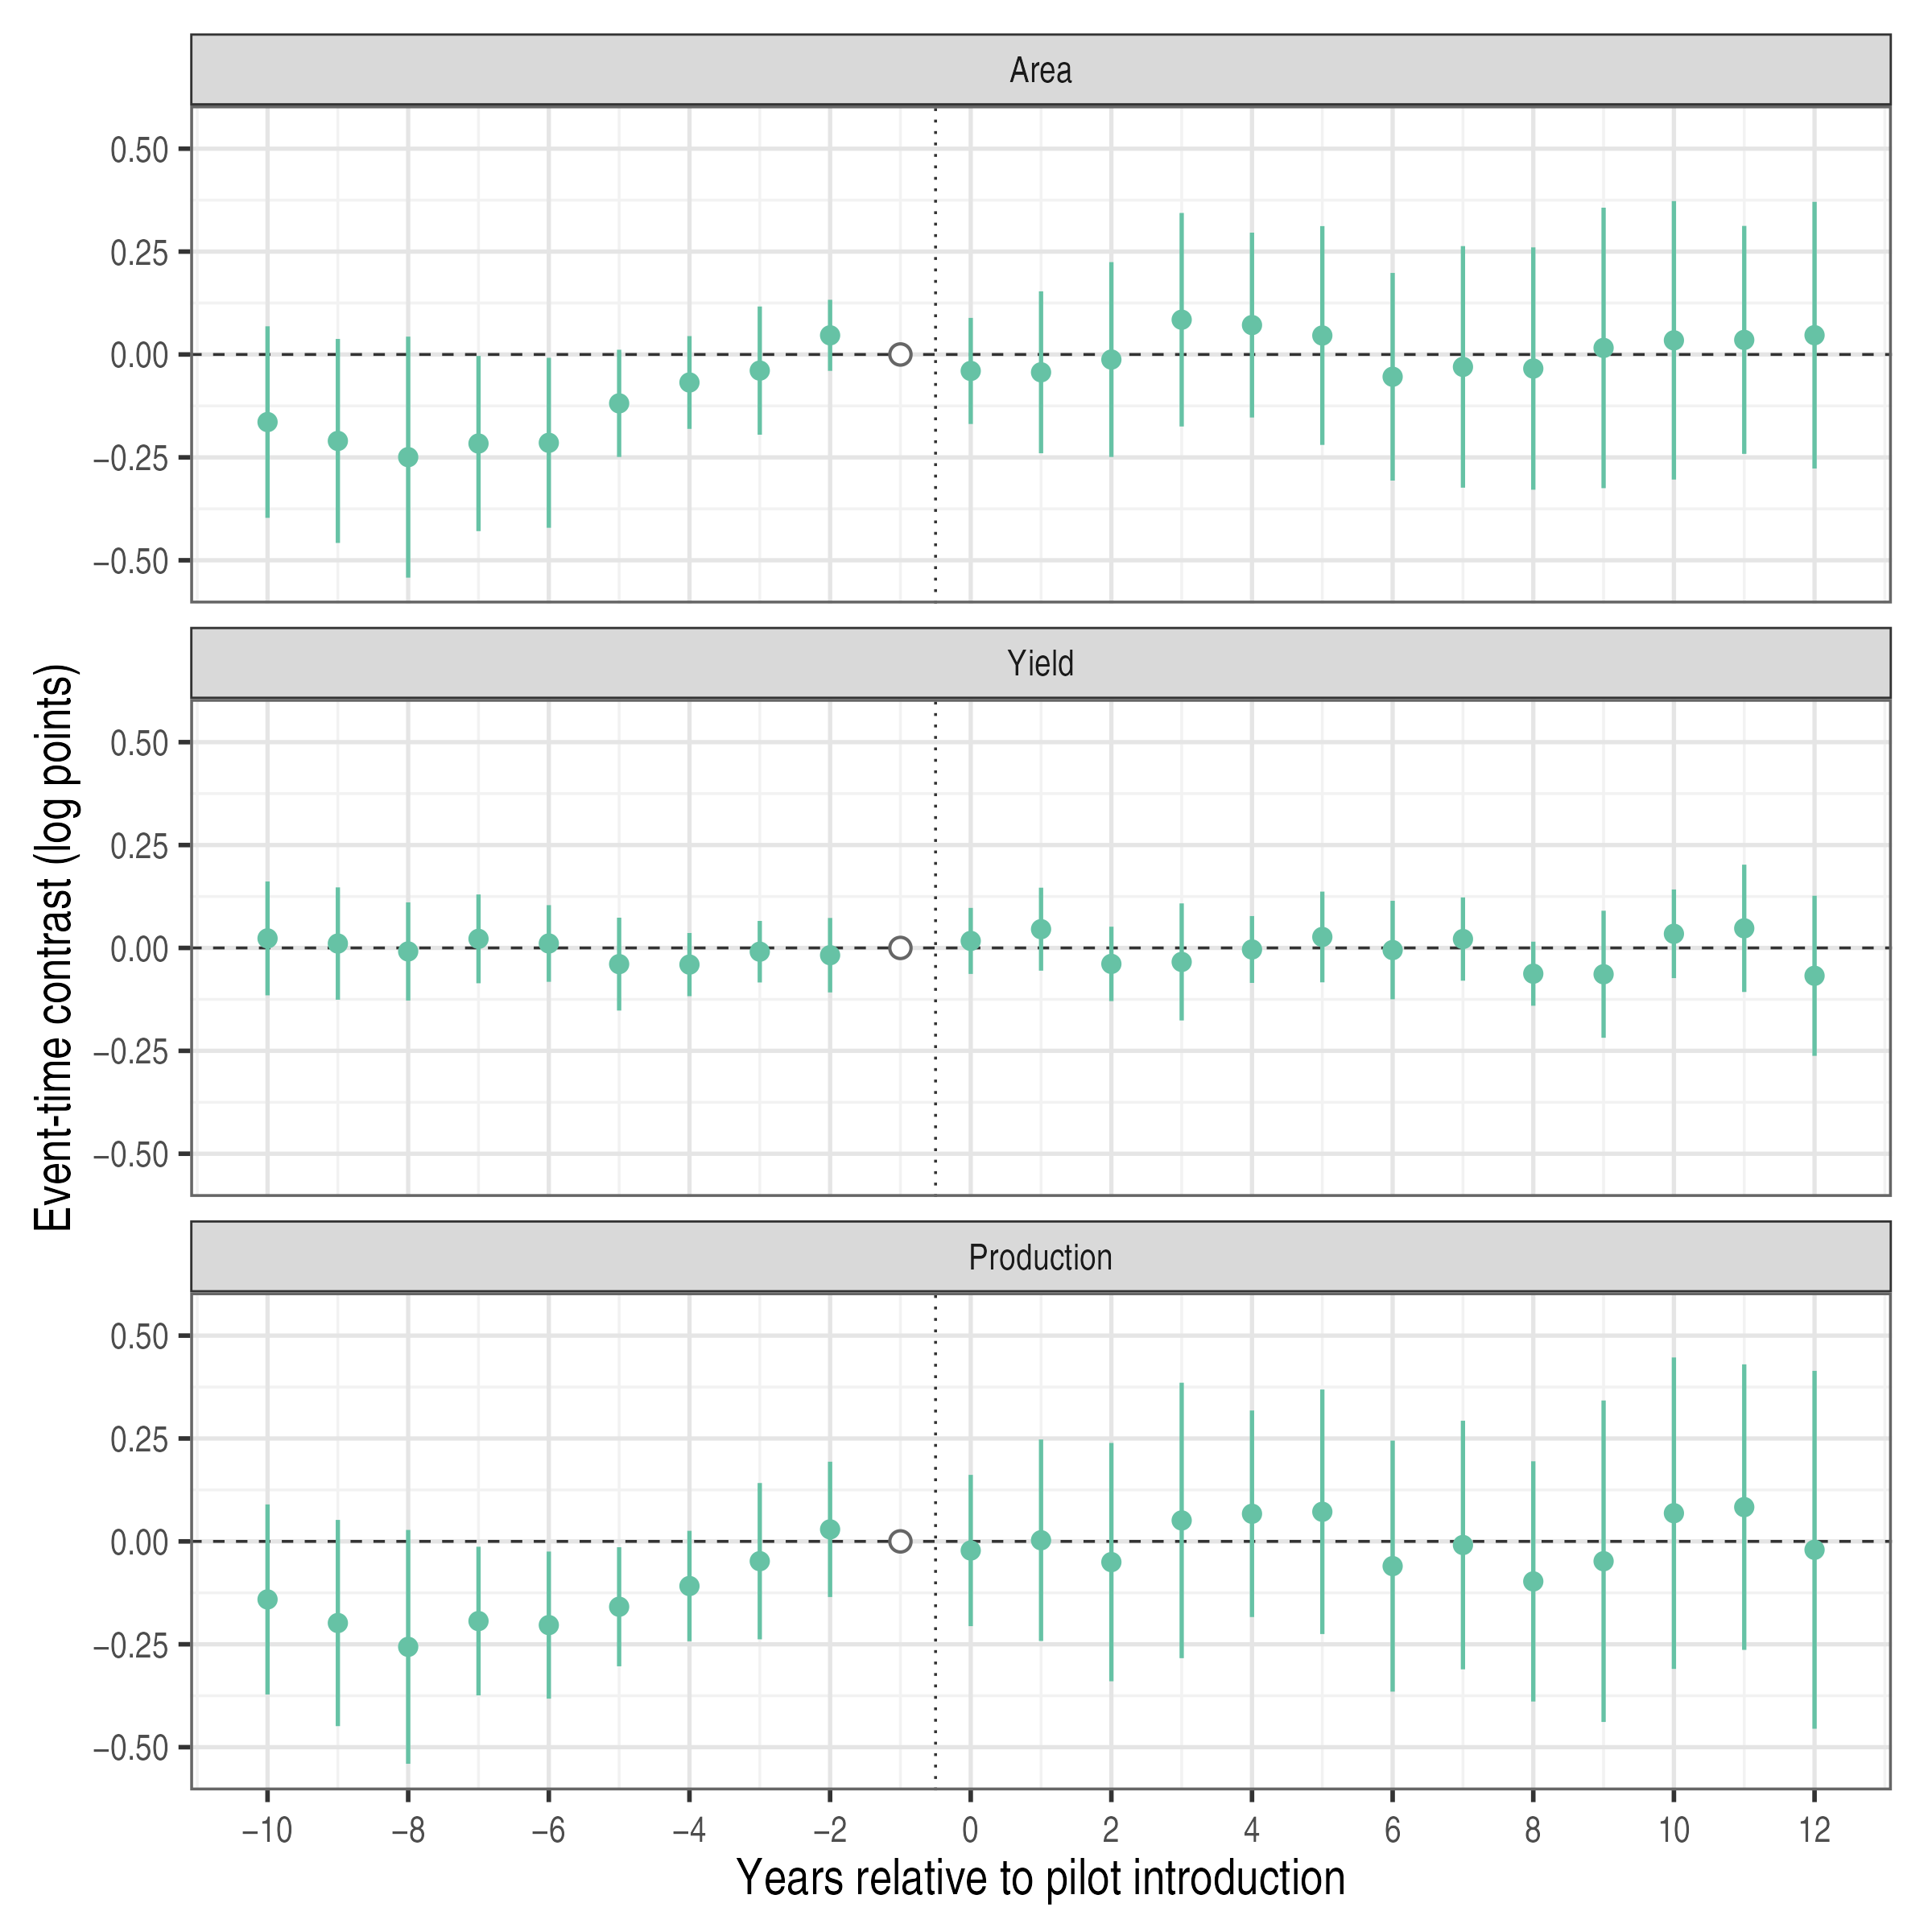
Notes: Event-time contrasts relative to the last pre-pilot year (open circle), averaged over the six treated crops; comparison crops exclude the other treated crops. Bars are exploratory 95 percent intervals from 9,999 Webb multiplier draws; nominal coverage is not established for this design (Appendix A). The vertical dotted line separates pre-pilot and post-pilot years; post-pilot years include the transition years between the pilot and expansion.

This pre-pilot divergence also affects the choice of baseline. A reference year close to introduction measures subsequent changes from a later point in the relative gains of treated crops. Section 5.3 examines how earlier reference periods change the contrasts.

5.2 Aggregate and Crop-Level Contrasts
Table 4 presents the main contrasts using two comparison pools. The first includes the full pool. The second excludes spring napa cabbage and spring radish, whose survey method changed in 2012. The documentation used here does not establish how these series relate to the winter series reported separately from 2014.
Table 4
Mean Post-Period Contrasts
 | (1)  Area | (2)  Yield | (3)  Production
Panel A. Full comparison pool
Mean contrast | 0.011 | −0.012 | −0.002
 | (0.141) | (0.056) | (0.168)
 | [−0.253, 0.275] | [−0.118, 0.093] | [−0.318, 0.315]
Comparison series | 22 | 22 | 22
Panel B. Excluding two spring series
Mean contrast | −0.069 | −0.014 | −0.084
 | (0.139) | (0.059) | (0.169)
 | [−0.332, 0.193] | [−0.125, 0.096] | [−0.406, 0.238]
Comparison series | 20 | 20 | 20
Notes: Log outcomes; six treated crops; ten target years. Target years begin with the coded expansion year, whereas Figure 6 indexes time relative to pilot introduction. Panel B excludes spring napa cabbage and spring radish. Score-based standard errors in parentheses and 95 percent intervals in brackets from 9,999 Webb multiplier draws; their nominal coverage is not established for this design (Appendix A). * p < 0.10, ** p < 0.05, *** p < 0.01.

Using the full pool, I obtain mean contrasts of 0.011 log points for area, −0.012 for yield, and −0.002 for production, with respective p-values of 0.94, 0.84, and 0.99. Excluding the two spring series changes the contrasts to −0.069, −0.014, and −0.084. Area reverses sign and production moves further below zero, while yield changes little. With the seven crops and yearbook dates used before the timing was verified, the full-pool contrasts are 0.048, −0.028, and 0.020 (Table 5, Panel H). The production interval under the full pool, approximately [−0.32, 0.31] log points, permits both substantial decreases and substantial increases.
Figure 7 reports the crop-specific means underlying the aggregate contrasts.
Figure 7
Mean Contrasts by Treated Crop
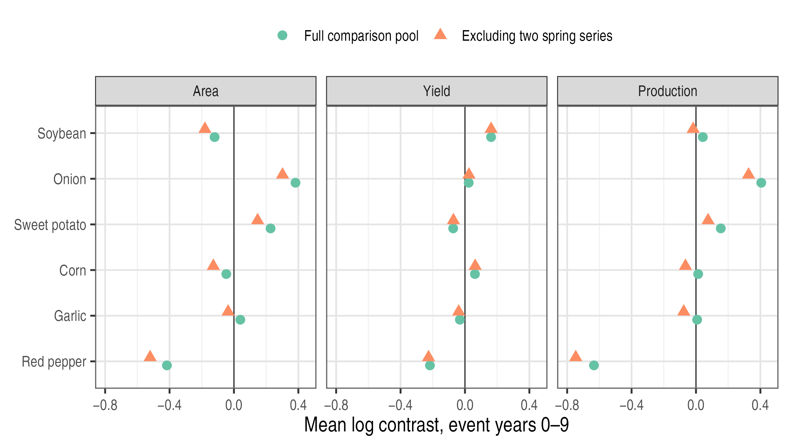
Notes: Each point averages ten crop-specific contrasts. Circles use the full comparison pool, and triangles exclude spring napa cabbage and spring radish. Log points.

The small aggregate masks large differences across crops. Production contrasts are 0.406 for onion, 0.154 for sweet potato, and −0.634 for red pepper. Under equal weights, these crops contribute approximately 0.068, 0.026, and −0.106 log points, respectively. Dropping one crop at a time moves the aggregate between −0.083 and 0.125 (Appendix Table A1). These changes show that individual crops strongly influence the mean. They do not establish whether the underlying movements arise from insurance, other shocks, or different untreated trends.

5.3 Sensitivity to Comparison Choices
Table 5 changes one comparison choice at a time and reports the results in the same format as Table 4.
Table 5
Sensitivity to the Reference Period, Comparison Crops, and Timing
 | (1)  Area | (2)  Yield | (3)  Production
Panel A. Reference period: mean of last five pre-pilot years
Contrast | 0.051 | 0.008 | 0.059
 | (0.154) | (0.049) | (0.170)
 | [−0.244, 0.346] | [−0.085, 0.102] | [−0.264, 0.382]
Panel B. Reference period: mean of all pre-pilot years
Contrast | 0.238 | −0.029 | 0.209
 | (0.202) | (0.076) | (0.208)
 | [−0.144, 0.621] | [−0.172, 0.114] | [−0.184, 0.601]
Panel C. Comparison crops: field crops only
Contrast | −0.082 | −0.011 | −0.094
 | (0.198) | (0.083) | (0.250)
 | [−0.450, 0.285] | [−0.166, 0.143] | [−0.557, 0.369]
Panel D. Comparison crops: excluding uncertain seasonal forms
Contrast | −0.113 | −0.005 | −0.118
 | (0.160) | (0.067) | (0.196)
 | [−0.414, 0.187] | [−0.130, 0.120] | [−0.487, 0.250]
Panel E. Timing: product-table years
Contrast | 0.015 | −0.012 | 0.002
 | (0.139) | (0.056) | (0.165)
 | [−0.247, 0.277] | [−0.116, 0.092] | [−0.308, 0.313]
Panel F. Timing: target years begin with pilot
Contrast | 0.001 | −0.010 | −0.009
 | (0.117) | (0.050) | (0.136)
 | [−0.220, 0.221] | [−0.102, 0.082] | [−0.267, 0.249]
Panel G. Timing: Yearbook main-program years
Contrast | 0.003 | −0.012 | −0.009
 | (0.145) | (0.058) | (0.172)
 | [−0.270, 0.276] | [−0.123, 0.099] | [−0.334, 0.316]
Panel H. Seven crops with previous timing
Contrast | 0.048 | −0.028 | 0.020
 | (0.139) | (0.055) | (0.159)
 | [−0.219, 0.316] | [−0.133, 0.076] | [−0.284, 0.323]
Notes: Log outcomes; six treated crops (seven in Panel H); ten target years; full comparison pool unless stated. Score-based standard errors in parentheses and 95 percent intervals in brackets from 9,999 Webb multiplier draws (Appendix A). * p < 0.10, ** p < 0.05, *** p < 0.01. The main specification is reported in Table 4, Panel A. Multi-year references require comparison crops to be observed and not yet exposed in every reference year. Panel D excludes napa cabbage and radish forms, carrot, and green onions, whose survey definitions are uncertain. Panel F starts the ten target years at the pilot year rather than the expansion year. Panel G dates expansion by the main-program years recorded in the yearbook. Panel H reproduces the earlier specification with seven crops, yearbook dates, and spring potato dated 2008 (pilot) and 2013 (expansion).

None of the specifications produces a statistically significant contrast at the 5 percent level. The smallest p-value is 0.244, for area when all pre-pilot years form the reference. The reference period and comparison pool nevertheless change the point estimates substantially. Earlier reference periods raise the production contrast to 0.059 and 0.209. This pattern is consistent with Figure 6: earlier baselines capture years before treated crops made relative gains. Restricting the comparison pool lowers the production contrast to −0.094 or −0.118. Alternative timing definitions change the production contrast little, to between −0.009 and 0.002; the earlier seven-crop specification gives 0.020 (Panel H). Standard errors for area and production range from 0.12 to 0.25, and all reported intervals include zero. The estimates therefore change across specifications while remaining imprecise.
Pre-pilot area weights also change the aggregate (Table 6). The production contrast falls from −0.002 to −0.105 with the full comparison pool and from −0.084 to −0.186 after excluding the two spring series. Soybean and red pepper account for 65 percent of these weights. Onion and sweet potato, which have positive contrasts, receive less weight. None of the weighted contrasts is statistically significant. This weighting provides a different summary of the same crop contrasts; it does not estimate the percentage change in national production.
Table 6
Contrasts under Pre-Pilot Area Weights
 | (1)  Area | (2)  Yield | (3)  Production
Panel A. Full comparison pool
Contrast | −0.108 | 0.004 | −0.105
 | (0.140) | (0.092) | (0.189)
 | [−0.368, 0.152] | [−0.158, 0.165] | [−0.439, 0.229]
Panel B. Excluding two spring series
Contrast | −0.186 | 0.001 | −0.186
 | (0.135) | (0.095) | (0.192)
 | [−0.433, 0.060] | [−0.168, 0.169] | [−0.527, 0.156]
Notes: Rows and symbols as in Table 5. Contrasts with equal weights are reported in Table 4. Area weights are soybean 39.0, red pepper 25.7, garlic 13.4, sweet potato 7.6, corn 7.2, and onion 6.9 percent; equal weights are 16.7 percent. Comparison crops remain equally weighted within each contrast.

5.4 Municipal Rice Comparison
Table 7 compares the rice cohorts over 2000-2008. Early entrants had a mean planted area of 14,425 hectares, compared with 13,666 hectares among later entrants. Mean slopes of log area were approximately −0.011 per year in both cohorts, although area levels were more dispersed among early entrants. Welch tests do not reject equality of the reported means at the 10 percent level.
Table 7
Pre-Pilot Characteristics of Early and Later Rice Municipalities, 2000-2008
 | (1)  Early entrants | (2)  Later entrants | (3)  Difference
Mean planted area, 2000-2008 (ha) | 14,425 | 13,666 | 759
 | (5,871) | (1,998) | (1,572)
Annual growth of planted area, 2000-2008 | −0.011 | −0.011 | −0.000
 | (0.011) | (0.009) | (0.004)
Change in log planted area, 2000-2008 | −0.079 | −0.075 | −0.003
 | (0.077) | (0.069) | (0.030)
Dispersion around the pre-pilot trend | 0.017 | 0.012 | 0.005
 | (0.012) | (0.003) | (0.003)
Municipalities | 17 | 9
Notes: Columns (1) and (2) report means across municipalities, with standard deviations in parentheses. Column (3) reports the difference in means, with its Welch standard error in parentheses. Annual growth is the least-squares slope of log planted area on year; dispersion around the pre-pilot trend is the standard deviation of the residuals from that trend. * p < 0.10, ** p < 0.05, *** p < 0.01, from Welch t-tests. Data from Statistics Korea (n.d.).

The main estimate from equation (7) is −0.021 log points (Table 8). Its 95 percent interval, [−0.064, 0.022], corresponds to approximately −6.2 to +2.2 percent. Figure 8 reports pre-pilot coefficients between approximately −0.001 and 0.010, with a joint p-value of 0.52. Assigning a placebo period of 2006-2008 within the pre-pilot sample gives an estimate of 0.001 (p = 0.956).
Table 8
Rice Planted Area in Pilot and Later-Entering Municipalities, 2000-2010
 | (1)  Main sample | (2)  Excluding municipalities adjoining weirs
Early entry × Post | −0.021 | −0.002
 | (0.022) | (0.021)
 | [−0.064, 0.022] | [−0.045, 0.039]
Municipalities (early / later) | 17 / 9 | 14 / 8
Municipality-years | 286 | 242
Municipality and year FE | Yes | Yes
Notes: The dependent variable is log paddy-rice planted area. Municipality-clustered (CR1) standard errors in parentheses. The 95 percent intervals in brackets and the significance levels are based on the null-imposed wild cluster bootstrap-t with Webb weights, 9,999 draws, and municipality clusters. * p < 0.10, ** p < 0.05, *** p < 0.01. Column (2) excludes Gumi, Sangju, Naju, and Uiseong, municipalities adjoining weirs built under the Four Major Rivers Restoration Project (K-water, n.d.-a, n.d.-b).

The estimate changes to −0.002 (p = 0.940) when I exclude Gumi, Sangju, Naju, and Uiseong, which adjoin weirs built under the Four Major Rivers Restoration Project. This result shows sensitivity to the municipalities included. Because the exclusion changes the sample, it does not separately identify the effect of river works. As an additional inference check, province-clustered CR1 standard errors yield p = 0.387 using a t distribution with seven degrees of freedom. Inference at this level relies on only eight province clusters.
Figure 8
Event-Study Coefficients for Rice Planted Area, 2000-2010
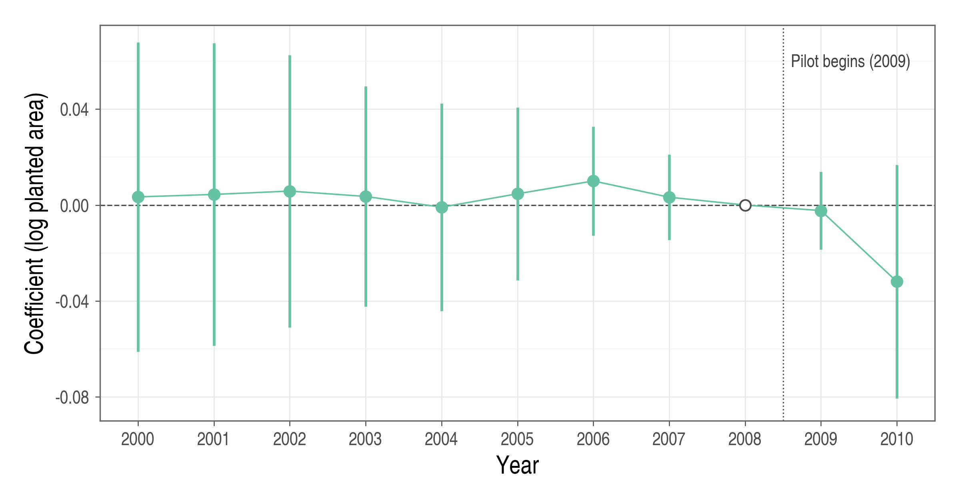
Notes: Coefficients from a regression of log paddy-rice planted area on municipality and year fixed effects and interactions of early-entry status with year indicators; 2008 is the reference year (open circle). Bars are 95 percent confidence intervals based on municipality-clustered (CR1) standard errors with t(25) critical values; they differ from the wild bootstrap intervals in Table 8. The sample comprises 17 early and nine later-entering municipalities over 2000-2010.

5.5 Comparability of Treated and Comparison Crops
Table 9 shows that treated and comparison crops followed different pre-pilot growth paths. Across the six treated and 22 contributing comparison crops, mean log-area slopes were −0.016 and −0.046 per year, respectively. Mean production slopes were −0.007 and −0.031. Yield slopes were closer, at 0.008 and 0.015. The standardized differences are 0.83 for area, 0.64 for production, and −0.37 for yield. The larger gaps for area and production reinforce the divergence shown in Figure 6.
Table 9
Pre-Pilot Growth of Treated and Comparison Crops, 1998-2007
 | (1)  Treated crops | (2)  Comparison crops | (3)  Difference | (4)  Std. difference
Annual growth of cultivated area | −0.016 | −0.046 | 0.030 | 0.833
 | (0.024) | (0.045)
Annual growth of yield | 0.008 | 0.015 | −0.007 | −0.371
 | (0.021) | (0.014)
Annual growth of production | −0.007 | −0.031 | 0.023 | 0.643
 | (0.023) | (0.046)
Crop series | 6 | 22
Notes: Unweighted means of crop-specific least-squares slopes of log outcomes on year over 1998-2007; standard deviations across crops in parentheses. Difference is the treated mean minus the comparison mean. Standardized difference divides that gap by the square root of the average of the two group variances; it is descriptive, not a test statistic. Large and small green onions have eight annual observations; other crops have ten.

The national results therefore depend on which growth histories define the comparison. Changing the reference period or comparison pool changes those histories, helping explain the sensitivity of the estimates. The municipal analysis removes differences in crop identity but still relies on comparisons of regional growth paths.

6. Discussion and Policy Implications

6.1 Policy Implications
The institutional assessment identifies distinct evaluation priorities for each form of support. Premium subsidies reduce the price of protection, administrative subsidies finance delivery, and state reinsurance shares losses that are difficult to diversify. Production responses address only one part of program performance. A broader assessment requires evidence on access, the distribution of support, service quality, and public financial exposure. Subsidies and indemnities are transfers, so their monetary amounts alone do not measure welfare gains. A welfare assessment must also consider the benefits of risk protection, behavioral responses, the resources used to deliver insurance, and the cost of raising public funds.
For premium support, the policy question is how the existing subsidy schedule balances affordability and the distribution of public assistance. The cap limits national support per policyholder per product, while the amount received below the cap depends on eligible premiums and subsidy rates. Assessing this distribution requires considering household income, farm size, crop choice, coverage, and local subsidies. Such an assessment would help determine whether changes to the schedule could improve targeting while maintaining access to insurance.
For administrative support, evaluation can build on existing expenditure controls, reporting requirements, and loss-assessment procedures (MAFRA, 2026). Linking expenditure data to service outcomes would help assess what public funding delivers. Relevant measures include administrative cost per active contract, loss-assessment cost per completed claim, settlement times, and the frequency and reasons for assessment revisions. Comparisons should distinguish cost categories and account for differences in product complexity and regional service conditions.
For reinsurance, evaluation should examine how the loss-sharing rules allocate risk between private insurers and the state. Comparing the existing arrangement with alternative retention levels and loss-sharing terms under the same loss scenarios would clarify their implications for private incentives and public financing. Relevant outcomes include expected net public cost, financing needs in severe or consecutive loss years, and the risk retained by private insurers. These comparisons would inform whether adjustments to the reinsurance terms are warranted.

6.2 Climate Risk and the Design of Support
Climate risk can change both the size of losses and their dependence across regions. More frequent or severe losses can raise expected claims. Holding regional loss distributions fixed, higher pairwise correlations increase the variance of aggregate losses. Under a purely proportional treaty with a fixed sharing rate, expected ceded claims remain unchanged. Under nonlinear contracts, expected reinsurance payments also depend on joint tail behavior; correlation alone does not determine how those payments change.
Stress tests should therefore apply the actual treaty to joint regional loss scenarios. They should distinguish expected net expenditure from the financing required in severe or consecutive loss years. Climate risk may also raise the cost of premium support. If risk-rated premiums increase, public subsidy spending can rise even when subsidy rates remain fixed, subject to the applicable caps.

6.3 Limitations and Future Research
Several limitations constrain the empirical conclusions. The national analysis uses aggregate outcomes for insured and uninsured farms, so it cannot identify participants’ production responses or the household distribution of premium support. Divergent pre-pilot trajectories further limit causal interpretation, and small-sample inference remains uncertain. Crop substitution presents another concern. If insurance shifts land from comparison crops to insured crops, the comparison outcomes may respond to the program. Correlations in crop areas alone cannot establish whether such shifts occur.
The rice analysis holds crop identity fixed but observes only two post-pilot years. It therefore describes short-run changes in the early-pilot setting. Rollout timing was not randomized, and changing local investment or weather may differ across cohorts. The national comparisons likewise depend on the selection and timing of insured crops. These designs do not separately identify how expected disaster relief affects enrollment or production decisions.
Future work could link insurance contracts to farm-production records to distinguish enrollment, coverage choices, and production responses while addressing selection into insurance. Regional rollout designs would benefit from stronger evidence on the selection of locations and introduction dates. Identifying whether disaster relief discourages enrollment would require variation in assistance that can be separated from disaster severity. Fiscal analysis would require treaty-level models incorporating the full loss-sharing rules, joint regional losses, and financing conditions.

7. Conclusion
In this thesis, I assess premium subsidies, administrative cost subsidies, and state reinsurance in South Korea’s crop disaster insurance program. The instruments address different constraints and require different evidence. Premium support should be evaluated by access and distribution, administrative support by cost and service quality, and reinsurance by risk allocation and fiscal exposure.
The empirical comparisons show how production patterns vary with insurance availability and comparison choices. Across six annual crops, the mean production contrast is −0.002 log points, with an exploratory 95 percent interval of [−0.318, 0.315]. Its sign depends on the comparison crops and aggregation weights, and pre-pilot growth differs across groups. For municipal rice area, the estimate is −0.021 log points, with a 95 percent interval of [−0.064, 0.022]. This estimate also changes with sample composition. The rice design holds crop identity fixed and has closer observed pre-pilot paths, but covers only two years after introduction. These results leave substantial uncertainty about production responses and do not provide a separate test of moral hazard.
The institutional assessment identifies the evidence needed to evaluate each instrument. For premium support, this means examining who receives assistance and whether the schedule maintains access to protection. For administrative support, it means relating expenditure to comparable measures of cost and service quality. For reinsurance, it means applying existing and alternative loss-sharing terms to the same loss scenarios and comparing private retention with public financing needs. The contribution of this thesis is to connect these evaluation questions to the production evidence. The appropriate design of support depends on access, delivery, and risk allocation as well as on changes in agricultural output.

REFERENCES
Agricultural Policy Insurance & Finance Service. (n.d.). Crop disaster insurance enrollment and payment statistics by year, crop, and province [Data set]. Public Data Portal. https://www.data.go.kr
Callaway, B., & Sant’Anna, P. H. C. (2021). Difference-in-differences with multiple time periods. Journal of Econometrics, 225(2), 200-230. https://doi.org/10.1016/j.jeconom.2020.12.001
Cameron, A. C., Gelbach, J. B., & Miller, D. L. (2008). Bootstrap-based improvements for inference with clustered errors. Review of Economics and Statistics, 90(3), 414-427. https://doi.org/10.1162/rest.90.3.414
Choi, K. H., Chae, G. S., & Yoon, B. S. (2010). The performance and tasks of crop insurance (Research Report R615). Korea Rural Economic Institute. https://www.krei.re.kr/krei/page/53?biblioId=373070&cmd=view
Goodwin, B. K., Vandeveer, M. L., & Deal, J. L. (2004). An empirical analysis of acreage effects of participation in the federal crop insurance program. American Journal of Agricultural Economics, 86(4), 1058-1077. https://doi.org/10.1111/j.0002-9092.2004.00653.x
Han, S. (2014). An empirical analysis on the production and price effect by agricultural disaster insurance. KDI Journal of Economic Policy, 36(4), 135-169. https://doi.org/10.23895/kdijep.2014.36.4.135
Hazell, P., Sberro-Kessler, R., & Varangis, P. (2017). When and how should agricultural insurance be subsidized? Issues and good practices. World Bank Group. http://documents.worldbank.org/curated/en/330501498850168402
Jeong, W. H., & Choi, K. H. (2013). Expanding the agricultural and fishery disaster reinsurance fund and securing stable financing (Research Report C2013-29). Korea Rural Economic Institute. https://www.krei.re.kr/attach/pdf/605ba745-af00-2a94-e054-b09928988b3c.pdf
Jia, R., Lin, J., Powers, M. R., & Wang, H. (2025). Catastrophe risk sharing among individuals, private insurance, and government. Journal of Risk and Insurance, 92(2), 263-311. https://doi.org/10.1111/jori.12506
Just, R. E., Calvin, L., & Quiggin, J. (1999). Adverse selection in crop insurance: Actuarial and asymmetric information incentives. American Journal of Agricultural Economics, 81(4), 834-849. https://doi.org/10.2307/1244328
K-water. (n.d.-a). Nakdong River weir management facilities. https://www.kwater.or.kr/busi/sub02/facilitiespresent03Page.do?s_mid=1509
K-water. (n.d.-b). Yeongsan River weir management facilities. https://www.kwater.or.kr/water/sub01/sub05/20050049/works.do?s_mid=910&s_officecode=50039533
Kang, S., & Chung, W. (2017). An evaluation of current government reinsurance program and its improvement strategies for crop insurance. Korean Journal of Agricultural Economics, 58(2), 21-48. https://doi.org/10.24997/KJAE.2017.58.2.21
Kim, T. H., Kim, M. B., & Jeong, W. S. (2021). Improving the efficiency of crop disaster insurance (Research Report C2021-19). Korea Rural Economic Institute. https://www.krei.re.kr/attach/pdf/4fa8a92b-4019-45e9-923f-4f4da057cef1.pdf
Kook, S. Y., Kim, M. B., Kim, T. H., Joo, J. Y., Choi, H. D., Kim, D. Y., & Kim, S. H. (2024). Improving the operating system of crop disaster insurance (Research Report C2023-57). Korea Rural Economic Institute. https://www.krei.re.kr/attach/pdf/e4c5e193-861e-411d-b126-f20caf797a9c.pdf
Lee, J., & Jung, J. H. (2014). Adverse selection and moral hazard in the Korean crop insurance market. Korean Journal of Agricultural Economics, 55(1), 29-47. https://www.kaea1957.org/en/journal?mode=view&seqidx=182
Lee, S., & Kim, T. (2026). Effects of crop insurance on the output and technical efficiency of fruit farms: A stochastic frontier analysis. Journal of Rural Development, 49(1), 1-24. https://doi.org/10.36464/jrd.2026.49.1.001
Lusk, J. L. (2017). Distributional effects of crop insurance subsidies. Applied Economic Perspectives and Policy, 39(1), 1-15. https://doi.org/10.1093/aepp/ppw002
MacKinnon, J. G., Nielsen, M. Ø., & Webb, M. D. (2023). Cluster-robust inference: A guide to empirical practice. Journal of Econometrics, 232(2), 272-299. https://doi.org/10.1016/j.jeconom.2022.04.001
MacKinnon, J. G., & Webb, M. D. (2018). The wild bootstrap for few (treated) clusters. The Econometrics Journal, 21(2), 114-135. https://doi.org/10.1111/ectj.12107
Mahul, O., & Stutley, C. J. (2010). Government support to agricultural insurance: Challenges and options for developing countries. World Bank. https://doi.org/10.1596/978-0-8213-8217-2
Ministry for Food, Agriculture, Forestry and Fisheries. (2011a). Rice disaster insurance goes on sale from May 11 [Press release]. https://gongu.copyright.or.kr/gongu/wrt/wrt/view.do?menuNo=200019&wrtSn=12035486
Ministry for Food, Agriculture, Forestry and Fisheries. (2011b). Soybean disaster insurance enrollment period extended [Press release]. https://www.korea.kr/briefing/pressReleaseView.do?newsId=155771961
Ministry for Food, Agriculture, Forestry and Fisheries. (2012). Rice insurance expanded nationwide; farmers pay 20-30 percent of premiums [Press release]. https://www.korea.kr/news/policyNewsView.do?newsId=148732398
Ministry of Agriculture, Food and Rural Affairs. (2014). Make use of crop disaster insurance for worry-free farming [Press release]. https://www.korea.kr/briefing/pressReleaseView.do?newsId=155956185
Ministry of Agriculture, Food and Rural Affairs. (2025). 2025 agricultural insurance yearbook.
Ministry of Agriculture, Food and Rural Affairs. (2026). 2026 crop disaster insurance implementation guidelines. https://www.mafra.go.kr/bbs/home/798/596394/download.do
Miranda, M. J., & Glauber, J. W. (1997). Systemic risk, reinsurance, and the failure of crop insurance markets. American Journal of Agricultural Economics, 79(1), 206-215. https://doi.org/10.2307/1243954
Nam, K., & Ahn, B. (2022). The effect of purchasing crop insurance on the input utilization and farm income. Korean Journal of Agricultural Management and Policy, 49(2), 157-190. https://www.kci.go.kr/kciportal/ci/sereArticleSearch/ciSereArtiView.kci?sereArticleSearchBean.artiId=ART002860673
Nelson, C. H., & Loehman, E. T. (1987). Further toward a theory of agricultural insurance. American Journal of Agricultural Economics, 69(3), 523-531. https://doi.org/10.2307/1241688
Raschky, P. A., & Weck-Hannemann, H. (2007). Charity hazard: A real hazard to natural disaster insurance? Environmental Hazards, 7(4), 321-329. https://doi.org/10.1016/j.envhaz.2007.09.002
Roth, J. (2022). Pretest with caution: Event-study estimates after testing for parallel trends. American Economic Review: Insights, 4(3), 305-322. https://doi.org/10.1257/aeri.20210236
Statistics Korea. (2014). Regular statistical quality assessment of the Crop Production Survey: Final report. https://lib1.mods.go.kr/dl_image2/IMG/03/000000010074/SERVICE/000000010074_01.PDF
Statistics Korea. (n.d.). Crop Production Survey [Data set]. Korean Statistical Information Service. https://kosis.kr
Webb, M. D. (2023). Reworking wild bootstrap-based inference for clustered errors. Canadian Journal of Economics, 56(3), 839-858. https://doi.org/10.1111/caje.12661
Yu, J., Smith, A., & Sumner, D. A. (2018). Effects of crop insurance premium subsidies on crop acreage. American Journal of Agricultural Economics, 100(1), 91-114. https://doi.org/10.1093/ajae/aax058

Appendix A. National Inference and Crop Influence
The national contrast is linear in log outcomes and can be expressed as θ=c,t​act yct. I fit crop and year fixed effects using unexposed observations to obtain residuals ${\hat{u}}_{ct}$. Treated post-period residuals are then centered by their event-year contrast. The crop-level score and analytic standard error are
ψc=t​act uct, SEscore=GG-1c​ψc2, (A1)
where $G$ denotes the number of contributing crop series. For each of 9,999 draws, I draw one multiplier per crop with equal probability from Webb’s (2023) six-point distribution:
$v_{c}∈\left\{-\sqrt{3/2}, -1, -\sqrt{1/2}, \sqrt{1/2}, 1, \sqrt{3/2}\right\}.$(A2)
For each draw, the multiplier statistic is the sum of crop scores multiplied by their respective draws. The interval adds and subtracts the 95th percentile of the statistic’s absolute value from the estimated contrast. The p-value is the proportion of draws with an absolute value at least as large as the estimate, with a plus-one adjustment. Area-weighted and event-time statistics use the cell weights implied by equation (6) and the event-time comparisons, retaining the same residuals and draws. The joint pre-pilot test compares the sum of squared standardized contrasts with its distribution across these draws. Independent multipliers preserve dependence within crops but not residual dependence across crops. This score procedure differs from the null-imposed, studentized regression bootstrap used for rice. Webb weights alone do not establish its finite-sample validity.
Table A1
Leave-One-Crop-Out Contrasts
Omitted crop | (1)  Area | (2)  Yield | (3)  Production
Soybean | 0.037 | −0.047 | −0.011
Onion | −0.063 | −0.020 | −0.083
Sweet potato | −0.032 | 0.000 | −0.033
Corn | 0.023 | −0.027 | −0.005
Garlic | 0.005 | −0.009 | −0.004
Red pepper | 0.096 | 0.029 | 0.125
Notes: Log-point contrasts with five treated crops, the full comparison pool, the last pre-pilot reference year, and event years 0-9. Omitted crops are not added to the comparison pool.

A normal-approximation benchmark, treating the reported standard errors as fixed (0.168 for the national production contrast and 0.022 for the rice estimate), gives minimum detectable effects of approximately 0.47 and 0.06 log points for 80 percent power at a two-sided 5 percent level. These calculations do not establish the power of the bootstrap procedures used here.

