I-Patient Admission Clerk (AI To Humanize)
The Patient Admission Clerk module is responsible for 3 main functionalities which are:
- Admit Patient: Add a patient
- Discharge Patient: Remove the earliest admitted patient after treatment.
- View Patient Queue: Display all patients waiting for treatment
It is suppose that all patient admitted will be treated on a First-In-First-Out (FIFO) system. Each patient will have an ID, Name and condition type while being admitted in the system.

- Data Structure
The Patient Admission Clerk module is designed to manage incoming patients in a hospital in a structured and fair manner. Conceptually, this module can be represented using a Queue Abstract Data Type (ADT), which follows the First-In-First-Out (FIFO) principle. This means that the first patient to arrive is the first one to be treated, ensuring fairness and mimicking real-world hospital workflows. The main functions of Queue as ADT are:

- Enqueue(element): Adds an element to the rear (end) of the queue.
- Dequeue(): Removes the element from the front of the queue.
- Peek/Front(): Returns the element at the front without removing it.
- isEmpty(): Checks whether the queue has any elements.

Using a queue for patient management ensures that the admission process is orderly, prevents skipping or misordering of patients, and efficiently handles dynamic patient flow. This structure is especially suitable during peak hospital operations, where the number of patients can vary and the system must maintain a consistent order of treatment while allowing quick insertion and removal of patients. By applying this data structure, the system can provide a scalable, fair, and reliable mechanism for patient admission and discharge.

- Implementation and code explanation
Class definition and node structure

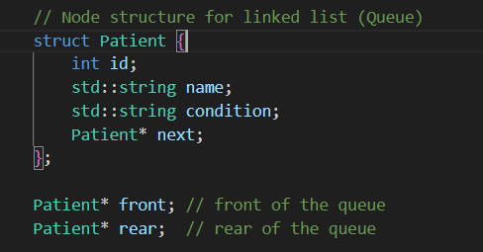

The purpose here is to define the node of the linked list; the front will point to the first patient/element of the queue while rear will point to the last patient/element of the queue, those pointer will allows efficient enqueue(at rear) and dequeue(from front) operations, which are main functions of the FIFO behaviour.

Constructor and Destructor

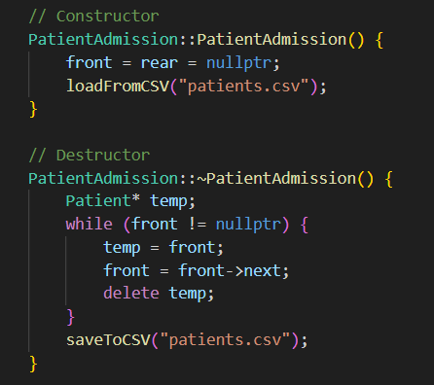

The Patient Admission Clerk module begins with a constructor that initializes an empty queue by setting both the front and rear pointers to nullptr. Upon startup, it also attempts to load previous patient data from a CSV file, ensuring that any previously recorded patients are restored into the queue structure. This design provides both initialization and data persistence, allowing the system to resume operations seamlessly between sessions. The destructor complements this by traversing the entire queue, deleting all dynamically allocated nodes to prevent memory leaks, and finally saving the current patient queue back to the CSV file before program termination.

Admit Patient (Enqueue)
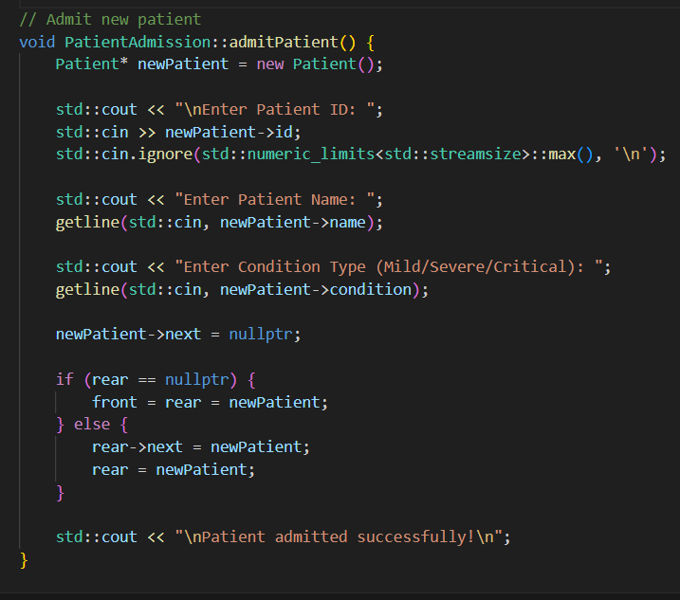

The enqueue operation (Add Patient) follows the standard logic of a linked-list-based queue. When the queue is empty, both the front and rear pointers are directed to the new patient node. In cases where the queue already contains patients, the new patient is linked after the current rear, and the rear pointer is updated to this new node. This ensures a First-In-First-Out (FIFO) order, reflecting a fair and realistic hospital patient admission process.

Discharge Patient (Dequeue)
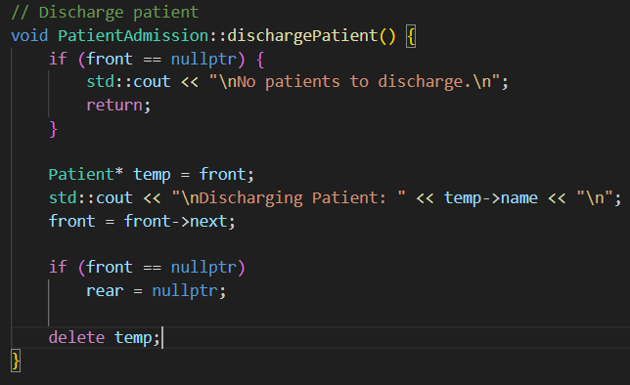

The dequeue operation (Discharge Patient) removes the patient positioned at the front of the queue — the one who has been waiting the longest. After removal, the front pointer is updated to point to the next patient in line. If the queue becomes empty as a result, both pointers are reset to nullptr to maintain queue integrity. This operation demonstrates a direct application of FIFO logic, ensuring that patients are treated in the order they were admitted.

View Patient queue
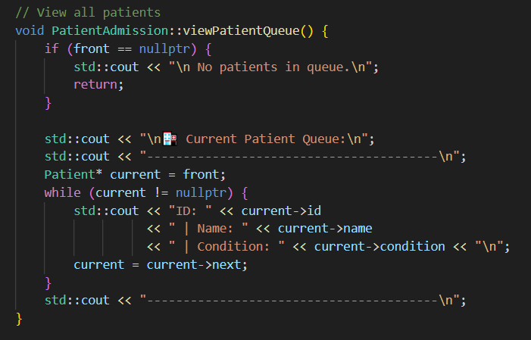

The display function traverses the queue from the front to the rear, showing all currently admitted patients in their order of arrival. This function illustrates simple linked-list traversal, allowing real-time viewing of patient data in an organized sequence.

CSV integration
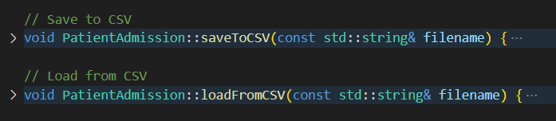

To handle persistence, the module includes saveToCSV and loadFromCSV functions. The first traverses the queue to write each patient’s information into a CSV file, while the second reads from that file to reconstruct the linked list in the same order. This design provides data continuity between sessions while keeping the system lightweight in runtime memory.

Menu Interface

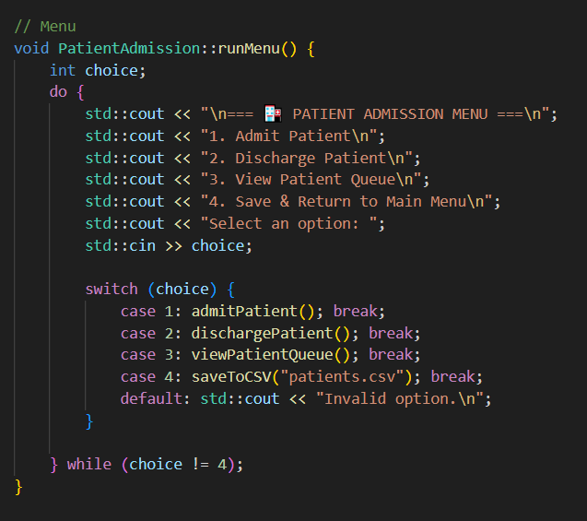

The interactive menu system offers a user-friendly interface where users can repeatedly perform queue operations — such as admitting, discharging, or viewing patients — until they choose to exit. Each menu option internally calls the respective queue operation, providing a smooth integration between user input and underlying data structure logic.

I/O Screenshot

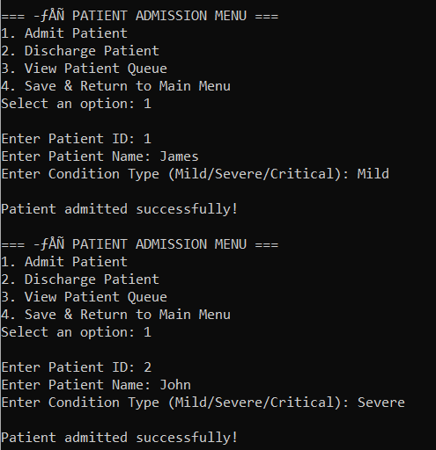

Here we added 2 patients which are James and John

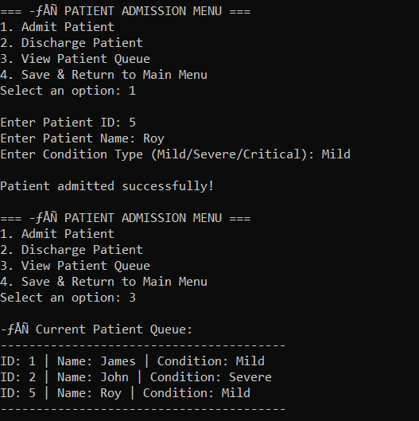

Then we added another patient which is Roy, and after that we check the patient queue and we can see that is sorted in order they get into.

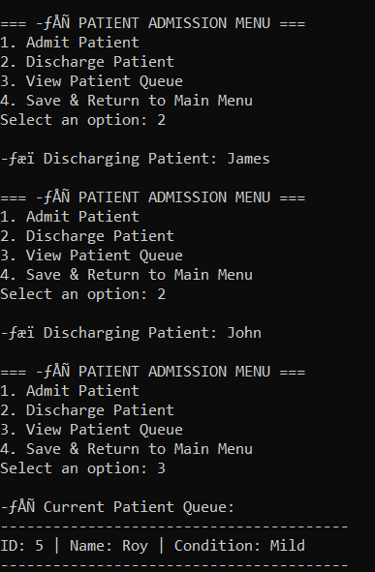

After that we discharge the patient, since James was the first patient admitted, he will be first to go out; followed by John. Then, we checked the queue which left Roy has the last patient in the queue.

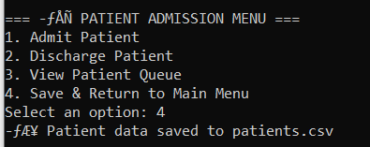

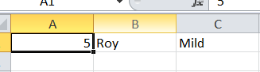

Here we can see that we have stored the latest data inside the CSV file and free up the node in the memory.

Critical review and area of improvement

While the Patient Admission module successfully implements a FIFO queue for managing patient intake, there are areas where its design could be further refined. The current linked-list approach ensures dynamic memory usage and straightforward enqueue/dequeue operations, but it assumes all patients are of equal priority. In real hospital settings, patients with severe or critical conditions would need to be prioritized, which this module does not handle. Additionally, operations like searching for a specific patient or updating their information require linear traversal of the queue, which may become cumbersome with a large patient load.

The CSV integration provides persistence, yet it only allows sequential read/write, meaning large datasets could slow down the system. Furthermore, the module is not designed for concurrent access; simultaneous admissions or discharges in a multi-user environment would require additional mechanisms like locks or queues. Despite these considerations, the module remains effective for basic hospital queue management, offering a solid foundation for future enhancements such as priority-based admission, concurrent handling, and more sophisticated patient data management.

II- Medical Supply Manager
The Medical Supply manager module is responsible for 3 main functionalities which are:
- AddSupply Stock: Record new supply items
- Use ‘Last Added' Supply: Remove the most recently added supply for usage.
- View Current Supplies: Show all supplies available.
It is suppose that the latest added supply will be used first. By this logic the most efficient algorithm to use will be Last-In-First-Out (LIFO), which makes the stack data structure as the perfect candidate.

a- Data Structure
The Medical Supply Manager module is designed to handle hospital supply storage and usage efficiently, following a structured system where the most recently added item is the first to be used. Conceptually, this module is represented using a Stack Abstract Data Type (ADT), which operates on the Last-In-First-Out (LIFO) principle. This means that the last supply added to storage is the first one removed when needed, reflecting how certain medical items are managed based on batch usage or accessibility.

The main functions of a Stack ADT are:
- Push(element): Adds an element to the top of the stack.
- Pop(): Removes the element from the top of the stack.
- Peek/Top(): Returns the element currently at the top without removing it.
- isEmpty(): Checks whether the stack contains any items.

Using a stack for medical supply management ensures that newly received supplies are easily accessible for immediate use, simplifying stock rotation and consumption during emergencies. It provides a clear, efficient, and dynamically manageable structure for adding and removing supplies. This approach also minimizes search and retrieval time, offering a practical balance between simplicity and performance for real-time hospital operations.
- Implementation and code explanation
Supply structure
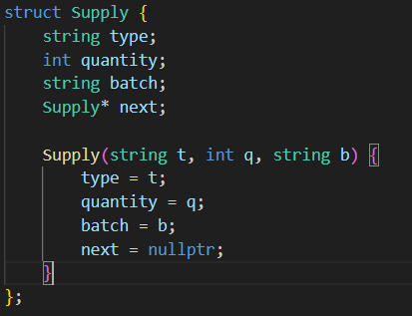

Each Supply node stores information about:
- Type: The kind of medical supply (e.g., gloves, syringes).
- Quantity: How many units are available.
- Batch: A code to identify production or arrival batch.
- Next: A pointer linking to the next supply in the stack.
This forms a linked list structure, where each new item is placed on top and points to the previous one.

SupplyManager Class

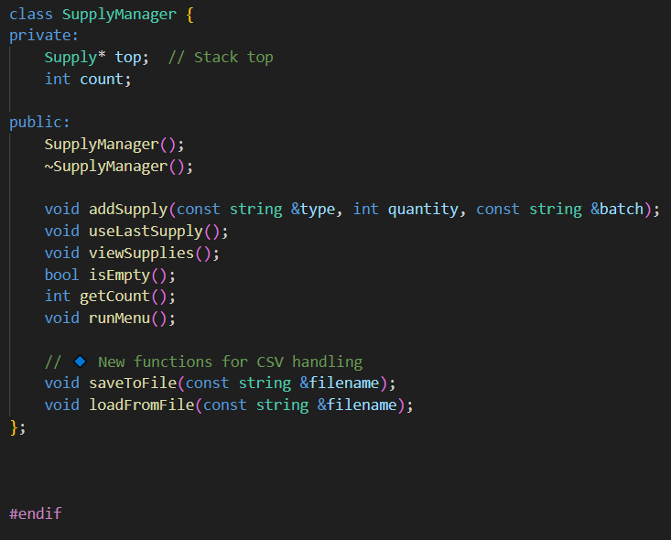

The SupplyManager class encapsulates the stack behavior and file management logic.
It contains:
Private members:
Supply* top; → Pointer to the top of the stack.
int count; → Tracks total number of supplies.

Public methods:
addSupply() → Push operation to add new supply.
useLastSupply() → Pop operation to remove the latest supply.
viewSupplies() → Displays all current supplies.

isEmpty() and getCount() → Utility checks.
runMenu() → Menu-driven interface for user interaction.
saveToFile() and loadFromFile() → Handle file persistence in CSV format.

By separating declarations into this header, the design promotes modularity and clean code organization.

Constructor
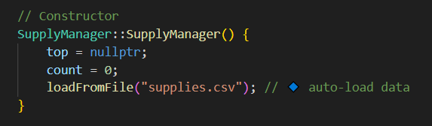

The constructor initializes the stack by setting the top pointer to nullptr and the supply counter count to zero. It then automatically calls the loadFromFile() function to import existing data from a CSV file, ensuring that previously stored supply records are reloaded when the program starts. This approach promotes data persistence and allows the system to continue where it left off.

Destructor

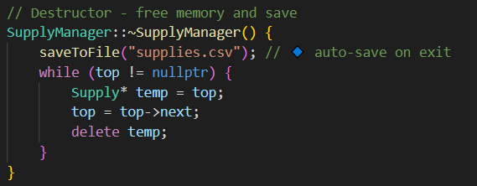
The destructor complements the constructor by handling proper memory cleanup and data preservation. Before deleting any dynamically allocated nodes, it calls saveToFile() to ensure that all current supply data is written to the CSV file. After saving, it iteratively deletes every node in the linked list, preventing memory leaks and maintaining safe termination of the program.

Adding supply

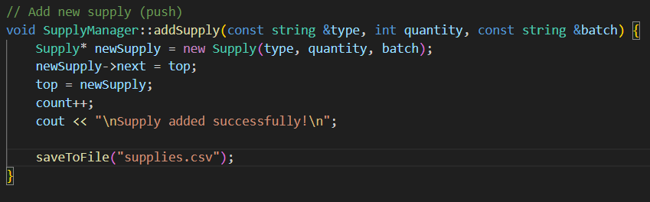

The addSupply() function performs the main push operation of the stack. When a new supply item is recorded, it creates a new node containing the given information—supply type, quantity, and batch—and places it on top of the stack. The new node’s next pointer is linked to the previous top node, effectively inserting it at the top. The count is increased by one, and the updated stack is immediately saved to the CSV file. This ensures the latest stock data is always backed up, even if the program closes unexpectedly.

Use last supply
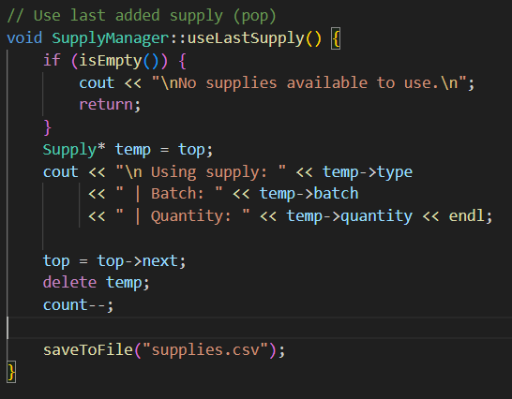
The useLastSupply() function implements the pop operation of the stack. When the user decides to use a supply, the program checks if the stack is empty. If not, it retrieves and displays the details of the top supply, removes it from the stack, and deletes its memory allocation. The count is reduced accordingly, and the updated stack is saved to file. This LIFO behavior ensures that the newest supplies are used first, which can be useful in environments where recent batches are prioritized for deployment.

View supplies

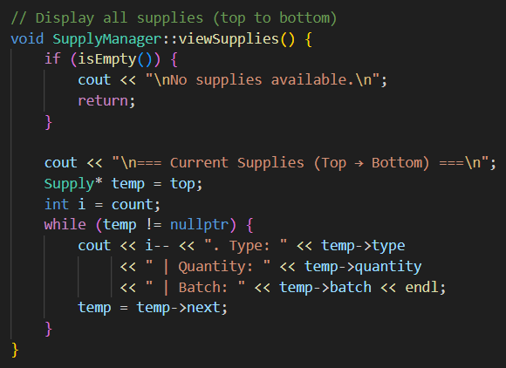

The viewSupplies() function provides a snapshot of the current stock. It traverses the stack from top to bottom, displaying each supply’s type, quantity, and batch number. Since the traversal starts from the top, the list is displayed in the order of most recently added to oldest. This visualization helps managers quickly see the latest additions and overall stock status.

Utility operations
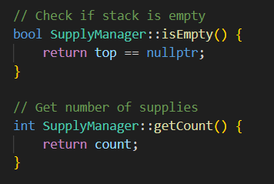
The isEmpty() and getCount() functions serve as utility operations. isEmpty() checks whether there are any items in the stack by returning true if the top pointer is nullptr. Meanwhile, getCount() returns the total number of supplies currently in storage. Both functions assist in validation and status monitoring during system operation.

Save and loading file
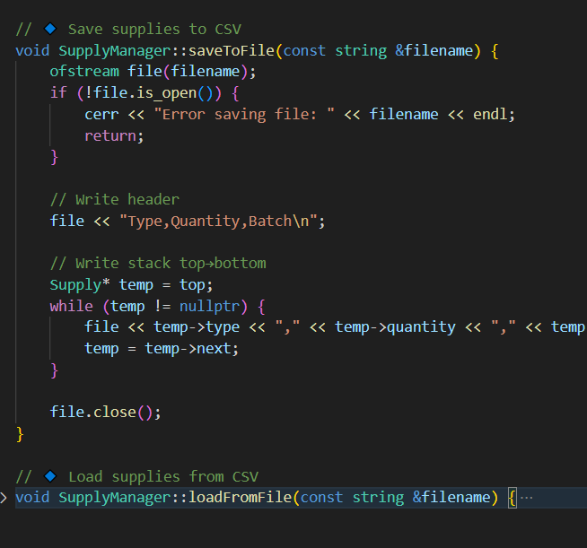
The saveToFile() function ensures data persistence by writing the current state of the stack to a CSV file named supplies.csv. It first writes a header line for clarity and then iterates through the stack, exporting each item’s details in a structured comma-separated format. Conversely, the loadFromFile() function reads data from the same CSV file when the program starts. It uses a string stream to parse each line into individual attributes and reconstructs the stack by repeatedly calling addSupply() for each record. If the file does not exist, the system starts fresh and notifies the user.

Run menu
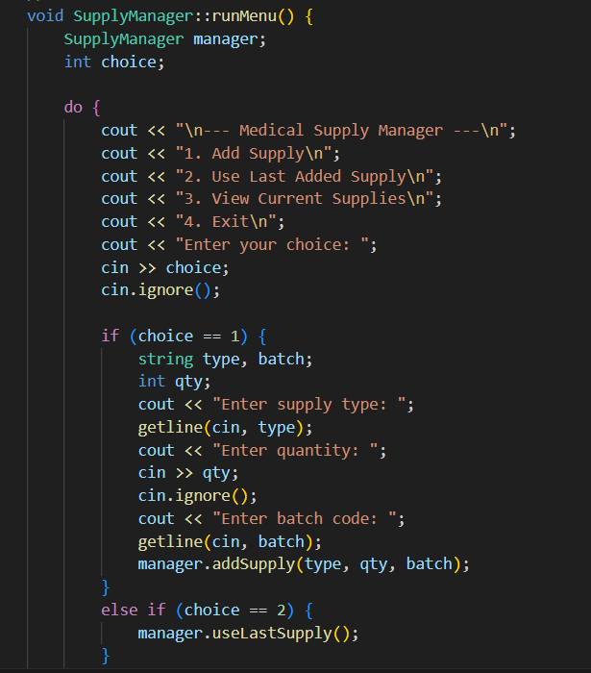

Finally, the runMenu() function serves as the user interface for the Medical Supply Manager module. It repeatedly presents the user with a simple text-based menu allowing them to add new supplies, use the last added supply, or view the current stock. The loop continues until the user chooses to exit, at which point all data is automatically saved. This design makes the system easy to interact with, even for non-technical users, while maintaining reliable backend functionality

Input and Output screenshot.

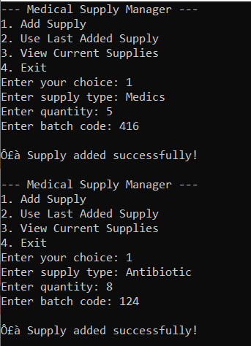

On the start of the functionality, lets add first 2 supply which will be Medics and Antibiotic.

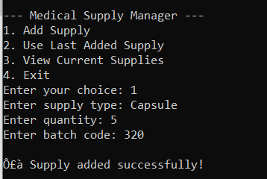

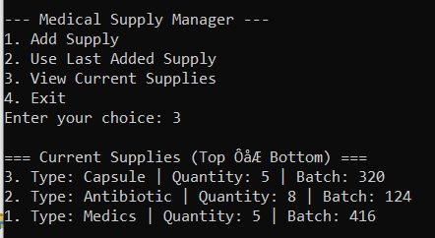

In these images, we added one more supply which is capsule and then we consult the list of current supply; and we can see that the latest added supply (aka capsule) is on top of the list.

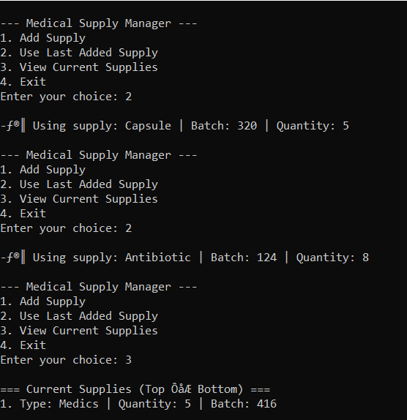

Lastly, we used the “Use Last Added Supply” functionality and we are retrieving the latest element on top of the stack which will be the element Capsule; and since we use it twice the next new element on the top which in this case is Antibiotic will be retrieved from the stack too. Finally we check the current supplies and we can see only the element ”Medics” is left as expected, and it is the element saved in the csv file as per below.

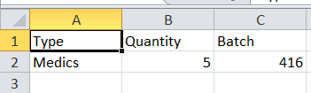

Critical Review and Areas of Improvement

The Medical Supply Manager module effectively applies a stack (LIFO) structure to manage medical supplies, ensuring that the most recently added items are used first. This approach is simple and efficient for quick access but does not fully reflect real-world inventory practices, where supplies are often managed based on expiration or priority. The strict LIFO design may lead to older supplies being overlooked or expiring at the bottom of the stack.

Another limitation lies in the system’s search and update functions. Since only the top element can be accessed efficiently, finding or modifying a specific supply requires linear traversal, which becomes inefficient as the dataset grows. The CSV-based persistence ensures data saving but can slow performance with frequent read/write operations and lacks support for multi-user or concurrent access.

Overall, the module successfully demonstrates stack operations and provides a functional foundation for managing small-scale medical inventories. Future enhancements could include expiry-based sorting, improved search efficiency, and database integration to handle larger and concurrent systems more effectively.

III- Emergency Department Officer
The Emergency Department Officer module is designed to manage critical hospital emergencies where patients must be treated based on the severity of their condition rather than the order of arrival. This module has three main functionalities:
- Log Emergency Case: Record a new emergency case with patient details (name, type of emergency, and priority level).
- Process Most Critical Case: Attend to and remove the case with the highest priority from the list.
- View Pending Emergency Cases: Display all current emergencies in descending order of severity.

a – Data Structure
The Emergency Department Officer module utilizes a Priority Queue (Heap) as its primary data structure. Unlike a normal queue, which processes elements in the order they arrive (FIFO), a priority queue ensures that elements with higher priority are processed first. In this context, the most critical emergency cases are always attended to before less severe ones, closely simulating real hospital triage systems. The main operations of a Priority Queue ADT are:
- Insert(element, priority): Adds a new emergency case with a defined priority level.
- ExtractMax()/ExtractMin(): Removes and returns the element with the highest (or lowest) priority.
- Peek(): Views the highest-priority case without removing it.
- isEmpty(): Checks if any emergency cases are pending.

By adopting a priority queue, the system ensures that medical staff can always access the most critical cases immediately, improving response efficiency and patient outcomes. This data structure offers an effective way to manage dynamic, time-sensitive workloads in emergency departments. It ensures that high-priority emergencies are not delayed by minor cases and provides an organized, real-time method for handling multiple incoming patients under pressure.
b- Implementation and code explanation

Class and struct
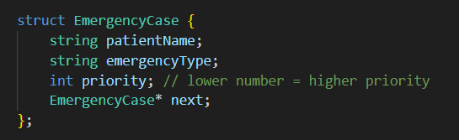

The Emergency Department Officer module is implemented using a priority-based linked list structure, where each emergency case is represented by a node of type EmergencyCase. This structure contains the patient’s name, the type of emergency, the priority level, and a pointer linking it to the next case in the list.
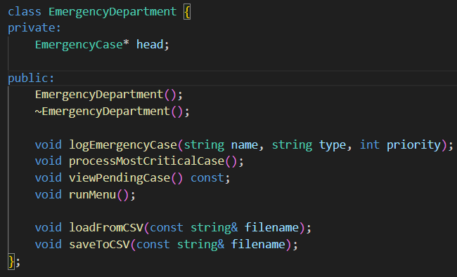
The EmergencyDepartment class manages this linked list and provides all functionalities needed to log, process, and view emergency cases efficiently.
Constructor and Destructor

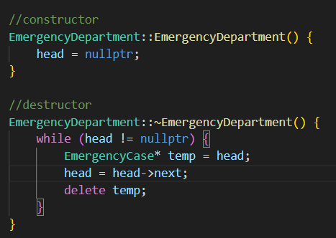

The class begins with a constructor that initializes the head pointer to nullptr, indicating that no emergency cases are currently recorded when the system starts. The destructor then ensures proper memory deallocation by iterating through the entire linked list and deleting every dynamically allocated node, thus preventing any memory leaks when the object is destroyed or the program exits.

Log emergency case
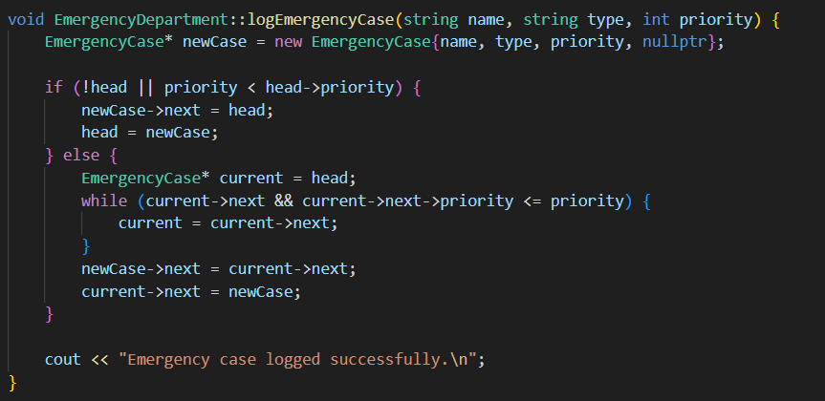

The logEmergencyCase() function is responsible for registering a new emergency record into the system. When a new case is entered, it dynamically creates a new node and inserts it into the linked list in sorted order according to its priority, where a smaller numerical value represents a more critical case. If the list is empty or the new case has a higher priority than the current head, it becomes the new head of the list. Otherwise, the function traverses the list until it finds the correct position where the priority value fits, ensuring that the emergency cases remain properly ordered. This guarantees that the most severe case is always positioned at the top of the list. Once inserted, the system confirms successful logging through a message output.

Process most critical case

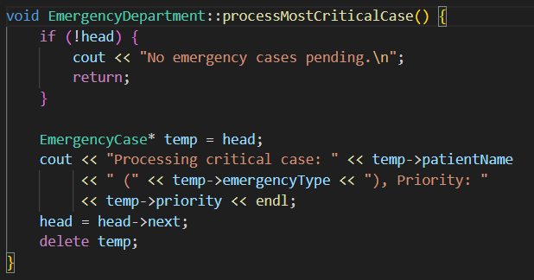

The processMostCriticalCase() method handles the treatment or processing of the most urgent emergency case in the list. It first checks if any cases exist; if none are pending, it informs the user accordingly. Otherwise, it removes the node located at the head of the list, displays its details including the patient’s name, emergency type, and priority, and then deallocates its memory. This mimics real hospital emergency triage workflows, ensuring that the most critical patients receive immediate attention before less severe ones.

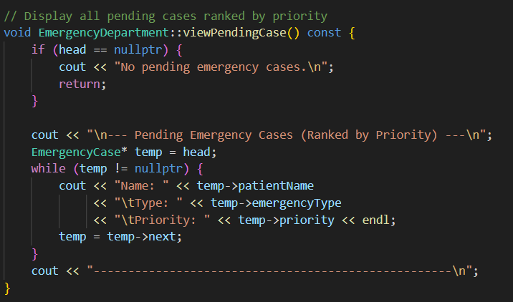

The viewPendingCase() method provides a clear view of all currently logged emergency cases, displaying them in order of priority from most to least critical. It traverses the linked list from the head, printing each patient’s information, allowing staff to easily review the current emergency queue.

CSV file saving/loading
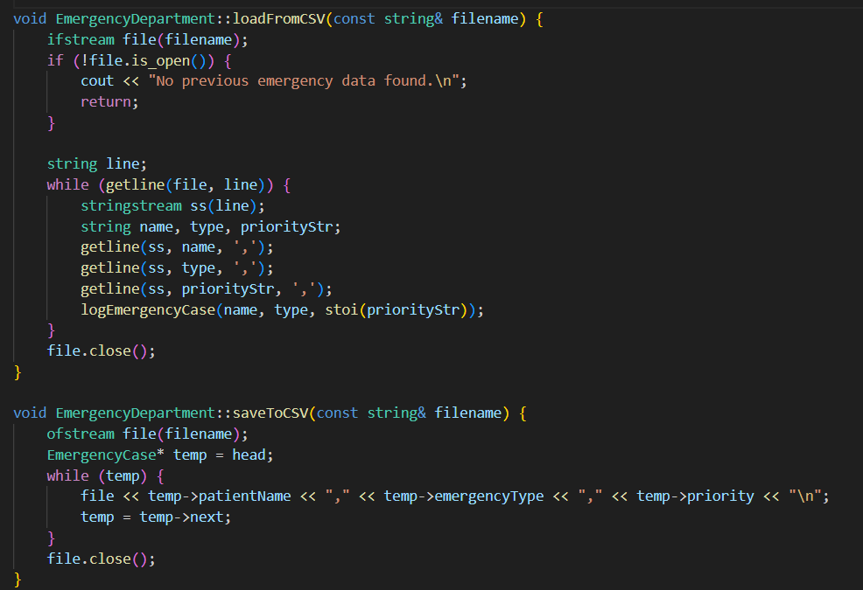

In terms of data persistence, the module includes two file-handling functions: loadFromCSV() and saveToCSV(). The loadFromCSV() function reads emergency records from a CSV file, line by line, extracting the patient name, emergency type, and priority. Each record is then reinserted into the linked list using the logEmergencyCase() method, effectively reconstructing the previous session’s data. If the file does not exist, the system notifies the user that no prior data was found. Conversely, the saveToCSV() function writes the current list of emergency cases back into a CSV file before the program closes. It traverses through the linked list and outputs each node’s information in CSV format, ensuring that all updates made during the session are permanently stored for future use.

Menu function

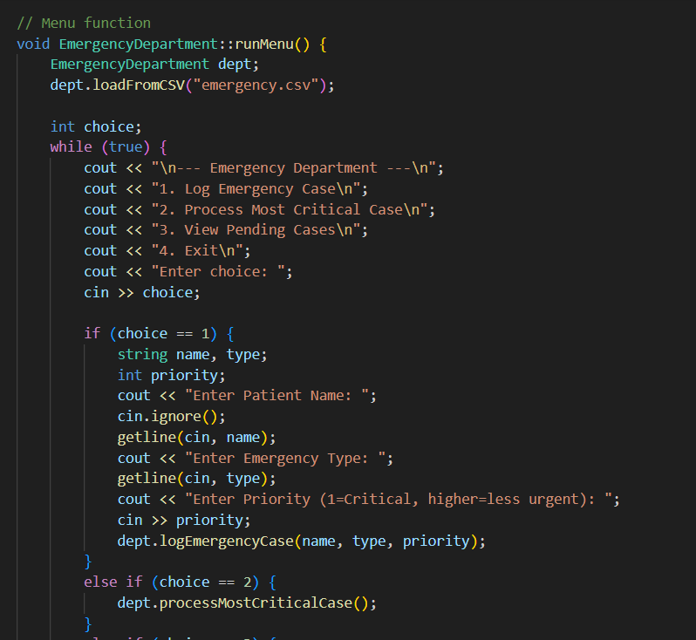

The runMenu() function serves as the main interactive interface between the user and the system. When executed, it first loads existing emergency data from the CSV file, if available. It then repeatedly displays a menu with options to log a new emergency case, process the most critical case, view all pending cases, or exit the program. When logging a new case, the function prompts the user to input the patient’s name, type of emergency, and priority level before inserting the record into the list. When processing, it calls the appropriate method to handle the most urgent case, and when viewing, it prints the current list of pending emergencies. Upon exiting, it saves all updated data back into the CSV file and confirms the operation with a message before terminating.

- Input and Output screenshot

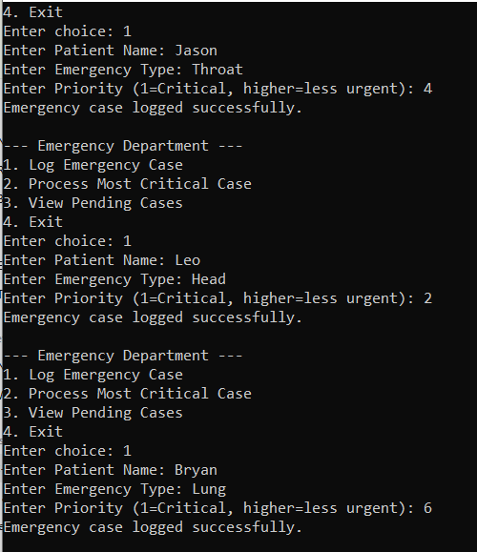

In this image we added 3 patients with different matters and different level of priority. As per the picture, the lower the number entered in priority, the more urgent it is; then in this case, among the 3 patients newly entered which are Jason, Leo and Bryan, Leo will be the patient that have to be treated first.

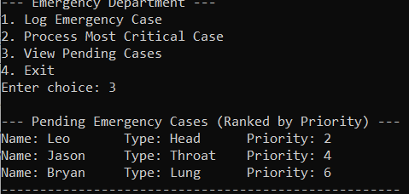

Here, we have the full list of patient that we have entered ranked by their priority level.

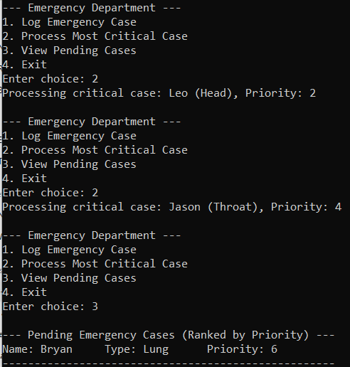

Next we will process the first two most critical cases, and it will be Leo first because it has the lowest number and then it will be Jason. We check the latest list of people in emergency and we can that only Bryan is left.

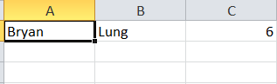
Finally, we can check that only Bryan is stored in the csv file as it is only the latest patient in the priority queue.

Critical Review and Areas of Improvement

The Emergency Department Officer module successfully demonstrates the use of a priority queue to manage emergency cases based on severity. By assigning lower numerical values to higher-priority cases, the system ensures that the most critical patients are treated first, effectively simulating a real hospital triage process. This implementation, using a linked list for dynamic memory allocation, is efficient for inserting new cases in order of urgency and for handling unpredictable workloads. The design is simple yet functional, providing a clear, logical flow of patient handling and easy integration with CSV file storage for data persistence between sessions.

However, while the module performs well for single-user operations, several limitations can be observed. The linked-list approach, though straightforward, results in linear-time insertion and traversal, which may become inefficient as the number of emergency cases increases. Additionally, since the system only considers a single numeric priority value, it does not account for situations where multiple factors—such as available resources, patient age, or condition type—should influence triage order. The CSV-based persistence, while convenient, lacks optimization for concurrent access or large-scale data, which could limit real-time collaboration among multiple emergency officers.

Overall, the module effectively demonstrates the application of a priority queue in a healthcare context, highlighting fairness and criticality in case management. Future improvements could include implementing a more advanced priority mechanism using heaps for faster insertion, integrating a database for better data management and concurrency, and expanding the triage model to include multiple decision factors to enhance realism and efficiency in emergency response systems.

IV- Ambulance dispatcher
The Ambulance Dispatcher module is responsible for managing the rotation and scheduling of ambulances to ensure fair and continuous hospital service. This module has three main functionalities:
  - Register Ambulance: Add a new ambulance to the active-duty rotation list.
  - Rotate Ambulance Shift: Rotate the duty schedule so each ambulance gets equal working time.
  - Display Ambulance Schedule: Show the current order of ambulances on duty in a cyclic manner.

a – Data Structure
The Ambulance Dispatcher module utilizes a Circular Queue (CQ) as its primary data structure. Unlike a regular queue that follows a straight First-In-First-Out (FIFO) process and ends after the last element, a circular queue connects the last position back to the first, forming a loop. This design allows continuous rotation without data shifting or reallocation—making it ideal for scheduling ambulances on repeating shifts.

The main operations of a Circular Queue Abstract Data Type (ADT) are:
- Enqueue(element): Adds a new ambulance to the queue (active-duty list).
- Dequeue(): Removes the ambulance at the front of the queue after completing its shift.
- Rotate(): Moves the front ambulance to the rear, effectively rotating the duty schedule.
- isEmpty(): Checks if there are any ambulances currently on duty.
- Display(): Shows all ambulances in their current order of rotation.
Using a circular queue for ambulance scheduling ensures fair workload distribution and eliminates idle or overworked units. This structure allows the dispatcher to maintain a continuous rotation system without restarting or clearing the queue. It efficiently supports real-time operations where shifts repeat regularly, making it especially suitable for 24/7 hospital logistics where equal rotation, fairness, and efficiency are essential.

b- Implementation and code explanation

Class and struct:

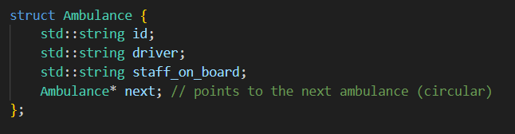

The program begins with the Ambulance structure, which represents each ambulance in the system. It stores the ambulance ID, driver name, and staff on board, along with a next pointer that links to the next ambulance in the sequence. Unlike a normal linked list, the last node in a circular queue points back to the first, creating a loop that supports infinite rotation.

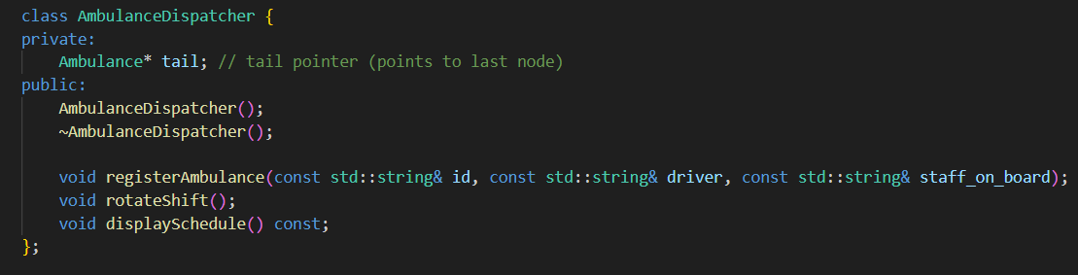
The AmbulanceDispatcher class manages all ambulance operations. It uses a single pointer, tail, which always points to the last ambulance in the circular queue. From this tail pointer, the program can access the first ambulance (using tail->next) and easily handle rotations or insertions without traversing the entire list, ensuring high efficiency.
Constructor and destructor

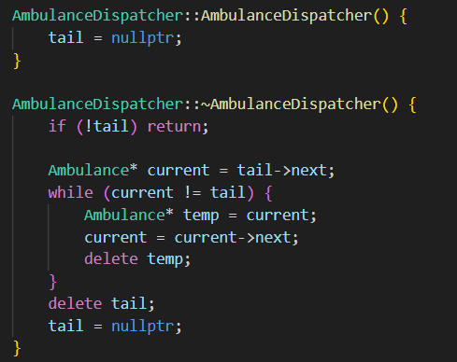

The constructor (AmbulanceDispatcher()) initializes the dispatcher by setting the tail pointer to nullptr, indicating that no ambulances are yet registered. This sets up an empty circular structure ready for use.

The destructor (~AmbulanceDispatcher()) ensures proper memory management when the program ends. Since the ambulances are connected in a circle, it carefully traverses the list, deleting each node one by one until all dynamically allocated memory is freed. This prevents memory leaks while safely breaking the circular link.
Register ambulance

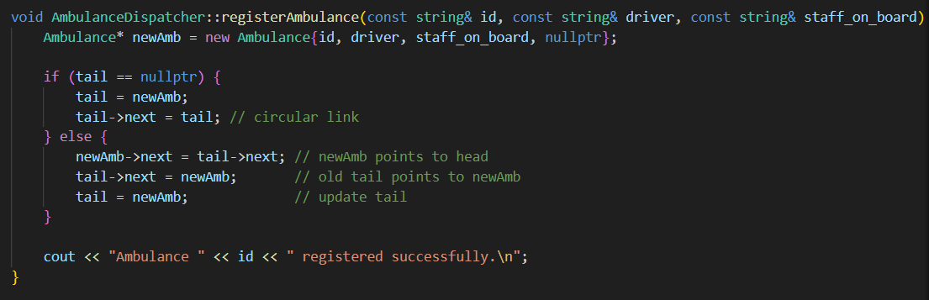

The registerAmbulance() function is responsible for adding a new ambulance to the active-duty list. If the list is empty, the new ambulance becomes both the head and tail, with its next pointer referencing itself to maintain the circular structure. If the list already contains ambulances, the new ambulance is added right after the current tail, and the tail pointer is updated to point to this new ambulance. This approach guarantees that every registration preserves the circular continuity of the system.

Rotate shift

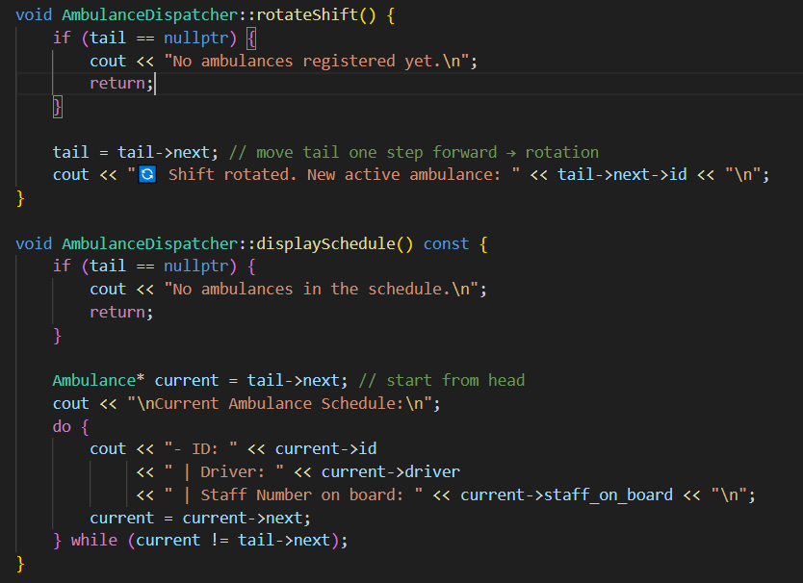

The rotateShift() function implements the rotation mechanism of the circular queue. By simply moving the tail pointer one step forward (tail = tail->next), the system effectively updates which ambulance is next in line for duty. This ensures fairness and balance in workload distribution, giving each ambulance an equal opportunity for deployment.

Display schedule

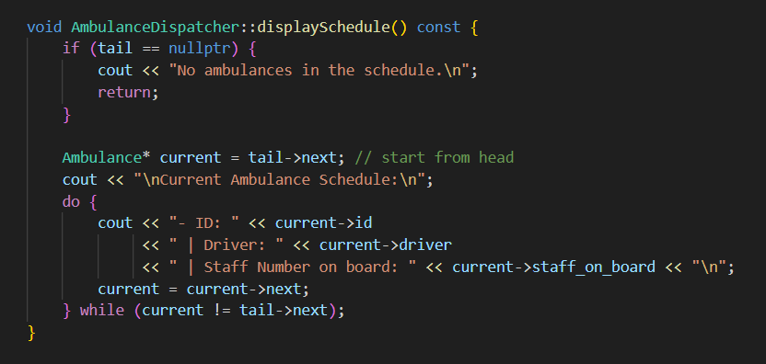

The displaySchedule() function allows the user to view all ambulances currently registered in the system. Starting from the ambulance right after the tail (which is the logical head), it traverses the circular list, printing each ambulance’s ID, driver name, and number of staff on board. The traversal continues until it loops back to the first ambulance, ensuring the complete schedule is displayed.

Main menu

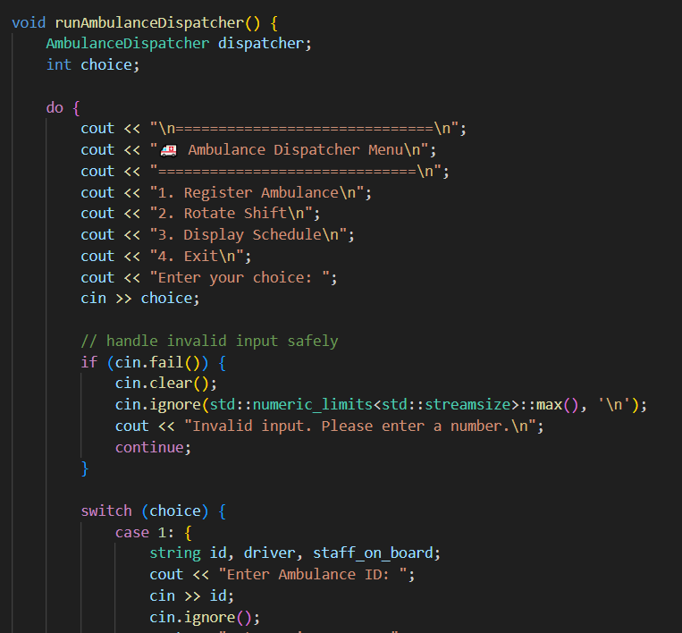

Lastly, the runAmbulanceDispatcher() function provides a user-friendly menu interface that allows interactive operation of the system. Through this menu, users can register new ambulances, rotate the current schedule, and display the existing list. Input validation is included to prevent incorrect entries, ensuring robust and error-resistant user interaction.

c- Input and Output screenshot
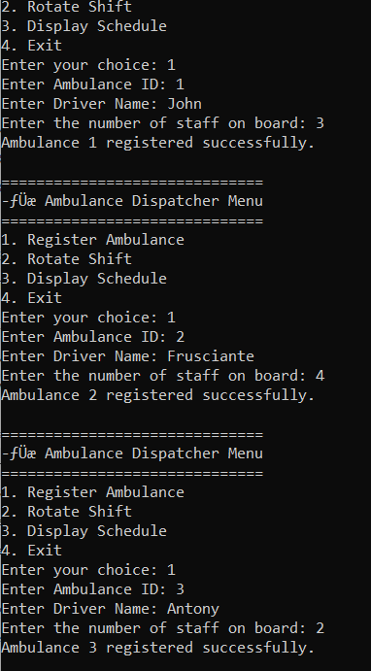

In this image, we added 3 ambulances with different number of staff on the board.

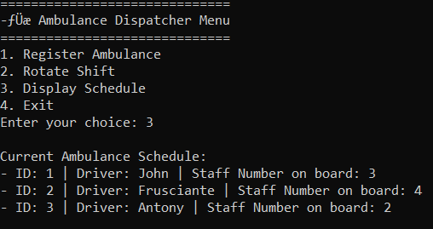

Next we displayed the current schedule, and as we can see the driver number 1 or John will be the first to go on duty or shift.

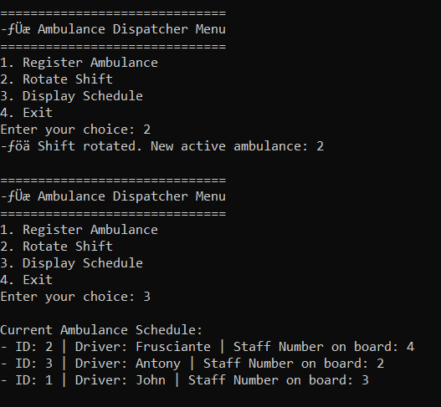

Next, when John finishes his duty/shift, we will do a shift rotation where John will go on the bottom of the list and the next driver will be the one behind John before which in this case will be Frusciante and as we rotate one last time, we can see that Frusciante now is on the end as he completed his duty (image below).

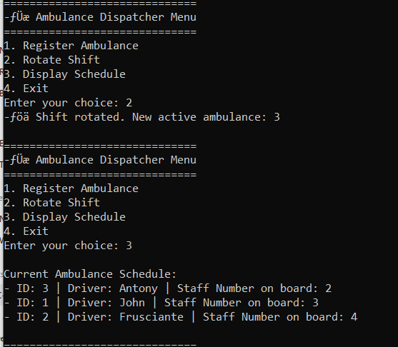

Critical Review and Areas of Improvement

The Ambulance Dispatcher module effectively demonstrates the practical use of a Circular Queue to manage ambulance scheduling in a continuous and fair rotation. By linking ambulances in a circular manner, the system ensures that each ambulance receives equal opportunity for duty without manual reassignment. The design efficiently uses a single tail pointer to control rotations and insertions, minimizing traversal time and maintaining simplicity in structure. Its clear object-oriented approach—featuring constructors, destructors, and modular functions—enhances code readability and maintainability. The module’s rotation mechanism mirrors real-world scheduling systems, ensuring uninterrupted ambulance readiness while promoting balanced workload distribution among staff.

However, while the implementation performs well for small to moderate data sizes, it has a few notable limitations. The reliance on a linked circular structure means that inserting, deleting, or modifying ambulance records requires linear traversal, which may reduce efficiency as the system scales. Additionally, the current design only supports basic registration and rotation functionalities, without tracking additional operational parameters such as ambulance status (available, en route, or under maintenance) or timestamps for shift rotations. The absence of persistent data storage means all records are lost when the program terminates, limiting its use for real hospital dispatch systems.

Overall, the Ambulance Dispatcher provides a strong conceptual and functional demonstration of circular queue operations applied to a real-world scenario. It effectively models fair scheduling and shift rotation but could be further enhanced by integrating database connectivity for data persistence, implementing priority-based scheduling for emergency response levels, and adding status monitoring features for a more comprehensive and realistic ambulance management system.

