# SUBMITTED TO: Ms. Neha Ma'am

# NAME: SANJHI JAIN

**Course: B. Sc. (H) Computer Science, III Year, VI Semester**

**COLLEGE ROLL NO: CSC/21/19**

**UNIV ROLL NO: 21059570046**

**PRACTICAL FILE for Core Paper XIII: Artificial Intelligence**

**PRACTICAL 01**

**FAMILY TREE**

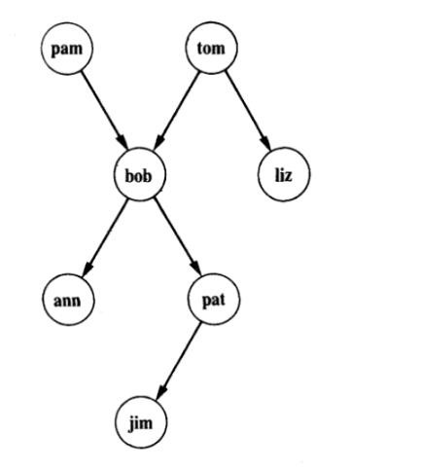

**PROLOG CODE**

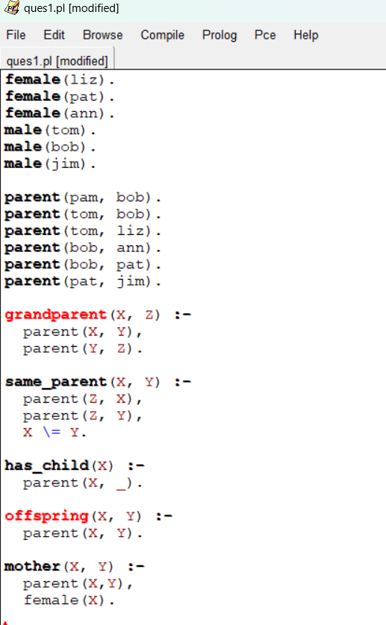

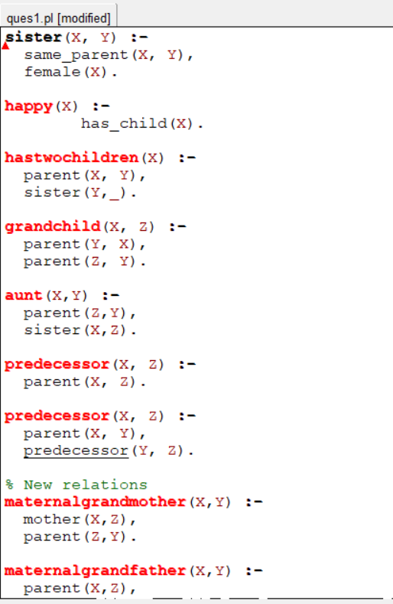

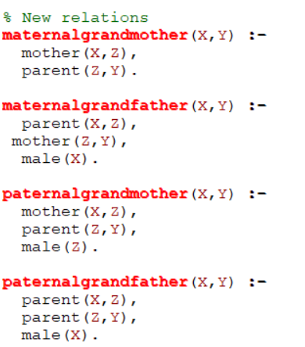

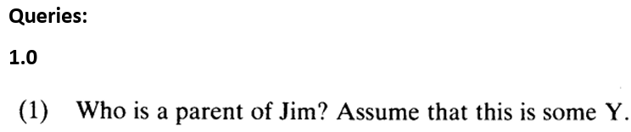

**ANS.**

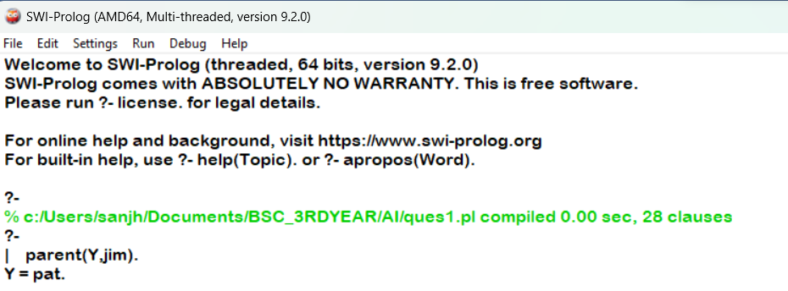



**ANS.**

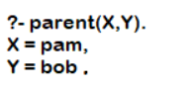



**ANS.**

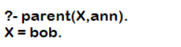



**ANS.**



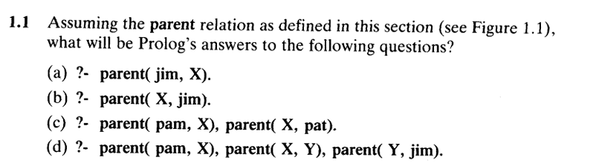

**ANS.**

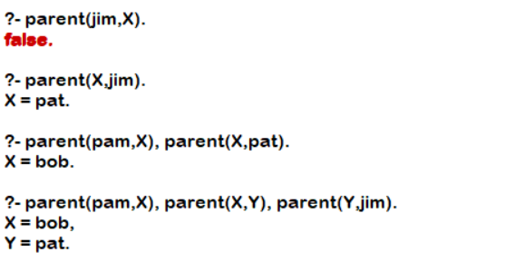

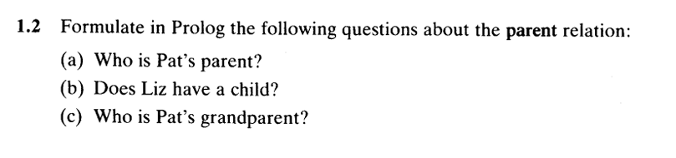

**ANS.**

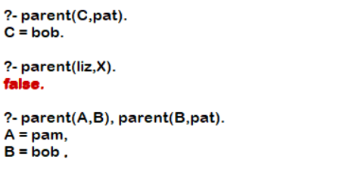

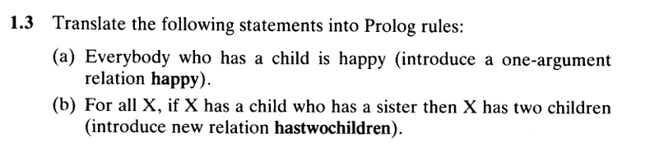

**ANS.**

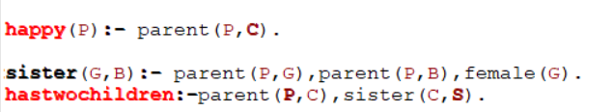

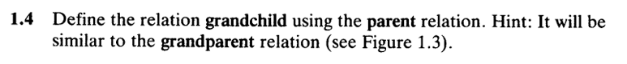

**ANS.**



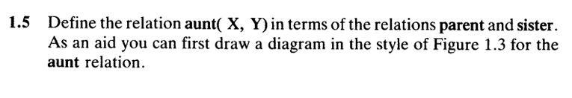

**ANS.**

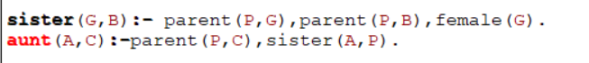

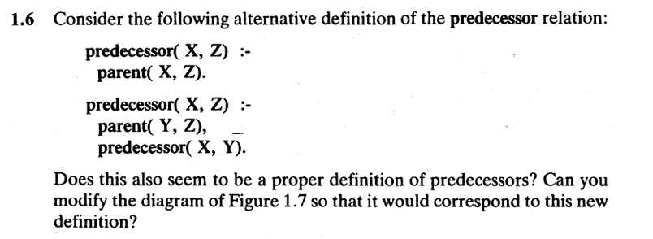

**ANS.**

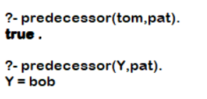

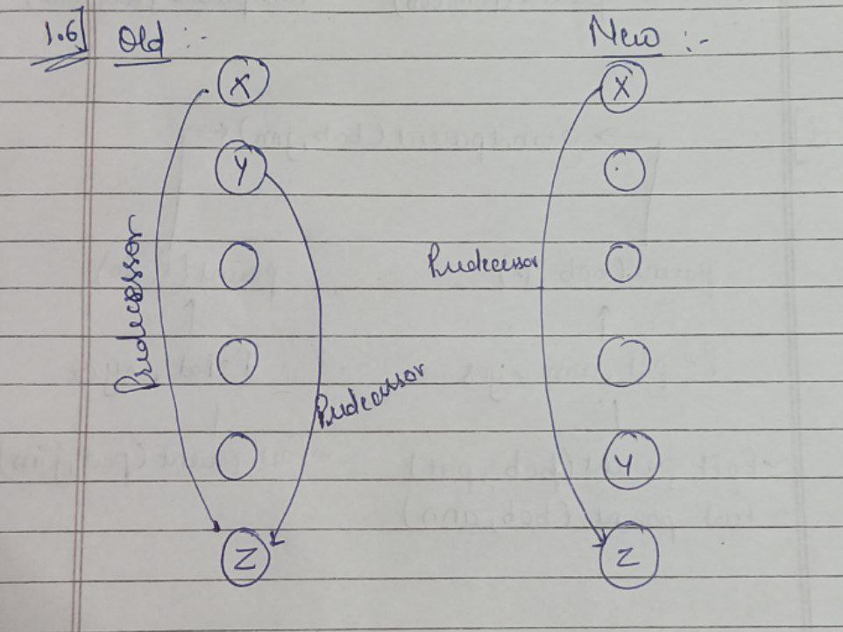

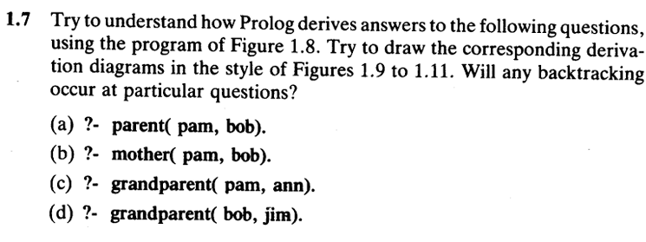

**ANS.**

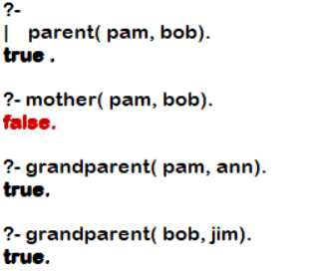

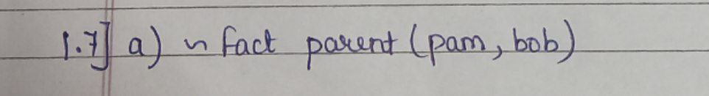

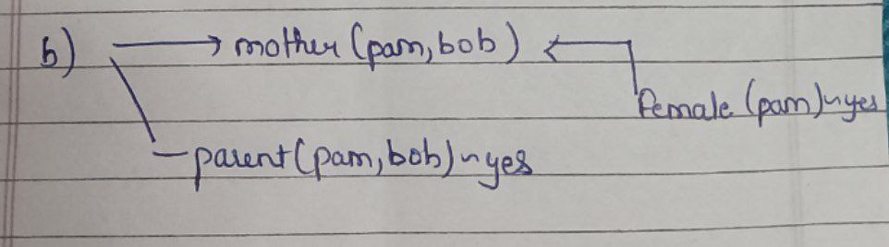

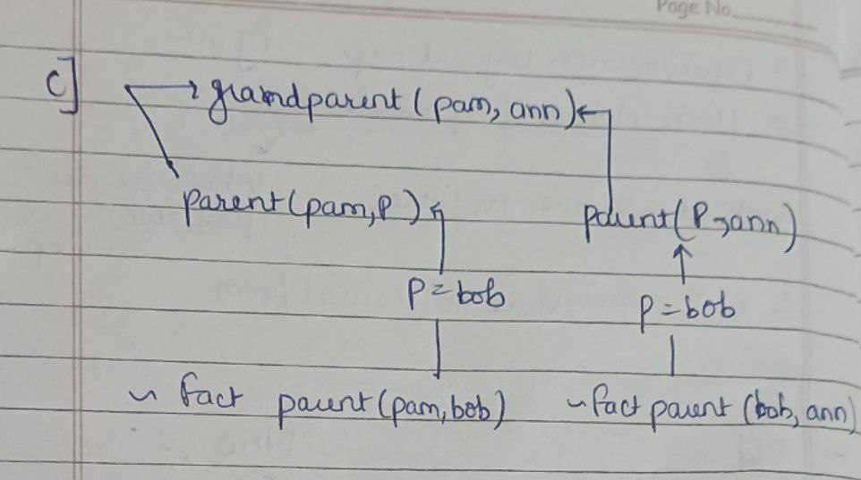

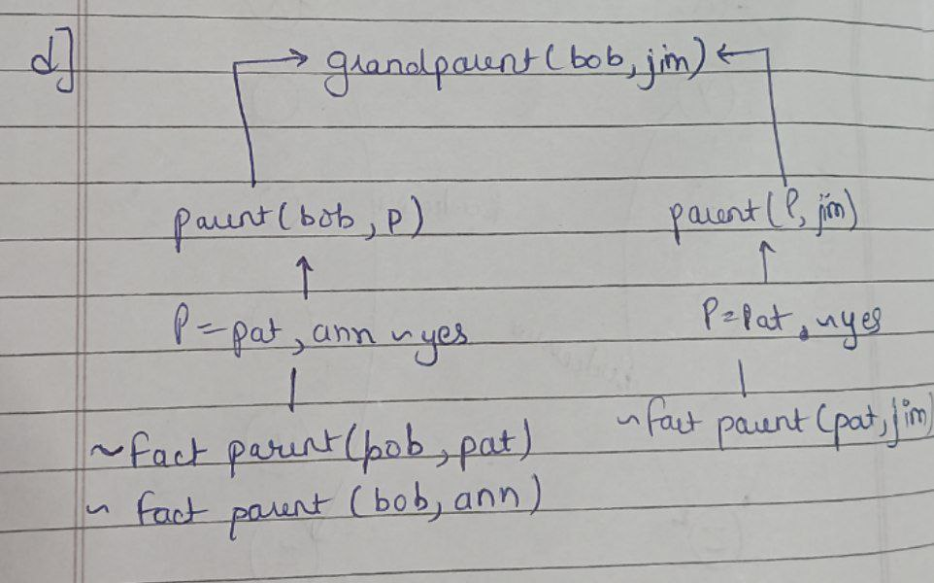

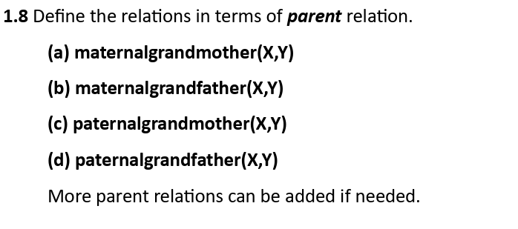

**ANS.**

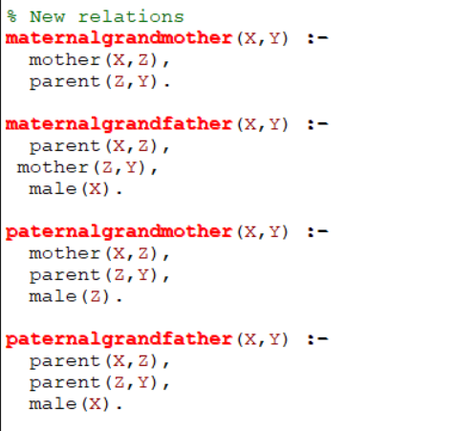

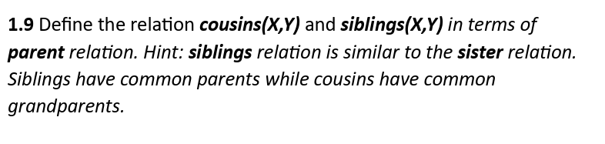

**ANS.**

