# SUBMITTED TO: Ms. Neha Ma'am

# NAME: SANJHI JAIN

**Course: B. Sc. (H) Computer Science, III Year, VI Semester**

**COLLEGE ROLL NO: CSC/21/19**

**UNIV ROLL NO: 21059570046**

**PRACTICAL FILE for Core Paper XIII: Artificial Intelligence**

**PRACTICAL 01**

1. **Write a prolog program to calculate the sum of two numbers.**

**PROLOG EDITOR CODE**

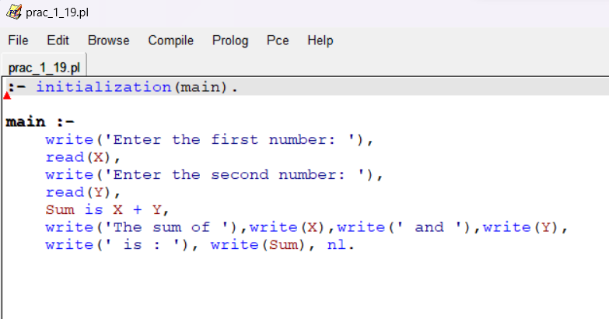

**PROLOG COMPILER CODE**

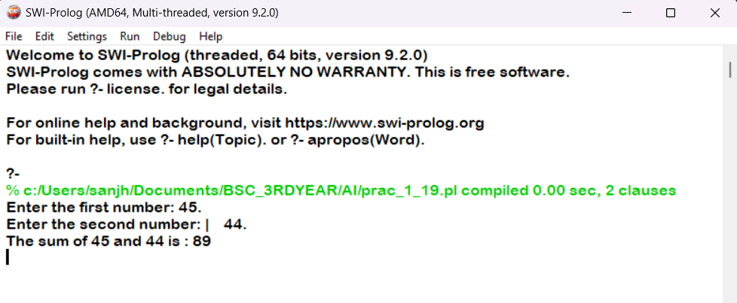

**PRACTICAL 02**

**2. Write a Prolog program to implement max(X, Y, M) so that M is the maximum of two numbers X and Y.**

**PROLOG EDITOR CODE**

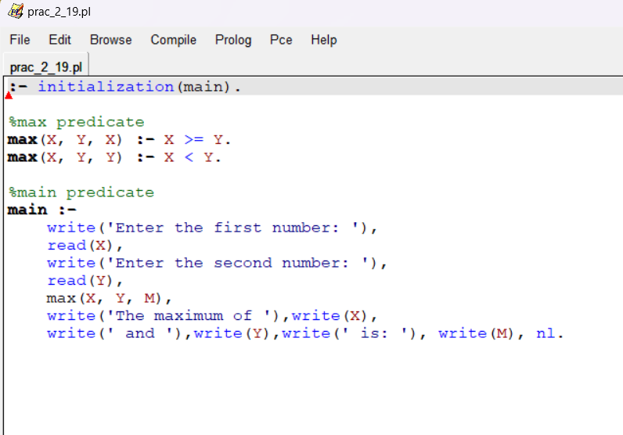

**PROLOG COMPILER CODE**

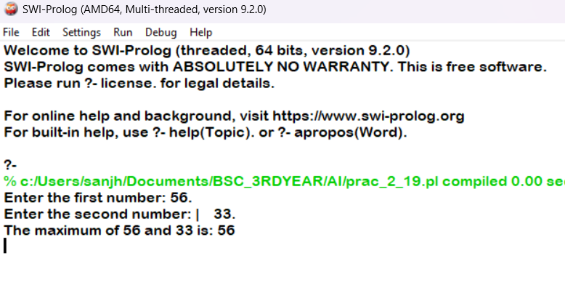

**PRACTICAL 03**

**3. Write a program in PROLOG to implement factorial (N, F) where F represents the factorial of a number N.**

**PROLOG EDITOR CODE**

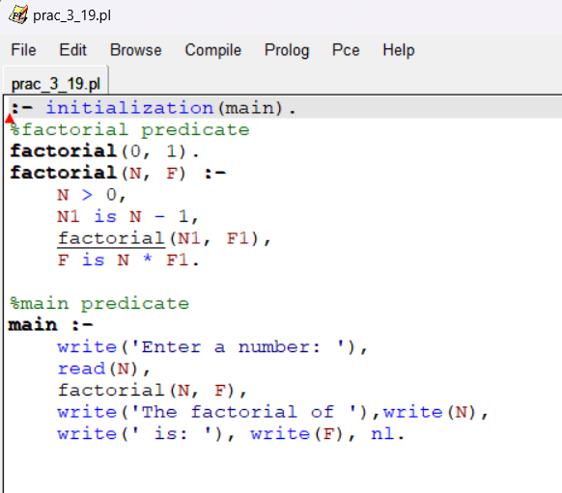

**PROLOG COMPILER CODE**

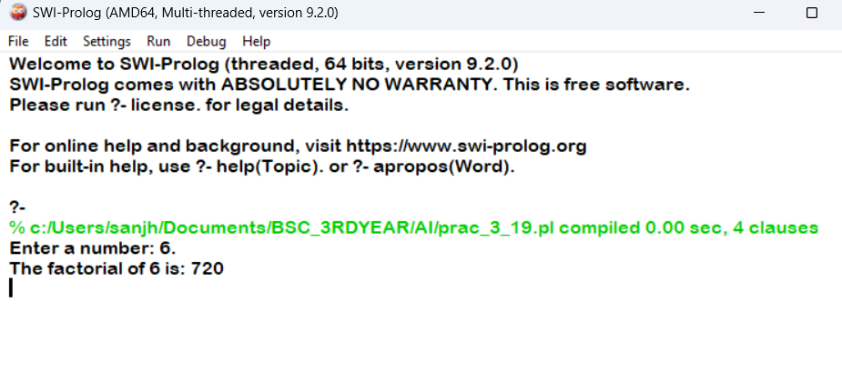

**PRACTICAL 04**

**4. Write a program in PROLOG to implement generate_fib(N,T) where T represents the Nth term of the fibonacci series.**

**PROLOG EDITOR CODE**

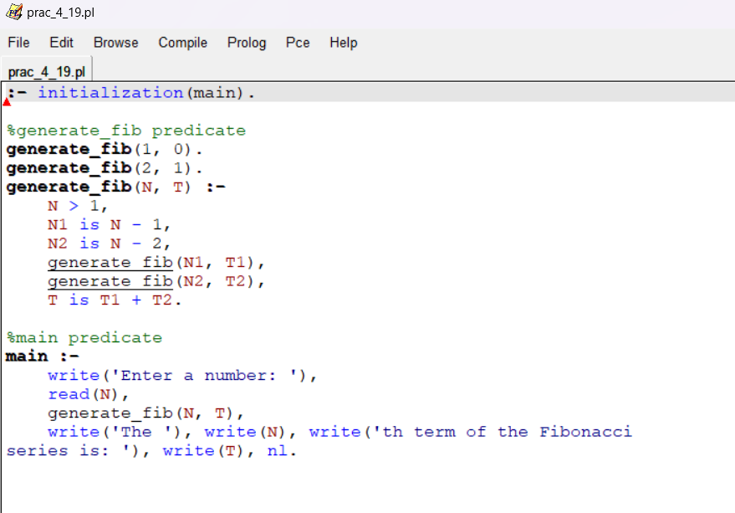

**PROLOG COMPILER CODE**

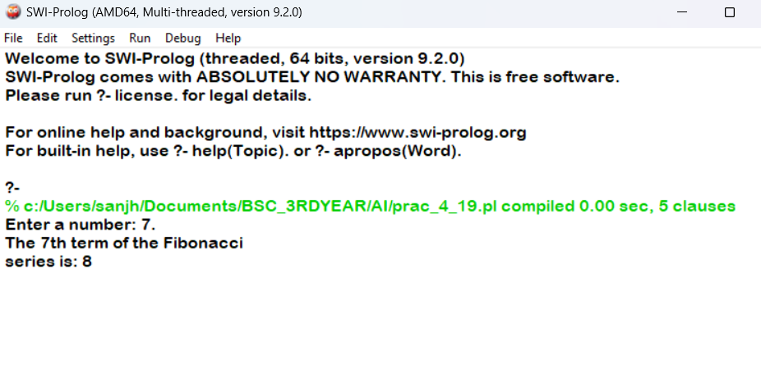

**PRACTICAL 05**

**5. Write a Prolog program to implement GCD of two numbers.**

**PROLOG EDITOR CODE**

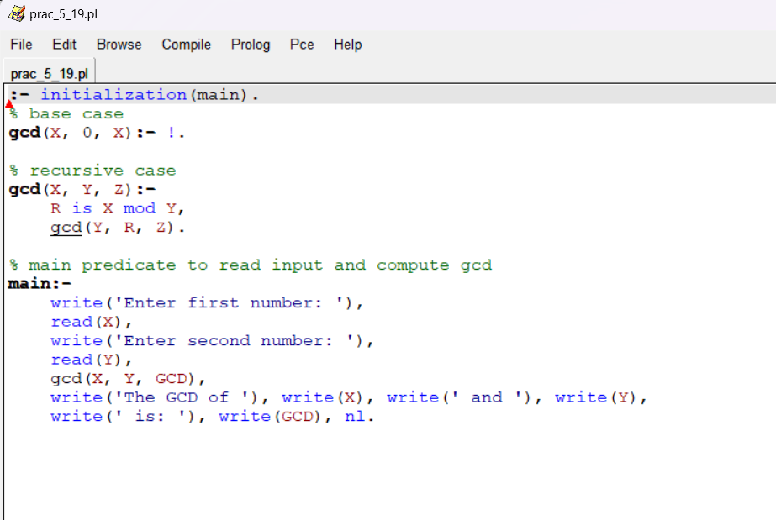

**PROLOG COMPILER CODE**

