# SUBMITTED TO: Ms. Neha Ma'am

# NAME: SANJHI JAIN

**Course: B. Sc. (H) Computer Science, III Year, VI Semester**

**COLLEGE ROLL NO: CSC/21/19**

**UNIV ROLL NO: 21059570046**

**PRACTICAL FILE for Core Paper XIII: Artificial Intelligence**

**PRACTICAL 11**

**11. Write a program in PROLOG to implement palindrome (L) which checks whether a list L is a palindrome or not.**

**PROLOG EDITOR CODE**

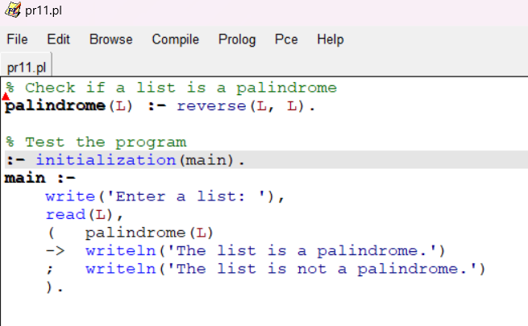

**PROLOG COMPILER CODE**

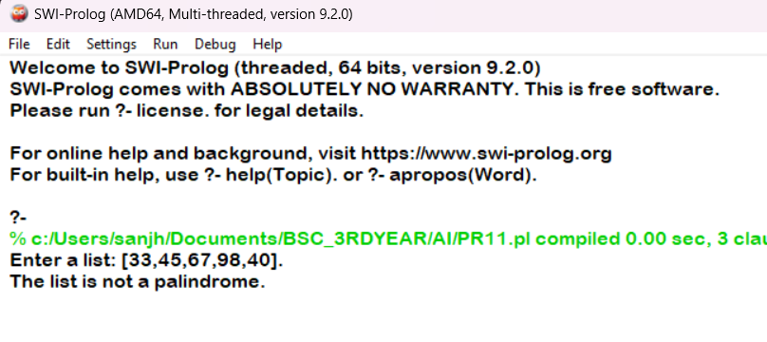

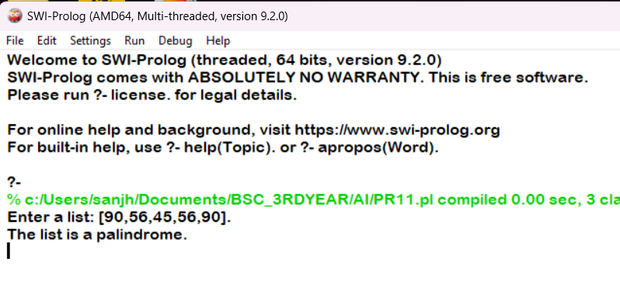

**PRACTICAL 12**

**12. Write a Prolog program to implement sumlist(L, S) so that S is the sum of a given list L.**

**PROLOG EDITOR CODE**

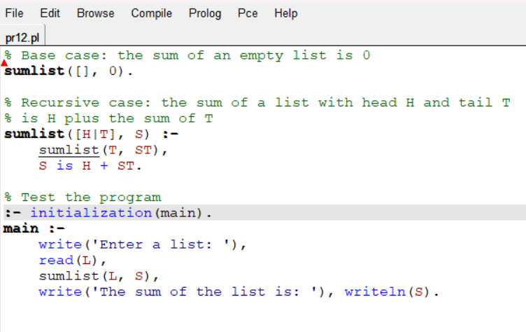

**PROLOG COMPILER CODE**

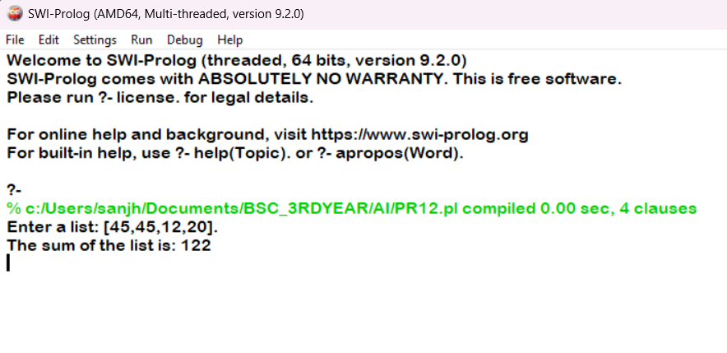

**PRACTICAL 13**

**13. Write a Prolog program to implement two predicates evenlength(List) and oddlength(List) so that they are true if their argument is a list of even or odd length respectively.**

**PROLOG EDITOR CODE**

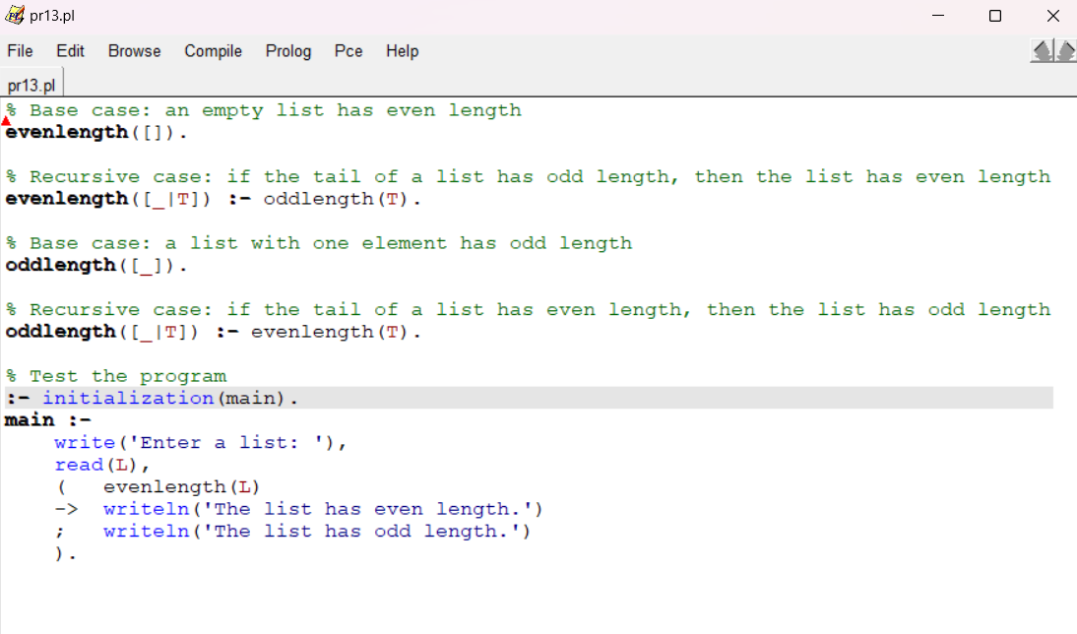

**PROLOG COMPILER CODE**

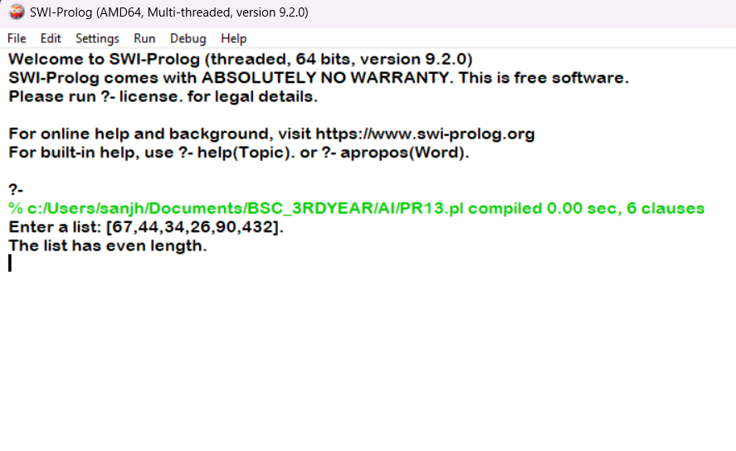

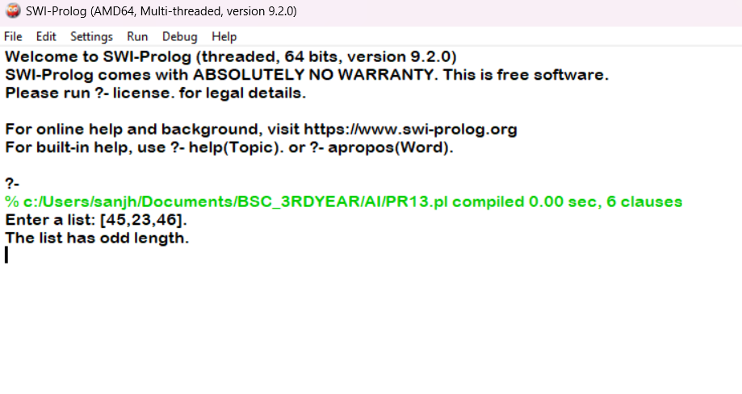

**PRACTICAL 14**

**14. Write a Prolog program to implement nth_element (N, L, X) where N is the desired position, L is a list and X represents the Nth element of L.**

**PROLOG EDITOR CODE**

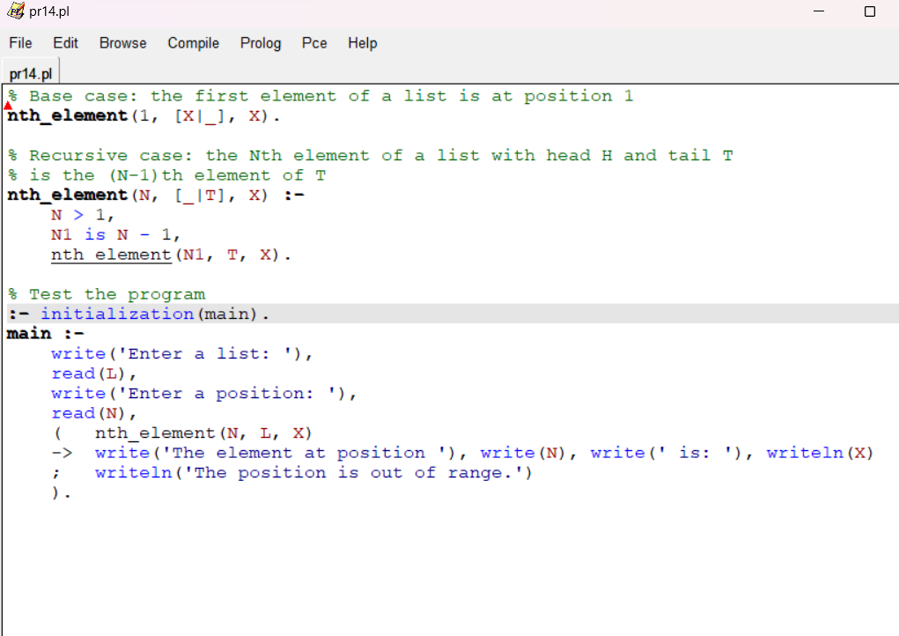

**PROLOG COMPILER CODE**

