# SUBMITTED TO: Ms. Neha Ma'am

# NAME: SANJHI JAIN

**Course: B. Sc. (H) Computer Science, III Year, VI Semester**

**COLLEGE ROLL NO: CSC/21/19**

**UNIV ROLL NO: 21059570046**

**PRACTICAL FILE for Core Paper XIII: Artificial Intelligence**

**PRACTICAL 15**

**15. Write a Prolog program to implement maxlist(L, M) so that M is the maximum number in the list.**

**PROLOG EDITOR CODE**

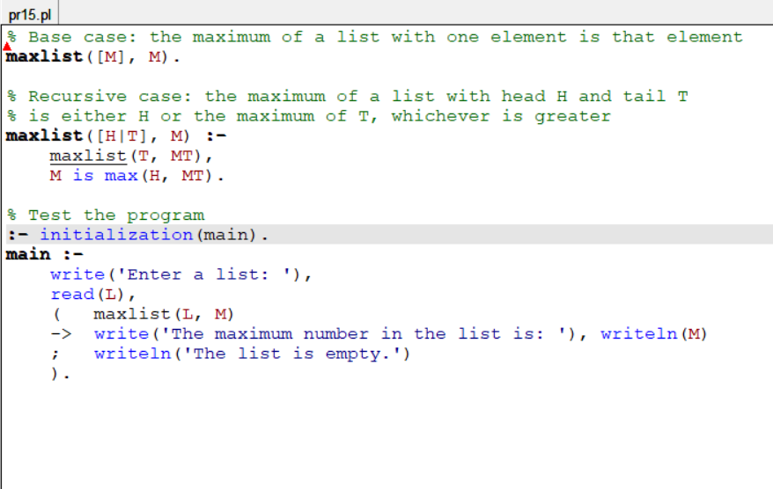

**PROLOG COMPILER CODE**

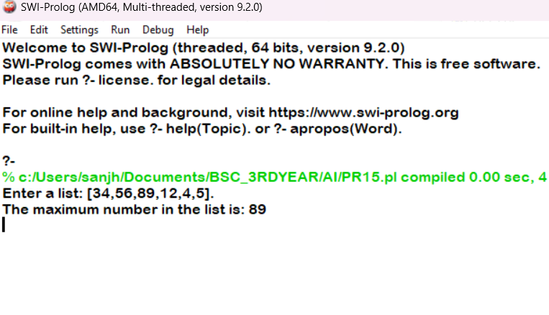

**PRACTICAL 16**

**16. Write a prolog program to implement insert_nth (I, N, L, R) that inserts an item I into Nth position of list L to generate a list R.**

**PROLOG EDITOR CODE**

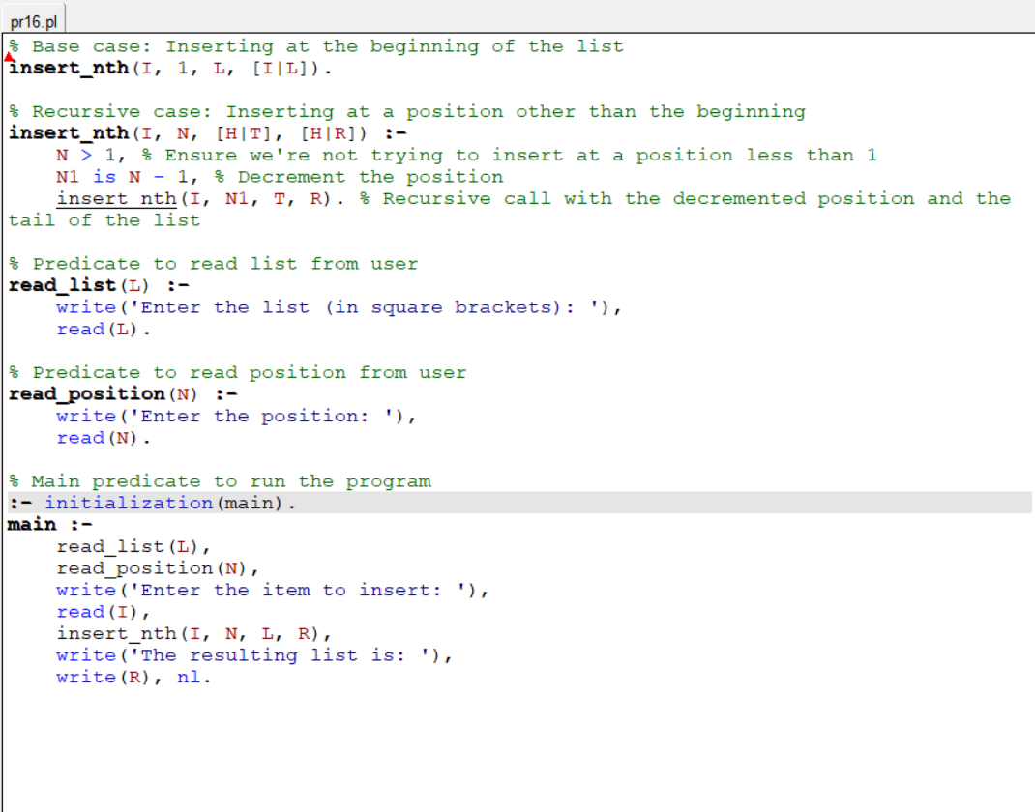

**PROLOG COMPILER CODE**

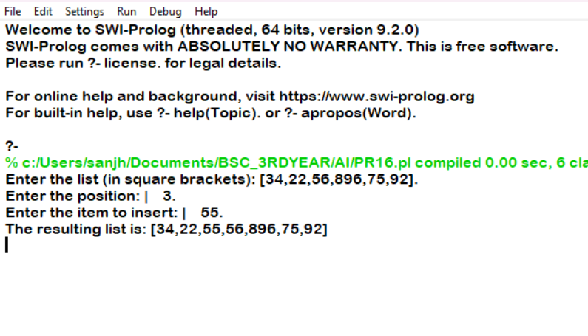

**PRACTICAL 17**

**17. Write a Prolog program to implement delete_nth (N, L, R) that removes the element on Nth position from a list L to generate a list R.**

**PROLOG EDITOR CODE**

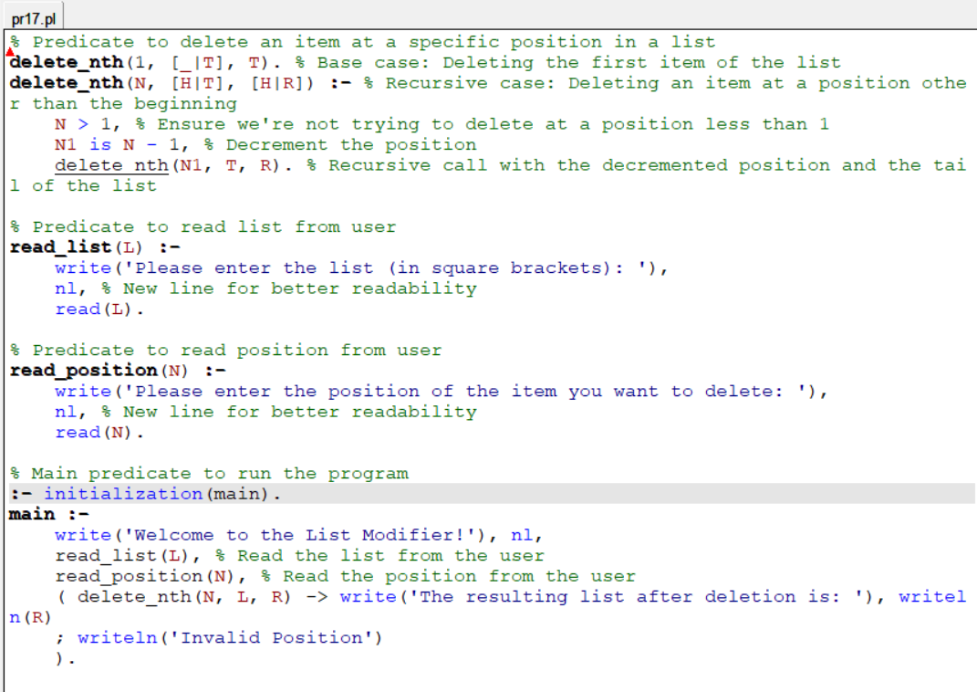

**PROLOG COMPILER CODE**

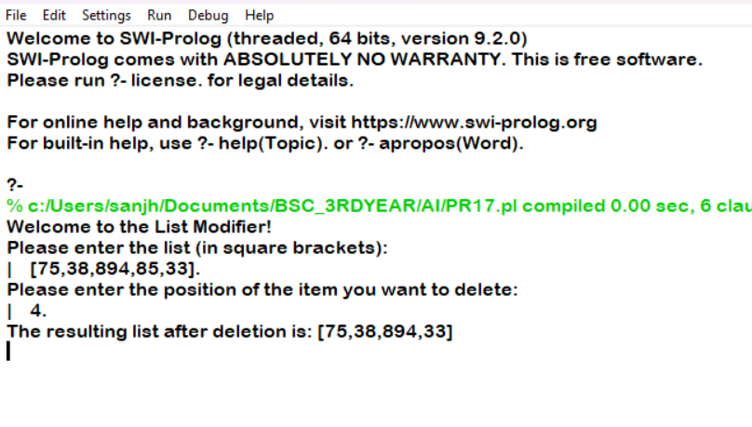

**PRACTICAL 18**

**18. Write a program in PROLOG to implement merge (L1, L2, L3) where L1 is first ordered list and L2 is second ordered list and L3 represents the merged list.**

**PROLOG EDITOR CODE**

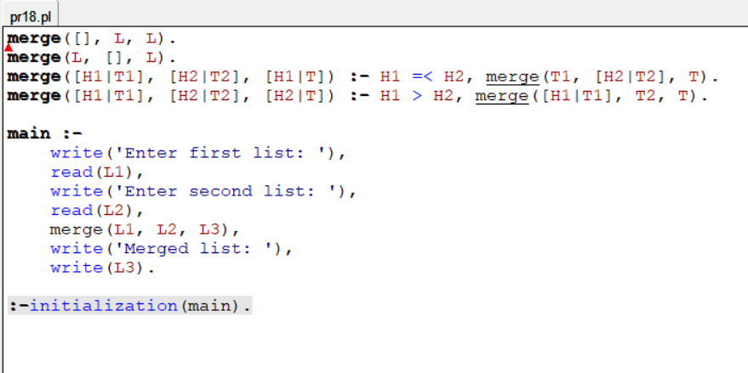

**PROLOG COMPILER CODE**

