# SUBMITTED TO: Ms. Neha Ma'am

# NAME: SANJHI JAIN

**Course: B. Sc. (H) Computer Science, III Year, VI Semester**

**COLLEGE ROLL NO: CSC/21/19**

**UNIV ROLL NO: 21059570046**

**PRACTICAL FILE for Core Paper XIII: Artificial Intelligence**

**PRACTICAL 06**

**6. Write a Prolog program to implement power (Num,Pow, Ans) : where Num is raised to the power Pow to get Ans.**

**PROLOG EDITOR CODE**

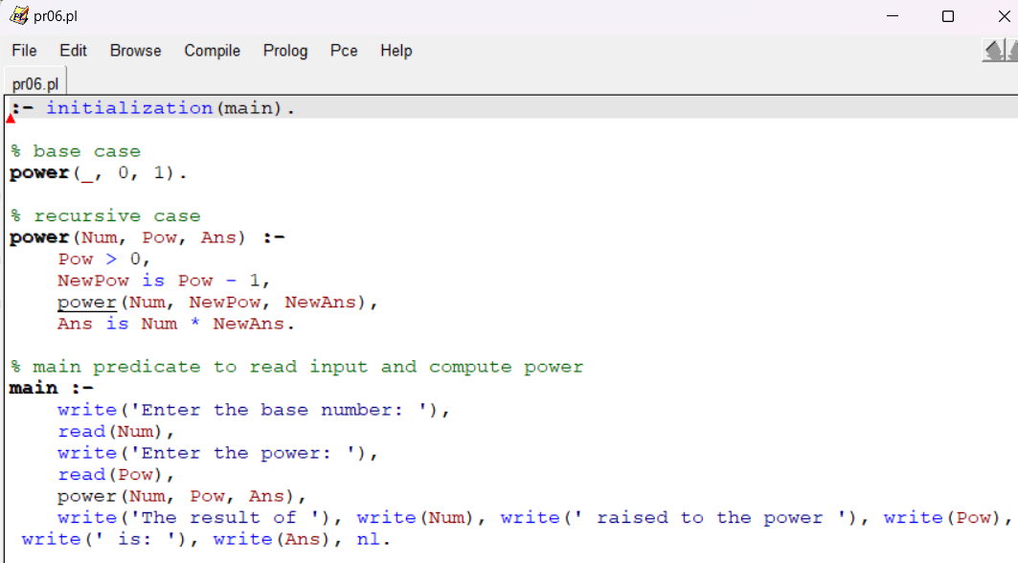

**PROLOG COMPILER CODE**

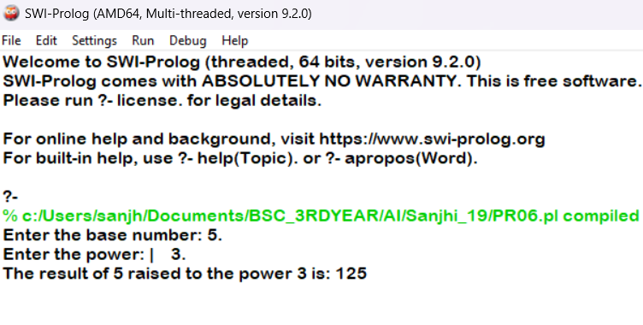

**PRACTICAL 07**

**7.** **Prolog program to implement multi (N1, N2, R) : where N1 and N2 denotes the numbers to be multiplied and R represents the result.**

**PROLOG EDITOR CODE**

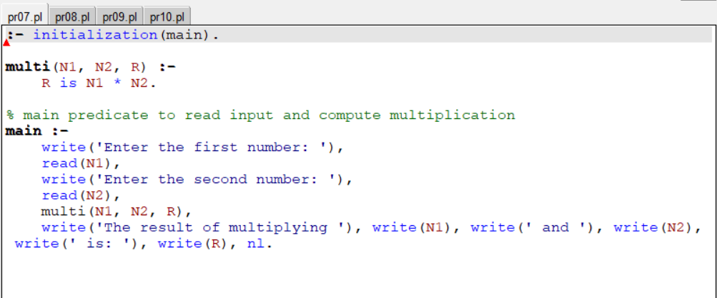

**PROLOG COMPILER CODE**

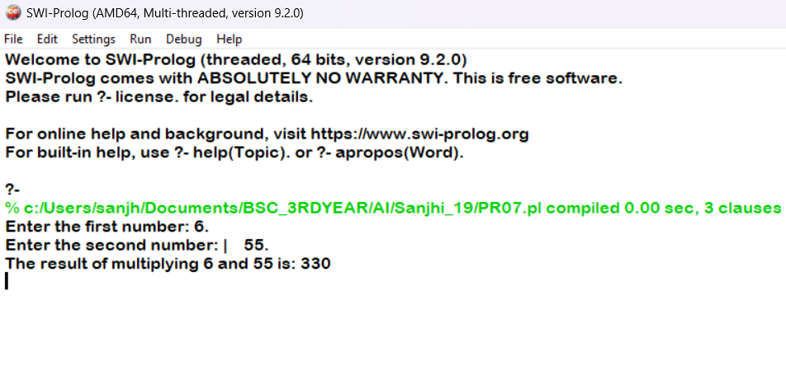

**PRACTICAL 08**

**8. Write a Prolog program to implement memb(X, L): to check whether X is a member of L or not.**

**PROLOG EDITOR CODE**

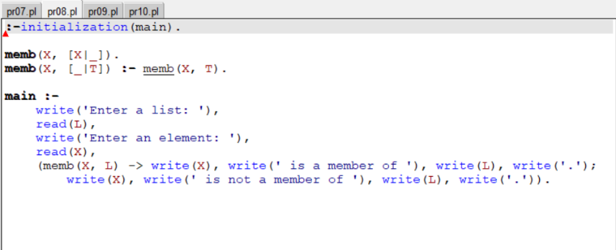

**PROLOG COMPILER CODE**

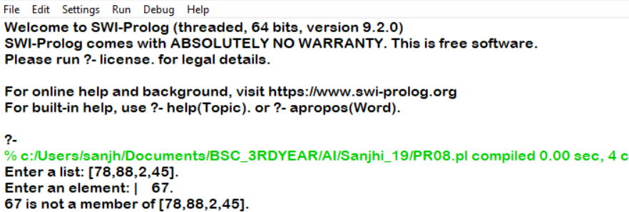

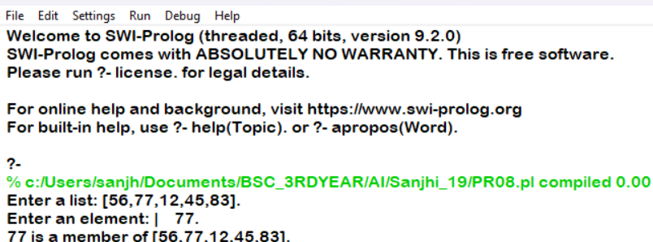

**PRACTICAL 09**

**9. Write a Prolog program to implement conc (L1, L2, L3) where L2 is the list to be appended with L1 to get the resulted list L3.**

**PROLOG EDITOR CODE**

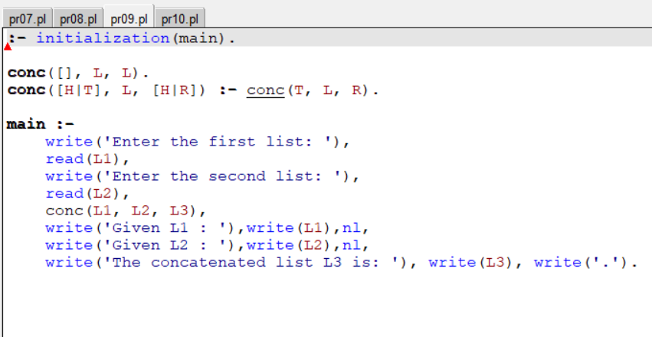

**PROLOG COMPILER CODE**

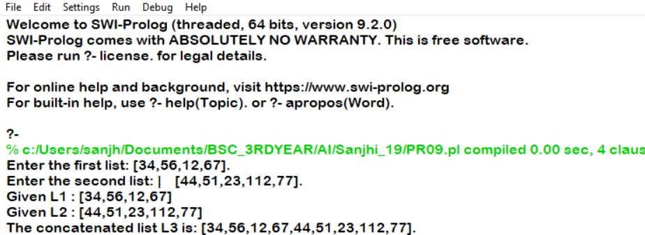

**PRACTICAL 10**

**10. Write a Prolog program to implement reverse (L, R) where List L is original and List R is reversed list.**

**PROLOG EDITOR CODE**

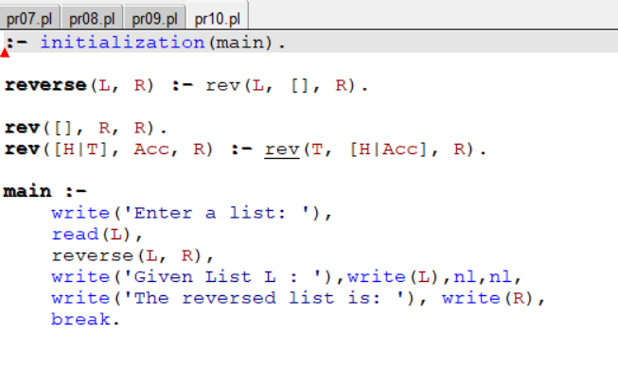

**PROLOG COMPILER CODE**

