**INTRODUCTION**

Scenario and Background

For this final project, I have chosen to check places in New York City where I can potentially establish an all Filipino restaurant. I have been in New York for a couple of times and I noticed that though the city has so much diversity in culture, only a few Filipino restaurants thrive. With this project (even if it is only theoretical), I could somehow see a glimpse or idea on where I can potentially create my legacy, should I have a chance to live and do business in New York.

Problem to be solved

How to find a location with the following considerations:

* Filipino restaurants already in place
* Number of Filipinos who are living in a specific place
* Neighborhoods that

**DATA SECTION**

* New York City with latitudes and longitudes
  + Data Source Link: <https://cocl.us/new_york_dataset>
* Restaurants including Filipino owned or inspired.
  + Data Source: Foursquare API

The above information will give us details on the density of each Borough/Neighborhood in New York City and the existing Filipino restaurants. In addition, we would know which neighborhood has Filipino restaurants and its rating. This way, we would know the place where we can establish a new restaurant and make it a hit.

**DATA PREPARATION**

In terms of Data Cleaning, there is not much needed clean up since what I did was used the information from the abovementioned sources (refer to Data Section) and used URL to extract data from the link plus the information from FourSquare.

**METHODOLOGY**

The strategy is to use the data or information mentioned above and map it in order to help us in identifying the choices or details for a place where we can setup our restaurant. The information will be consolidated in a map to have an easier visualization of the facts and facilitate in decision making. We would be using the following tools:

CSV reader for easier mapping of raw data.

Matlib for the plotting modules

Geo location to get the latitude and longitude information

Geopy_distance and Nominatim for converting an address to latitude and longitude.

**EXECUTION and RESULTS**

Since my initial run did not return any significant result of Filipino restaurants, I have changed the code a little bit by searching for Asian restaurants instead of just Filipino establishments. The reason being is that I only got 1 hit when I initially did the run with just Filipino restaurants as compared with Asian as the search. Below you could see that we have 32 hits within the neighborhoods of New York City.

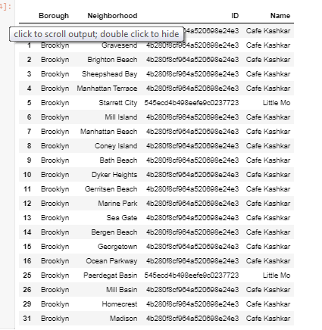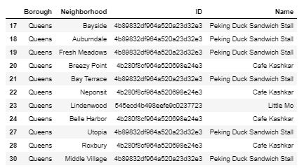

After getting all the Asian restaurants around New York City, I would next be checking the ratings and other information that would help us determine which restaurants have the highest positive ratings in the food/restaurant business. I believe that with this information, we would know the competition we are upped against when establishing a new restaurant in New York City. With this in mind, I have used FourSquare’s information to get the ratings for each Asian restaurant identified in this Capstone Specialization.

One consideration that I would like to include is how many neighborhoods in a borough across New York City. I believe that with more people, there are better chances of having more customers go to your restaurants or at least check your offerings to the neighborhood. With the table below, we would know which boroughs the highest count of neighborhoods plus which neighborhoods has Asian restaurants. With the latter, Queens has the highest number of neighborhoods among the boroughs of New York City.

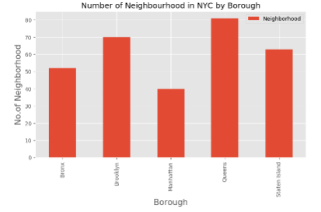

Next step, getting the list of restaurants in each borough/neighborhood. As you can see, only 2 (Brooklyn and Queens) have Asian restaurants, where Queens has the highest one.

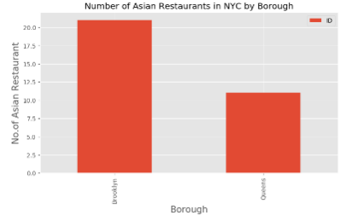

Further drilling, we got the ratings per restaurants in each borough and we filtered those restaurants with only 8 or higher ratings. We came up with only 2 restaurants, one is a Filipino restaurant and the other is a traditional Central Asian dish such as lamb kebabs and lagman noodles.

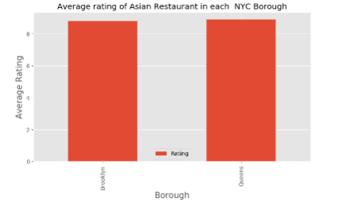

Using Folium map, we can visualize the lack of Asian restaurants with 8 or higher ratings (based on FourSquare).

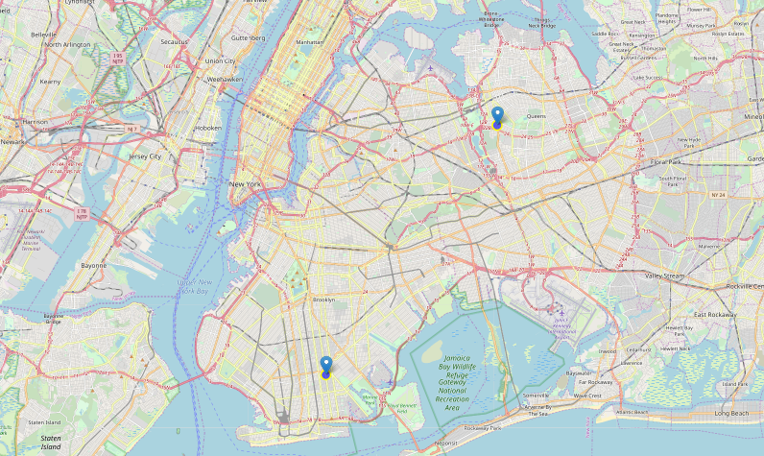

**DISCUSSION**

According to the analysis

Limitations of the study are as follow:

* Nearness in tourist spots and train stations
* This project heavily relies on the accuracy and updated information from FOURSQUARE API
* Rent / location
* The daily call quota of Foursquare for free developers. It somehow screws up my runs every time I do it.

**CONCLUSION**

In conclusion, we got a glimpse of how we can use data science in getting “answers” from complicated situations or scenarios. With numbers, we can objectively pinpoint some of our questions such as “where is the best place to eat Filipino food in a specific place?”. Also, on a personal note, I have enjoyed this specialization as it gave me an introduction on how to use both numbers and insight for everyday situations. This would tremendously help me in changing careers! This whole specialization has shown me on how to practically apply this in real life situations.

Tools such as mapping with Folium and Python libraries that handle JSON, plotting graphs are powerful techniques specially in this project since it helped me consolidate complex data and visualized information to make numbers be more easily understood.

With all the analyses and information that we have processed, I believe Queens would be the best place where we can establish a Filipino restaurant due to simple pointers:

* More neighborhoods
* Lesser competition with above 8 ratings based on FourSquare.

But if we check further and better opportunities, I believe we can establish one in Manhattan mainly because there are less Asian restaurants plus it is a go-to area of tourists which come by thousands every year.

In my opinion, there are more information that we need to include in this project such as:

* Crime rate
* Tourist footprint
* Location near subways, bus or transportation bay
* Population by ethnicity
* Buying power / GDP
* Restaurant ratings by an established food/restaurant committee

Lastly, in reiterating the abovementioned drawbacks, this project needs a more comprehensive analysis in the future. With this analysis, it will further cover the considerations not covered in this project.