TIME SERIES ANALYSIS PROJECT
Ruairi Kenealy, C20359883
Contents
Title Part 2, Seasonal Time Series Analysis: 1
Executive summary 1
Exploratory Data Analysis 3
Sources for Data sets 3
Data Last Updated 4
Labels on Graphs 4
Software used 4
R Packages used 4
Reading the data 4
Initial plot 5
Holdout 5
Smoothing the data 6
Fitting a moving average, kernel smoothing, loess and splines smoothing: 6
Decomposing the data 8
Is the data stationary? 12
Differencing 12
Choosing the Model 16
Holt Winters 20
Model evaluation and forecasting Accuracy 24
Forecasting using the chosen model(s) 24
Seasonal ARIMA 24
Conclusion 28

Title Part 2, Seasonal Time Series Analysis:

Executive summary
I chose the analysis of this data because I know I’ll be looking to buy an apartment so I’ve an interest in checking out the market. I also thought it would be a good idea to see what’s going on in a country outside of Ireland to see if it’s similar to here.
This study was done to examine the Quebec condo sales in Montreal. I found the data from a blog posted by Spencer Hayes in June of 2021, where in that blog there was a link containing the csv file of the information on prices of the condo sales in Quebec and the data was published by the Quebec professional Association of real estate Brokers. The data was observed from 2014 to 2021. The data is seasonal and observed month by month over 8 years.
The data was smoothed out using various smoothing methods such as moving average, kernel smoothing, LOESS and GAM. All these methods defined and fitted onto a plot made the data much more readable and easier to predict. To check if the data was stationary or not, ADF and ACF tests were used on the dataset and since the data was non-stationary differencing was applied in an attempt to transform and make the data more stationary.
A holdout was created from 2020 to 2021 which could be used to compare with the forecast on data from 2014-2019. All analysis on the data is based on the observations from 2014-2019. I fitted 4 different SARIMA models and 2 exponential Holt Winters models to fit to the data. I tested their accuracy and chose both the 4th SARIMA and ETS model for the forecast. That forecast matches the holdout plot.
The graphs from plotting the data show a sharp rise in median prices from 2019 onwards, no doubt the spread of COVID had a part to play in this though prices were steadily increasing from 2014. The prices also seemed to spike in Spring, suggesting the prices were increased at that time of year because the real estate market is traditionally active in Spring. On average the prices were 5% higher in the spring so that’s a good time to sell. The sharp rise in prices in 2020 and 2021 is mirrored in the rest of the Canadian market – see here.

Exploratory Data Analysis

Sources for Data sets

The original source of the data is the Quebec Association of Realtors website which has data from 2014 to March 2022 here:
https://apciq.ca/en/real-estate-market/statistiques-mensuelles-detaillees/
This data was collated into a Google docs spreadsheet by Spencer Hayes in May 2021. See:
https://towardsdatascience.com/finding-seasonal-trends-in-time-series-data-with-python-ce10c37aa861
Here is the Data
Date | Province_Median_Price | Province_Average_Time | Montreal_Median_Price | Montreal_Average_Time
01/01/2014 | 210000 | 135 | 220000 | 124
02/01/2014 | 212000 | 128 | 225000 | 117
03/01/2014 | 210000 | 130 | 225000 | 118
04/01/2014 | 214000 | 120 | 225000 | 113
05/01/2014 | 215000 | 125 | 226287 | 115
06/01/2014 | 220000 | 129 | 234525 | 122
07/01/2014 | 223000 | 130 | 235000 | 128
08/01/2014 | 214000 | 139 | 230150 | 128
09/01/2014 | 220000 | 134 | 234000 | 121
10/01/2014 | 221000 | 136 | 249000 | 119
11/01/2014 | 218000 | 132 | 230750 | 120
12/01/2014 | 215000 | 134 | 235000 | 129
13/01/2014 | 214000 | 134 | 230485 | 129
14/01/2014 | 212000 | 139 | 230000 | 125
15/01/2014 | 218500 | 132 | 235000 | 120
16/01/2014 | 215000 | 130 | 231950 | 123
17/01/2014 | 224900 | 127 | 239000 | 122
18/01/2014 | 224500 | 142 | 240000 | 118
19/01/2014 | 225000 | 127 | 245000 | 119

Data Source, Headers, and Labels
Headers in the data:
Date
Province_median_price
Province_average_time
Montreal_median_price
Montreal_average_time

Values:
Jan Feb Mar Apr May Jun Jul Aug Sep Oct Nov Dec
2014 220.000 225.000 225.000 225.000 226.287 234.525 235.000 230.150 234.000 249.000 230.750 235.000
2015 230.485 230.000 235.000 231.950 239.000 240.000 245.000 240.000 248.000 240.000 239.000 240.000
2016 238.000 226.000 231.600 235.000 240.000 245.000 250.000 250.000 250.000 245.000 248.000 245.000
2017 240.000 238.900 243.232 240.000 243.000 257.500 256.000 251.500 253.000 255.000 254.510 265.000
2018 244.750 250.000 240.000 245.350 257.000 256.000 265.000 265.000 263.000 265.000 264.900 272.863
2019 248.271 250.000 248.000 260.000 261.000 261.000 278.600 279.000 290.000 280.000 290.000 285.000
2020 275.000 275.000 287.000 289.900 280.000 305.000 312.000 312.000 318.000 323.500 316.000 325.000
2021 322.000 340.000 347.065 357.750 365.000

Data Last Updated
May 2021

Labels on Graphs
Y axis: Sale Price (thousands)
X axis: Year

Software used
R Studio version: 2022.02.1 Build 461
R.version(): R version 4.1.3 (2022-03-10)"
Excel version: Microsoft 365

R Packages used
library(readr)
library(forecast)
library(tseries)
library(mgcv)

Reading the data
setwd("C:/Users/ruair/Downloads/Forecasting_Time_series")
condo_sales = read.csv("quebec_real_estate.csv",header=T)
str(condo_sales)

Initial plot
values = condo_sales[4]
values = ts(values, start=c(2014,1), frequency=12)
ts.plot(values, main="Montreal Median Price", ylab="Number of People", type="l")
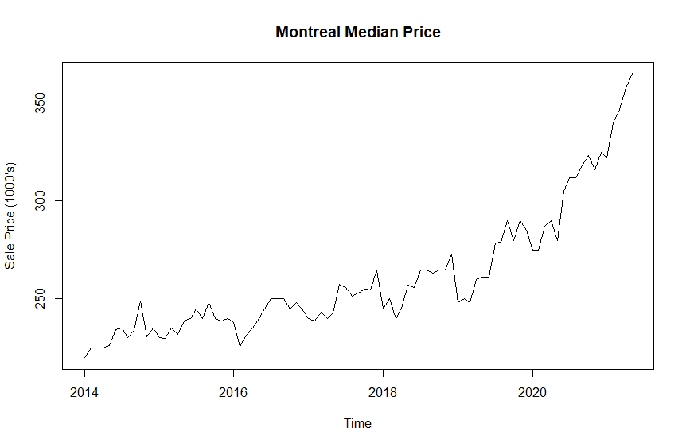

Holdout
I created a holdout for 2020 to 2021 in order to be able to see how observed data compares to forecasted data, though for much of the other analysis the data runs all the way to 2021.
values.holdout <- window(values, start=2020,end=2021)
values <- window(values, start=1967,end=2019)
ts.plot(cbind(values, values.holdout), main="Quebec condo market ",
ylab="Price (1000's)", type="l", col=c("red", "blue"), lty=c(1, 2))
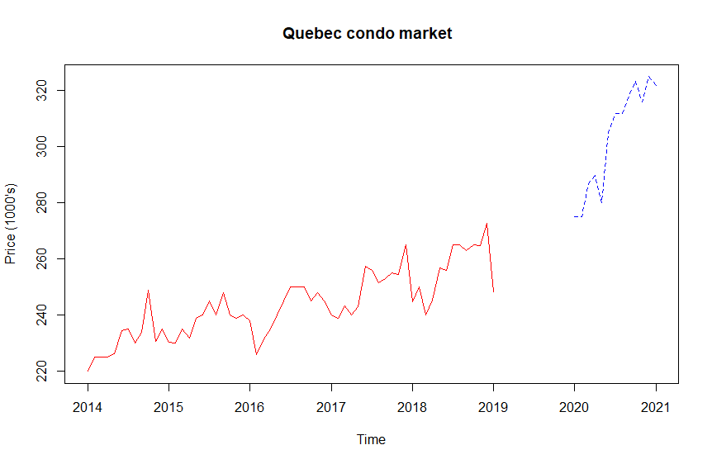

Smoothing the data

Fitting a moving average, kernel smoothing, loess and splines smoothing:
Smoothing was done in order to view and analyse the observed data in an easier and more predictable way, this was done through the various smoothing methods defined below, moving average(MA), kernel smoothing, etc.
Time points for fitting trend:
time.pts = c(1:length(values))
time.pts = c(time.pts - min(time.pts))/max(time.pts)
Defining smoothing methods:
values.mafilter.fit = filter(values, filter = rep(1/4, 4), sides = 2)
MA:
ma.fit = ma(values, order=2, centre=TRUE)
values.fit.ma = ts(ma.fit, start=c(2008, 1), frequency=12)
Kernel:
ksmooth.fit = ksmooth(time.pts, values, kernel = "box", bandwidth = 0.2)
values.fit.ksmooth = ts(ksmooth.fit$y,start=c(2008, 1),frequency=12)
LOESS:
loess.fit = loess(as.matrix(values)~time.pts, data=values, span=0.2)
values.fit.loess = ts(predict(loess.fit), start=c(2008, 1), frequency=12)
GAM:
gam.fit = gam(values~s(time.pts))
values.fit.gam = ts(fitted(gam.fit),start=c(2008, 1),frequency=12)

plotting smoothing values:
lines(values.fit.ksmooth,lwd=1, lty=4 ,col="purple")
lines(values.mafilter.fit, col="red")
lines(values.fit.loess, col="orange", lty=4)
lines(values.fit.gam, col="violet")
lines(values.fit.ma, col="cyan", lwd=3)
legend(x="topleft",c("kernel smoothing", "filter", "loess", "gam", "mav"),lty = c(4, 1), col=c("purple"))
ts.plot(values,ylab="sale price", main="Observed Values vs smoothing methods")
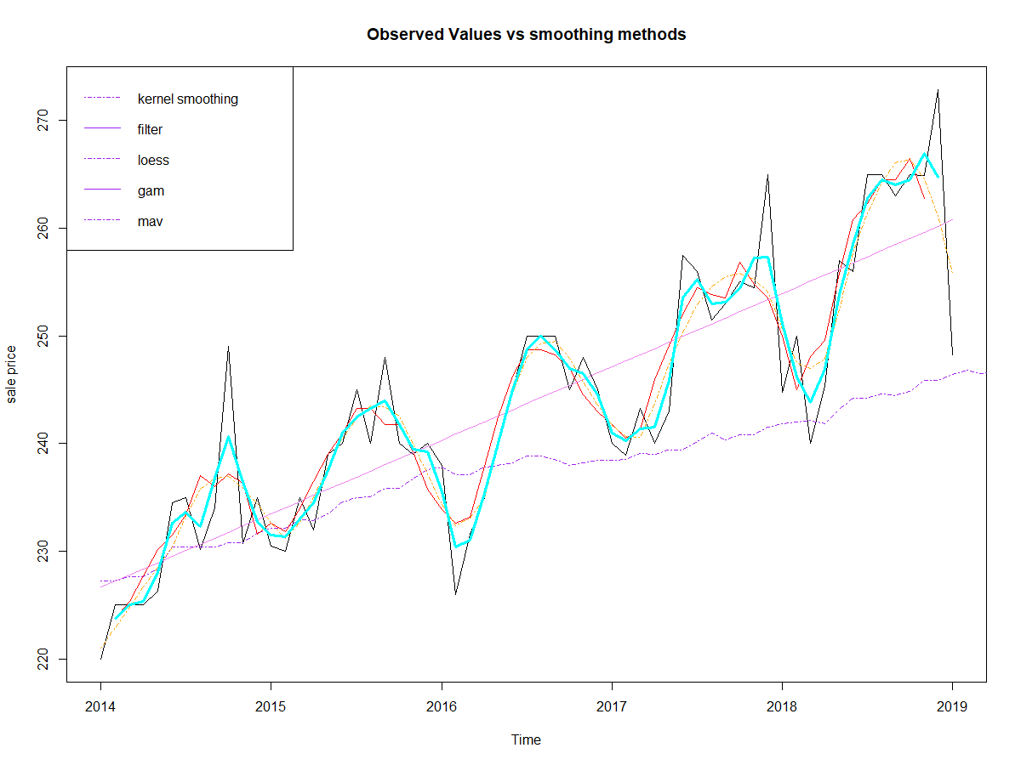

Decomposing the data
Decomposing a time series separates out trend, seasonality and residual/random/white noise. There are two forms of classical decomposition- additive and multiplicative. The R decompose() function performs classical seasonal decomposition using moving averages. We assume that this time series is multiplicative because the periods appear to be getting bigger.
values.ma.decomp = decompose(values.fit.ma, type=c("multiplicative"))
plot(values.ma.decomp)
A more detailed decomposition of this time-series can be seen below by using STL - Seasonal Decomposition of Time Series by LOESS: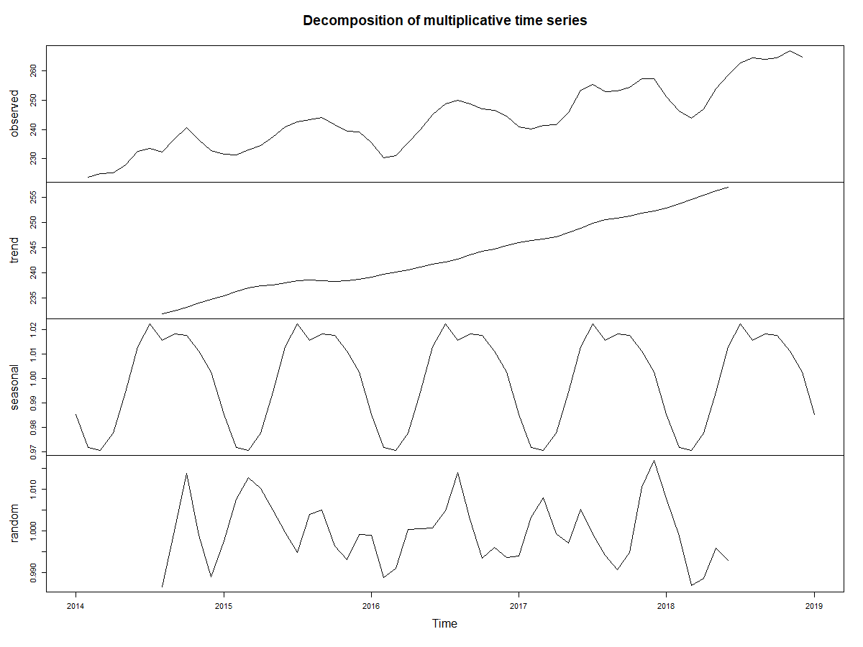
STL is a versatile and robust method for decomposing time series. STL is an acronym for “Seasonal and Trend decomposition using Loess”, while loess is a method for estimating nonlinear relationships. The STL method was developed by R. B. Cleveland et al. See plot below for the output produced using STL.

values.decomp.stl <- stl(na.omit(values.fit.ma[,1]), s.window="periodic")
plot(values.decomp.stl)
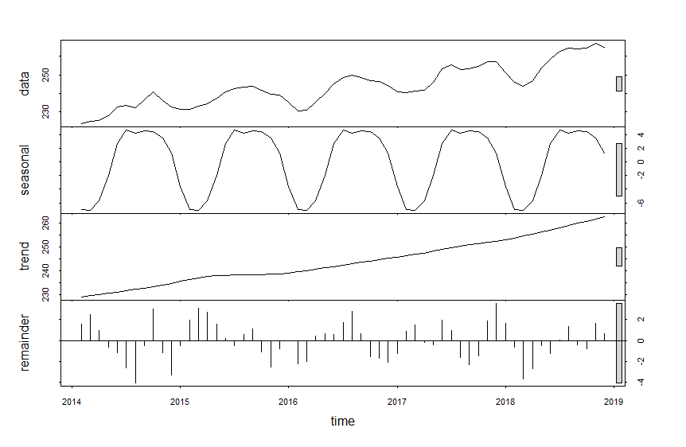
The R deseason function calculates anomalies of a RasterStack by supplying a suitable seasonal window. E. g. to create monthly anomalies of a raster stack of 12 layers per year, use cycle.window = 12.
values.deseason = seasadj(values.decomp.stl)
plot(values.deseason, main="Deseasonalized time series")
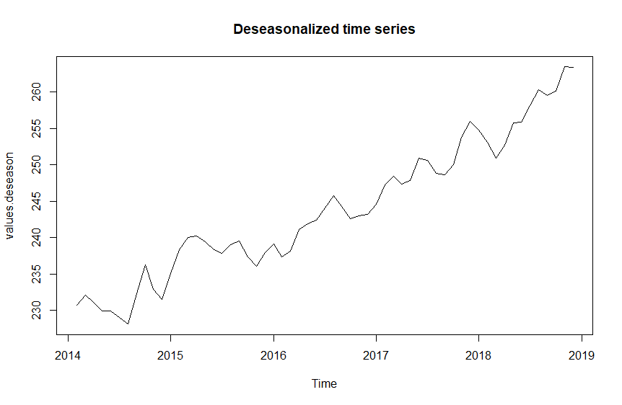
We can also print out the values from the STL.
print(values.decomp.stl)
Call:
stl(x = na.omit(values.fit.ma[, 1]), s.window = "periodic")
Components
seasonal trend remainder
Feb 2014 -6.936089 229.1336 1.55246856
Mar 2014 -7.056369 229.5972 2.45913934
Apr 2014 -5.733749 230.0608 0.99466048
May 2014 -1.934334 230.5758 -0.61675384
Jun 2014 2.627983 231.0908 -1.13456889
Jul 2014 4.644695 231.6358 -2.61172578
Aug 2014 4.225757 232.1807 -4.08148268
Sep 2014 4.513514 232.7354 -0.46146416
Oct 2014 4.409271 233.2902 2.98805487
Nov 2014 3.492821 234.0432 -1.16103982
Dec 2014 1.335672 234.7963 -3.32318506
Jan 2015 -3.589169 235.5897 -0.50801877
Feb 2015 -6.936089 236.3831 1.92422656
Mar 2015 -7.056369 236.9564 3.08750430
Apr 2015 -5.733749 237.5296 2.67913241
May 2015 -1.934334 237.8559 1.56588666
Jun 2015 2.627983 238.1823 0.18974016
Jul 2015 4.644695 238.2993 -0.44395399
Aug 2015 4.225757 238.4162 0.60800185
Sep 2015 4.513514 238.4053 1.08114267
Oct 2015 4.409271 238.3944 -1.05371601
Nov 2015 3.492821 238.5574 -2.55020911
Dec 2015 1.335672 238.7203 -0.80600275
Jan 2016 -3.589169 239.1497 -0.06057395
Feb 2016 -6.936089 239.5792 -2.24306611
Mar 2016 -7.056369 240.1298 -2.02344054
Apr 2016 -5.733749 240.6805 0.45328538
May 2016 -1.934334 241.2466 0.68774767
Jun 2016 2.627983 241.8127 0.55930921
Jul 2016 4.644695 242.3900 1.71528595
Aug 2016 4.225757 242.9673 2.80691267
Sep 2016 4.513514 243.5654 0.67107937
Oct 2016 4.409271 244.1635 -1.57275343
Nov 2016 3.492821 244.7167 -1.70950026
Dec 2016 1.335672 245.2699 -2.10554762
Jan 2017 -3.589169 245.7949 -1.23070026
Feb 2017 -6.936089 246.3199 0.87422615
Mar 2017 -7.056369 246.8925 1.50487763
Apr 2017 -5.733749 247.4651 -0.17337052
May 2017 -1.934334 248.2026 -0.39324559
Jun 2017 2.627983 248.9400 1.93197859
Jul 2017 4.644695 249.6519 0.95336231
Aug 2017 4.225757 250.3638 -1.58960398
Sep 2017 4.513514 250.8857 -2.27418933
Oct 2017 4.409271 251.4075 -1.43927418
Nov 2017 3.492821 251.9094 1.85279980
Dec 2017 1.335672 252.4113 3.56807323
Jan 2018 -3.589169 253.0670 1.64715658
Feb 2018 -6.936089 253.7228 -0.59918102
Mar 2018 -7.056369 254.5410 -3.64711417
Apr 2018 -5.733749 255.3592 -2.70044696
May 2018 -1.934334 256.2473 -0.47547316
Jun 2018 2.627983 257.1354 -1.26340011
Jul 2018 4.644695 258.0399 0.06537710
Aug 2018 4.225757 258.9444 1.32980429
Sep 2018 4.513514 259.8826 -0.39611510
Oct 2018 4.409271 260.8208 -0.75503399
Nov 2018 3.492821 261.7933 1.62963893
Dec 2018 1.335672 262.7658 0.62276130

Is the data stationary?
In the process of checking whether the data is stationary or not, a stationary model is applied to the data. If there is evidence of a seasonal component or a trend it is removed.
values.fit.ma <- ts(na.omit(values.fit.ma), frequency=12, start=c(2014, 1))
acf(values.fit.ma)
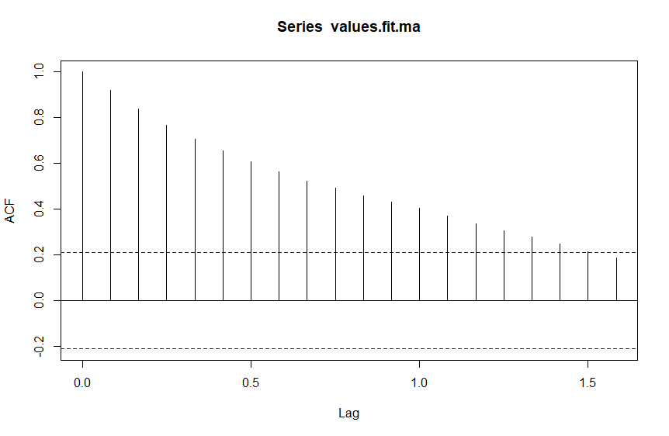
adf.test(values.fit.ma)
Result:
Augmented Dickey-Fuller Test
data: values.fit.ma
Dickey-Fuller = 1.5393, Lag order = 4, p-value = 0.99
alternative hypothesis: stationary
The data will need to be transformed to make it more stationary, this conclusion was derived from the ACF plot showing a sharp drop in values and from the result of the ADF test with the p-value being 0.99 meaning we can’t reject the null-hypothesis of non-stationarity.

Differencing
To make the data stationary various mathematical transforms must be used. We are using a lag of 12 because the data are monthly, and the period of the seasonality is 12 months.
values_diff12 = diff(values.fit.ma, lag = 12)
tm <- cbind(values, values_diff12)
plot(tm)
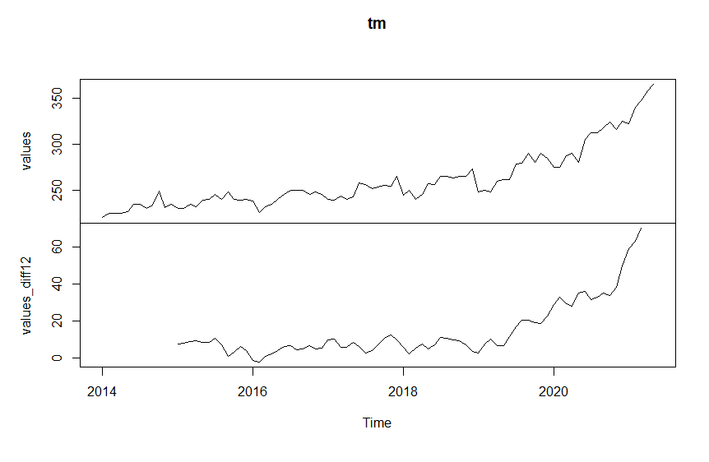
values_diff12_1 = diff(values_diff12)
tm <- cbind(values, values_diff12, values_diff12_1)
plot(tm)
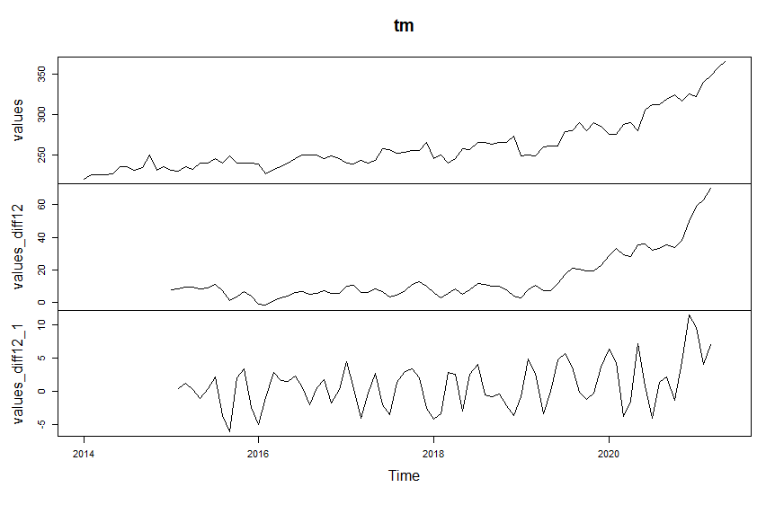
acf(na.omit(values_diff12_1), main="ACF for series after 1st difference")
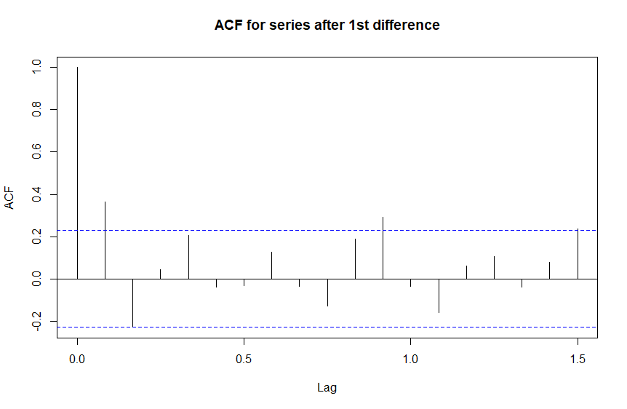
adf.test(na.omit(values_diff12_1))
Result:
Augmented Dickey-Fuller Test
data: na.omit(values_diff12_1)
Dickey-Fuller = -2.5724, Lag order = 4, p-value = 0.3421
alternative hypothesis: stationary
The data appear to be non-stationary because the p-value is above 0.05. There is also a seasonal component in the ACF.
diff.values <- na.omit(values_diff12_1)
par(mfrow=c(2,1))
acf(diff.values, main="")
pacf(diff.values, main="")
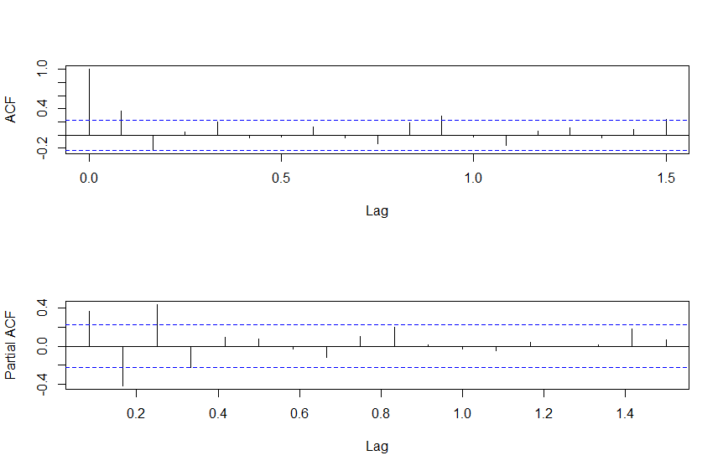

Choosing the Model
Model 1: Sarima
values.fit.sarima1 <- arima(values.fit.ma, order=c(1, 1, 0), seasonal = list(order = c(1, 1, 0), period = 12))
values.fit.sarima1
Result:
Call:
arima(x = values.fit.ma, order = c(1, 1, 0), seasonal = list(order = c(1, 1,
0), period = 12))
Coefficients:
ar1 sar1
0.4366 -0.1459
s.e. 0.1088 0.1442
sigma^2 estimated as 10.03: log likelihood = -190.53, aic = 387.05
Residuals
tsdisplay(residuals(values.fit.sarima1), lag.max=45, main='SARIMA Model 1 Residuals')
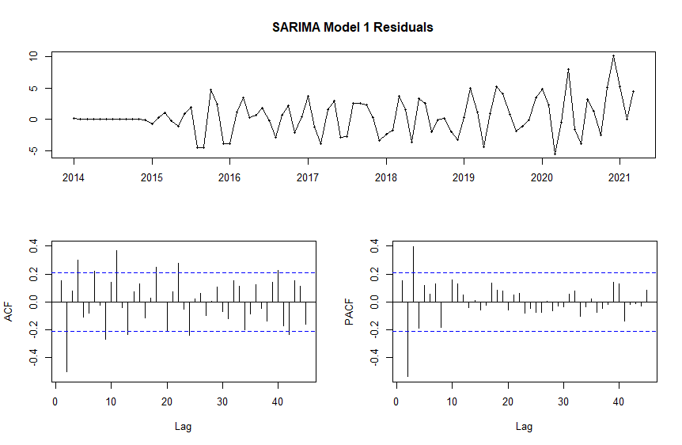
forecasting accuracy
forecast.sarima1 <- forecast(values.fit.sarima1, h=12) #12months
accuracy(forecast.sarima1)
Result:
ME RMSE MAE MPE MAPE MASE ACF1
Training set 0.4523532, 2.921444, 2.180838, 0.1446918, 0.8157319 ,0.1501135, 0.1516219

Model 2
values.fit.sarima2 <- arima(values.fit.ma, order=c(3, 1, 0), seasonal = list(order = c(1, 1, 0), period = 12))
values.fit.sarima2
Result:
Call:
arima(x = values.fit.ma, order = c(3, 1, 0), seasonal = list(order = c(1, 1,
0), period = 12))
Coefficients:
ar1 ar2 ar3 sar1
0.8571 -0.7208 0.6050 -0.0898
s.e. 0.1018 0.1063 0.1036 0.1350
sigma^2 estimated as 5.875: log likelihood = -171.47, aic = 352.94
residuals
tsdisplay(residuals(values.fit.sarima2), lag.max=45, main='SARIMA Model 2 Residuals')
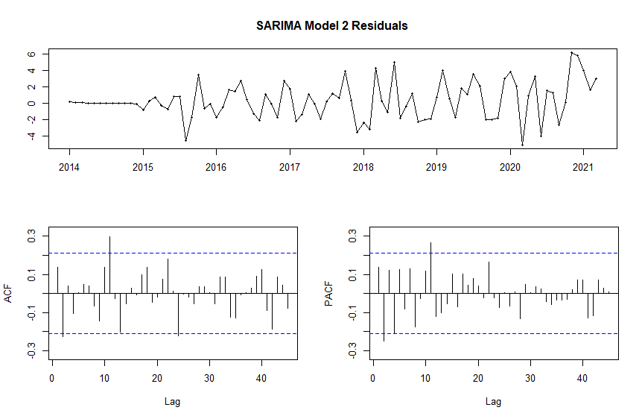
forecasting accuracy
forecast.sarima2 <- forecast(values.fit.sarima2, h=12) #12months
accuracy(forecast.sarima2)
Result:
ME RMSE MAE MPE MAPE MASE ACF1
Training set 0.3061826, 2.237134 ,1.675537, 0.0977514, 0.6224838, 0.1153322, 0.1388304

Model 3
values.fit.sarima3 <- arima(values.fit.ma, order=c(6, 1, 0), seasonal = list(order = c(1, 1, 0), period = 12))
values.fit.sarima3
Results:
Call:
arima(x = values.fit.ma, order = c(6, 1, 0), seasonal = list(order = c(1, 1,
0), period = 12))
Coefficients:
ar1 ar2 ar3 ar4 ar5 ar6 sar1
1.0738 -1.1323 1.0706 -0.5219 0.2987 0.0237 -0.1295
s.e. 0.1185 0.1696 0.2077 0.2127 0.1695 0.1305 0.1385
sigma^2 estimated as 4.968: log likelihood = -165.76, aic = 347.52
Residuals
tsdisplay(residuals(values.fit.sarima3), lag.max=45, main='SARIMA Model 3 Residuals')
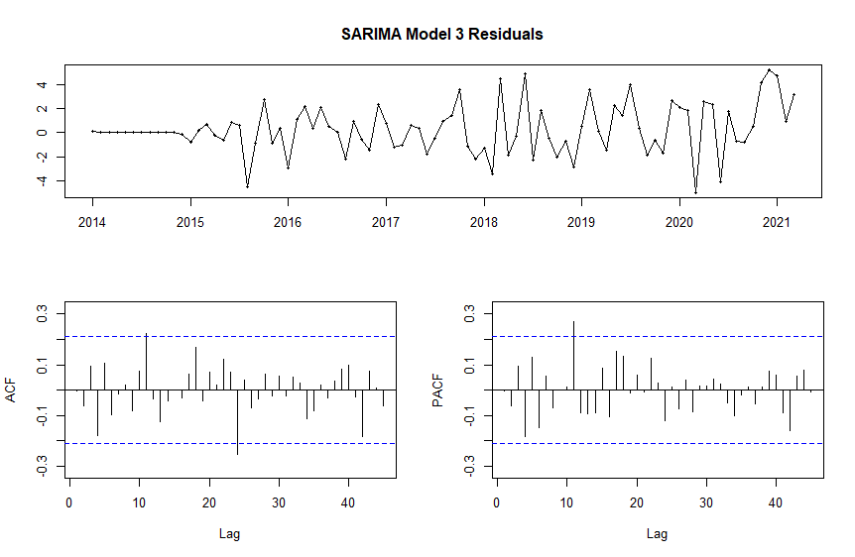
forecasting accuracy
forecast.sarima3 <- forecast(values.fit.sarima3, h=12) #12months
accuracy(forecast.sarima3)
Results:
ME RMSE MAE MPE MAPE MASE
Training set 0.2719145, 2.057356, 1.519558, 0.08627085, 0.5666311, 0.1045957 –
ACF1 0.004227259
As the results for the previous tests were bad, another method to use is Auto.arima, which can be used to estimate conclusions and view with the conclusions drawn so far.
Auto.arima
values.fit.sarima4 <- auto.arima(ma.fit, seasonal = TRUE)
values.fit.sarima4
Results:
Series: ma.fit
ARIMA(2,2,0)(0,1,0)[12]
Coefficients:
ar1 ar2
-0.0202 -0.7469
s.e. 0.0774 0.0753
sigma^2 = 6.406: log likelihood = -174.01
AIC=354.02 AICc=354.37 BIC=360.89
Residuals
tsdisplay(residuals(values.fit.sarima4), lag.max=45, main='SARIMA Model 4 Residuals'
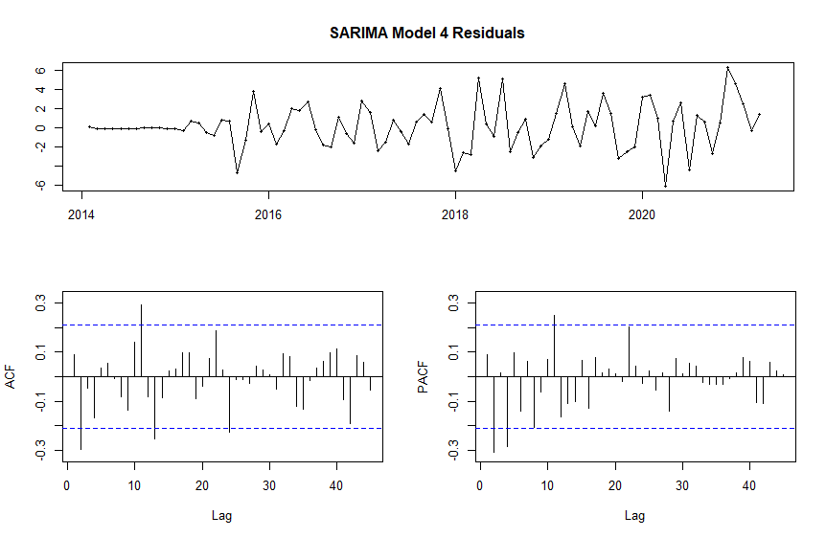The Auto.arima shows 2 non-seasonal terms and 0 seasonal for AR.

Holt Winters
This model shows exponential smoothing on the data.
Model 1
values.fit.hw1 <- ets(values.fit.ma, model="MAM", damped=FALSE)
values.fit.hw1
Results:
ETS(M,A,M)
Call:
ets(y = values.fit.ma, model = "MAM", damped = FALSE)
Smoothing parameters:
alpha = 0.2845
beta = 0.0372
gamma = 2e-04
Initial states:
l = 230.3517
b = -0.2942
s = 0.9805 1.0102 1.0097 1.0187 1.0225 1.0223
1.0172 1.0108 0.9909 0.9845 0.971 0.9616
sigma: 0.0184
AIC AICc BIC
675.4992 684.3688 717.4196
Plot(values.fit.hw1)
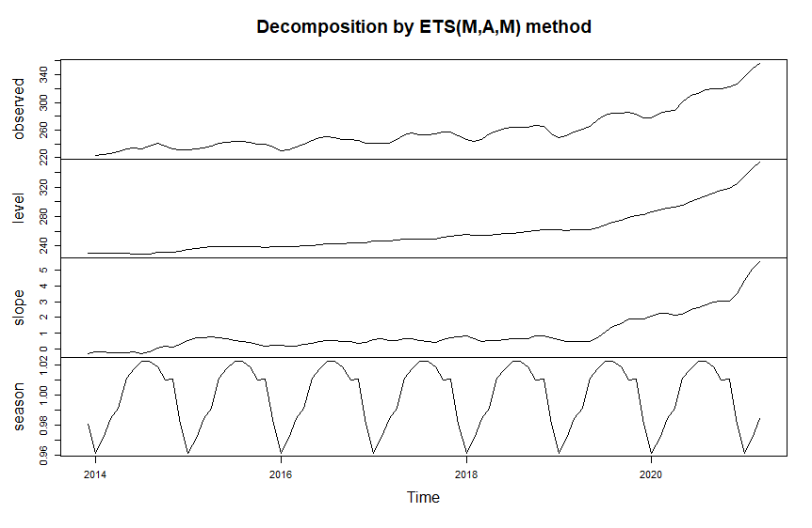
accuracy(values.fit.hw1)
Results:

ME RMSE MAE MPE MAPE MASE ACF1
Training set 1.785745, 4.822824, 3.169552, 0.5904164, 1.152957, 0.2181696, 0.6855246
Model 2
values.fit.hw2 <- ets(values.fit.ma, model="MAM",
damped=TRUE)
values.fit.hw2
Results:
ETS(M,Ad,M)
Call:
ets(y = values.fit.ma, model = "MAM", damped = TRUE)
Smoothing parameters:
alpha = 0.9999
beta = 0.1319
gamma = 1e-04
phi = 0.9534
Initial states:
l = 228.9442
b = 0.1643
s = 0.9791 0.9988 1.0091 1.0141 1.0182 1.0196
1.0232 1.0133 0.9956 0.9834 0.9757 0.9698
sigma: 0.0116
AIC AICc BIC
595.4691 605.5279 639.8554
plot(values.fit.hw2)
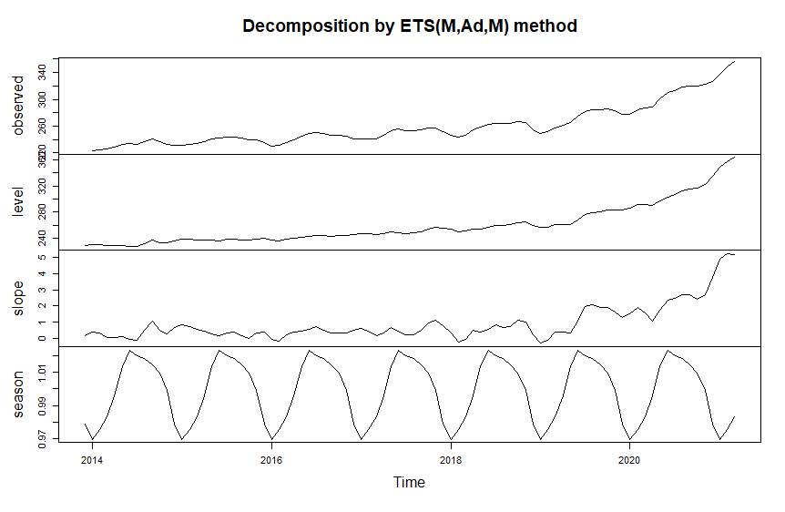
accuracy(values.fit.hw2)
Results:
ME RMSE MAE MPE MAPE MASE ACF1
Training set 0.7388153, 2.835673, 2.139511, 0.2428983, 0.8034506, 0.1472689, 0.3975071

Model evaluation and forecasting
Checking Accuracy
values.holdout <- window(values, start=2020,end=2021)
values2021 <- ts(values.holdout, start = c(2020, 1), frequency=12)
plot.ts(values2021)
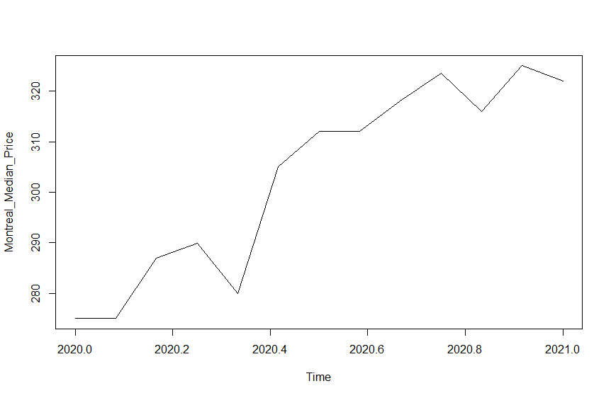

Forecasting using the chosen model(s)

Seasonal ARIMA
forecast.values.sarima4 <- forecast(values.fit.sarima4, h=12)
plot(forecast.values.sarima4)
lines(values2021, col="cyan", lwd=2, lty=3)
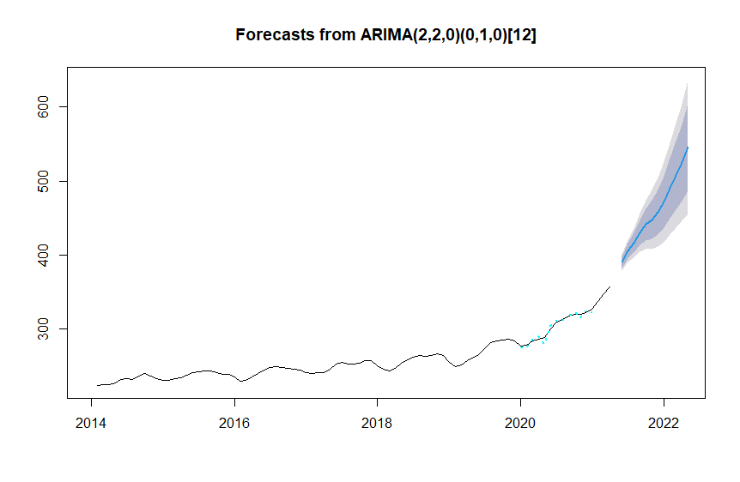
accuracy(forecast.values.sarima4, values2021)
Results:
ME RMSE MAE MPE MAPE MASE
Training set 0.03603153, 1.139661, 0.8698042, 0.01081753, 0.3539355, 0.1298755 ACF1 0.03935313
Test set 11.46374127 11.463741 11.4637413 4.16863319 4.1686332 1.7117169 NA

Box.test(residuals(values.fit.sarima4), type="Ljung-Box")
Results:
Box-Ljung test
data: residuals(values.fit.sarima4)
X-squared = 0.096098, df = 1, p-value = 0.7566

par(mfrow=c(2,2))
acf(na.omit(values.fit.sarima4$residuals))
pacf(na.omit(values.fit.sarima4$residuals))
plot(na.omit(values.fit.sarima4$residuals))
qqnorm(na.omit(values.fit.sarima4$residuals))
qqline(na.omit(values.fit.sarima4$residuals), col="cyan")
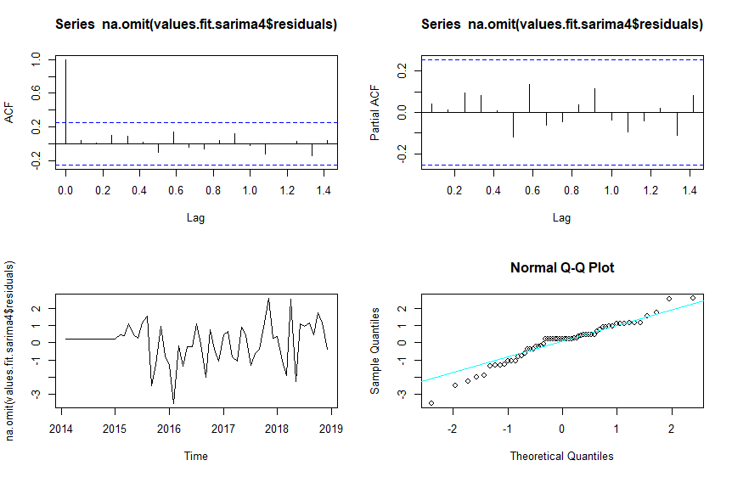

Holt Winters seasonal smoothing
plot(forecast(values.fit.hw2))
lines(values2021, col="cyan", lwd=2, lty=3)
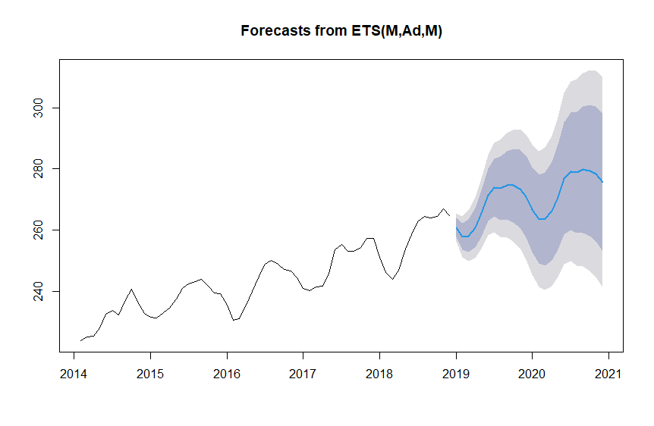
accuracy(forecast(values.fit.hw2), values2021)
Results:
ME RMSE MAE MPE MAPE MASE ACF1
Training set 0.3363142 1.876372 1.57032 0.1335901 0.6433088 0.2344735 0.1622858 Theil's U NA
Test set 25.5842728 28.685498 25.58427 8.3294081 8.3294081 3.8201343 0.6093803 2.704669

Box.test(residuals(values.fit.hw2), type="Ljung-Box")
Results:
Box-Ljung test
data: residuals(values.fit.hw2)
X-squared = 1.7218, df = 1, p-value = 0.1895

par(mfrow=c(2,2))
acf(values.fit.hw2$residuals)
pacf(values.fit.hw2$residuals)
plot(values.fit.hw2$residuals)
qqnorm(values.fit.hw2$residuals)
qqline(values.fit.hw2$residuals, col="cyan")
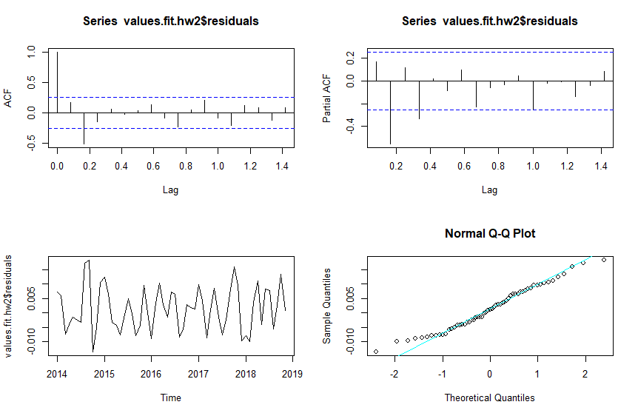

forecast.values.sarima4
Results:
Point Forecast Lo 80 Hi 80 Lo 95 Hi 95
Feb 2019 252.9291 249.2271 256.6310 247.2674 258.5907
Mar 2019 252.2582 248.2761 256.2403 246.1681 258.3483
Apr 2019 254.6536 250.6714 258.6358 248.5633 260.7439
May 2019 260.4908 256.5085 264.4730 254.4005 266.5811
Jun 2019 265.8459 261.8636 269.8281 259.7556 271.9362
Jul 2019 269.2804 265.2982 273.2627 263.1901 275.3707
Aug 2019 269.9264 265.9442 273.9087 263.8361 276.0167
Sep 2019 269.6535 265.6712 273.6357 263.5631 275.7438
Oct 2019 270.0664 266.0842 274.0486 263.9761 276.1567
Nov 2019 272.0145 268.0323 275.9967 265.9242 278.1048
Dec 2019 270.4256 266.4434 274.4078 264.3353 276.5159
Jan 2020 263.5363 259.4126 267.6599 257.2297 269.8428

Conclusion
I fitted 4 different SARIMA models and 2 exponential Holt Winters models to fit to the data. I tested their accuracy and chose both the 4th SARIMA and ETS model for the forecast. That forecast matches the holdout plot because the prices continued to rise sharply in 2021.
The graphs from plotting the data show a sharp rise in median prices from 2019 onwards, no doubt the spread of COVID had a part to play in this though prices were steadily increasing from 2014. The prices also seemed to spike in Spring, suggesting the prices were increased at that time of year because the real estate market is traditionally active in Spring. On average the prices were 5% higher in the spring so that’s a good time to sell. The sharp rise in prices in 2020 and 2021 is mirrored in the rest of the Canadian market – see here.
It would be a good idea to check the exact correlation with the general Canadian real estate market and also to check if there is any correlation with mortgage rates.

