About 2nd project

The first screen is contacts screen which has following things.

* Contacts shown in ascending order of their names.
* A floating plus icon to add new contacts.
* A search box to search contact names.
* A star icon on each contact tile to make a contact as favourite and unfavourite.
* A drawer menu to switch between contact list and favourite lists.
* Each contact is left swipable and containts delete and edit button.
* 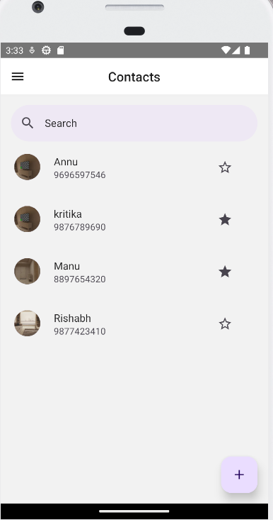

Drawer Menu.

This is a favourite screen.

Search Functionality.

Click on plus icon to see add new contact page.

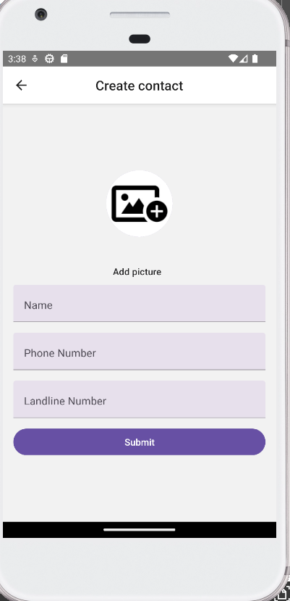

Validation applied for adding the contacts.

Swipe the contacts left to see the delete and edit button.

Message displayed after the user is deleted.

About 1st project.

First page is to add the Budget the budget.

This project has two screens.

The has used react redux.

Validation for the page .

After submitting successfully or clicking on cancel

The budget entry listing page will come

