TASK 1 – Size the Traffic Before Choosing Anything

1. Traffic of one line and of the plant
Converted every source to Mbps first, then added them up. For the robots: 200 bytes = 1,600 bits, sent every 2 ms, so each robot sends 500 commands a second.
Source | Working | Traffic per line
Robot controllers (40) | 1,600 bits × 500/s = 800 kbps each; 800 kbps × 40 | 32 Mbps
Vibration sensors (600) | 50 B = 400 bits; 400 bps × 600 = 240,000 bps | 0.24 Mbps
CCTV cameras (24) | 4 Mbps × 24 | 96 Mbps
Office users (150) | 10% active = 15 users; 15 × 2 Mbps | 30 Mbps
Total, one line | 32 + 0.24 + 96 + 30 | 158.24 Mbps

Plant with 8 lines: 158.24 × 8 = 1,265.92 Mbps, which is about 1.27 Gbps.

2. Biggest sender versus strictest delay
The biggest sender is CCTV with 96 Mbps, which is 60.7% of the line (robots are 20.2%, office 19.0% and sensors only 0.15%). The strictest delay belongs to the robot controllers: a 10 ms deadline, with a new command every 2 ms. So they are not the same source. The robots send only a fifth of the data, but they are the most sensitive to delay. This is why I cannot design the network by looking at volume alone.

3. Is one 1 Gbps uplink enough?
- One line: 158.24 Mbps is 15.8% of 1 Gbps, so it is fine.
- Eight lines: 1,265.92 Mbps is 126.6% of 1 Gbps. It is about 266 Mbps more than the link can carry, so the uplink is not enough for the full plant. Even at a safe 70% target (700 Mbps) it would be overloaded.
Robot commands in the same queue as CCTV: when the link is overloaded, the queue grows and every packet waits in the same line. A robot command stuck behind video frames is delayed. For example, if the switch buffer holds 1 MB (my assumption), draining it at 1 Gbps takes 8 ms, which already eats most of the 10 ms deadline. When the buffer is full, packets are dropped and TCP has to retransmit, which takes even longer. So the robots would miss their deadline. The fix is to put robot traffic in its own VLAN and priority queue (802.1p/DSCP, strict priority), and to limit CCTV or move to a 10 Gbps uplink.

4. Ranking by harm of a 100 ms delay
Rank | Traffic | Reason
1 | Robot commands | 100 ms is 10 times the 10 ms deadline, and 50 commands (100 / 2 ms) would be late. The robot can move wrongly, stop, or hit something.
2 | Vibration sensors | Readings come about once per second, so 100 ms is only a small shift, but a late alarm on a failing machine can cost money.
3 | CCTV video | The live picture is just 0.1 s behind. A receive buffer hides it, so no real harm.
4 | Office / ERP / e-mail | People do not notice 100 ms when loading a page or sending a mail.

Alternative Concept Analysis – motion-triggered CCTV
If cameras send clips only 5% of the time, CCTV becomes 24 × 4 Mbps × 0.05 = 4.8 Mbps.
 | Continuous CCTV | Motion clips only
One line | 158.24 Mbps | 32 + 0.24 + 4.8 + 30 = 67.04 Mbps
Eight lines | 1,265.92 Mbps (126.6%) | 536.32 Mbps (53.6%)

The line traffic falls by 57.6%, and the plant fits inside the 1 Gbps uplink with room to spare. So the uplink is no longer the bottleneck. The trade-off is that the live view is lost, the cameras need local storage, and a clip can still burst at full camera speed, so I would still keep the robot VLAN in a priority queue.
Evidence: 1 line = 158.24 Mbps, 8 lines = 1,265.92 Mbps; CCTV is the largest, robots are the strictest; ranking: robots > sensors > CCTV > office.

TASK 2 – Count the Domains in the Contractor’s Drawing

1. Collision and broadcast domains
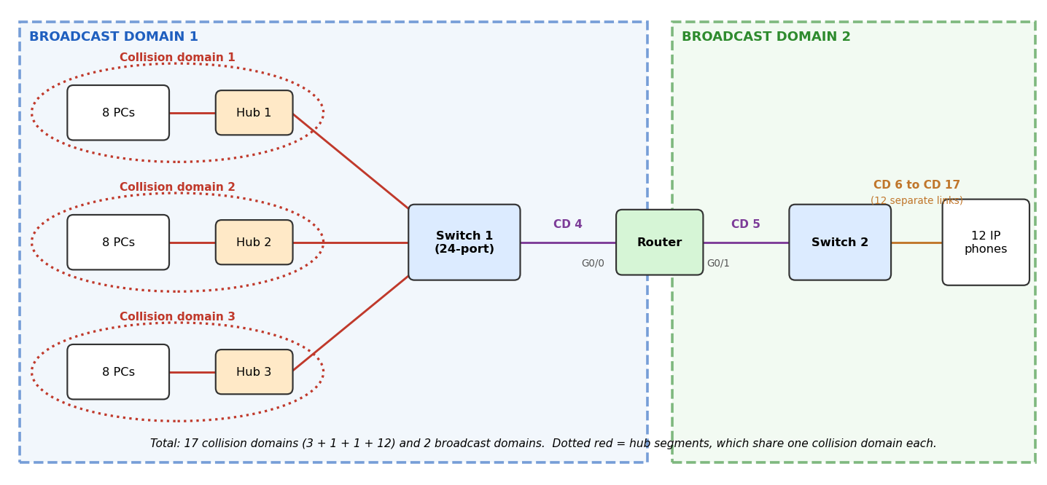
Figure 1: Marked drawing of the office block.
- Collision domains = 17. Each hub with its 8 PCs shares one collision domain, because a hub just repeats the signal to every port (3 domains). The switch–router link is 1 domain and the router–second switch link is 1 domain. The second switch gives every IP phone its own port, so 12 more domains. 3 + 1 + 1 + 12 = 17.
- Broadcast domains = 2. The switches and hubs pass broadcasts on, but the router does not. Everything on the left of G0/0 is one domain (24 PCs, hubs and switch 1), and the phones behind G0/1 are the second.

2. OSI layer of each device
Device | OSI layer | Reason
Hub | 1 – Physical | Only repeats bits and signals; it does not read any address.
Switch | 2 – Data link | Reads the MAC address and forwards only to the right port.
Router | 3 – Network | Reads the IP address and forwards between networks.
PCs and IP phones | 1 to 7 (all layers) | End devices that run the applications.

A hub cannot stop collisions because it knows nothing about addresses. It copies every frame to all other ports, so all the connected PCs share one wire electrically. If two PCs send at the same time, the signals collide and everyone on that hub sees it (CSMA/CD has to handle it, and half-duplex is forced).

3. Point-to-point and multipoint links
- Point-to-point: switch 1 to router G0/0, router G0/1 to switch 2, and each phone to switch 2. Only two devices are on each cable.
- Multipoint (shared): each hub segment, where 8 PCs and the uplink all share the same medium and compete for it.

4. Standards table
Technology | Standard | Body
Ethernet | IEEE 802.3 | IEEE
Wi-Fi | IEEE 802.11 (Wi-Fi Alliance certifies products) | IEEE
IPv4 | RFC 791 | IETF
OSI model | ISO 7498 | ISO
5G | 3GPP releases (IMT-2020 requirements) | 3GPP / ITU

The plant should buy only standard-compliant equipment because devices from different vendors then work together, we are not locked to one supplier, spares and upgrades are easier to find, and the equipment has been tested against the same rules (including safety and radio regulations).

Alternative Concept Analysis – three unmanaged switches instead of hubs
 | Hubs (now) | Switches | Change
Collision domains | 17 | 24 + 3 + 1 + 1 + 12 = 41 | more, each link is separate
Broadcast domains | 2 | 2 | no change

What it fixes: collisions between PCs disappear, each PC gets its own full-duplex 100 Mbps or 1 Gbps link instead of sharing, and bandwidth goes up a lot.
What it does not fix: the 24 PCs are still in one broadcast domain. Unmanaged switches also have no VLANs, no QoS, no port security or monitoring, so there is still no priority for important traffic. Those need managed switches.
Evidence: 17 collision domains and 2 broadcast domains on the marked drawing, device layers and standards table above.

TASK 3 – Read a Captured Frame Layer by Layer

1. Layer and PDU of each line
Line in capture | OSI layer | Protocol | PDU
Ethernet II | 2 – Data link | Ethernet | Frame
IPv4 | 3 – Network | IP | Packet
TCP | 4 – Transport | TCP | Segment
Data (Modbus write) | 7 – Application | Modbus | Data / message

2. Routers crossed
The controller sets TTL = 64 and the capture shows 61. Each router lowers the TTL by 1, so 64 − 61 = 3 routers were crossed.

3. Bytes on the wire and overhead
Ethernet header 14 bytes (6 + 6 + 2), IPv4 header 20, TCP header 20 (no options assumed), FCS 4. The preamble and inter-frame gap are not counted.
 | Robot command (12 B) | Camera packet (1,400 B)
Data | 12 | 1,400
Headers + FCS (14 + 20 + 20 + 4) | 58 | 58
Total on the wire | 70 bytes | 1,458 bytes
Overhead | 58 / 70 = 82.9% | 58 / 1,458 = 4.0%

Header cost is fixed per packet, so a tiny command wastes 83% of what is sent while a big packet wastes only 4%. For small commands the headers matter more than the data. It also means my Task 1 figures were payload only: 200-byte robot commands plus 58 bytes of headers would really be 258 bytes, so the robots would need about 41.3 Mbps per line instead of 32 Mbps.

4. Which layer handles each fault
Fault | Layer | What happens
(a) Wrong MAC address | Data link (2) | The NIC or switch does not match its own address and drops the frame.
(b) TTL reaches 0 | Network (3) | The router drops the packet and sends back an ICMP Time Exceeded.
(c) Destination port closed | Transport (4) | The host answers with a TCP reset (RST).

5. TCP/IP model mapped to OSI
TCP/IP layer | OSI layers
Application | Application, Presentation, Session (7, 6, 5)
Transport | Transport (4)
Internet | Network (3)
Network access (link) | Data link and Physical (2, 1)

Complete the Code – TODO 1
def send(message):
pdu = message
for layer, tag in LAYERS:
if tag == "ETH": # data link adds header and trailer
pdu = "[" + tag + "|" + pdu + "|FCS]"
else:
pdu = "[" + tag + "|" + pdu + "]"
print(f"{layer:<12} adds {tag:<4} -> {len(pdu):>3} bytes")
return pdu
Output (matches the expected output):
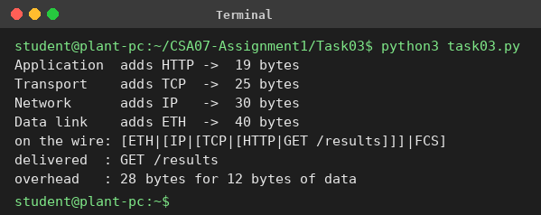
Then I changed the message to 1,400 bytes. In my toy model the 28 bytes of headers are 70.0% of a 12-byte message’s frame but only 2.0% of the 1,400-byte frame. With the real headers it is 82.86% against 3.98%, as calculated above.
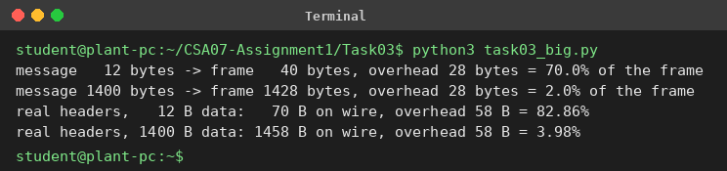

Alternative Concept Analysis – command directly in Ethernet (EtherType 0x8892)
- Headers saved: no IP (20 bytes) and no TCP (20 bytes), so 40 bytes per command. The frame would be 14 + 12 + 4 = 30 bytes.
- There is a catch: Ethernet needs at least 64 bytes per frame, so the 12-byte command is padded to 46 bytes of payload. Real frame = 64 bytes.
On a 100 Mbps link (12.5 MB/s) | With IP + TCP | Raw Ethernet | Gain
Bytes per command (no padding rule) | 70 | 30 | 40 saved
Commands per second | 178,571 | 416,667 | +238,095
Bytes per command (with 64-byte minimum) | 70 | 64 | 6 saved
Commands per second | 178,571 | 195,312 | +16,741

What the plant loses without IP: routing (the frames cannot cross a router, so no head-office access or remote monitoring), reliability (TCP’s retransmission, ordering and flow control), and layer-3 security such as firewalls and ACLs. Everything must stay in one flat Layer 2 network. The gain in speed is real but small for tiny commands because of the 64-byte minimum.
Evidence: layer-by-layer table, TTL gives 3 routers, 70 B (82.9%) versus 1,458 B (4.0%), faults mapped to layers 2, 3 and 4.

TASK 4 – Choose a Medium for Each Run (There Is a Trap)

1. Medium for each run
Run | Distance | Medium | Deciding reason
(a) Robot cell next to arc welders | 85 m | Cat6A S/FTP | Within the 100 m copper limit and the shielding blocks the welding noise (EMI).
(b) Office floor to shop-floor switch | 140 m | Multimode fibre | Over 100 m, so copper will not work. Fibre is also immune to electrical noise.
(c) Shop floor to data centre | 550 m | Single-mode fibre | 550 m is at or beyond the limit of multimode (about 300 to 550 m depending on speed); single-mode handles km and allows 10G.
(d) Plant to head office | 400 km | Leased line (carrier fibre) | Far beyond any cable we can own; the carrier provides the path, amplifiers and an SLA.

2. The trap
The trap is run (b). It looks like ordinary office wiring, but 140 m is above the 100 m limit of copper Ethernet, so a normal Cat6 cable would fail. Run (c) cannot use copper either, and run (d) cannot use any plant-owned cable at all. The only run that works with copper is (a), and it needs the shielded type.

3. Shannon capacity
C = B × log2(1 + SNR), with SNR as a ratio = 10^(dB / 10).
- 40 dB: SNR = 10,000. C = 250 MHz × log2(10,001) = 3,321.96 Mbps.
- 15 dB: SNR = 31.62. C = 250 MHz × log2(32.62) = 1,256.95 Mbps.
Noise near the welders cuts the theoretical ceiling by about 62% (3,322 to 1,257 Mbps). For the robot cell it means that an ordinary unshielded cable would get a poor SNR, more bit errors and more retransmissions, and so more delay. That is why I choose shielded S/FTP. The robots need only about 32 Mbps per line, so capacity is not the problem; reliability is.

4. Why measured speed is below the Shannon limit
Shannon gives a perfect upper limit that needs ideal coding. Real links use practical modulation and error-correcting codes, lose bits to headers, preamble, inter-frame gaps, ACKs and retransmissions, and suffer from crosstalk, attenuation and noise that changes over time. So the measured rate is always lower.

Complete the Code – TODO 1 and TODO 2
def nyquist(bandwidth_hz, levels):
return 2 * bandwidth_hz * math.log2(levels)

def shannon(bandwidth_hz, snr_db):
snr = 10 ** (snr_db / 10)
return bandwidth_hz * math.log2(1 + snr)
Output (first four lines match the expected output; the rest is my extra work):
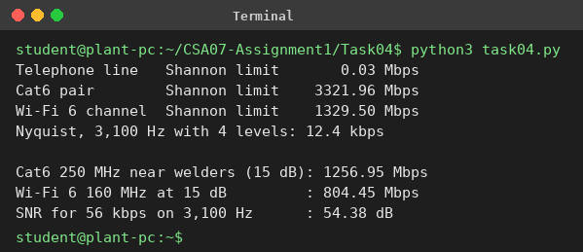
SNR needed for 56 kbps on a 3,100 Hz line: 1 + SNR = 2^(56,000 / 3,100) = 2^18.06, so SNR ≈ 274,000, which is 54.38 dB. A normal analogue telephone line gives about 30 to 35 dB, so 54 dB is not realistic. (The old 56k modems only worked because the ISP end was digital, which removed one noisy analogue conversion.)

Alternative Concept Analysis – Wi-Fi 6 in the robot cell
160 MHz at 15 dB: C = 160 MHz × log2(32.62) = 804.45 Mbps. That is far more than the 32 Mbps the robots need, so capacity is not the problem. The problem is delay and jitter. Wi-Fi uses CSMA/CA with random back-off on a shared, unlicensed channel, retransmits when a frame is lost, and welding adds interference. None of that can guarantee every command arrives within 10 ms. So I would not use Wi-Fi for the robot commands. Shielded cable stays for the robots; Wi-Fi can be used for non-critical devices.
Evidence: medium for each run, trapped run (b) found, Shannon values 3,321.96 and 1,256.95 Mbps, and 804.45 Mbps for Wi-Fi 6.

TASK 5 – Wi-Fi 6 or 5G for Moving Equipment?

1. Hand-overs and unreachable time
The AGV needs 1,200 m / 2 m/s = 600 s (10 minutes) for one trip.
 | Wi-Fi (APs 30 m apart) | Private 5G (cells 300 m)
Cells along the route | 1,200 / 30 = 40 | 1,200 / 300 = 4
Hand-overs per trip | 39 | 3
Time per hand-over | 150 ms | 20 ms
Unreachable per trip | 39 × 150 ms = 5.85 s | 3 × 20 ms = 60 ms
Share of the trip | 5.85 / 600 = 0.98% | 0.06 / 600 = 0.01%
10 ms command slots missed | 39 × 15 = 585 | 3 × 2 = 6

Even one Wi-Fi hand-over (150 ms) is 15 times the 10 ms deadline. The 5G hand-over of 20 ms is also above 10 ms, but it is much shorter and happens only 3 times. It can be reduced further with overlapping cells and dual connectivity.

2. 5G service type for each device
Device | 5G service | Reason
AGVs | URLLC | 10 ms deadline and very high reliability needed.
CCTV cameras | eMBB | High bandwidth: 24 × 4 Mbps = 96 Mbps per line.
Sensors | mMTC | Huge number of devices, tiny data (600 × 50 B/s).

3. Where Bluetooth, Zigbee or LoRa are better
- Bluetooth (BLE): short range (about 10 m) such as tool tags, wearable badges for workers, handheld scanners and headsets.
- Zigbee: low-power mesh for many small sensors and switches inside a hall, for example temperature, door and lighting sensors.
- LoRa: long range, very low data and years on a battery, for example tank levels, outdoor yards, remote buildings and slow temperature reporting.
They are better where devices send tiny amounts of data, run on batteries and cost must be low. Wi-Fi and 5G would be overkill and drain the battery.

4. Could Wi-Fi 6 with 802.11r meet the deadline?
802.11r fast roaming reduces the hand-over, commonly to around 50 ms (a figure I am assuming). Then 39 × 50 ms = 1.95 s per trip, and each hand-over is still 5 times the 10 ms deadline, so it would still miss commands. What stays risky: contention and random back-off on the shared channel, interference in unlicensed bands, the client deciding when to roam (sticky clients), and no hard delay guarantee. So Wi-Fi 6 is not safe for 10 ms AGV commands.

Alternative Concept Analysis – LoRaWAN for the sensors
600 sensors × 50 bytes per second = 30,000 B/s = 240 kbps. One LoRa gateway handles about 5 kbps, so 240 / 5 = 48 times too much. At 50 B/s each (400 bps), a gateway can serve only about 12 sensors. So the vibration sensors cannot go on LoRa.
If a sensor sends 50 bytes only once a minute, it needs 400 / 60 = 6.7 bps, and 600 of them need 4 kbps, which fits in the 5 kbps (80% load). Decision: slow sensors (temperature, once a minute) go on LoRa, while the fast vibration sensors stay on Wi-Fi (or wired/5G mMTC).
Evidence: 39 against 3 hand-overs, 5.85 s against 0.06 s per trip, service types mapped, LoRa load 240 kbps against 5 kbps.

TASK 6 – Interpret an Ethernet Port Report

1. What the counters mean
- Late collision: a collision detected after the first 64 bytes (512 bits) have been sent. On a healthy half-duplex link collisions should happen early, so a late one means the other end is transmitting when it should not, or the cable is too long.
- CRC error: a frame arrived but its FCS did not match, so it was corrupted (noise, a collision fragment, or a bad cable/NIC).
Together (412 late collisions and 1,907 CRC errors, which add up to most of the 2,381 rx_errors) they point to a duplex mismatch: one end is half duplex and the other is full duplex. The full-duplex end sends without listening, the half-duplex end sees late collisions, and the frames get broken and fail the CRC.

2. Likely cause and the fix
The PC is fixed at 100 Mb/s half duplex with auto-negotiation off, while the gigabit switch port is on auto (or full). The two ends do not agree. The fix is to let both ends auto-negotiate (gigabit Ethernet actually needs auto-negotiation).
# Linux
sudo ethtool -s eth0 autoneg on
ethtool eth0 # check: Speed 1000Mb/s, Duplex Full

# Windows (PowerShell, as administrator)
Set-NetAdapterAdvancedProperty -Name "Ethernet" -DisplayName "Speed & Duplex" -DisplayValue "Auto Negotiation"

# Cisco switch port (keep it on auto too)
interface gigabitEthernet 1/0/12
speed auto
duplex auto
After the change I would clear the counters and check that late collisions and CRC errors stay at 0.

3. MAC addresses
- 01:00:5e:0a:01:02 is a group address. The first byte 01 = 00000001, and its last bit (the I/G bit) is 1, which means group/multicast. The prefix 01:00:5e is IPv4 multicast, and the last 23 bits map to an address like 224.10.1.2.
- 3c:52:82:4e:11:07: the first three bytes 3c:52:82 are the OUI, which identifies the manufacturer of the network card (assigned by IEEE). The last three bytes 4e:11:07 are the card’s own number. The first byte 3c has its I/G bit as 0, so it is a unicast address.

4. Jumbo frames for the CCTV storage server
Yes, they would help. With a 1,500-byte MTU the useful data is 1,460 of every 1,538 bytes on the wire (94.9%). With 9,000 bytes it is 8,960 of 9,038 (99.1%), and the server handles about six times fewer packets, so less CPU and fewer interrupts.
For them to work, everything on the path must be changed to the same large MTU: the server NIC, the storage, every switch port in between (jumbo frames enabled on the switches), and the cameras’ VLAN or a separate storage VLAN. A router would have to fragment them, and a device that does not support jumbo frames drops them. I would not use them on the robot VLAN. On Linux: ip link set eth0 mtu 9000.

Alternative Concept Analysis – ring versus star
One cable cut | Ring with fast recovery | Star of switches
Recovery time | About 200 ms with MRP (10 to 30 ms with the fast profiles); RSTP takes seconds | No automatic recovery; it lasts until the cable is repaired (minutes to hours)
Who loses connection | Everything that crosses the cut link for a moment; afterwards nobody, traffic goes the other way round the ring | The device behind the cut cable; if it is an uplink, the whole group of devices behind it
Trade-off | Less cable, survives one failure, but a 200 ms gap is 20 missed robot commands | Simple and a failure stays local, but uplinks need a second path

For the shop floor I would use a ring with the fastest recovery profile between the line switches (the backbone), and a star for the robots, so that one cut cannot cut off a whole line.
Evidence: duplex mismatch diagnosed, commands given, 01:00:5e... is multicast, 3c:52:82 is the vendor OUI, jumbo frames raise efficiency from 94.9% to 99.1%.

TASK 7 – Will the Receiver Notice the Error?

1. CRC of 1101011011 with generator 1011
The generator has 4 bits, so I add 3 zeros to the data: 1101011011000. Then I do the modulo-2 division, XOR-ing 1011 under every leading 1:
1101011011000 <- data + 000
1011 <- divisor under the leading 1 (bit 1)
-------------
0110011011000
1011 <- divisor under the leading 1 (bit 2)
-------------
0011111011000
1011 <- divisor under the leading 1 (bit 3)
-------------
0001001011000
1011 <- divisor under the leading 1 (bit 4)
-------------
0000010011000
1011 <- divisor under the leading 1 (bit 6)
-------------
0000000101000
1011 <- divisor under the leading 1 (bit 8)
-------------
0000000000100

remainder (last 3 bits) = 100
CRC bits = 100. Transmitted frame = 1101011011100. The program gives the same result.

2. Received frame 1101011011101
Dividing 1101011011101 by 1011 leaves the remainder 001, which is not zero. So the frame is rejected. The received frame differs from the transmitted one only in the last bit, which is why the remainder is 001.

3. Burst errors and an undetectable error
The generator has 3 check bits (degree 3), so it is certain to detect any burst error up to 3 bits long. A burst of 4 bits can slip through if the error pattern is exactly the generator.
An error pattern that it cannot detect is the generator itself, 1011, at any position, for example 0000000001011. The error polynomial is then a multiple of x³ + x + 1, so (frame + error) still divides with remainder 0, and the receiver accepts a wrong frame. My program confirmed this (see the screenshot below, three shifted positions of 1011 are accepted).

4. Two-dimensional parity
I picked this 4 × 4 block. The last column holds the even row parity, the last row holds the even column parity.
 | c1 | c2 | c3 | c4 | row parity
row 1 | 1 | 0 | 1 | 1 | 1
row 2 | 0 | 1 | 1 | 0 | 0
row 3 | 1 | 1 | 0 | 0 | 0
row 4 | 0 | 0 | 1 | 1 | 0
col parity | 0 | 0 | 1 | 0 | 1

A 4-bit error pattern it misses: flip the four corners of a rectangle, for example the bits in row 1/column 1, row 1/column 2, row 2/column 1 and row 2/column 2. Every affected row and every affected column now has two flips, so all the parities still match and nothing is noticed.

5. Internet checksum of 4500, 0073, 0000, 4000
Add the words: 4500 + 0073 = 4573; 4573 + 0000 = 4573; 4573 + 4000 = 8573. There is no carry to add back. The one’s complement of 8573 is FFFF − 8573 = 7A8C. So the checksum = 7A8C.

Complete the Code – TODO 1
def mod2_div(dividend, divisor):
rem = list(dividend)
for i in range(len(dividend) - len(divisor) + 1):
if rem[i] == "1":
for j in range(len(divisor)):
rem[i + j] = str(int(rem[i + j]) ^ int(divisor[j]))
return "".join(rem[-(len(divisor) - 1):])
Output (the first four lines match the expected output; below them is my search for undetected errors):
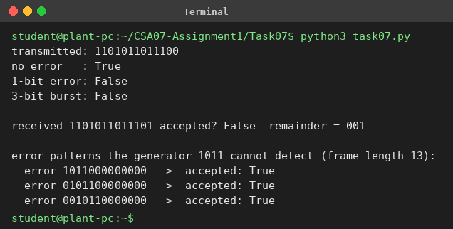
In the output, False means the check failed, so the error was detected. The three-bit burst was detected, as expected.

Alternative Concept Analysis – even parity versus CRC-3
I tested five error patterns on the 13-bit frame (for parity, one extra parity bit is added):
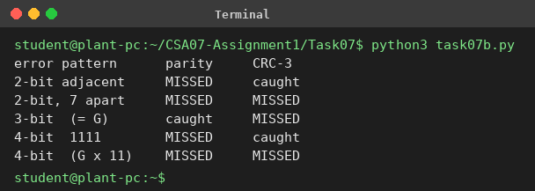
Error pattern | Even parity | CRC-3 (1011) | Note
2-bit: 0000000000011 | missed | caught | adjacent bits
2-bit: 1000000100000 | missed | missed | 7 apart (x⁷ + 1 is a multiple of G)
3-bit: 0000000001011 | caught | missed | odd weight, equals G
4-bit: 0000000001111 | missed | caught | CRC remainder is 100
4-bit: 0000000011101 | missed | missed | = G × (x + 1)

Caught by parity but missed by CRC-3: odd-weight errors that are multiples of the generator, such as the 3-bit pattern 1011. Caught by CRC but missed by parity: any even-weight error that is not a multiple of G, such as 11 and 1111.
Parity can only see an odd number of flipped bits, so it misses every even-sized error. CRC-3 is much stronger overall: it catches all single bits, all bursts up to 3 bits, and most other patterns, and it only misses error patterns that are exact multiples of the generator. A real Ethernet CRC-32 is stronger again.
Evidence: CRC = 100, frame 1101011011100, received frame rejected (remainder 001), checksum = 7A8C, and undetected errors shown for both methods.

TASK 8 – Correct the Error or Ask Again?

1. Hamming check bits for a 16-bit word
The rule is 2^r ≥ m + r + 1, with m = 16.
- r = 4: 2⁴ = 16, but m + r + 1 = 21. 16 is less than 21, so 4 bits are not enough.
- r = 5: 2⁵ = 32, and m + r + 1 = 22. 32 is at least 22, so 5 bits work.
Answer: 5 check bits. The codeword is 21 bits. Overhead = 5/16 = 31.25% on top of the data (5/21 = 23.8% of what is transmitted).

2. Minimum Hamming distance of {00000, 01011, 10101, 11110}
Pair | XOR | Distance
00000 and 01011 | 01011 | 3
00000 and 10101 | 10101 | 3
00000 and 11110 | 11110 | 4
01011 and 10101 | 11110 | 4
01011 and 11110 | 10101 | 3
10101 and 11110 | 01011 | 3

Minimum distance d = 3. It can detect d − 1 = 2 errors and correct (d − 1)/2 = 1 error.

3. Correcting 0110111 (sent as 0110011)
Bits 1 to 7 of the received word are 0, 1, 1, 0, 1, 1, 1.
- s1 (positions 1, 3, 5, 7): 0 ⊕ 1 ⊕ 1 ⊕ 1 = 1
- s2 (positions 2, 3, 6, 7): 1 ⊕ 1 ⊕ 1 ⊕ 1 = 0
- s3 (positions 4, 5, 6, 7): 0 ⊕ 1 ⊕ 1 ⊕ 1 = 1
Error position = s1 + 2·s2 + 4·s3 = 1 + 0 + 4 = 5. Flipping bit 5 gives 0110011. The data bits (positions 3, 5, 6, 7) are 1011.
Corrected codeword: 0110011. Corrected data: 1011.

4. FEC or ARQ for this link?
Bit-error rate = 0.001, 16-bit reading, retransmission takes 40 ms.
 | Hamming FEC | Retransmission (ARQ)
Bits per reading | 16 + 5 = 21 (fixed) | 16 / (1 − 0.0159) ≈ 16.26 (average)
Chance of trouble | 2 or more errors in 21 bits ≈ 0.02% | 1 − 0.999¹⁶ ≈ 1.59% need resending
Average extra delay | about 0 ms (0.008 ms if the rare failures are resent) | 0.0161 × 40 ms ≈ 0.65 ms
Worst-case delay | none for single errors | 40 ms, about 1 reading in 63
Needs a return channel | No | Yes (ACK / NAK)

My choice: FEC. ARQ sends fewer bits on average at this error rate, so on pure efficiency it wins. But a vibration sensor is used for live monitoring, and about one reading in 63 would be 40 ms late. That jitter matters more than 5 extra bits. FEC gives a steady delay and does not need the receiver to answer. If the error rate got worse, ARQ would get worse while FEC overhead stays the same. If the radio link loses bits in bursts, I would add interleaving or a CRC as a backup.
Why video streaming and 5G use FEC: video is real time, so a packet that arrives after its play-out time is useless and waiting for a retransmission is pointless. Streaming also goes to many viewers, so the sender cannot resend separately to each. 5G uses strong codes (LDPC and polar) because the radio channel is noisy and resending adds delay; it adds a quick hybrid ARQ on top, but FEC does the main work.

Complete the Code – TODO 1
def decode(c):
s1 = c[0] ^ c[2] ^ c[4] ^ c[6] # positions 1,3,5,7
s2 = c[1] ^ c[2] ^ c[5] ^ c[6] # positions 2,3,6,7
s3 = c[3] ^ c[4] ^ c[5] ^ c[6] # positions 4,5,6,7
pos = s1 + 2 * s2 + 4 * s3
c = c[:] # work on a copy
if pos != 0:
c[pos - 1] ^= 1 # flip the bad bit
return pos, [c[2], c[4], c[5], c[6]]
Output (matches the expected output):
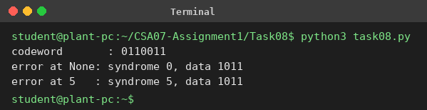
Flipping two bits: I flipped bits 3 and 5 of 0110011, giving 0100111. The syndrome is the XOR of the two positions, 3 ⊕ 5 = 6, so the decoder flips bit 6, which was correct. Now three bits are wrong and the data is 0101 instead of 1011, with no warning. Distance 3 can correct one error, but two errors look like a different single error.
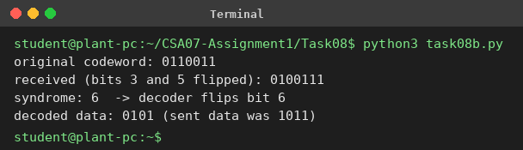

Alternative Concept Analysis
The table in part 4 is the comparison: Hamming sends 21 bits with about 0 ms added delay, retransmission sends about 16.26 bits with about 0.65 ms average delay and 40 ms spikes. Because the sensor data is time-sensitive, Hamming correction is the better choice.
Evidence: 5 check bits, d = 3, 0110111 corrects to 0110011 (data 1011), FEC chosen for steady delay.

TASK 9 – How Big Must the Window Be?
Link: 400 km of fibre at 1 Gbps, frames of 1,500 bytes (12,000 bits), speed 2 × 10⁸ m/s.

1. Timing
- Transmission time = 12,000 / 10⁹ = 12 µs
- Propagation time = 400,000 / (2 × 10⁸) = 2 ms = 2,000 µs
- a = 2,000 / 12 ≈ 166.67

2. Stop-and-wait utilisation
U = 1 / (1 + 2a) = 1 / 334.33 ≈ 0.00299, which is 0.3%. In Mbps that is 0.00299 × 1,000 ≈ 3 Mbps. So the 1 Gbps link behaves like a 3 Mbps link, because the sender waits for each ACK.

3. Smallest window and sequence-number bits
W ≥ 1 + 2a = 334.33, so W = 335 frames.
- Go-Back-N: W ≤ 2ⁿ − 1, so 2ⁿ ≥ 336. 2⁸ = 256 is too small, 2⁹ = 512 works. 9 bits.
- Selective Repeat: W ≤ 2ⁿ⁻¹, so 2ⁿ⁻¹ ≥ 335. 2⁸ = 256 is too small, 2⁹ = 512 works, so n = 10. 10 bits.

4. Which resends fewer frames after one loss?
Selective Repeat. It resends only the lost frame. Go-Back-N resends the lost frame and everything after it, which could be up to about 335 frames here. The cost to the receiver is that Selective Repeat needs a buffer to hold the out-of-order frames until the missing one arrives, a window of 335 frames, and it must acknowledge each frame separately. The Go-Back-N receiver needs a buffer of only 1 frame.

5. Frame delimiting in HDLC and PPP
- HDLC: frames start and end with the flag 01111110 (0x7E). Bit stuffing keeps that pattern out of the data: after five 1s in a row, the sender inserts a 0 and the receiver removes it.
- PPP: uses the same 0x7E flag. On byte-oriented links it uses byte stuffing: 0x7E or 0x7D inside the data becomes 0x7D followed by the byte XOR 0x20.

Complete the Code – TODO 1
def utilisation(frame_bits, rate_bps, distance_m, window, speed=2e8):
tx = frame_bits / rate_bps # transmission time
prop = distance_m / speed # propagation time
a = prop / tx
u = min(1, window / (1 + 2 * a))
return u, a
Output (the first three lines match the expected output; the rest is extra):
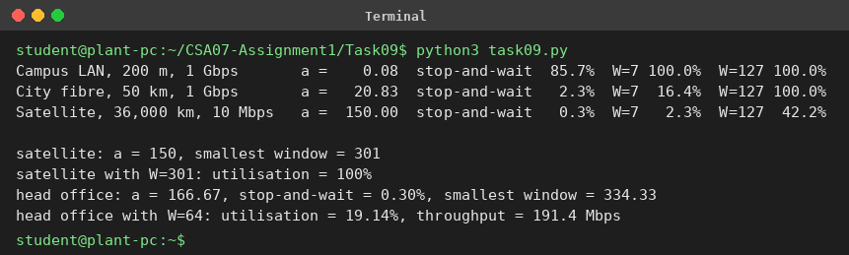
Smallest window on the satellite link: a = 150, so W ≥ 1 + 2 × 150 = 301 frames. The program confirms that W = 301 gives 100% (and W = 127 gives only 42.2%).

Alternative Concept Analysis – Selective Repeat, window 64
- Utilisation = 64 / 334.33 = 19.1%.
- Throughput = 0.191 × 1 Gbps ≈ 191 Mbps.
- Receiver buffer = 64 × 1,500 B = 96,000 B ≈ 96 KB.
 | W = 64 | W = 335
Utilisation | 19.1% | 100%
Throughput | 191 Mbps | 1 Gbps
Receiver buffer | 96 KB | about 502.5 KB
Sequence bits (SR) | 7 | 10

A window of 64 uses less memory but wastes more than 80% of the link. About 500 KB of buffer is cheap on modern hardware, so the bigger window is worth it. Protocol choice: Selective Repeat.
Evidence: a = 166.67, stop-and-wait 0.3% (about 3 Mbps), window 335, 9 bits for Go-Back-N and 10 for Selective Repeat, W = 301 on the satellite link.

TASK 10 – Find Where the Delay Comes From

1. Propagation delay
400 km / (2 × 10⁸ m/s) = 2 ms one way. Traceroute shows round-trip times, so the round trip is 4 ms. The last hop is about 12.6 ms (average of 12.6, 12.4 and 12.9). So propagation explains 4 / 12.6 ≈ 32% of the delay. The other 8.6 ms is queueing, processing and serialisation in the routers, and a fibre path that is longer than the straight 400 km.

2. The 38.2 ms value and the stars
- Hop 3, 38.2 ms: not a fault. The router answers traceroute with its control-plane CPU at low priority, so one reply was slow. The hops after it (11.5 to 12.9 ms) are normal, so the real path was not slow. If the path itself had been delayed, all later hops would show 38 ms or more.
- Hop 5, * * *: not a fault either. That router is set not to answer ICMP (or rate-limits it), but it still forwards packets, because hop 6 answers normally.

3. Which hop adds the most delay
Hop | Average RTT | Increase over previous | Comment
1 | 0.57 ms | 0.57 | Local gateway
2 | 3.13 ms | 2.57 | 100.64.0.1 is carrier-grade NAT (ISP)
3 | 4.1 ms (without the spike) | 0.97 | Spike ignored
4 | 11.8 ms | 7.70 | Largest jump, the long-distance WAN link
6 | 12.63 ms | 0.83 | Head-office server

Hop 4 (103.21.8.17) adds the most, about 7.7 ms. This fits the 4 ms round-trip propagation of the 400 km plus about 3.7 ms of carrier equipment and queueing.

4. Traceroute, ping and Wireshark capture
Commands I run and screenshot (Windows: tracert; Linux: traceroute):
tracert example.com (Linux/Mac: traceroute example.com)
ping -n 10 example.com (Linux/Mac: ping -c 10 example.com)
Wireshark display filter: icmp or tcp.port == 443

[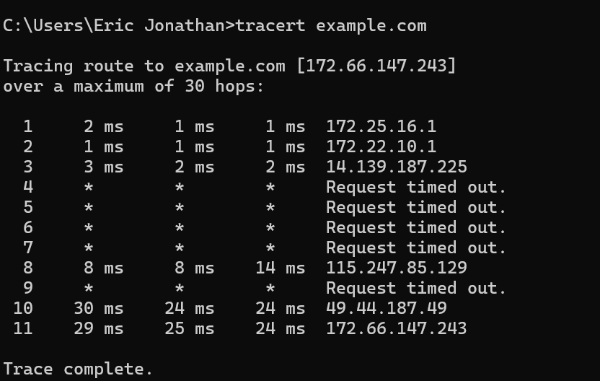

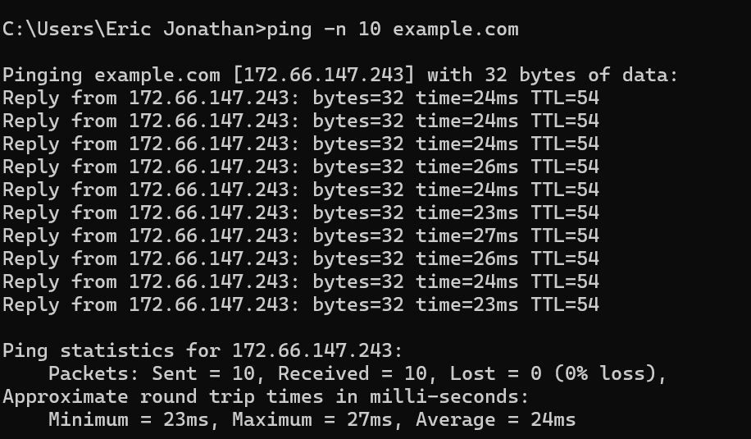

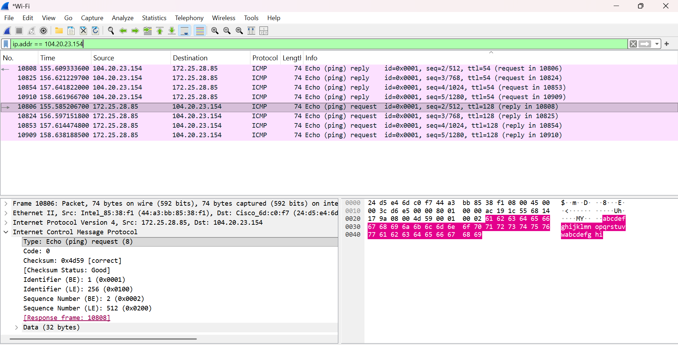

Layer | Header (from my capture) | What to note
Data link | Ethernet II | Source and destination MAC, EtherType 0x0800
Network | IPv4 | Source and destination IP, TTL, protocol
Transport | TCP / ICMP | Ports, sequence numbers, flags (or ICMP type and code)
Application | HTTP / DNS / TLS | Application data

Alternative Concept Analysis – SNMP and NetFlow versus ping and traceroute
Problem | SNMP counters | NetFlow | Ping / traceroute
Spike at hop 3 | Shows interface drops or high CPU/queue if polled around then; polling every 30 to 60 s | Does not measure delay | Only if someone runs it at that moment; one sample can mislead (as here)
Hop 5 stars | Shows the interface is up and carrying traffic, so no fault | Shows normal flows through it | Cannot tell a fault from ICMP filtering
Hop 4 big delay | Link utilisation and errors show whether it is congestion | Shows which flows (for example CCTV) fill the link | Measures the delay but not the cause
How quickly | 30 to 60 s (traps in seconds) | 1 to 60 s (export timers) | Only when run

Continuous monitoring catches problems as they happen and keeps history for comparison, while manual tests only show a snapshot. One limit: SNMP and NetFlow work only on devices I manage, and hops 3 to 5 belong to the ISP, so for them I can use only active probes such as a scheduled ping or IP SLA.
Evidence: 2 ms one-way (4 ms round trip) explains 32% of 12.6 ms; hop 3 and hop 5 are not faults; hop 4 adds the most (7.7 ms); my own captures go in the marked spaces.

TASK 11 – Defend the Network Design

1. Medium, wireless and Ethernet settings per area
Area | Choice | Numbers that justify it
Robot cell (85 m) | Cat6A S/FTP, 1 Gbps full duplex, auto-negotiation on both ends, own VLAN with priority queue | Robots 32 Mbps per line (Task 1); shielded to beat welding noise (SNR 15 dB gives 1,257 Mbps, Task 4); duplex mismatch must be avoided (Task 6).
Office floor (140 m) | Multimode fibre to the shop-floor switch; Wi-Fi 6 for office users | 140 m is over the 100 m copper limit; office peak is only 30 Mbps per line.
Shop floor to data centre (550 m) | Single-mode fibre, 10 Gbps uplink | 8 lines need 1,266 Mbps, which is 126.6% of 1 Gbps (Task 1), so 10 Gbps (12.7%).
Plant to head office (400 km) | Carrier leased line, 1 Gbps with an SLA, plus a backup path | Propagation 2 ms one way; the traceroute shows 12.6 ms in total (Task 10).
AGVs (moving) | Private 5G, URLLC | 3 hand-overs of 20 ms (60 ms per trip) against 39 of 150 ms (5.85 s) on Wi-Fi (Task 5).
Sensors | Vibration sensors on Wi-Fi or wired; slow temperature sensors on LoRa or Zigbee | Vibration: 240 kbps per line, too much for LoRa’s 5 kbps; once-a-minute sensors need 4 kbps (Task 5).
CCTV | Cable, with motion-triggered clips | 96 Mbps per line is 60.7% of all traffic; clips cut it to 4.8 Mbps (Task 1).

2. Error control and flow control per link
Link | Method | Calculation
Wired shop floor | Ethernet CRC-32 detection, retransmit by upper layer | Wired BER is tiny, so errors are rare and a resend costs only one small command.
Noisy sensor radio link | Forward error correction (Hamming) | 21 bits with about 0 ms extra delay against ARQ’s 40 ms spikes on 1.6% of readings (Task 8).
Head-office link | Sliding window (Selective Repeat or TCP with SACK), window of 335 frames | Stop-and-wait gives 0.3% (about 3 Mbps); window 335 gives 100%; needs 10 sequence bits (Task 9).
AGV 5G link | 5G’s own FEC and hybrid ARQ | URLLC is built to give very high reliability within the 10 ms deadline.

3. The two biggest remaining risks
- The 5G hand-over of 20 ms is still above the 10 ms deadline. With 50 AGVs there would still be 3 × 2 = 6 missed slots per trip each. I would reduce this with overlapping cells and dual connectivity, and make the AGV stop safely if it hears nothing for 10 ms.
- A single path to the head office. One leased line is one point of failure for ERP and production data. I would add a second provider or a backup link. The robots keep working locally, but the plant loses head-office data.

4. Does it still work for five plants?
Yes, if CCTV stays local. Five plants with continuous CCTV would be 5 × 1,266 = 6,330 Mbps, which would never fit. With CCTV kept local, only production, sensor and office data cross the WAN (sensors are only about 2 Mbps per plant). Each plant gets its own leased line, and the head-office side needs a 10 Gbps core. With 1,500 devices per plant (7,500 in all) I would use VLANs and a separate subnet per area to keep broadcast domains small (Task 2), and routing between plants.

Alternative Concept Analysis – everything on private 5G
Traffic (per line) | Mbps | Share | Where
Robot commands | 32 | 20.2% | 5G (URLLC): needs low delay and mobility
Sensors | 0.24 | 0.15% | 5G (mMTC) or LoRa
Office users | 30 | 19.0% | Wi-Fi or cable
CCTV | 96 | 60.7% | Cable: fixed cameras, most of the data

5G should carry the traffic that needs mobility or hard delay limits: AGVs, robot commands and the many small sensors, about 32.24 Mbps per line (258 Mbps for 8 lines, about 20% of the total). The CCTV cameras do not move and produce 60.7% of the traffic, so putting them on a shared 5G cell would use up its capacity. They must stay on cable. The backbone also has to stay on fibre anyway, because the 5G base stations themselves need wired backhaul.
Evidence: each recommendation above quotes numbers from Tasks 1 to 10.

TASK 12 – Re-evaluate and Adapt the Design
New requirement: private 5G on the shop floor and 50 AGVs that must never miss a command. My decision is to MODIFY the original design (not redesign everything).

A. Impact Analysis
The task gives no AGV traffic figures, so I am assuming each AGV receives a 200-byte command every 10 ms (160 kbps) and sends one 4 Mbps camera stream, like a CCTV camera. That is 4.16 Mbps per AGV, so 50 AGVs add 208 Mbps (8 Mbps of commands and 200 Mbps of video).
Plant traffic (8 lines) | Continuous CCTV | Motion-triggered CCTV
Before AGVs (Task 1) | 1,265.92 Mbps | 536.32 Mbps
AGVs added | +208 Mbps (+16.4%) | +208 Mbps
After AGVs | 1,473.92 Mbps | 744.32 Mbps
On a 1 Gbps uplink | 147% (not enough) | 74% (too high)
On a 10 Gbps uplink | 14.7% | 7.4%

- Media: the 5G radio units need fibre backhaul and power, and the uplink must grow from 1 Gbps to 10 Gbps.
- Wireless: Wi-Fi is no longer suitable for the moving AGVs; they move to private 5G.
- Error control: the AGV link now relies on 5G’s FEC and hybrid ARQ; the QoS settings must mark AGV commands as the highest priority together with the robot commands.

B. Test of the Original Design (Wi-Fi for AGVs)
Per trip of 1.2 km (600 s) | Original Wi-Fi | With 802.11r (about 50 ms, assumed)
Hand-overs | 39 | 39
Unreachable time per AGV | 39 × 150 ms = 5.85 s | 39 × 50 ms = 1.95 s
Missed 10 ms slots per AGV | 39 × 15 = 585 | 39 × 5 = 195
For 50 AGVs | 29,250 missed | 9,750 missed
Availability of the AGV | 1 − 5.85/600 = 99.03% | 99.68%

A hand-over happens every 30 m / 2 m/s = 15 s per AGV, so with 50 AGVs there is a hand-over somewhere about every 0.3 s (50 / 15 = 3.3 per second), each one a gap of at least 50 to 150 ms. The requirement is zero missed commands, so the original Wi-Fi design fails the test.

C. Adaptation
Area | Original | Revised
AGVs | Wi-Fi 6 | Private 5G, URLLC; about 4 cells along the 1.2 km route plus overlap for dual connectivity
Robot cell | Cat6A S/FTP, VLAN | Retained
Office | Wi-Fi 6 | Retained
CCTV | Cable | Retained on cable, motion-triggered clips
Backbone | Single-mode fibre, 1 Gbps | Single-mode fibre, 10 Gbps, with fibre backhaul to the 5G units and a ring with fast recovery
Head-office link | 1 Gbps leased line | Retained, plus a backup path; window 335
QoS | Robot priority queue | AGV and robot commands both in the top priority queue

D. Defence
Measure per trip | Original (Wi-Fi) | Revised (5G)
Hand-overs | 39 | 3
Unreachable time | 5.85 s | 0.06 s
Missed 10 ms slots per AGV | 585 | 6 (near 0 with dual connectivity)
Availability | 99.03% | 99.99%

The numbers show that the weak point was only the wireless part for moving equipment. I keep everything else because it already works: shielded cable has a fixed low delay and no radio licence; Wi-Fi 6 is fine for offices at 30 Mbps. Moving everything to 5G would be more expensive and would put 60.7% of the traffic (CCTV) on a shared cell.
Trade-offs: private 5G costs more (radio units, core, spectrum, trained staff) and the 20 ms hand-over still exceeds 10 ms, so I rely on dual connectivity and an AGV safe-stop. In return I get 98 times less unreachable time per trip (5.85 s down to 0.06 s), and the uplink at 10 Gbps will have room for the added 208 Mbps and for the five-plant growth.

