# Email Invite



(Email invite page to faculty)

This email invite will be sent to all the faculty email addresses that have been uploaded in the faculty database to join the platform. The email will contain a link which will direct the faculty to the UnivInks page to set up his profile. Since a Faculty user has privileged access on the Univinks platform, there is no direct sign up process. The only way a faculty can set up his/her profile is through this email invitation.

# Create password

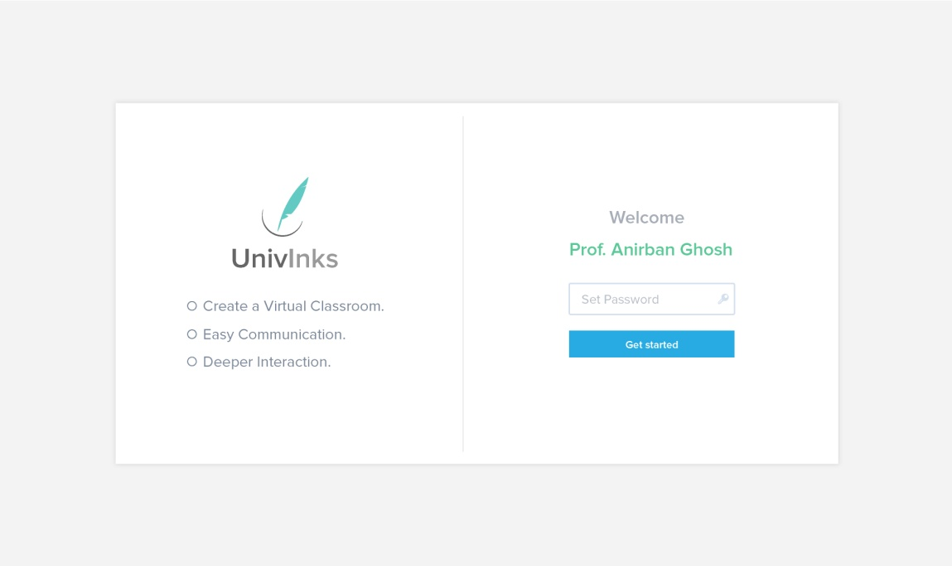

(Create password page. First time user)

The link in the email invite page will direct the faculty user to this page where he will be asked to create a new password.

# Selecting Department



(Selecting Department Page)

This is the first step in the setup process the faculty is directed to after he/she has created a new password. This page will have a basic question, “Are you a teaching Faculty in any other department?” If the faculty answers a yes, it will ask the faculty to select from the list of all available departments with his/her own department selected by default. The default department will be selected based on the information fetched from the faculty database uploaded by the college admin. Remember, the faculty database uploaded by admin has three columns: Name, email and Department. Email is used to send the invite and Department is used to select the parent department for a faculty.

# Selecting Subjects

(Select Subject Page)

A list of subjects in each semester, in form of tiles will appear on screen for one course at a time. Clicking "Next" will display similar list for next course. For example a faculty of Computer Science Department is also teaches in Information Technology department and both departments have B.Tech and M.Tech courses, so 4 such group of tiles will appear one after the other. Once all courses are done, the next button will change to "Finish Setup".

# Faculty Dashboard

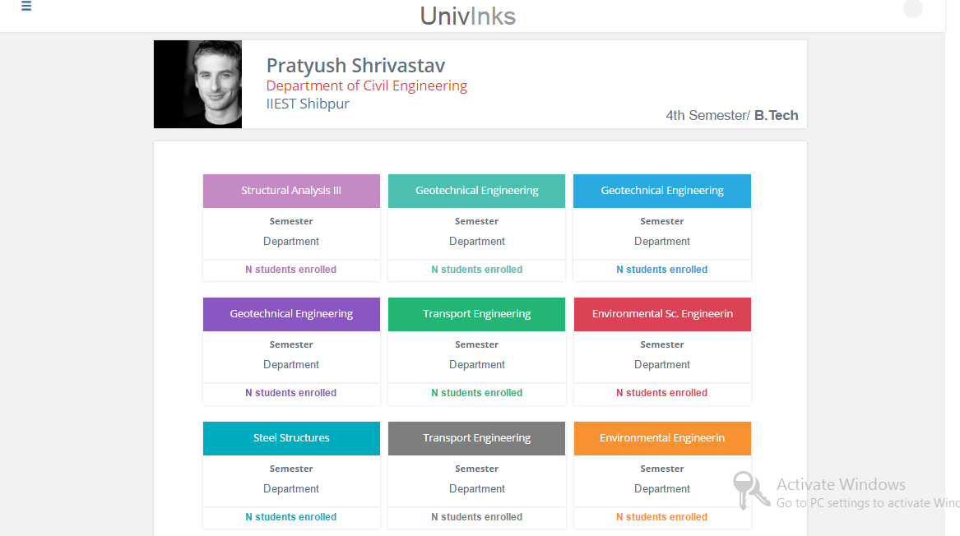

The faculty dashboard will have all the subjects that he/she is currently teaching in form of tiles for quick access. To access a particular subject the faculty will click on the specific tile.

# Subject Dashboard

The subject dashboard has three tabs: Files, Discussions and Assignment. Each tab has its specific functions.

# Files

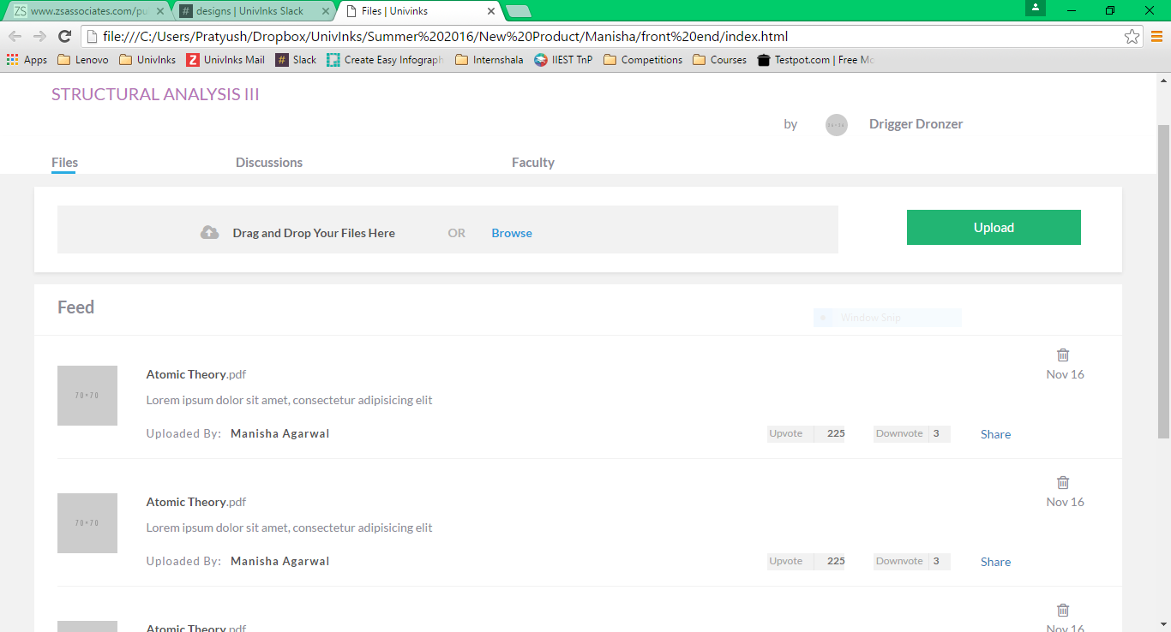

Under the files tab there will be a list of all files that have been previously shared by the faculty. The upload frame will let the faculty upload a new file. Once the user drags and drops or selects a file and clicks upload a modal will open up to ask for the file name and description after which it will be uploaded. The icon to the left on the uploaded file strip will be a file type icon.

*Note: The above screenshot is of the files feed on the student side. The one on the faculty side will be same with two small changes. First, “By <Faculty Name>” will change to “N students enrolled” and the “Uploaded by: <name> will not be there.



(Upload modal)

# Discussions

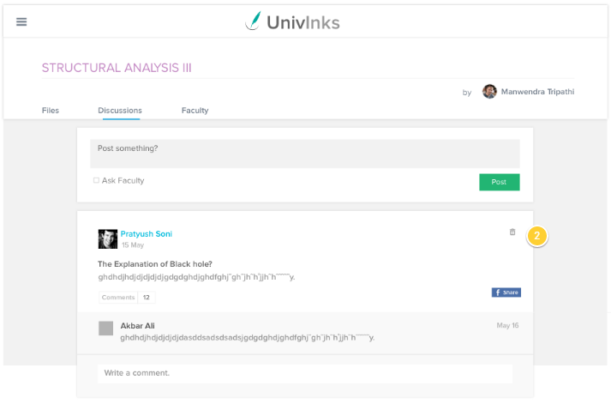

The text editor under the discussions tab will be used by the faculty to start a new discussion. The cards labelled “2” will have previously posted discussions with posted comments. The feed will have discussions which have been posted by the faculty and the discussions in which the faculty has been added by students.

“Write a comment” will let the faculty post a comment to the discussion.

*Note: The above screenshot is of the discussions page on the student side. The one on the faculty side will not have the “Ask Faculty” check box. There will be only two tabs “Files” and “Discussions”.

# F36D09F0-B36F-4FD6-8736-8E58ACCBCDC6.pngAssignments

The assignment section in the faculty profile will let the faculty post a new assignment and accept submissions. The post assignments part will be similar to the upload section under the files tab. The above image is of the accepted assignments feed. Each submission has three options:

* Info: to view the submission
* Mark for review: mark the submission for review. The student will be notified of the action and will be asked to submit a revision.
* Approve: To Approve a submission.