**1 : Git vs GitHub vs GitBash?**

* **Git** is a free, open-source software, it is a distributed version control tool that developers install locally on their personal computers.

It is CLI based toll

Gitpush , gitpull cmd

* **GitHub** is a service, a cloud-based centralized Git repositories.

It is GUI based.

* **Git Bash** is a LI terminal that provides a Unix-like environment on Windows.

It allows developers to use Git in a command-line interface

**2 : SSH vs Putty vs Linux terminal vs BASH vs WinSCP**

First of all : All of these interact with Linux via text-based commands. From checking logs, to adjusting configs, to accessing filesystems, to restarting things like webserver /MySQL etc.

* **SSH (Secure Shell) :** SSH is a protocol used to securely connect to a remote computer or server over a network. It is a encrypted communication for data security.



* **PuTTY :**PuTTY is a free and open-source terminal for Windows that supports SSH, Telnet, and other protocols.
* PuTTY provides features like session management, logging etc
* Commonly used by IT professionals and developers for managing remote servers via command-line interface (CLI)
* **Linux Terminal** : The Linux terminal is a CLI interface that allows users to interact with the OS**.**
* **Bash (Bourne Again SHell)** : Bash is a CLI based and scripting language for Unix-like OS. It allows users to execute commands, run scripts, and automate tasks in a command-line environment. it support arrays and functions
* **WinSCP :** It is a GUI interface and allows users to securely transfer files between a local and a remote computer. It supports various file transfer protocols, including SFTP, SCP, FTP**.**

**3 : Name some editors you have used in Linux.**

* Vi and VIM are the top editors in Linux. Other options include Nano and Pico

### **4 : How do you list active processes?  Can you stop one from running?**

* **ps** List running processes
* **ps -ef**  Get the status of a process
* **Kill -9 [pid]** Stop a process. A pid of 0 will stop all processes.

**5 : YUM vs APT diff. ( Package manager)**

* **YUM** is primarily used in Red Hat-based distributions like CentOS, Fedora, and Red Hat Enterprise Linux ( RHEL ).
* **APT** is used in Debian-based distributions like Ubuntu and Debian.
* Both tools manage software installations, updates, and removal

**6 : what is Linux Kernel?**

* Linux Kernel is a brain of Linux OS, it connects hardware with software.
* It manages services like CPU memory and other task
* It manages Multitasking, Network management etc.

**7 : What is shell in Linux and how its different from Bash?**

* The Linux **Shell** terminal is a CLI interface that allows users to interact with the OS
* **BASH** is a specific type of shell with advance features, it is CLI based and scripting language for Unix-like OS. It allows users to execute commands, run scripts, and automate tasks in a command-line environment, it support arrays and functions.

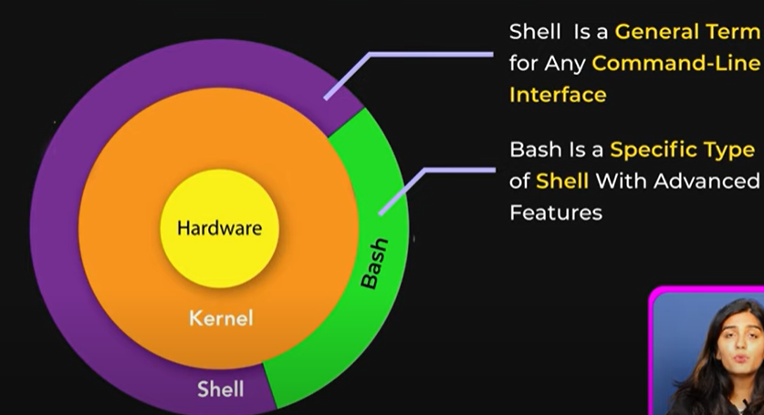

**8 : chmod 777 test.sh** 