Phase 1 – Complete Streaming & Event Contract
(Lovable-Style No-Code Builder)
This document defines the COMPLETE and FINAL Phase‑1 streaming contract between the LLM, Backend, and Frontend for the no‑code builder platform.
The document is written in plain, human‑readable language. Every technical concept is followed by an explicit JSON example, formatted as copy‑paste‑ready code blocks.
⚠️ IMPORTANT: This is a Phase‑1 contract and MUST be reviewed by Frontend, Backend, AI, Infra, and Product stakeholders before being considered locked.
Multi-chunk file generation introduces a risk of out-of-order or missing content during LLM streaming. This requires an explicit platform-level strategy to guarantee deterministic file assembly and avoid broken code.

1. Responsibility Matrix
LLM (Intent Emitter)
- Emits structured streaming events only
- Does NOT control builds, previews, deployments, or versions
Backend (Executor & Stream Owner)
- Owns SSE lifecycle
- Validates all incoming LLM events
- Owns filesystem, build, logs, preview URLs, versions
Frontend (Pure Renderer)
- Renders UI strictly from events
- Never guesses state

2. Universal Event Envelope
Every event streamed from backend to frontend MUST follow this envelope. The frontend routes behavior strictly using `event_type`.
{
"event_id": "evt_0001",
"event_type": "chat.message",
"timestamp": "2025-01-04T10:15:30Z",
"project_id": "proj_123",
"conversation_id": "conv_456",
"payload": {}
}

3. Chat & Cognition Events

3.1 Chat Message
Used for human‑readable narration only. No logic is derived from this event.
{
"event_type": "chat.message",
"payload": {
"content": "I am setting up the project structure and dependencies."
}
}

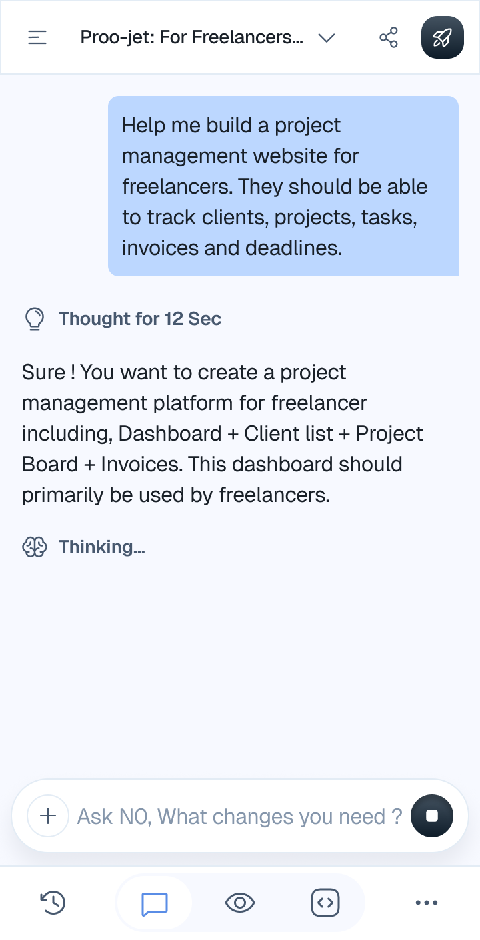

3.2 Thinking Events
Thinking events are used purely for UX feedback.
- thinking.start → Show 'Thinking…'
- thinking.end → Show 'Thought for X seconds'
{
"event_type": "thinking.start",
"payload": {}
}
{
"event_type": "thinking.end",
"payload": {
"duration_ms": 12000
}
}
Image: refer the image in point 2 for thought

4. Progress & Planning Events
Progress events visualize execution steps. Progress may initially appear as a modal and later transition inline into chat.
{
"event_type": "progress.init",
"payload": {
"mode": "modal",
"steps": [
{ "id": "plan", "label": "Planning", "status": "pending" },
{ "id": "scaffold", "label": "Scaffolding", "status": "pending" },
{ "id": "deps", "label": "Dependencies", "status": "pending" },
{ "id": "code", "label": "Code Generation", "status": "pending" },
{ "id": "build", "label": "Build", "status": "pending" },
{ "id": "run", "label": "Preview", "status": "pending" },
{ "id": "verify", "label": "Verification", "status": "pending" }
]
}
}
{
"event_type": "progress.update",
"payload": {
"step_id": "code",
"status": "in_progress"
}
}
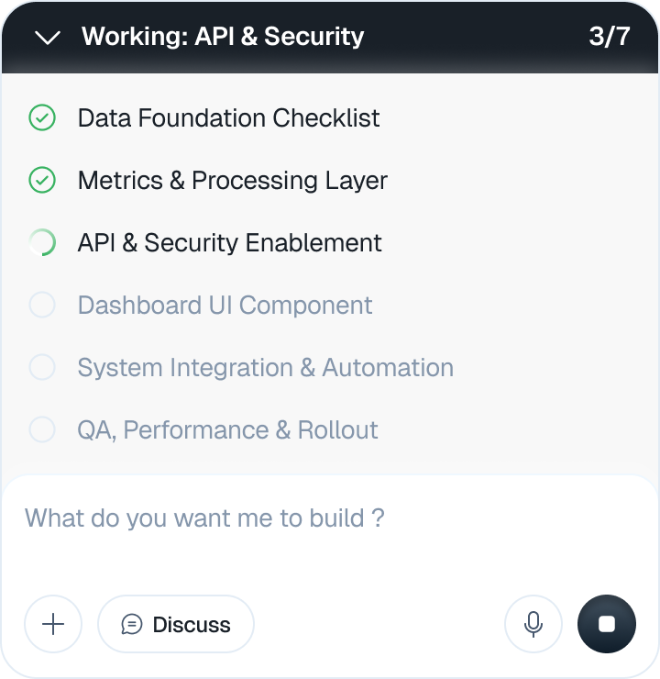
{
"event_type": "progress.transition",
"payload": {
"mode": "inline"
}
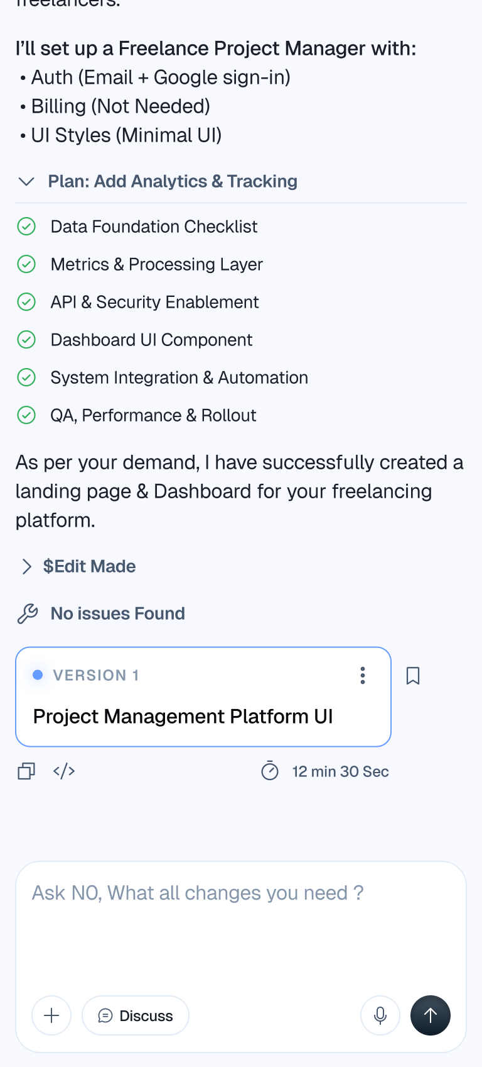

5. Filesystem Events (Monaco + Backend)
Filesystem events define the REAL project structure. Monaco editor and backend container filesystem must stay perfectly in sync.
IMPORTANT: `fs.write` is the SINGLE SOURCE OF TRUTH for code.
{
"event_type": "fs.create",
"payload": {
"path": "src/components/modal",
"kind": "folder"
}
}
{
"event_type": "fs.write",
"payload": {
"path": "src/components/modal/Modal.tsx",
"kind": "file",
"language": "typescript",
"content": "export function Modal() { ... }"
}
}
{
"event_type": "fs.delete",
"payload": {
"path": "src/legacy.tsx"
}
}

Image : this is for the the monoco editor file system so no figma yet

6. Edit Timeline (Chat – Edits Made Panel)
Edit events power the 'Edits Made' panel in the chat UI. They are NOT the source of truth for code.
`edit.start` may be emitted multiple times with content chunks to animate typing in the chat panel.
{
"event_type": "edit.read",
"payload": {
"path": "src/Contact.tsx"
}
}
{
"event_type": "edit.start",
"payload": {
"path": "src/Contact.tsx",
"content": "export const Contact = () => {"
}
}
{
"event_type": "edit.end",
"payload": {
"path": "src/Contact.tsx",
"duration_ms": 12000
}
}
{
"event_type": "edit.security_check",
"payload": {
"path": "src/Contact.tsx",
"status": "passed"
}
}
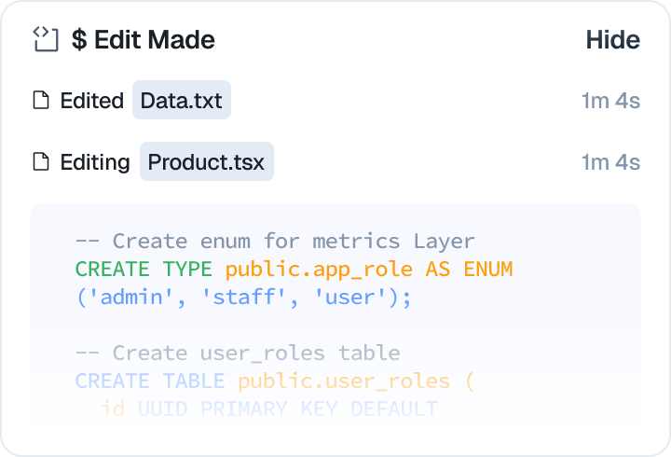

7. Build, Preview & Logs (Backend‑Owned)
The following events are emitted ONLY by backend services. LLM MUST NEVER emit or control these events.
{
"event_type": "build.start",
"payload": {
"container_id": "ctr_001"
}
}
{
"event_type": "build.log",
"payload": {
"level": "info",
"message": "Installing dependencies..."
}
}
{
"event_type": "build.error",
"payload": {
"message": "Build failed",
"details": "Missing dependency"
}
}
{
"event_type": "preview.ready",
"payload": {
"url": "https://preview.platform.ai/proj_123",
"port": 5173
}
}
image : backend area not for llm

8. Versions & Deployment
Versioning and deployment lifecycle are backend‑owned and fully decoupled from LLM behavior.
{
"event_type": "version.created",
"payload": {
"version_id": "v1",
"label": "Initial Stable",
"status": "stable"
}
}
{
"event_type": "version.deployed",
"payload": {
"version_id": "v1",
"environment": "production"
}
}

image : backend area not for llm

9. Suggestions, Modals & User Interaction
{
"event_type": "suggestion",
"payload": {
"id": "next",
"label": "What do you want to do next?",
"options": [
"Add authentication",
"Enable dark mode"
]
}
}
{
"event_type": "ui.multiselect",
"payload": {
"id": "enable_ai",
"title": "Enable AI",
"options": [
{ "id": "deps", "label": "Install dependencies" },
{ "id": "routing", "label": "Update routing" }
]
}
}
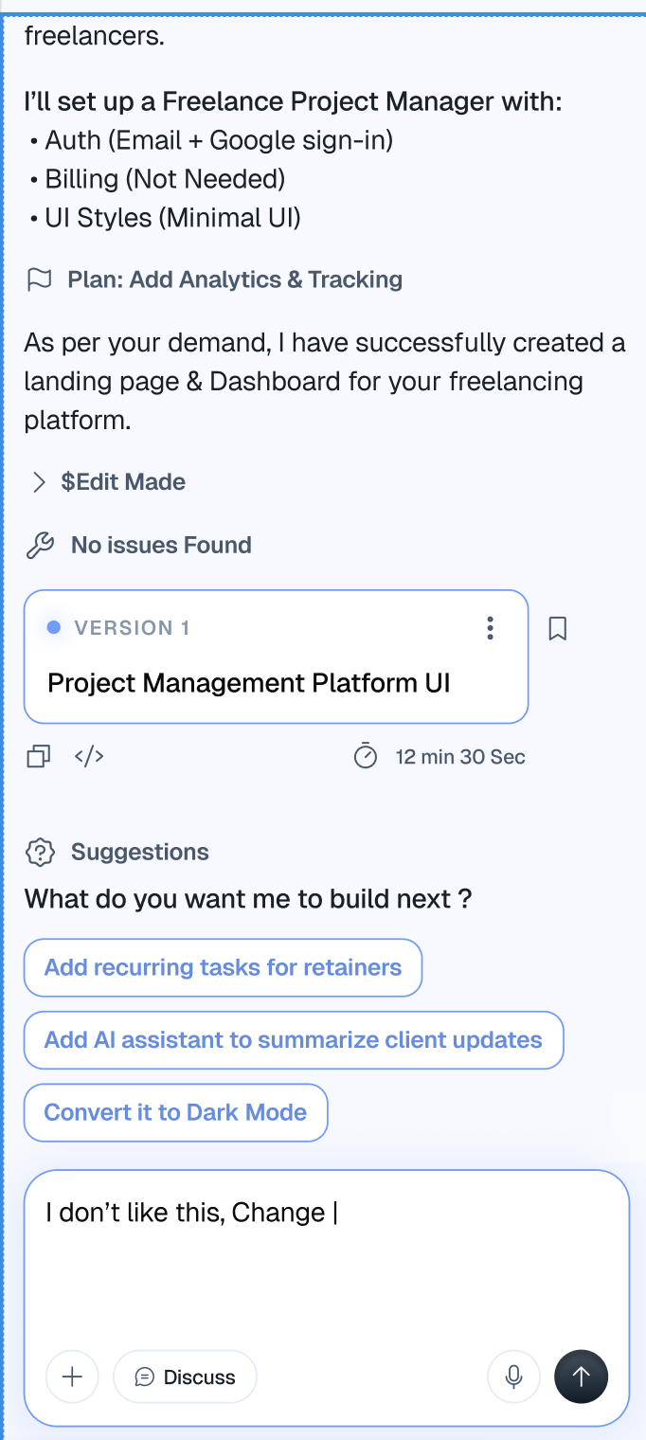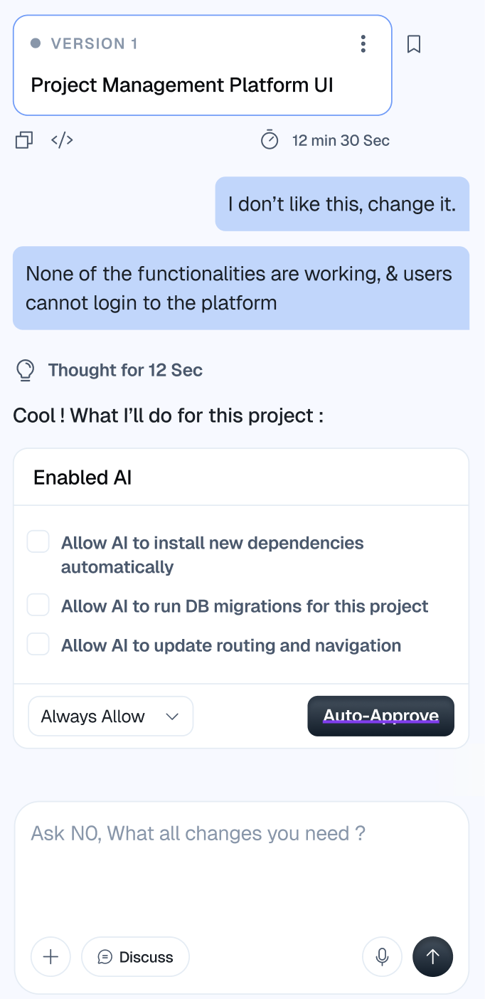

10. Errors, Issues & Recovery
{
"event_type": "error",
"payload": {
"scope": "runtime | llm | validation | build",
"message": "Users cannot login",
"details": "Auth misconfigured",
"actions": ["retry", "ask_user", "auto_fix"]
}
}

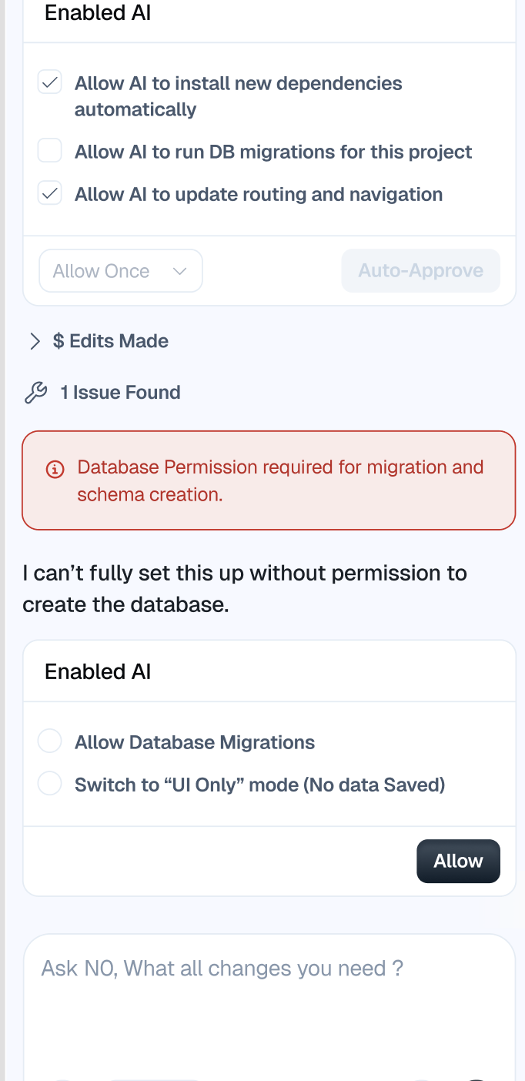

11. Stream Lifecycle & Input Control
Frontend MUST re‑enable user input ONLY after receiving one of the following terminal events.
{
"event_type": "stream.complete",
"payload": {}
}
{
"event_type": "stream.await_input",
"payload": {
"reason": "suggestion | multiselect"
}
}
{
"event_type": "stream.failed",
"payload": {}
}
IMAGE: ANY EVENT THAT STOPS THE STREAM AND ALLOW USER INPUT
NO IMAGE AVAILABLE

