Ridwan Khan

9/6/17

Work Break Down:

Name of the task- Todo List

Estimated No of hours- 5 hours

Actual time spent- 8-10 hours

Notes- I underestimated the time it would take to complete this task. I haven’t had much background in PHP. The web development course, with HTML 5 helped a lot in terms of organizing the website. I tried to keep it simple just so I can make sure that I don’t over complicate anything.

Issues- I used a lot of time just setting up the whole server. I ended up using XAMPP and I had a lot of trouble with connecting to ports since I had applications that were already connected to them. The HTML section was a lot easier than the PHP section.

Functional Requirements:

* Add Tasks
* Remove Tasks
* View Tasks

Non-Functional Requirements:

* Live view of tasks added
* Simple design creates easy use
* Tasks stay in order

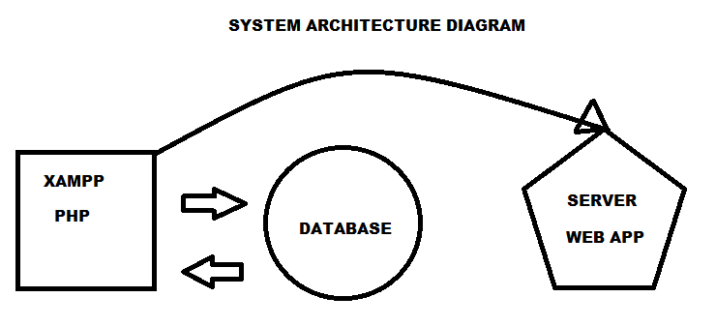

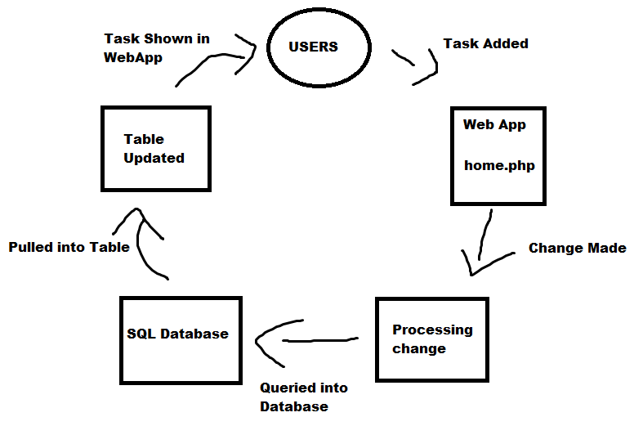

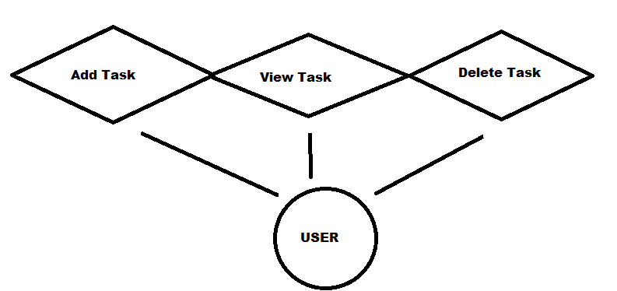

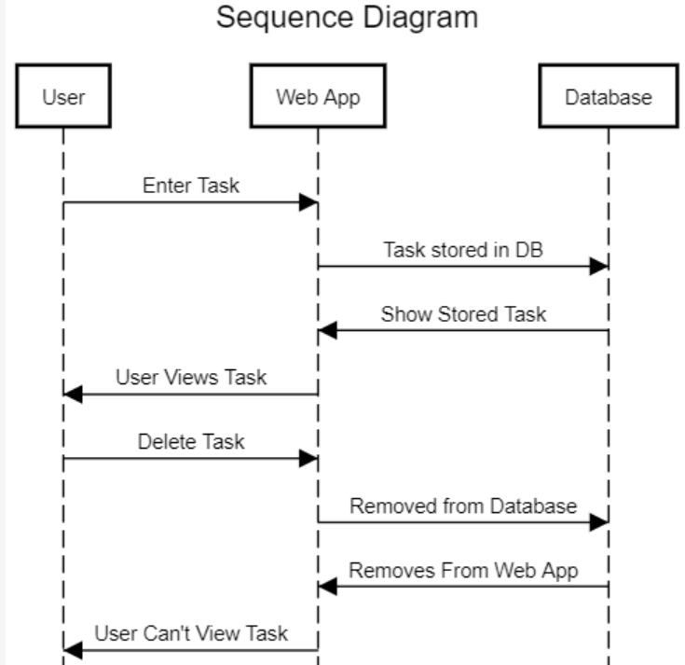

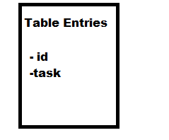

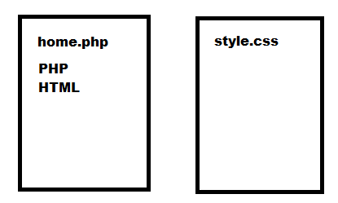

**Test Case:**

*Adding Tasks-*

* Make sure list is empty, add a task
* Make sure list has a task, add a task
* Add a task after one has been deleted

*Tasks are added and working correctly when user performs any function

*Viewing Tasks-*

* All Tasks can be viewed once added

*Deleting Tasks-*

* Tasks can be deleted once added

*Observe tasks that user chooses to be deleted, are deleted