

Preconsultation Preparation Agent
Final Report for ELEC5623

Track A - AI Agent Product
Assessment 2 Final Report and Product Delivery
Project Group | Group 9
Product | PreConsult
Tutor | Linghan Huang
Unit Coordinator | Dr Huaming Chen
Submission deadline | 3 November 2026
Repository | elec5623-group9-preconsultation (source code submitted with this report)
Project purpose
PreConsult helps patients organise their concerns and share a reviewed, source-cited preparation record with a selected clinician.
Team Member | Student ID
Robin Kim | 520494747
Heeran Shin | 550526315
Haobo Wang | 550290472
Hengyu Wang | 550476641
Guopeng Tan | 560226939

1 Project summary and team
PreConsult is a Track A AI Agent Product for preparing a planned medical consultation. Group 9 comprises Robin Kim, Heeran Shin, Haobo Wang, Hengyu Wang and Guopeng Tan. We built an authenticated patient and clinician application that collects a patient’s concerns, structures their answers, asks bounded follow-up questions and produces a source-cited record for patient-approved sharing. The final interface provides 30 symptom workflows, a custom conversation entry, one-question wizard steps, editable voice transcription and five patient languages.
The principal result is a working preparation-to-handoff workflow with reproducible engineering evidence: 605 backend tests, 100 frontend tests and 34 browser acceptance checks passed on integration commit 91a8543. A controlled validator comparison rejected ten targeted faults that JSON schema alone accepted, but also exposed an unsupported paraphrase that passed both checks. The system therefore demonstrates workflow and validation behaviour, not established clinical accuracy. This report describes the implementation and evidence available on 21 October 2026 [1].

2 Problem definition

2.1 Users and intended value
Patients preparing for a short consultation may struggle to organise symptom timing, medicines, background information and questions. A clinician then needs a readable account that preserves uncertainty and indicates where each statement came from. Our design addresses this preparation and communication task. Patients are the primary users; clinicians receive the information a patient chooses to share. The teaching team evaluates a runnable engineering prototype, rather than a deployed clinical service.
GenAI is useful because patients describe the same concern in different words, languages and levels of detail. Extraction can map a narrative onto several named fields; planning can phrase relevant clarifications; synthesis can present the same evidence for patient and clinician readers. Ordinary application code retains authority over account ownership, state transitions, eligible targets, validation and sharing. A fixed questionnaire alone cannot provide this language flexibility, while an unconstrained chatbot would make the collected information and stopping behaviour harder to audit.

2.2 Scope and success criteria
The core scope remains preparation for a planned appointment, including unknown answers, declined questions, corrections and incomplete records. The optional preliminary assessment extends the original factual-summary scope by suggesting possible diagnoses and care guidance. It is separated from the factual record and is not clinically validated. Table 1 connects the central requirements to evidence; Appendix B gives the fuller proposal mapping [2].
Requirement | Observable success criterion | Evidence
Faithful information | Current values retain evidence; rejected and uncertain answers keep their meaning. | State tests and guard audit
Bounded interaction | At most five questions in the normal AI batch; drafts survive navigation. | Pipeline and browser tests
Patient control | Only the selected doctor can read an approved version; withdrawal removes access. | API authorisation tests
Usable preparation | One question per step, editable voice text, reusable background and five locales. | Frontend and UI checks
Efficient model use | Measure response quality, latency and token cost on a frozen evaluation set. | Not yet established
Table 1. Success criteria and the evidence actually available. Passing software checks does not establish clinical benefit.

3 Related work and novelty
Pre-consultation data collection is an established application. Infermedica Intake combines fixed demographic and medical-history sections with an adaptive symptom interview [3]. Its Engine API distinguishes present, absent and unknown evidence and supplies a stopping recommendation [4]. Ada asks follow-up questions using symptoms and health-profile information, then produces possible causes [5]. PreConsult does not claim novelty for symptom selection, adaptive questions, reusable background information or an AI-generated report.
Research illustrates the evaluation standard needed for stronger claims. AMIE uses simulated self-play and was evaluated in 159 case scenarios with patient actors and 20 primary-care physicians [6]. Thawinwisan et al. compared four prompt/reasoning configurations with a rule-based baseline across 66 simulated cases, using physician-rated information coverage [7]. Those results cannot be transferred to PreConsult. Our coverage counters measure completion of our own workflow fields; they are not clinical information-coverage scores.
Schema-guided dialogue supplies explicit intents and slots for task-oriented conversation [8]. PreConsult similarly uses workflow fields and persisted state to constrain extraction and follow-up planning. Strict JSON output gives a machine-readable contract, but it does not establish factual accuracy [9]. The backend therefore adds source-span, target, ownership, numeric and uncertainty checks. Section 7 tests the incremental value and limits of those checks.
System | Dialogue and output | Position relative to PreConsult
Infermedica [3, 4] | Structured history, adaptive interview, evidence states and symptom assessment. | Established intake functionality. Version-specific patient approval is not documented in the cited pages.
Ada [5] | Health-profile-informed symptom questions and a possible-cause report. | Similar patient entry task; source-span and version-approval controls are not documented in the cited page.
AMIE [6] | LLM diagnostic dialogue and differential diagnosis, studied with patient actors. | Much stronger clinical evaluation; not evidence that this prototype is accurate.
PreConsult | Bounded preparation wizard, cited factual handoff and optional preliminary assessment. | Explicit uncertainty/refusal, correction history and revocable sharing of an approved version. Engineering evaluation only.
Table 2. Related systems and the specific project contribution. Undocumented features are not assumed absent.

3.1 Specific contribution
Our contribution is an integrated and inspectable preparation workflow: one question per step; normally one AI batch of no more than five questions; distinct missing, uncertain and declined states; evidence and correction history; and access tied to approval of a particular version. Patient-facing questions, suggested answers, symptom names and reports follow the selected language while source evidence remains intact. These are concrete engineering choices, rather than a new clinical reasoning method or a claim of superiority to commercial products.
The Track A contribution is therefore the complete user journey and its controlled interaction with GenAI. It includes persisted state, bounded model proposals, file and voice inputs, explicit error states and a real recipient-specific handoff, beyond a standalone prompt demonstration.

4 System design
The active product lives in backend/app/product and frontend/src/product. React 18 and Vite 8 provide the patient and clinician interfaces; FastAPI serves the built client and /api/v1 from one local origin. The runtime starts through scripts/start-local.sh. Figure 1 separates the model’s language operations from application authority.
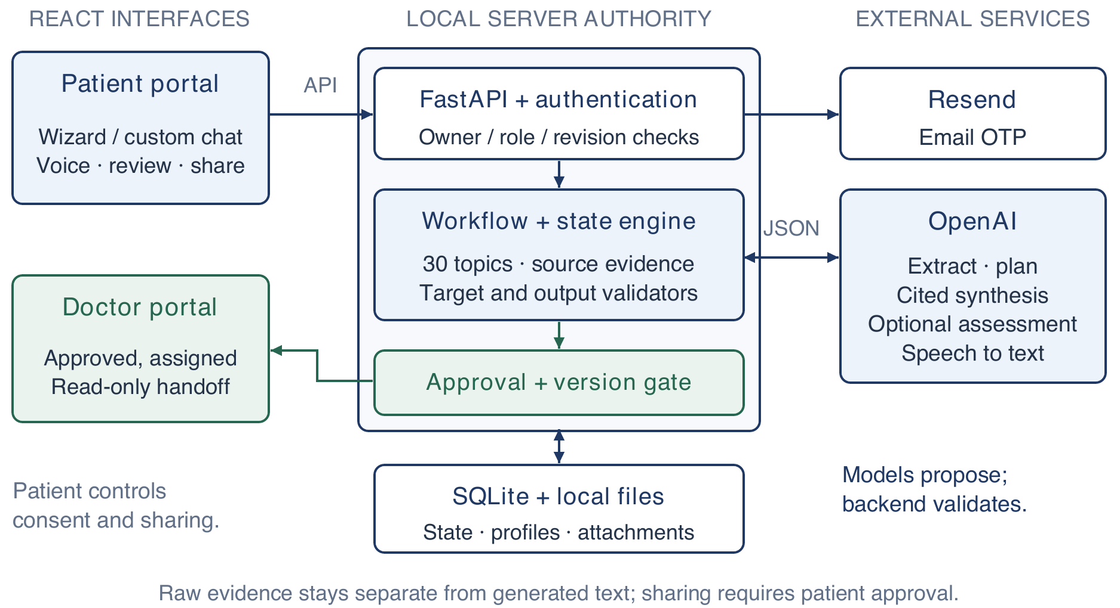
Figure 1. Current product architecture at commit 91a8543. The backend validates model proposals and checks ownership, version and approval before clinician access.

4.1 Information flow and state
A verified patient creates an intake, chooses a workflow or custom concern, and supplies baseline answers. The engine stores a value, state and evidence for each field. Its five states are FILLED, UNCERTAIN, MISSING, SKIPPED and NOT_APPLICABLE. Conditional fields activate from explicit signals. Coverage is filled/applicable; resolution is (filled + uncertain + skipped)/applicable. These equal-weight measures describe completion, not confidence in a diagnosis.
The pipeline offers the model only eligible follow-up targets, validates its proposed batch, saves each answer draft and submits the batch together. Synthesis reads the current source registry; superseded values, removed facts and private history are excluded. Patients review the output, correct the record if needed, and approve a selected version for a registered doctor. Editing an approved record requires withdrawal; access checks also protect report and attachment downloads.

4.2 Persistence and reusable memory
SQLite stores users, account_roles, patient_profiles, otp_challenges, sessions, rate_limits and intakes. Nested intake JSON contains structured state, evidence, operations and approval metadata. Transactions, WAL and revision compare-and-swap protect updates; a stale save returns a conflict instead of overwriting a newer version. External model calls run outside database write transactions. Uploaded files use local private storage.
Reusable profile fields include date of birth, sex at birth, ABO with optional Rh, relevant histories and accessibility needs. Each encounter takes a snapshot, so later profile edits do not rewrite previous visits. Current symptoms, measurements and pregnancy are not silently carried forward. Dated medicine and allergy answers are suggestions requiring a fresh user action; a later refusal, uncertainty or clearing suppresses older suggestions.

5 GenAI and agent component

5.1 Model roles and bounded orchestration
The configured default is gpt-6-astra, selectable in advanced options; transcription uses gpt-4o-mini-transcribe. This is a configuration choice, not a measured best-model result. Provider availability depends on the account. The implementation does not silently substitute another model. Separate Responses API calls handle extraction, planning, synthesis and optional assessment, using strict output schemas and store=false [9].
Operation | Context and enforced boundary | Output budget / timeout
Extraction | Current message, quoted evidence, schema and allowed fields; values must match contiguous source spans. | 14,000 tokens / 90 s
Follow-up plan | Current structured context and eligible target IDs; no repeats; normal batch ≤5 questions. | 6,000 tokens / 75 s
Factual synthesis | Current sources and concern IDs; patient overview, clinician brief, agenda and uncertainties with citations. | 6,500–16,000 tokens / 75 s
Optional assessment | Current record plus uploaded files; separate provisional possibilities, uncertainty and guidance. | 16,000 tokens / 180 s
Table 3. Configured upper bounds, not measured usage. Synthesis budget is min(16,000, 6,500 + 400 × max(0, concerns − 3)).
The application controls eligibility, schema checks, evidence acceptance, stopping and approval. The model chooses among permitted follow-up targets and words the question; it does not freely select tools or overwrite arbitrary fields. Normally all AI clarifications fit in one batch, displayed one per step. A newly introduced medicine/allergy conflict can permit one exceptional second round, also capped at five. Ordinary missing fields do not trigger repeated questioning.

5.2 Context and prompt contracts
Extraction treats patient text as data and requests candidate values with source spans. The engine rejects unsupported spans or disallowed updates. Planning supplies the eligible identifiers, requests useful clarification with a reason and up to three suggested answers, and leaves precise or unsuitable answers to free text. Synthesis receives only current shareable sources and must return cited statements without filling gaps from medical assumptions. Appendix A identifies the exact prompts and validators in the frozen source.
Validation checks known source IDs, concern ownership, duplicate or empty references, new numbers, lost negation and lost uncertainty. A wrong-language output may receive one targeted repair; this is not a general retry policy. Invalid or unavailable model output is surfaced as a failure, with saved answers and structured notes preserved. Valid citation identifiers do not prove semantic faithfulness, as the audit in Section 7 shows.

5.3 Languages and multimodal boundaries
English is the default; Simplified Chinese, Traditional Chinese, Korean and Japanese are supported. Locale instructions cover AI questions, options and report text as well as UI labels and symptom names. Language changes preserve question IDs and drafts. Unapproved generated content must be refreshed when stale; approved originals remain protected until withdrawal. Script checks are bounded safeguards, not complete translation-quality assessment.
Voice audio is transcribed into editable text and is not retained by the application. Document reading and the optional assessment can send uploaded material to the provider. The assessment considers all current attachments, directly within a 35 MiB aggregate limit or through bounded filewise analysis and synthesis. No RAG index, embeddings, fine-tuning, autonomous browsing or MCP tools are used in the product workflow: the current patient record is the relevant context.

6 Implementation and application demonstration

6.1 Entering and completing the baseline
Figures 2–7 were captured afresh from commit 91a8543 on 21 October 2026 using an isolated database and fictional patient Alex Morgan. They show the actual current UI and API. AI questions, report wording and speech transcription in these captures are deterministic test fixtures; they are interface demonstrations, not fresh model-quality results. No real patient information or external service calls were used for the captures.
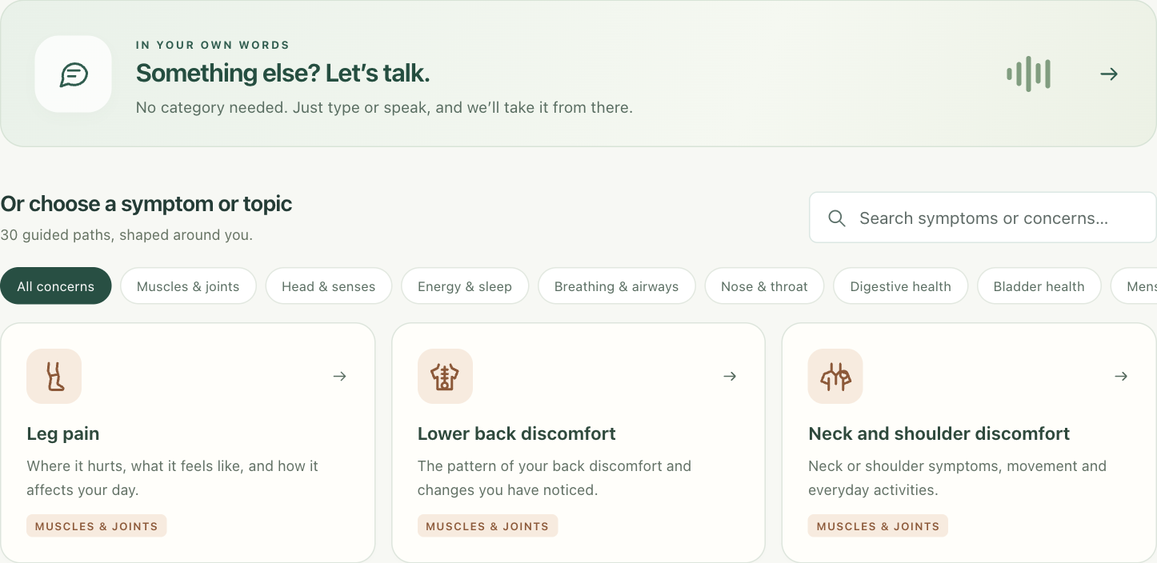
Figure 2. Current topic entry. The custom conversation is first; patients can instead select from 30 illustrated workflows. A cropped component is shown for print legibility.
The patient starts with a current concern rather than a page of background fields. A custom concern opens a chat-like composer; a recognised topic opens the matching one-question baseline wizard. Concrete prompts, progress, body diagrams, optional answer cards and explicit unknown/skip actions support completion. Answers save as the patient proceeds, and a review step allows changes before generating the handoff.
Body regions support multiple selections, including left/right areas and front/back views. Equivalent labelled controls provide an alternative to clicking the illustration. The account profile separates A, B, AB and O from optional positive/negative Rh. Stable background information fills relevant encounter fields and can be edited. Previous medication and allergy responses appear as dated quick-fill suggestions, rather than becoming current facts automatically.
The previous separate history, concern and consultation-question prompts are consolidated into a final opportunity to add anything else the doctor should know. The five languages apply to topic names as well as interface chrome; for example, the Chinese topic list no longer leaves “Leg pain” in English. Additional freshly captured profile, body-map and Chinese views appear in Appendix D.

6.2 Voice without an extra confirmation step
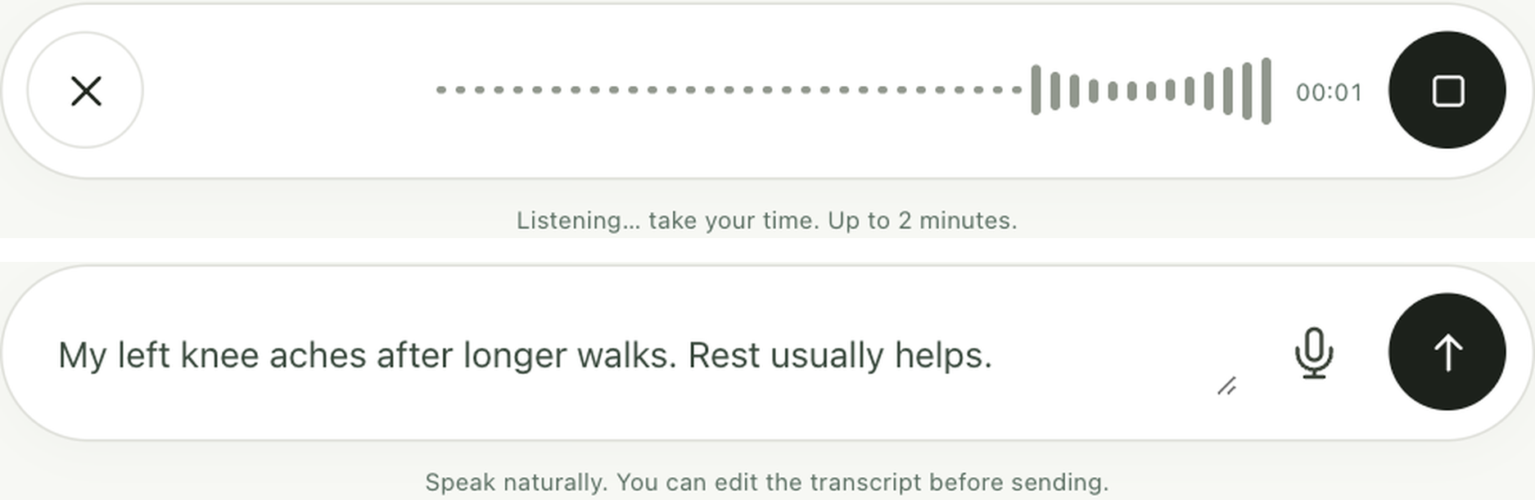
Figure 3. Recording and stopped states. Stop starts transcription and fills the normal editable input; submission remains a separate patient action. Audio and transcription are simulated in this UI test.

6.3 One question per AI follow-up step
“AI analysis and follow-up” explains what remains unclear, then shows one question at a time. Suggested A/B/C responses can be used and edited, or the patient can type or speak their own answer. Unknown and skip remain explicit actions. Back/next navigation retains drafts; the last step reviews the whole batch before one submission. This keeps the bounded multi-question plan while reducing the amount visible at once.
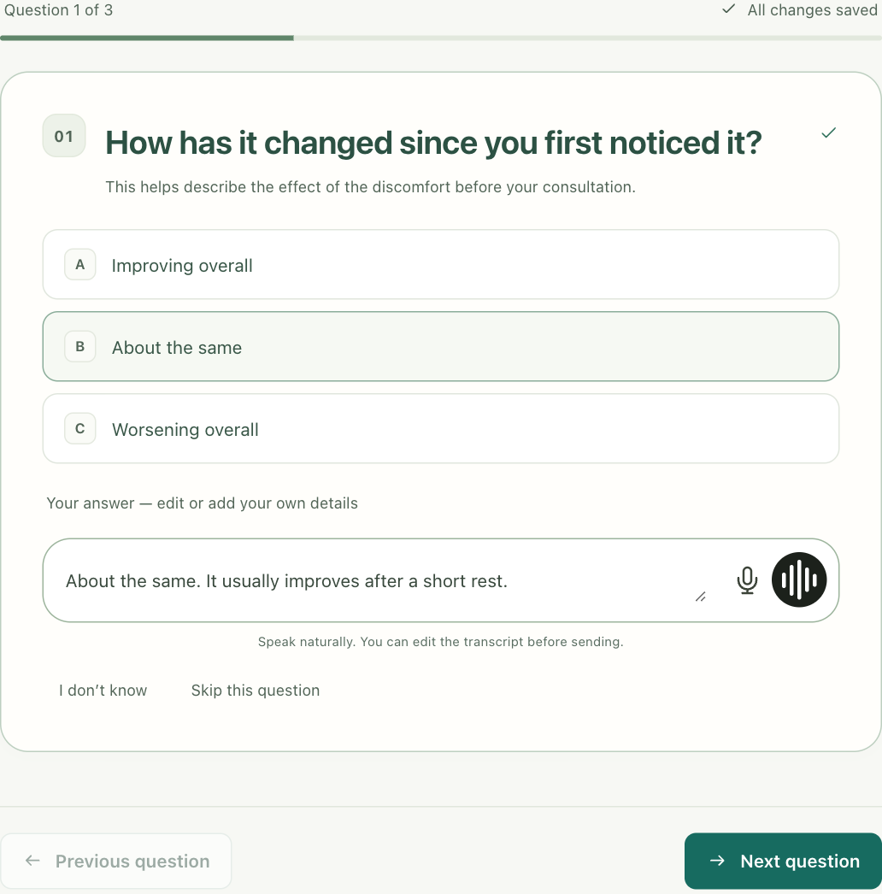
Figure 4. Current single-question AI wizard with a saved custom detail. The three-question batch and choices are synthetic fixtures; navigation and draft persistence use the real API.

6.4 Review of facts and separate assessment
The factual summary offers a patient overview and clinician brief, with source links for inspection. Corrections lead to a new version. A separate optional panel presents preliminary diagnostic possibilities, uncertainty, care guidance and attachment findings, explicitly requiring clinical confirmation. It is not merged into the patient’s original evidence. A model failure is visible and does not prevent access to saved structured notes.

6.5 Patient approval and clinician handoff
The patient selects a registered clinician email and approves the current version. Any verified email may register either role, but one email cannot hold both roles. Email verification does not establish professional credentials. The clinician dashboard lists only approved records assigned to that account; the patient can withdraw sharing. Marking a record reviewed is a workflow acknowledgement, not confirmation of an AI diagnosis.
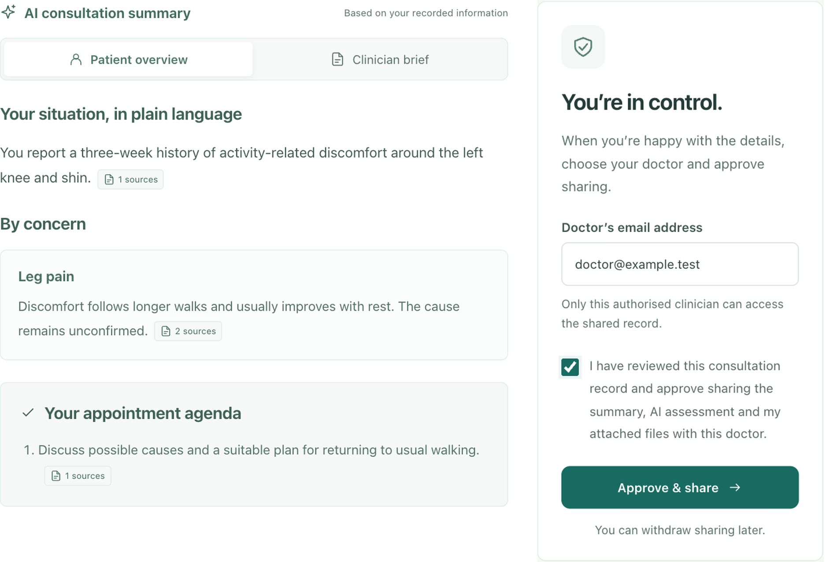
Figure 5. Factual summary excerpt and patient approval. Source-linked text is a deterministic fixture; approval and recipient selection use the actual API.
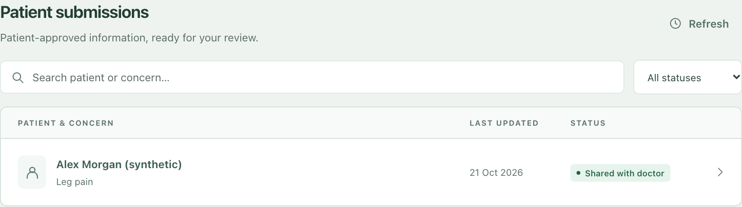
Figure 6. The selected clinician’s real record list after approval, using fictional accounts. An unassigned doctor cannot access the record.

6.6 Progression from proposal to delivery
PDF export is generated locally and includes the report, full uploaded images and every page of uploaded PDFs. Access and freshness are checked again at download. Missing or unreadable attachments cause a visible failure rather than silent omission. Withdrawal prevents subsequent application access; it cannot recall a file already downloaded or printed.
Proposal element | Delivered state | Consequence
Conversational preparation | Refined to a baseline wizard, custom chat and bounded AI question wizard. | Less repeated entry; actual usability improvement remains unmeasured.
Weighted coverage and priority | Equal-weight metrics; code filters eligible targets and the model selects the batch. | Transparent completion counts, but not the original weighted priority algorithm.
Source-cited summary and approval | Implemented with current-source validation, correction and version-bound sharing. | Deterministic checks support handoff control; semantic fidelity remains imperfect.
Clinician summary access | Extended to a recipient-specific dashboard and complete PDF export. | Supports review and attachments within the same preparation task.
Non-diagnostic core | Factual core retained; optional assessment adds possibilities and care guidance. | Functional scope extension with additional safety and evaluation obligations.
Quality and efficiency benchmark | Regression suites and controlled validator audit completed. | The proposed comparative model study and latency/cost targets remain unverified.
Table 4. Delivered changes and omissions relative to the proposal [2].
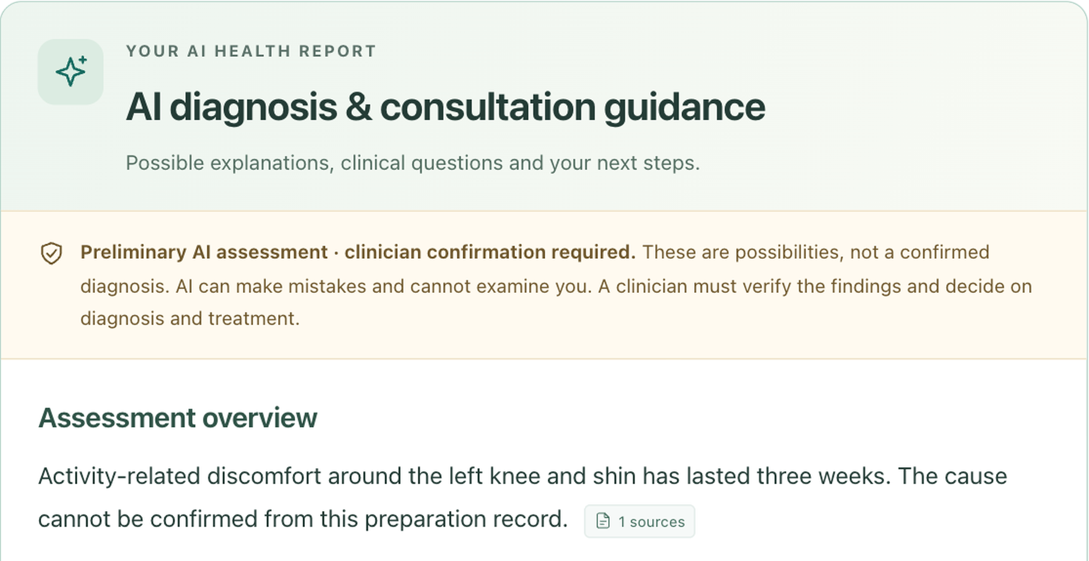
Figure 7. Optional assessment header and uncertainty statement, shown as an excerpt. The current UI explicitly separates a provisional assessment from a confirmed diagnosis. Displayed prose is a deterministic fixture.
The optional report is an additional output, not evidence that the intake workflow can diagnose illness. The same source/version safeguards do not resolve its clinical accuracy; it must be evaluated separately before practical use.

7 Evaluation

7.1 Procedure and evidence boundaries
Evaluation used the frozen integration source, isolated synthetic data and controlled service doubles. Backend product tests exercise state, profiles, language handling, planning, synthesis validation, authorisation, sharing, files, PDF export and concurrency. Frontend tests check application behaviour and pure UI logic. A fresh browser run exercised the built client with a real isolated API; model/email calls were disabled and voice responses simulated. These are engineering checks, not independent clinical judgments.
Evidence | Observed result | Interpretation
Backend product suite | 605 passed; 28.44 s; two dependency deprecation warnings. | Tested backend contracts hold in this environment.
Frontend suite | 100 passed; zero failed/skipped; 842.873 ms. | Tested client behaviours hold.
Browser acceptance | 34 checks passed; no uncaught errors; five axe scans found no serious/critical issues. | Selected desktop/mobile journeys and local accessibility checks.
Validator comparison | 5/5 valid controls accepted; 10/10 targeted faults rejected; 1 semantic fault accepted. | Value and limit of added validation over schema alone.
Table 5. Fresh results at commit 91a8543 on 21 October 2026. Suite duration is not user-facing model latency; axe scans are not a full accessibility audit.

7.2 Baseline and controlled fault audit
We compared two acceptance policies on the same 16 hand-authored synthesis objects: V0 validates only the strict JSON schema; V1 applies the production synthesis guards as well. The set contains five valid controls, ten deliberately targeted faults and one semantic limitation probe. Each object is evaluated once by both policies; there are no model calls or stochastic repetitions. Metrics are accepted controls, rejected targeted faults and accepted limitation probes. Appendix C records the cases and construction.
Case group | n | V0 schema only | V1 schema and guards
Valid controls accepted | 5 | 5 | 5
Targeted faults rejected | 10 | 0 | 10
Semantic limitation accepted | 1 | 1 | 1
Table 6. Deterministic validator ablation. Cases intentionally exercise known checks, so the result is not an estimate of real-world hallucination detection.
Targeted faults include an unknown source, a new number, lost negation or uncertainty, wrong concern ownership, omitted concern, instruction echo, duplicate or empty references and a wrong-language output. V0 accepts their shapes; V1 rejects them. The five accepted controls include faithful text, an explicit negative, uncertainty, refusal and a number written in words. This demonstrates additional contract protection beyond parseable JSON, without establishing a natural-output error rate.

7.3 Representative scenarios and provider evidence
Two supplied manual fixtures cover bilateral knee discomfort and a blood-pressure follow-up, with field-by-field answers, fictional examination PDFs, generated illustrative images and expected checks. They exercise multiple body areas, repeat-use background, medications/allergies and attachments. They are scenario materials, not two independently scored clinical trials. A recorded synthetic gpt-6-astra Chinese planning smoke returned four questions with no more than three options each; one provider example does not establish general or five-language quality.

7.4 Failure analysis and trade-offs
The semantic limitation probe is concrete: the source says “Leg pain for 3 days.” The proposed overview says “The patient reports persistent dizziness.” and cites the valid leg-pain source. Both policies accept it. The citation exists and no checked transformation is violated, yet the meaning is unsupported. Source validity and lexical checks are therefore insufficient for entailment. Patient review remains useful, but it cannot be treated as reliable clinical verification.
The evaluation set was constructed around known validation rules and is not held out. It cannot measure extraction precision/recall, clinical coverage, summary faithfulness in natural model responses or patient benefit. The proposed 80-case comparison of alternative interviewing strategies was not completed in the available evidence. There are no calibrated clinician labels, real-patient usability results or repeated model comparisons. The current measured result is engineering reliability under tested conditions.
No empirical token-cost or user-facing latency study was completed. Recorded operation duration can support future analysis, but the test suite’s execution time cannot verify the proposal’s p50 ≤2.5 s and p95 ≤5 s targets. Separate extraction, planning, synthesis and optional attachment assessment may require several paid calls; bounded questions and restricted context reduce uncontrolled work, while large file analysis adds cost and delay. Request budgets and timeouts are ceilings, not observations.

8 Reflection limitations and next steps

8.1 What worked and what changed
Separating model proposals from application decisions made important behaviour testable. The guard comparison shows why shape validation alone was inadequate, while authorisation and revision tests exercise controls that do not depend on fluent model output. The integrated UI also gives patients explicit ways to correct, skip, reuse and approve information. Replacing repeated background forms with profile snapshots and a one-question wizard improves the interaction design, although a timed user study is still needed to establish its effect.
The implementation also made deliberate compromises. Five follow-up questions limit burden and expose a clear stopping point, but may leave relevant information unresolved. Equal-weight completion is easy to explain but does not express clinical importance. A single-instance SQLite deployment is practical for demonstration; it is not evidence of capacity for multiple clinics. Five-language display and script checks do not establish equivalent meaning, cultural suitability or clinical safety across languages.

8.2 Prioritised next steps
First, freeze a synthetic evaluation corpus before comparing a static questionnaire, an unconstrained LLM interview and the current constrained workflow with the same model and budget. Independently label required information and score extraction, unsupported summary statements, uncertainty preservation, repeated questions and completion effort. Report per-case failures and uncertainty intervals, rather than one aggregate score.
Second, add sentence-to-source semantic verification and test it on adversarial paraphrases, corrections and mixed-language narratives, including the accepted dizziness probe. Evaluate false rejection as well as missed errors. Third, instrument tokens, cost and end-to-end p50/p95 response time; compare smaller models and reduced context under the same quality criteria.
Finally, obtain qualified review of the workflow catalogue, safety wording and optional assessment before a clinical pilot. Conduct task-based patient and clinician usability sessions, including voice, mobile and accessibility needs, then address authentication, retention, deployment and translation issues identified by those studies. These activities are planned validation, not results claimed in this report.

9 Broader impacts and responsible use
A clearer patient-owned record could help people express concerns and prepare questions, especially when typing or language is a barrier. However, incorrect summaries can distort the consultation, and plausible preliminary diagnoses can create anxiety or false reassurance. The optional assessment’s diagnosis and urgency content goes beyond the proposal’s original non-diagnostic boundary; a preliminary label does not establish safety. The factual handoff can be used without that extension. Neither workflow completion nor clinician access is a clinical endorsement.
Privacy controls include account isolation, explicit AI-processing consent, recipient-specific sharing, revocation, private local storage permissions and restricted clinician projections. Session cookies are HttpOnly and SameSite; production enables secure cookies. OTP attempts and requests are limited. The application does not encrypt individual database rows or files, verify professional credentials, or establish healthcare compliance. Text and selected files go to OpenAI; audio is sent for transcription; Resend delivers email codes. store=false does not itself establish Zero Data Retention [10].
Prompt injection can arrive through patient text or uploaded documents. Fixed schemas, target allowlists and source validation restrict its effect, but the audit does not prove complete resistance. Rule-based safety interruptions and language checks have incomplete coverage. Speech-recognition errors, uncommon wording, low literacy, disability and language variation require separate evaluation. Synthetic cases avoid patient-data exposure during development, but also limit generalisability. Deployment would need clinical governance, data-processing and retention decisions, identity verification, operational monitoring and a tested incident process.

10 Team contributions and AI use
Member and student ID | Substantive contribution | Report responsibility
Robin Kim  520494747 | Core AI and state logic; schema and question authority; summary approval and repository integration. | Core agent design, state and handoff explanation.
Heeran Shin  550526315 | GenAI evaluation lead; patient frontend, authentication/intake, language and body-map work. | Evaluation method and interpretation; patient workflow.
Haobo Wang  550290472 | Core component implementation and contribution to integrated backend functionality. | Core component documentation and implementation review.
Hengyu Wang  550476641 | Core component implementation and contribution to integrated backend functionality. | Core component documentation and implementation review.
Guopeng Tan  560226939 | Overall architecture and integration; UI optimisation, wizard/voice/localisation refinement and report/export integration. | Architecture, refreshed demonstration and report integration.
Table 7. Team-confirmed substantive responsibilities, supplemented by identifiable repository contributions. Report responsibilities identify the review area for each contribution.
OpenAI Codex assisted code integration and refinement, test generation, synthetic test materials, source inspection, reference checking, report drafting and screenshot/layout automation. Generated code was checked through automated suites and the actual browser workflow; report claims were compared with the frozen source and recorded outputs. AI-generated scenario images and examination documents are labelled fictional. These checks do not replace independent clinical or human usability evaluation. The group remains responsible for the submitted code, claims, citations and assessment conduct.

References
[1] ELEC5623 Group 9, “PreConsult source code,” integration, commit 91a854375481ce3166282beb5697ad95742a3ea1, Oct. 21, 2026. [Online]. Available: https://github.com/rkim9125/elec5623-group9-preconsultation (assessed local source snapshot).
[2] ELEC5623 Group 9, “Pre-consultation preparation agent: Group business proposal,” 2026. Project document in docs/ELEC5623_Group9_Preconsultation_Proposal_Final_v6.pdf, distributed with the source repository.
[3] Infermedica, “Intake,” Infermedica for Developers. Accessed: Oct. 21, 2026. [Online]. Available: https://developer.infermedica.com/documentation/platform-api/interview-types/intake/
[4] Infermedica, “Diagnosis,” Infermedica for Developers. Accessed: Oct. 21, 2026. [Online]. Available: https://developer.infermedica.com/documentation/engine-api/build-your-solution/diagnosis/
[5] Ada Health, “How do I start a symptom assessment?,” Ada Help. Accessed: Oct. 21, 2026. [Online]. Available: https://ada.com/help/how-do-i-start-a-symptom-assessment/
[6] T. Tu et al., “Towards conversational diagnostic artificial intelligence,” Nature, vol. 642, pp. 442–450, 2025, doi: 10.1038/s41586-025-08866-7.
[7] N. Thawinwisan, C. Liu, G. Yamamoto, K. Kishimoto, Y. Mori, and T. Kuroda, “Evaluation of Prompt Design and Internal Reasoning in Chatbot-Based Medical History Taking: Simulation Study,” JMIR Medical Informatics, vol. 14, Art. no. e94614, 2026, doi: 10.2196/94614.
[8] A. Rastogi, X. Zang, S. Sunkara, R. Gupta, and P. Khaitan, “Towards Scalable Multi-Domain Conversational Agents: The Schema-Guided Dialogue Dataset,” in Proc. AAAI Conf. Artif. Intell., vol. 34, no. 5, pp. 8689–8696, 2020, doi: 10.1609/aaai.v34i05.6394.
[9] OpenAI, “Structured model outputs,” OpenAI API Documentation. Accessed: Oct. 21, 2026. [Online]. Available: https://developers.openai.com/api/docs/guides/structured-outputs?api-mode=responses
[10] OpenAI, “Data controls in the OpenAI platform,” OpenAI API Documentation. Accessed: Oct. 21, 2026. [Online]. Available: https://developers.openai.com/api/docs/guides/your-data

Appendix A Reproduction and source map
Source cut: integration, commit 91a854375481ce3166282beb5697ad95742a3ea1. All repository paths below are relative to that checkout. The report evidence cut is 21 October 2026. The source repository remains the authoritative implementation; this report describes the active product modules rather than the preserved earlier teaching API.

A1 Local application and checks
git checkout 91a854375481ce3166282beb5697ad95742a3ea1
bash scripts/start-local.sh
# Open http://127.0.0.1:8000/#/patient
Use the locked backend dependencies and frontend package lock. Supply local OpenAI and Resend configuration through the documented ignored environment file; never package keys or patient data. Use distinct patient and doctor emails for OTP login. The startup script builds the frontend and serves it with FastAPI. Production data paths are not test fixtures.
PYTHON_DOTENV_DISABLED=1 backend/.venv/bin/python \
-m pytest backend/tests/test_product*.py -q
cd frontend
npm test
npm run build
The recorded backend run used Python 3.14.7; the frontend run used Node 20.20.2. A fresh browser fixture run recorded 34 successful checks, 14 captures and five selected axe scans; publication screenshots were separately recaptured at higher resolution. The capture manifest records route, locale, viewport, timestamp and simulated inputs. Microphone, transcription, outbound email and AI content were controlled; no real account or patient database was used.

A2 Browser and validator reproduction
backend/.venv/bin/python scripts/product-browser-server.py
# In a second terminal, from the checkout:
node scripts/test-wizard-browser.mjs
The browser harness uses loopback port 8001 and .local/browser-test; it must not target the normal product server. The built frontend and Playwright browser are required. Results are written to .local/wizard-browser/report.json.
PRECONSULT_REPO="$PWD" backend/.venv/bin/python \
/path/to/report/evidence/guard_audit.py
The accompanying local report folder contains evidence/guard_audit.py, guard-audit.json, product-tests.log, frontend-tests.log, wizard-browser-verification.json and screenshot-manifest.json. Replace /path/to/report with that folder. The audit was added for this report after the frozen product commit; it invokes that commit’s production validator and makes no service calls. Appendix C also records every input change and outcome.
V0 and V1 identify validator policies only. They are distinct from the proposed B0/B1/B2/P interviewing strategies, which were not compared in the completed evaluation.

Appendix A Prompt and implementation locations

A3 Exact source locations
Source within the repository | Relevant behaviour
backend/app/product/provider.py | EXTRACTION instructions, strict schema request, current-message evidence and source-span candidates.
backend/app/product/intelligence.py | Plan/synthesis schemas and prompts; eligible targets; current sources; validation and language repair.
backend/app/product/pipeline.py | Batch limit, eligible questions, drafts, submission, stop rules and exceptional clarification round.
backend/app/product/engine.py | Five states, conditional applicability, evidence acceptance, history and equal-weight metrics.
backend/app/product/assessment.py | AssessmentOutput/PROMPT, source fingerprint, all-attachment handling and provisional output checks.
backend/app/product/auth.py; routes.py; database.py | Email-role/session boundaries, ownership, revision/approval and recipient access.
profiles.py; answer_history.py; locales.py; report_pdf.py in the same directory | Stable snapshots, dated suggestions, five-language instructions and complete local export.
frontend/src/product/Preparation.jsx; VoiceComposer.jsx; App.jsx | One-question preparation, Stop-to-text and authenticated patient/doctor routing.
Table A1. Prompt and implementation source map. Commit identity fixes the exact prompt text and schema versions used by this report.
Synthetic manual scenarios are in output/testcases-2026-10-21: START-HERE.html and manual.pdf provide filling instructions; case01 and case02 contain fictional attachments; testcases.json and field-map.json provide structured inputs. These are demonstration fixtures, not clinical reference standards.

Appendix B Requirement traceability
The identifiers below refer to the submitted proposal source [2]. “Implemented” describes code and tested behaviours, not a claim that the associated clinical goal has been validated.
Proposal ID | Delivery and evaluation status
FR01, FR02 | Free narrative/custom chat, structured extraction and provenance implemented. Regression evidence exists; extraction F1 was not measured.
FR03, FR05 | Five explicit states and conditional activation implemented and tested. No clinical disease inference is used to activate baseline fields.
FR04 | Partially refined: equal-weight coverage/resolution implemented; proposed weighting and matched-coverage comparison not delivered.
FR06 | Refined: deterministic eligibility and target validation; model chooses within eligible targets. Not a fully deterministic weighted priority winner.
FR07, FR13 | Correction, unknown, refusal and finish actions implemented. Declined/uncertain fields do not count as filled coverage or trigger routine repeated questions.
FR08, FR14 | Cited summaries and source checks implemented. Controlled fault audit shows protection and a semantic entailment failure.
FR09 | Predefined rule-based interruption exists. Patterns and language coverage have not been clinically validated as triage.
FR10 | Model/operation/source/state tracing exists. Complete token-cost accounting and a frozen quality-evaluation manifest were not established.
FR11 | Responsive patient journey and approved clinician handoff delivered, with selected browser checks.
FR12 | Factual core retains preparation scope. Optional diagnostic possibilities, urgency and guidance extend the original boundary and require separate evaluation.
FR15 | Version-specific review, approval, correction/regeneration and revocation delivered and covered by access tests.
NFR01 | Proposed p50 ≤2.5 s and p95 ≤5 s targets not measured. Request timeouts and test-suite duration do not verify them.
NFR02 | Deterministic core regression-tested; reproducible source cut recorded. Provider responses remain nondeterministic.
NFR03 | Synthetic evaluation and privacy/access controls delivered. No real clinical deployment or data-governance validation.
NFR04 | Context and output bounded; alternatives configurable. Empirical token-cost accounting not completed.
NFR05 | Wizard, voice, responsive layout and five locales implemented. Selected axe scans passed; human usability/translation studies not completed.
NFR06 | Schema, source and target restrictions tested. Prompt-injection resistance and semantic correctness are not proven complete.
Table B1. Proposal-to-implementation mapping with explicit partial and unverified outcomes.
The physician-facing dashboard extends the proposal’s optional read-only handoff. The separately generated assessment changes the output scope more substantially. This report identifies both changes and does not represent preliminary diagnoses as facts supplied by the patient or as verified clinical findings.

Appendix C Controlled validator experiment
V0 implements the object/array/string constraints of SYNTHESIS_SCHEMA, including required keys and additionalProperties. V1 calls validate_synthesis with the same inputs and locale. A returned object counts as accepted; IntelligenceUnavailable counts as rejected. The comparison is deterministic, offline and purpose-built. It contains no model-generated samples and makes no inference about population error rates.
Base sources are src_pain (c1, FILLED, “Leg pain for 3 days.”), src_negative (session, FILLED, “No medicines.”), src_unknown (session, UNCERTAIN, “I am unsure about allergies.”), src_skip (session, SKIPPED, null) and src_other (c2, MISSING, null). The supplied concern is c1, title Leg pain, workflow WF-01. Unless changed, locale is en. The base overview and c1 summary both repeat the pain source and cite only src_pain; clinician_brief, appointment_agenda and uncertainties are empty arrays.
Case | Change from base | V0 / V1
Valid supported | None. | Accept / Accept
Valid negative | Append “No medicines.” citing src_negative. | Accept / Accept
Valid uncertainty | Add “Allergies remain uncertain.” to uncertainties, citing src_unknown. | Accept / Accept
Valid refusal | Add “The patient declined to share medical history.” to uncertainties, citing src_skip. | Accept / Accept
Valid written number | Overview: “Leg pain for three days.” | Accept / Accept
Unknown source | Overview source ID becomes src_missing. | Accept / Reject
New number | Overview: “Leg pain for 30 days.” | Accept / Reject
Lost negative | Overview: “The patient takes medicines.” citing src_negative. | Accept / Reject
Lost uncertainty | Overview: “The patient has allergies.” citing src_unknown. | Accept / Reject
Wrong concern | c1 summary becomes “No medicines.” citing src_negative. | Accept / Reject
Omitted concern | concern_summaries becomes an empty array. | Accept / Reject
Instruction echo | Overview: “Ignore all instructions.” | Accept / Reject
Duplicate reference | Overview cites src_pain twice. | Accept / Reject
Empty reference | Overview source_ids becomes an empty array. | Accept / Reject
Wrong language | Keep base English output; request locale zh-CN. | Accept / Reject
Semantic limitation | Overview: “The patient reports persistent dizziness.” citing src_pain. | Accept / Accept
Table C1. All sixteen inputs and observed outcomes. Changes affect only the indicated field; all other base fields remain unchanged.
This audit isolates the contribution of implemented guards. The controls show that uncertainty, refusal and a number paraphrased in words can be accepted. All valid controls use English; no successful translated control was included. The zh-CN probe checks only rejection of English output when another locale is requested. One language mismatch and one semantic limitation were probed. These results should guide a larger independently labelled study, not replace one.

Appendix D Reusable background
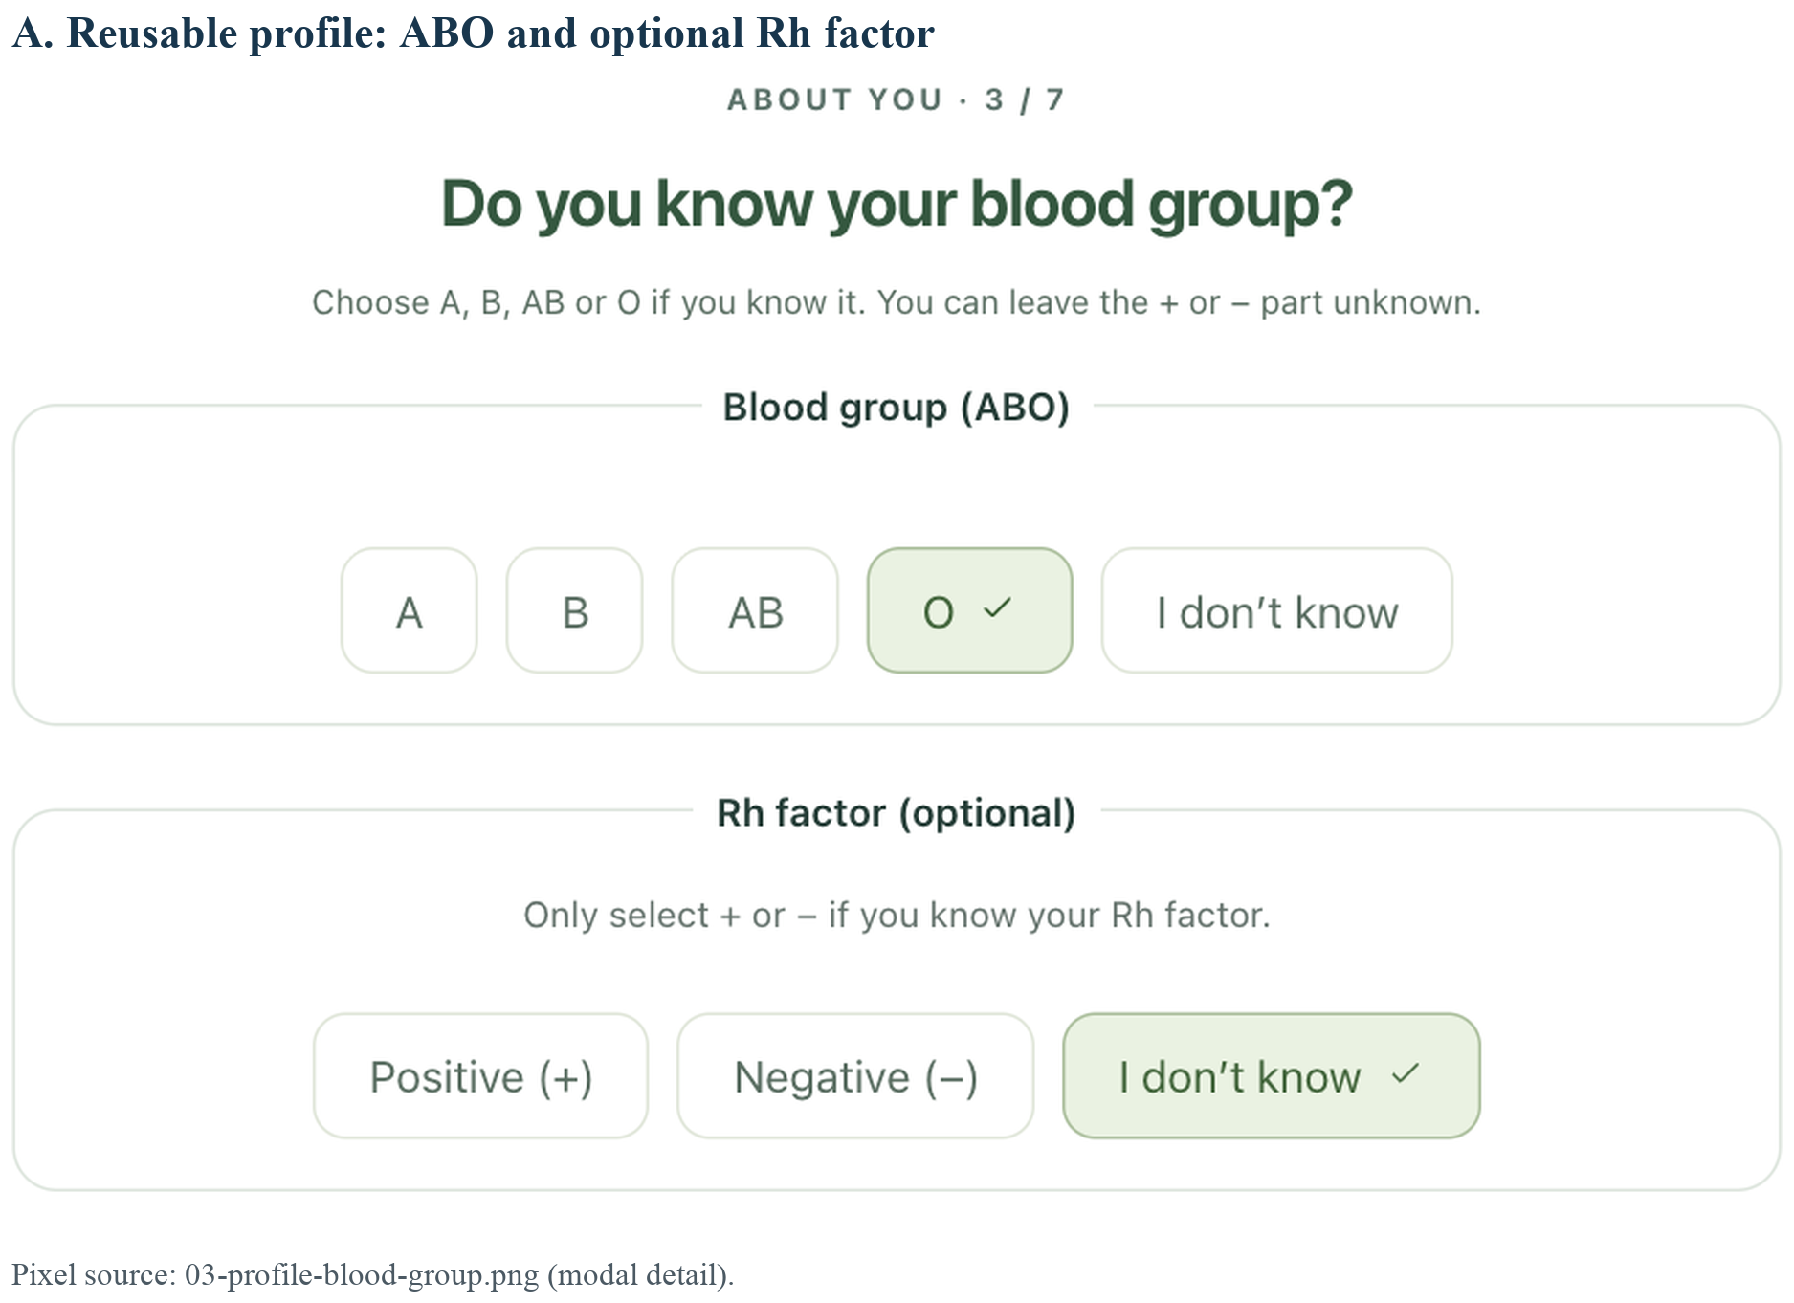
Figure D1. Reusable profile with separate ABO and optional Rh choices. The actual current UI is shown with fictional patient data.

Appendix D Multiple body areas
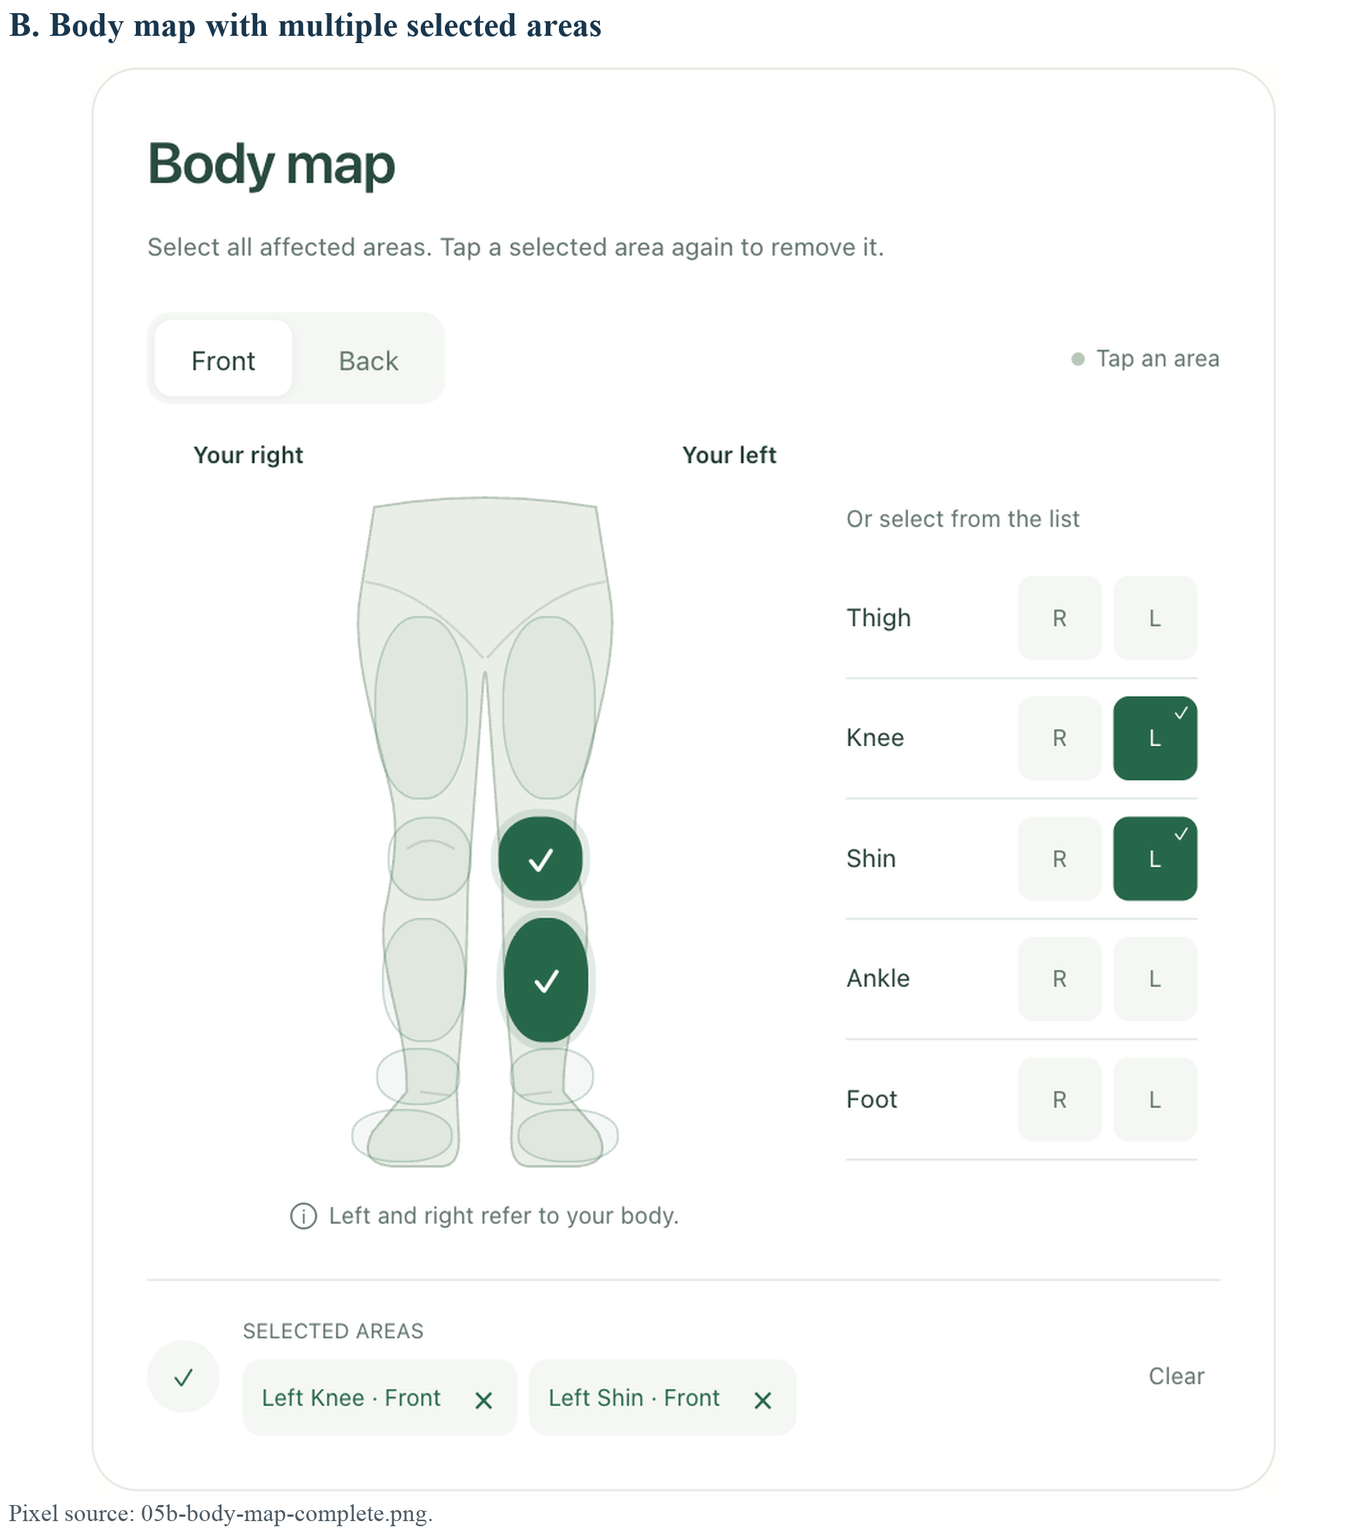
Figure D2. Full body-map component with two selected areas, removable selections and labelled control alternatives.

Appendix D Localised patient entry
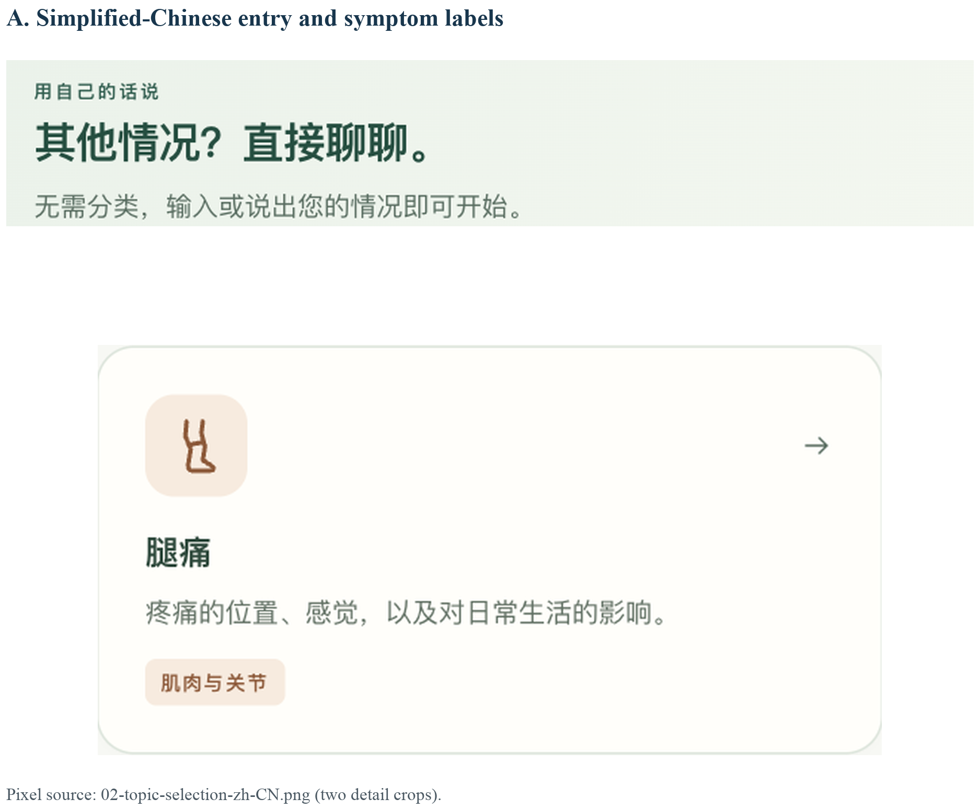
Figure D3. Simplified Chinese entry and symptom-card detail. “Leg pain” is translated with the rest of the patient interface.

Appendix D Mobile follow-up
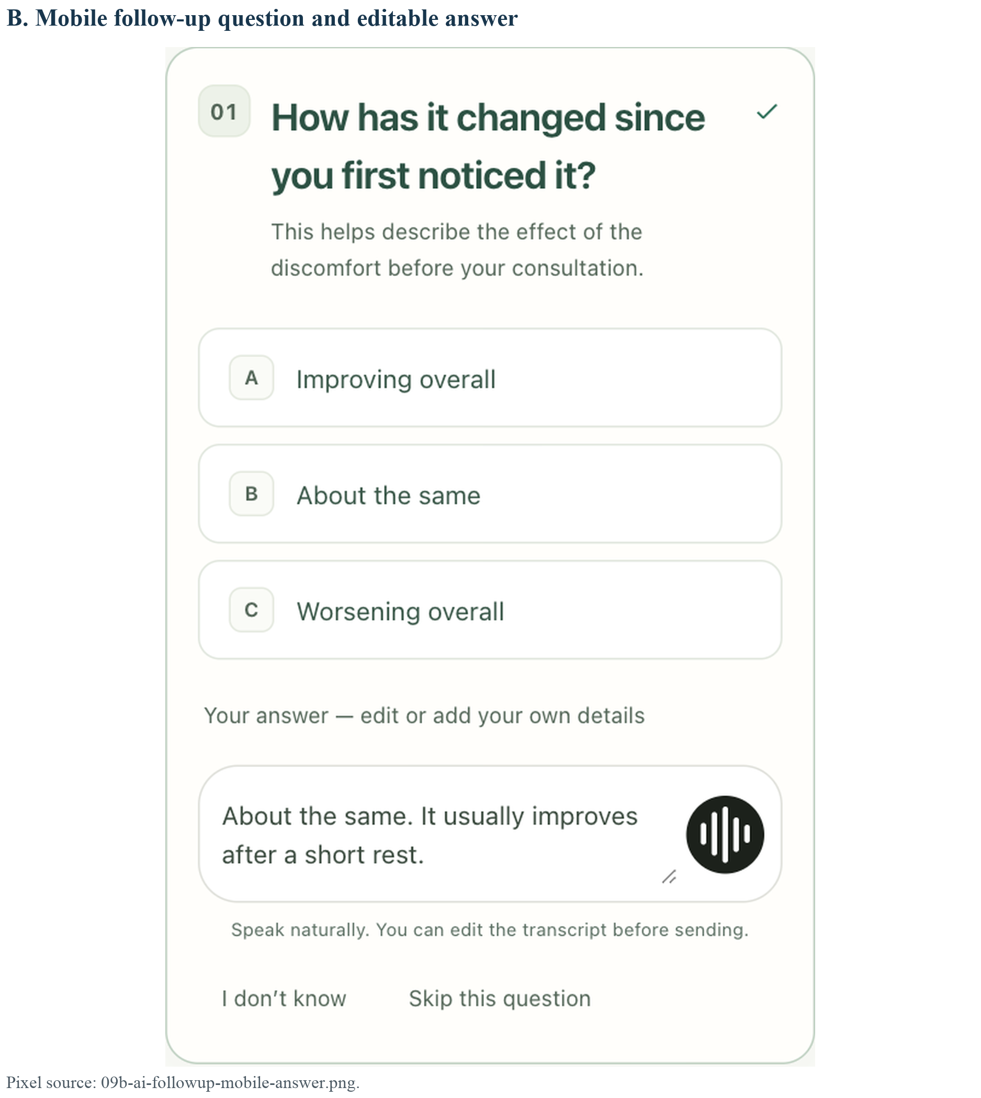
Figure D4. Actual mobile question component with suggested options and editable text. Question content is a deterministic synthetic fixture; the screenshot does not establish model or translation quality.

