INTRODUCTION

Now a days, the bank customers were depending on the net or the bank straightly for all their account details and can’t able to involve in the bank process directly. This Problem can be solved through Mobile Banking System. The title of the project is MOBILE BANKING. The main aim of the project is to mobilize the Bank Process that is used to reduce the customer transaction-time as well as user can able to access from anywhere through mobile.

Mobile banking enable customer to access the information from his personal mobile and can able to view his account details. This system also used to transact money to another client through the keypad of the mobile itself. The user can also verify his Cheque and demand draft details if another person may pass a demand draft or Cheque.

The Mobile Banking System runs in a Mobile Browser (Nokia Simulator). The software consists of two parts viz, the server part and the client part. The server part is present in Mobile Banking server in the form of Downloaded Application module. The client part is present at each client’s mobile the server and the client are connected to each other over the Internet using WAP technology.

Mobile Banking provides a system for the user to access his bank account through his Mobile. The system also enables the user to pay his EB Bill, Telephone Bill through his mobile as well as pay for some other services, which he has availed. The Mobile banking system is not just for payment but a user of the system can also transfer money to another account holder through this system. He can receive from his bank or from his business associates or friend or other person who is also connected to the system.

Hardware requirements:

Processor : Pentium-III
Processor speed : 750 MHZ
Mother board : Mercury

Primary memory [RAM] : 128 MB
Secondary memory : 40 GB
CD-ROM : Samsung 52 x MAX
Floppy Disk drive : 1.44 MB
Monitor : 14” samtron
Keyboard : Samsung 104 keys
Mouse : Logitech

Wireless Markup Language (WML)

Introduction to WML:

WML (Wireless Markup Language) is a markup language based on WML. Technically it is an XML application. Just like HTML and XML, WML is read and Interpreted by a browser built into the WAP device. For WAP devices, the browser is Commonly called a micro browser, indicating that its capabilities are somewhat limited. Additional limitations may be the result of the device that the micro browser runs on. If You have no prior knowledge of XML; you will probably find WML much more Stringent than HTML.WML files are referred to as “decks”. Each deck consists of one or more cards. Cards begin and end with<card> tags, while decks begin and end with <deck> tags. When the WML micro browser accesses the WML document (or deck), it reads the whole <Card> tag in WML is very similar to the <a name> tag of HTML. WAP devices have very little memory, so there is a limit to how big each WML Deck can be. The limit varies a great deal from one browser to another. These limits refer to the compiled form of your deck, which is usually fairly small compared to the plain text XML, code that you send out from the server.

Reasons to use WML:
WML is used in the WAP environment instead of HTML. WML is designed for wireless devices. Compared to HTML, WML requires very little bandwidth and much less processing strength to render, which means longer lasting batteries. Finally, HTML requires a larger display than is available on a mobile phone.

Wireless Markup Language Script (WML Script)

Wireless Markup Language Script (WML Script) was designed to overcome the limitations of WML for creating complicated interactions on wireless devices like pre-Processing and validating data for an online ordering form. WML Script is similar to JavaScript. However WML Script, keeping to the Bandwidth and memory limitations of wireless devices, is more compact and simpler than JavaScript. WML Script and WML closely integrate with one another. Because WML Script Is Run locally on the device browser, and not on a remote server, the wireless device doesn’t have to send data to the server as often. This means visitors to your site using a
Wireless device have a much faster experience – and on the Internet that often can make the difference between someone both staying on your site and returning later.

sNokia Simulator:

- Nokia Mobile Internet Toolkit 4.0
- Nokia 5100 SDK

Nokia Mobile Internet Toolkit 4.0

Nokia Mobile Internet Toolkit (NMIT) consists of a set of editors for creating various types of mobile Internet content. NMIT enables the display of this content on Multiple supported phone SDKs, such as the Nokia 5100 content authoring SDK as well As the Nokia Mobile Browser Simulator (NMB)”concept” phone SDK. Phone SDKs are installed separately. NMIT detects installed, supported phone SDKs at startup and lists these in its SDK Control Panel. You can display Content you Author on any supported phone SDK by simply clicking a Show button within an editor.
Most NMIT editors are used for creating XML-based content types defined by Document type definitions (DTDs). These editors employ content validation to check Content against a DTD, and they provide futures for easily selecting elements and Attributions for insertion based on current cursor position. In addition, NMIT provides a DTD manager through which you can import new DTDs for use by NMIT editors. Nokia Mobile Internet Toolkit (NMIT) 4.0, which has been newly redesigned to Focus primarily on content authoring futures and to support multiple active phone SDKs.

NMIT 4.0 defers considerably from the previous NMIT 3.1 versions in that the following NMIT 3.1 components are no longer included with NMIT and are now available as Separate downloads from forum Nokia. WAP Server Simulator, newly renamed Nokia WAP Gateway Simulator (NWGS)

- Nokia Mobile Browser (NMB) 3.01 device simulator, Newly renamed
- Nokia Mobile Browser (NMB) Simulator 4.0. In additional, the NMIT 3.1
- Set of tab views for viewing current, session, Bookmarks, WTLS, and
- WIM information is not included in NMIT 4.0. These views, which are
- Used for diagnostic monitoring of the interaction of phone SDKs with the
- Network, have been integrated within each phone SDK and made
- Accessible through a window attached to each running SDK instance.

This redesign of NMIT provides several benefits such as the ability to:
- Launch multiple phone SDKs and multiple instances of most individual phone SDKs.
- Send content simultaneously to multiple instances of running phone SDKs.
- Launch diagnostic views from running individual phone SDKs with
- View panels targeted individually to phone SDKs capability; for
Example,

WIM and WTLS views are absent from the diagnostic views of

Phone SDKs that do not support these functions.
- Associate file types with NMIT editors during
- NMIT installation so that double-checking a file of
- That type opens the file in an NMIT editor

NMIT enables you to launch the following tools:

- SDK control panel. This tool for managing phone SDKs is an integral part of NMIT.
- DTD manager. This tool for supplementing the DTDs used by NMIT’s XML-based editors is an integral part of NMIT.
- DRM (Digital Rights Management). This tool, a single user WAP gateway, is a separate application, not integrated with NMIT.

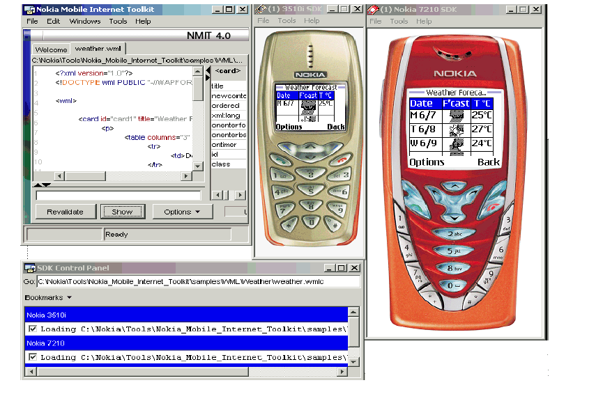

Nokia 5100 SDK:

The Nokia 5100 software Developer’s kit (Nokia 5100 sdk) is a development Tool that let’s you preview how wireless content will look and work when it is ultimately To an actual Nokia 5100 mobile handset for the Americas. You can also use the Nokia 5100 SDK to develop content for other Nokia handsets with characteristics and Functionality those are similar to that of the Nokia 5100 handset. The Nokia 5100 SDK has an XHTML color browser and an HTTP communications Stack that lets the SDK directly receive from web servers without going through a WAP

Gateway.

With this SDK, you can view local files or receive mobile Internet content using an HTTP connection.

Such content includes:
- Web content designed to be browsed on a mobile phone, such as brows able WML and XML content
- Wireless messages such as MMS (multimedia message service) and SI/SL (service Indictor/Service Load) push messages.

To simulate pressing the buttons on a Nokia 5100 mobile handset, click the Corresponding keys on the SDK with the mouse.

Nokia Mobile Browser 4.0 SDK (NMB):

NMB is a mobile phone SDK that includes a mobile Internet browser for browsing

Both mobile Internet content (through a WAP connection) and local file content. It fully

Supports the content authoring features of Nokia Mobile Toolkit 4.0(NMIT) and can be used to display XHTML and WML content, as well as push message. It also can be used Standalone.

- NMB 4.0 can be launched as a standalone browser or used in conjunction with Nokia Mobile Internet Toolkit (NMIT), or both simultaneously.

- You can launch multiple instances of NMB 4.0 simultaneously and use these Independently, and you can display NMIT 4.0 content on all running instances Of NMB 4.0.

- NMB 4.0 now includes diagnostic views through its Tools>Diagnostic menu.

Wish to preview how their content will look before it is ultimately deployed on a mobile Phone handset.

Using NMB, content developers can mobile Internet content developed using Nokia Toolkit 4.0(NMIT), as well as local file content resident on Internet servers and accessed through a WAP connection. WAP connection may be made through either a WAP gateway server or through Nokia’s WAP gateway simulator (NWGS)

WAP protocol Support:

The Nokia mobile Browser 4.0 SDK supports the WAP June 2000(or WAP version 1.2.2) Specification. These may be found at the WAP Forum site at the page titled the June 2000 (WAP 1.2.1) conformance release. Supported content includes WML, WML Script, and XHTML, as well as WBMP and GIF image formats.

Character Set Supports:

The Nokia Mobile Browser 4.0 SDK supports the following character sets:
- US ASCII (ISO-8859-1)
- UTF-8
- UCS-2 (ISO-10646-UCS-2)

ARCHITECTURAL DESIGN

Architectural design is concerned with the refining of the conceptual view of the system; identify the internal process of the system The diagrams of the Individual modules are in the APPENDIX 1.

Here various operations are divided into modules that as their own interfaces with the required information and the various modules are

- Registration/User Verification
- Wap Registration
- Balance Enquiry
- Statement Enquiry
- Fund Transfer
- EB, Telephone Bill Payment
- DD/Cheque Request
- Change Password

Registration/User Verification& Wap Registration:

This module gives full information about the particular registered user (i.e. the account type and personal details). If the user wants to register newly he should enter the personal details and the type of account information so that the wap registration form is correspondingly generated if the account type is current account, if he is a Fixed Deposit account holder the wap registration form is not generated to that particular account holder.

The option gives full information about the user details, it also has another two options to select as account type. First one is fixed deposit holder, it means that particular amount is deposited in the bank for a particular duration (say for 3years) and the user is allowed to perform operations within the interest amount and the second one the current account type, here the user is allowed for Wap registration and allowed to access his account information through his Mobile.

Balance Enquiry:

This module is used to reserve the bus and train or flight tickets, ticket cancellation and checking the reservation status.This module it displays three options. First one is used for train reservation. Second one is used for bus reservation. Third one is used for flight reservation.Train reservation display five options. First one used to display all the reservation details (train no, train name, passenger name, class, date and so on). Second one is used to display the reservation status. Third one is used to display available tickets in the train. Fourth one is used to reserve the tickets. Fifth and one is used to cancel the tickets. The same process is implemented by the bus and flight reservation. (REF.APPENDIX1.2)

CHATTING:

This module is used to share the information between two clients provided the clients register in this service provider.Before entering into the chat room, first the users enter the secret code. If the user enter the correct secret code then the users enter into the chat room, and the user will be able to chat with other client also and he will be able to send message or receive message. At a time he can chat with two or more client also. (REF.APPENDIX1.3)

IMAGE STREAMING:

This module is used for the entertainment purpose. The collection images are stored in the database. These images are created by a motion picture.
First the user selects the movie name. Then the server searches the movie on the database and passes the movie from database to simulator. (REF.APPEDIX1.4)

