**Assignment-1**

**MCQs:**

1. C. Windows Subsystem for Linux
2. B. cd ~
3. B. Apt
4. C. Network Layer
5. B. It Defines the range of IP address in a Network
6. B. mkdir
7. C. Providing Command line interface
8. B. Apache
9. B. Domain Name System
10. A. Cat

**Tasks:**

**1.Ls** command implementation.

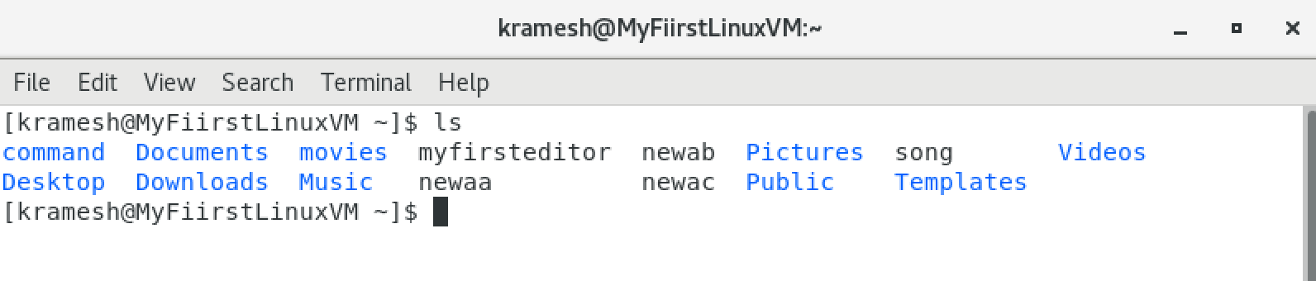

2.Created new directory named **documents**

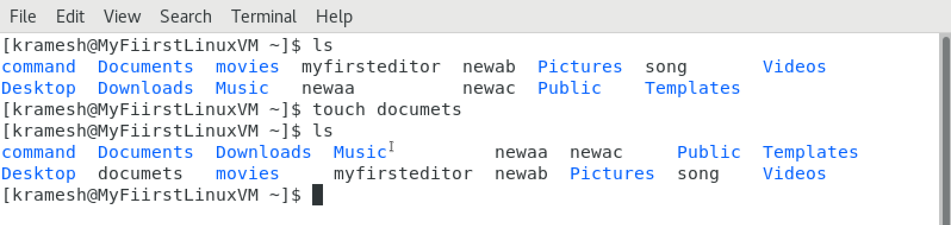

3.Make the **myfile.txt’s** owner access to read and write and others access to read only.

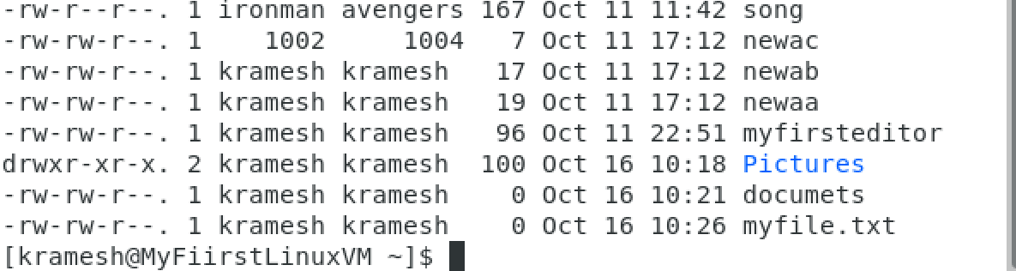



4.Installed text editor **nano** with **yum** package manager in cent OS.

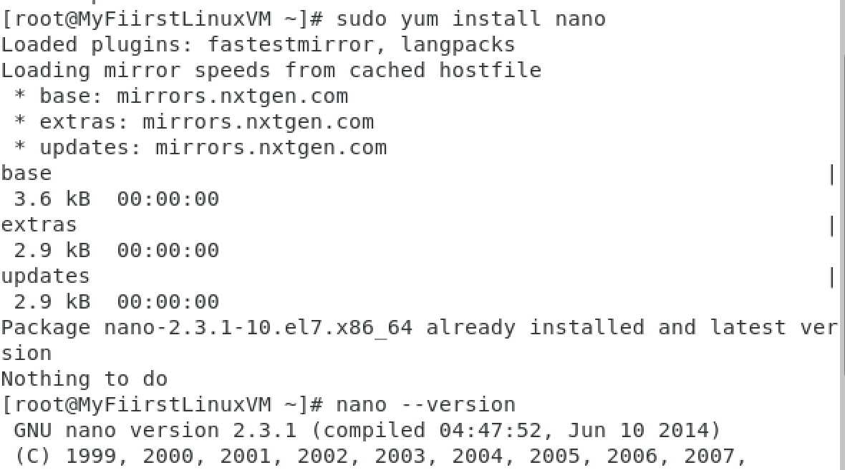

7.Using Bash Scripts, Printed **Hello world** in the command line

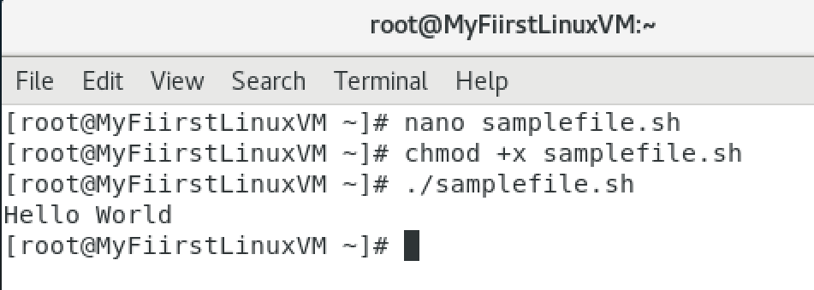

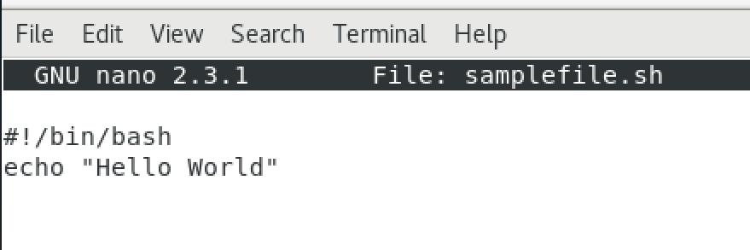

8.To check the google’s connectivity by execute **ping** command.

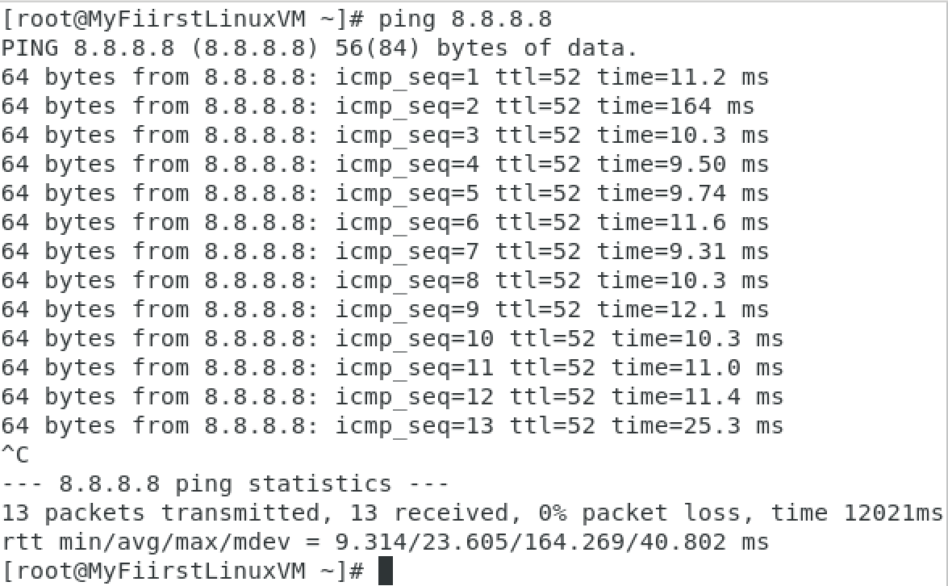

9.Created **targetfile.txt** in the Documents directory.

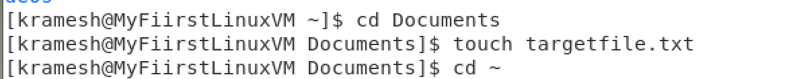

Link mylink file to the targetfile which was created in the documents folder



Check whether symbolic link is created or not



10.With the help of **netstat** command, listed the network connections.

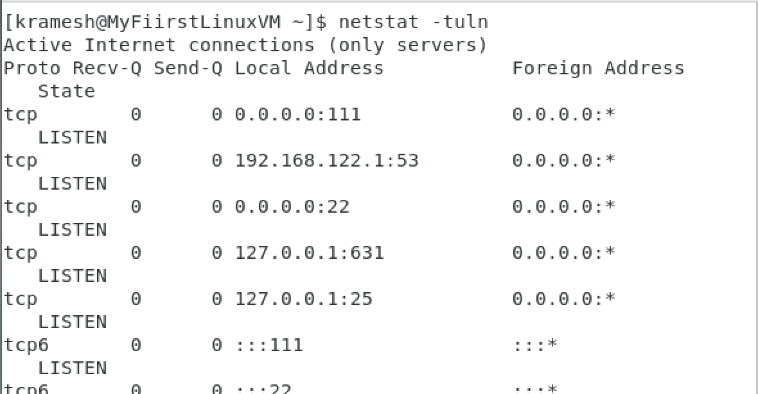

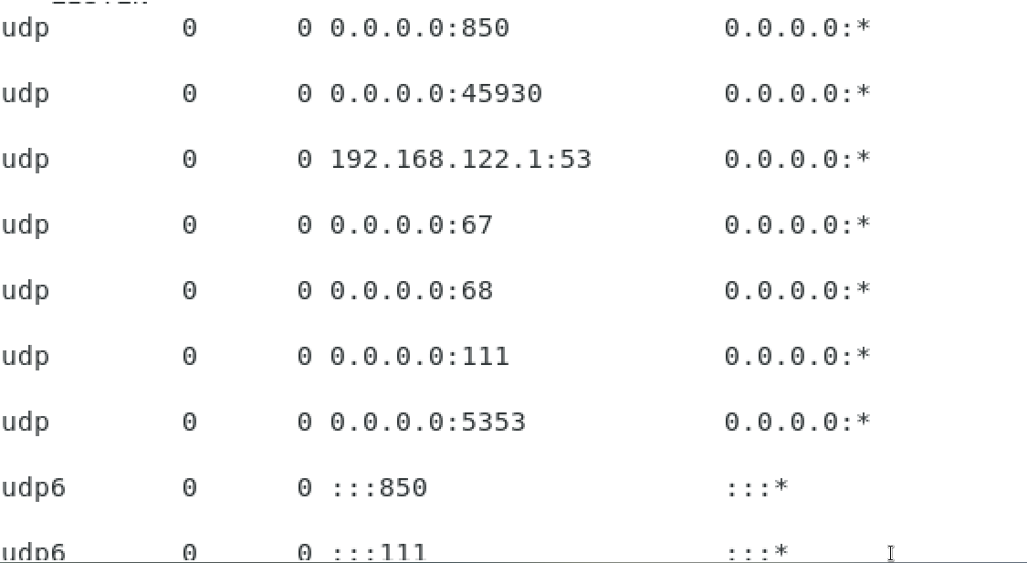

**Labs:**

WSL installation:

1. Go to the Microsoft store and install the WSL through it.
2. Then we need to install any one of the Linux distributions.
3. So far now, installed Ubuntu distributions from same Microsoft store.
4. After ubuntu installation open it from the start menu and check it’s version.

Basic Linux Commands:

1. Ls -> this command lists all the files and directories in the particular location.
2. Ls -l -> it will list all the directories with some description such as size, ownership, groups, etc..
3. Ls -lt -> it will list all the directories with date and time
4. Ls -ltr -> do same thing with sort the results by older file to newer files.
5. Cd -> helps to go inside the directory
6. Mkdir -> (Make Directory) it will create new directory in the particular path.
7. Touch -> it will create new file and we can able to edit it through one of the editors.

File Permissions:

Every file has some permissions and it shows in this format **drwxrwxrwx** and **-rwxrwxrwx.**

* r-> read
* w->write
* x->execute
* 1st three bit represents **User** and 2nd three bits represents **groups** and 3rd three bits represents **others** that is everyone.
* For example, -rw-r-x-rw- => this format conveys that user having the permission of read and write the file, groups can read and execute the file and others can read and write the file.
* Chmod u-r filename -> remove the user’s read access from the file
* Chmod g+r filename -> add the group’s read access for the file

Bash Scripting:

* 1st we need to create the empty file with the **.sh** extension in any folder.
* Then with the help of any one of the editor open the file.
* Add the shebang line at the beginning to make the file as a shell scripting file **“#!/bin/bash”.**
* Write the *echo “Hello world”* in it and save the file and exit from it.
* Then change the permission for the file as **chmod a+r filename.sh**.
* With the help of this command **./filename.sh**, it will show the written item in the command prompt.