**Assignment-2**

**YAML Basics:**

**MCQs:**

1. YAML Ain’t Markup Language
2. Using Square Brackets [].

**Tasks:**

List of fruits and their colors

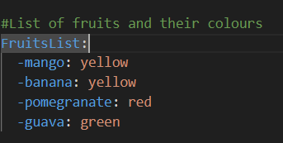

Server configuration in YAML

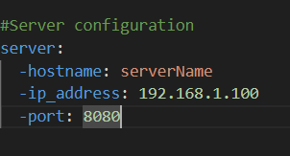

**MCQs:**

1. Frequent integration of code changes
2. Jenkins
3. What is Azure DevOps primarily used for?
   1. Software development and delivery
4. Which components are part of Azure DevOps?
   1. Azure board and azure pipelines
5. In Azure DevOps, what is the purpose of a build pipeline?
   1. To automate the build and test process
6. What is the role of version control in the software development lifecycle?
   1. Tracking changes in source code

**Tasks:**

Continuous Integration pipeline for Angular Application.

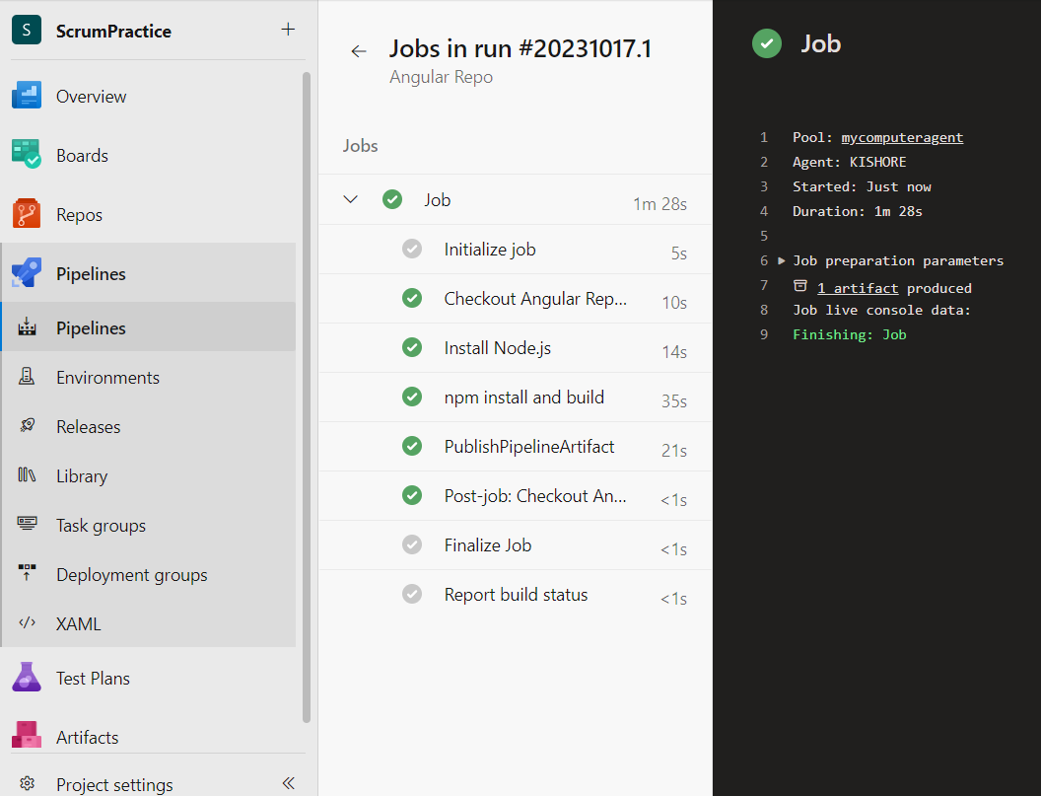

Continuous Integration pipeline for Web Application.

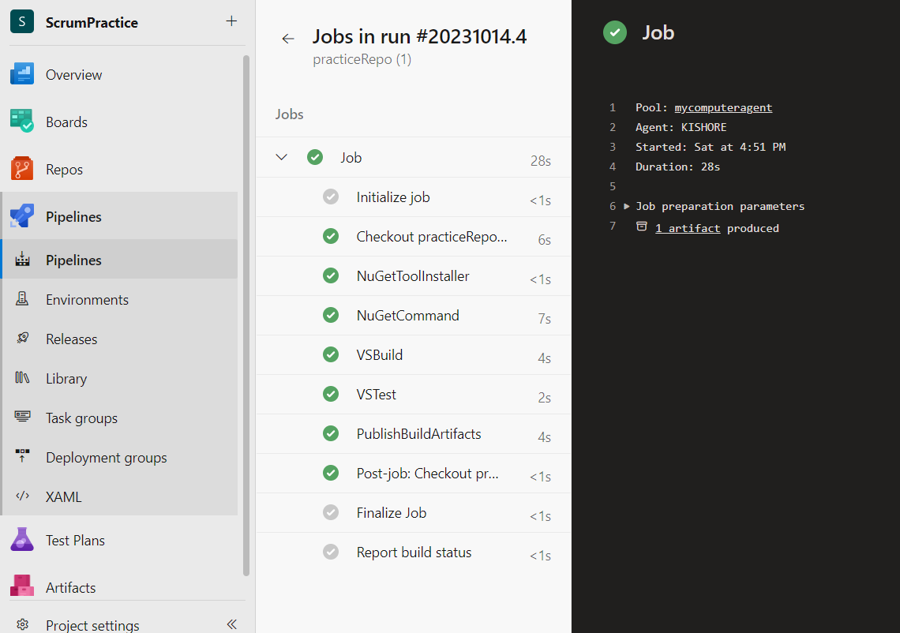

Continuous Integration pipeline for React Application.

