WebSockets:(Bidirecitonal)

Client make a requests

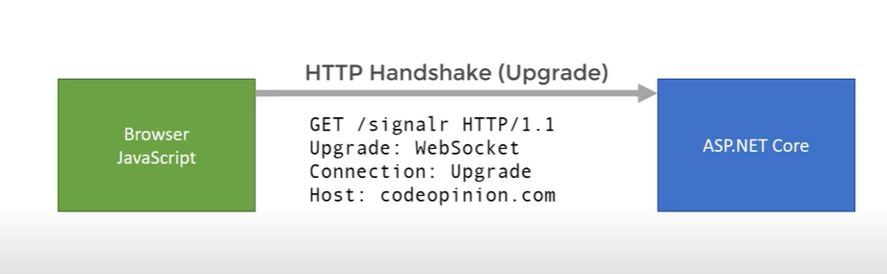

server gives response

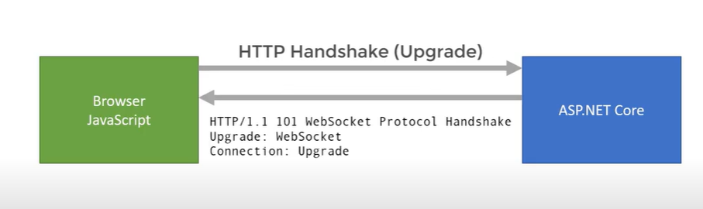

After receiving response there will make a bidirectional connection between client and server.

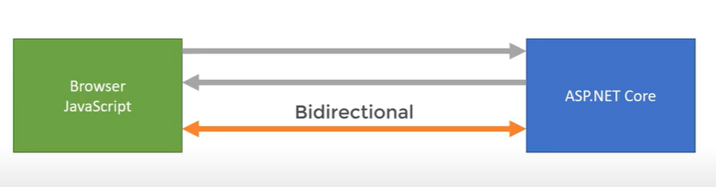

Server Sent events:(as name specifies)

Once client makes connection then server push data through the connection,

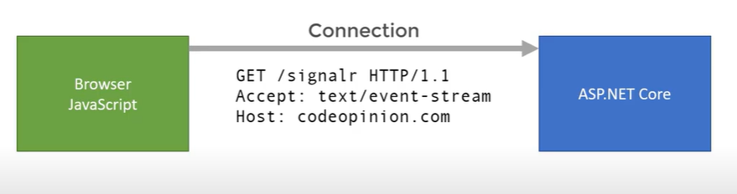

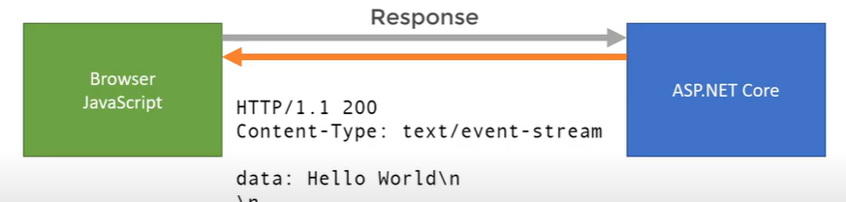

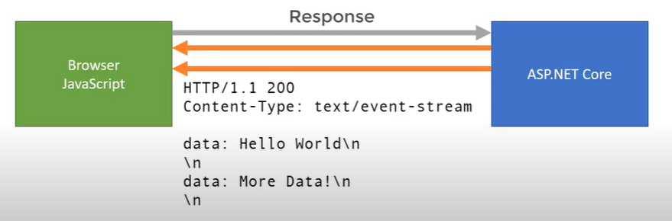

Once the empty line is identifies client start to processing the data from the server