- Valid parenthesis using stack

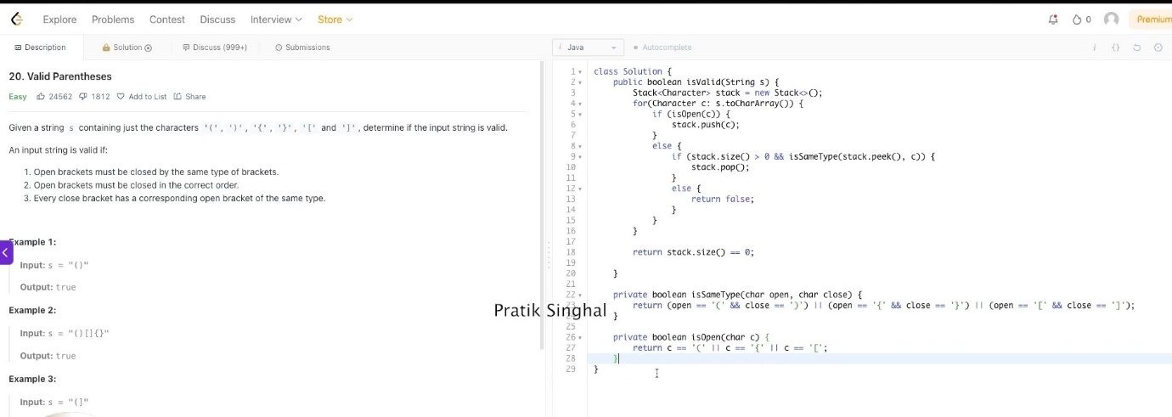

- Sort Colors Dutch national flag problem

https://www.youtube.com/watch?v=6sMssUHgaBs&list=PLd-xs2sUKNsp1tOPG2Xz6nedAdC4eVyQa&index=1

