Start the program by running command prompt.

Run “javac RSAGenKey.java”

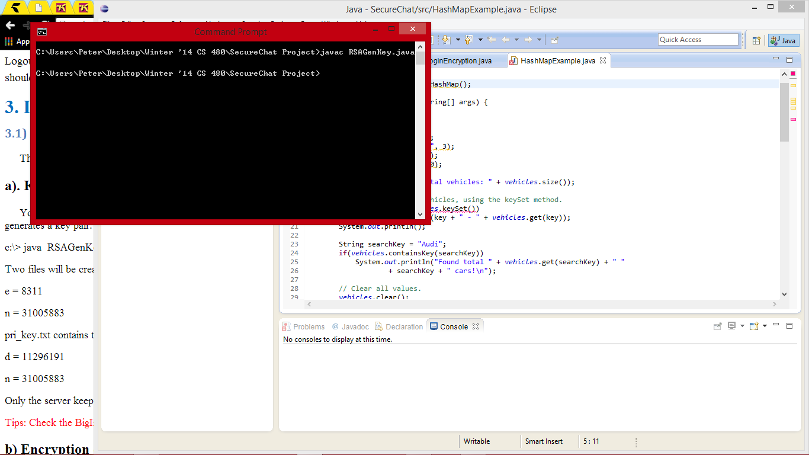

Run “java RSAGenKey #”. The # should be a number, not the symbol itself.

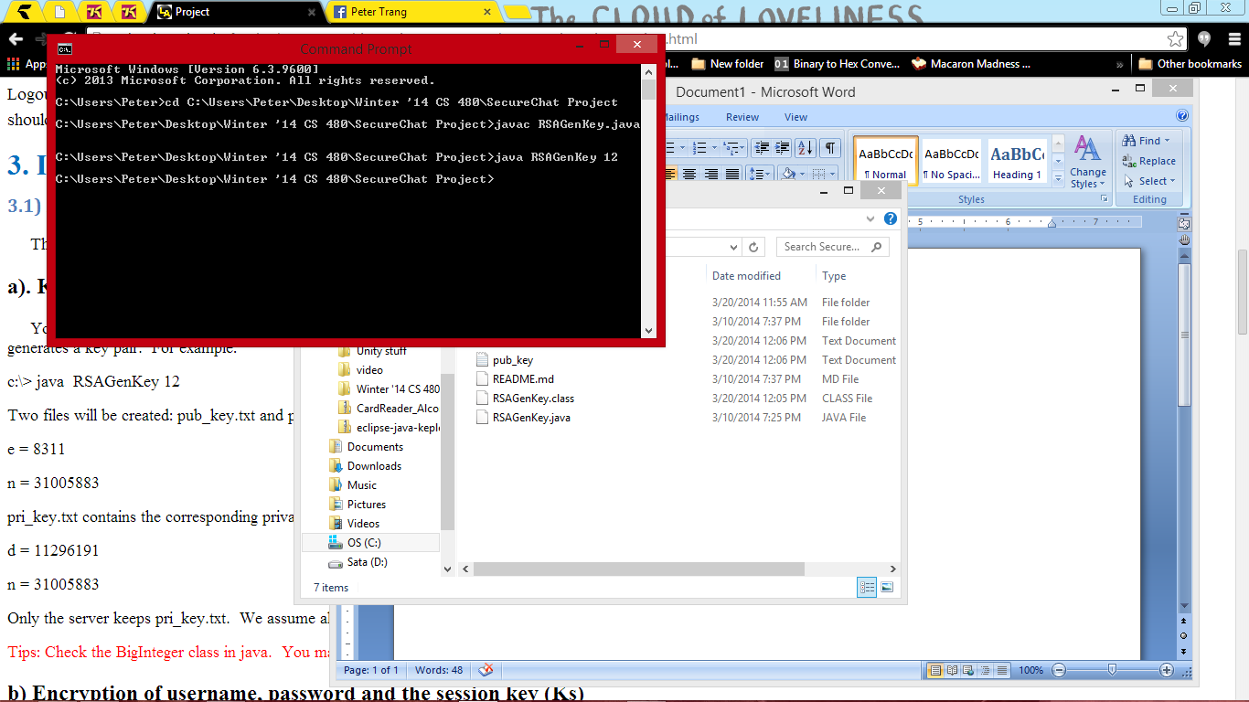

Once generated, two text file will be created “pub_key.txt” and “pri_key.txt”.

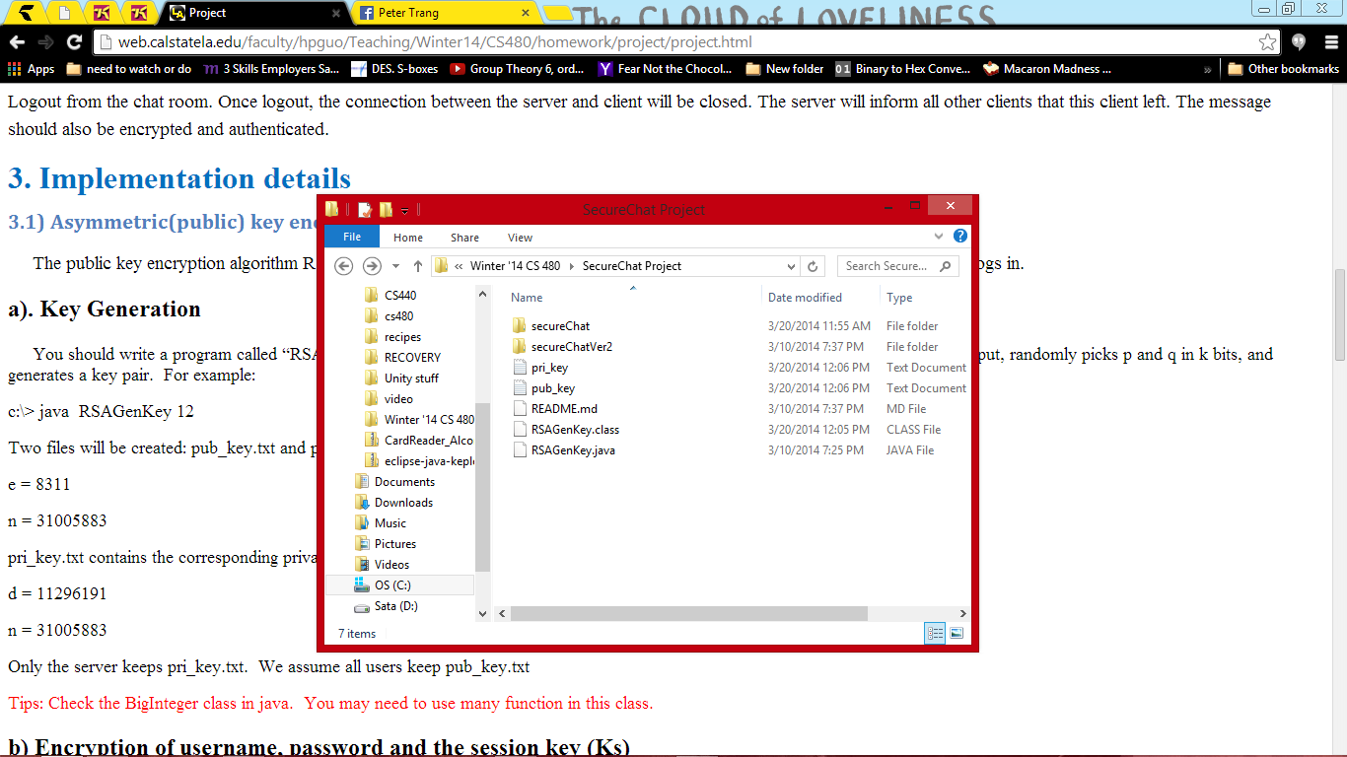

Every time you want to generate a new key, delete the old one first.