**Excel-Assignment**

**Question 1:**

What is the difference between 'Paste' and 'Paste Special' in Excel? Briefly

explain with examples.

**Answer:**

**Paste (Standard)**

This is the default command, usually performed with Ctrl + V. It's a simple, all-in-one paste that copies everything from the source cell(s) to the destination. This includes:

* The cell's **value**
* Any underlying **formulas**
* All **formatting** (e.g., font, colour, cell borders)
* **Comments**
* **Data validation** rules

**Example:** If you copy a cell with the formula =A1+B1 and red formatting, a standard paste will replicate the formula and the red formatting in the new location.

**Paste Special**

This command, accessed with Ctrl + Alt + V, gives you granular control over the paste operation. Instead of pasting everything, you can choose to paste only specific elements.

**Examples of Paste Special Options:**

* **Values:** Pastes only the calculated value of a cell, ignoring the formula and formatting. This is useful for "hard-coding" results.
  + *Example:* Copying a cell with the formula =10*5 and using "Paste Special > Values" will paste the number 50, not the formula.
* **Formulas:** Pastes only the formula, without the formatting from the source cell.
* **Formats:** Pastes only the formatting, leaving the original values and formulas in the destination cell untouched.
* **Transpose:** Changes the orientation of the data, converting rows to columns and vice-versa. *
* **Operations:** Allows you to perform mathematical operations (add, subtract, multiply, divide) with the copied data and the destination cells.

*Example:* To add 5 to a range of numbers, you can type 5 in a cell, copy it, then use "Paste Special > Add" on the target range.

**Question 2:**

Describe the functions and usefulness of 'Freeze Panes' and 'Split Panes' in Excel.

**Answer:**

**Freeze Panes:**

**Function:** Freeze Panes locks specific rows and/or columns in place. When you scroll down or to the right, the frozen rows and columns remain visible while the rest of the data moves.

**Usefulness:** This is extremely useful for keeping header rows or a key identifier column in view. For example, if you have a spreadsheet with a header row of "Name," "Department," and "Salary," freezing that row allows you to always see what each column represents, no matter how far down you scroll. It prevents you from losing context in a large dataset.

**Split Panes:**

**Function:** Split Panes divides the worksheet into two or four independent viewing sections. Each section has its own scroll bars, allowing you to scroll through different parts of the same worksheet simultaneously.

**Usefulness:** This is ideal for comparing data in different areas of a worksheet without having to constantly scroll back and forth. For instance, you could split the screen to view data from January in the top pane while simultaneously looking at data from December in the bottom pane. It's like having multiple windows open for the same sheet.

The difference can be summarized as:

* **Freeze Panes** locks a section of your sheet to a fixed position.
* **Split Panes** creates independent scrolling sections within the same sheet.

**Question 3:**

Explain the difference between inserting a new row and inserting a new column in Excel. Can you insert multiple rows or columns at once?

**Answer:**

**Inserting a New Row:**

* A new row is inserted **above** the currently selected row.
* To insert: Right-click the row number (on the left side of the sheet) and select "Insert."
* A new, blank row will appear directly above the selected row.

**Inserting a New Column:**

* A new column is inserted to the left of the currently selected column.
* To insert: Right-click the column letter (at the top of the sheet) and select "Insert."
* A new, blank column will appear directly to the left of the selected column.

**Inserting Multiple Rows or Columns**

* Yes, you can insert multiple rows or columns at once.
* **Method:**
* Select the same number of rows or columns that you want to insert. For example, to insert three new rows, select three existing rows.
* Right-click on the selection.
* Choose "Insert."
* Excel will insert the new rows above your selection or the new columns to the left of your selection.
* This method saves time compared to inserting one row or column at a time.

**Question 4:**

What are logical functions in Excel? Provide examples of at least two logical functions and their applications.

**Answer:**

**Excel Logical Functions**

Logical functions are used to perform a logical test on data. They evaluate a condition and return a result of either TRUE or FALSE based on whether the condition is met. These functions are fundamental for creating conditional formulas and automating decision-making within a spreadsheet

**Example 1: IF Function**

* **Function:** The IF function is the most common logical function. It checks if a condition is true or false and then returns a specific value for each outcome.
* **Syntax:** =IF (logical_test, value_if_true, value_if_false)
* **Application:** A common application is to assign a "Pass" or "Fail" status based on a student's score.
* Formula Example*:* =IF(B2>=70, "Pass", "Fail")
* **Explanation:** This formula checks if the score in cell B2 is greater than or equal to 70. If it is, the cell will display "Pass." If not, it will display "Fail."

**Example 2: AND Function**

* **Function:** The AND function is used to test multiple conditions at the same time. It only returns TRUE if all of the conditions are met. If even one condition is false, the function returns FALSE.
* **Syntax:** =AND (logical1, logical2, ...)
* **Application:** You might use AND to determine if an employee is eligible for a bonus.
* Formula Example*:* =AND(C2>50000, D2="Excellent")
* **Explanation:** This formula checks two conditions: whether the sales in cell C2 are greater than $50,000 AND the performance rating in cell D2 is "Excellent." The formula will only return TRUE if both of those conditions are met

**Example 3: OR Function**

* **Function**: The OR function is a logical function that checks if at least one of the conditions you specify is true. It returns TRUE if any of the conditions are met, and it returns FALSE only if all of the conditions are false.
* **Syntax**: =OR (logical1, logical2, ...)
* **Application**: The OR function is useful for situations where a positive outcome can be triggered by multiple possibilities. For example, you could use it to check if a student passed a class based on either their final exam score or their project score.
* Formula Example: =OR(B2>=90, C2>=90)
* **Explanation:** This formula checks if the score in cell B2 is 90 or greater OR if the score in cell C2 is 90 or greater. The result will be TRUE if either (or both) of these conditions are met. The result will be FALSE only if both scores are less than 90.

**Question 5:**

Discuss the purpose of 'XLOOKUP' and how it differs from the traditional 'VLOOKUP' function.

**Answer:**

**The Purpose of XLOOKUP**

* XLOOKUP is designed to be a more modern and robust replacement for several older lookup functions, including VLOOKUP and HLOOKUP.
* Its purpose is to find a value in a column or row and return a corresponding value from another column or row, with greater flexibility and fewer limitations than its predecessors.

**Key Differences: XLOOKUP vs. VLOOKUP**

* **Search Direction:** VLOOKUP can only look for data to the right of the lookup column. XLOOKUP has no such limitation; it can search left or right and vertically or horizontally (eliminating the need for HLOOKUP).
* Lookup & Return Ranges: VLOOKUP requires you to define a single, large table array and then specify a column index number. This can break if you add or delete columns. XLOOKUP uses separate arguments for the lookup array (where you're searching) and the return array (where you want the result from). This makes formulas more stable and easier to read.
* **Exact Match:** XLOOKUP defaults to an exact match, which is what most users need. VLOOKUP defaults to an approximate match, which can lead to errors if you don't explicitly set the fourth argument to FALSE.
* **Handling Errors:** XLOOKUP has a built-in if_not_found argument, allowing you to specify a custom message if the lookup value isn't found. VLOOKUP simply returns a #N/A error unless you wrap it in an IFERROR function.
* **Search Modes:** XLOOKUP can search from the first item to the last or from the last item to the first. This is useful for finding the most recent or oldest entry in a list with duplicate values. VLOOKUP can only search from the top down.

**VLOOKUP**: VLOOKUP(lookup_value, table_array, col_index_num, [range_lookup])

**XLOOKUP**: XLOOKUP(lookup_value, lookup_array, return_array, [if_not_found], [match_mode], [search_mode])

**HLOOKUP**: HLOOKUP(lookup_value, table_array, row_index_num, [range_lookup])

**VLOOKUP**

* lookup_value: The value you want to look for.
* table_array: The range of data to search. The lookup value **must** be in the first column of this range.
* col_index_num: The column number in the table_array from which to return the result.
* [range_lookup]: A logical value. TRUE (or 1) for an approximate match, FALSE (or 0) for an exact match. TRUE is the default.

**XLOOKUP**

* lookup_value: The value you want to find.
* lookup_array: The range or array to search within.
* return_array: The range or array from which to return the result.
* [if_not_found]: The value to return if a match isn't found. If omitted, it returns #N/A.
* [match_mode]: Specifies the match type. 0 for an exact match (default), -1 for an exact match or next smaller item, 1 for an exact match or next larger item, 2 for a wildcard match.
* [search_mode]: Specifies the search direction. 1 for a search starting from the first item (default), -1 for a reverse search starting from the last item.

**Question 6:**

Create a worksheet titled 'Employee Data' with columns: Name, Age, Department.

Add 5 rows of data. Format as follows:

Bold and center-align the header row

Apply a fill color

Auto-fit column width

**Answer:**

**Header row is made bold and centre aligned along with fill colour**

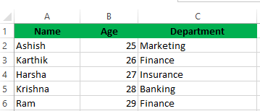

**Auto-fit column width:**

**There are 3 methods:**

Hover on the separation line of columns and double click

Select the entire sheet and double click on any column separation line

We can use ribbon also, in the home tab, from cells group, select format, from drop-down select auto-fir column width

The method I used here is: Select the entire sheet and double click on any column separation line

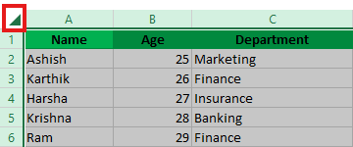

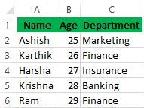

**Question 7:**

Demonstrate how to insert and delete multiple rows and columns in Excel. (Provide screenshots before and after the changes.)

**Answer:**

Multiple rows and columns can be inserted by selecting the no. of rows and columns we want to add -> right click -> insert

They can be deleted as follows: select no. of rows or columns we want to delete -> right click -> delete

**Inserting & deleting multiple rows:**

Before:

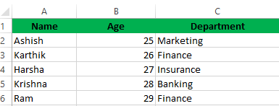

Insertion process:

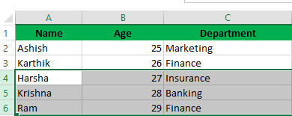

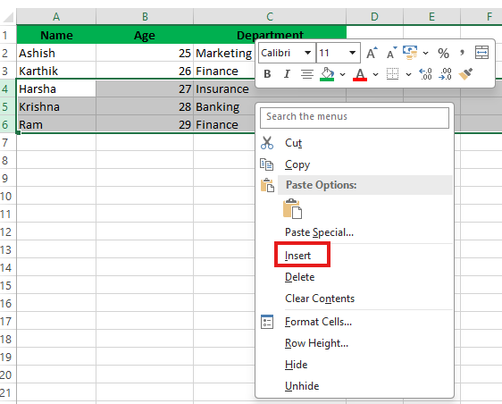

After:

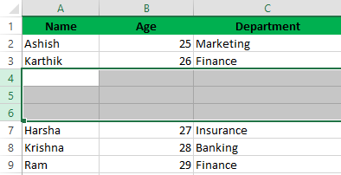

**Deleting:**

Before:

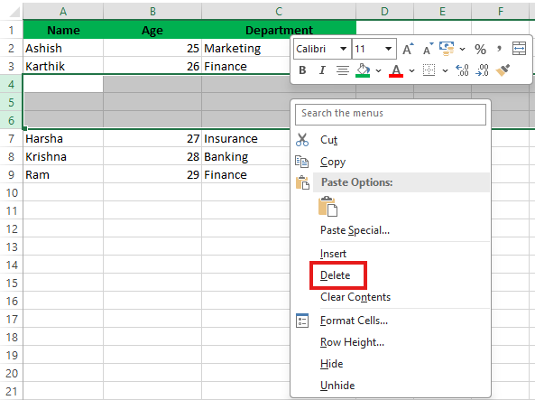

After:

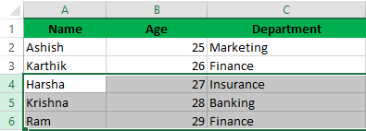

**Inserting & deleting multiple columns:**

Before:

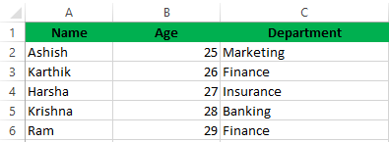

Insertion process:

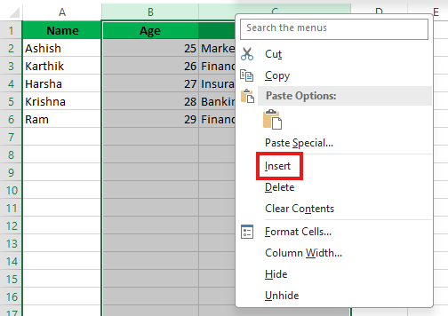

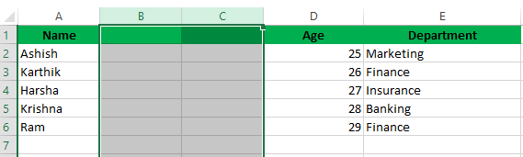

**Deleting:**

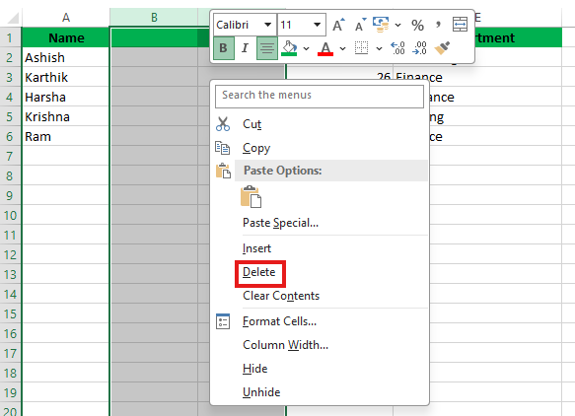

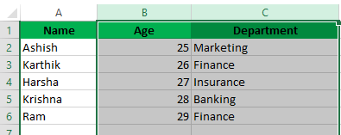

**Question 8:**

Use Excel's 'Find and Replace' feature to update department names in a sample table.

**Answer:**

Action: Replacing Finance department with Sales Department

Before replacing:

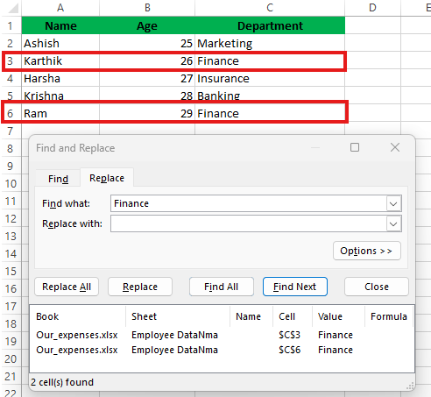

After replacing:

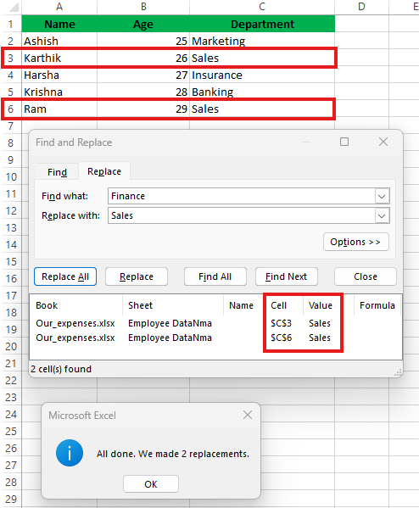

**Question 9:**

Create a small numerical dataset and apply the following functions:

● AVERAGE ● MAX ● MIN

**Answer:**

Created named ranges for columns:

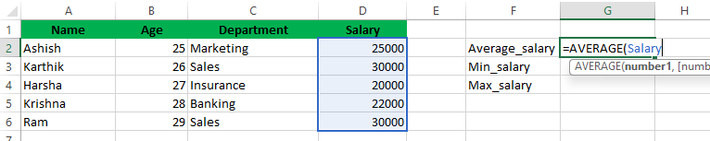

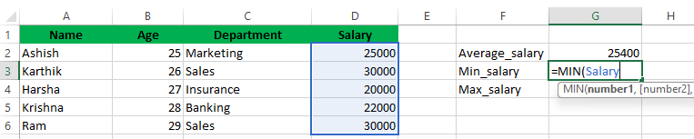

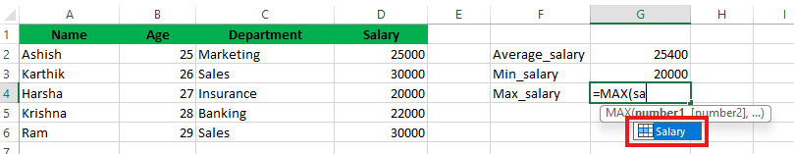

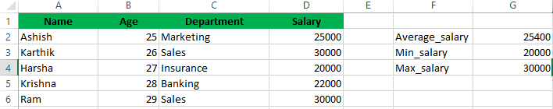

**Question 10:**

You're working with a dataset that contains missing values. As a Data Scientist, explain how you'd detect and handle missing data using Excel.

Mention tools like: ● Go To Special ● ISBLANK ● COUNTBLANK

**Answer:**

Working hours are having null values:

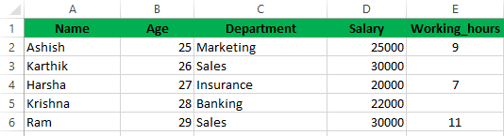

As the numeric column has missing values, we can use countblank() to identify/detect how many null values are present

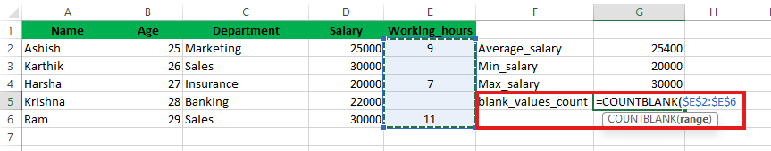

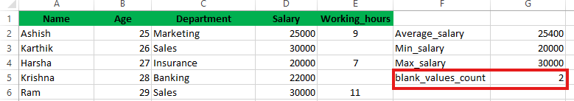

**Go To Special**

* **Purpose:** Quickly highlight blank cells in a dataset.
* **Steps:**
  1. Select your data range.
  2. Press F5 → Click **Go to Special**.
  3. Choose **Blanks** → Click OK.
* **Result:** All blank cells are selected, making it easy to fill, delete, or format them.
* **Handling:**

**ISBLANK ()**

* **Purpose:** Checks if a specific cell is empty.
* **Usage:** =ISBLANK(A2)
* **Returns:**
  + TRUE if A2 is blank.
  + FALSE if A2 contains any value (even a formula returning "").
* **Handling:** =IF(ISBLANK(A2), "Missing", "Value is present")

**COUNTBLANK ()**

* **Purpose:** Counts how many blank cells exist in a range.
* **Usage:** =COUNTBLANK (A2:A100)
* **Result:** Total number of empty cells in the specified range.
* **Handling:**
  + Imputation depends according to business – either to remove blank rows or impute with some random categorical or numerical value
  + We can impute statistically too – with average, mean, median, mode

I prefer using countblank() to identify number of blanks we have and impute them according

Here I want to impute with the median as it is less affected by outliers

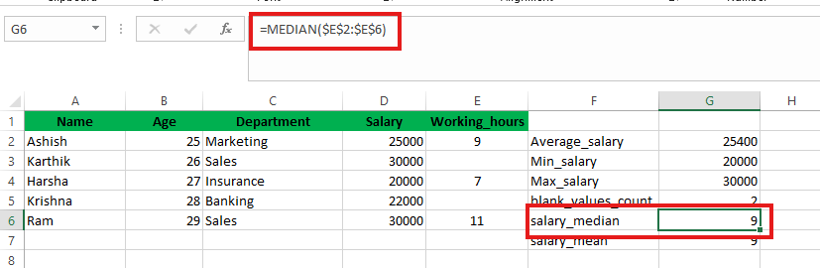

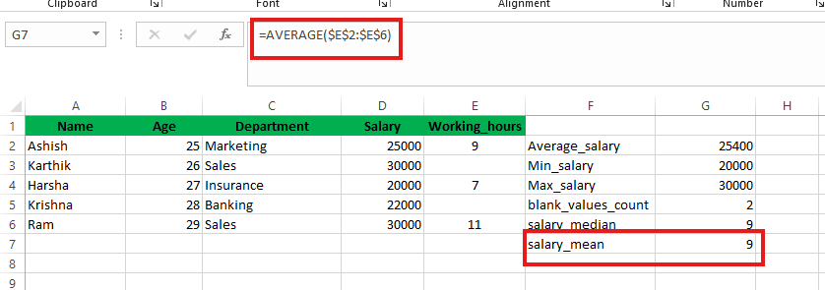

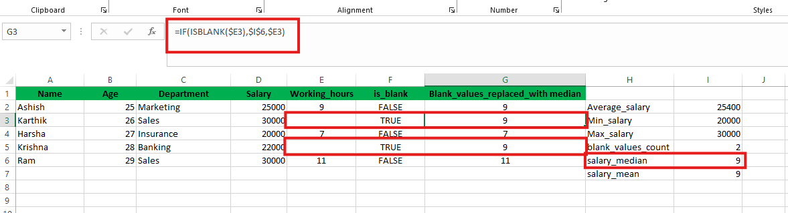

If we don’t need working hours, we can delete the column and rename the replaced with median column to working hours

**If we have errors in the working hours column, that can be handled by using =IFERROR ()**

Please refer below screenshot:

