EXP 1 :Build a basic LAN topology (switch + PCs) in Cisco Packet Tracer.

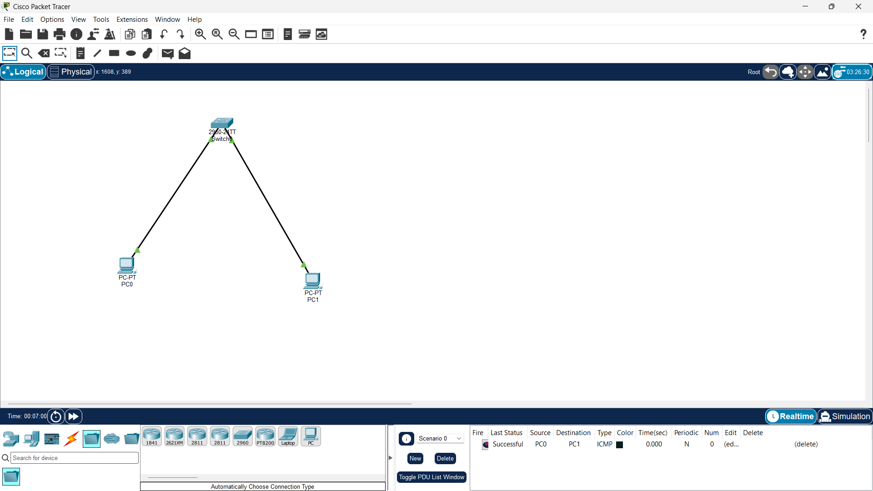
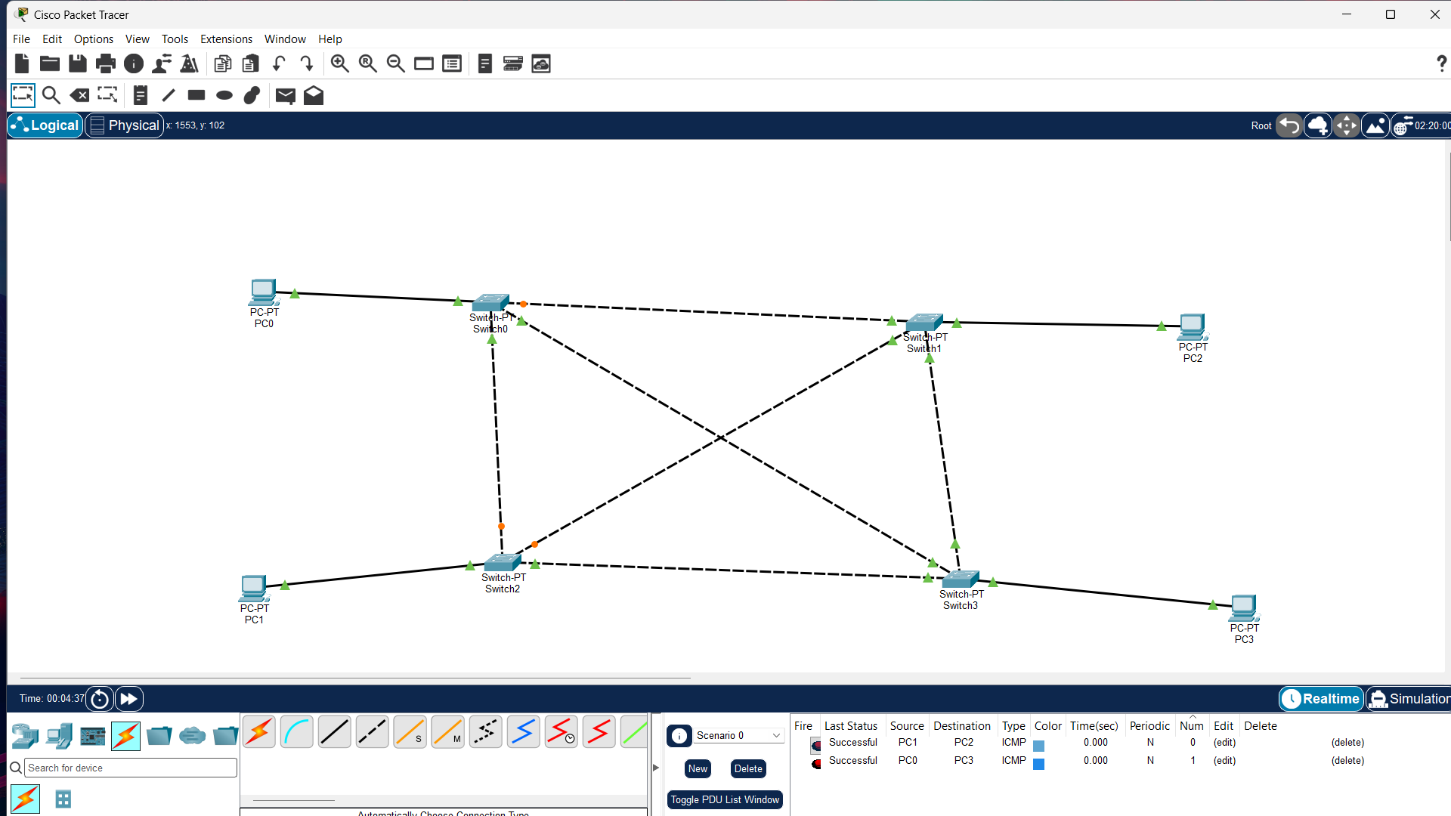
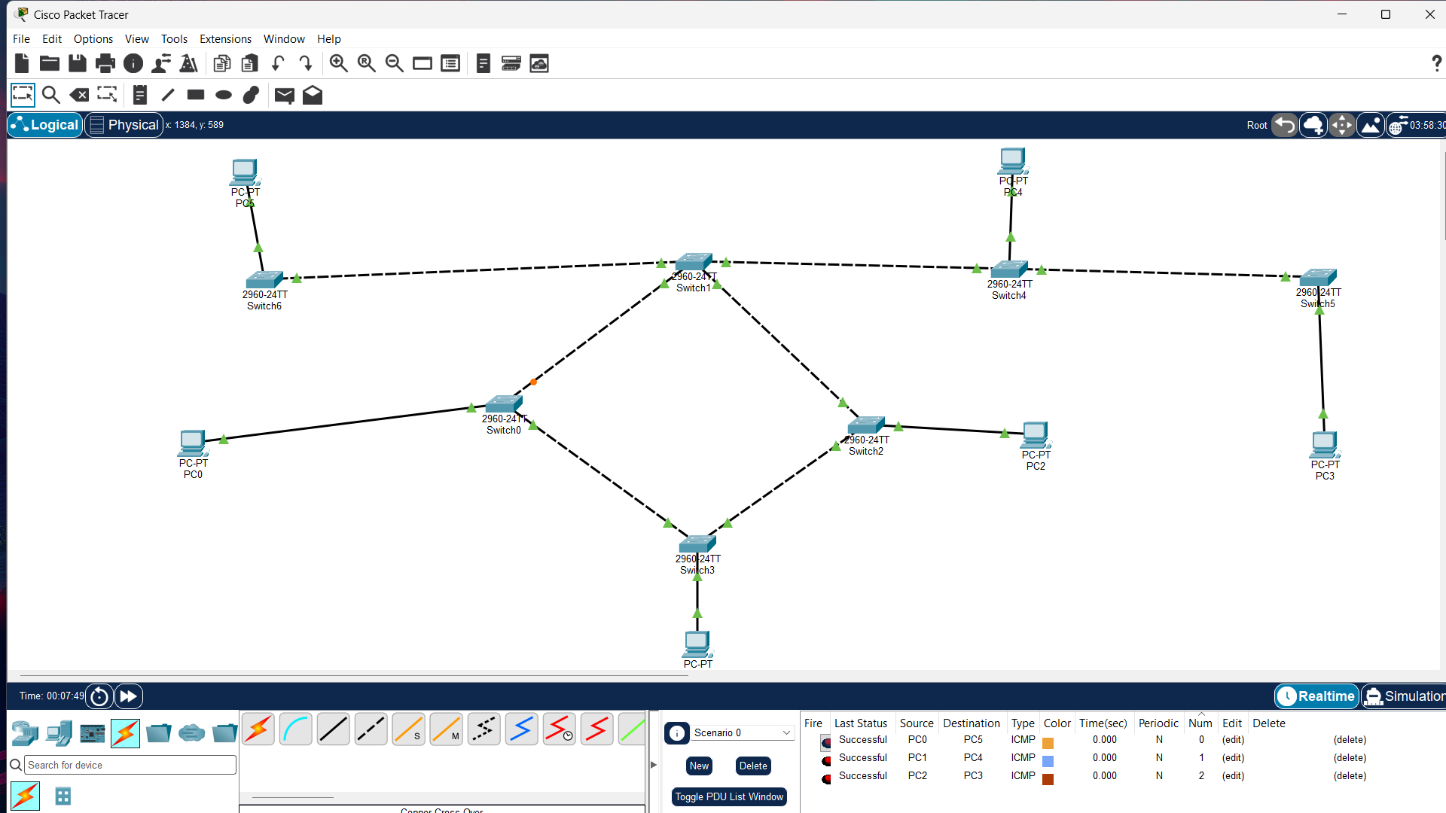

EXP 2 : Configure VLANs and inter-VLAN routing in Packet Tracer.
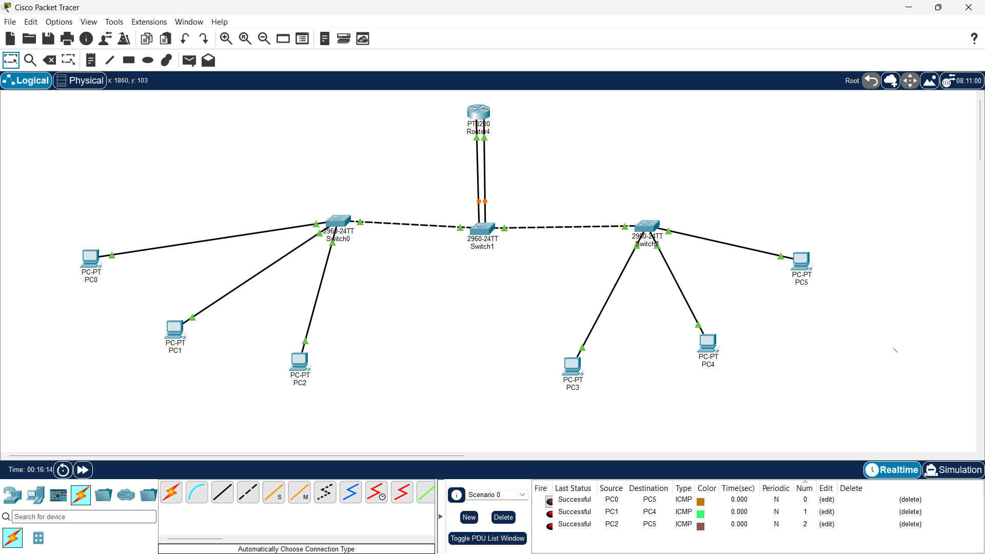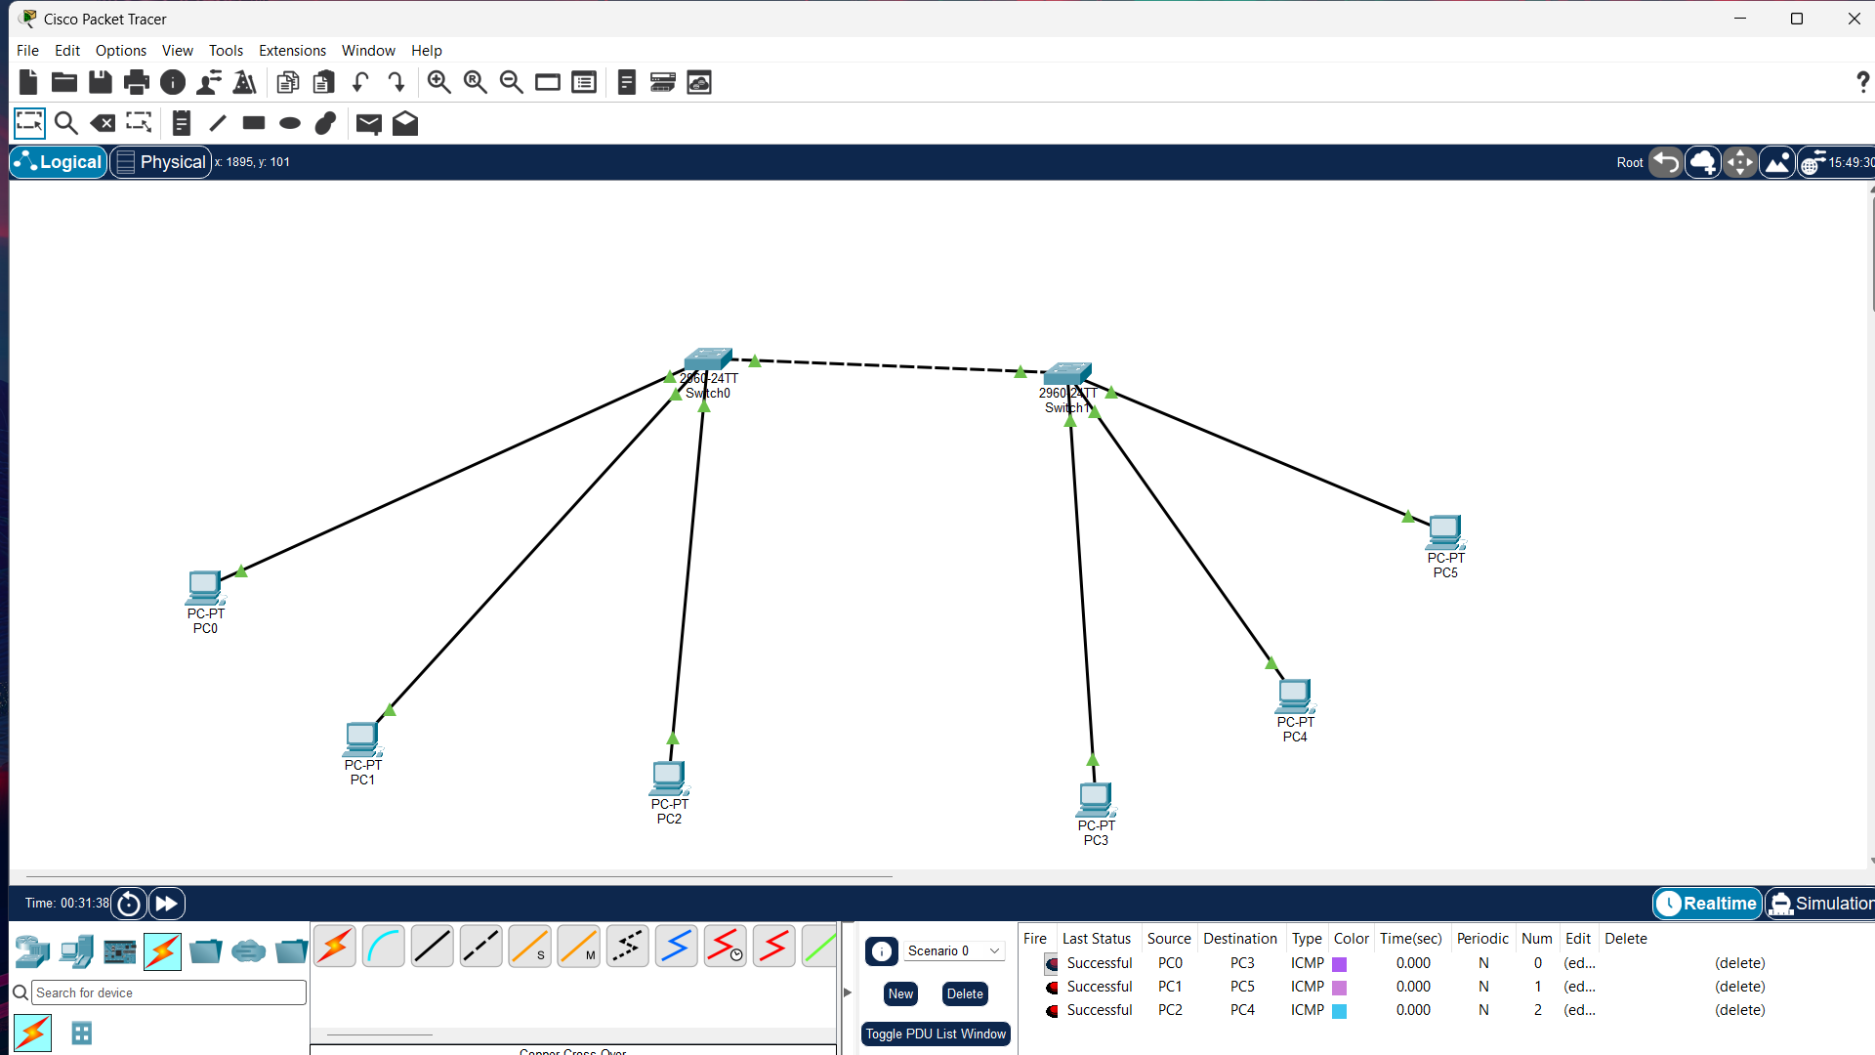

EXP 3:Configuration and Analysis of DNS and DHCP Services for Automated Network Address and Name Management using Cisco Packet Tracer
