26Aug2016: Home Loan declaration at TESCO for final settlement:

266, WEST PART NALLUR VILLAGE, Loan# 82001328

Let-out property

A. Rent received                                                              30000

B. Less: Municipal tax/Property tax paid                                1000

C. Net Annual Value (N.A.V) (A-B)                                           29000

D. Less: Repairs & Maintenance (30% of N.A.V) 9000

E. Less: Interest on housing loan                                               121997

F. Income/Loss from the let out property (C-D-E)             - 101997

Income tax declaration in TESCO when I was leaving TESCO:

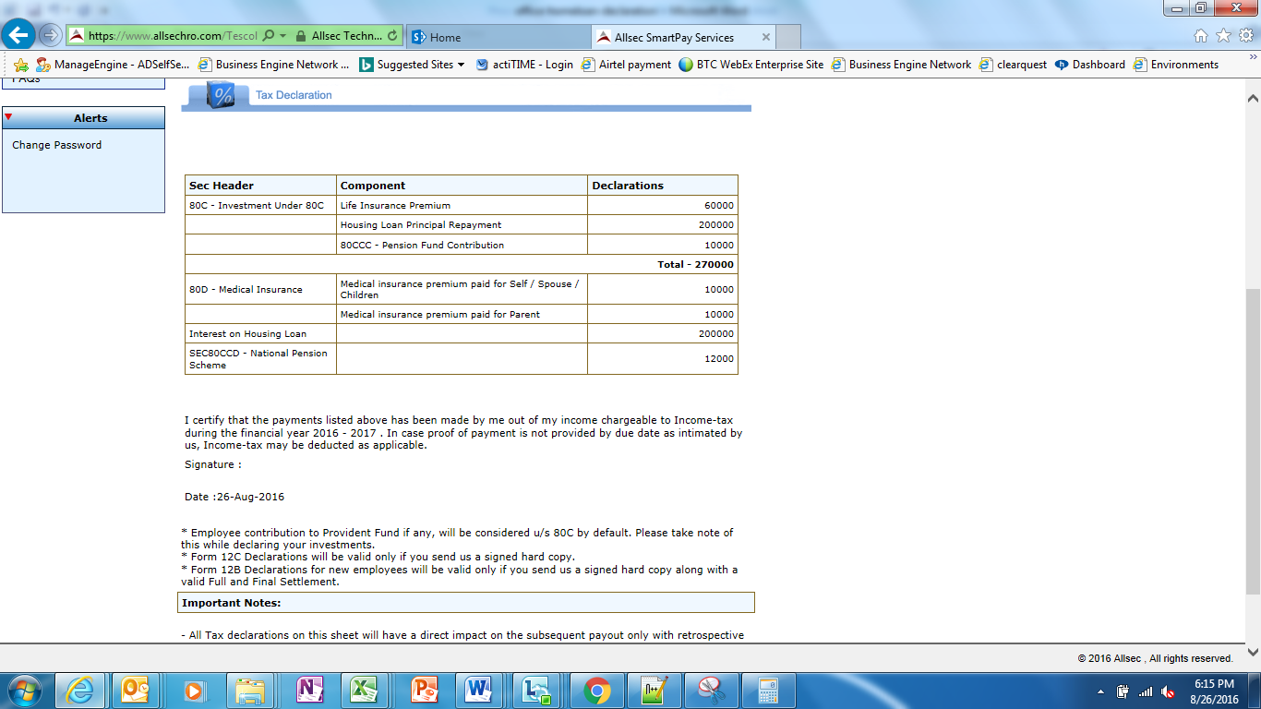

26Aug2016: End

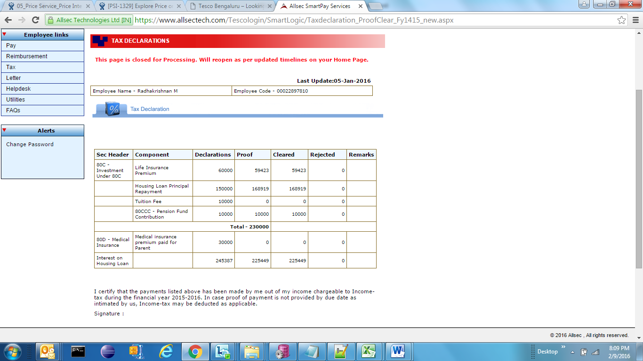

Hi,

My employee id: 22897810

I have two home loans and one proerty has been let out for rent.

I request you to update the interest on home loan to be 2,50,000.00.

Here is the detail of let out property:

266, West Part Nallur Village, Akila Garden, Bagalur Road, Hosur - 635109.

Name: M Radhakrishnan

PAN# ACYPR4730Q

TESCO EMPLOYEE

EMP# 22897810

Let-out property

A. Rent received 30000

B. Less: Municipal tax/Property tax paid NIL

C. Net Annual Value (N.A.V) (A-B) 30000

D. Less: Repairs & Maintenance (30% of N.A.V) 9000

E. Less: Interest on housing loan 129771

F. Income/Loss from the let out property (C-D-E) -108771

Loan from Sundaram BNP Paripas Home Finance Ltd & Acc# 82001328

Thanks & Regards,

RK.

~~Hi,~~

~~My employee id: 22897810~~

~~I have two home loans and one proerty has been let out for rent.~~

~~I request you to update the interest on home loan to be 2,50,000.00.~~

~~Here is the detail of let out property:~~

~~H/26, Rainbow Garden, Bagalur Road, Hosur - 635109.~~

~~Name: M Radhakrishnan~~

~~PAN# ACYPR4730Q~~

~~TESCO EMPLOYEE~~

~~EMP# 22897810~~

~~Let-out property~~

~~A. Rent received 30000~~

~~B. Less: Municipal tax/Property tax paid NIL~~

~~C. Net Annual Value (N.A.V) (A-B) 30000~~

~~D. Less: Repairs & Maintenance (30% of N.A.V) 9000~~

~~E. Less: Interest on housing loan 66387~~

~~F. Income/Loss from the let out property (C-D-E) -45387~~

~~Loan from Indian Bank & Acc# 778395549~~

~~Thanks & Regards,~~

~~RK.~~

Final Update after update of Home loan:

