**What are Hypervisors?**

**Hypervisors are a crucial piece of software that makes virtualization possible.** It abstracts guest machines and the operating system they run on from the actual hardware.

In essence, hypervisors create a virtualization layer that separates [CPU / Processors](https://phoenixnap.com/kb/single-vs-dual-processors-server), RAM and other physical resources from the virtual machines you create.

The machine we install a hypervisor on is called a host machine, as opposed to guest virtual machines that run on top of them.

Hypervisors emulate available resources so that guest machines can use them. No matter what operating system you boot up with a virtual machine, it will think that actual physical hardware is at its disposal.

From a VM’s standpoint, there is no difference between the physical and virtualized environment. Guest machines do not know the hypervisor created them in a virtual environment and that they share the available computing power. Since virtual machines run simultaneously with the hardware that powers them, they are entirely dependent on their stable operation.

* **Type 1 Hypervisor**. Also called bare metal or native
* **Type 2 Hypervisor**. Also known as hosted hypervisors.

**Type 1 Hypervisor**

A [bare metal hypervisor](https://phoenixnap.com/blog/what-is-bare-metal-hypervisor) (Type 1) is a layer of software we install directly on top of a physical server and its underlying hardware.

There is no software or any operating system in between, hence the name “bare metal hypervisor.” For this reason, type 1 hypervisors proved to provide excellent performance and stability since they do not run inside Windows or other operating systems.

Type 1 hypervisors are an OS themselves, a very basic one on top of which you run virtual machines. This means that the physical machine the hypervisor is running on serves only for virtualization purposes. You will not be able to use it for anything else.

Thus, we mostly find type 1 hypervisors in enterprise environments.

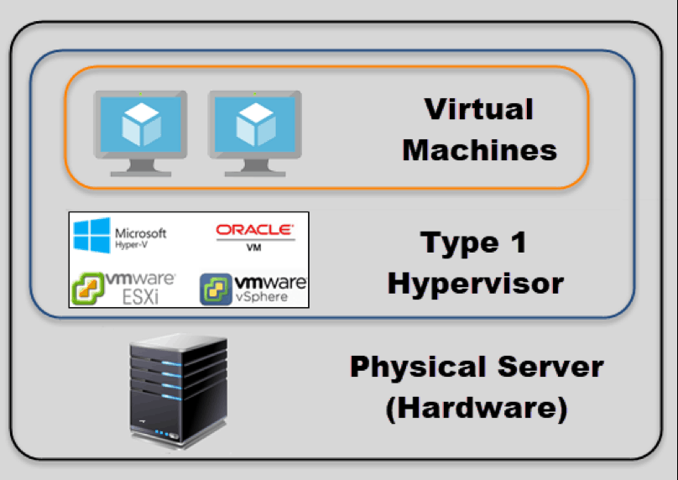

**Hypervisor Type 1 Performance**

Given that type 1 hypervisors are relatively simple, they do not offer many functionalities on their own.

Once you boot up a physical server with a bare metal hypervisor installed, it displays a command prompt-like screen. If you connect a monitor to the server, what you get to see are some of the hardware and network details. This is usually the CPU type, the amount of memory, the IP address and the MAC address.

Below is an example of VMware type 1 hypervisor’s screen after the server boots up.

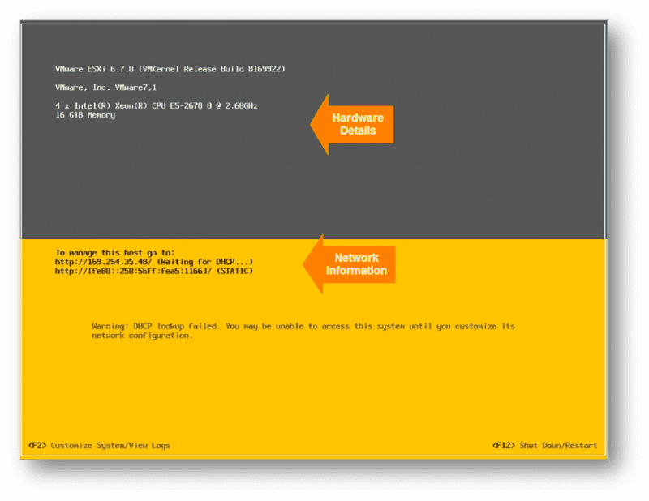

Other type 1 hypervisors may look quite different but they also allow only simple server configuration. This usually consists of changing the date and time, IP address, password, and similar. In order to create virtual instances, you need a management console on another machine. Using the console, you connect to the hypervisor on the server to manage your virtual environment.

A management console can be web-based or a separate software package you install on the desired machine you will use for remote management. Depending on what functionalities you need, the license cost for management consoles changes substantially. One of the actions you can perform include moving virtual machines between physical servers, manually or automatically, according to the resource needs of a VM at a given point. This migration happens without any impact to the end users. The same goes if a piece of hardware or a whole server fails. Properly configured management software moves virtual machines to a working server as soon as an issue arises. Once the problem is taken care of, the restoration procedure also happens automatically and seamlessly.

One of the best features of type 1 hypervisors is that they allow over-allocation of physical resources.

With type 1 hypervisors, you can assign more resources to your virtual machines than you have available. For example, if you have 128GB of RAM on your server and eight virtual machines, you can assign 24GB of RAM to each of them. This totals to 192GB of RAM, but VMs themselves will not actually consume all 24GB from the physical server. The VMs think they have 24GB, while in reality they only use the amount of RAM they need at a particular moment.

The hypervisor allocates only the amount of necessary resources for an instance to be fully functional. This is one of the reasons all [modern enterprise data centers](https://phoenixnap.com/), such as phoenixNAP, use type 1 hypervisors.

**Type 1 Vendors**

There are many different hypervisor vendors available. Most provide trial periods to test out before you decide to buy.

The licensing costs can be high if you want all those bells and whistles they offer.

These are the most common **type 1 hypervisors**:

**VMware vSphere** with **ESX/ESXi** as a part of the package.

VMware is an industry-leading vendor of virtualization technology, and many large data centers run on their products. It may not be the most cost-effective solution for smaller IT environments. If you do not need all the advanced features VMware vSphere offers, there is a free version of this hypervisor and multiple commercial editions.

**KVM (Kernel-based Virtual Machine):**

KVM is built into Linux as an added functionality. It lets you convert Linux kernel into a hypervisor. It is sometimes confused to be a type 2 hypervisor. It actually has direct access to hardware along with virtual machines it hosts. KVM is an open source hypervisor that contains all features of Linux with the addition of many other functionalities making it one of the top choices for enterprise environments. Some of the highlights include live migration, scheduling and resource control, and higher prioritization.

**Microsoft Hyper-V:**

Even though VMware’s hypervisor is higher on the ladder with numerous advanced features, Microsoft’s Hyper-V has become a worthy opponent. Microsoft also offers a free edition of their hypervisor, but if you want a GUI and additional functionalities, you will have to go for one of the commercial versions. Hyper-V may not offer as many features as VMware vSphere package, but you are still getting live migration, replication of virtual machines, dynamic memory and many others.

**Oracle VM:**

This hypervisor has open source Xen at its core and is free. Advanced features are only available in paid versions. Even though Oracle VM is essentially a stable product, it is not as robust as vSphere, KVM or Hyper-V.

**Citrix Hypervisor** (formerly known as **Xen Server**):

This Server virtualization platform by Citrix is best suited for enterprise environments. It can handle all types of workloads and provides features for the most demanding tasks. Citrix is proud of their proprietary features, such as Intel and [NVIDIA enhanced virtualized graphics](https://phoenixnap.com/kb/how-to-install-nvidia-tesla-drivers) and workload security with Direct Inspect APIs.

**Type 2 Hypervisor**

This type of hypervisor runs inside of an operating system of a physical host machine.

This is why we call **type 2 hypervisors hosted hypervisors.** As opposed to type 1 hypervisors that run directly on the hardware, hosted hypervisors have one software layer underneath. What we have in this case is:

* A physical machine.
* An operating system installed on the hardware (Windows, Linux, MacOS).
* A type 2 hypervisor software within that operating system.
* The actual instances of guest virtual machines.

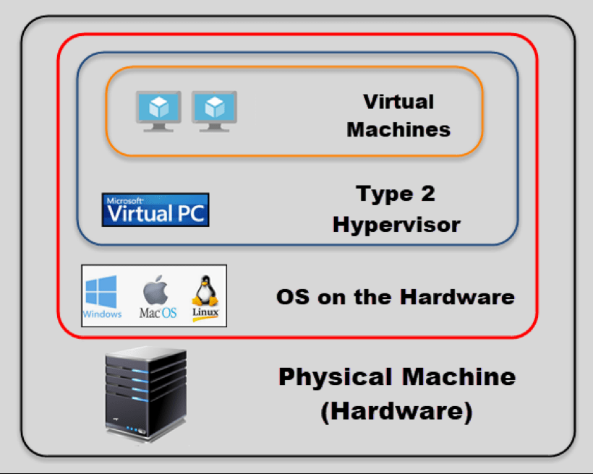

Type 2 hypervisors are typically found in environments with a small number of servers.

What makes them convenient is that you do not need a management console on another machine to set up and manage virtual machines. You do all of this on the server where you install the desired hypervisor. They are not any different from other applications you have in your operating system.

When you launch a virtual machine, you get another window to perform all tasks.

**Hypervisor Type 2 Performance**

Hosted hypervisors essentially also act as management consoles for virtual machines, you can perform any task using the inbuilt functionalities.

There is no need to install a separate piece of software on another machine to create and maintain your virtual environment. You install and run a type 2 hypervisor as you would any other application within your OS. You can create snapshots or clone your virtual machines, import or export appliances, etc.

Here is one example of a type 2 hypervisor interface (VirtualBox by Oracle):

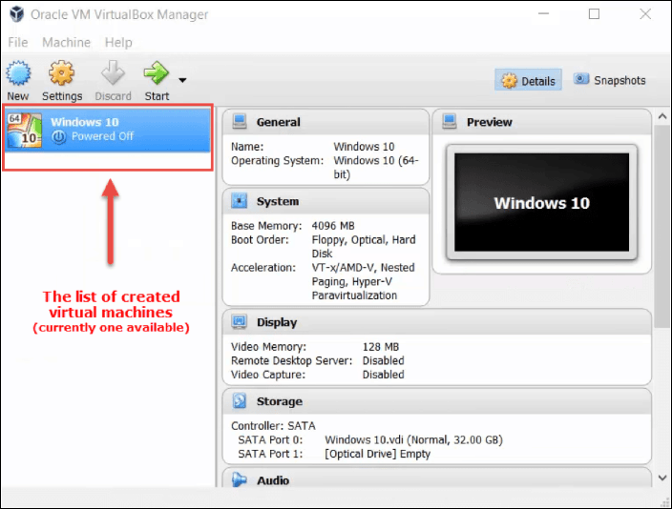

You need to be careful when allocating actual resources with this type of hypervisor.

Bare metal hypervisors can dynamically allocate available resources depending on the current needs of a particular VM. A type 2 hypervisor occupies whatever you allocate to a virtual machine.

When you assign 8GB of RAM to a VM, that amount will be taken up even if the VM is not using almost any of it. If the host machine has 32GB of RAM and you create three VMs with 8GB each, you are left with 8GB of RAM to keep the physical machine running. Creating another VM with 8GB of ram would bring down your system. This is especially important to remember to avoid over-allocating your resources and crashing the host machine.

Type 2 hypervisors are convenient for testing new software and research projects.

It is possible to use one physical machine to run multiple instances with different operating systems to test how an application behaves in each environment or to create a specific network environment. You only need to make sure there are enough physical resources to keep both the host and the virtual machines running.

**Type 2 Vendors**

As is the case with bare metal hypervisors, here we can also choose between numerous vendors and products.

Conveniently, many type 2 hypervisors are free in their basic versions and provide sufficient functionalities.

Some even provide advanced features and performance boosts when you install add-on packages, free of charge. We will mention a few of the most used hosted hypervisors:

**Oracle VM VirtualBox**. A free but stable product with enough features for personal use and most use cases for smaller businesses. VirtualBox is not resource demanding, and it has proven to be a good solution for both desktop and server virtualization. It provides support for guest multiprocessing with up to 32 vCPUs per virtual machine, PXE Network boot, snapshot trees, and many more.

**VMware Workstation Pro / VMware Fusion**. VMware Workstation Pro is a type 2 hypervisor for Windows OS. It is full of advanced features and has seamless integration with vSphere. This allows you to move your apps between desktop and cloud environments.

Of course, it comes with the price, and there is no free version. If you want to take a glimpse into VMware hosted hypervisors free of charge, you can try VMware Workstation Player. This is the basic version of the hypervisor suitable for small sandbox environments.

For MacOS users, VMware developed Fusion that is similar to their Workstation product. It comes with somewhat fewer features, but also carries a smaller price tag.

**Windows Virtual PC**. Only supports Windows 7 as a host machine and Windows OS on guest machines. This includes multiple versions of Windows 7 and Vista, as well as XP SP3. Virtual PC is completely free.

**Parallels Desktop**. A competitor to VMware Fusion. It is primarily intended for MacOS users and offers plenty of features depending on the version you purchase. Some of the features are network conditioning, integration with Chef/Ohai/Docker/Vagrant, support for up to 128GB of per VM, etc.

**Type 1 vs. Type 2 Hypervisor**

**Choosing the right type of hypervisor** strictly depends on your individual needs.

The first thing you need to bear in mind is the size of the virtual environment you intend to run.

For personal use and smaller deployments, you can go for one of the type 2 hypervisors. If budget is not an issue, VMware will not be short of any features you may need. Otherwise, Oracle VM VirtualBox is a hypervisor that will provide most of the functionalities you may need.

Things get more complicated with enterprise environments.

Even though type 1 hypervisors are the way to go, you need to take into consideration many factors before you make a decision. The critical factor is usually the licensing cost. This is where you need to pay extra attention since licensing may be per server, [per CPU or sometimes even per core](https://phoenixnap.com/kb/single-vs-dual-processors-server). On the current market, the battle is going on between VMware vSphere and Microsoft Hyper-V. While Hyper-V was falling behind a few years back, it has undoubtedly become a valid choice, even for large deployments and the same goes for KVM.

Many vendors offer multiple products and layers of licenses to accommodate any organization. You may want to create a list of the requirements such as how many

VMs you need, maximum allowed resources per VM, nodes per cluster, specific functionalities, and then check which of these products best fits in. Note that trial periods can be beneficial when making a decision which hypervisor to choose.