Rahul Matta

1/16/16

For my project, I decided to interact with my iPhone’s accelerometer. In my app, the output “hello” is displayed when the phone’s front face (more or less) faces the sky. Otherwise, the output “world” is displayed. Accelerometer data from the phone is measured through g-force, in the x, y, and z axes. The following diagram demonstrates how the axes are represented.

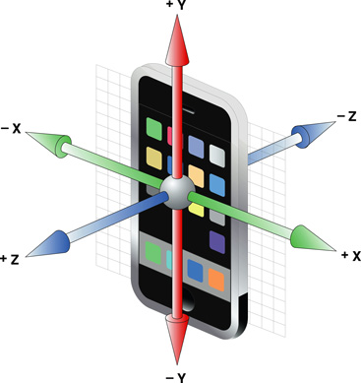

More formally, the threshold which my app detected was whether the g-force along the z axis was greater than 7 m/s2. A measurement of ~9.8 m/s2 would suggest that the phone is exactly facing the sky, whereas a measurement of ~0 m/s2‑suggests that the phone is oriented in the manner shown above. Every 200 milliseconds, the measurement is taken and posted to my backend, which is set up through firebase.