SANTHIRA TECHNOLOGIES
LinkedEye AI
Product Architecture, Flow & Connectivity Document
On-Premise AI Observability Platform for Trading Infrastructure
Version: 1.0 | Date: April 2026
Author: Rajkumar A | Classification: Confidential
Contact: rk.madhu2026@gmail.com | Phone: +91 9176772077

1. Executive Summary
LinkedEye AI is an on-premise artificial intelligence observability platform built specifically for trading technology infrastructure. It converts natural language questions into real-time answers backed by live data from Prometheus, Elasticsearch, Loki, Kubernetes, and the LinkedEye database — with zero reliance on external cloud services.

The platform eliminates the need for engineers to manually correlate dashboards, dig through log files, or piece together root causes during incidents. A NOC engineer types a question in plain English and receives an answer with Grafana-style inline metric charts, Datadog-style log views, AI root cause analysis, and exact remediation commands — all within seconds.

Core Value Proposition
Your NOC engineer types: "Why is the BSE queue spiking?" and gets the root cause, the correlated log evidence, and the fix command — in under 10 seconds. No dashboard switching. No log digging. No guesswork.

Metric | Value
Platform Type | On-Premise AI Observability (no cloud dependency)
Primary Target | Trading technology firms, MSPs, GCCs in India
Deployment | Docker Compose (SMB) / Kubernetes Helm (Enterprise)
LLM Runtime | Local Ollama (Mistral/LLaMA3) — data never leaves premises
Open Source Layer | 6 MCP servers published to Anthropic registry (MIT license)
Proprietary Layer | LangGraph orchestrator, AI platform, multi-tenant routing
Live Since | Deployed and validated at Finspot Technology, Bangalore
Daily Order Volume | 360,000+ orders monitored across NSE/BSE/NFO/BFO

2. Product Overview

2.1 What LinkedEye AI Does
LinkedEye AI is the intelligence layer added on top of the existing LinkedEye monitoring platform. While the base LinkedEye platform already monitors 16 infrastructure parameters — from server hardware to trading system processes — the AI layer transforms passive monitoring data into active intelligence.

The system works in three stages. First, it understands what the engineer is asking. Second, it fetches the relevant real data from the appropriate data sources. Third, it explains that data in plain English with visual context. The LLM is never asked to guess — it only reads and explains data that has already been fetched.

2.2 What It Monitors
Category | Data Sources | Example Queries
Trading System | Elasticsearch OMS logs | Why was order #10234 rejected?
Server Metrics | Prometheus + Node Exporter | Show CPU of prod-oms-02 last 1 hour
Application Logs | Loki + Promtail | Why is payments-api pod crashing?
Kubernetes | K8s API + kube-state-metrics | Which pods restarted more than 3 times today?
Network Devices | SNMP (Cisco/Aruba/Huawei) | Which switch ports are above 80% utilization?
URL / SSL | LinkedEye DB + cert check | Which SSL certificates expire in 30 days?
Hardware | iDRAC / iLO via IPMI | Show fan and temperature status for KVM hosts
Queue Monitoring | Prometheus custom metrics | Is BSE queue approaching threshold?
OMS Latency | Prometheus OMS metrics | Show P99 latency across all exchanges today
BOD/EOD Checks | LinkedEye DB + scripts | Is system ready for market open?

2.3 Key Differentiators
Feature | How LinkedEye AI Is Different
Zero Hallucination | LLM only reads fetched real data. It never answers from memory or guesses.
On-Premise LLM | Runs Ollama locally. No data sent to OpenAI, Anthropic, or any cloud.
Trading-Domain Specific | Built for NSE/BSE/OMS environments. No generic observability tool matches this.
Grafana-Style Charts Inline | Metric graphs render directly inside the chat response.
Datadog-Style Log Viewer | Structured log tables with severity filtering inside chat.
MCP Architecture | Each data source is an independent MCP server — modular and open source.
LinkedEye Integration | AI layer plugs into existing LinkedEye platform, no replacement needed.
Multi-Tenant | MSPs can monitor all client environments from one platform.

3. Architecture Overview
The platform is organized into six distinct layers, each with a specific responsibility. This separation ensures that each component can be developed, tested, and deployed independently.

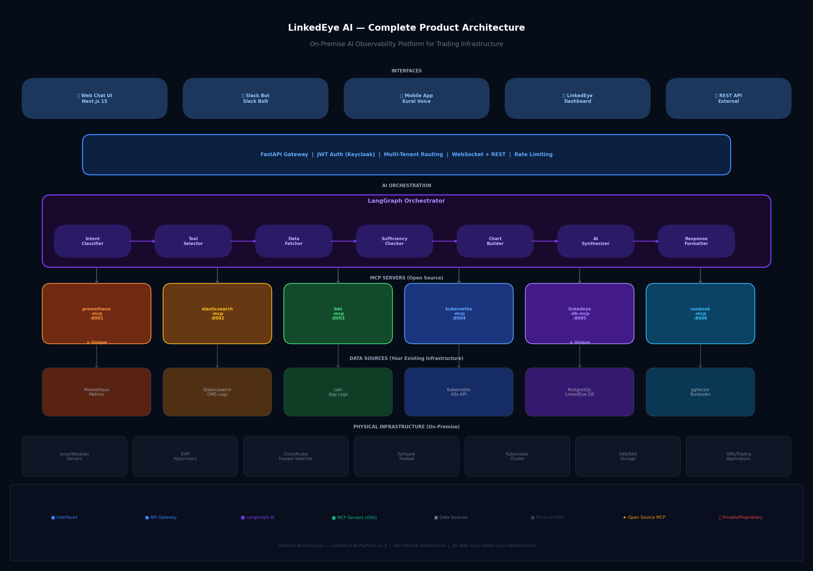
Figure 1: LinkedEye AI — Complete Product Architecture (6 Layers)

3.1 Architecture Layers
Layer | Components & Responsibility
Layer 1 — Interfaces | Web Chat UI (Next.js 15), Slack Bot (Bolt), Mobile/Kural, LinkedEye Dashboard, REST API
Layer 2 — API Gateway | FastAPI: JWT auth via Keycloak, multi-tenant routing, WebSocket, rate limiting
Layer 3 — AI Orchestration | LangGraph: Intent classifier, tool selector, data fetcher, chart builder, AI synthesizer
Layer 4 — MCP Servers (OSS) | 6 open source MCP servers: prometheus, elasticsearch, loki, kubernetes, linkedeye-db, runbook
Layer 5 — Data Sources | Prometheus, Elasticsearch, Loki, K8s API, PostgreSQL, pgVector
Layer 6 — Physical Infra | Linux/Windows servers, KVM, Cisco/Aruba/Huawei switches, Fortigate, SAN/NAS, OMS

3.2 Data Flow Principle
The fundamental design principle of LinkedEye AI is that the LLM is always the last component in the chain, never the first. Every query follows this strict sequence:

- Engineer submits natural language question via chat or Slack
- LangGraph classifies the intent (POD_CRASH, METRICS, ORDER_ANALYSIS, etc.)
- LangGraph selects the appropriate MCP server(s) to call based on intent
- MCP servers fetch real, live data from Prometheus, Elasticsearch, Loki, or K8s API
- Sufficiency check: if data is incomplete, additional MCP calls are made
- Chart builder converts time-series data into Recharts-compatible JSON for visualization
- AI synthesizer (LLM) receives the real data and generates a plain English explanation
- Response rendered: Grafana chart + Datadog logs + root cause + fix + source citations

Zero Hallucination Guarantee
The LLM is instructed: "Only use the data provided. Never guess. Every statement must cite a specific log line, metric value, or data source." If the data does not contain the answer, the system says so explicitly rather than fabricating a response.

4. MCP Server Architecture
The Model Context Protocol (MCP) is Anthropic's open standard for connecting AI models to external data sources. LinkedEye AI uses MCP as the integration layer between the LangGraph orchestrator and all data sources. Each data source is wrapped in an independent MCP server that exposes structured tools the AI agent can call.

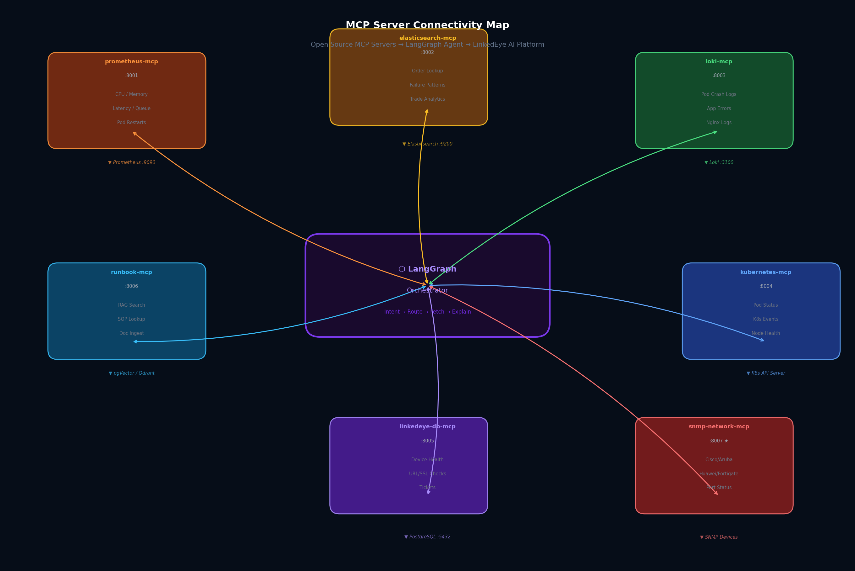
Figure 2: MCP Server Connectivity Map — 7 servers surrounding the LangGraph core

4.1 MCP Server Inventory
MCP Server | Port | Tools Exposed
prometheus-mcp | :8001 | get_cpu_usage, get_memory_usage, get_pod_restarts, get_queue_metrics, get_oms_latency
elasticsearch-mcp | :8002 | get_order_by_id, get_order_failures, get_trade_analytics, get_failure_patterns
loki-mcp | :8003 | get_pod_logs, get_app_errors, get_nginx_errors, get_crash_logs
kubernetes-mcp | :8004 | get_pod_status, get_k8s_events, get_node_health, get_deployment_info
linkedeye-db-mcp | :8005 | get_device_health, get_url_ssl_status, get_open_tickets, get_site_summary, get_hardware_status
runbook-mcp | :8006 | search_runbook_rag, get_sop_by_issue, ingest_new_runbook
snmp-network-mcp * | :8007 | get_switch_port_status, get_device_utilization, get_vlan_info, get_arp_table

* snmp-network-mcp is a world-first open source MCP server for network devices. No equivalent exists in the Anthropic MCP registry. Supports Cisco IOS/NX-OS, Aruba CX, Huawei VRP, and Fortigate via SNMP v2/v3.

4.2 Open Source vs Proprietary Split
Component | License / Access
prometheus-mcp | MIT — Open Source (github.com/santhira-technologies)
elasticsearch-mcp | MIT — Open Source
loki-mcp | MIT — Open Source
kubernetes-mcp | MIT — Open Source
snmp-network-mcp | MIT — Open Source (UNIQUE — first in registry)
runbook-mcp | MIT — Open Source
LangGraph Orchestrator | Proprietary — LinkedEye AI Platform
Multi-Tenant Gateway | Proprietary — LinkedEye AI Platform
Chart Builder | Proprietary — LinkedEye AI Platform
AI Synthesizer Prompts | Proprietary — LinkedEye AI Platform
LinkedEye Dashboard | Proprietary — LinkedEye Platform

4.3 MCP Communication Protocol
All MCP servers communicate using Server-Sent Events (SSE) transport over HTTP. The LangGraph agent connects to each server using the official MCP Python client library. Each tool call follows the standard MCP request/response format with typed parameters and structured JSON responses.

# MCP Tool Call Example
result = await session.call_tool(
name="get_cpu_usage",
arguments={"server": "prod-oms-02", "duration": "1h"}
)
# Returns: {"series": [...], "peak": 94.2, "avg": 61.3}

5. LangGraph Query Flow
LangGraph is used as the AI orchestration framework because it provides stateful, conditional graph-based workflows. Unlike simple chain-based frameworks, LangGraph can route queries to different data sources based on intent, retry data fetching if results are insufficient, and maintain state across multiple tool calls within a single query.

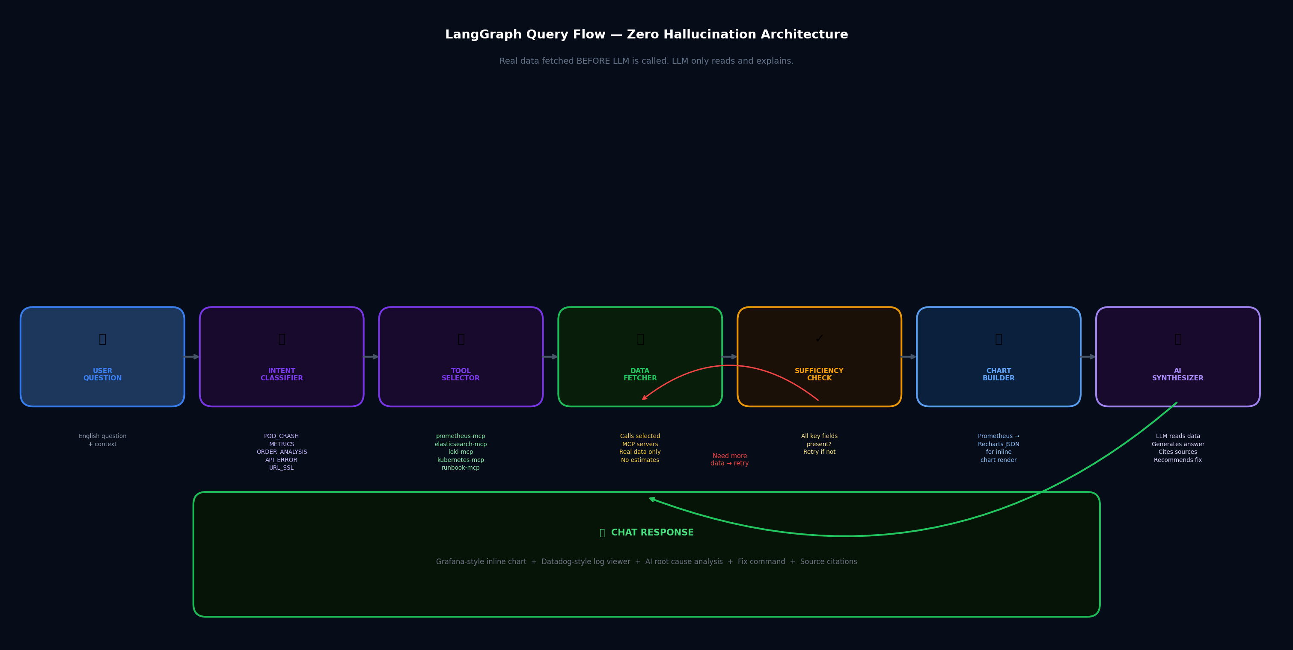
Figure 3: LangGraph Query Flow — 7 nodes from question to structured response

5.1 Graph Nodes
Node | Responsibility | Output
Intent Classifier | LLM classifies query into one of 8 intent types | intent: POD_CRASH | METRICS | ORDER_ANALYSIS | API_ERROR | URL_SSL | APP_LOGS | HARDWARE | COMBINED
Tool Selector | Selects which MCP servers to call based on intent | List of MCP server + tool combinations
Data Fetcher | Calls selected MCP tools, collects real data | fetched_data: structured JSON from all sources
Sufficiency Checker | Validates if fetched data can answer the question | Route: "sufficient" or "need_more_data" (retry)
Chart Builder | Converts time-series data to Recharts JSON config | chart_spec: type, data, axes, thresholds, colors
AI Synthesizer | LLM reads real data, generates plain English answer | answer: explanation with citations and fix steps
Response Formatter | Structures final response for web or Slack output | JSON: answer + chart + logs + severity + sources

5.2 Intent Routing Table
Intent Type | MCP Servers Called | Example Query
POD_CRASH | prometheus-mcp + loki-mcp + kubernetes-mcp | "Why is payments-api pod crashing?"
API_ERROR | loki-mcp + prometheus-mcp | "Why is trading-api returning 500 errors?"
METRICS | prometheus-mcp | "Show CPU of prod-oms-02 last 1 hour"
ORDER_ANALYSIS | elasticsearch-mcp | "Why was order #10234 rejected?"
URL_SSL | linkedeye-db-mcp | "Which SSL certs expire in 30 days?"
APP_LOGS | loki-mcp + elasticsearch-mcp | "Show all errors in order-service last 1 hour"
HARDWARE | linkedeye-db-mcp + prometheus-mcp | "Show fan and CPU status for KVM hosts"
COMBINED | All relevant servers | "Did the CPU spike cause order failures today?"

5.3 State Object
LangGraph passes a typed state object through every node. This ensures all data collected in early nodes is available to later nodes without re-fetching.

class QueryState(TypedDict):
question: str # Original question
intent: str # Classified intent type
entities: dict # Extracted: server, pod, order_id, duration
fetched_data: dict # Real data from MCP servers
chart_spec: Optional[dict] # Recharts config (if metrics query)
answer: str # LLM-generated explanation
citations: List[str] # Source references
severity: str # critical | warning | info
needs_more: bool # Retry flag

6. Deployment Architecture
LinkedEye AI is designed for on-premise deployment with no external cloud dependencies. The entire stack — including the LLM — runs within the customer's own data center. Two deployment modes are supported depending on the customer's infrastructure maturity.

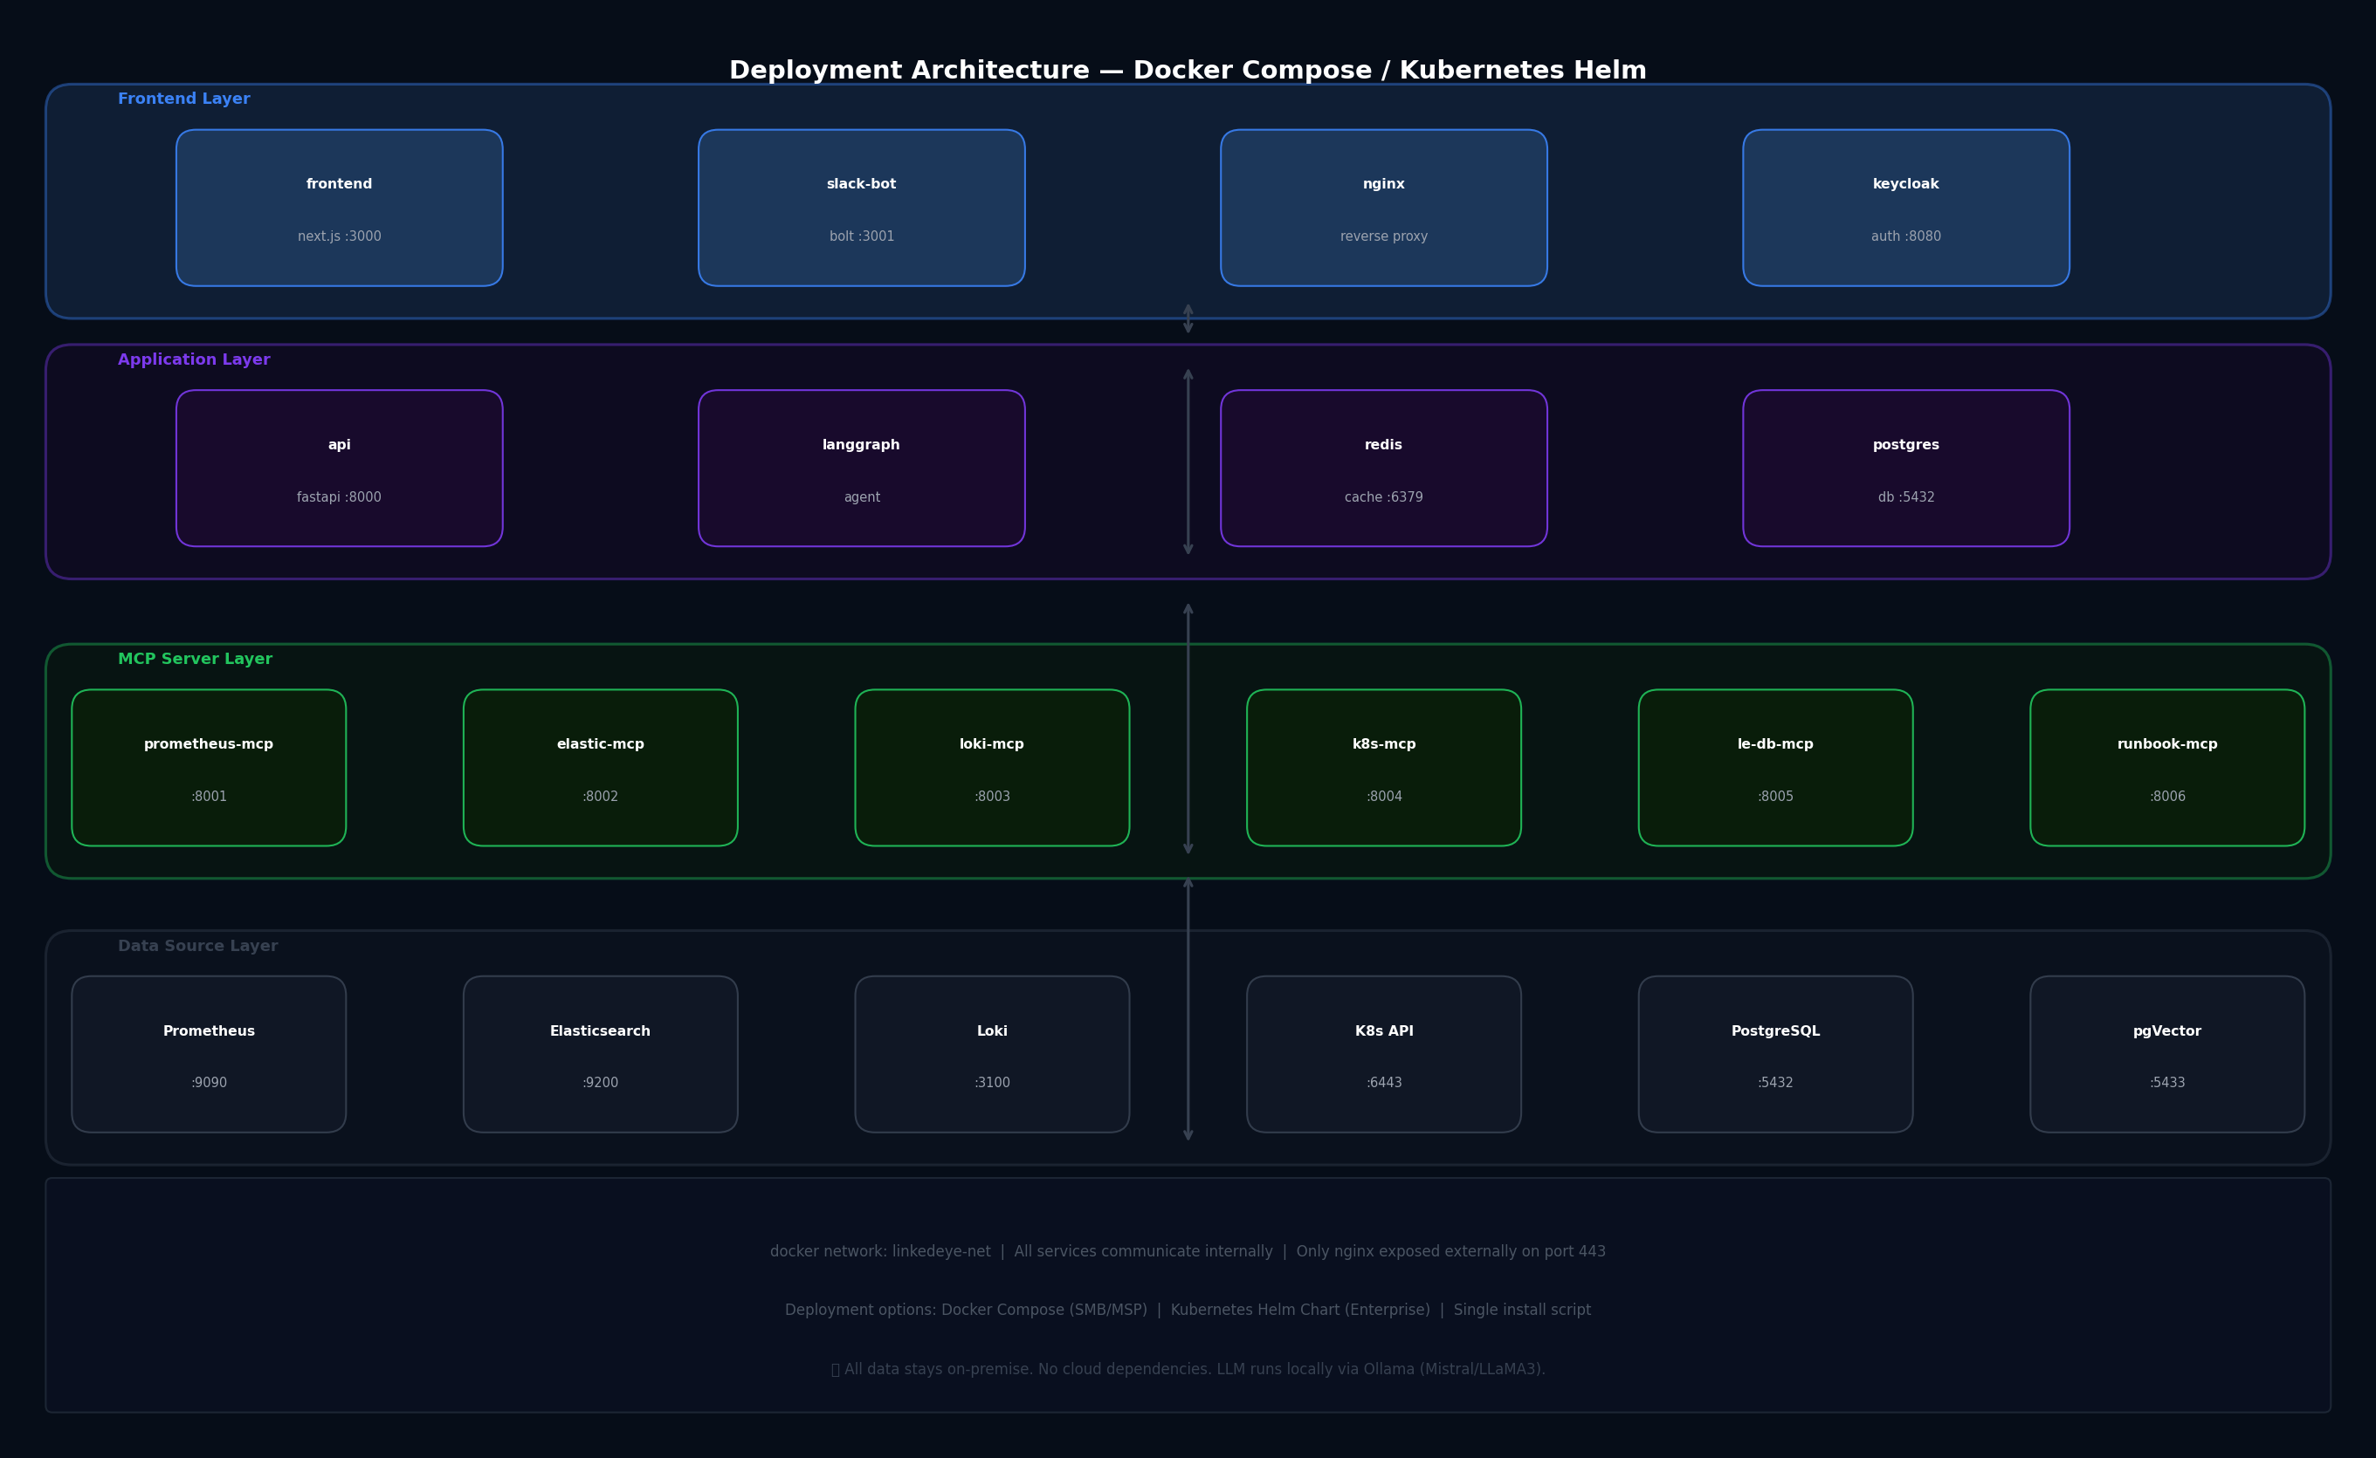
Figure 4: Deployment Architecture — Docker Compose and Kubernetes Helm options

6.1 Docker Compose Deployment (SMB/MSP)
Recommended for MSPs and small-to-medium trading firms. Single-server deployment with all components running as Docker containers on one physical or virtual machine.

- Minimum spec: 16 vCPU, 32GB RAM, 500GB SSD
- All services on internal Docker network: linkedeye-net
- Only nginx exposed externally on port 443 with SSL termination
- Single install command: docker-compose up -d
- LLM: Ollama with Mistral 7B or LLaMA3 8B running locally

6.2 Kubernetes Helm Deployment (Enterprise)
Recommended for large trading firms, GCCs, and enterprise MSPs requiring high availability and horizontal scaling.

- Helm chart with configurable replicas per service
- Horizontal Pod Autoscaling on the FastAPI and LangGraph agent layers
- Persistent volumes for PostgreSQL, pgVector, and Loki storage
- Ingress controller with TLS and rate limiting
- Keycloak for enterprise SSO and RBAC

6.3 Service Port Reference
Service | Internal Port | Description
nginx | 443 (external) | Reverse proxy, SSL termination
frontend (Next.js) | 3000 | Web chat interface
api (FastAPI) | 8000 | REST + WebSocket API gateway
keycloak | 8080 | Authentication and authorization
prometheus-mcp | 8001 | Prometheus MCP server
elasticsearch-mcp | 8002 | Elasticsearch MCP server
loki-mcp | 8003 | Loki MCP server
kubernetes-mcp | 8004 | Kubernetes API MCP server
linkedeye-db-mcp | 8005 | LinkedEye DB MCP server
runbook-mcp | 8006 | RAG runbook MCP server
redis | 6379 | Session and response cache
postgresql | 5432 | Application database
ollama | 11434 | Local LLM runtime

7. Full Technology Stack
Layer | Technology | Purpose
Frontend | Next.js 15 + TailwindCSS | Chat UI, Grafana charts, Datadog log viewer
Charts | Recharts (React) | Inline metric visualization
API Gateway | Python 3.11 + FastAPI | REST, WebSocket, auth middleware
AI Orchestration | LangGraph + LangChain | Multi-step agent workflow
LLM (cloud) | DeepSeek / GPT-4o API | AI synthesis (cloud-connected mode)
LLM (on-prem) | Ollama + Mistral 7B | AI synthesis (air-gapped mode)
MCP Framework | FastMCP (Python) | MCP server implementation
Metrics DB | Prometheus TSDB | Time-series metrics storage
Log Store | Loki + Promtail | Application and system log aggregation
Search Engine | Elasticsearch / OpenSearch | OMS logs, order data, full-text search
App Database | PostgreSQL 15 | Users, sessions, audit, tickets
Vector Store | pgVector / Qdrant | RAG embeddings for runbooks
Cache | Redis 7 | Session management, response caching
Auth | Keycloak / Clerk.dev | SSO, JWT, RBAC, multi-tenant
Container Runtime | Docker + Docker Compose | Development and SMB deployment
Orchestration | Kubernetes + Helm | Enterprise deployment
Slack Integration | Slack Bolt (Python) | Chat interface via Slack
Network Monitoring | SNMP v2/v3 | Cisco, Aruba, Huawei, Fortigate
K8s Metrics | kube-state-metrics + cAdvisor | Pod/node/deployment metrics
Log Shipping | Promtail + Fluentbit | Log collection from all sources

8. Integration & Connectivity Map

8.1 Inbound Integrations (Data Sources)
Source System | Protocol / Method | Data Collected
Prometheus | HTTP API /api/v1/query_range | CPU, memory, disk, network, OMS latency, queue size
Elasticsearch | REST API /_search | OMS order logs, rejection reasons, trade data
Loki | HTTP API /loki/api/v1/query_range | Pod logs, app errors, nginx access logs
Kubernetes API | REST API + kubectl | Pod status, events, deployments, node health
PostgreSQL | SQL queries via psycopg2 | Device health, tickets, URL checks, audit logs
SNMP Devices | SNMP v2/v3 GET/WALK | Switch port status, CPU, memory, temperature
iDRAC / iLO | Redfish REST API | Fan, disk, battery, power supply status

8.2 Outbound Integrations (Notifications)
Destination | Protocol | Trigger
Slack | Slack Bolt Webhook | Critical alerts, query responses, daily reports
Email | SMTP | Incident summaries, SSL expiry warnings
PagerDuty | REST API | P1 critical incidents (optional integration)
Webhook | HTTP POST | Custom integrations with existing ITSM tools
LinkedEye Tickets | Internal API | Auto-create tickets from AI-detected issues

8.3 Authentication Flow
All user access is controlled through Keycloak, which supports enterprise SSO (SAML/OIDC) and local user management. JWT tokens are issued per session and validated on every API request. Multi-tenant isolation ensures that MCP servers are routed to the correct customer environment based on the tenant claim in the JWT.

- User logs in via Keycloak (SSO or local credentials)
- JWT issued with tenant_id, role (admin/viewer/engineer), and site_access claims
- FastAPI middleware validates JWT on every request
- Tenant router directs queries to correct Prometheus/ES/Loki endpoints for that tenant
- Vault (existing LinkedEye module) stores all credentials — no plaintext secrets in config files

9. Open Source Strategy
The MCP servers are published as open source under the MIT license. This creates a distribution channel that turns every DevOps engineer who installs a free MCP server into a potential LinkedEye enterprise customer.

Repository | Submission Target
github.com/santhira-technologies/prometheus-mcp | Anthropic MCP Registry + npm @santhira/prometheus-mcp
github.com/santhira-technologies/elasticsearch-mcp | Anthropic MCP Registry + pip santhira-elasticsearch-mcp
github.com/santhira-technologies/loki-mcp | Anthropic MCP Registry
github.com/santhira-technologies/kubernetes-mcp | Anthropic MCP Registry
github.com/santhira-technologies/snmp-network-mcp | Anthropic MCP Registry — WORLD FIRST for network devices
github.com/santhira-technologies/trading-oms-mcp | Anthropic MCP Registry — WORLD FIRST for trading OMS

Business Flywheel
Open source MCP servers get GitHub stars and community adoption. Engineers hit limits and discover LinkedEye AI. Companies buy the enterprise platform. Revenue funds more open source work. This is the exact model used by Grafana Labs ($6B), HashiCorp ($6.7B), and Elastic ($2.4B IPO).

10. Product Family — Santhira Technologies
Product | Target Customer | Position
LinkedEye AI | Trading firms, MSPs, GCCs | Entry point: AI chat on existing infra
NexusIQ | General MSPs (all verticals) | MSP command center with multi-client management
LinkedEye Enterprise | Large enterprises | Full 66-module ITSM platform (ServiceNow alternative)
Kural | Indian DevOps engineers | Voice-first DevOps assistant (Tamil/Hindi/English)
MCP Servers (OSS) | All engineers globally | Distribution channel and community building

10.1 Upsell Path
- Customer installs free MCP server from GitHub
- Discovers LinkedEye AI — tries free 30-day pilot
- Converts to LinkedEye AI paid (Rs.15,000-35,000/month)
- Needs full ITSM → upsells to LinkedEye Enterprise
- Voice interface for team → adds Kural subscription

11. MVP Build Plan — 8 Weeks
Week | Focus | Deliverable
Week 1 | MCP Foundation | prometheus-mcp + elasticsearch-mcp working, curl-tested
Week 2 | LangGraph Core | Intent classifier + data fetcher wired to MCP servers
Week 3 | Loki + K8s MCP | Pod crash analysis and log queries working end-to-end
Week 4 | FastAPI + WebSocket | Chat API live, frontend connecting, streaming responses
Week 5 | Chart + Log UI | Grafana-style charts and Datadog-style logs rendering inline
Week 6 | LinkedEye DB MCP + RAG | Device health queries + runbook RAG search working
Week 7 | Slack Bot | Full Slack interface with chart PNG uploads
Week 8 | Finspot Pilot | Live deployment at Finspot Technology for validation

11.1 Revenue Target
Timeline | Target
Month 3 | 2 customers x Rs.15,000 = Rs.30,000 MRR
Month 6 | 6 customers x Rs.25,000 = Rs.1,50,000 MRR
Month 9 | 12 customers x Rs.30,000 = Rs.3,60,000 MRR
Month 12 | 20 customers x Rs.35,000 = Rs.7,00,000 MRR (~$100K ARR)

12. Contact & Next Steps
Detail | Information
Founder | Rajkumar A — Senior DevOps Engineer + Founder, Santhira Technologies
Email | rk.madhu2026@gmail.com
Phone | +91 9176772077
Location | Bangalore / Tamil Nadu, India
LinkedIn | linkedin.com/in/rajkumar-a
GitHub Org | github.com/santhira-technologies (to be published)
Demo Environment | Live at Finspot Technology — available for reference calls
Pilot Offer | Free 30-day pilot for qualified trading firms and MSPs

Schedule a Demo
We offer a live 30-minute demo using real production data from a trading infrastructure environment. See the AI answer questions about order rejections, pod crashes, and queue breaches in real time. Contact rk.madhu2026@gmail.com to schedule.

