Star of the Toy Farm
Star and the Midnight Feast
A Star of the Toy Farm story
Anshika Mahesh
Best after Star Finds a Home.
A sleepover, a show-and-tell prize, a riddle-loving goat, and a midnight feast — Star learns that bravery isn’t only mountains. It’s looking after friends when the night gets messy.
Copyright
Star and the Midnight Feast
A Star of the Toy Farm story
Copyright © 2026 Anshika Mahesh
First Kindle edition 2026
All rights reserved. No part of this book may be reproduced without permission from the author, except for brief quotations in a review.
This is a work of fiction. Names, characters, and incidents are from the author’s imagination.
Contents

Main characters
1. After the Mountain
2. Show and Tell
3. Barney the Riddle Goat
4. The Vacuum Strikes
5. Invited!
6. Meet Avril
7. Rules of the Night
8. Midnight Feast
9. Morning Mess
10. The Monster Bath
11. What Leaders Do
12. Tips from Star (and Goodnight)
The End
About the Author

Main characters
Star — Toy sheep, farmyard leader, narrator
Bundle — Loyal dog (nickname: Security Guard)
Mia — Adventurer cow from Star Finds a Home
Barney — New goat who loves riddles (Smarty Pants)
Sophia — Their girl. She hears them when grown-ups aren’t listening.
Avril — Sophia’s cousin; sleepover host

Chapter 1. After the Mountain
If you are just meeting me: my name is Star. I am a toy sheep. I used to live on a shop shelf and wonder why I existed. Then I became Sophia’s birthday gift, found Bundle the dog, helped bring Mia the cow home, and climbed a hill in a backpack.
Now ordinary mornings felt… small.
“Leaders still have jobs,” Bundle reminded me, pacing the hay like a tiny security guard. “Keep the farm safe. Keep the secret. Only Sophia hears us — and only when Mum and Dad aren’t listening.”
Mia stretched. “Small mornings are when the next adventure sneaks up,” she said.
She was right.

Chapter 2. Show and Tell
Sophia was excited to tell everyone at school what had happened — carefully, of course.
“Remember — you’ve got to act like toys,” she warned Bundle and me. “Be still. Don’t move. There will be parents and teachers!”
“I really want to get a prize!” she added.
We spent the morning practising being perfectly still. Bundle’s ear twitched once. I almost giggled. Sophia glared. We froze harder.
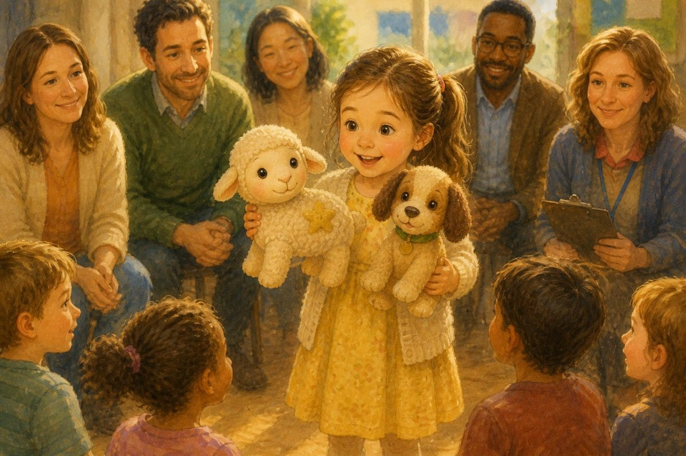
Be still. Don’t move.
At the hall, parents and teachers assembled. Sophia was the first to go. She talked about her toy farm, but she didn’t tell them we could talk. “Since you love toys so much…” said the announcer — and she did get praise!
Best of all, she whispered on the way home, “There’s a new friend coming to the farm. A goat. His name is Barney.”

Chapter 3. Barney the Riddle Goat
Barney was grass-coloured, with little horns and a brain full of riddles.
“What has hands but no body?” he asked the moment he arrived.
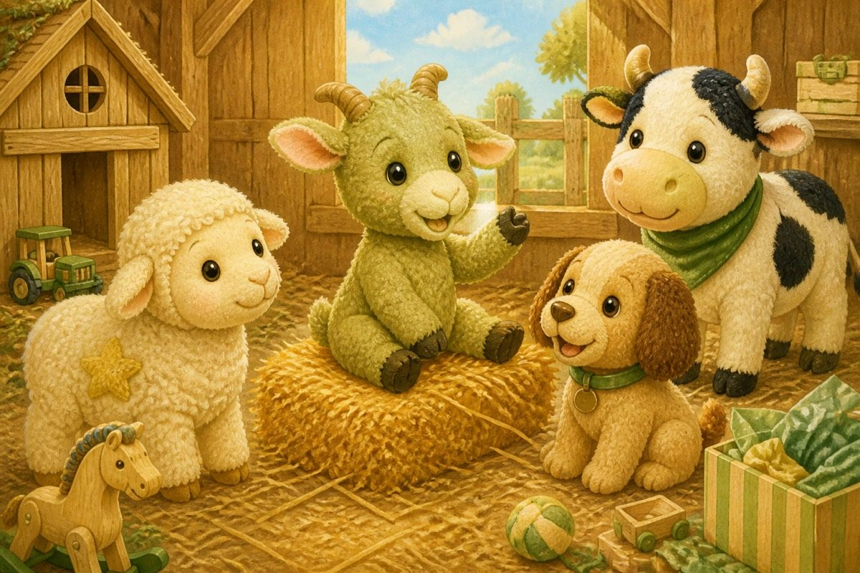
What has hands but no body?
“A clock!” I said.
“What has a face but never needs a tissue?”
“Also a clock,” muttered Bundle, “if you ask me.”
Barney really was clever. Soon we all had nicknames:
• Bundle — Security Guard
• Lina — Miss Business
• Me — Floor Sailor (I do sail across the floor)
• Barney — Smarty Pants
• Mia — Adventurer
I liked Barney. Bundle worried. “Loud newcomers spoil secrets,” he whispered.
“Then we’ll teach him the rule,” I said. “That’s what leaders do.”

Chapter 4. The Vacuum Strikes
One day the silver monster appeared again. It only made a few turns before — too late! — it tugged my friends toward its hungry mouth.
“Oh no!” I cried.
I grabbed Bundle’s paw. Mia shoved Barney behind a chair leg. Barney started a riddle out of nerves — “What sucks but isn’t rude—” and I clapped a woolly hoof over his mouth just as Mrs Johns looked over.
We froze. Ordinary toys. Ordinary silence.
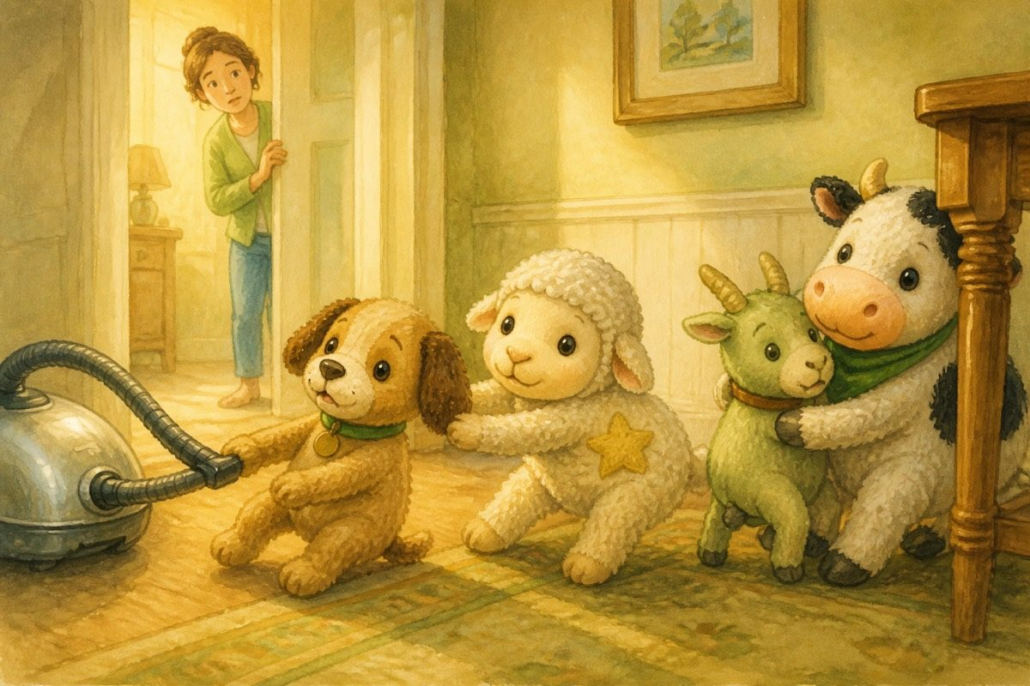
Ordinary toys. Ordinary silence.
When the monster left, my friends were so relieved to see me. And how we laughed when Sophia came home — quietly, into pillows, so Mum wouldn’t hear.
Home still had adventures. Scary ones.

Chapter 5. Invited!
After school, Sophia was jumping with excitement.
“I’m invited to a sleepover at Avril’s — and I told her all about you! I told Avril you can talk!” she said with a happy glow.
Bundle’s ears drooped. “You told—?”
“She’s my cousin,” Sophia said. “Just for one night. Same rule: freeze if grown-ups come.”
We all helped pack. Toothpaste, toothbrush, nightclothes, another set of clothes, board games. We mapped the route carefully, considering we might be up all night. Even five minutes of rest was crucial.
We got stuck in a huge traffic jam. My wool wanted to wriggle. “Leaders stay calm,” I whispered to Bundle, and we pretended we had not noticed anything. Mostly.

Chapter 6. Meet Avril
“Meet Avril — she doesn’t talk much; she just plays sounds,” said Mr Johns, and then he left.
It was our secret time.
Avril was shocked to see us move and talk! We took turns introducing ourselves. Barney began a riddle. Bundle stepped on his hoof.
“I hoped adults couldn’t see us talking,” I whispered.
“They say that if you do, you’ll become… well… ordinary toys forever,” said Bundle. “So we’d better be careful.”
Sophia looked at Avril. “Tonight, Avril can hear you too — but only us. If Mum or Dad or Auntie comes, freeze. Deal?”
“Deal,” said Avril, eyes shining.
I didn’t know if Bundle’s forever-ordinary warning was true. I only knew I didn’t want to find out.

Chapter 7. Rules of the Night
Before the fun, we made rules. Leaders love rules (Bundle loves them most).
1. Whisper only. 2. Freeze if you hear footsteps. 3. Barney: no loud riddles near doors. 4. Chocolate crumbs go in the bin — not on wool.
Avril and Sophia planned the midnight feast in a notebook. Torch. Cake. Songs. Games on the lawn in the morning.
Away from our own farmyard, I felt like a real leader. Also a little bit small. Mia nudged me. “You’ve climbed a mountain in a bag,” she said. “You can climb a night in a cousin’s house.”

Chapter 8. Midnight Feast
Once Avril’s parents were asleep, we turned on our torch and danced. We sang songs among ourselves — quietly.
Finally, we opened our basket. There was cake and chocolate. It was delicious! It tasted even better than grass!
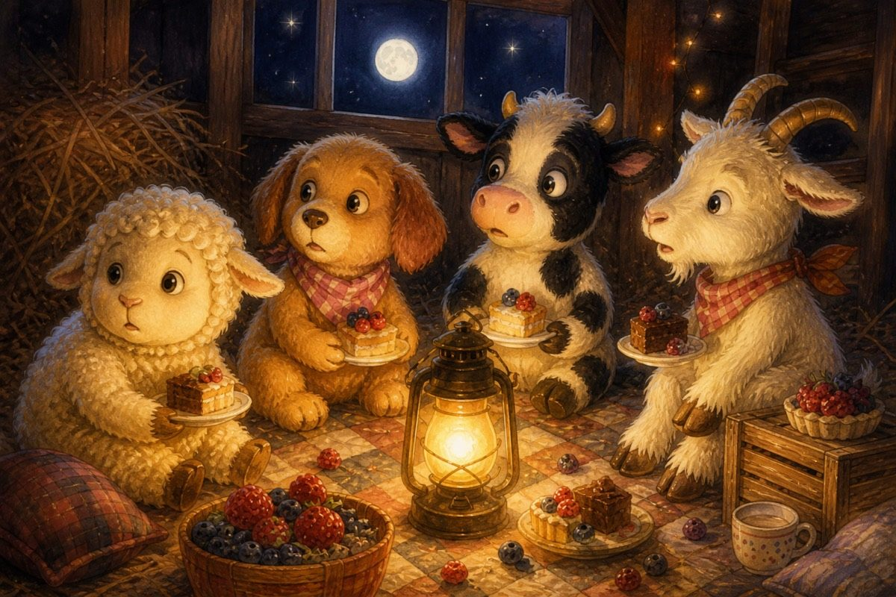
It tasted even better than grass!
Then — a creak in the hall.
“Freeze! Torch off!” I hissed.
Everyone froze. Bundle became a statue dog. Barney’s riddle died in his throat. For a second I thought Bundle’s warning was coming true — ordinary toys forever. Then the footsteps paused… and went the other way. A door closed.
We waited ten whole heartbeats. Then Sophia whispered, “Feast continues — but softer.”
Softer cake is still cake. We finished every crumb we dared.

Chapter 9. Morning Mess
We didn’t get up till ten o’clock — way past our usual time. We ate a little and headed into a fun morning of games on the lawn.
The only problem was not being seen by her parents. And the other problem…
“My, what a dirty bunch!” someone said from the doorway. “What on earth was that?”
Chocolate on my wool. Grass on Mia. A suspicious crumb on Barney’s horn.
Panic!
“Neat row — now!” I whispered. We flopped in a line, faces blank, while Sophia mumbled something about “outdoor games” and whisked us toward the bag. Avril stuffed wrappers into her pocket like a secret agent.
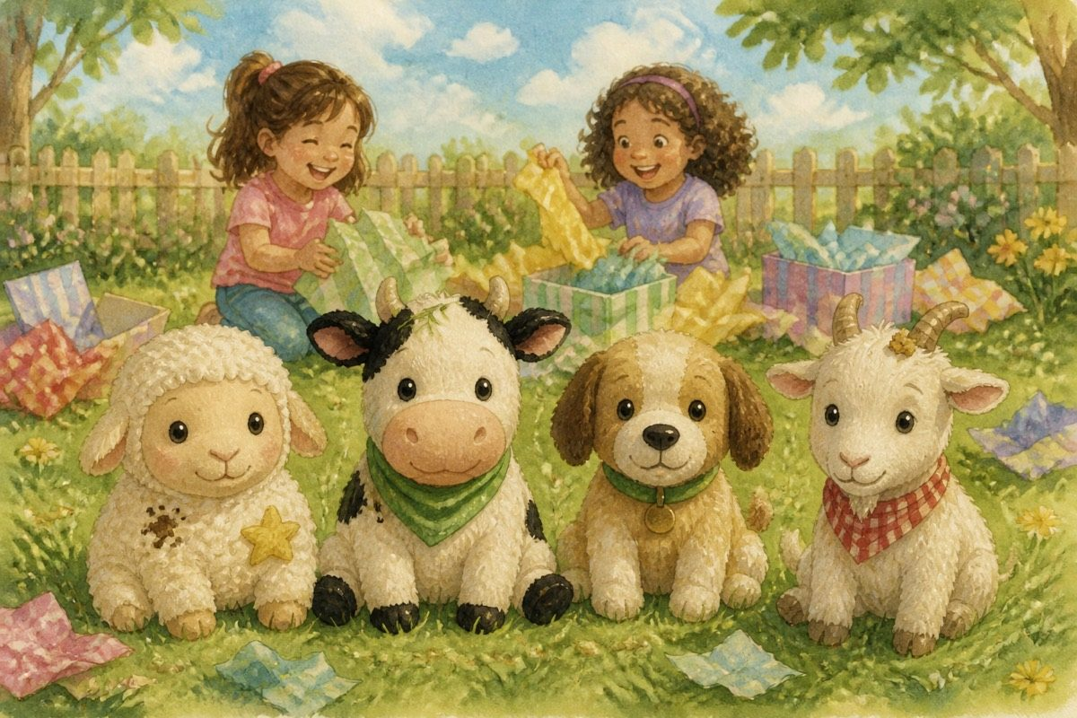
Neat row — now!
We were happy. Sleepovers were the best. Also the messiest.

Chapter 10. The Monster Bath
Back home, a different kind of monster waited — the washing machine!
(Because of the mess. Cause, then effect. Bundle said that twice.)
I was so dizzy I fell about inside. A few long turns later, Mrs Johns checked we were still the same toys. Thankfully, all my friends were okay. They hated the monster as much as I did, but at least they knew what was coming.
We complained to Sophia, who said, “I’m sorry! I never meant to put you in a monster. I thought she’d just give you a bubble bath instead.”
Soon we forgave her. Leaders forgive. Also, clean wool feels nice — once the spinning stops.

Chapter 11. What Leaders Do
That evening the farmyard was quiet. Starlight on hay. No monsters. No traffic jams.
“Secrets are hard,” I said.
“Friends matter more than prizes or feasts,” said Mia.
Barney cleared his throat. “What belongs to you, but others use it more than you do?”
We thought. Bundle frowned so hard his ears folded.
“Your name,” Barney said softly. “Or… your family. People say them. Love them. You’re still you.”
Sophia tiptoed in and hugged us without waking the house. She didn’t explain anything to Mum. She didn’t need to.
Looking after friends when the night gets messy — that is also what leaders do.

Chapter 12. Tips from Star (and Goodnight)
Now that I’m ending this diary for a while, I want to give you one more tip on making friends.
Don’t only ask, “Can I be your friend?” Try this instead: Name — ask what their name means. Place — ask where they live (not in my case!). Hobby — ask what they love and why. Thing — ask their favourite thing. By then you’ll know them better.
And if you ever have a midnight feast: freeze when you hear footsteps. Softer cake is still cake.
The farmyard is asleep. I am not wondering why I exist anymore.
I am wondering what adventure comes next.
— Star (From a kid, to a kid)

The End
I am wondering what adventure comes next.

About the Author
A sleepover, a show-and-tell prize, a riddle-loving goat, and a midnight feast — Star learns that bravery isn’t only mountains. It’s looking after friends when the night gets messy.
Anshika Mahesh is 12 years old. She writes stories about friendship, courage, and kindness — from a kid, to a kid.

