Star of the Toy Farm
Star Finds a Home
A Star of the Toy Farm story
Anshika Mahesh
From a kid, to a kid.
Star is a toy sheep who wonders why she exists. When she becomes Sophia’s birthday gift, she finds friends on the toy farm — but a missing cow named Mia pulls her into her first real adventure.
Copyright
Star Finds a Home
A Star of the Toy Farm story
Copyright © 2026 Anshika Mahesh
First Kindle edition 2026
All rights reserved. No part of this book may be reproduced without permission from the author, except for brief quotations in a review.
This is a work of fiction. Names, characters, and incidents are from the author’s imagination.
Contents

Main characters
1. On the Shelf
2. Chosen (and Wrapped!)
3. Birthday Morning
4. Bundle and a Purpose
5. My Name is Star
6. Bedtime (and the Door)
7. The Silver Monster
8. Finding Mia
9. Farmyard Leaders
10. The Mountain Day
11. When Sophia Is Poorly
12. A Family
The End
About the Author

Main characters
Star — A toy sheep, and our narrator
Sophia — Owner of the toy farm (age 5). She understands the toys when no other grown-ups are listening.
Bundle — A toy dog, Star’s first friend
Mia — A toy cow who went outside… and came back with stories
Pinky, Flappy & Lina — Farm friends (pig, duck, cat)
Mr & Mrs Johns — Sophia’s parents

Chapter 1. On the Shelf
I lived on a shelf in a toy shop, right near the window. Every morning, sunlight poured onto my wool, and every evening I watched the street lights blink awake. I was a toy sheep — soft, quiet, and very curious.
From my shelf I could see people walking past with shopping bags, dogs tugging on leads, and children pressing their noses to the glass. Sometimes a child would point at me and smile. That was the best feeling in the world. Then they would leave, and I would wonder again.
Why was I here? What was I for?
The other toys around me seemed so sure of themselves. The teddy bears looked cuddly. The racing cars looked fast. The dolls looked ready for tea parties. I only knew how to sit still and wait.
At night, when the shop closed and everything grew quiet, I stared at the moon through the window and whispered to myself, “One day, someone will choose me. One day, I will know why I exist.”
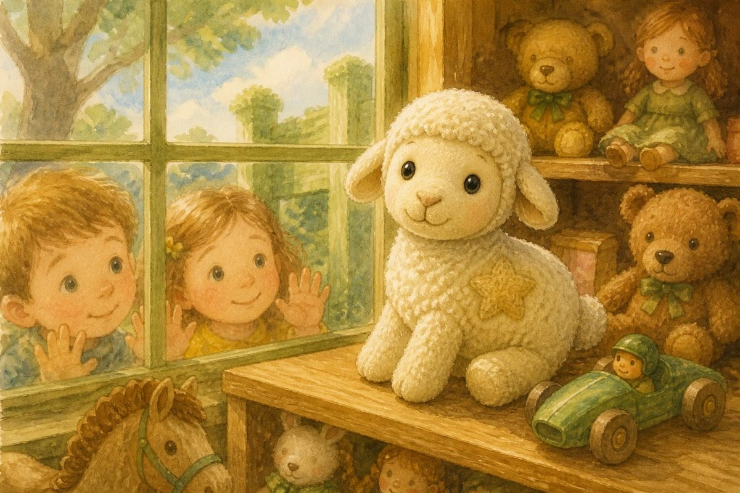
One day, someone will choose me.
I did not know then that my day was almost here.

Chapter 2. Chosen (and Wrapped!)
It happened on a busy afternoon. A kind-looking couple stopped in front of my shelf. The lady picked me up carefully and turned me around, checking my soft ears and little blank tag.
“She’s perfect,” she said. “Sophia has been wanting a sheep for her toy farm.”
“Then she’s coming home with us,” the man replied.
Home? Farm? Sophia?
Before I could even understand those words, they carried me to the counter. Money changed hands. A bag rustled. Then — oh no! — they put paper all around me!
It was so tight inside. There was hardly a finger’s gap. I almost couldn’t breathe (well, toys don’t really breathe, but it felt like that!). I heard them sticking something on the paper and wondered, “Why exactly am I in a stuffy package when I am meant to be cuddled and played with?”
It was dark and scary. I wished I could go back to my shelf and look outside the window. There wasn’t even a tear to peep through! I just sat in there, not knowing what was going to happen to me.
I was scared… and a little excited too. Somewhere out there, a girl named Sophia was waiting — and I was going to be her birthday present.

Chapter 3. Birthday Morning
After a long day of bumping about in the dark, I heard faint voices. “It’s almost time — we’ve got to get ready. She’ll be up any moment now!”
“Why are they so worried?” I wondered. I wished I could see who they were.
Suddenly someone grabbed me tightly and took me to a room.
“Sophia, wake up! It’s your birthday and we’ve got a present for you!”
“Finally! I’ve been waiting for ages for this day!”
Slowly, the paper around me tore off. It was like magic, and I was so glad to be out of that package.
“Oh, thank you so much, Mummy and Daddy — it’s just what I wanted! Now my toy animal collection is almost complete!” said Sophia.
She hugged me tightly, like she wouldn’t let me go. She carried me through the morning wearing a huge grin. After a long breakfast, she placed me in a toy farm filled with toy animals just like me.
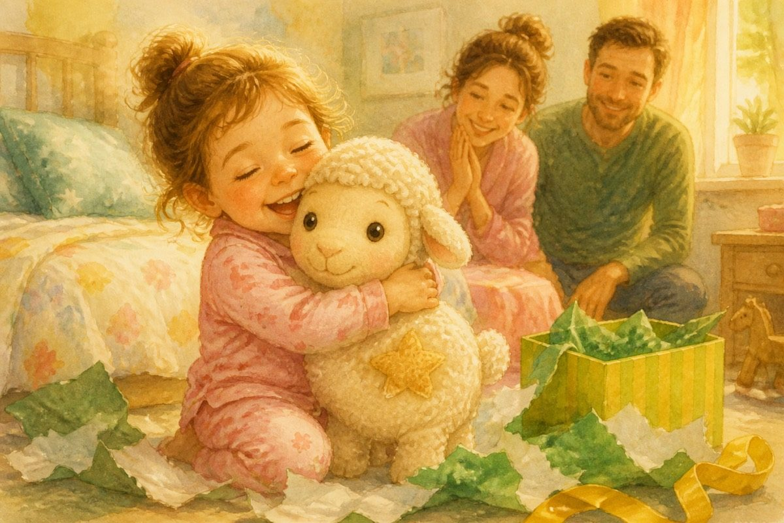
She hugged me tightly, like she wouldn’t let me go.

Chapter 4. Bundle and a Purpose
“Hello!” said a toy dog. “Welcome to our family. We are happy to meet you!”
“Hello — it’s nice to meet you. Why are we here?” I asked.
“We now belong to Sophia,” he said. “She takes care of us by washing us, playing with us, feeding us and more. Don’t worry — she’s the best owner a toy could wish for.”
Those words changed my life forever. They made me realise that I had a purpose — my purpose was to give children joy and give them company. I never forgot those words. Even today, they are still fresh in my mind.
“Is everything okay?” asked my new friend.
“I guess so, but I didn’t know that I even served a purpose until today.”
“That’s how I felt when I came here for the first time,” he replied. “Not only do we serve a purpose — everything serves a purpose.”
I simply couldn’t believe I had so much to learn. How could I not have known the reason for my existence? It was all very confusing, as though my mind was playing tricks on me.
I talked with my new friend and noticed that every animal except me had a tag.
“What’s that for?” I asked.
“It’s a piece of paper with our names,” he said.
“You have names!” I exclaimed. “I didn’t know toys could have names. What’s your name?”
“My name is Bundle,” he replied.
“Will I get a name too?”
“Of course you will. Every toy has a name.”

Chapter 5. My Name is Star
“I didn’t know that. Does everything have a name?” I asked.
“There are lots of things you don’t know. Yes, of course everything has a name,” Bundle replied.
Just then Sophia came and picked me up.
“I’ve just decided on a name for you. Your name is Star, as you are the brightest of my toys,” she said.
She tied a tag around my neck which said Star. I belonged in the toy farm with the rest of the animals — and now I had a name of my own.
That afternoon the farmyard buzzed. I met Pinky the pig, who snorted hello. I met Flappy the duck, who already had her eye on a little pond. And I met Lina the cat, who loved climbing (though she never liked climbing back down).
There were other toys too — a whole soft farm — but those three grinned at me first, and that was enough for one day.
I was really starting to enjoy myself.

Chapter 6. Bedtime (and the Door)
I was playing happily with my new friends when I suddenly felt very tired. I’d never felt tired before. I just sat and looked out of the window, waiting for something to happen.
“Time for bedtime,” said Sophia.
“Bedtime?” I exclaimed. “What’s that?!”
“We close our eyes till the sun rises,” replied Bundle.
“It sounds scary!”
“It’s not. You’ll love it. Let’s go to our hay beds.”
So I followed him. Lina was sleeping next to me.
“Good night,” said someone softly.
“Umm… good night?” I replied.
At first it was difficult to sleep, but then sleep came all at once.
I woke bright and early the next morning and went out to explore. Near the farmyard I noticed a little door that stood slightly open.
“What’s out there?” I asked.
Bundle shuddered. “Nobody knows. Once there was a cow named Mia… and then she went through that door. She promised she’d come back. She hasn’t — not really. Not the same. Not to stay.”
I was silent throughout the morning, thinking about the door.
Was it calling me? I didn’t know. I would rather stay in… but somehow I knew I was going to have to ask Sophia about this.

Chapter 7. The Silver Monster
So I ventured out of my farmyard home, wondering where to go and what to do.
As I was exploring the house, I saw something big, scary and silver. Before I knew it, it was leaning towards me! I ran as fast as my little toy legs could go — and then I remembered how the silver monster couldn’t climb. So I ran towards higher ground.
(Grown-ups call it a vacuum cleaner. I still call it a monster.)
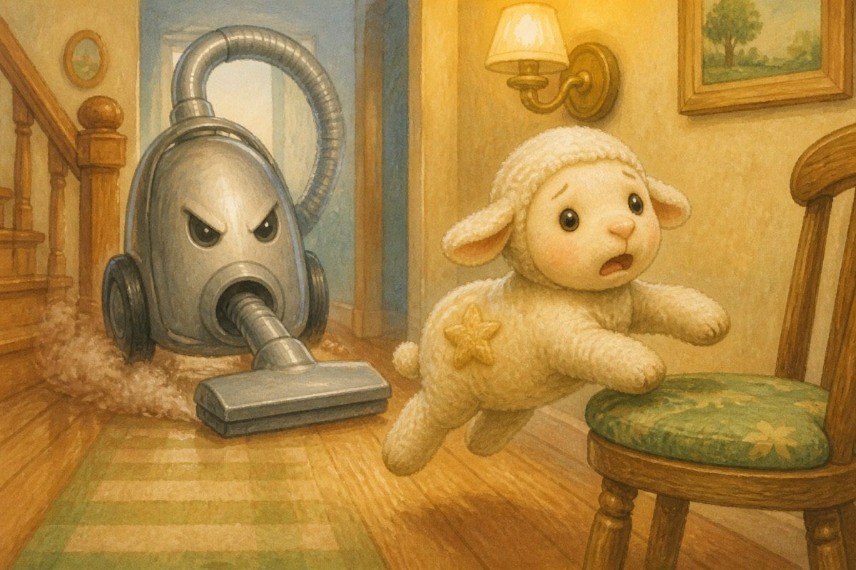
I still call it a monster.
I couldn’t find Sophia at first. Well, actually, I didn’t find her — she found me! I was still looking around when she saw me and scooped me up.
“Star, you really need to be careful,” she said gently. “Especially when Mum and Dad are around. They mustn’t know you move and talk. Only I can hear you — and only when we’re alone. That’s our rule.”
“I need to ask you something,” I said in my toy way.
“Well, what is it?”
“What’s outside the door that’s opposite the farm?”
“Oh — there’s a lot more out there. Why did you want to know?”
“Well, I just wanted to explore. But my friend Bundle said I should stay here… Mia is out there somewhere. Can’t we find her? We really miss her.”
Sophia smiled. “Then let’s go look.”

Chapter 8. Finding Mia
We went out and looked. We searched here and there. We searched under the garden bench. We searched behind the flower pots. We even checked the shady place where the hose curls like a snake.
“Maybe she’s over there,” I suggested. So we went and searched again.
Then we took a wrong turn past the compost heap. Something rustled. I froze — but it was only a leaf.
We almost lost hope. Then I saw a name tag in the grass — the same kind Bundle had shown me. I looked up, and there she was!
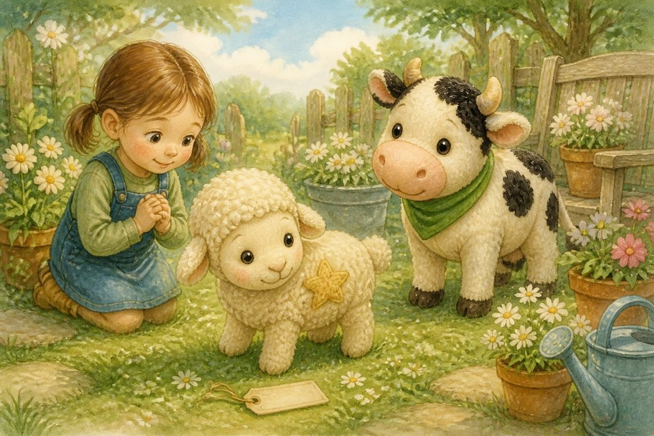
Then I saw a name tag in the grass.
Mia told us her story. She had only wanted to find out if it was really dangerous. She found real grass that tasted better than any grass she had ever eaten — soft, fresh and tender. She lived on it for months. Every now and then, water appeared from nowhere and poured from the sky. It was scary at first, but she adjusted.
“Till now,” Mia said. “But now that I’m back, I’ll be your friend. I might visit the grass sometimes… but I won’t disappear without saying.”
We were still digesting all of this when Sophia said, “Come on in, and you can tell me your story.”

Chapter 9. Farmyard Leaders
We went inside.
“Star!” exclaimed Bundle. “Thank goodness you’re back!” Then he saw Mia. “Is that you? I thought you were gone for good!”
“I promised I’d come back,” said Mia. “Didn’t you believe me when I said that?”
“I missed you,” Bundle whispered.
“You both have done great service to the farm,” said Sophia, “and I think it’s a good idea to let you be the farmyard leaders. Whatever that means!”
“It means you tell the rest of the group things and give orders when things need doing,” explained Bundle. “Leaders!”
As leaders, we had to keep everyone safe and sound while Sophia went to school in the morning and came back in the afternoon.
“But next year I’ll come a bit later than that,” Sophia told us, “so you’ll have to manage without me for a bit longer.” She had already explained how to evacuate in case of a storm.
That night, before hay beds, Bundle and I counted everyone. Pinky, Flappy, Lina, Mia — all there. Then I closed the little door, the one Mia had walked through, until morning.
I felt very proud to be a leader.

Chapter 10. The Mountain Day
Saturday was our favourite day — it meant Sophia got the whole day to be with us.
She came home with an excited expression. “Guess what? We’re climbing the hill today — and of course you’re coming! I can’t wait.”
“Last time, under the big clouds, I got scared of being outside,” I protested.
“If we get wet she puts us in the bag,” said Flappy.
We packed. Mia and I almost forgot first aid — luckily Bundle reminded us. We packed chilly-weather gear and some grass for snacking. As soon as Sophia closed the bag, I turned on my brave face.
As she kept climbing, she panted and puffed. “Maybe she needs some encouragement to keep going,” I suggested.
“Yes — let’s keep whispering brave things in her ear!” said Mia.
We banged the side of the bag with all our might. Sophia jumped, opened it, and pretended to her dad that she only wanted a sandwich. We whispered courage in her ear when no grown-ups were looking — then stopped for a picnic breakfast.
At the top, the view was truly magical. I could see cities, villages and hills. I had never seen so much in my life. We had a scrumptious lunch of hillside grass. Even Mia agreed that it was better than anything before.
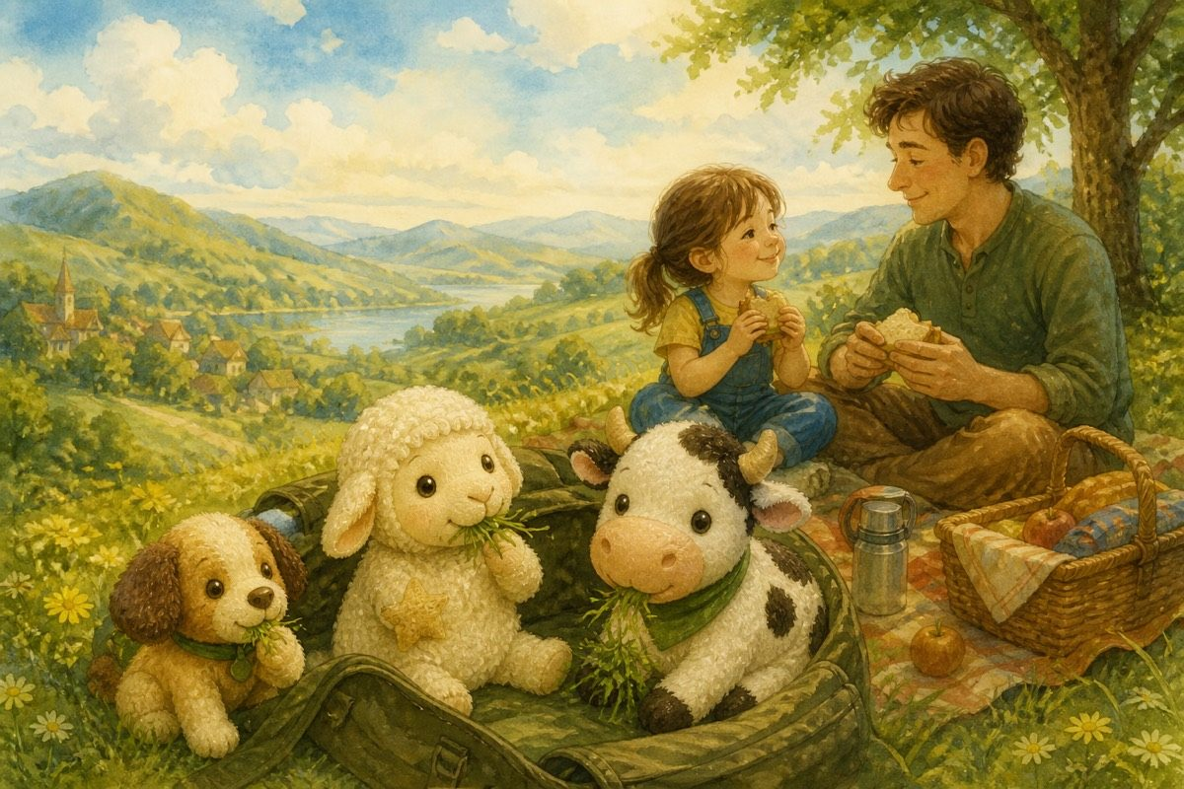
At the top, the view was truly magical.
While we rested, Sophia made up a tiny story with us: a prince on one side of a forest, a princess on the other, a tower, a question, and a happy ending — all in about five lines. Then it was time to go home.
Going back wasn’t hard — though ordinary mornings afterwards felt small. Freedom and home, in the same breath.

Chapter 11. When Sophia Is Poorly
Sophia didn’t have to go to school the next day. Bundle whispered, “Maybe she’s unwell.”
“Let’s go check on her,” I said.
So we hid behind curtains and sneaked into her room. I couldn’t believe what I saw. Sophia was in bed, sneezing and coughing. She looked tired — then she cheered up when she saw us.
“I have an allergy and didn’t carry a scarf when there was too much dust,” she whispered. “Mum mustn’t know you’re nurses.”
As soon as her mother left, we looked after her. We were the nurses and doctors. We made her day better.
Later that afternoon the silver monster growled again in the hallway. It almost swallowed Pinky’s ear — Bundle yanked her free, and we all froze like ordinary toys until Mrs Johns wheeled the monster away. Then we laughed so hard we had to bury our faces in the quilt.
Purpose isn’t only big mountains. Sometimes it’s sitting still beside someone who feels poorly.

Chapter 12. A Family
I can’t believe how much I’ve learnt.
Not long ago I sat on a shop shelf and didn’t even know why I existed. Then I got a name. Then we found Mia. Then we climbed a hill. Then we cared for Sophia when she needed us.
I still love adventure. But I know my purpose now: joy, company, and family.
And that is the best thing I could ever own.
— Star (From a kid, to a kid)
A tiny tip from Star:
• Ask a new friend’s name — and what it means.
• Invent a silly game while you wait (stacking apples works).
• Keep a diary. Every diary’s story is different.

The End
And that is the best thing I could ever own.

About the Author
Star is a toy sheep who wonders why she exists. When she becomes Sophia’s birthday gift, she finds friends on the toy farm — but a missing cow named Mia pulls her into her first real adventure.
Anshika Mahesh is 12 years old. She writes stories about friendship, courage, and kindness — from a kid, to a kid.
The next Star of the Toy Farm story is Star and the Midnight Feast.

