All Countries Environmental Data

## Method: DiCA

## Dataset

* Data: Measurements of environment conditions in Countries
* Rows: There are 137 observations, 1 for each country.
* Columns: Total 29 variables
* Qualitative: Country (nominal), Happiness (Ordinal).
* Quantitative: Aspect, Slope Crop Land, Tree Canopy Wind Cloud & Multiple variables for Temp & Rain
* Structure of Data

str(country_env_df)

## 'data.frame': 137 obs. of 29 variables:  
## $ Country : Factor w/ 137 levels "Afghanistan",..: 1 2 3 4 5 6 7 8 9 10 ...  
## $ Happiness_Rank : Ord.factor w/ 3 levels "VH"<"H"<"U": 3 2 2 3 1 3 1 1 2 2 ...  
## $ accessibility_to_cities: num 317.7 73.8 1212.8 378.2 209.2 ...  
## $ elevation : num 1832 652 557 1061 683 ...  
## $ aspect : num 201 192 185 174 145 ...  
## $ slope : num 1.516 1.89 0.171 0.193 0.624 ...  
## $ cropland_cover : num 9.51 23.35 3.69 2.79 21.96 ...  
## $ tree_canopy_cover : num 0.375 12.805 0.177 19.87 8.834 ...  
## $ isothermality : num 35.9 33.2 40.3 64.3 49.9 ...  
## $ rain_coldestQuart : num 128.72 392.51 25.29 8.05 79.09 ...  
## $ rain_driestMonth : num 1.722 40.088 0.935 0.26 17.183 ...  
## $ rain_driestQuart : num 8.3 138.15 6.09 4.43 60.49 ...  
## $ rain_mean_annual : num 311.3 1151.1 79.5 1023.4 539.9 ...  
## $ rain_seasonailty : num 91.6 38.5 67.1 91.5 48.3 ...  
## $ rain_warmestQuart : num 12.69 138.33 9.51 318.54 183.14 ...  
## $ rain_wettestMonth : num 67.8 159 13.4 202.2 79.2 ...  
## $ rain_wettestQuart : num 175.8 435.9 33.3 524.3 211.7 ...  
## $ temp_annual_range : num 40.3 27.1 36.5 21.5 26.8 ...  
## $ temp_coldestQuart : num -0.261 3.58 13.152 18.794 8.024 ...  
## $ temp_diurnal_range : num 14.72 9.11 14.87 13.85 13.46 ...  
## $ temp_driestQuart : num 21.1 19.6 26.9 18.9 11.1 ...  
## $ temp_max_warmestMonth : num 32 26.3 41.5 31 28.2 ...  
## $ temp_mean_annual : num 11.5 11.5 23 21.6 14.2 ...  
## $ temp_min_coldestMonth : num -8.312 -0.806 5.058 9.549 1.443 ...  
## $ temp_seasonality : num 88.2 62.7 75.1 18.5 47.6 ...  
## $ temp_warmestQuart : num 22.7 19.6 32.5 23.3 20.2 ...  
## $ temp_wettestQuart : num 3.95 5.27 20.81 22.76 16.48 ...  
## $ wind : num 3.43 2.47 4.03 2.16 4.27 ...  
## $ cloudiness : num 114.2 181.1 90.7 187.5 159 ...

* Research Question

How do the 137 countries differ on these variables?

## Analysis

Let’s observe the distribution of each variables to get an intuition of how we can bin these variables. It’s important to have nearly equal number of observations in the each bin and to try to cut the variables in a way to so that each new binned distribution is nearly Gaussian. We can also verify that our binning is appropiate by calculating Spearman Correlation for each of original variable and binned variable, the correlation coefficient should be close to 1.

### Density plot

plot_bins <- function(df, col) {  
 plot_col <- ggplot(df) + aes(df[,col]) + geom_density() +   
 geom_vline(xintercept = cut_points[[col]], color = 'red') +  
 xlab(col) + theme_minimal() + ylab(NULL) +  
 theme(axis.text.y = element_blank())  
 return(plot_col)  
}  
  
bin_hist_list <- lapply(colnames(country_env_df_for_pca), function (col) plot_bins(country_env_df_for_pca, col))  
  
plot_grid(plotlist=bin_hist_list)

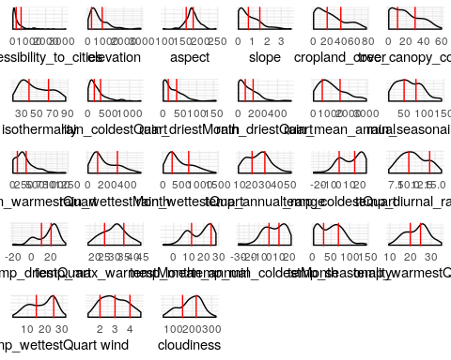

### Binning

Structure of Data after binning based on above observation.

## 'data.frame': 137 obs. of 27 variables:  
## $ accessibility_to_cities: int 2 1 3 2 2 1 3 1 1 1 ...  
## $ elevation : int 3 2 2 3 2 3 2 3 2 1 ...  
## $ aspect : int 3 3 3 2 1 3 3 2 1 2 ...  
## $ slope : int 3 3 1 1 1 3 1 2 2 1 ...  
## $ cropland_cover : int 1 2 1 1 2 2 1 2 2 3 ...  
## $ tree_canopy_cover : int 1 2 1 2 1 1 1 3 1 2 ...  
## $ isothermality : int 1 1 2 2 2 1 2 1 1 2 ...  
## $ rain_coldestQuart : int 1 3 1 1 1 1 1 2 1 1 ...  
## $ rain_driestMonth : int 1 3 1 1 2 2 1 3 2 1 ...  
## $ rain_driestQuart : int 1 2 1 1 1 1 1 3 1 1 ...  
## $ rain_mean_annual : int 1 2 1 2 2 2 1 2 1 3 ...  
## $ rain_seasonailty : int 3 1 2 3 1 1 2 1 1 3 ...  
## $ rain_warmestQuart : int 1 2 1 3 2 2 2 3 1 3 ...  
## $ rain_wettestMonth : int 1 2 1 2 1 1 1 2 1 3 ...  
## $ rain_wettestQuart : int 1 2 1 2 1 1 1 2 1 3 ...  
## $ temp_annual_range : int 3 2 3 2 2 3 2 2 3 2 ...  
## $ temp_coldestQuart : int 1 2 2 3 2 1 2 1 2 3 ...  
## $ temp_diurnal_range : int 3 1 3 2 2 2 2 1 1 1 ...  
## $ temp_driestQuart : int 3 2 3 2 2 1 2 1 2 2 ...  
## $ temp_max_warmestMonth : int 2 2 3 2 2 1 3 1 2 2 ...  
## $ temp_mean_annual : int 1 1 2 2 2 1 2 1 1 3 ...  
## $ temp_min_coldestMonth : int 1 1 2 2 2 1 2 1 1 3 ...  
## $ temp_seasonality : int 3 2 3 1 2 3 2 2 3 2 ...  
## $ temp_warmestQuart : int 2 1 3 2 2 1 3 1 2 3 ...  
## $ temp_wettestQuart : int 1 1 2 2 2 1 2 1 1 3 ...  
## $ wind : int 3 2 4 2 4 1 4 2 2 2 ...  
## $ cloudiness : int 1 2 1 2 2 2 1 3 2 2 ...

### Spearman Correlation

Let’s observe correlation between original data and binned data to make sure that neither the correlation ceofficient is too low or perfect.

cor_spear <- mapply(function(x,y) cor(x, as.integer(y),method = "spearman"), country_env_df_for_pca, country_env_df_for_mca)  
#columns = colnames(country_env_df_for_pca)  
#cor_df <- data.frame(col = columns, corr = cor_spear)  
cor_p <- as.data.frame(cor_spear)  
  
ggplot(data=cor_p, aes(x=rownames(cor_p), y=cor_p$cor_spear)) +  
 geom_bar(stat="identity") + theme(axis.text.x=element_text(angle=90,hjust=1,vjust=0.5)) +  
 xlab("") + ylab("Spearmen Correlation") + ylim(0, 1)

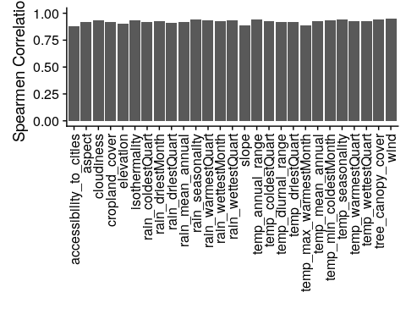

### Correlation Plot

Visually analyze multicollinearity in the system of the original data

heatmap.2(t(happiness_dummies) %*% as.matrix(country_env_df_for_mca), col = rev(heat.colors(16)), dendrogram = 'none', trace = 'none', margins = c(8, 16)) #tracecol=NA)

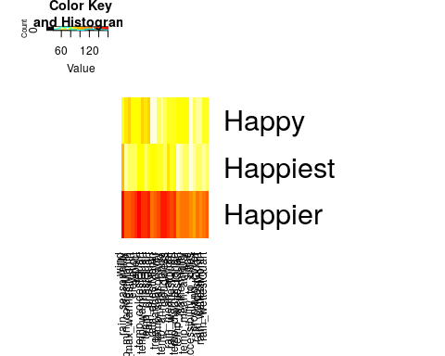

### Heatmap

For binned data.

corrMatBurt.list <- phi2Mat4BurtTable(country_env_df_for_mca)  
corr4MCA <- corrplot.mixed(as.matrix(corrMatBurt.list$phi2.mat,  
 title = "Phi2: (squared) Correlation Map for MCA"))

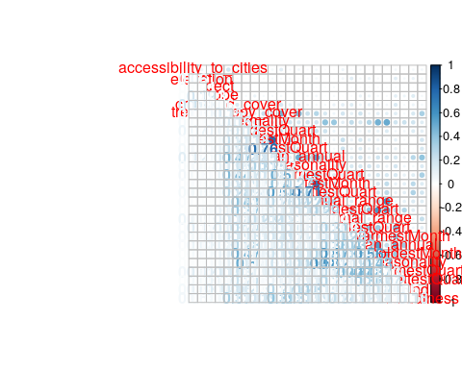

a0001a.corMat.phi2 <- recordPlot()

## Identify Latent Components - MCA (With Inference)

### Scree Plot

Gives amount of information explained by corresponding component. Gives an intuition to decide which components best represent data in order to answer the research question.

P.S. The most contribution component may not always be most useful for a given research question.

PTCA4CATA::PlotScree(ev = country_env_mca$TExPosition.Data$eigs,  
 p.ev = country_env_mca_inf$Inference.Data$components$p.vals,  
 title = 'SCREE Plot',  
 plotKaiser = TRUE  
)

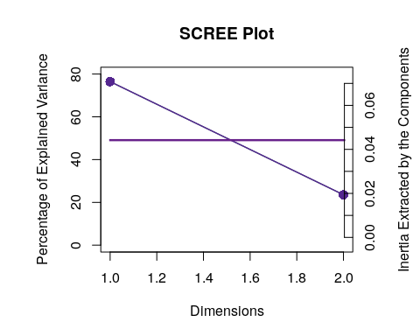

### Factor Scores

**With Confidence Interval** 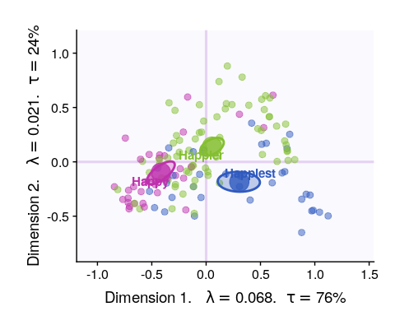

**With Tolerance Interval**

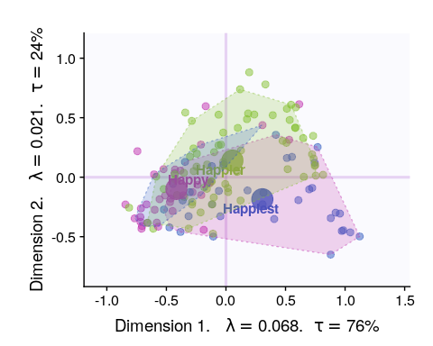

#### Loadings

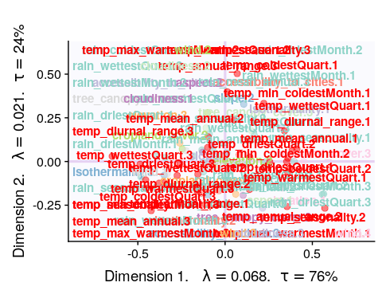

#### Loadings (correlation plot)

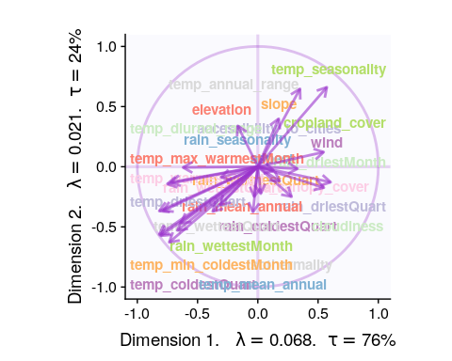

#### Most Contributing Variables (Inference)

Let’s plot variable contributions against each chosen components i.e. 1, 2.

* With Bootstrap Ratio

BR <- country_env_mca_inf$Inference.Data$boot.data$fj.boot.data$tests$boot.ratios  
  
for (i in c(1, 2)) {  
 laDim = i  
 ba001.BR1 <- PrettyBarPlot2(BR[,laDim],  
 threshold = 2,  
 font.size = 5,  
 color4bar = gplots::col2hex(col4J), # we need hex code  
 main = paste0('DiCA: Bootstrap ratio ',laDim),  
 ylab = 'Bootstrap ratios',horizontal = FALSE  
 #ylim = c(1.2*min(BR[,laDim]), 1.2*max(BR[,laDim]))  
 )  
 print(ba001.BR1)  
}

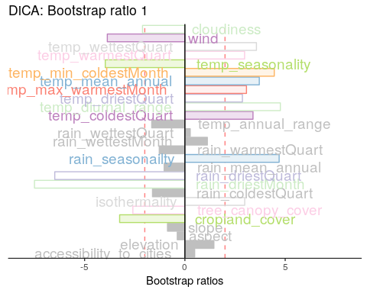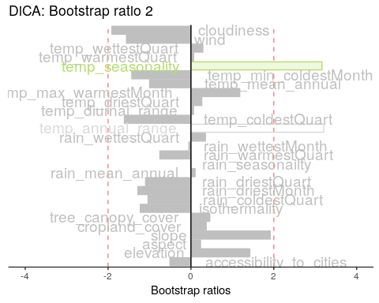

#### Permutation Test

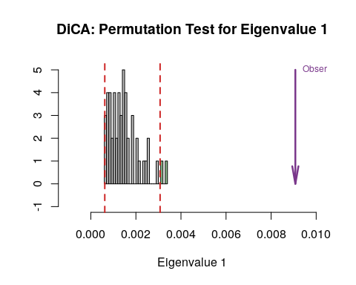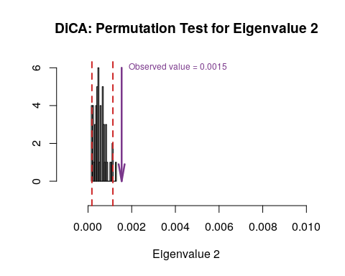

#### Parallet Test

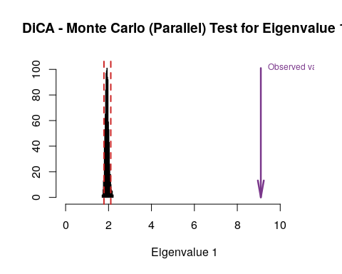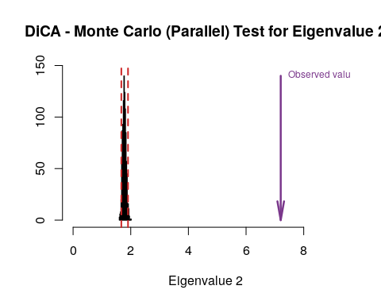

#### Bootstrap Test

#country_env_pca_br <- PTCA4CATA::Boot4Mean(country_env_pca$ExPosition.Data$fi, design = country_env_df$Happiness_Rank, niter=100, suppressProgressBar = FALSE)  
country_env_mca_bs <- data4PCCAR::boot.eigen(X = country_env_df_for_mca, nIter = 1000)  
  
for (i in c(1, 2)) {  
 zeDim = i  
 prettyHist(country_env_mca_bs$boot.eigs[,zeDim],   
 observed = country_env_mca_bs$fixed.eigs[zeDim],   
 xlim = c(0, country_env_mca_bs$fixed.eigs[zeDim]+2), # needs to set by hand  
 breaks = 20,  
 border = "black",   
 main = paste0("Bootstrapped distribution for Eigenvalue ",zeDim),  
 xlab = paste0("Eigenvalue ",zeDim),   
 ylab = "",   
 counts = FALSE,   
 cutoffs = c(0.025, 0.975))  
}

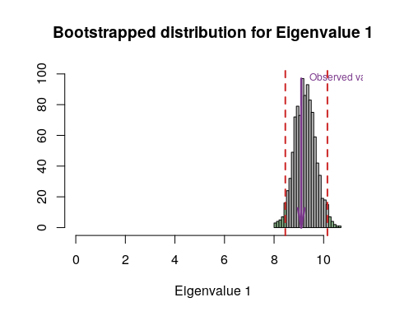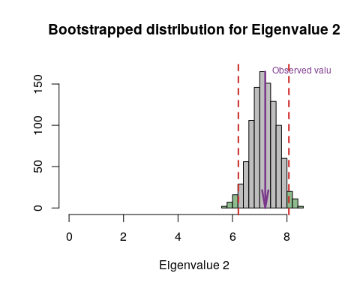

### Conclusion

Among PCA, MCA, BADA and DiCA, DiCA is able to best seperate the data based on levels of happiness. It seems increase in temperature is correlated with increase in happiness and increase in rain decreases happiness.