Ritesh_Malaiya_Group_1_DiSTATIS

## Skipping install of 'PTCA4CATA' from a github remote, the SHA1 (0a982b85) has not changed since last install.  
## Use `force = TRUE` to force installation

## DiSTATIS

To be filled

### Dataset

4 Pianist for each of 3 Composers

|  |  |  |  |  |  |  |  |  |  |  |
| --- | --- | --- | --- | --- | --- | --- | --- | --- | --- | --- |
|  | bc001 | bc002 | bc003 | bc004 | bc005 | bc006 | bc007 | bc008 | bc009 | bc010 |
| Bach.Arrau.1 | 1 | 2 | 1 | 2 | 3 | 1 | 1 | 3 | 1 | 1 |
| Bach.Arrau.2 | 2 | 1 | 1 | 2 | 3 | 1 | 1 | 2 | 1 | 1 |
| Bach.Arrau.3 | 1 | 3 | 2 | 1 | 1 | 1 | 2 | 2 | 3 | 3 |
| Bach.Baren.4 | 1 | 3 | 2 | 2 | 2 | 1 | 2 | 3 | 1 | 1 |
| Bach.Baren.5 | 1 | 1 | 2 | 3 | 3 | 3 | 3 | 3 | 1 | 2 |
| Bach.Baren.6 | 1 | 3 | 3 | 2 | 3 | 1 | 2 | 1 | 3 | 1 |
| ``` |  |  |  |  |  |  |  |  |  |  |

## [1] Bootstrap On Factor Scores. Iterations #:   
## [2] 1000

### SCREE Plot

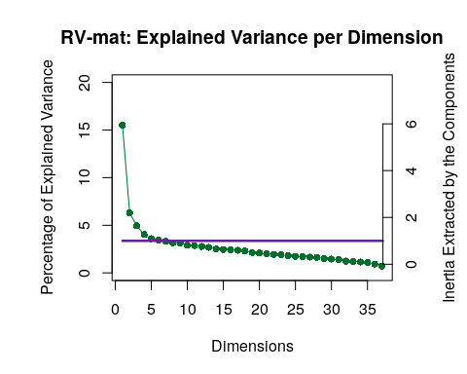

### Plotting Assessor Matrix

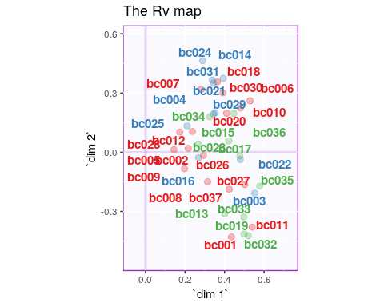

### ConvexHull

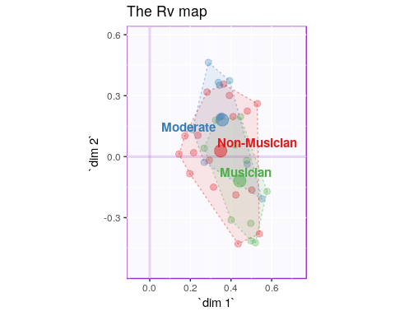

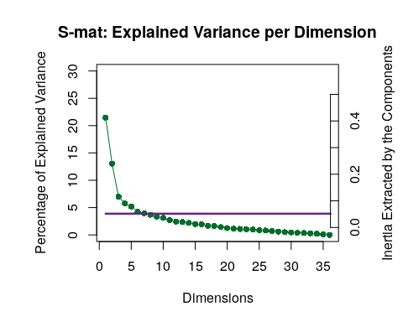

### I Set

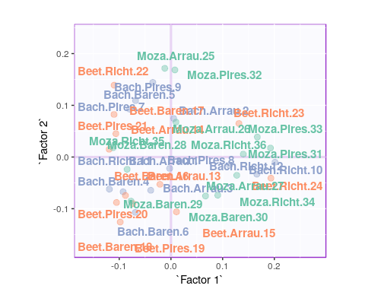

## Warning: Removed 3 rows containing missing values (geom_text_repel).

