Latent Topic Modeling on Twitter Data

# Method: CA

Correspondence Analysis (CA) is a multivariate graphical technique designed to explore relationships among categorical variables. The outcome from correspondence analysis is a graphical display of the rows and columns of a contingency table that is designed to permit visualization of the salient relationships among the variable responses in a low-dimensional space. Such a representation reveals a more global picture of the relationships among row-column pairs which would otherwise not be detected through a pairwise analysis.

**Calculate CA:**

* Step 1: Compute row and column averages
* Step 2: Compute the expected values
* Step 3: Compute the residuals
* Step 4: Plotting labels with similar residuals close together
* Step 5: Interpreting the relationship between row and column labels

**How to Interpret Correspondence Analysis Plots**

Correspondence analysis does not show us which rows have the highest numbers, nor which columns have the highest numbers. It instead shows us the relativities.

* The further things are from the origin, the more discriminating they are.
* Look at the length of the line connecting the row label to the origin. Longer lines indicate that the row label is highly associated with some of the column labels (i.e., it has at least one high residual).
* Look at the length of the label connecting the column label to the origin. Longer lines again indicate a high association between the column label and one or more row labels.
* Look at the angle formed between these two lines. Really small angles indicate association. 90 degree angles indicate no relationship. Angles near 180 degrees indicate negative associations.

# Dataset

## 9 10 11 12 13 14 15 16  
## #actu 33 1887 1719 0 2248 2178 0 2046  
## #ada 5442 8017 25570 8335 7913 4790 4459 5966  
## #airdrop 11441 36136 65027 47022 44009 28802 31422 20915  
## #altcoin 8576 27302 34043 33968 35554 23094 29489 21702  
## #amazon 0 985 706 0 0 0 0 0  
## #bch 2256 5532 0 0 5837 6713 0 4335  
## #binanc 2967 10488 9240 10857 8285 8518 11244 7510  
## #bitcoin 48217 203875 217191 222528 181728 169374 217601 146159  
## #bitcoincash 805 3329 3176 3487 2468 2912 3852 7995  
## #bittrex 0 0 0 0 0 0 0 1327  
## #blockchain 25360 104908 121667 126158 119212 101804 120474 82617  
## #bounti 5951 18956 32387 27493 29709 15770 22262 14486  
## #btc 28617 95589 119714 95818 91273 76517 91924 64283  
## #bts 0 0 0 9725 0 0 0 4577  
## #busi 29 1283 1041 0 1989 0 0 1566  
## #cambridgeanalyt 0 0 0 5004 1658 0 0 0  
## #cambridgeanalytica 0 0 780 13947 4700 4102 6515 1851  
## #coin 544 2564 0 0 12546 4176 0 0  
## #coinbas 674 0 0 0 0 1647 2644 0  
## #congress 0 0 0 0 0 0 2309 0  
## #costarica 0 0 0 0 0 0 0 0  
## #crowdfund 1649 0 0 0 0 0 9194 4170  
## #crowdsal 0 4511 0 7858 4876 5252 9604 4020  
## #crypto 23912 84945 101526 96566 88437 81127 102777 75307  
## #cryptocurr 25722 97272 114420 117667 107539 95315 116701 86840  
## #cryptonew 0 2919 2865 8174 2009 6030 8484 0  
## #cybersecur 2396 8491 9800 12639 9689 11301 15782 8265  
## #dash 2861 8558 9124 8832 6340 8412 4518 5950  
## #data 0 0 0 3958 2986 2558 3721 1867  
## #date 0 0 0 0 0 0 0 0  
## #deletefacebook 0 0 0 5732 3050 1797 2762 0  
## #digitalmarket 0 895 710 0 0 0 0 1356  
## #digitizecoin 0 0 0 0 0 0 4733 0  
## #earn 0 0 0 0 8515 0 0 0  
## #elsalvador 0 0 0 0 0 0 0 0  
## #energytoken 5921 8852 0 0 0 0 0 0  
## #eo 4481 9439 0 4646 6158 4802 0 4102  
## #erc20 1385 0 5729 6245 7331 4942 4706 4441  
## #escort 0 0 0 0 0 0 0 5084  
## #etc 1643 6167 0 0 0 0 0 0  
## #eth 28904 90509 118505 96421 101394 82375 90647 65281  
## #ether 4201 17129 19586 20965 23653 24212 24726 14193  
## #ethereum 37313 145661 163302 160486 153445 141294 157889 123366  
## #f8 0 0 0 0 0 0 0 0  
## #facebook 949 50748 41961 130670 86932 76678 128772 63718  
## #facebookdatabreach 0 0 0 0 1635 0 2683 0  
## #facebookdataleak 0 0 0 0 0 0 2801 0  
## #facebookg 0 0 0 3196 0 0 0 0  
## #faitsdiv 33 1882 1717 0 2241 2173 0 2037  
## #fintech 1109 4166 3392 3953 2660 2524 3768 1911  
## #follow 18 0 0 0 0 0 0 0  
## #free 2102 8614 2947 0 11960 0 0 0  
## #freecoin 0 0 0 0 0 0 9535 0  
## #freetoken 1882 6550 7427 8803 18341 10097 11549 6243  
## #game 0 0 0 0 4687 0 0 0  
## #gdpr 0 0 0 0 0 0 0 1499  
## #geoloc 0 0 0 4655 8009 9285 10856 4415  
## #girl 0 0 0 0 0 0 0 5119  
## #googl 42 2779 2532 4691 5555 3372 4228 3154  
## #grab 0 0 9192 0 0 0 0 0  
## #gto 3015 0 0 0 0 0 0 0  
## #guatemala 0 0 0 0 0 0 0 0  
## #hiphop 21 1249 950 0 0 0 0 0  
## #ico 22618 85294 106509 107006 96788 85156 99988 71690  
## #info 35 1918 1747 2435 2295 2217 0 2101  
## #instagram 153 7778 5601 8764 7736 7760 8403 7887  
## #invest 2549 10826 4243 10145 8789 10133 11408 6770  
## #justic 35 1962 1773 2452 2316 2263 2288 2205  
## #linkedin 23 1091 948 0 0 0 0 1384  
## #litecoin 6944 24524 28035 22353 22159 18549 19239 13606  
## #live 1444 0 0 0 8888 0 0 0  
## #ltc 10626 24905 26691 24203 20939 17617 18332 18170  
## #maga 0 0 0 0 0 0 2999 0  
## #mana 0 0 14506 0 0 0 0 0  
## #market 36 2763 1954 3032 4668 2457 2865 2591  
## #markzuckerberg 0 0 0 3952 0 1805 7903 0  
## #média 33 1917 1760 0 2271 2192 0 2047  
## #mexico 0 0 0 0 0 0 0 0  
## #money 759 3616 3129 0 11018 1775 0 0  
## #music 46 2458 2201 3045 2798 2846 3027 2820  
## #neo 6536 17747 12554 11168 10211 8381 7989 5928  
## #new 734 11244 6719 5867 6333 10280 5774 9363  
## #nowplay 0 0 0 0 0 0 0 0  
## #np 0 0 0 0 0 0 0 0  
## #opirium 0 0 0 0 0 4354 4372 0  
## #panama 0 0 0 0 0 0 0 0  
## #pdata 0 0 0 0 0 4269 4318 0  
## #pinterest 0 924 745 0 0 0 0 0  
## #privaci 0 0 0 5047 4843 3767 6267 3097  
## #qanon 0 0 0 0 0 0 2491 0  
## #radiocapitol 33 1882 1717 0 2241 2173 0 2037  
## #rippl 10406 30151 21378 20985 19602 17416 19468 13612  
## #rt 0 0 0 0 0 0 0 0  
## #smm 0 1249 922 0 0 1509 0 1194  
## #snapchat 20 1406 984 0 1697 1602 0 1631  
## #socialmedia 84 5468 4141 8751 6959 6267 8052 6012  
## #socialmediamarket 20 0 0 0 0 0 0 0  
## #soundcloud 31 1424 1162 0 0 0 0 1183  
## #submityourmus 21 1158 885 0 0 0 0 0  
## #tge 0 0 0 0 0 0 5112 4757  
## #tinder 0 0 0 0 0 0 0 0  
## #token 6253 25055 27857 26829 41958 27994 27825 14562  
## #tokensal 5635 21400 22542 21919 21075 22293 27843 27337  
## #trade 3952 12218 12189 10300 9258 9860 10287 8306  
## #travel 0 0 0 0 0 0 0 0  
## #tron 3465 7741 0 4996 0 4132 6167 0  
## #trump 0 0 0 3805 0 0 0 0  
## #trx 8392 19648 34732 21853 17709 13922 17372 13047  
## #twitter 160 8199 6384 11196 9690 8526 9834 8848  
## #uniqu 33 1887 1720 2527 2248 2251 0 2045  
## #usa 21 0 0 0 0 0 0 0  
## #usd 0 0 0 0 2241 0 0 0  
## #verg 2493 6675 0 0 0 0 0 0  
## #video 0 0 0 0 0 0 0 0  
## #vip 0 0 0 0 0 0 0 0  
## #webradio 33 1882 1718 0 2241 2173 0 2039  
## #whatsapp 0 1146 836 0 0 0 0 0  
## #xem 0 0 0 0 0 0 0 0  
## #xlm 5289 11806 5957 5749 5579 4759 0 3891  
## #xmr 1428 0 0 0 0 0 0 0  
## #xrb 3144 6450 0 0 0 0 0 0  
## #xrp 11169 33533 29413 25704 23416 20931 21598 17065  
## #xvg 6037 10978 33533 15046 9724 6645 8805 9520  
## #youtub 84 3921 2951 4276 3684 3824 4257 4265  
## #zuckerberg 0 0 0 4287 1763 2614 18855 1838  
## 000facebook 0 0 0 4391 2785 2602 3727 1675  
## 000guarium 0 0 0 0 0 0 0 1311  
## account 0 0 0 3637 1793 1493 2533 0  
## ad 41 1610 1252 2824 2556 2127 2790 1640  
## airdrop 4272 8952 17883 10533 7212 6779 7201 4515  
## al 0 0 0 0 0 0 2312 1263  
## analytica 0 0 0 5653 1681 1826 2917 0  
## app 0 0 0 0 0 0 0 0  
## bitcoin 2711 14780 14408 13655 7537 7178 11675 5826  
## blockchain 679 3830 3165 9959 6873 5983 8528 5830  
## btc 7909 28256 28966 32636 25442 21654 27668 20829  
## busi 19 957 765 0 0 0 0 0  
## buy 0 0 3049 3092 2252 1773 2703 2144  
## call 0 0 0 0 2079 0 0 0  
## cambridg 0 0 0 5210 0 1697 2915 0  
## ce 25 1120 1013 0 0 0 0 1296  
## ceo 0 0 0 0 0 0 2327 0  
## chanc 0 0 10243 0 0 0 0 0  
## check 23 0 0 0 0 0 0 0  
## compani 0 0 0 2474 0 0 0 0  
## con 24 0 727 0 0 0 0 0  
## congress 0 0 0 0 0 0 2865 0  
## crypto 1098 10822 5945 10172 8295 7665 9818 6544  
## cryptocurr 956 5092 5437 5222 3318 3026 8716 2091  
## data 0 0 1377 13700 8052 6269 11498 3051  
## date 0 0 0 0 0 0 0 0  
## dato 0 0 0 2483 0 0 0 0  
## day 0 935 0 0 0 0 0 0  
## de 113 6790 8049 24821 15463 13950 22702 12976  
## delet 0 0 0 3964 1851 0 0 0  
## di 0 0 0 3647 0 0 0 0  
## earn 2223 5665 0 0 0 0 0 0  
## el 28 1370 1071 4103 2548 2433 4281 2327  
## en 120 5497 4486 9932 7427 7699 9991 7677  
## eth 3241 11422 11191 13177 8228 6775 9134 6817  
## exchang 0 3077 0 2945 0 1639 2622 0  
## facebook 94 5427 4555 15673 10760 8853 15829 7125  
## fb 0 0 0 2720 0 0 2346 0  
## featur 0 0 0 0 0 0 0 0  
## follow 38 1233 1023 0 0 0 0 1291  
## free 5808 16399 25969 12939 5688 6081 4254 1327  
## friend 1510 0 11701 0 0 0 0 0  
## goal 0 0 9690 0 0 0 0 0  
## hear 0 0 0 0 0 0 3143 0  
## hour 0 0 0 0 0 1838 2616 0  
## ico 0 7126 2803 8051 0 4069 8521 5162  
## invest 0 2545 0 0 0 0 0 0  
## join 6079 19880 19144 14644 12512 10303 11544 9214  
## la 80 3471 2896 9927 6200 5685 7844 4939  
## las 23 0 0 0 0 0 0 0  
## le 0 0 0 2617 1695 0 2817 1396  
## les 19 0 0 0 0 0 0 0  
## link 0 0 8352 5435 0 0 0 0  
## live 18 917 808 0 0 0 0 0  
## los 0 0 0 0 0 1652 0 0  
## mani 0 0 10111 0 0 0 0 0  
## mark 0 0 0 2944 0 0 6420 0  
## market 822 4974 4242 4148 3030 2923 3997 1837  
## media 33 1383 1208 3226 2058 1885 3156 1705  
## million 0 0 0 0 0 1853 0 0  
## mine 0 2674 2724 0 0 0 0 0  
## moment 26 1072 964 0 0 0 0 1193  
## news 0 1296 827 0 1615 1580 0 0  
## offer 0 0 5691 0 0 0 0 0  
## page 66 2644 2094 3646 2885 2674 3505 2364  
## para 20 1126 805 0 1709 1636 0 1655  
## peopl 18 0 10731 3429 1921 2004 3763 0  
## person 0 0 0 2847 0 0 0 0  
## platform 0 4424 0 4653 4636 4337 4483 3521  
## por 19 0 0 0 0 0 0 0  
## post 32 1751 1211 2450 2007 1685 2311 1629  
## price 1243 10972 6949 7200 9158 4847 7262 3282  
## privaci 0 0 0 2567 2799 2136 4267 1673  
## project 2154 11358 21611 14398 12914 12225 13507 9354  
## question 0 0 0 0 0 0 3826 0  
## radiocapitol 25 997 922 0 0 0 0 0  
## reach 0 0 9778 0 0 0 0 0  
## refer 0 0 5695 0 0 0 0 0  
## regist 0 0 13344 4883 0 0 0 0  
## scandal 0 0 0 3077 1805 1632 0 0  
## secur 564 0 0 0 0 0 0 0  
## sell 0 0 0 0 0 0 0 1423  
## senat 0 0 0 0 0 0 3569 0  
## share 0 0 14946 6956 0 1833 2849 0  
## social 60 2131 1766 5031 3234 2631 4526 2540  
## start 0 2745 7559 0 0 0 0 1323  
## su 0 0 0 0 0 0 0 1254  
## sur 0 914 0 0 0 0 0 0  
## telegram 557 0 0 0 0 0 0 0  
## time 28 0 7462 7755 1627 0 2645 0  
## tip 19 0 0 0 0 0 0 0  
## token 5349 17632 45257 23837 16045 13554 16261 9327  
## trade 730 3604 3056 2933 0 1966 0 1375  
## user 0 0 0 4479 2942 3965 5084 2144  
## video 18 1236 766 0 0 0 0 0  
## world 0 0 0 3240 0 0 0 0  
## zuckerberg 0 0 0 4690 1625 2486 11162 1224  
## 17 18  
## #actu 2078 1070  
## #ada 5662 3024  
## #airdrop 25835 12552  
## #altcoin 22645 11037  
## #amazon 1223 0  
## #bch 8765 3517  
## #binanc 11870 5286  
## #bitcoin 158495 75997  
## #bitcoincash 11788 7675  
## #bittrex 0 0  
## #blockchain 99271 49005  
## #bounti 12209 5916  
## #btc 76877 35862  
## #bts 0 0  
## #busi 1457 712  
## #cambridgeanalyt 0 0  
## #cambridgeanalytica 1307 826  
## #coin 0 0  
## #coinbas 0 0  
## #congress 0 0  
## #costarica 0 1258  
## #crowdfund 4572 0  
## #crowdsal 4487 0  
## #crypto 87376 42214  
## #cryptocurr 91921 43949  
## #cryptonew 1773 0  
## #cybersecur 4301 0  
## #dash 7772 2968  
## #data 1233 0  
## #date 0 832  
## #deletefacebook 0 0  
## #digitalmarket 1218 0  
## #digitizecoin 0 0  
## #earn 0 0  
## #elsalvador 0 5021  
## #energytoken 0 0  
## #eo 10170 5725  
## #erc20 5897 3412  
## #escort 2142 5796  
## #etc 0 0  
## #eth 77083 37647  
## #ether 14613 7550  
## #ethereum 128290 63917  
## #f8 0 1318  
## #facebook 57189 32773  
## #facebookdatabreach 0 0  
## #facebookdataleak 0 0  
## #facebookg 0 0  
## #faitsdiv 2069 1067  
## #fintech 6752 1578  
## #follow 0 0  
## #free 0 0  
## #freecoin 0 0  
## #freetoken 13292 5198  
## #game 0 0  
## #gdpr 0 0  
## #geoloc 4390 0  
## #girl 0 1818  
## #googl 3154 1144  
## #grab 0 0  
## #gto 0 0  
## #guatemala 0 5024  
## #hiphop 1102 0  
## #ico 66002 30532  
## #info 2118 1077  
## #instagram 7987 3791  
## #invest 7421 1640  
## #justic 2266 1125  
## #linkedin 1390 0  
## #litecoin 16692 8097  
## #live 0 0  
## #ltc 19869 9654  
## #maga 0 0  
## #mana 0 0  
## #market 2902 1449  
## #markzuckerberg 0 0  
## #média 2093 1075  
## #mexico 2147 5094  
## #money 0 0  
## #music 2985 1497  
## #neo 11323 4541  
## #new 12422 7881  
## #nowplay 0 1820  
## #np 6086 5036  
## #opirium 0 0  
## #panama 0 4941  
## #pdata 0 0  
## #pinterest 0 0  
## #privaci 1785 1170  
## #qanon 0 0  
## #radiocapitol 2069 1065  
## #rippl 19950 9200  
## #rt 0 4098  
## #smm 0 0  
## #snapchat 1688 725  
## #socialmedia 5996 3210  
## #socialmediamarket 1045 0  
## #soundcloud 1213 0  
## #submityourmus 0 0  
## #tge 5659 2672  
## #tinder 0 767  
## #token 14649 7684  
## #tokensal 22074 9379  
## #trade 9931 4516  
## #travel 2145 1876  
## #tron 6643 2890  
## #trump 0 0  
## #trx 18464 9152  
## #twitter 8827 3895  
## #uniqu 2073 1067  
## #usa 2307 5215  
## #usd 0 0  
## #verg 0 0  
## #video 6392 1499  
## #vip 0 5005  
## #webradio 2069 1067  
## #whatsapp 0 1342  
## #xem 3921 0  
## #xlm 5308 2706  
## #xmr 0 0  
## #xrb 0 0  
## #xrp 26585 12577  
## #xvg 5656 3131  
## #youtub 4256 2146  
## #zuckerberg 0 712  
## 000facebook 1191 1052  
## 000guarium 0 0  
## account 0 0  
## ad 1670 772  
## airdrop 6496 2585  
## al 0 0  
## analytica 0 0  
## app 0 820  
## bitcoin 8137 3793  
## blockchain 7076 1368  
## btc 27933 14644  
## busi 0 0  
## buy 2452 1038  
## call 0 0  
## cambridg 0 0  
## ce 1241 669  
## ceo 0 0  
## chanc 0 0  
## check 0 0  
## compani 0 0  
## con 1020 0  
## congress 0 0  
## crypto 7519 1661  
## cryptocurr 2740 1309  
## data 1886 1282  
## date 0 1409  
## dato 0 0  
## day 0 0  
## de 11409 11511  
## delet 0 0  
## di 0 0  
## earn 0 0  
## el 1834 1198  
## en 6994 3685  
## eth 8523 4759  
## exchang 0 0  
## facebook 5951 3817  
## fb 0 0  
## featur 0 815  
## follow 1173 675  
## free 1846 0  
## friend 0 0  
## goal 0 0  
## hear 0 0  
## hour 0 0  
## ico 0 0  
## invest 0 0  
## join 8760 2836  
## la 4419 2675  
## las 0 0  
## le 1059 834  
## les 0 725  
## link 0 0  
## live 0 0  
## los 0 0  
## mani 0 0  
## mark 0 0  
## market 4216 1311  
## media 1494 672  
## million 0 0  
## mine 0 0  
## moment 1192 0  
## news 0 703  
## offer 0 0  
## page 2321 1154  
## para 1425 1028  
## peopl 0 0  
## person 0 0  
## platform 0 0  
## por 0 0  
## post 1722 898  
## price 4641 1921  
## privaci 0 780  
## project 8053 3245  
## question 0 0  
## radiocapitol 1091 0  
## reach 0 0  
## refer 0 0  
## regist 0 0  
## scandal 0 0  
## secur 0 0  
## sell 0 0  
## senat 0 0  
## share 0 0  
## social 2228 1072  
## start 0 0  
## su 0 0  
## sur 0 0  
## telegram 0 0  
## time 0 0  
## tip 0 0  
## token 13797 4653  
## trade 1859 0  
## user 1281 895  
## video 1042 0  
## world 0 0  
## zuckerberg 0 763

* Research Question
  + Do we see new words appearing on a particular week

# Analysis

## Heatmap

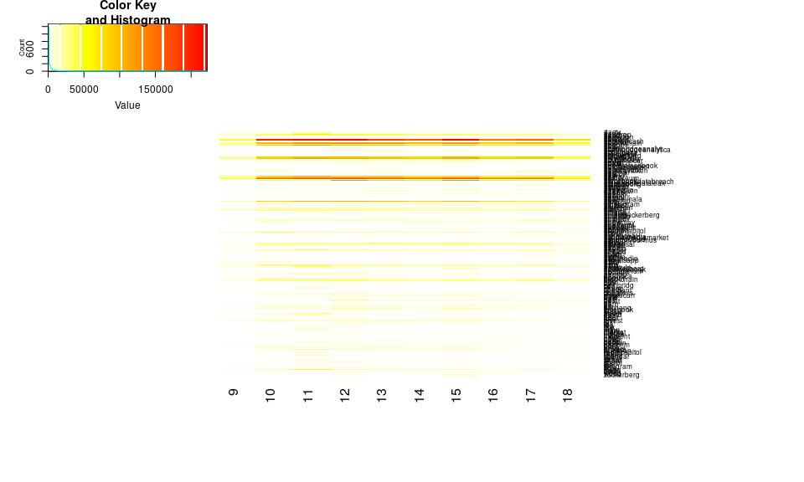

## Scree Plot

Gives amount of information explained by corresponding component. Gives an intuition to decide which components best represent data in order to answer the research question.

P.S. The most contribution component may not always be most useful for a given research question.

PTCA4CATA::PlotScree(ev = resCA.sym$ExPosition.Data$eigs,  
 #p.ev = we_data_inf$Inference.Data$components$p.vals,  
 title = 'SCREE Plot',  
 plotKaiser = TRUE  
)

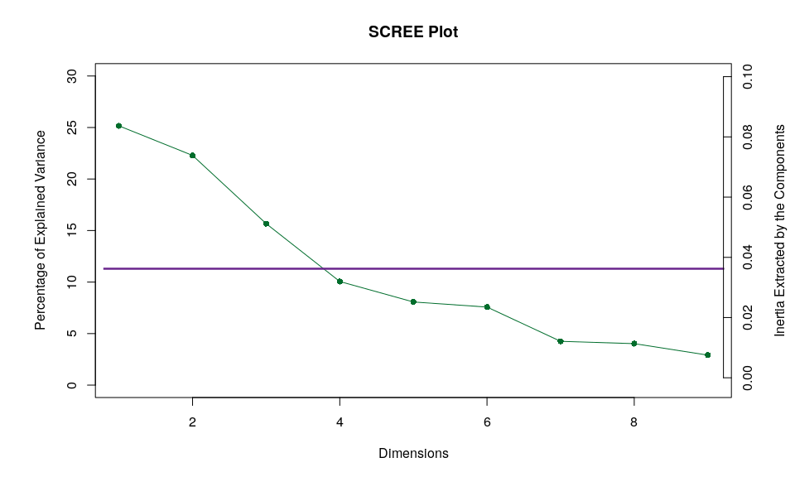

## Factor Scores

### Asymmetric Plot

#### Asymmetric Plot  
  
map.IJ.asym <- asymMap$baseMap + asymMap$J_labels +   
 asymMap$J_points + labels4CA #+ legend$zeMap_dots + legend$zeMap_text  
print(map.IJ.asym)

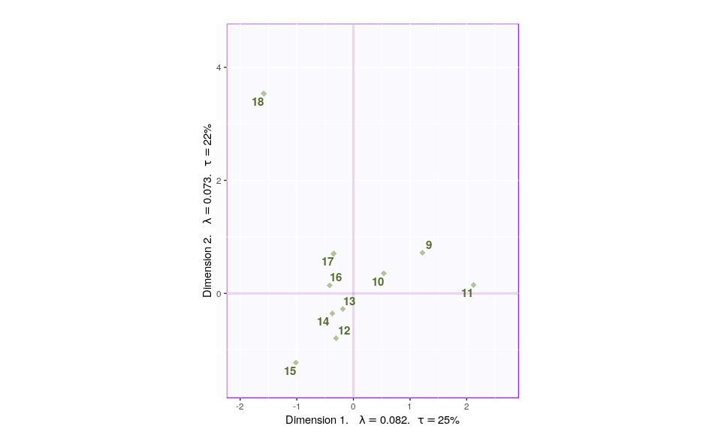

#### Asymmetric Plot  
  
map.IJ.asym <- asymMap$baseMap + asymMap$I_labels +   
 asymMap$I_points + labels4CA #+ legend$zeMap_dots + legend$zeMap_text  
print(map.IJ.asym)

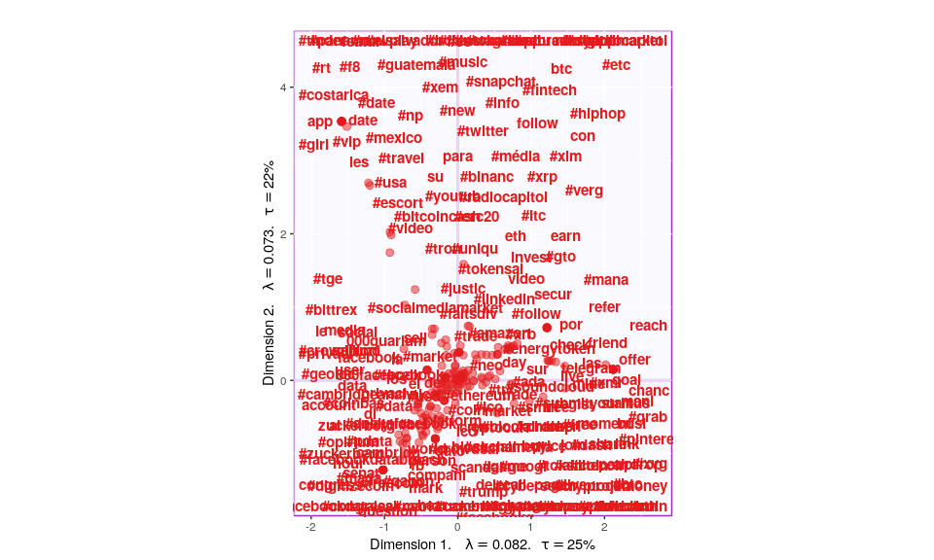

#### Asymmetric Plot  
  
map.IJ.asym <- asymMap$baseMap + asymMap$I_labels +   
 asymMap$I_points + asymMap$J_labels +   
 asymMap$J_points + labels4CA #+ legend$zeMap_dots + legend$zeMap_text  
print(map.IJ.asym)

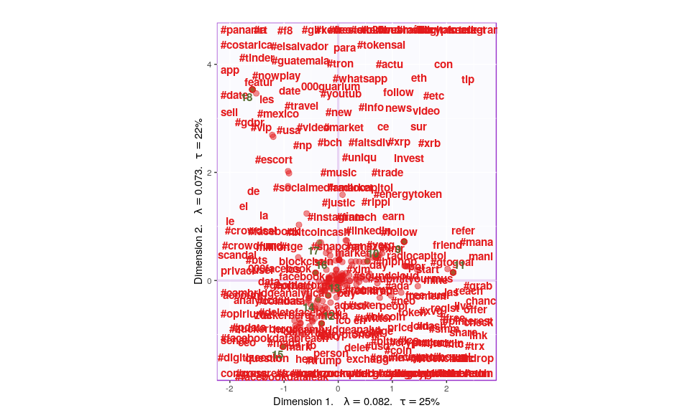

tweets_eth_supp <- supplementaryRows(tweets_eth,resCA.asym)  
asymMap_supp <- createFactorMapIJ(tweets_eth_supp$fii,Fj,  
 #col.points.i = color4Authors,  
 #col.labels.i = color4Authors  
 )  
  
map.IJ.asym <- asymMap$baseMap + #asymMap$I_labels +   
 #asymMap$I_points +   
 asymMap$J_labels +   
 asymMap$J_points + labels4CA + #+ legend$zeMap_dots + legend$zeMap_text  
 asymMap_supp$I_points + asymMap_supp$I_labels  
  
print(map.IJ.asym)

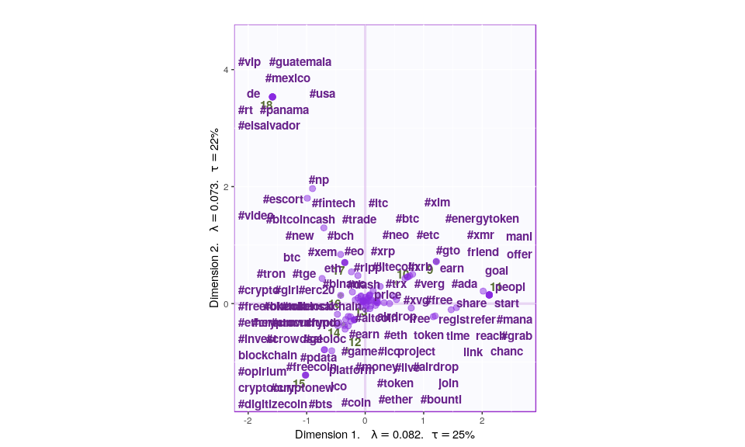

tweets_facebook_supp <- supplementaryRows(tweets_facebook,resCA.asym)  
asymMap_supp <- createFactorMapIJ(tweets_facebook_supp$fii,Fj,  
 #col.points.i = color4Authors,  
 #col.labels.i = color4Authors  
 )  
  
map.IJ.asym <- asymMap$baseMap + #asymMap$I_labels +   
 #asymMap$I_points +   
 asymMap$J_labels +   
 asymMap$J_points + labels4CA + #+ legend$zeMap_dots + legend$zeMap_text  
 asymMap_supp$I_points + asymMap_supp$I_labels  
  
print(map.IJ.asym)

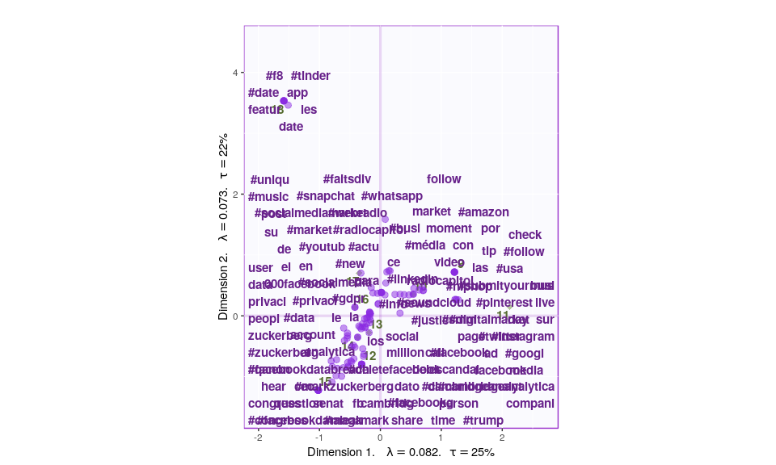

tweets_bitcoin_supp <- supplementaryRows(tweets_bitcoin,resCA.asym)  
asymMap_supp <- createFactorMapIJ(tweets_bitcoin_supp$fii,Fj,  
 #col.points.i = color4Authors,  
 #col.labels.i = color4Authors  
 )  
  
map.IJ.asym <- asymMap$baseMap + #asymMap$I_labels +   
 #asymMap$I_points +   
 asymMap$J_labels +   
 asymMap$J_points + labels4CA + #+ legend$zeMap_dots + legend$zeMap_text  
 asymMap_supp$I_points + asymMap_supp$I_labels  
  
print(map.IJ.asym)

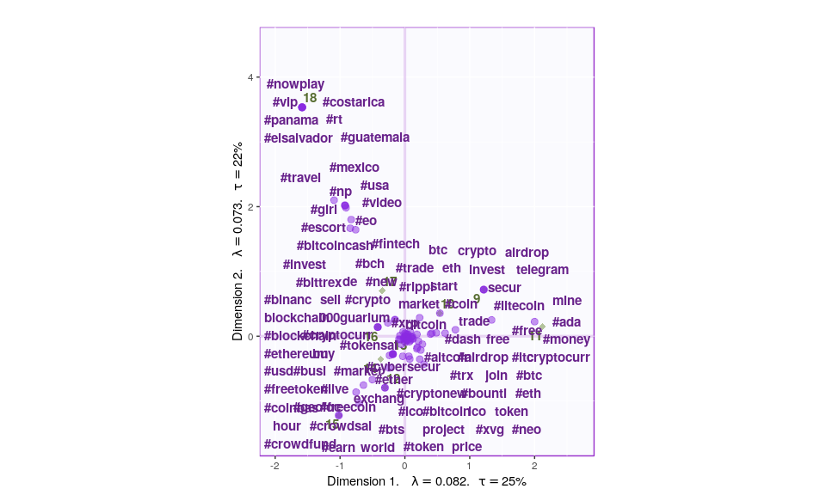

### Symmetric Plot

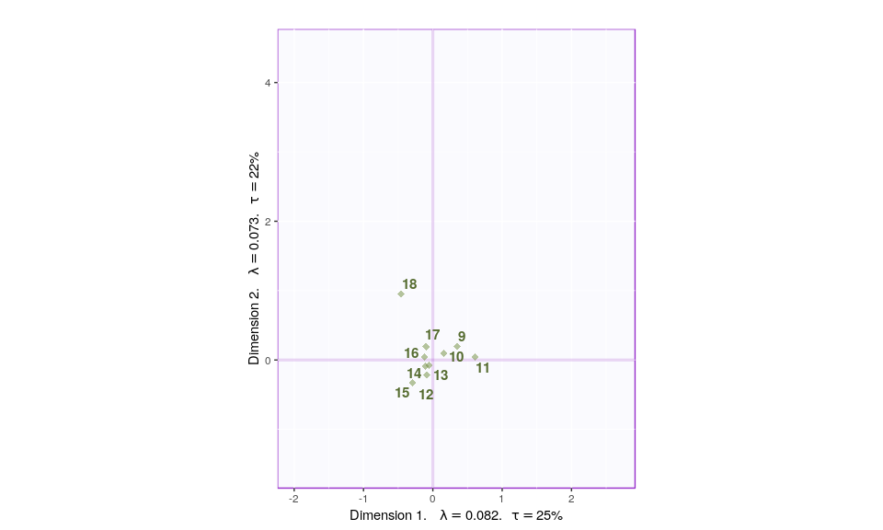

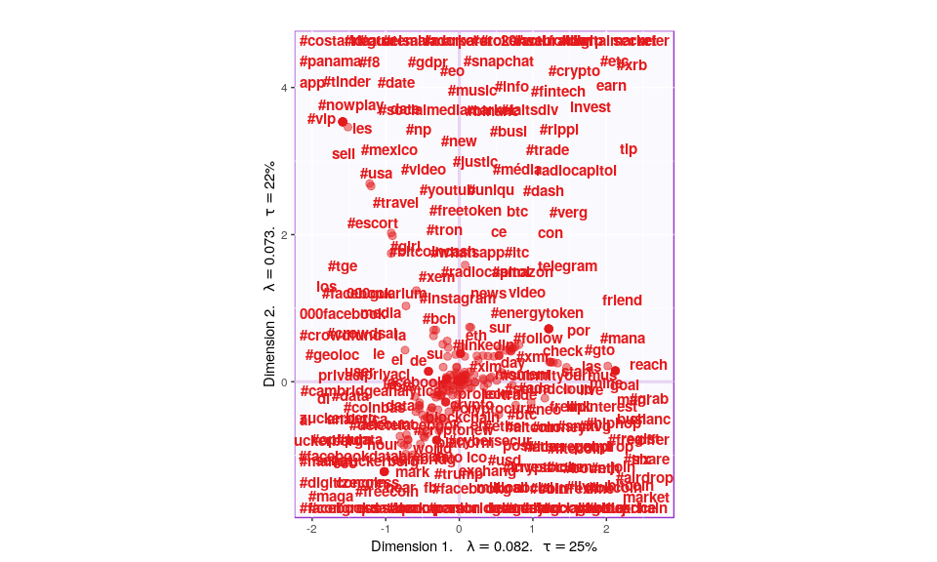

## Most Contributing Variables

PTCA4CATA::PrettyBarPlot2(ctr.I[,1],   
 threshold = 1 / NROW(ctr.I),   
 font.size = 4,   
 color4bar = gplots::col2hex(color4I),   
 color4ns = 'grey',   
 main = 'Observations: Contributions (Signed)',   
 ylab = 'Contributions', ylim = c(1.2*min(ctr.I),  
 1.2*max(ctr.I) ),   
 horizontal = FALSE )

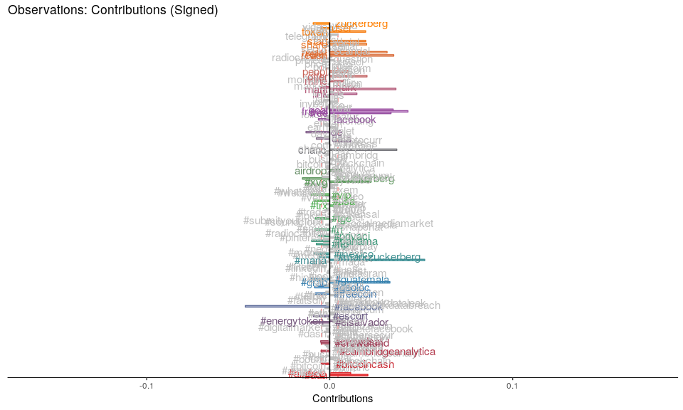

PTCA4CATA::PrettyBarPlot2(ctr.J[,1],   
 threshold = 1 / NROW(ctr.J),   
 font.size = 4,   
 color4bar = gplots::col2hex(color4J),   
 color4ns = 'grey',   
 main = 'Observations: Contributions (Signed)',   
 ylab = 'Contributions', ylim = c(1.2*min(ctr.J),  
 1.2*max(ctr.J) ),   
 horizontal = FALSE )

