<https://hub.docker.com/repository/docker/rajkumarcloud001/prod/>

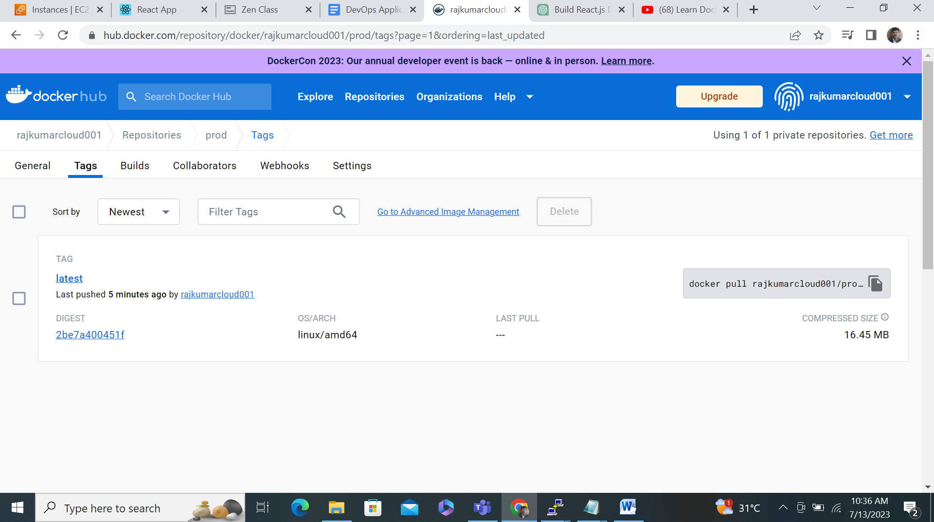

<https://hub.docker.com/repository/docker/rajkumarcloud001/prod/>

