1. Generating the PTX File as follows:

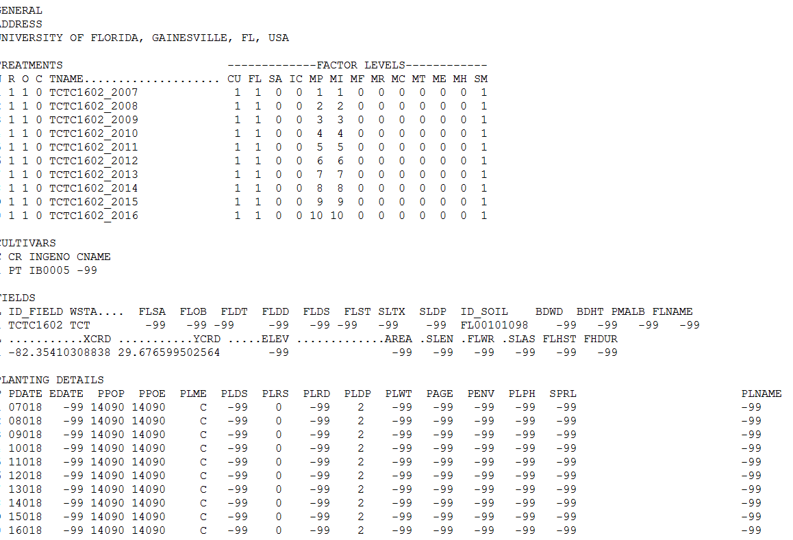

1. Modified the Layout further in the Irrigation and Fertilizer window.

Note: Earlier Piyush was just hiding the irrigation table But I am not hiding the table but I am disabling the table. If we hide the table it is not good for the layout. So we just keep the layout as it is and just disable.

1. Saving all the files as we discussed in the Data folder.

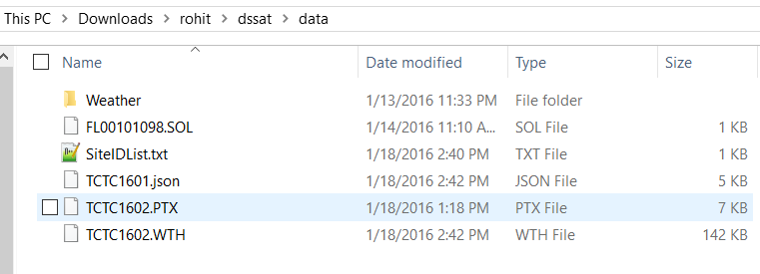

1. Prepared a Development File for the Future Developers. Which demonstrates what the use of which method is. This file is in progress. As and when I am working on my code I will keep on modifying this file.

