1HW_Mattern - Visualization class I

Rebecca Mattern

September 21, 2017

#### 3.1.1 Prerequisites:

library( ggplot2 )  
# library( tidyverse )

#### 3.2.4 Examine dataset mpg: (excluding #4)

1. I see a table of data
2. There are 234 rows and 11 columns.
3. The drv variable describes the type of wheel drive (front, rear, or four).

mpg

## # A tibble: 234 x 11  
## manufacturer model displ year cyl trans drv cty hwy  
## <chr> <chr> <dbl> <int> <int> <chr> <chr> <int> <int>  
## 1 audi a4 1.8 1999 4 auto(l5) f 18 29  
## 2 audi a4 1.8 1999 4 manual(m5) f 21 29  
## 3 audi a4 2.0 2008 4 manual(m6) f 20 31  
## 4 audi a4 2.0 2008 4 auto(av) f 21 30  
## 5 audi a4 2.8 1999 6 auto(l5) f 16 26  
## 6 audi a4 2.8 1999 6 manual(m5) f 18 26  
## 7 audi a4 3.1 2008 6 auto(av) f 18 27  
## 8 audi a4 quattro 1.8 1999 4 manual(m5) 4 18 26  
## 9 audi a4 quattro 1.8 1999 4 auto(l5) 4 16 25  
## 10 audi a4 quattro 2.0 2008 4 manual(m6) 4 20 28  
## # ... with 224 more rows, and 2 more variables: fl <chr>, class <chr>

1. (excluded)
2. It is not useful because they are both categorical variables and thus cannot show any correlation.

# nPlot1_Height  
 ggplot( data = mpg ) +  
 geom_point( mapping = aes( x = class, y = drv ) )

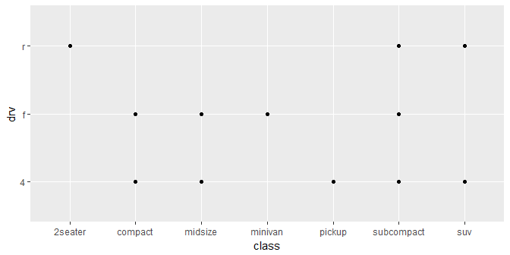

#### 3.3.1 Plot relationship between engine size and highway mileage: (excluding #3)

1. The parenthesis needs to go before color="blue", not afterwards.
2. The categorical variables are: model, trans, drv, fl, and class. The continuous variables are: disp, year, cyl, cty, and hwy. The ?mpg commands shows up in the help tab on the lower right hand corner of RStudio.
3. (excluded)
4. RStudio advises against using size for a discrete variable and only the color variable shows up.
5. It shapes the size of the data points based on numerical value, it uses circles.

ggplot( data = mpg ) +  
 geom_point( mapping = aes( x = displ, y = hwy ) )

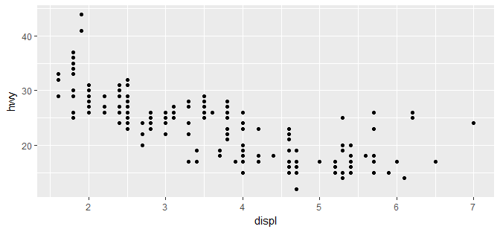

1. It is an incomplete expression.

ggplot( data = mpg ) +  
 geom_point( mapping = aes( x = displ, y = hwy, stroke = cyl ) )

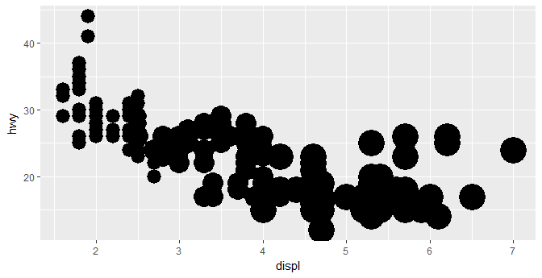

#### 3.5.1 Add Facets: (excluding #4)

1. There are boxes for each of the continous values.

ggplot( data = mpg ) +  
 geom_point( mapping = aes( x = class, y = drv ) ) + facet_grid( . ~ cyl )

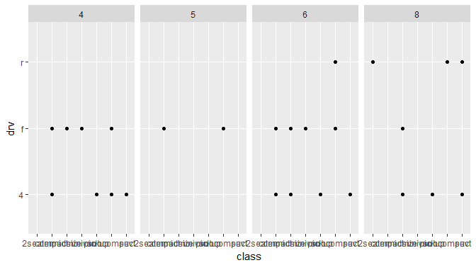

1. The empty cells mean that there are no instances when the rear wheel drive had 4 or 5 cylinders.

ggplot( data = mpg ) +  
 geom_point( mapping = aes( x = drv, y = cyl ) ) + facet_grid( drv ~ cyl )

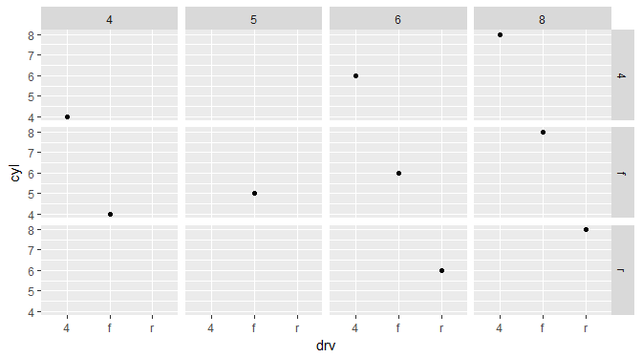

1. The period (.) serves as a filler so that drv is only compared to itself. It is only a one-direction grid.

ggplot( data = mpg ) +  
 geom_point( mapping = aes( x = displ, y = hwy ) ) + facet_grid( drv ~ . )

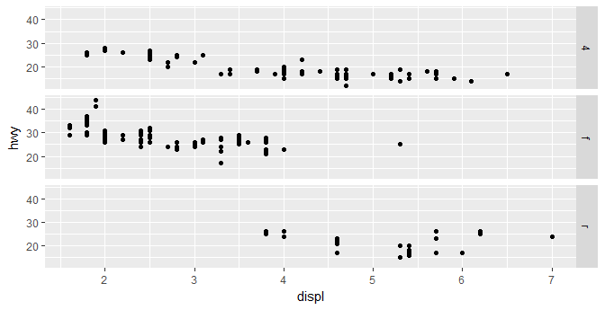

1. (excluded)
2. nRow and nCol stands for the number of rows and columns. The other option controls are scales, shrink, labeller, as.table, switch, drop, dir, and strip.position. Facet_grid doesn't have nrow or ncol option, because its row and column parameters are set by a variable.
3. When using facet_grid you should usually put the variable with more unique levels in the columns to prevent from there being too many boxes. It needs to be specific to only a few, so that they can be compared more easily.

ggplot( data = mpg ) +  
 geom_point( mapping = aes( x = displ, y = hwy ) ) + facet_grid( . ~ cyl )

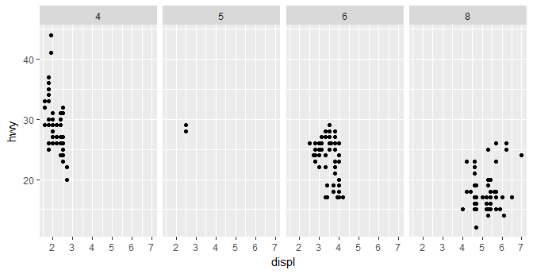

#### 3.6.1 Add more geometric layers / objects: (excluding #6)

1. To draw a line chart you would use geom_abline.
   * Boxplot: geom_boxplot()
   * Histogram: geom_histogram Area
   * Chart: geom_area.
2. The visualization matched my predictions.
3. show.legend=FALSE takes away the key. Taking it away puts the key back.
4. It took away the shading.
5. The graphs looked the same because both adequately established the inputs.
6. (excluded)

ggplot( data = mpg, mapping = aes(x = displ, y = hwy, color = drv)) +  
 geom_point() +  
 geom_smooth(se=FALSE)

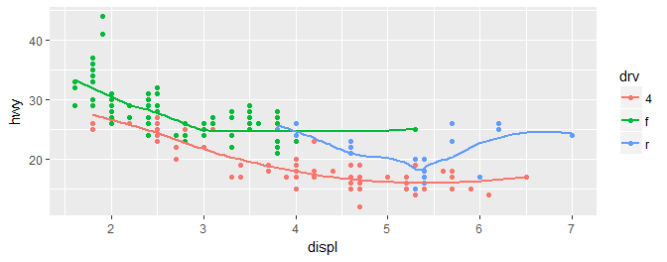

#### 3.7.1 Statistical Transformations (excluding #3)

1. The default geom associated with stat_summary is geom_pointrange. You could rewrite it with that function.
2. Geom_col allows you to add a y aesthetic. Geom_bar only allows for one variable and hence shows the count.

ggplot( data = diamonds ) +  
 geom_col( mapping = aes( x = cut, y = z ) )

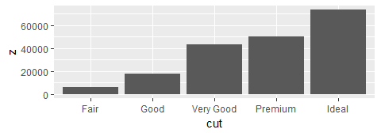

1. (excluded)
2. Stat_smooth uses se, x, y, ymin, and ymax variables.
3. Without group = 1, the variables all look the same, they are evenly distributed.

#### 3.8.1 Position Adjustments

1. The problem is that there are a few outliers. You could improve it by cutting off the domain at cty=30.
2. Height and width.
3. Geom_jitter scatters the points around the grid, where geom_count places one point on every intersection of gridlines.
4. The default position is "dodge".

ggplot( data = mpg ) + geom_boxplot( mapping = aes( x = cyl, y = model ) )

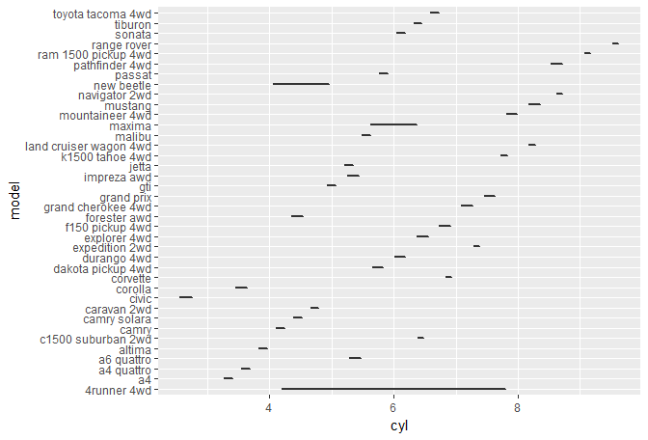

#### 3.9.1 Coordinate Systems

1. labs() adds labels by adding text to the axis, plot title, or caption below the plot.
2. Coord_map shows a 3D image on a 2D space, and coord_quickmap aligns the image straightly.
3. The plot shows that city and highway are positively correlated. Coord_fixed changes the ratio dimensions of the plot. Geom_abline adds the line beside the plotted points.

ggplot( data = mpg) + geom_bar( mapping = aes( x = displ ) ) + coord_polar( )

