# Machine Learning: -

Machine learning is the field of computer science that uses statistical techniques to give computer systems the ability to “learn” with data, without being explicitly programmed.

Types of Machine Learning:

1. Supervised Learning

2. Unsupervised Learning

3. Semi supervised

4.Reinforcement

-> **Supervised Learning: -**

1.Regression: - if the label is a number and any type of result.

2.Classification: - if the label is yes/No like email is spam or not it's called classification.

**->Unsupervised Learning: -**

1.Clustering

2. Dimensionality Reduction

3. Anomaly detection

4. Association Rule learning

**Batch ML vs Online ML:** -

Batch ML: - this is also called offline ML.

**Disadvantage of Batch ML: -** 1. Lots of Data

2.Hardware Limitation

3. Availability

Data

Test

ML

**Online Machine Learning: -**

First, we collect some data and then we build a machine learning algorithm and once it is trained then we test it and after upload on the server.

In this type of learning our model is predicting the given data and as well as learning from this data.

Example:1. Chat bots

**Batch vs Online Learning: -**

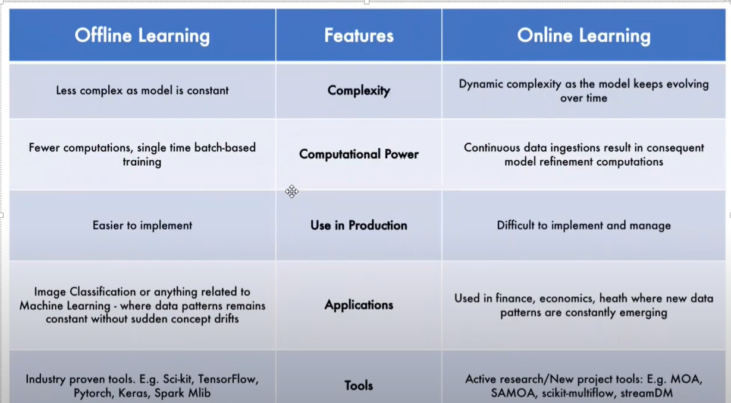

**# Instance Base vs Model Base Machine learning: -**

**Instance Base: -** Not more work by algorithm when the algorithm apply on the datasets algorithm finds neighboring data of data on algorithm applied and predict the result.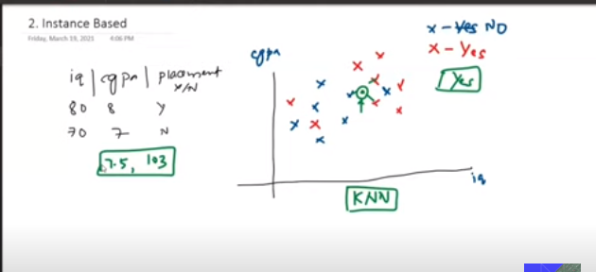

**Model Base: -** In model base learning when we feed data points to algorithm it understands the behavior of data by the help of mathematical function.

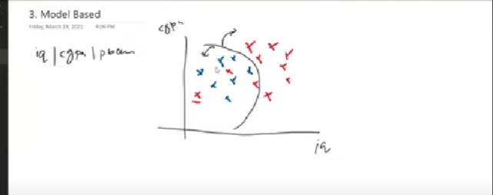

After predicating the mathematical relation, it does not require data points to predict the result.

**# Machine Learning Development life cycle: -**

**1.Frame the Problem: -** frame every problem throughout the journey of development.

**2.Gathering Data: -** collect the required data from different places.

**3.Data Preprocessing: -** format the data in which machine learning algorithm work on properly.

e.g. - remove duplicates

Remove missing value

**4.Ecploratory Data Analysis: -** visualize the data and analyze the data for development find the relationship b/w the data.

**5.Feature Engineering and Selection: -** creating new feature which helps the analyze the data.

**6.Model Training Evaluation and Selection: -**

**7.Model Development: -**

**8.Testing: -**

9.Optimize: -

**# Tensors: -**

1D – Tensor: -

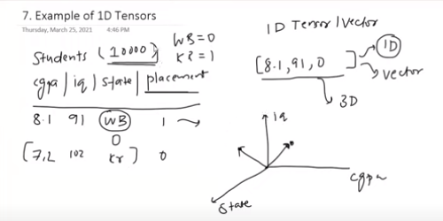

2-D Tensor: -

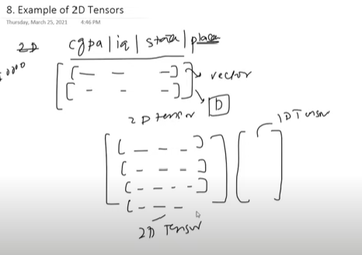

3-D Tensor: -

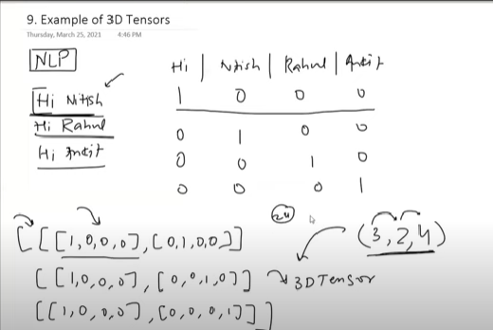

4-D Tensor: -

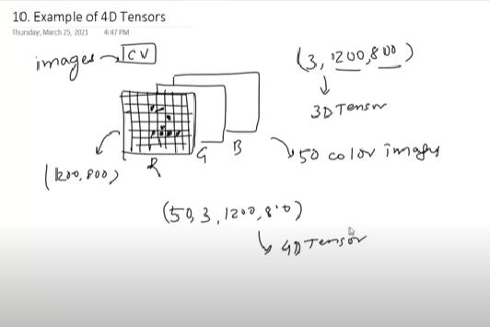

5-D Tensor: -

