Introduction

Steps

* Download Apache-Tomcat Server from the give link
* Extract the archived downloaded file and paste the extracted folder into “C” drive.(Fig:1)
* Ensure that “JAVA_HOME” and “JRE_HOME” is set properly. (Fig:2)
* Configure tomcat server port number
  + Go to C:\apache-tomcat<version>\conf
  + Edit “server.xml”, find “Connector port=8080” and set port number.
* Start Tomcat server
  + Go to C:\apache-tomcat<version>\bin
  + Start command prompt by pressing ALT+D and write “CMD” then press enter.
  + Write “startup” and press enter from command prompt.
* Run tomcat server
  + Open any browser
  + Search for “localhost:8080”, here 8080 is port number for tomcat server.

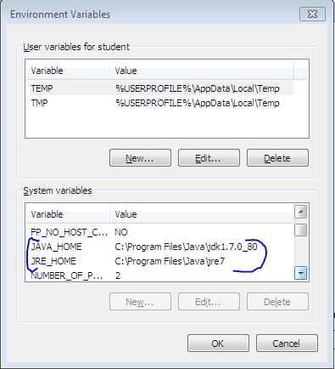

Fig:2

