#include<stdio.h>
#include<stdlib.h>
#define MAX (50)

void linearSearch(int array[], int size, int item);
void binarySearch(int array[], int size, int item);

void main()
{
int number,item,i,array[MAX];
printf("\nEnter the number of elements: ");
scanf("%d",&number);
printf("\nEnter %d numbers....\n",number);
for(i = 1 ; i<=number; i++)
{
scanf("%d",&array[i]);

}
printf("\nEnter the number to be search: ");
scanf("%d",&item);
linearSearch(array,number,item);
binarySearch(array, number,item);

}

void linearSearch(int array[], int size, int item)
{
int i=1;
printf("============Linear Search===============");

//size = sizeof(array);

while(array[i] != item)
{i++;}
if(i == size+1)
{
printf("\nNot Found...");
}

else
{
printf("\nFound.....");
printf("\nComparisons: %d \n",i);
}

}

void binarySearch(int array[], int size, int item)
{
int i=0,beg,end,mid;
printf("\n============Binary Search===============");
beg = 0;
end = size;

do
{
i++;
mid = (int)((beg+end)/2);
if(item == array[mid] || item == array[beg] || item == array[end])
{
printf("\nFound");
printf("\nComparisons: %d\n",i);
break;
}
else
{
if(item < array[mid])
{
end = mid-1;
}
else if(item > array[mid])
{
beg = mid+1;
}
}

}while(beg != end && beg<end);

if(item != array[mid] && item != array[beg] && item != array[end])
{
printf("\nNot Found\n");
}

}

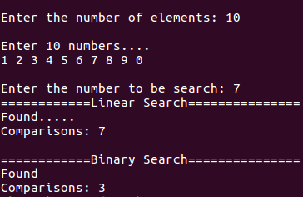
Output:

