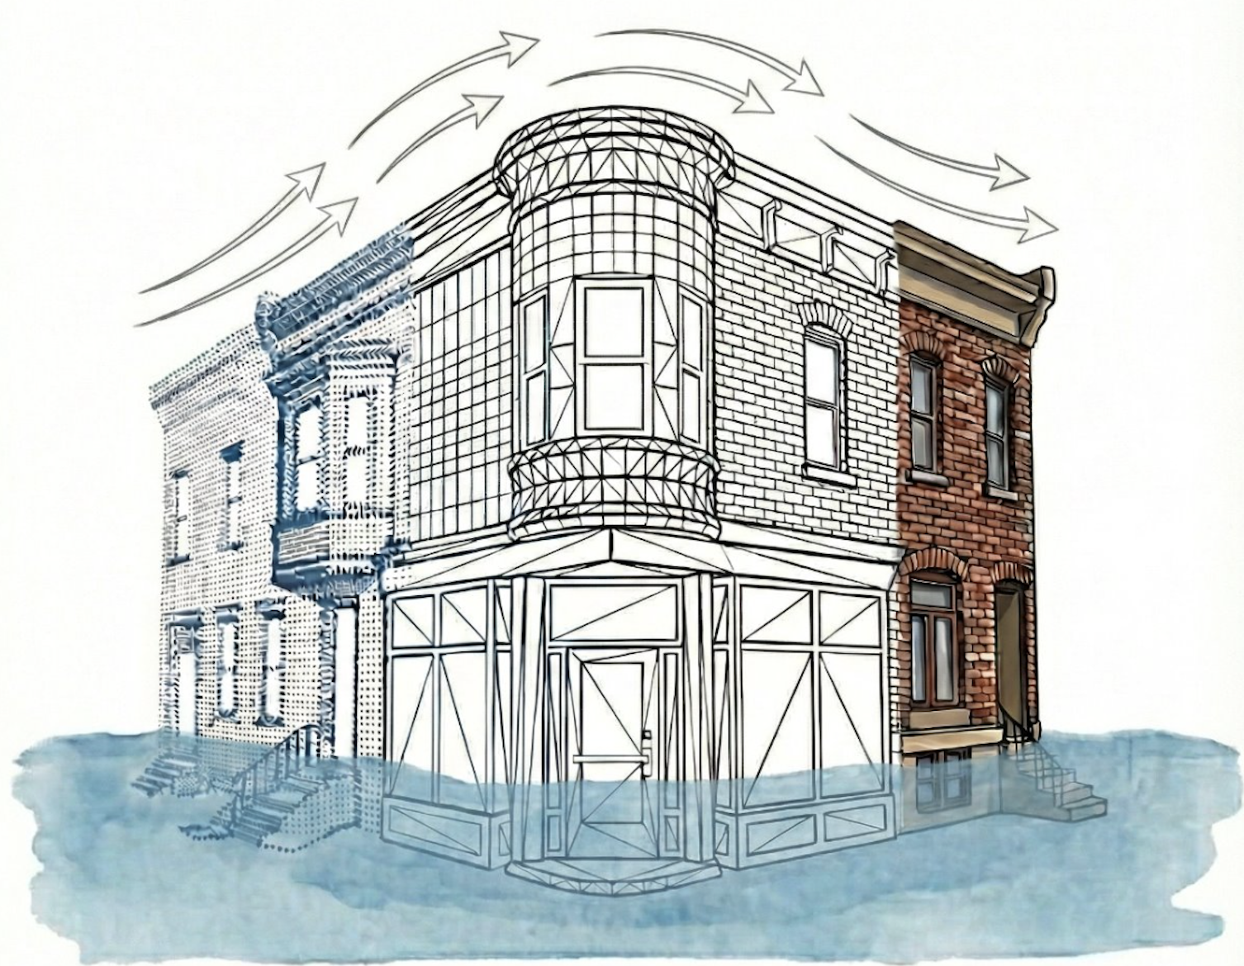 | Dr. Rebecca Napolitano  Heritage 3D Lab: Damage. Data. Design  ECoRE BuildingN486 | nap@psu.edu  https://rkn2.github.io/heritage3d-lab/ | The Pennsylvania State University  College of Engineering  Department of Architectural Engineering  https://www.ae.psu.edu/ | 

[INSERT DOCUMENT HERE]


Dr. Rebecca Napolitano (nap@psu.edu) | Assistant Professor | Director of the Heritage 3D lab
Department of Architectural Engineering | The Pennsylvania State University

