RKADE Keypad Interface
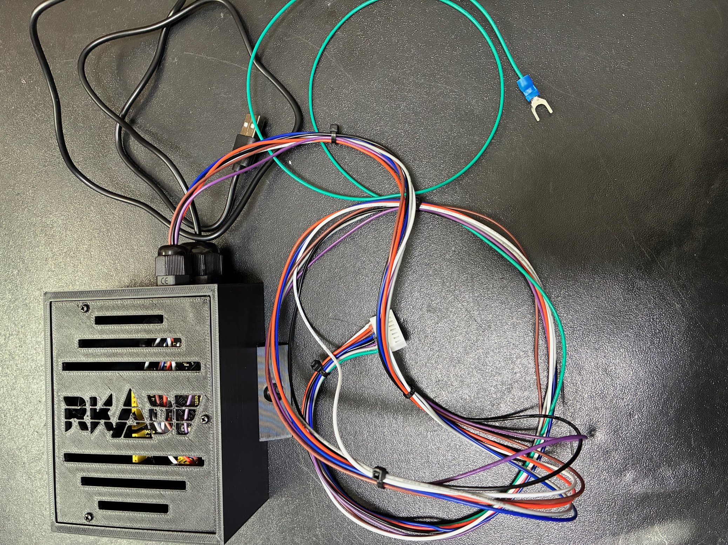
USB To PC

Chassis Ground

8-Pin to Keypad

The RKADE keypad interface allows a Happ-style, arcade original keypad to show in Windows as a keyboard. This allows use of the keypad in emulators/teknoparrot/windows games/etc.
The 7 and 8 pin keypads shown below have been tested.
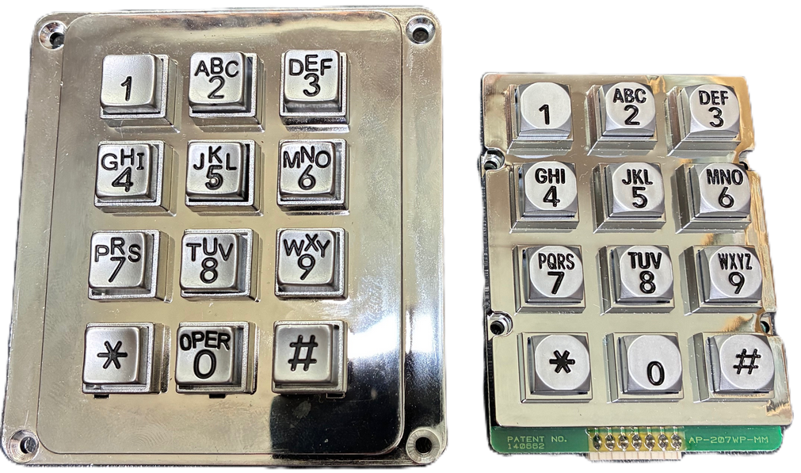

Some keypads (as in the larger above) will have 8 pins, the 8th being a pin for chassis ground. In that case, the connection would look as shown below. The ground terminal can be attached to a metal chassis or the grounding block of the game cabinet. The ground is not necessary for the keypad to function, it is there for redirecting static shock.
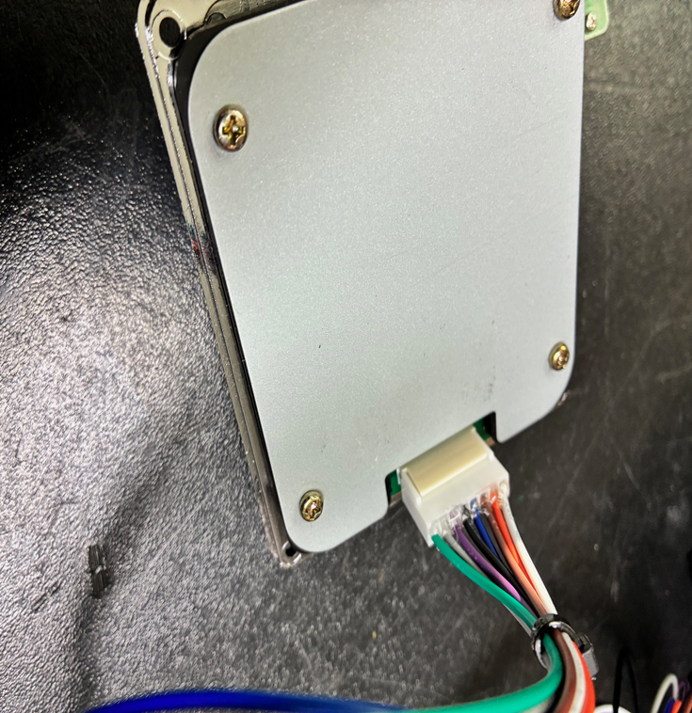

In the case of the 7 pin version, no chassis ground is provided, so the green/ground wire is not used, as shown below. Note that the un-connected pin is the green/ground.
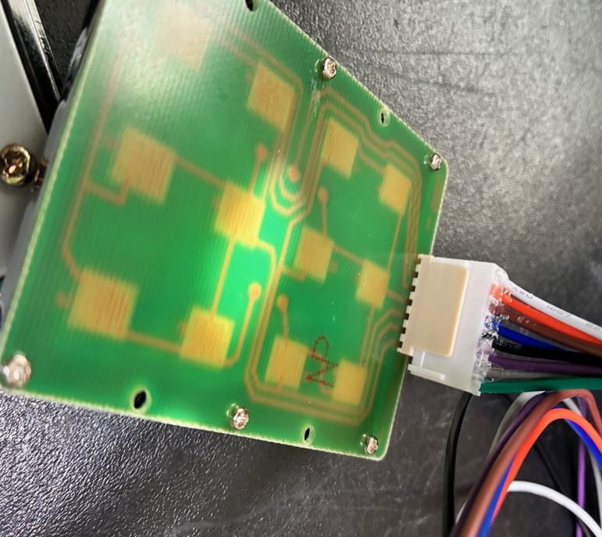

Usage
To test the device after connected, open Notepad (or some text editor), and check that the buttons return the expected numbers or characters. Note that, when you press a keypad key, the RKADE device will automatically switch the system NumLock to On (otherwise numbers will not be entered). You can also press and hold the ‘6’ (for 1 second or more) to manually toggle NumLock as well.
Different games have various expectations for the key codes it accepts. Some games consider # or Enter (to finalize input) by sending the ‘.’ character and others the actual Enter keycode. To accommodate this, pressing the # key sends the ‘.’ character, and holding the # key for 1 second or more sends the Enter character.
Similarly, games have different expectations for the keycodes used for backspace/delete of the last number. Some expect ‘*’ and others ‘/’. For this case, pressing ‘*’ sends ‘*’, and holding ‘*’ for more than 1 seconds sends ‘/’.
Moreover, some games (eg, FNF Drift) do not work with numpad/keypad numbers, but expect only the keycodes from the numbers at the top of the keyboard. To accommodate this, the keypad can be put into a non-numpad mode so that those number keys are sent instead of the numpad number codes. This is accomplished by holding down the 0 key for 1 second or more to toggle the mode. In mode 2, the non-numpad numbers are sent for 0-9, Enter is sent for # key, and ‘n’ is sent for * (to accommodate FNF drift and similar games). Alternatively, to set a specific mode, hold the 1 key for numpad mode/mode 1 or hold down the 2 key for non-numpad mode/mode 2.
So in short, if the games is not recognizing the keypad numbers, hold down the 0 key for 1 second or more to change number mode, then try number keys again. If it is not finalizing the input and going to the next screen, hold down the # key or the * key. If holding down # does not work for backspace, hold down *.
In the case SuperBikes 2 on TeknoParrot, to enter the keypad entry screen it requires you to hold the key setup in the Controller Setup for ‘Enter PIN’. You can set this up as one of the controller buttons, or use the ‘3’ key on the keypad. That key allows sending a held-down ‘3’, if you hold down the ‘3’ for more than one second.
Finally, be aware that emulators may also have mechanisms to map keypad keystrokes as well, which will help simplify and standardize the input. MAME does for games that support keypads, and some games on TeknoParrot have keypad mapping in the Game Configuration screen (original FNF, Dead Heat, etc).

Serial Port Commands
The RKADE Keypad interface allows control via the Serial (COMM) port. To find the COMM port, check for the Arduino in device manager while only the keypad interface is plugged into USB.
You can query or change the keypad mode by sending, for example ‘mode 1’ to change to numpad mode, or send ‘mode 2’ to change to non-keypad mode (equivalent to holding down 1 or 2).
A Windows batch file as shown below could be used to automate the mode change before starting the game (COM7 meaning port 7 in this example, your port may be different):
mode BAUD=9600 PARITY=n DATA=8
echo mode 1 > COM7:
AutoHotKey or MameHooker could also be used to automate this mode change per game.

The latest version of this document is available on the https://rkade.shop product page.

