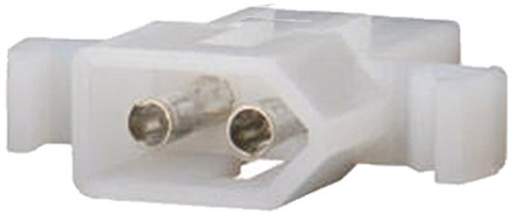
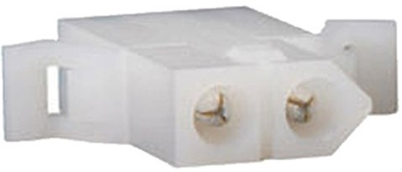
RKADE Installation Instructions
Figure 2: Included Steering Power Connector
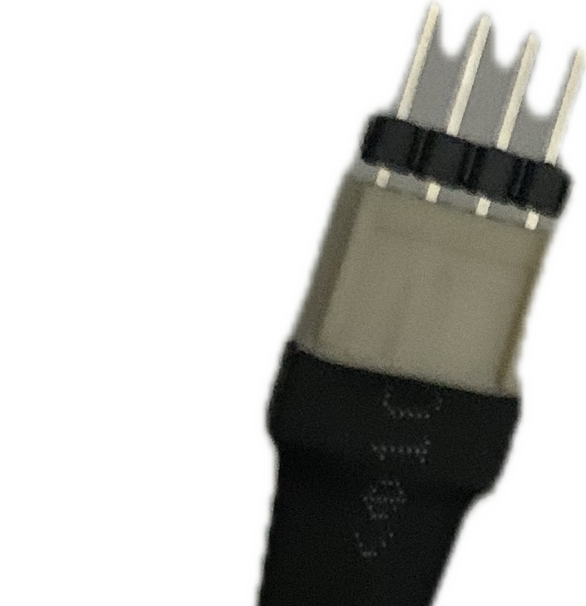Figure 3: Supplied Steering Sensor Connector

Caution: Before beginning installation, ensure that the PC, the RKADE, and attached devices are powered OFF and unplugged. Attachments SHOULD NOT be made while devices are powered on.

Steering Power and Sensor
- Ensure Steering motor is rated for at least 24v DC (most are labeled 37v or 96v, which are the maximum values, but generally run at 24v)
- Attach the Steering Power connectors shown in Figures 1 and 2

- Attach the steering connectors as shown below. Note that the supplied connector has a gender change insert, which can be removed if not needed. Both middle pins of the supplied wire are connected to the yellow wire for Pin 2 of the steering potentiometer, in the case that you need to reverse the connection (when powered off) if the steering tracking shows in reverse later. If the connector from the steering potentiometer has a stopper that does not allow 2 middle pins, you can remove the unneeded gender change pin from the supplied cable by pulling strait out with a pliers. Generally, the Red wire goes to Pin 1 on the pot, Yellow to Pin 2, and Black to Pin 3. Some systems have the Black and Red reversed.
Figure 1: Power connector from Steering Motor
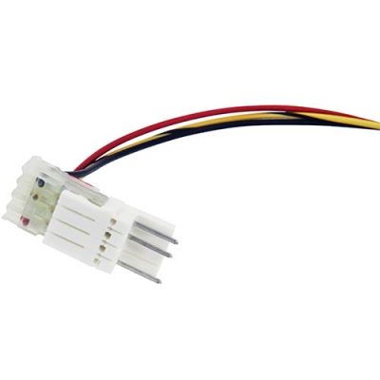Figure 4: Typical connector coming from steering pot

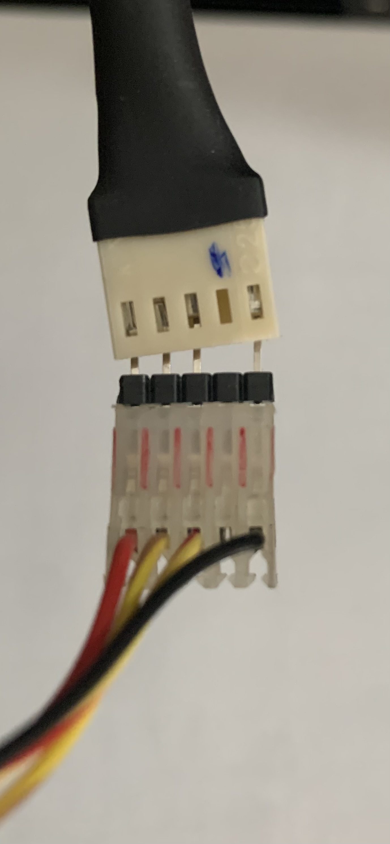
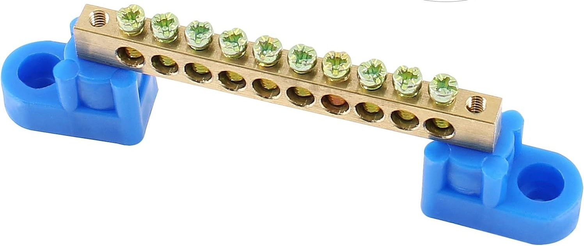

Pedals Connector
Most systems use 5 pin pedal connectors as shown below, where the second pin from the bottom is unused. If this is the case for your system, attach as shown below (fully inserted).

If your connector is not like that, just ensure that the Red (Pin 1) and Black (Pin 3) are mated with the matching-labeled supplied wires, and Pin 2 from the pots are attached to those labeled Pin 2 (ACC or BRK, ie. gas or break). If these end up tracking backwards, you will need to reverse the Red and Black (while systems are powered off).

Button/Switch Connectors
The button/switch connectors are hooked up to be ground-triggered, meaning that one side of the switch is connected to ground, and the other to a Button wire labeled 1-14. There is a wire labeled BTN GND that should be attached to a terminal block (shown below).

Each button microswitch has 2 or 3 male connectors, a COM (common), NO (normally open), and NC (normally closed). The COM terminal should be connected to the ground block, and the NO to the wire labeled for the Button (1-14). If you have a 3 connector microswitch and it is not labeled, the COM is normally on the bottom by itself, and the NO is in the middle.

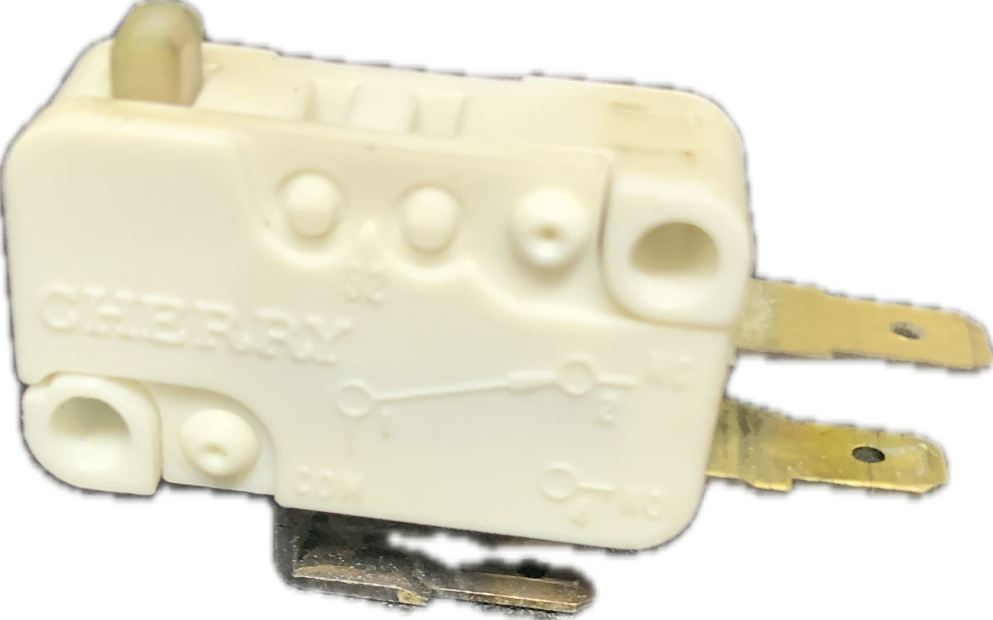

If using a 4 speed shifter with microswitches or leaf switches, wires for 1-4 are labeled Button 1/Shift 1, etc for convenience. You can use any Button or Button/Shift wire and map it how you prefer, there is no functional difference.
However, to support the Happ 4 microswitch/6 speed shifter, you should use the wires labeled Button/Shift 1-4 and enable the demux option later in the Configuration Utility.

USB Connection
The USB connection should be connected to the Windows 10/11 PC that will be running the games.

Power Supply Connections
The wall plug should be connected to an outlet capable of providing up to 5 amps for the steering motor.
The included power supply should be shipped already connected. If needed, the wall plug black wire goes to the L(ine) terminal, the wall plug white wire to N(eutral), and wall plug green to the ground terminal. The Red PWR SUPPLY 24v+ to the V+ terminal, and the PWR SUPPLY GND to the V- terminal (shown below).
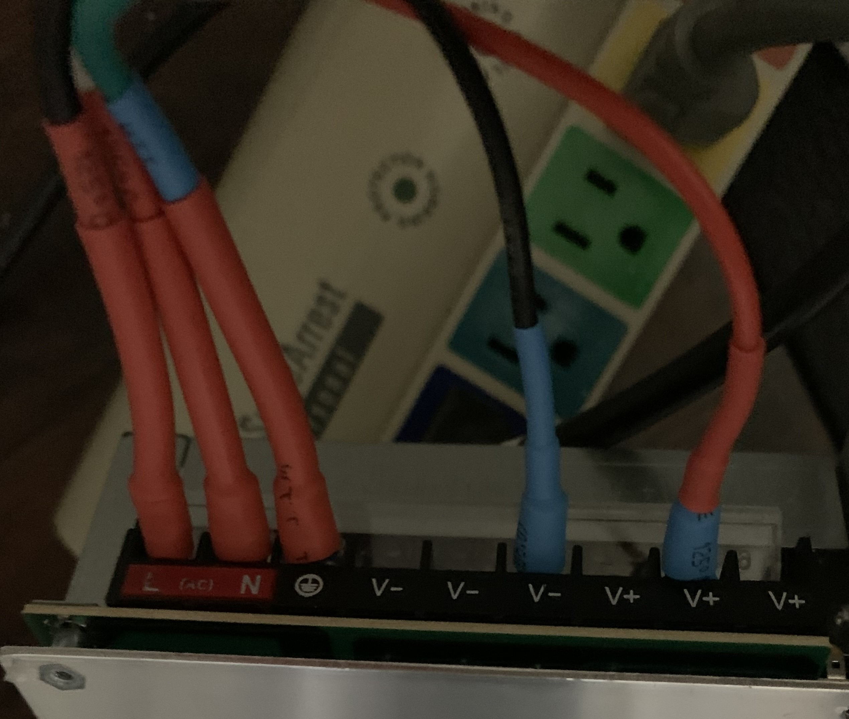

Initial Configuration
- After double checking all connections, power on the PC and plug in the Power Supply.
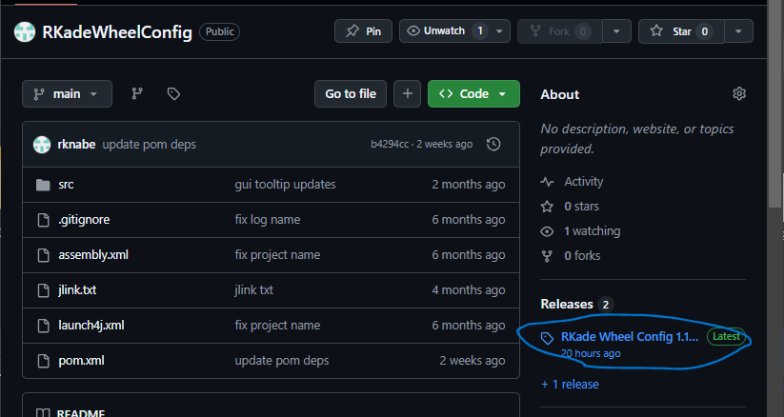
- Go to https://github.com/rknabe/RKadeWheelConfig and download the Release of the Wheel Config utility:
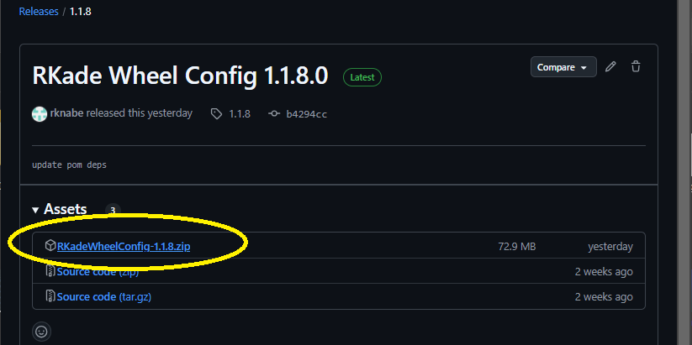
- On the Release page, download the latest zip file:

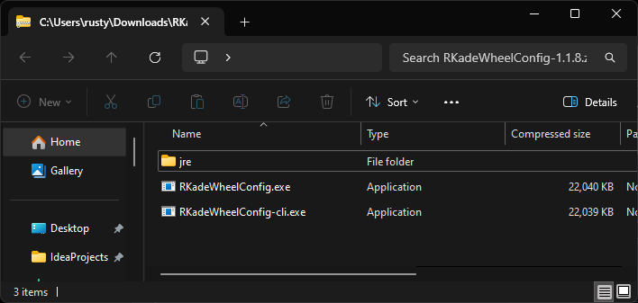
- Un-zip the zip file to a folder, and place in desired location on hard drive, the folder contents consist of 2 EXE files, and a JRE folder:

- Create a shortcut for the RkadeWheelConfig.exe and place shortcut on desktop.
- Launch the shortcut, and the RKADE Wheel Config app should show similar to below:
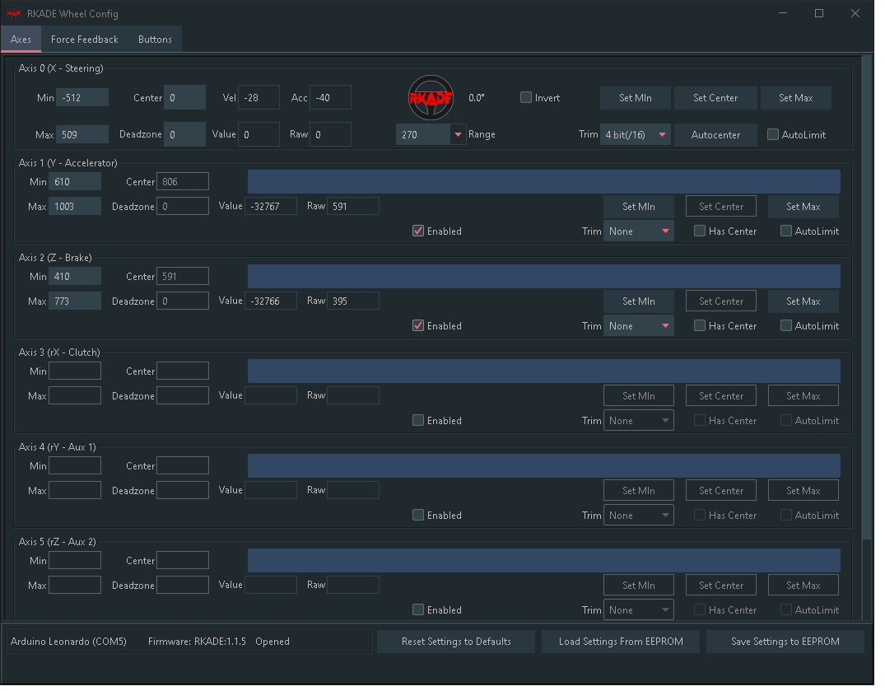

- Note on the bottom left that the comm port, version version, and ‘Opened’ should be showing, and the wheel and pedals should show movement on the displays.

Calibrating Wheels and Pedals

Set the min and max values for the Wheel
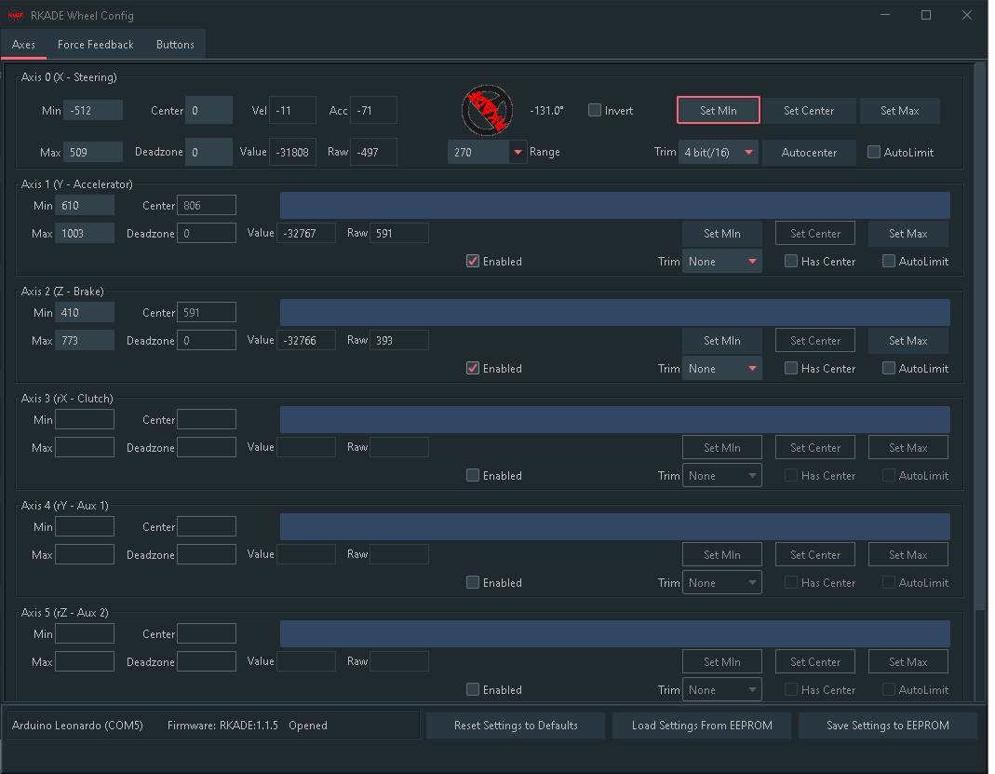
- Turn the wheel fully counter-clockwise, and then click the Set Min button:
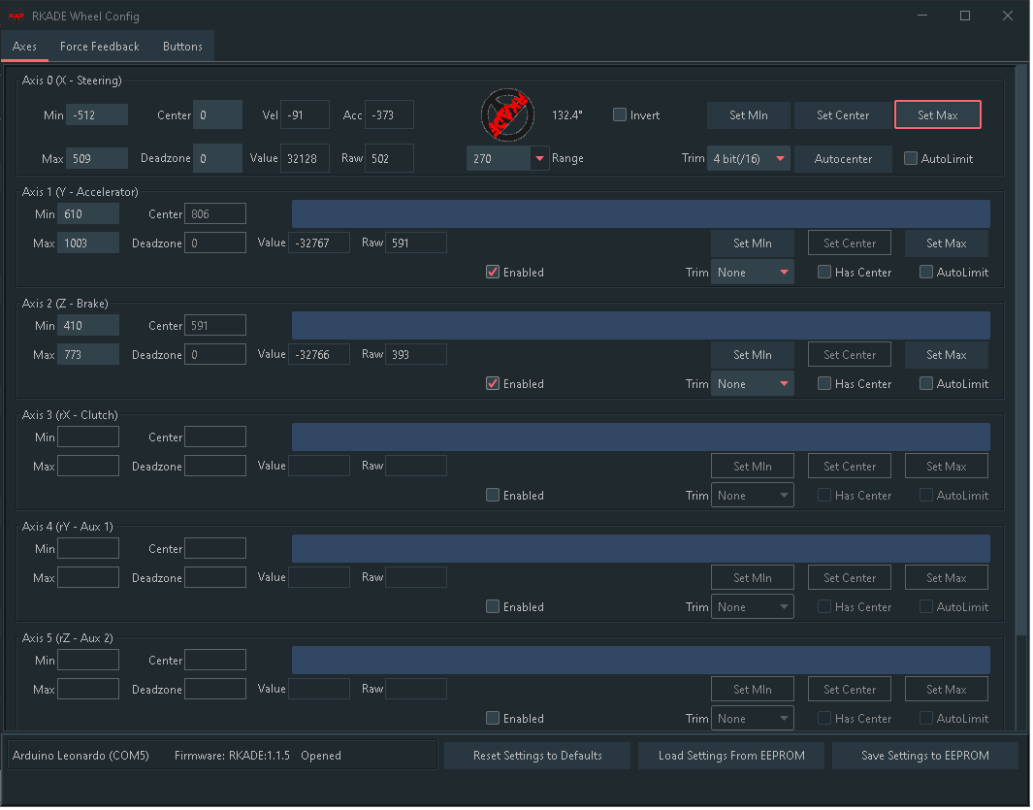
- Turn the wheel fully clockwise, and then click the Set Max button:

Set the Min and Max values for the Accelerator and Brake
- With no pressure on the Accelerator pedal, note the current Raw value beneath the Accelerator range bar. Set the Accelerator Min value to 10-15 above the current Raw value. This will keep the Accelerator from triggering a value due to temperature change, or even slight pressure on the pedal. This gives the resting position a little dead-zone before triggering.
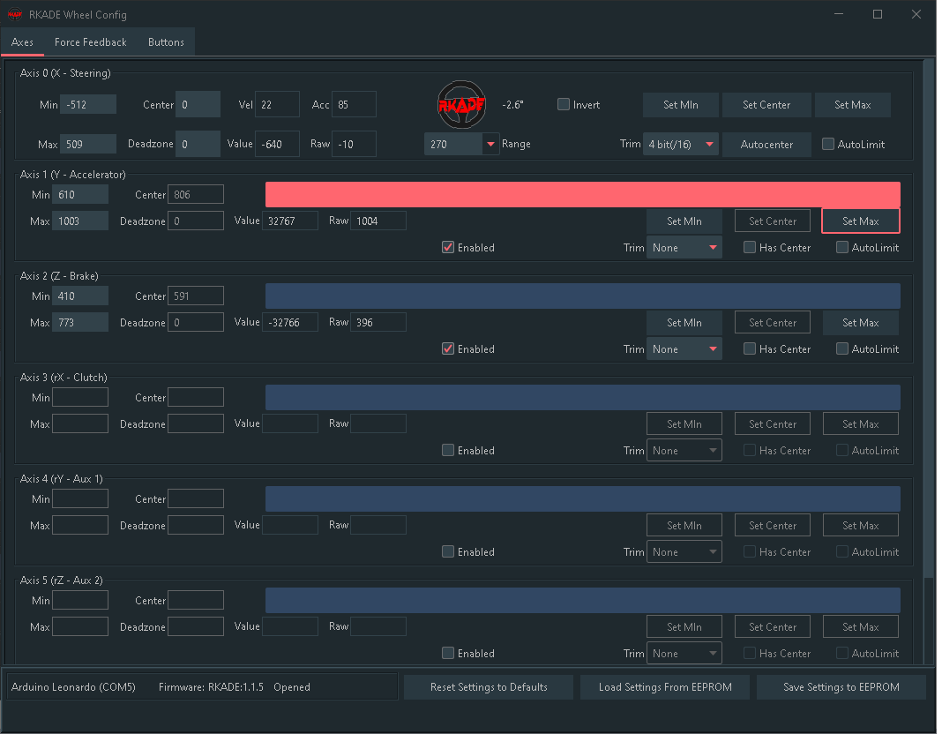
- Press the Accelerator pedal fully, and click the Set Max button for the Accelerator:
- Do the same for the Brake Min and Max.
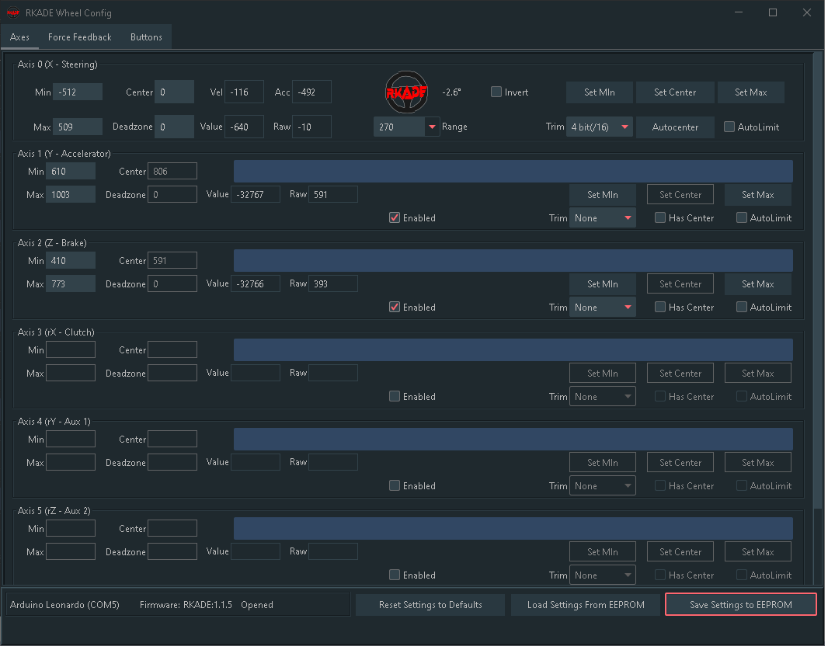
- Once you have the settings how you like, click the Save Settings to EEPROM at the bottom right:
Note: You must Save the Settings to EEPROM to permanently set any values on this utility. If you do not Save, the values will reset to the former values after power-off.

Configure Force-Feedback
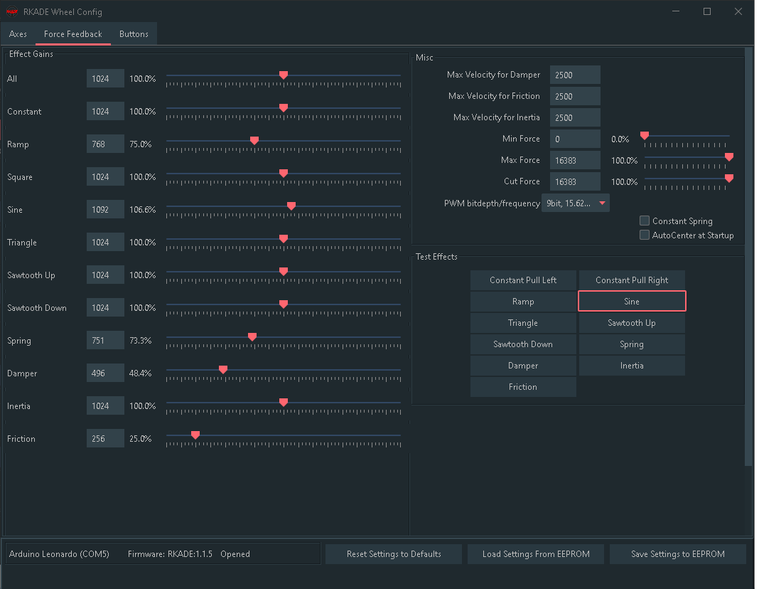
- Click on the Force Feedback tab on the top left:
Here, you can fine-tune the power for the standard ffb effects, test the effects, and enable/disable Constant Spring.
- With hands off the wheel, press the button to test the Sine effect. The wheel should shimmy left and right.
- After the previous effect stops, test that the Constant Pull Left and Right go in the correct direction.
- After the previous effect stops, enable the Constant Spring option. You should feel increasing resistance the further you turn the wheel. This option is handy for games that do not have Spring enabled, or has no FFB, or is too loose in the wheel.

Button/Shifter Configuration
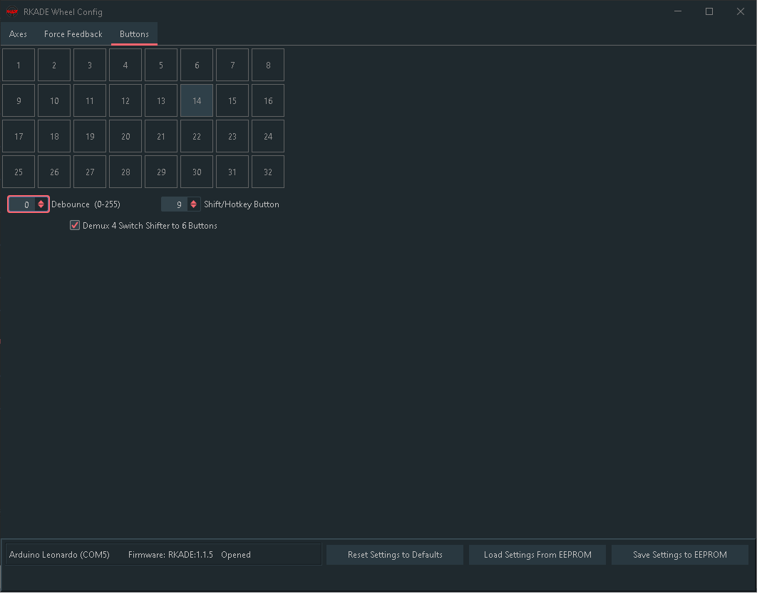
- Click the Buttons tab at the top of the app:
- Press each attached button or switch, it should show pressed as does button 14 in the above example.
- You can assign a Shift/Hotkey button to create virtual buttons for buttons 15-28. In the example above, the hotkey is button 9. If I hold that button, and then press another button, it will show a button press for the corresponding button (15-28).
- The Demux option should only be set when Button wires 1-4 are attached to a Happ 4 switch/6 Speed shifter. This will interpret the 4 button positions as the correct gear button.
- The Debounce option is used to prevent single button presses from showing multiple presses due to button “bouncing”, which can occur with poor quality microswitches. Note that the higher the value, the more time is required between button presses for each press to register.

FFB Arcade Plugin Setup
The RKADE interface is supported by the FFB Arcade Plugin, which provides FFB for Mame, Model 2, SuperModel3, Demul, Flycast, PC Steam, and TeknoParrot. This plugin is available at: https://github.com/Boomslangnz/FFBArcadePlugin
When using the FFB Plugin setup, it is important to enable the checkbox for ‘Alternative FFB’, otherwise you will not get consistent feedback strength to the left and right (see below for setting).
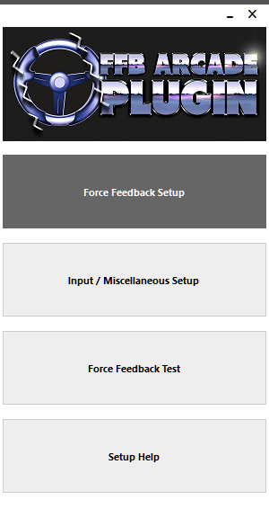

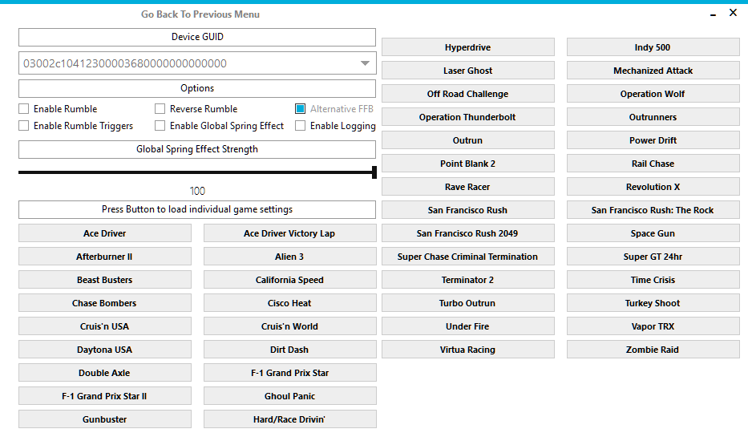

Configuration Utility Command Line Reference
An additional program is provided via the RkadeWheelConfig-cli.exe executable in the Release zip file. This provides scripting support for certain features.

For options, run ‘RKadeWheelConfig-cli.exe -help’ from a command line within the RKadeWheelConfig folder where the exe resides. Running this shows, for example:
usage: Help
-autocenter Perform automatic range and center calibration
-center Set wheel center to current position
-h,--help
-springoff Turn off constant spring effect
-springon Turn on constant spring effect

Using the springon/springoff option is helpful for running before/after games that need Constant Spring enabled for the correct feel.

