RKADE Gun Installation Instructions

Caution: Before beginning installation, ensure that the PC, the RKADE, and attached devices are powered OFF and unplugged. Attachments SHOULD NOT be made while devices are powered on.

Button/Switch Connectors
The button/switch connectors are hooked up to be ground-triggered, meaning that one side of the switch is connected to ground, and the other to a Button wire labeled 1-14. There is a wire labeled BTN GND that should be attached to a terminal block (shown below).

Each button microswitch has 2 or 3 male connectors, a COM (common), NO (normally open), and NC (normally closed). The COM terminal should be connected to the ground block, and the NO to the wire labeled for the Button (1-14). If you have a 3 connector microswitch and it is not labeled, the COM is normally on the bottom by itself, and the NO is in the middle.
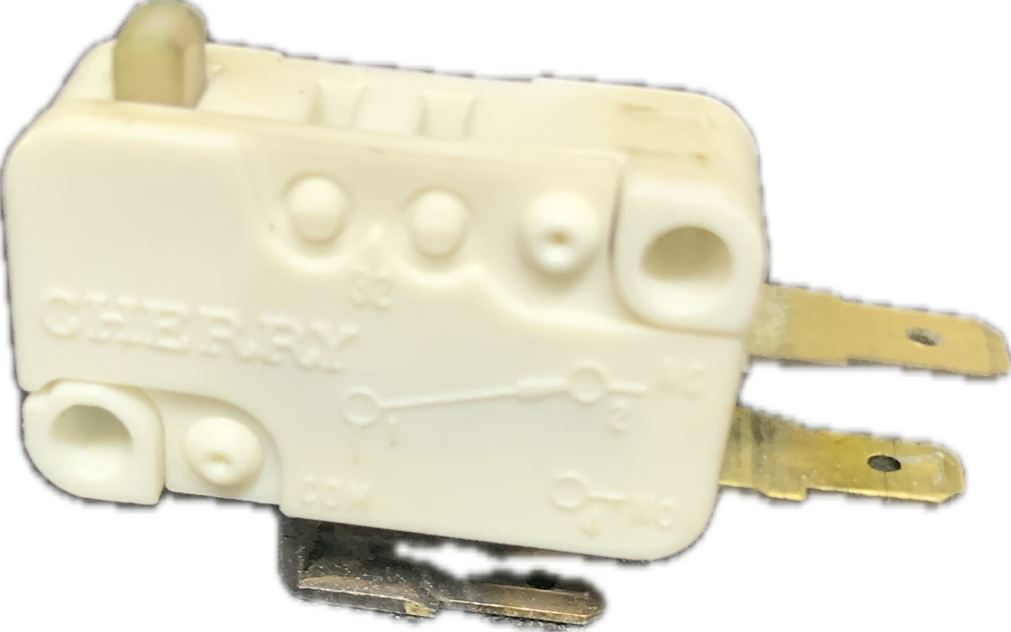

If using a 4 speed shifter with microswitches or leaf switches, wires for 1-4 are labeled Button 1/Shift 1, etc for convenience. You can use any Button or Button/Shift wire and map it how you prefer, there is no functional difference.
However, to support the Happ 4 microswitch/6 speed shifter, you should use the wires labeled Button/Shift 1-4 and enable the demux option later in the Configuration Utility.

USB Connection
The USB connection should be connected to the Windows 10/11 PC that will be running the games. Generally, for gaming devices USB 2.0 is preferred (USB 2.0 is usually colored Black in the receiving port, and USB 3+ is Blue or Teal).
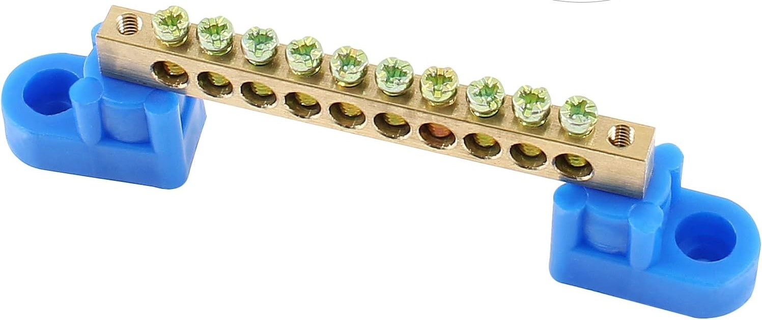
Also, ensure that you are using a USB port that powers off when the system powers off. Some PC’s have USB ports with a power symbol, and those ports may stay on after shutdown. Some PC BIOS allows this to be turned off as well. Either disable it, or use a USB 2.0 port that does not have the always-on power.

Power Supply Connections
The wall plug should be connected to an outlet capable of providing up to 5 amps for the steering motor.
The included power supply should be shipped already connected, as shown below.

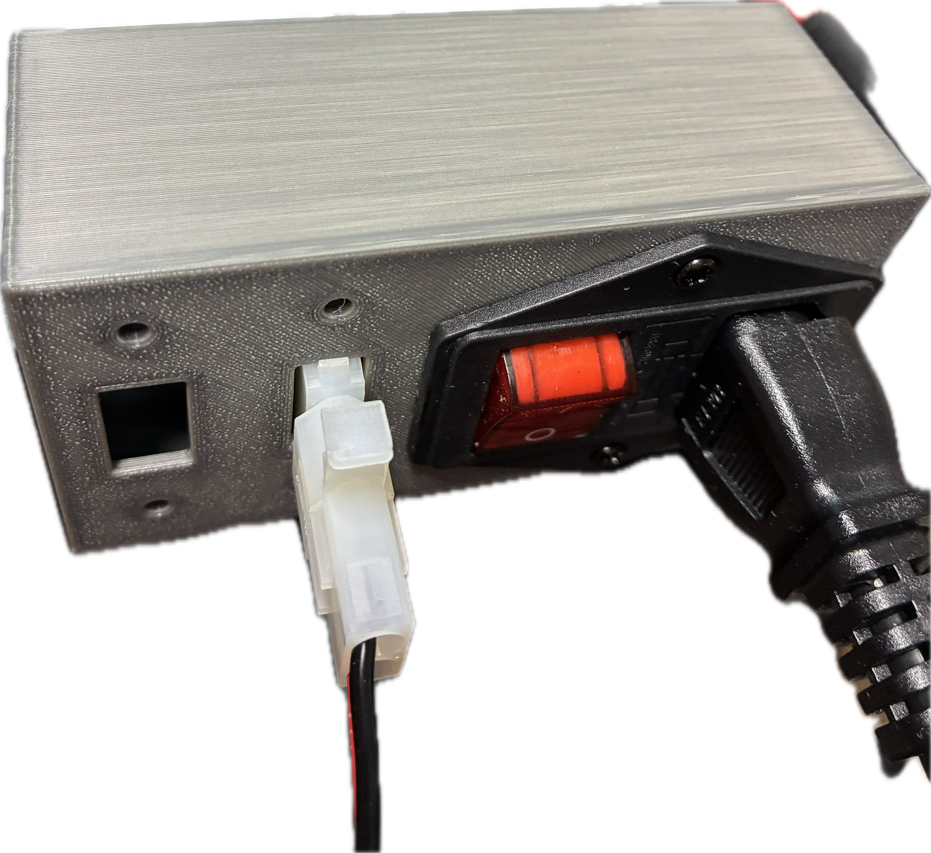

Initial Configuration
- After double checking all connections, power on the PC and plug in the Power Supply.
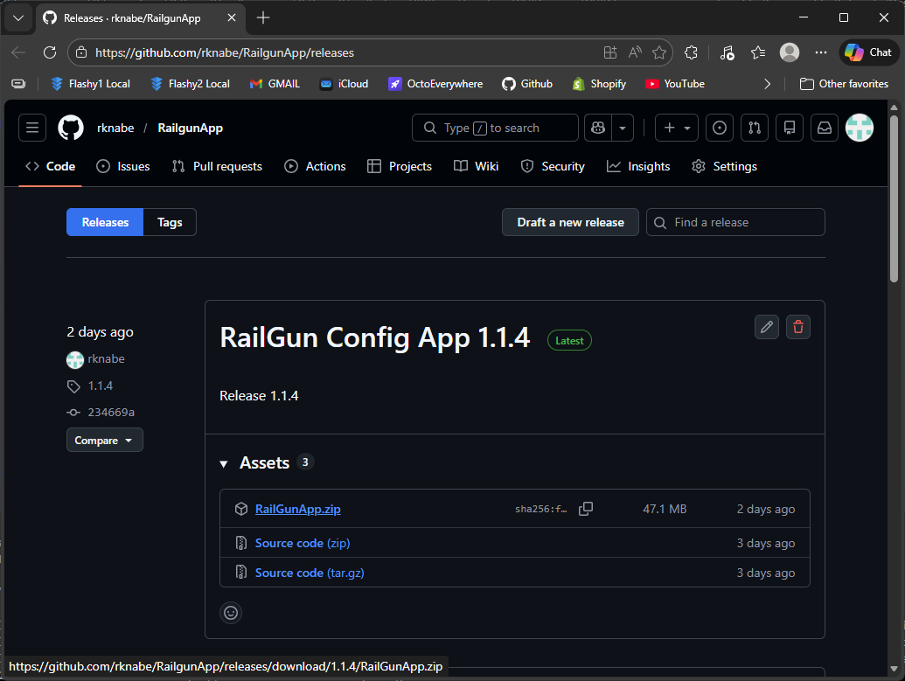
- Go to https://github.com/rknabe/RailgunApp/releases and download the Release of the RailGunApp:
- Un-zip the zip file to a folder, and place in desired location on hard drive, the folder contents consist of the EXE files, and a JRE folder
- Create a shortcut for the RailGunApp.exe and place shortcut on desktop.
- Launch the shortcut, and the Config app should show similar to below:
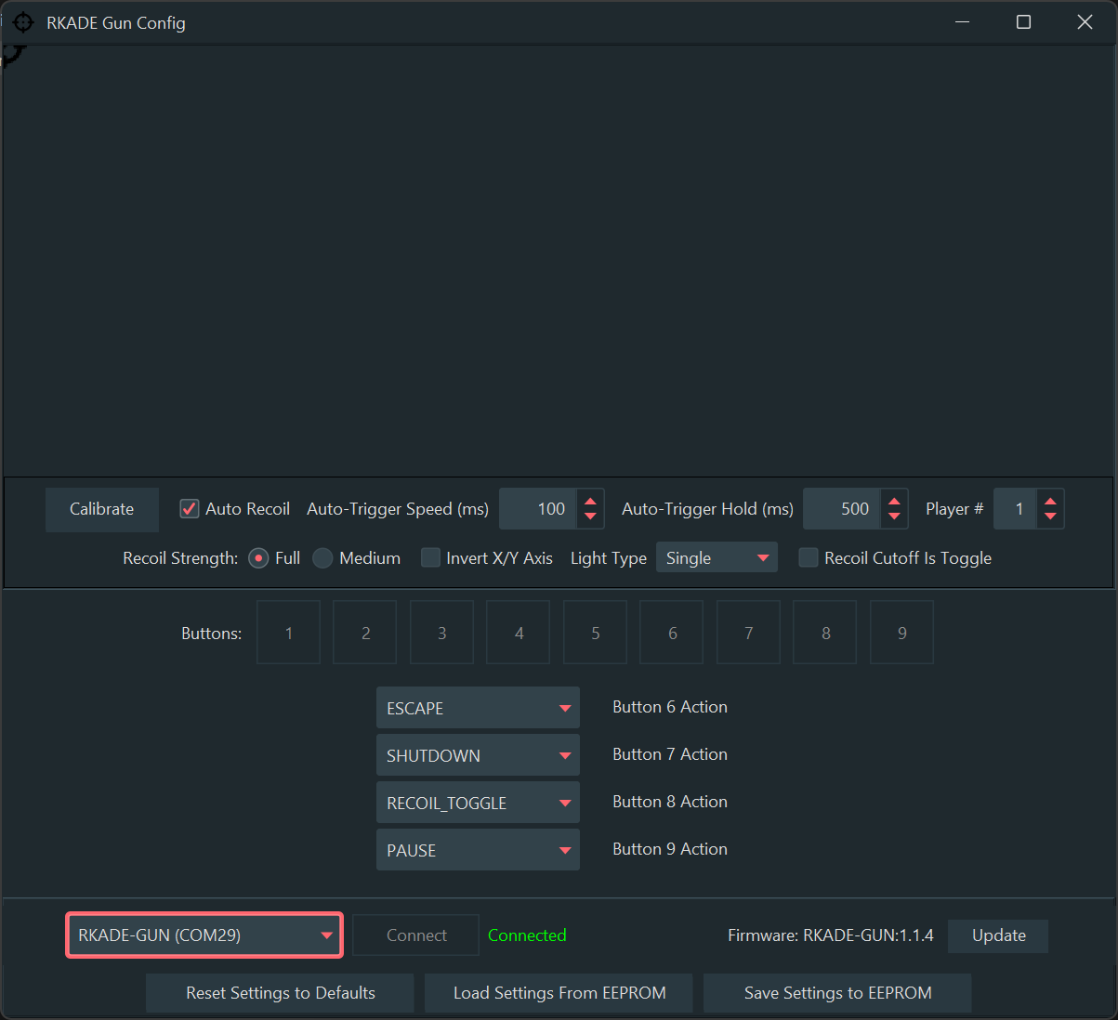

Note: You must Save the Settings to EEPROM to permanently set any values on this utility. If you do not Save, the values will reset to the former values after power-off.

Calibrating The Axes
Click the Calibrate button, and while the popup dialog is showing (15 secs or so), move guns fully up and down, and fully left and right.After the dialog expires, click the Save Settings to EEPROM to preserve the calibration.

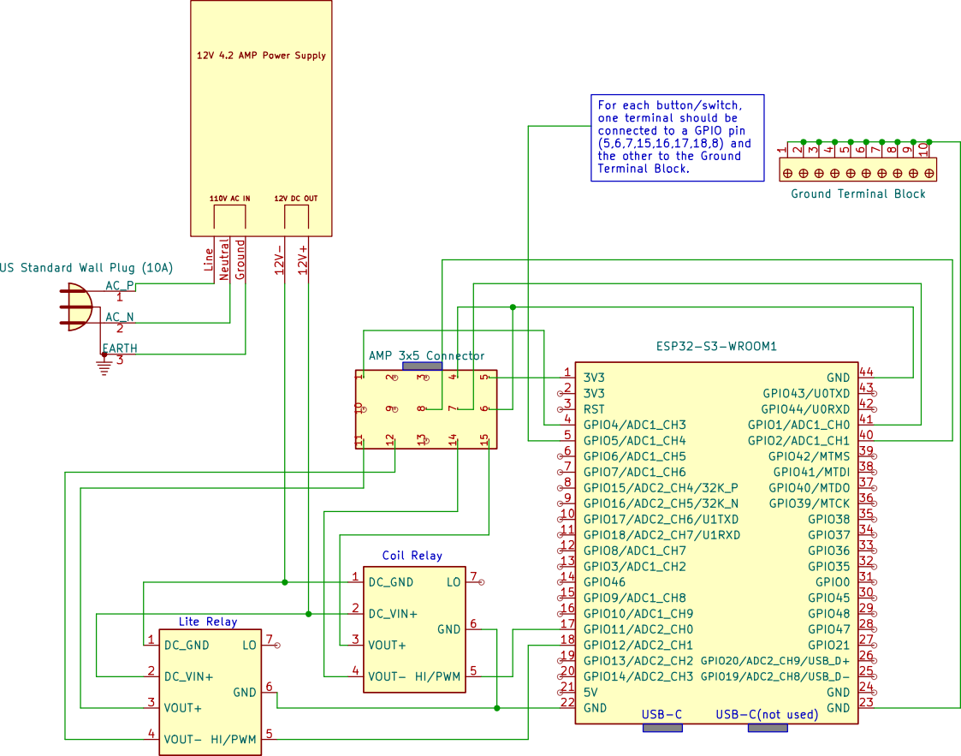
Internal Schematic

