Never Miss a Power Platform Update:
Building a Daily Blog Digest with Power Automate
How I automated a personalized HTML email digest and Microsoft Teams channel notification
for the Power Platform blog — using RSS, Office 365 Outlook, Microsoft Teams,
and Power Automate expressions — all in under an hour.
Ranjith Neela · Power Platform Architect · EPMPoint · February 28, 2026
ranjith.neela@epmpoint.com
────────────────────────────────────────────────────────────────────────────────

The Problem: Information Overload
If you work in the Microsoft ecosystem — and especially with Power Platform — you already know the challenge: the official Microsoft Power Platform Blog publishes new content constantly. Release announcements, feature previews, admin tips, community spotlights — keeping up means bookmarking the site, setting browser alerts, or relying on social media feeds that bury the signal in noise.
I wanted something cleaner: a single daily notification that shows exactly what was published in the last 24 hours, formatted beautifully, with one-click links to each article — delivered to my inbox and to my team's Microsoft Teams channel. And I wanted it to be zero-maintenance — no servers, no code to deploy, no subscriptions.
The answer, naturally, was Power Automate.
💡 WHAT YOU WILL LEARN In this post I walk through the design, the flow logic, and the key decisions behind the Power Platform Blog Digest solution — a fully exportable Power Automate cloud flow that monitors the Microsoft Power Platform RSS feed and delivers a polished HTML digest email and a Microsoft Teams Adaptive Card notification every morning.

What the Flow Does — At a Glance
The flow is simple by design. Every day at 8:00 AM UTC it wakes up, checks the Power Platform blog's public RSS feed for posts published in the previous 24 hours, and either:
- Sends a styled HTML digest email via Office 365 Outlook and posts an Adaptive Card to Microsoft Teams if new posts are found, or
- Exits gracefully (status: Succeeded, no notifications sent) if there is nothing new.
A separate error-handling scope catches any unexpected failures and fires an alert email to an admin address — so you always know if something went wrong.
SAMPLE DIGEST EMAIL AS RECEIVED IN MICROSOFT OUTLOOK (1 OF 3)
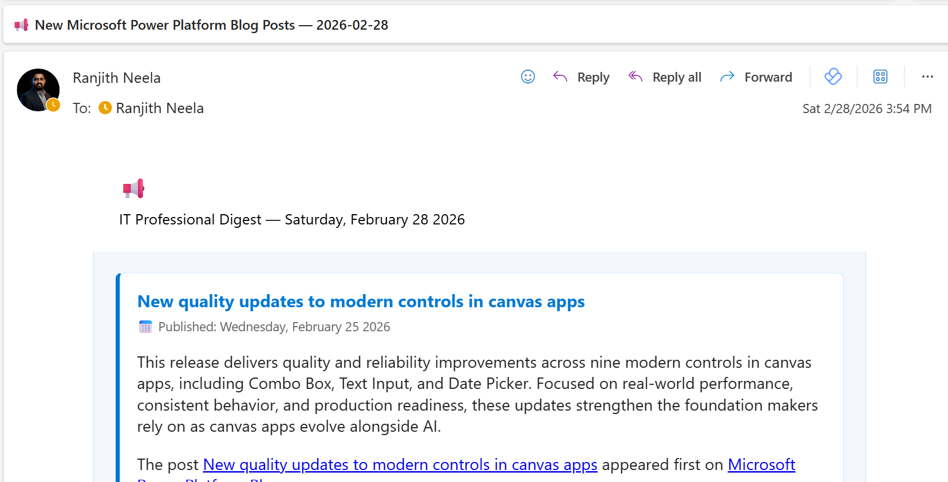
The email arrives with subject 'New Microsoft Power Platform Blog Posts — [date]' — the branded header and first post card are immediately visible
SAMPLE DIGEST EMAIL — CONTINUED (2 OF 3)
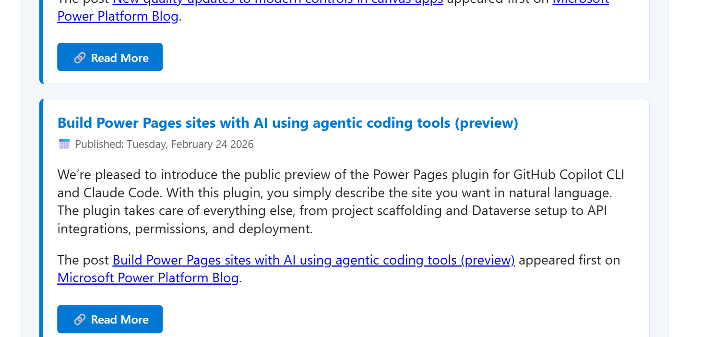
Scrolling reveals additional post cards — each with title, publish date, summary, and a 'Read More' button linking directly to the article
SAMPLE DIGEST EMAIL — FOOTER (3 OF 3)
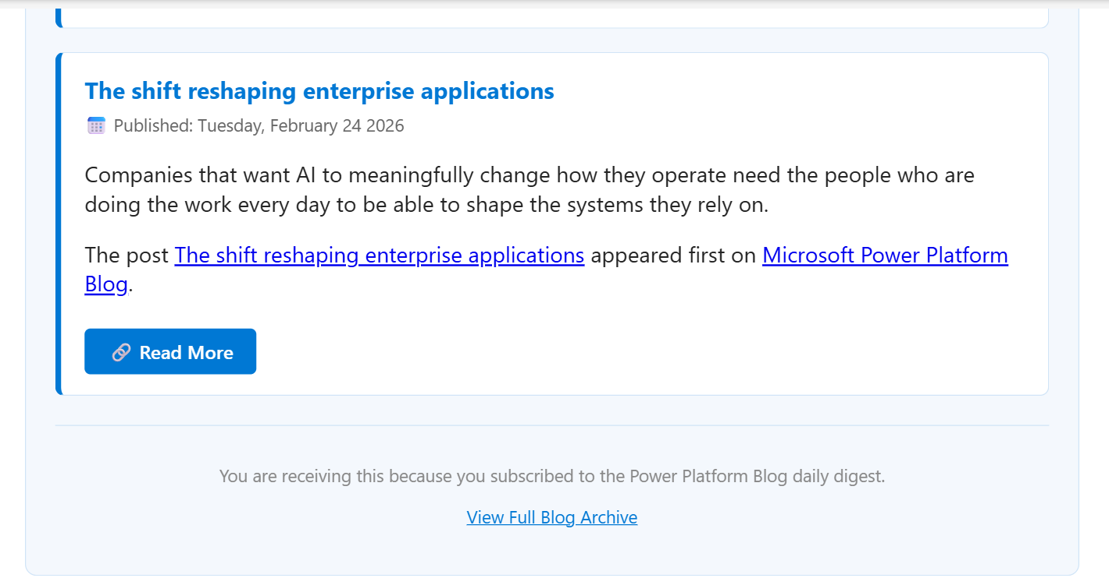
The email closes with the final post card and a subtle footer with a 'View Full Blog Archive' link

Flow Architecture — Step by Step
The flow has three top-level building blocks: an initialization step, a Main Scope that does all the real work, and an Error Handler Scope that runs only on failure.
- 1. Trigger — Recurrence (Daily at 8:00 AM UTC)
A simple recurrence trigger fires once per day. No event, no webhook — just a reliable schedule so the flow is predictable and easy to monitor in run history.
- 2. Initialize Variables — HTML_Body
Empty string variables are declared before the main scope. The primary accumulator (HTML_Body) is filled with styled post cards during the loop and later injected between the email header and footer.
- 3. List All RSS Feed Items & Filter (last 24 hours)
The built-in RSS connector calls the Power Platform blog feed. A Filter Array action limits results to items published within the last 24 hours using addDays(utcNow(), -1).
- 4. Condition — Any New Posts?
A condition checks length(body('List_all_RSS_feed_items')) > 0. If false, a Terminate action marks the run Succeeded with a friendly message and no notifications are sent.
- 5. Apply to Each — Build HTML Cards
For every RSS item, a Compose action renders a self-contained styled div card containing the post title (linked), publish date, summary text, and a 'Read More' button. Each card is then appended to the HTML_Body variable.
- 6. Compose Email Header & Footer
After the loop, two Compose actions generate a branded gradient header banner (with today's date) and a footer with a link to the full blog archive.
- 7. Compose Full Email Body & Final Card
A single expression merges Header + HTML_Body variable + Footer into the final email body string. A separate Compose assembles the Teams Adaptive Card payload from the same post data.
- 8. Send Notification Email (Office 365 Outlook)
The HTML digest is dispatched via the Office 365 Outlook connector to the NotificationEmail environment variable recipient. The subject line includes today's date for easy identification.
- T. Post Card in a Chat or Channel (Microsoft Teams)
Immediately after the email, the flow posts the digest as an Adaptive Card to a configured Microsoft Teams chat or channel — giving the whole team instant visibility without anyone needing to check their inbox.
- ! Error Handler Scope (runs only on failure)
If Main Scope fails or times out, a second scope builds an HTML error report — capturing the error code and message — and sends it to a separate AlertEmail environment variable.
POWER AUTOMATE DESIGNER — FULL FLOW VIEW
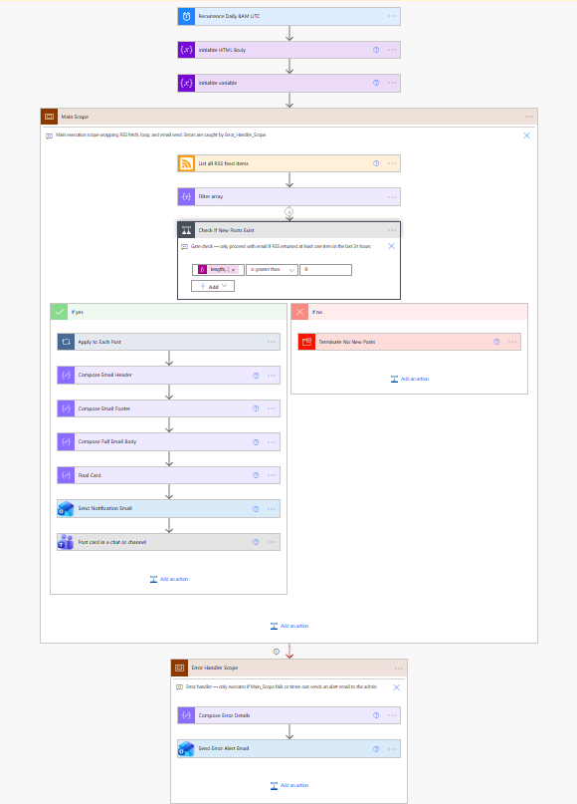
Power Automate designer view — the complete flow from Recurrence trigger through Main Scope (including the 'Post card in a chat or channel' Teams step) to the Error Handler Scope

Key Design Decisions

Why Two Scopes?
Wrapping the main logic in a Scope action is the cleanest way to implement try/catch semantics in Power Automate. The Error Handler Scope is configured with runAfter: { Main_Scope: ["Failed", "TimedOut"] }, which means it is completely invisible during a healthy run and only activates when something goes wrong. This pattern keeps the happy-path logic clean and the error-path logic isolated.

Graceful Exit When No Posts Are Found
Rather than sending empty notifications on quiet days, the flow uses a Terminate action inside the else branch with runStatus: "Succeeded". This keeps your run history green (not red) for no-news days, which matters when you are monitoring many flows.

Dual-Channel Delivery: Email and Teams
The flow delivers the same digest content through two channels in a single run. The Office 365 Outlook action sends a rich, self-contained HTML email for in-depth reading, while the Teams connector posts an Adaptive Card to a shared channel — giving the whole team at-a-glance visibility without anyone needing to check their inbox. Both notifications fire from the same flow run, so there is zero duplication of effort.

HTML Email Built Entirely in Flow Expressions
Every piece of HTML — from the gradient header to the individual post cards — is generated using Power Automate Compose actions and inline expressions. There is no external template engine, no Azure Function, no storage account. The entire rendering pipeline lives inside the flow definition.

Environment Variables Instead of Hard-Coded Values
The NotificationEmail and AlertEmail values are defined as environment variables within the Power Platform solution — not hard-coded inside actions. This means anyone who imports the solution can set the email addresses directly in the solution's Environment Variables section without touching the flow internals, making it truly plug-and-play across environments.
ENVIRONMENT VARIABLES IN THE SOLUTION (1 OF 2)
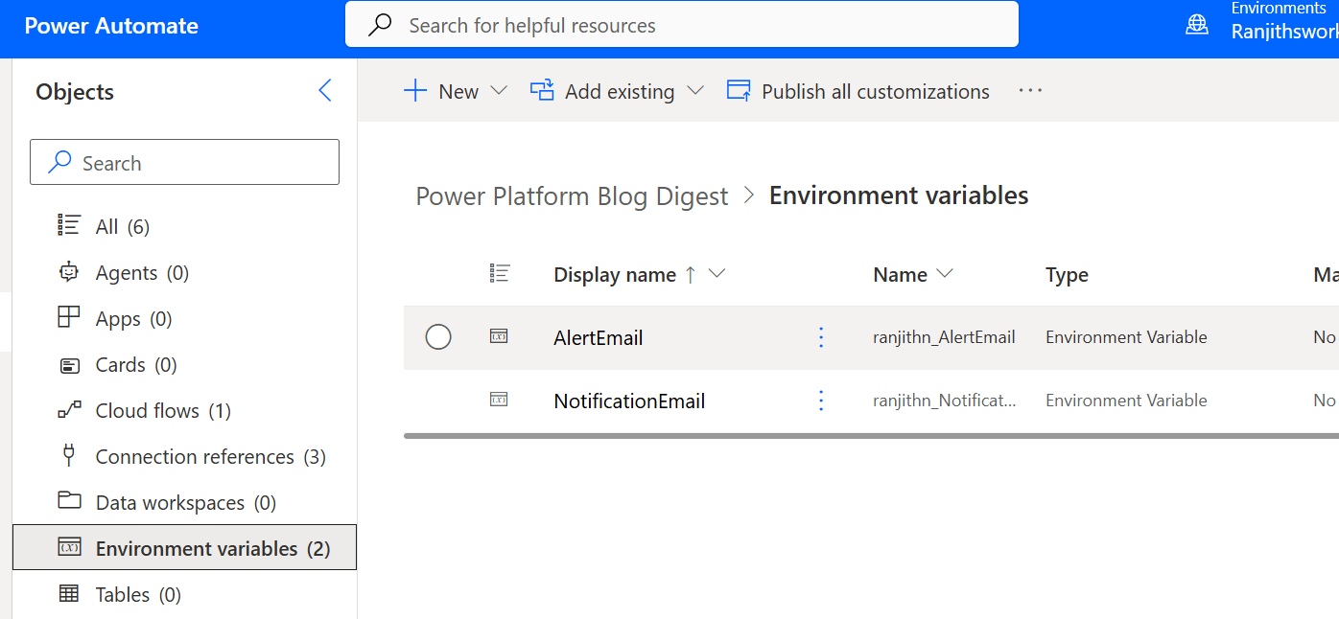
The solution's Environment Variables section — AlertEmail and NotificationEmail are configured here once, keeping the flow portable across environments without any internal edits
ENVIRONMENT VARIABLES USED INSIDE THE FLOW (2 OF 2)
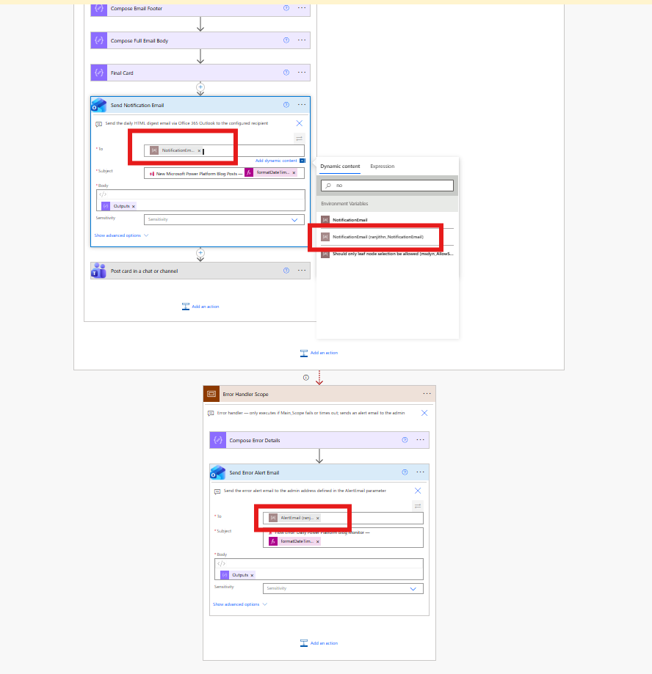
Inside the flow — the Send Notification Email action resolves the NotificationEmail environment variable at runtime; the Error Handler Scope below uses the same pattern for AlertEmail

What the Notifications Look Like

Email Digest in Outlook
The generated email is fully self-contained HTML — no external CSS, no linked stylesheets — so it renders reliably across email clients.
Element | Design Choice
Header | Microsoft blue gradient banner with today's date — instantly recognisable
Post Cards | White card with blue left border, title in brand blue, publish date, summary, and a 'Read More' CTA button
Footer | Subtle grey separator with a direct link to the full blog archive
Font | Segoe UI — consistent with Microsoft product design
Max width | 720 px — optimal for desktop email clients; readable on mobile

EMAIL POST CARD CLOSE-UP
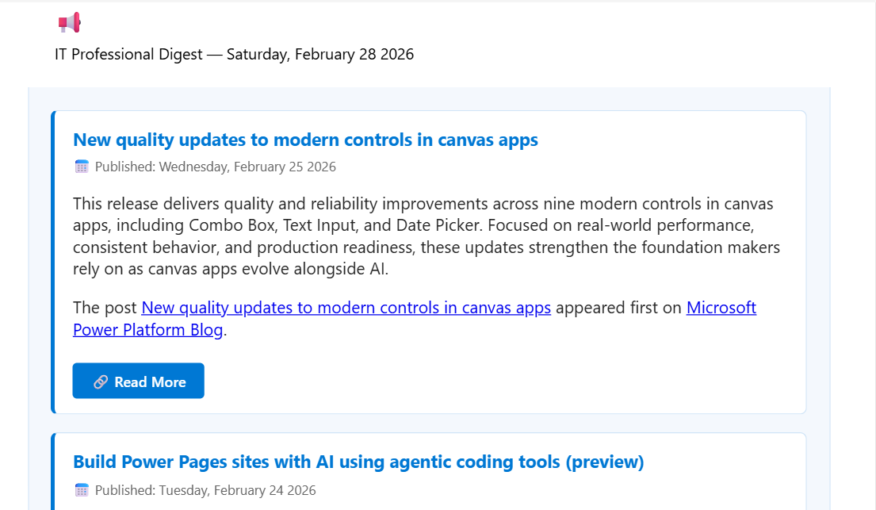
A single email post card — article title linked to the full post, calendar-icon publish date, rich summary text, and a prominent 'Read More' button

Microsoft Teams Channel Card
In parallel with the email, the flow posts an Adaptive Card from the EPMPoint Workflows bot to the configured Teams chat or channel. The card presents each new post with its title, publish date, summary, and a 'Read More' button — giving the team instant awareness of the day's Power Platform news directly in their Teams feed, without switching to email.
TEAMS ADAPTIVE CARD CLOSE-UP (1 OF 2)
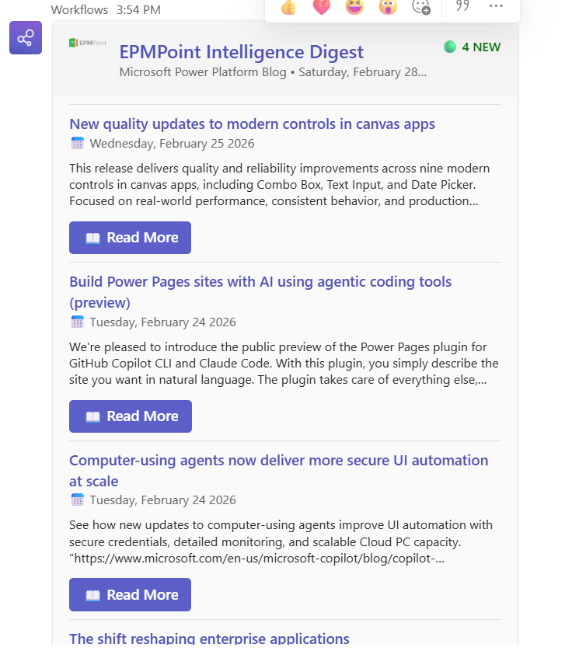
Close-up of the Teams Adaptive Card — the 'EPMPoint Intelligence Digest' card lists each new post with title, publish date, summary, and a Read More button, mirroring the email digest inside Teams
TEAMS FULL NOTIFICATION VIEW (2 OF 2)
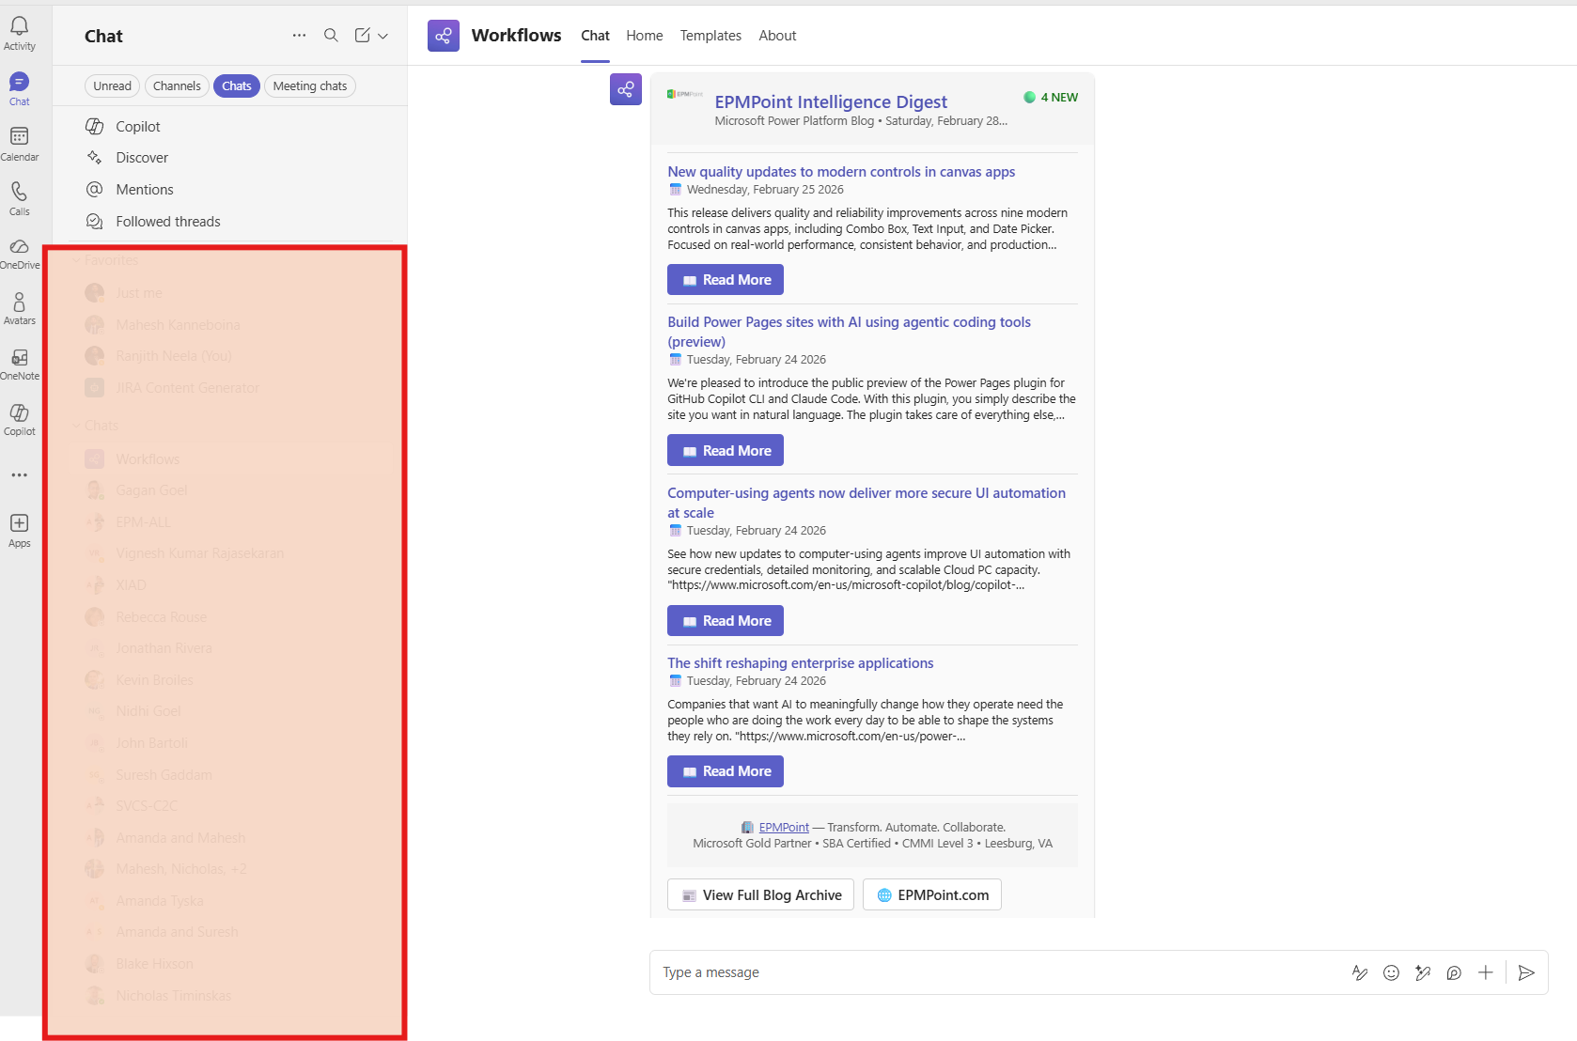
Full Teams view — the card appears in the Workflows chat showing all four new blog posts, with EPMPoint branding and 'View Full Blog Archive' button at the bottom
ERROR HANDLER SCOPE — ALERT EMAIL
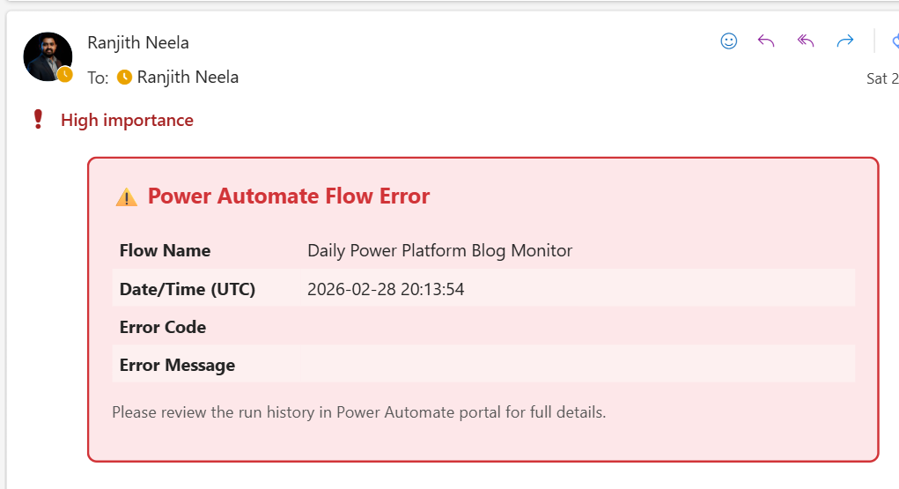
Error alert email from the Error Handler Scope — sent as high importance, showing flow name, UTC timestamp, error code, and error message; prompts the admin to review run history in the portal

Prerequisites & How to Import
📋 WHAT YOU NEED A Power Platform environment with Dataverse · An Office 365 Outlook licence · A Microsoft Teams licence · Maker permissions in the target environment
- Download the solution ZIP — PowerPlatformBlogDigest_1_0_0_3.zip
- Navigate to make.powerautomate.com → your environment → Solutions
- Click Import solution and upload the ZIP
- During import, create or select connections for RSS, Office 365 Outlook, and Microsoft Teams
- After import, open the solution and set values for the NotificationEmail and AlertEmail environment variables
- Open the flow and configure the 'Post card in a chat or channel' action with your target Teams team and channel
- Save and Turn on the flow
POWER PLATFORM SOLUTION CONTENTS AFTER IMPORT (1 OF 2)
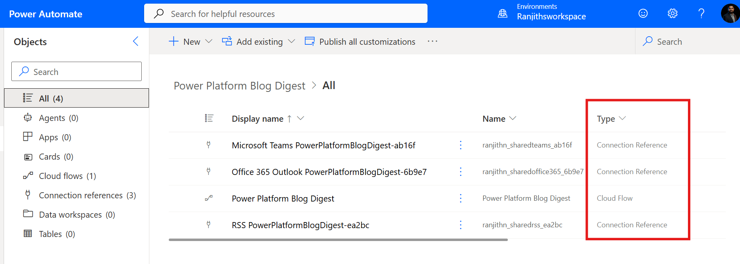
The imported solution contains 4 objects — one Cloud Flow ('Power Platform Blog Digest') and three Connection References for Microsoft Teams, Office 365 Outlook, and RSS
SOLUTION CONNECTION REFERENCES (2 OF 2)
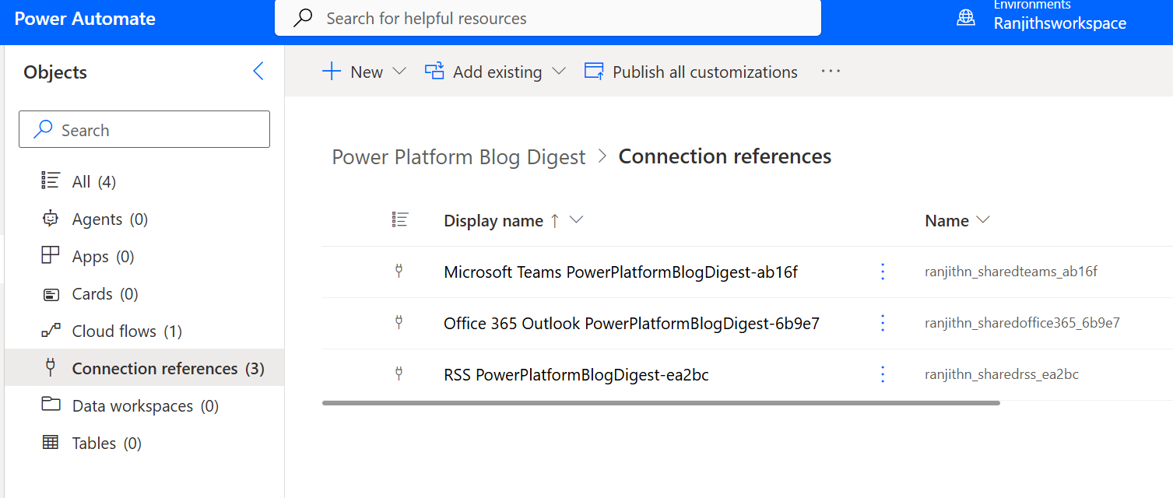
Connection References detail — all three connectors (Microsoft Teams, Office 365 Outlook, RSS) must be linked to active connections before the flow will run

Ideas for Extending This Flow
The current flow delivers a daily dual-channel digest with full error handling and does it well. Natural extensions include:
- Multiple RSS feeds — Add the Power Apps, Power BI, and Copilot Studio blogs to the same digest by parallelising additional RSS actions
- Weekly digest mode — Change the recurrence to run on Mondays with a -7 day offset to capture the full previous week in one card
- Audience filtering — Filter specifically for IT Pro or Developer posts using the blog's audience query parameters
- Dataverse logging — Write each digest run to a Dataverse table for audit and trend analysis
- Keyword alerts — Flag posts matching keywords like 'Copilot', 'deprecation', or 'breaking change'
✅ PRO TIP If you want the digest to cover the weekend, consider changing the recurrence to run on Mondays with a -3 day offset instead of -1. That way Friday, Saturday, and Sunday posts all appear in the Monday morning email and Teams card.

Wrapping Up
The Power Platform Blog Digest is a great example of what I love about Power Automate: you can solve a real, everyday problem without writing a single line of server-side code, without provisioning any infrastructure, and without any ongoing maintenance burden. The entire solution — from trigger to dual-channel notification to error handling — lives inside a single exported solution ZIP that you can import into any environment in minutes.
Whether your team prefers email or Teams (or both), this flow has you covered. You get a rich HTML Outlook digest for in-depth reading and a quick Teams Adaptive Card for at-a-glance awareness — all from the same single flow run, zero extra effort.
The solution is packaged as PowerPlatformBlogDigest_1_0_0_3.zip and is ready to import into any environment today. If you find this useful, feel free to extend it, remix it, and share it with your team.

────────────────────────────────────────────────────────────────────────────────
About the Author
Ranjith Neela
Power Platform Architect | EPMPoint | ranjith.neela@epmpoint.com
Ranjith is a Power Platform architect at EPMPoint, specialising in Power Automate, Power Apps, and Dataverse solutions for enterprise clients. He is passionate about building elegant, low-code automations that eliminate repetitive work and surface the right information at the right time.

