HOW TO READ THIS EXAMPLE · This is an annotated sample of a short final-deliverable-style report. The orange notes in the left margin point out specific formatting choices that match the standards on the course page. The report has been shortened — a real deliverable would be longer — but the standards apply at any length. The fictional firm in this example, GreenPath Solutions, is the same firm referenced earlier in the course.

Donor Engagement Strategy
A recommendations report for GreenPath Solutions · Prepared by the River Valley Consulting Team · May 2026
ANNOTATION · HEADING HIERARCHY One H1 used only for the document title. Major sections below use H2; subsections use H3. The hierarchy is consistent throughout.

Executive Summary
GreenPath Solutions' individual donor base grew 12 percent in 2025, but recurring giving lagged peer firms in the sustainability sector. This report identifies three priorities for strengthening donor retention and recommends a phased approach the team can implement within the next two quarters.
Our analysis draws on twelve months of donor data, four stakeholder interviews, and a benchmark scan of comparable sustainability consultancies. The findings consistently point to one strategic shift: GreenPath's donor relationships are healthy at the entry stage but thin out before reaching recurring status.
The three priorities described below focus on what GreenPath can do in the conversion window between a donor's first gift and their second.
ANNOTATION · WHITE SPACE AND PARAGRAPH LENGTH Paragraphs run four to six lines and are separated by consistent spacing. Walls of text are split at natural breaks rather than left as a single block.

Background
GreenPath Solutions, a Portland-based sustainability consulting firm, supports a network of individual and corporate donors who fund its community programming arm. Individual donors currently contribute roughly 38 percent of program revenue.
Over the past year, GreenPath's leadership has identified donor retention as a strategic gap. While first-time donor acquisition is healthy, the firm sees significantly fewer of these donors return for a second gift than peer firms report.

Methodology
Our team conducted three streams of research between March and April 2026:
- Quantitative review of twelve months of GreenPath donor records, including gift size, frequency, and source channel.
- Four stakeholder interviews with GreenPath staff: the Director of Development, two program leads, and the volunteer coordinator.
- A sector benchmark comparing donor engagement practices at five comparable sustainability consultancies, drawing on publicly available materials.

Findings

Donor segments
GreenPath's donor base divides into three distinct segments with different giving patterns and retention rates. Table 1 summarizes the segments and the patterns associated with each.
Table 1. Donor segments at GreenPath Solutions, 2025
Donor segment | Average gift | First-year retention | Multi-year retention
First-time donors | $85 | 28% | 14%
Recurring donors | $145 | 71% | 58%
Major donors ($500+) | $1,250 | 84% | 76%
The retention gap between first-time and recurring donors is the largest in the segment data. Closing even a portion of that gap represents a substantial revenue opportunity.
ANNOTATION · TABLE FORMAT Descriptive title placed ABOVE the table (not below). Header row is visually distinct. Column widths are sized to content. The table is referenced from the surrounding text rather than left to stand on its own.

Giving patterns
Recurring donors give roughly three times more annually than the average first-time donor, both because their gift sizes are higher and because their gifts repeat. Figure 1 shows the share of annual donor revenue contributed by each segment.
Figure 1. Share of annual donor revenue, by donor segment (2025)
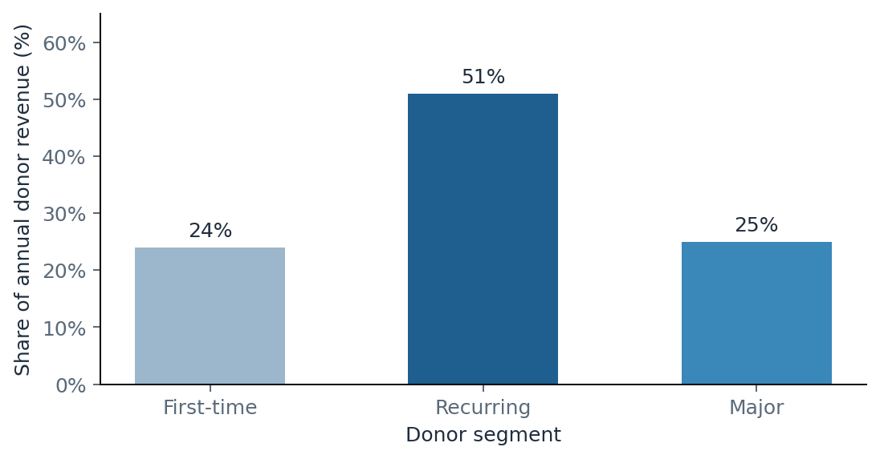
Source: GreenPath internal donor records, March 2026.
ANNOTATION · CHART FORMATTING Title above the chart. Axes are labeled, including units. A single accent color is used to draw the eye to the segment carrying the largest share. The data source is cited directly beneath the visual.

Key finding
The largest revenue opportunity is not acquiring new donors. It is moving more first-time donors into the recurring segment. A five percentage point lift in first-year retention would generate more revenue than a comparable acquisition increase.

ANNOTATION · CALLOUT BOX, USED SPARINGLY A single callout box flags the report's most important finding. Used once, the callout draws attention. Used on every page, callouts lose their effect — so this report has only one.

Recommendations
Based on the findings above, our team recommends three priorities for the next two quarters. Each is described briefly below; full implementation detail appears in Appendix A.

Priority 1: A structured first-90-days flow
Most first-time donors disengage between their first gift and the moment a typical communication cadence would re-engage them. A structured 90-day flow — thank-you call within 48 hours, impact email at day 30, invitation to a small event at day 60 — closes this gap without significant new spend.

Priority 2: Recurring giving as the default ask
GreenPath's current giving page presents a one-time gift as the default, with recurring giving as a secondary choice. Reversing this default has been shown across the sector to lift recurring conversion meaningfully, with no negative effect on overall giving.

Priority 3: Donor segmentation in the CRM
The current CRM does not distinguish first-time, recurring, and major donors in a way that supports differentiated communication. A modest reconfiguration would allow GreenPath's communications team to tailor messaging without adding staff capacity.
ANNOTATION · TERMINOLOGY CONSISTENCY Throughout the report, the same terms are used for the same things: donor segment (not group, tier, or bucket); recurring donor (not repeat, returning, or monthly); first-time donor (not new, one-time, or initial). Inconsistent terms read as careless and can confuse the reader about whether two terms mean the same thing.

Next Steps
We recommend GreenPath's Development team work through these priorities in sequence rather than parallel, beginning with the first-90-days flow as the highest-leverage near-term move. Our team is available to support the design of the day-1 through day-90 communication sequence in the next two weeks.
River Valley Consulting Team · Submitted May 2026 · Prepared for GreenPath Solutions

